HW1 – Monthly KPI AI Reporting Workflow

GitHub Repository

https://github.com/helchiparnia-sketch/kpi-ai-reporting-workflow.git

Introduction / Overview
This project implements an automated monthly KPI reporting system using a workflow automation tool (n8n). The system retrieves business performance data from a spreadsheet, processes it using an AI model, and generates an executive-level management report.
The workflow demonstrates integration between:
- a scheduled trigger,
- external data source (Google Sheets or CSV),
- AI-based processing,
- and automated report generation.
The goal is to eliminate manual reporting and automatically produce structured business insights on a monthly basis.

Workflow Structure

Trigger (Schedule Trigger)
The workflow is initiated using a monthly schedule trigger configured to run on the first day of each month at a fixed time.
This simulates an automated business reporting cycle without manual intervention.

Data Source (Google Sheets / CSV)
The system retrieves KPI data from a structured spreadsheet containing:
- Month
- Revenue
- Customers
- Churn Rate
- Expenses
This dataset acts as the external business data source for the workflow.

Processing Function (AI Model)
The extracted KPI data is sent to an AI model (OpenAI / Message a Model node), which processes the raw numbers and generates a structured executive report.
The AI performs:
- revenue interpretation
- customer and churn analysis
- expense evaluation
- profitability insights
- business recommendations

Output Generation (AI Report)
The AI generates a structured monthly KPI report including:
- Executive Summary
- Key Metrics Overview
- Revenue Analysis
- Customer & Churn Analysis
- Expense Breakdown
- Recommendations
The output is formatted in a structured text/Markdown format suitable for business reporting.

Delivery (Email Output)
The final generated report is automatically sent via email to the designated recipient.
This ensures that stakeholders receive monthly insights without manual reporting effort.

Test Case
The system was tested using sample KPI data from the spreadsheet.

Sample Input Data:
- Month: March
- Revenue: 120,000
- Customers: 530
- Churn Rate: 3.2%
- Expenses: 75,000

Execution Result:
The workflow successfully:
- Triggered on schedule
- Retrieved KPI data from spreadsheet
- Processed data using AI model
- Generated structured KPI report
- Sent the final report via email

Output Validation:
The AI-generated report included:
- revenue performance analysis
- churn and customer evaluation
- profitability insights
- actionable recommendations
This confirms that the workflow executed successfully.

Results
The system successfully automates the KPI reporting process and eliminates the need for manual report creation.
Key outcomes:
- Automated execution via schedule trigger
- Accurate data extraction from spreadsheet
- AI-generated executive-level insights
- Fully structured business report output
- Successful email delivery of report

External Integration Note
This project uses Google Sheets (or CSV file system) as the external data source.
The AI model (OpenAI via n8n) is integrated to process raw KPI data and generate structured business intelligence reports.
The email service acts as the final delivery layer for automated reporting.

Final Note
This workflow demonstrates a complete end-to-end automation pipeline:
Trigger → Data Source → AI Processing → Business Insight Generation → Automated Delivery
It simulates a real-world business intelligence system used in reporting automation.

n8n work flow 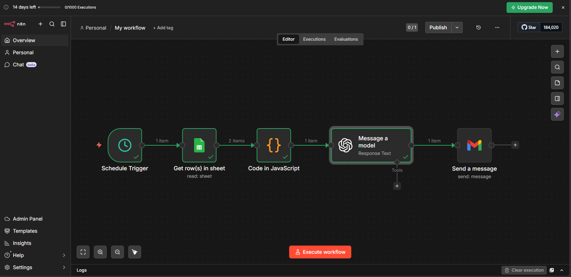Github repository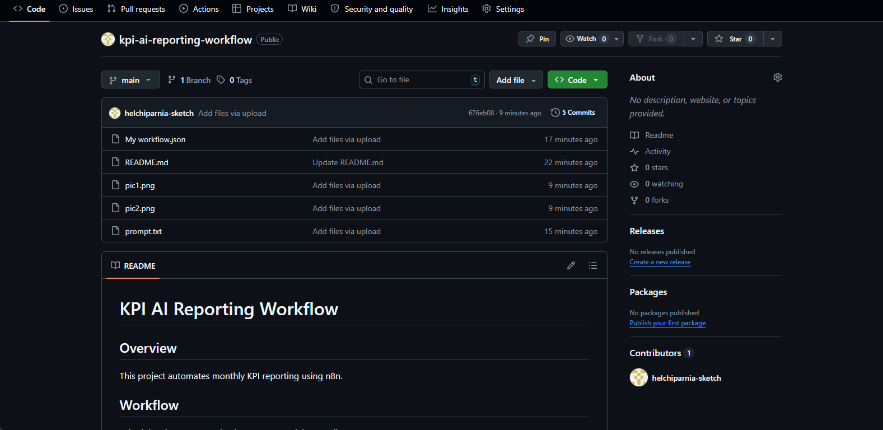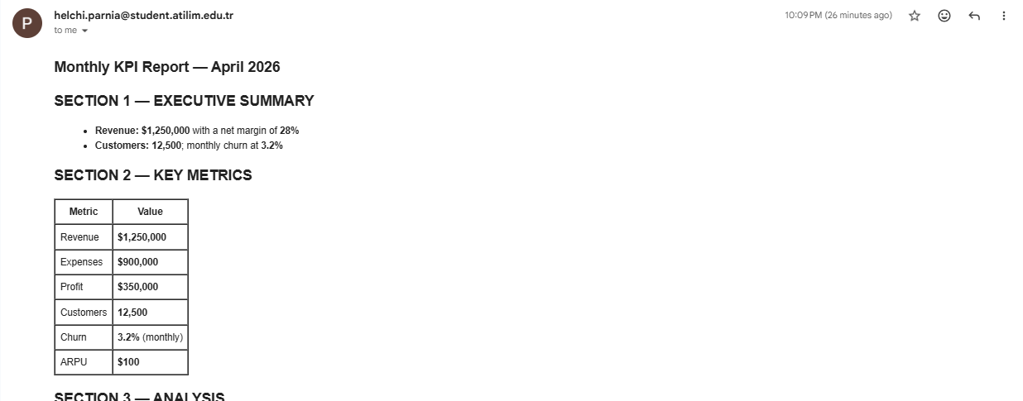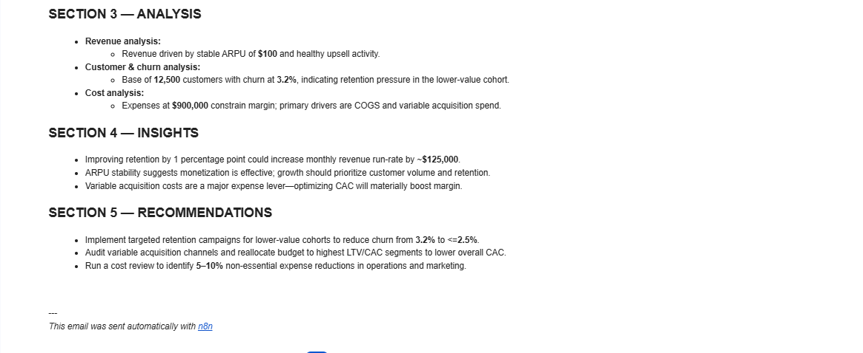inbox report

