HELCOM SPIA (QGIS Plugin) - User Guide
This guide explains how to download, install, and use the HELCOM SPIA QGIS plugin.

Getting the Plugin
1. Open the plugin repository:
https://github.com/yourname/ecp-raster-analysis-tool.
2. Click **Code → Download ZIP**.
3. Save the `.zip` file locally.

Installing the Plugin in QGIS
1. Open QGIS.
2. Go to: Plugins → Manage and Install Plugins → Install from ZIP.
3. Select the downloaded `.zip` file.
4. Click Install Plugin.
5. Enable the plugin if not enabled automatically.

After installation you should see the plugin:
- in the QGIS Plugins menu.
- optionally in the QGIS toolbar.

Starting the Plugin
1. Open QGIS.
2. Go to: Plugins → HELCOM SPIA.
3. The plugin dialog will open.
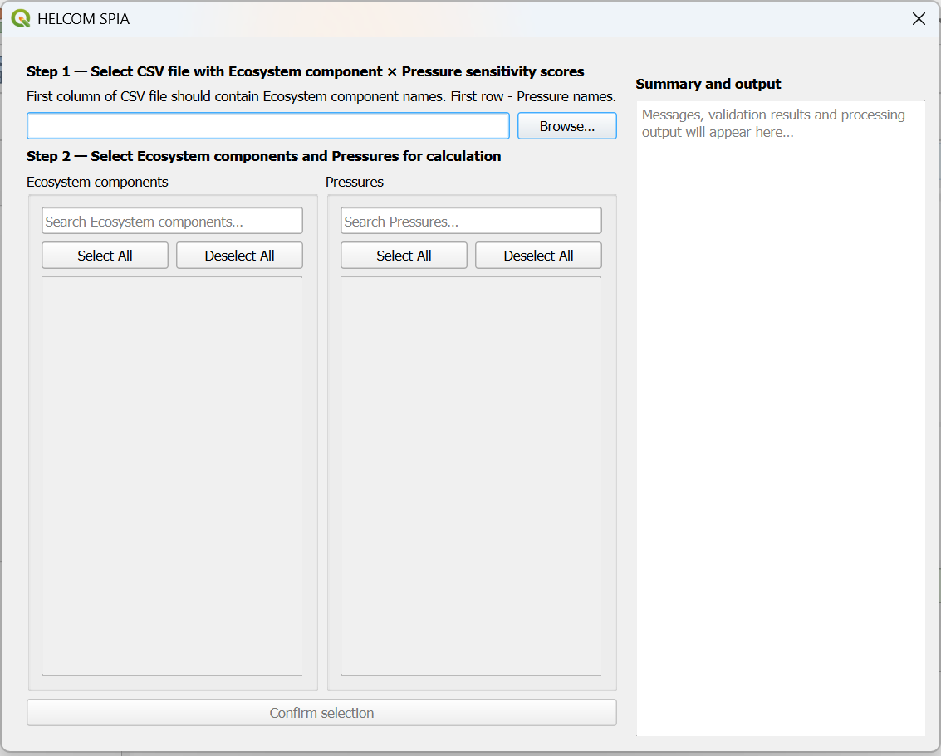

Overview of Workflow
The plugin guides you through a step-by-step process:
1. Load EC×P score matrix (CSV).
2. Select Ecosystem components (EC) and Pressures (P).
3. Validate raster inputs.
4. Choose processing tools.
5. Run analysis.
6. Review outputs.

Step-by-Step Usage
Step 1 – Load sensitivity score matrix (CSV):
- Click Browse…
- Select a CSV file containing EC×P sensitivity scores.

CSV structure:
- First row contains Pressure names.
- First column contains Ecosystem component names.
- Values: EC×P sensitivity scores.

Example:
 | Pressure 1 | Pressure 2
Ecosystem component 1 | 0.7 | 1.5
Ecosystem component 2 | 0 | 2

Step 2 – Select ECs and Ps
Use checkboxes to select:
- Ecosystem components.
- Pressures.

Optional:
- Use search fields to filter items.
- Use Select All / Deselect All.

When at least one EC and one P is selected:
- Confirm selection button becomes available.
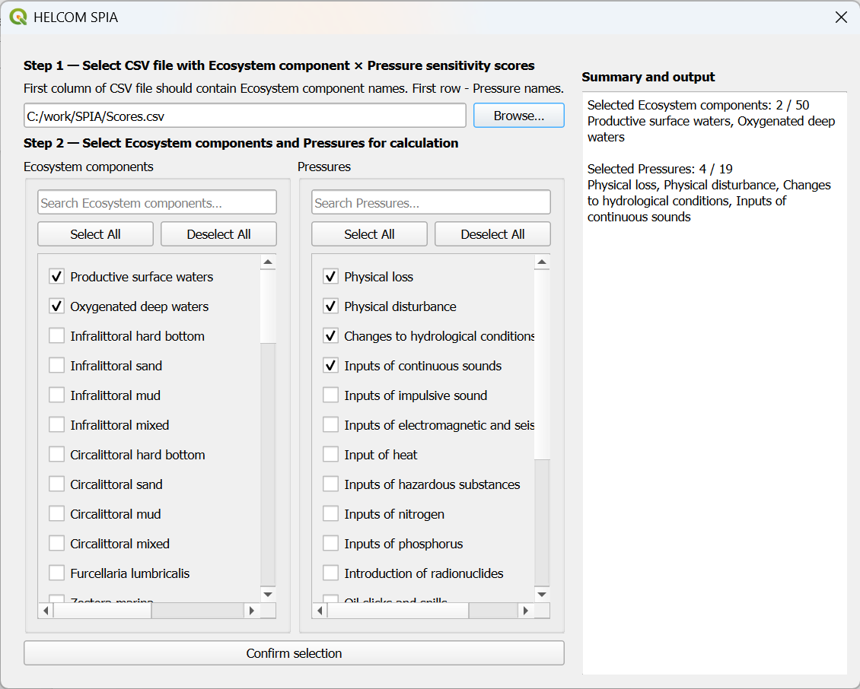

Step 3 – Confirm selection
Click: Confirm selection.
Then:
- Selection summary appears on the right.
- Next step is unlocked.

Step 4 – Select raster folders
You must choose:
- Folder with EC rasters.
- Folder with P raster.
Each folder should contain “.tif” files matching selected labels.
Example:
Productive surface waters.tif
Oxygenated deep waters.tif
Physical loss.tif
Physical disturbance.tif

Step 5 – Validate raster inputs
Click: Validate rasters.
The plugin will check:
- File availability
- CRS consistency
- Resolution
- Dimensions
- Extent
- Data type

Possible validation outcomes:
- All good. Possible to proceed.
- Some selected EC and/or P rasters are missing in chosen folders. Possible to proceed with existing.
- No selected EC and/or P rasters in chosen folders. Processing stopped.
- Raster validation passed with warnings. Possible to proceed.
- Critical validation errors. Processing stopped.

Step 6 – Choose tools and output folder

Select folder where outputs will be saved.
Choose one or more SPIA tools to run:
- Impact index SUM tool
- Impact index AVERAGE tool
- Pressure index SUM tool
- Pressure index weighted SUM tool
The plugin will create a timestamped result folder: SPIA-results-YYYY-MM-DD-HH-MM-SS in the selected output folder. Tools produce following outputs:
Tool | Output TIF file | Output CSV
Impact index SUM tool | Impact-index-SUM-YYYY-MM-DD-HH-MM-SS.tif | Contribution-matrix-YYYY-MM-DD-HH-MM-SS.csv
Impact index AVERAGE tool | Impact-index-AVERAGE-YYYY-MM-DD-HH-MM-SS.tif | Contribution-matrix-YYYY-MM-DD-HH-MM-SS.csv
Pressure index SUM tool | Pressure-index-SUM-YYYY-MM-DD-HH-MM-SS.tif
Pressure index weighted SUM tool | Pressure-index-weighted-SUM-YYYY-MM-DD-HH-MM-SS.tif

If Add result rasters to the QGIS map checkbox is checked, produced TIF file can be added to QGIS map.
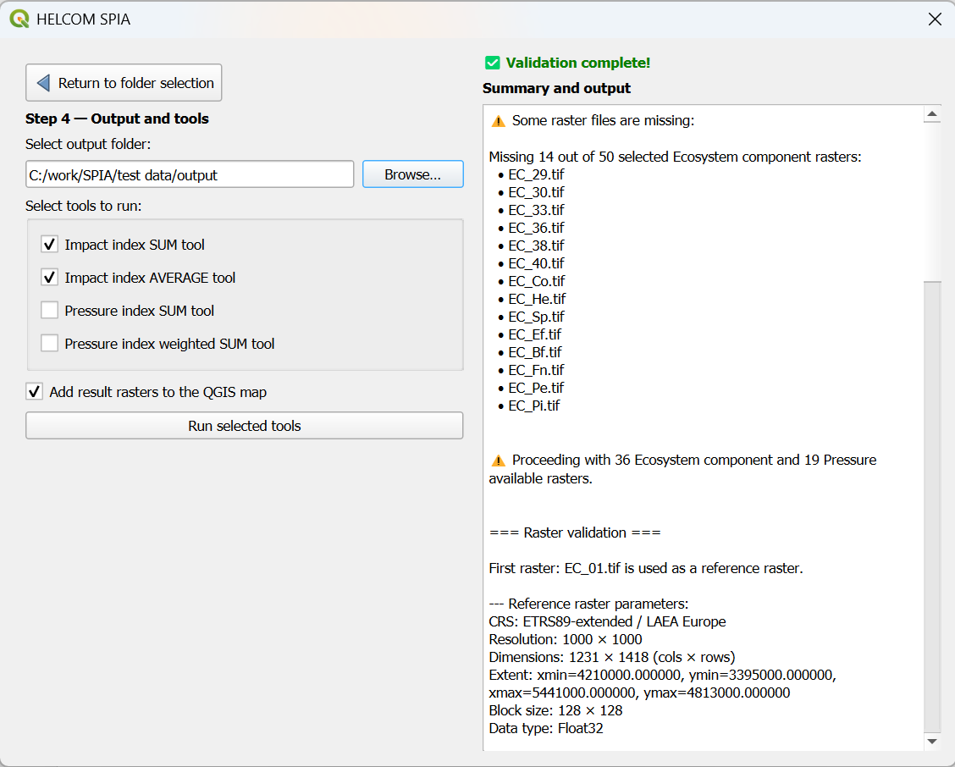

Step 7 – Run processing
Click Run selected tools.
During processing progress bar shows progress and estimated processing time.
To cancel processing click Cancel processing. Processing will stop safely and no incomplete outputs will be written.
After processing is finished:
- Generated output files are listed.
- Raster layers are added to the map (if Add result rasters to the QGIS map checkbox is checked).
- Button Start the whole processing again appears. Processing can be repeated with different input files.
- Plugin can be closed by clicking on the X in the top right.

Performance Tips
- Impact index SUM tool and Impact index AVERAGE tool share computation. It is faster to run them together.
- Large datasets may take many hours. Consider running tool with many large datasets during the night or weekend.

Common Issues
No rasters found:
- Check folder paths
- Check file names match CSV labels

Validation fails:
- Ensure rasters share CRS, resolution, extent

Processing is slow:
- Reduce number of ECs / Ps
- Use smaller raster datasets for testing

Best Practices
- Start with small datasets
- Validate inputs before running
- Use timestamped outputs to compare runs
- Keep EC/P naming consistent

