**NOVOS RESULTADOS**

**NÃO PODEMOS MUDAR O TITULO - Factors associated with ACT compared to CBT for insomnia.**

**Objective:** To evaluate factors associated with acceptance and commitment therapy (ACT) compared to cognitive behavioral therapy (CBT) for insomnia and compared to wait list before and after treatment. **Method:** Participants were 227 adults (xxx women; M age = xxx, SD = xx) meeting DSM-5 diagnostic criteria for chronic insomnia and who were participants in a randomized clinical trial comparing ACT vs CBT vs WL for insomnia. Participants completed the Insomnia Severity Index (ISI), Hospital Anxiety and Depression Scale (HADS), Acceptance Action Questionnaire-II (AAQ-II), Dysfunctional Beliefs and Attitudes About Sleep Scale (DBAS) and Sleep Problem Acceptance Questionnaire (SPAQ) at three moments (pre-treatment, post-treatment and 6-month follow-up). Insomnia, depression, anxiety, psychological inflexibility, acceptance, and beliefs about sleep were assessed as potential factors associated with therapeutic group (ACT or CBT or WL). Multivariate analyses were conducted using MULTINOMIAL logistic regression in three moments (pre-treatment, post-treatment and 6-month follow-up). **Results:** At pre-treatment, the variables were not associated with the therapeutic modality/group. In post-treatment dysfunctional beliefs about sleep (OR=1.02[1.002-1.041]) was associated with ACT. Each additional point on the DBAS reduces the chances of the individual having performed CBT. In 6-month follow-up anxiety (OR=0.81[0.66-0.99]) and psychological flexibility (OR=1.10[1.01-1.21) were associated with CBT in the multiple logistic regression model. Each additional point on the anxiety scale reduces the chances of the individual having completed CBT. Each additional point on the psychological inflexibility scale increases the individual's chances of completing the CBT. **Conclusion:** These results demonstrate that CBT has a better effect on sleep beliefs immediately after treatment ends and that ACT has a better effect on anxiety after 6 months. The different change trajectories for the two therapy groups provide insights into behavioral change via a cognitive versus contextual approach for insomnia.

**RESUMO COMO FOI ENVIADO PAR O CONGRESSO**

**Factors associated with ACT compared to CBT for insomnia.**

Renatha El Rafihi-Ferreira, Ila Marques Porto Linares, Marwin Carmo, Altay Souza.

**Objective:** To evaluate factors associated with acceptance and commitment therapy (ACT) compared to cognitive behavioral therapy (CBT) for insomnia before and after treatment. **Method:** Participants were 152 adults (115 women; M age = 40.6 years, SD = 10.2) meeting DSM-5 diagnostic criteria for chronic insomnia and who were participants in a randomized clinical trial comparing ACT vs CBT for insomnia. Participants completed the NEO Five-Factor Inventory before treatment and completed the Insomnia Severity Index (ISI), Hospital Anxiety and Depression Scale (HADS), Acceptance Action Questionnaire-II (AAQ-II), Dysfunctional Beliefs and Attitudes About Sleep Scale (DBAS) and Sleep Problem Acceptance Questionnaire (SPAQ) at three moments (pre-treatment, post-treatment and 6-month follow-up). Personality traits (openness, conscientiousness, agreeableness, extraversion, and neuroticism), insomnia, depression, anxiety, psychological inflexibility, acceptance, and beliefs about sleep were assessed as potential factors associated with therapeutic group (ACT or CBT). Multivariate analyses were conducted using binary logistic regression in three moments (pre-treatment, post-treatment and 6-month follow-up). **Results:** At pre-treatment, the variables were not associated with the therapeutic modality. In post-treatment dysfunctional beliefs about sleep (OR=1.02[1.002-1.041]) was associated with ACT. Each additional point on the DBAS reduces the chances of the individual having performed CBT. In 6-month follow-up anxiety (OR=0.81[0.66-0.99]) and psychological flexibility (OR=1.10[1.01-1.21) were associated with CBT in the multiple logistic regression model. Each additional point on the anxiety scale reduces the chances of the individual having completed CBT. Each additional point on the psychological inflexibility scale increases the individual's chances of completing the CBT. **Conclusion:** These results demonstrate that CBT has a better effect on sleep beliefs immediately after treatment ends and that ACT has a better effect on anxiety after 6 months. The different change trajectories for the two therapy groups provide insights into behavioral change via a cognitive versus contextual approach for insomnia.

PÓS –

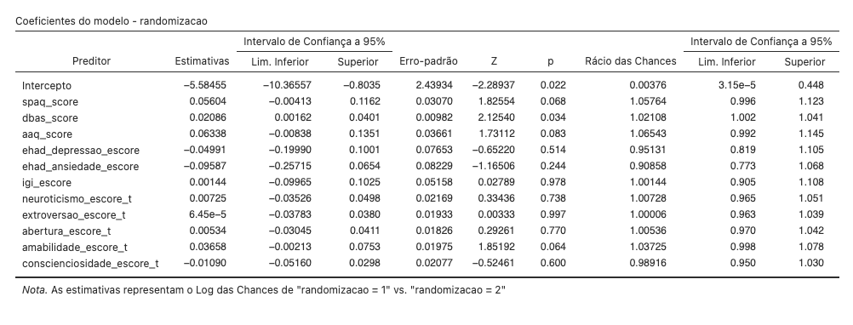



FOLLOW –



pos



follow

