Data Visualization in RStudio

Helee Rana

8/20/2020

require(tidyverse)

## Loading required package: tidyverse

## ── Attaching packages ─────────────────────────────────────── tidyverse 1.3.0 ──

## ✓ ggplot2 3.2.1 ✓ purrr 0.3.3  
## ✓ tibble 2.1.3 ✓ dplyr 0.8.4  
## ✓ tidyr 1.0.2 ✓ stringr 1.4.0  
## ✓ readr 1.3.1 ✓ forcats 0.4.0

## ── Conflicts ────────────────────────────────────────── tidyverse_conflicts() ──  
## x dplyr::filter() masks stats::filter()  
## x dplyr::lag() masks stats::lag()

require(gapminder)

## Loading required package: gapminder

names(gapminder)

## [1] "country" "continent" "year" "lifeExp" "pop" "gdpPercap"

ggplot(gapminder, aes(x=lifeExp, y=gdpPercap)) +geom_point()

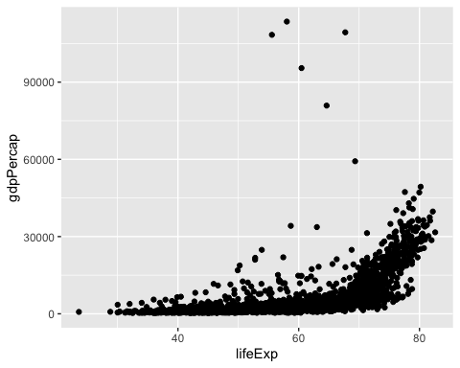

gapminder %>% ggplot(aes(x=lifeExp, y=gdpPercap)) +geom_point()



gapminder %>% ggplot(aes(x=pop, y=lifeExp)) +geom_point()

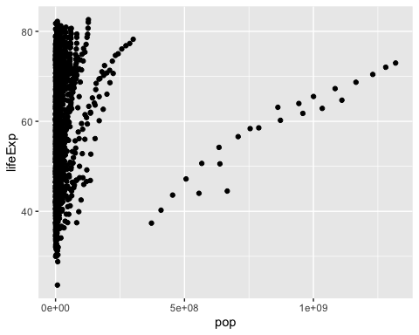

gapminder%>%filter(continent=='Africa') %>%ggplot(aes(x=pop, y=lifeExp)) +geom_point()

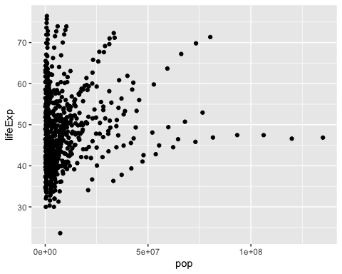

gapminder%>%ggplot(aes(x=pop, y=lifeExp, color=continent))+geom_point() +theme_classic()

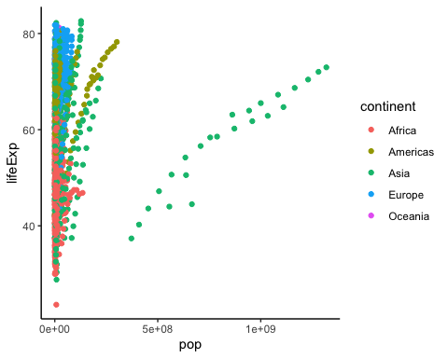

gapminder%>%ggplot(aes(x=pop, y=lifeExp, color=year))+geom_point() +theme_classic()

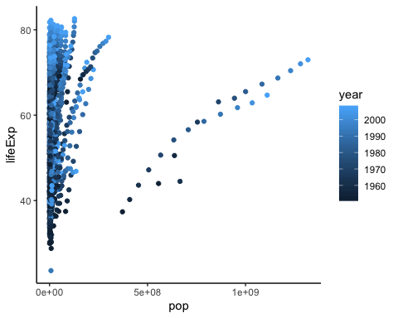

gapminder%>%ggplot(aes(x=pop, y=lifeExp, color=as.factor(year)))+geom_point() +theme_classic()

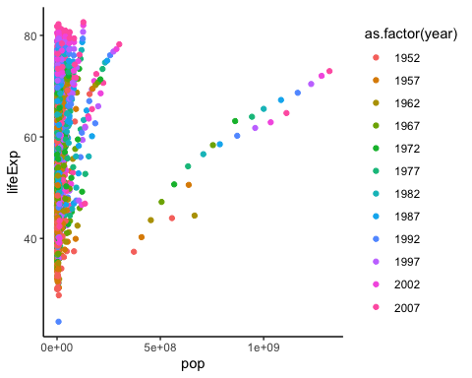

gapminder%>%ggplot(aes(x=pop, y=lifeExp, alpha=gdpPercap))+geom_point() +theme_classic()

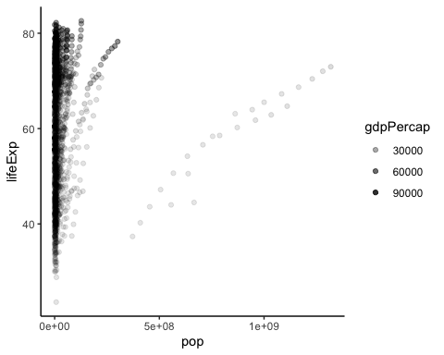

gapminder%>%ggplot(aes(x=pop, y=lifeExp, color=country)) + geom_point()

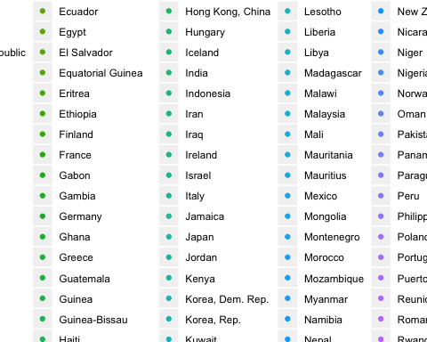

gapminder%>%ggplot(aes(x=lifeExp, y=gdpPercap, color=continent)) + geom_point()

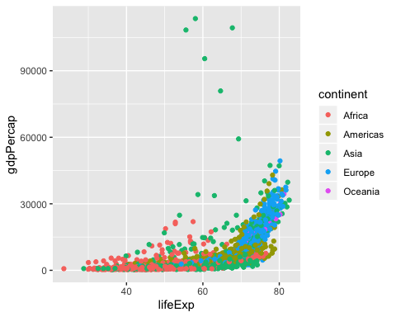

gapminder%>%ggplot(aes(x=lifeExp, y=gdpPercap)) + geom_point(color='red')

