How to Play

*Written for MRGL beta 1.0.0*

Characters

Each character is represented with an ASCII character. You can mouse over characters to see what they are. Here are some examples:

|  |  |  |  |
| --- | --- | --- | --- |
|  | Player (you) |  | Enemy (cockroach) |
|  | NPC (shopkeeper) |  | Item (bandage) |
|  | Stairs |  |  |

Interface

Main Menu

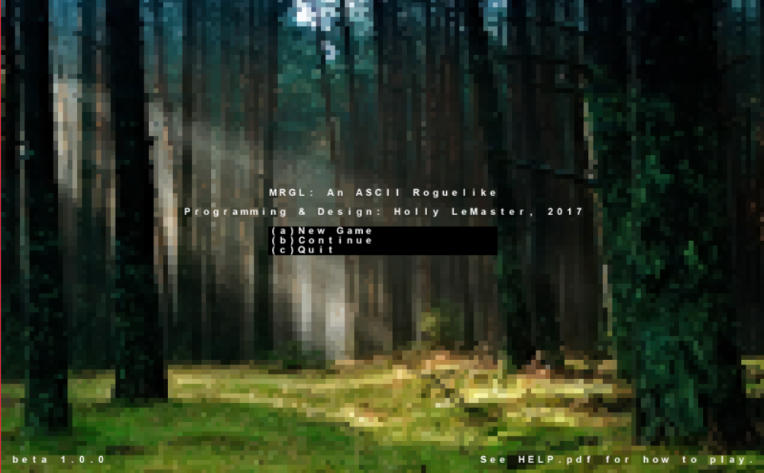

Press the key corresponding to the option in the menu.

New Game – start a new game

Continue – load a saved game

Quit – quit the game

Game

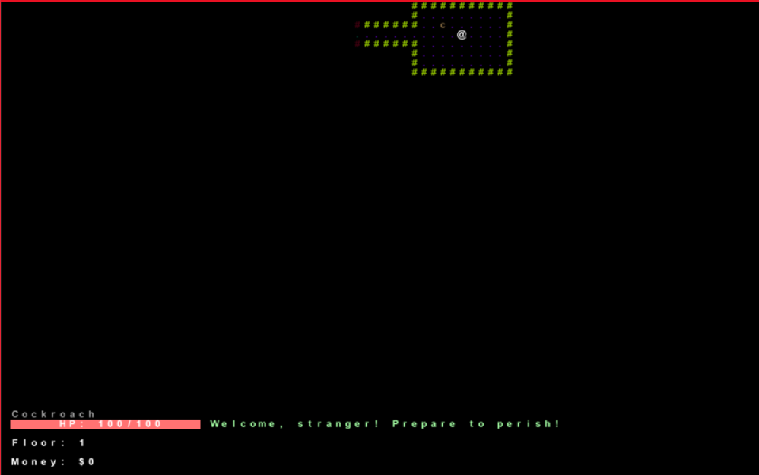

Selected object

Money

Current floor

Health

Messages

Messages – display information about what’s going on

Selected object – name of object player has the mouse cursor over

Health – amount of health player has

Current floor – number of floor player is on

Money – amount of money player has accumulated

In-game menus

Inventory

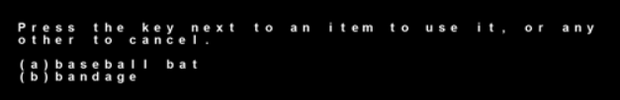

Press the letter next to the item to bring up interactions for that item.

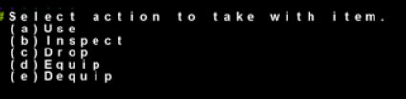

Press the letter next to the option to use it.

Use – use a consumable item

Inspect – view information about an item, plus any stat bonuses it may have

Drop – drop an item onto the ground

Equip – equip a piece of equipment

Dequip – remove a piece of equipment and place it back in the inventory

Shop

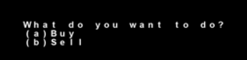

Press the letter next to the option to buy or sell items.

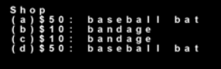

Press the letter next to the option to buy an item. You must have enough money to pay for it. Prices are listed before the name of an item. A purchased item will go into your inventory.

Controls