

July 9, 2018

Dear Sir,

We acknowledge that Ms Wenqing He is currently extending her graduation date for one year in order to take up the internship program with Morgan Stanley in Hong Kong. As a well known international university with very high placement rate of undergraduate students in job market, we strongly encourage students to take any opportunity to secure more real world experience which is essential for their future career development. We strongly recommend Ms. He to attend the training which will definitely benefit to her academic studies and equip herself for future challenge in the financial industry.

Ms Wenqing He still has to obtain 13 credits before graduation, which include the following courses. We believe the actual work experience that Ms. He has been gained will help her to complete the remaining courses confidently. The internship with financial institutions is one of our requirement towards graduation.

|  |  |
| --- | --- |
| Course Name | Credits |
| Financial Engineering | 3 |
| Intermediate Financial Accounting | 3 |
| Financial Risk Management | 3 |
| Graduation Thesis | 4 |

The above courses are all open on spring semester which will begin in February 2019. Ms. He has to return to school to meet all course requirements and complete her studies in June 2019.

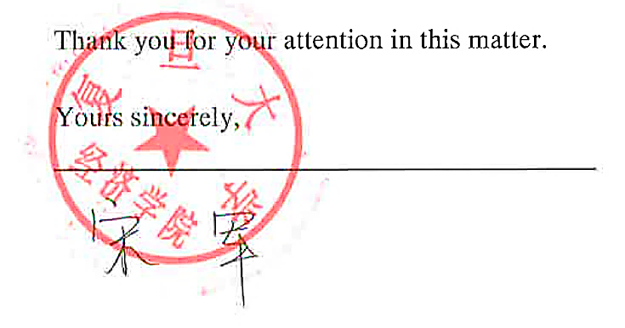

Associate Professor, Dean of International Finance Department, Fudan University