
TOBB Economy & Technology University
BIL 481 Software Engineering

Project Management Plan (PMP)
Reference: IEEE 1058 / ISO/IEC 12207

Group Members
Helen Parlar – Artificial Intelligence Engineering
Mete Kılıç – Artificial Intelligence Engineering
Ahmet Çakmak – Medicine & Artificial Intelligence Engineering

Table Of Contents
1. Project Overview 3
1.1. Scope 3
1.2. Stakeholders 3
1.3. Deliverables 3
2. Organization and Roles 4
3. Project Schedule 4
4. Budget and Resources 5
5. Risk Management 5
6. Quality Assurance 6
6.1. Economic and Financial Constraints 6
6.2. Environmental and Socio-Cultural Constraints 6
6.3. Health and Safety Considerations 7
6.4. Legal and Ethical Constraints 7
6.5. Technological Constraints 7
6.6. Temporal Constraints 7
6.7. Sustainability Factors 7
7. Appendix 7
8. Document-Spesific Task Matrix 9
9. References 9

1. Project Overview
The Clinical Appointment System aims to enhance healthcare appointment processes by guiding patients to the most appropriate polyclinic based on their symptoms using AI-driven recommendations (OpenAI API).
Goals:
• Prevent unnecessary or incorrect appointments.
• Increase clinic efficiency by AI-supported routing.
• Provide a user-friendly, functional appointment interface.
• Maintain reliability through CI/CD, code review, and testing.

Scope
Inclusions:
• Users select a polyclinic and view symptom lists.
• If ≥3–4 symptoms match, user proceeds to appointment scheduling.
• Otherwise, user can input symptoms manually to get automatic redirection.
• Functional UI integrated with a hospital database (doctors and schedules).
• User authentication for Patient, Doctor, and Administrator roles.
Exclusions:
- No medical diagnosis, prescription, or treatment advice.
- No video conferencing or online consultation.
- No insurance or payment management.
- No integration with MHRS or hospital systems.

Stakeholders
• Patients – Make appointments.
• Doctors – Manage schedules.
• Administrators – Manage users and data.
• Development Team – Build and test the system.

Deliverables
• Requirements Document
• ER Diagram & UI Wireframes
• Functional Prototype
• Test Report
• Deployed System & User Manual
• Final Report & Demo Presentation

2. Organization and Roles
Role | Responsibilities | Team Members
Project Manager | Oversees all phases, manages risks, ensures scope alignment. | All Members
Requirements and System Design | Initially determining requirements, inclusions, exclusions and creating a road map. | All Members
Backend Developer | Implements backend with Flask/Django and AI routing. | Helen Parlar, Mete Kılıç
Frontend Developer | Develops UI and integrates frontend with backend. | Ahmet Çakmak, Mete Kılıç
Database Engineer | Designs database schema and ensures data integrity. | Ahmet Çakmak, Helen Parlar
QA Engineer | Designs and executes test scenarios. | Mete Kılıç, Helen Parlar
AI Engineer | Designs prompts and integrates OpenAI API for clinic routing. | Ahmet Çakmak, Mete Kılıç

3. Project Schedule
The project is planned over 12 weeks, divided into distinct phases.
Phase | Description | Deliverables
Requirements Analysis | Define functional requirements and API endpoints. | Requirements Document
System Design | Create architecture, database schema, and UI wireframes. | ER Diagram, UI Mockups
Development | Implement backend, frontend, and AI integration. | Functional Prototype
Testing & Validation | Conduct functional and AI tests. | Test Report
Deployment | Deploy system and prepare user manual. | Deployed System, User Manual
Project Closure & Evaluation | Evaluate outcomes and prepare final report. | Final Report & Presentation

4. Budget and Resources
Resources:
- Languages: Python, JavaScript
- IDE: Visual Studio Code
- Frameworks: Flask/Django, React/Vue
- Database: MySQL
- AI Integration: OpenAI API
- Deployment: AWS (if applicable)
- Version Control: GitHub
- Communication: WhatsApp, Discord, Zoom
- Testing: Postman, Selenium
Budget:
- Primarily open-source tools minimize cost.
- OpenAI API and AWS costs are minimal.
- No hardware costs; personal devices are used.

5. Risk Management
Risk | Impact | Mitigation
Scope Expansion | Deviation from project timeline and increased workload | Any additional features or changes must go through a formal evaluation and approval process by all team members before implementation.
Ambiguous AI Output | Incorrect routing | It can be fixed by implementing clear prompt design and post-processing filters.
Inaccurate Symptom Recommendation | User confusion and decreased system reliability | It is good to use a basic rule-based matching system at first.
Data Security Issues | Privacy violation | System and API connections will not contain any personal medical data.
Technical Complexity | Development bottlenecks and code integration errors | Development tools and frameworks that align with the team’s existing skills are selected for the project.
Project Delays | Timeline shift | Meeting with group participants regularly and working cooperately will reduce the possibility of delay.
Integration Failures | System instability | Modular testing and version control will be used.

6. Quality Assurance
In alignment with the PMP methodology and ISO 9001 quality management principles, this project acknowledges that various constraints and external factors may influence its overall performance and quality outcomes.
These constraints are systematically analyzed in terms of their potential impact on quality objectives, feasibility within project scope, and compliance with relevant standards and stakeholder expectations.
6.1. Economic and Financial Constraints
The project primarily relies on open-source tools and student-accessible cloud resources. However, limited funding may restrict extended API usage or large-scale deployment. This risk will be mitigated by optimizing API calls, minimizing computational overhead, and scheduling controlled testing sessions.
6.2. Environmental and Socio-Cultural Constraints
The system operates within a healthcare context that demands ethical responsibility, user trust, and respect for privacy. The interface and recommendations must be inclusive, unbiased, and designed to ensure accessibility for users from diverse social and cultural backgrounds.
6.3. Health and Safety Considerations
Since the application provides symptom-based clinic guidance, accuracy and clarity are essential to prevent user misinterpretation. The system does not replace medical consultation and clearly communicates that recommendations are for informational purposes only.
6.4. Legal and Ethical Constraints
All collected information will adhere to data protection regulations and exclude identifiable personal or medical data. Ethical AI use principles will guide prompt design, ensuring that outputs are safe, non-discriminatory, and transparent.
6.5. Technological Constraints
The project’s technical limitations include API quota limits, potential latency in cloud responses, and dependency on external AI services. Contingency mechanisms (e.g., caching, fallback logic) will reduce these effects to maintain usability and reliability.
6.6. Temporal Constraints
The project timeline spans 12 weeks, requiring strict adherence to milestones to ensure successful completion. Weekly progress reviews and GitHub version tracking will support effective time management.
6.7. Sustainability Factors
The system aims for long-term maintainability through modular architecture, documented code, and scalable database design. Energy efficiency and minimal server utilization are also considered in deployment planning.
A risk register will be continuously maintained to track potential quality-related issues arising from these constraints. Each risk will include its likelihood, severity, and defined mitigation strategies. Regular evaluation meetings will ensure that corrective actions are implemented promptly to uphold quality, safety, and ethical standards throughout the project lifecycle.

7. Appendix
- System Architecture Diagram
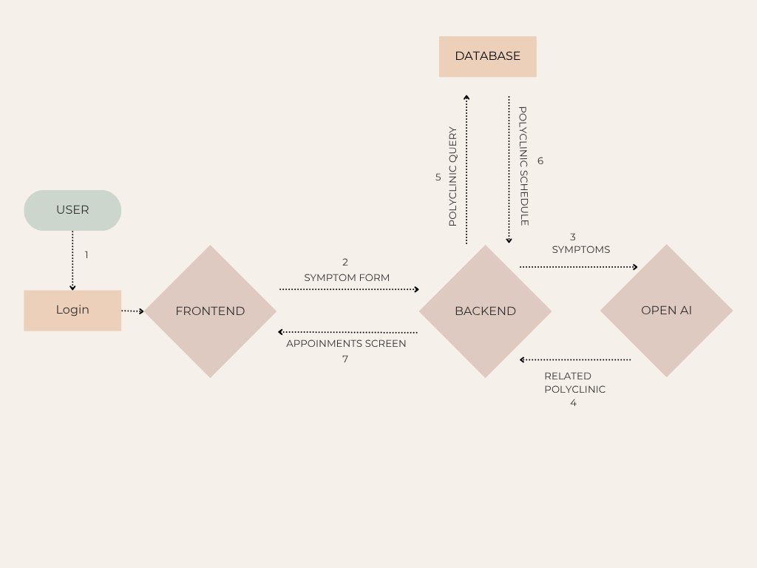

- ER Diagram
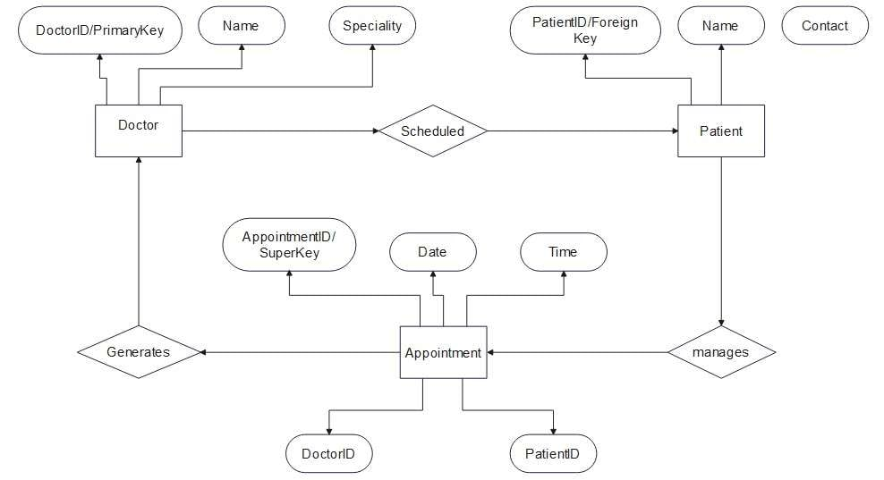
- Gantt Chart
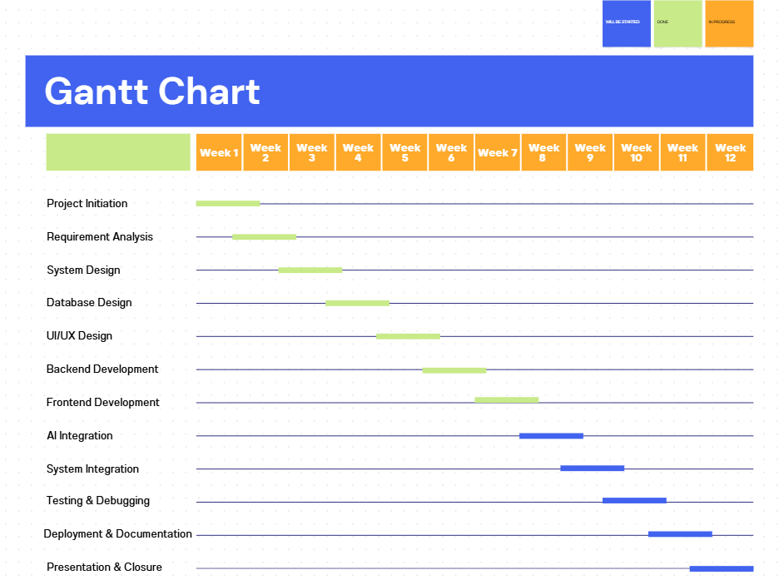

8. Document-Spesific Task Matrix
Task/Section | Responsible Member(s)
Project Scope Definition | Helen Parlar, Mete Kılıç
Project Objectives & Overview | Ahmet Çakmak
Project Organization (Roles & Responsibilities) | Mete Kılıç
Key Phases & Timeline (Gantt Chart) | Helen Parlar
Resource & Budget Planning | Ahmet Çakmak
Risk Management | Helen Parlar, Ahmet Çakmak
Communication & Change Management Plan | Ahmet Çakmak
Quality Assurance Section | Mete Kılıç
IEEE Formatting & Editing | Helen Parlar
Final Review & Submission | Helen Parlar, Mete Kılıç, Ahmet Çakmak

9. References
• IEEE 1058 / ISO/IEC 12207 Standards
• Bitirme Projeleri Kılavuzu 2025 – TOBB ETU
• OpenAI API Documentation
• Flask, React, MySQL Official Docs

