Names: Adina Kugler, Jess Laudie, Helena Lindsay, Anna Bustamante, Francis Driscoll

WORKSHEET

1. What types of information does Firefox manage using SQLite?  Briefly explain

the contents of two or three databases.

* Formhistory.sqlite contains four tables, 3 indices, views, and triggers. One of these tables is called mox_formhistory and has 6 columns and 6 rows. The columns include id, fieldname, value, timesUsed, firstUsed, lastUsed, and guld.
* Protections.sqlite contains tables, indices, views, and triggers. Mine displays one table called events. ‘Events’ has four variables: id, type, count, and timestamp.
* The ‘cookies’ database is managing cookies created while using Firefox. This database has 1 table that includes integers and text that detail creation times, dates accessed, hosts, and a bunch of other data tracked when visiting websites.

2. In what database and tables are your bookmarks stored?  Why do you think

Firefox stores the title and url separately?

Bookmarks are stored in the places.sqlite database. The title is stored in the moz_bookmarks table and the url is stored in the moz_places table. These might be stored separately because people rename the title of a bookmark so it is not indicative of the actual “place” in Mozilla. Furthermore, there are many more URLs included in places that are not bookmarked. Having to include bookmarked URLs in the bookmarks table would be redundant. Also, each attribute has a different use and domain so they must be separate.

3. Write an SQL statement that selects your bookmarks. For each one, display

only the title, url, date added (as an integer), and visit count.

SELECT moz_bookmarks.title, moz_places.url, moz_bookmarks.dateAdded, moz_places.visit_count

FROM moz_bookmarks

JOIN moz_places ON moz_bookmarks.fk=moz_places.id

4. Write an SQL statement that lists the base domain, name, and value for each

of your cookies in order of expiration date.

SELECT moz_cookies.baseDomain, moz_cookies.name, moz_cookies.value

FROM moz_cookies

Order BY expiry

5. Write an SQL statement to show how many cookies you have for each domain.

Note that you will need to use the "count" function instead of sum.

SELECT baseDomain, COUNT(moz_cookies.baseDomain)

FROM moz_cookies

GROUP by baseDomain

6. What are the top five movies since the year 2000, in terms of adjusted

gross income?

SELECT movie.title , movie.year, movie.adjusted

FROM movie

WHERE movie.year > 1999

ORDER BY movie.adjusted DESC LIMIT 5;

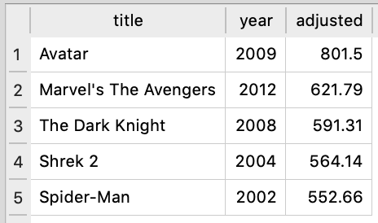

7. What are the title, author, and year of books from Russia in the top 100?

(For convenience, you can right-click the results and "Copy Rows as CSV.")

SELECT title, author, year FROM book WHERE book.country = 'Russia'

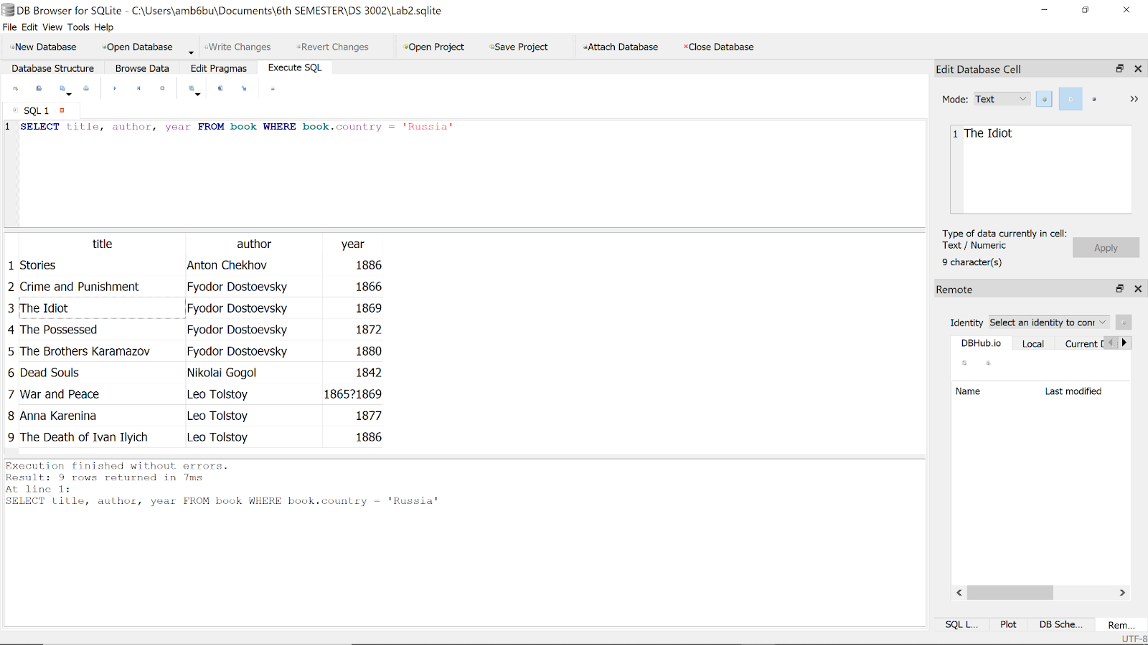

8. What are the names and symbols of the periodic elements with an atomic mass

of more than 280? Display the results from lightest to heaviest.

SELECT name, symbol FROM periodic WHERE mass > 280 ORDER BY periodic.mass ASC

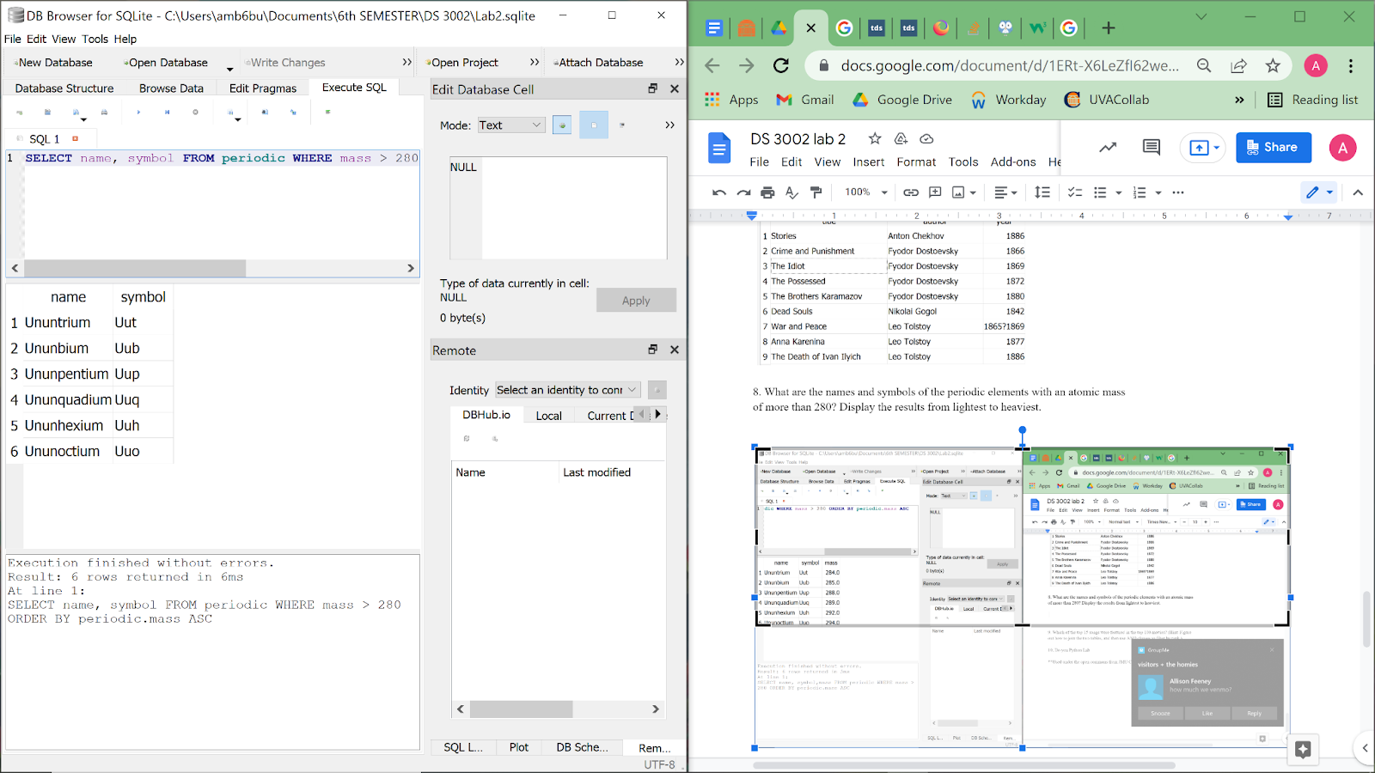

9. Which of the top 15 songs were featured in the top 100 movies? (Hint: Figure

out how to join the two tables, and then use AND clauses to filter by rank.)

SELECT song.title , song.film, song.rank

FROM song

JOIN movie ON  song.film = movie.title

WHERE song.rank <=15 AND movie.rank <= 100;

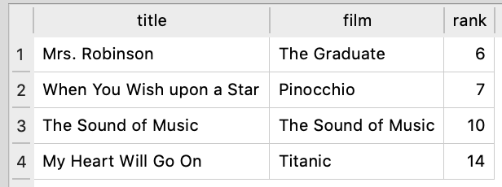

10. Do you Python Lab

**Used under the open commons from JMU CS101 Labs