**Lesson – 3**

**Reading work:** Do the reading of concepts discussed in this chapter.

**Problem: 1**

Create your own Customer class. A Customer has a firstName, lastName, socSecurityNum (which you can represent as a String), also it has billingAddress and a shippingAddress(which you can represent as a type of Address. Initialize billingAddress and shippingAddress through its setter from Customer class.

Create a constructor for your Customer class to initialize firstName, lastName and socSecurityNum. Create getter, and setter methods for all five attributes.

Create an Address class with the attributes such as street, city, state and zip(which you can represent as a String). Create a constructor to initialize fields of Address class.

Your Customer class should have a toString() method that provides a string representation of the customer. A typical toString() output would be "[Joe, Smith, ssn: 332-221-4444]". Just copy this code in your Customer class.

public String toString() {

return "[" + firstName + ", " + lastName + ", " + "ssn: " + socSecurityNum + "]";

}

In the main method of a Main class, create three instances of Customer (be sure to create instances of Address to populate their billingAddress and shippingAddress fields using setters). Add these instances to an array. Then loop through the array and print to the console all those Customers whose billingAddress is located in the city of Chicago (when you create instances of Customer initially, be sure to create at least one Customer whose billing address is in Chicago).

**Problem – 2**

(Target-Heart-Rate Calculator) While exercising, you can use a heart-rate monitor to see that your heart rate stays within a safe range suggested by your trainers and doctors. According to the American Heart Association (AHA), the formula for calculating your Maximum Heart Rate (MHR) in beats per minute is 220 minus your age in years. Your target heart rate is a range that’s 50–85% of your maximum heart rate.

[Formula: To Calculate Target heart rate range is mentioned below ]

* 1. Assign Resting Heart Rate (RHR) = 70. (Assign as a Constant)
  2. Assign Maximum Heart Rate (MHR) = 220 – age.
  3. Calculate Average Heart Rate (AHR) = MHR – RHR.
  4. Assign Lower Boundary (LB) = 0.5 (Assign as a Constant)
  5. Assign Upper Boundary (UB) = 0.85. (Assign as a Constant)
  6. Calculate Lower Boundary Target Heart Rate (LBTHR)= (AHR*LB) + RHR,
  7. Calculate Upper Boundary Target Heart Rate (UBTHR) = (AHR*UB) + RHR
  8. The Result of Target Heart Rate Range is between LBTHR and UBTHR

Create a class called HeartRates. The class attributes should include the person’s first name, last name and date of birth. Your class should have a constructor that receives this data as parameters. For each attribute provide set and get methods. The class also should include

a. A method that calculates and returns the person’s age (in years), ( Refer lesson3\dateapi\AgeCalculator.java)

b. A method that calculates and returns the person’s maximum heart rate.

c. A method that calculates and prints the person’s target heart rate range.

d. Override the toString() method to display the person’s first name, last name and date of birth, person’s age in (years), maximum heart rate(MHR).

Write a Java app that prompts for the person’s information, instantiates an object of class HeartRates and prints the required information. **You may not get the same output due to current date changes.**

**Expected Output**

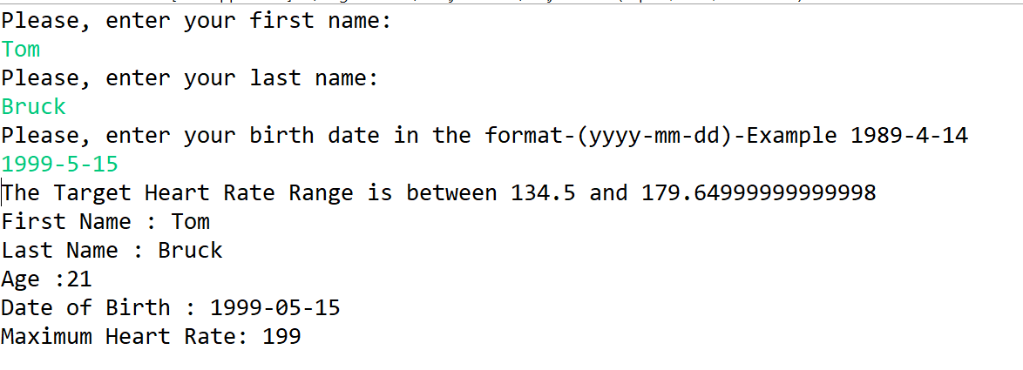

**Problem 3:**

Develop a Java application that helps a global team schedule meetings across different time zones. The application should allow users to create an event by specifying a date and time, view the event in a different time zone, and calculate the days until the event. Nicely show the date and time display.

**Requirements:**  
1. Create an Event to the input the details and print the requested details:

a. Allow users to input the event name, date and time for a new event.  
 b. Display the day of the week (Eg: Sunday, Monday) for the event date and check if it

is in a leap year.

c. Calculate and display the number of days from the current date to the event date.

2. Write a function to Format Event Details.

a. A Function, nicely format and display the event date and time, including the

default system time zone.

Eg: Sunday, October 20, 2024 @ 10:30 [America/Chicago]

3. Time Zone Conversion function:

a. Convert the event's date and time from the system's default time zone to any other,

specified time zone entered by the user.

Sample Time Zones  
 America/Panama  
 America/Chicago  
 America/Indiana/Indianapolis  
 America/Santiago  
 America/Phoenix

**Problem – 4 – Immutable concepts**

Create Java classes for Triangle, Rectangle, and Circle as Immutable.

1. **Triangle** and **Circle**: Use the record class feature in Java to make these classes immutable.
2. **Rectangle**: Create this class manually as an immutable class without using the record feature.

**Note:** Input validation for class attributes is optional and can be implemented at your discretion.

Provide implementation of area computation in each class with a method

public double computeArea()

Constructor should accept the data necessary to specify the figure, and to compute its area. The values accepted by the constructor should be stored in (private) instance fields of the class. For example, Rectangle should have instance fields width and length, and the constructor should look like this

public Rectangle(double width, double length)

For Triangle, you may use arguments base and height. And for Circle, use radius as the constructor argument.

Create a fourth-class Main that will, in its main method, test these three figure classes as follows: It will create one instance of each (you can make your own choice for the dimensions of your figures and get the input from the console) and then print to the console the area of each. Typical output would be:

A Sample Output looks like this:

Enter C for Circle

Enter R for Rectangle

Enter T for Triangle

R

Enter the width of the Rectangle

120

Enter the height of the Rectangle

200

The area of Rectangle is: 24000.00

Do you want to continue(y/n) : y

Enter C for Circle

Enter R for Rectangle

Enter T for Triangle

R

Enter the width of the Rectangle

20

Enter the height of the Rectangle

20

The area of Rectangle is: 400.00

**Here are some area formulas, in case you do not remember them:**

Area of a rectangle = width * height

Area of a triangle = 1/2 * base * height

Area of a circle = PI * radius * radius

**Problem 5:** Pizza Order Management with Enums and Switch Expressions

1. Define an enum named **PizzaSize** representing different pizza sizes (SMALL, MEDIUM, LARGE).
2. Define an enum named **PizzaType** representing different pizza types (VEGGIE, PEPPERONI, CHEEZE, BBQCHICKEN).
3. Create a Class
4. An attribute for the pizza size of type PizzaSize.
5. An attribute for the pizza type of type PizzaType.
6. An attribute for the quantity
7. The attribute price not initialized through constructor, need

to calculate the price, based on PizzaSize and PizzaType using a private method calculatePrice().

1. A constructor to initialize PizzaSize, PizzaType and quantity.
2. Create a private void calculatePrice() method which assign the price instance using Switch expression and enum types. You can assign some default values based on the pizza sizes (SMALL($8), MEDIUM($10), LARGE($12) using Switch expression to return the sizeprice. In the same way another switch return the default price based on the types of Pizza(VEGGIE($1), PEPPERONI($2), CHEEZE($1.5), BBQCHICKEN($2)). Finally assign the price instance by adding the sizeprice and typeprice multiplied by quantity.
3. A method printOrderSummary() that returns a string summarizing the pizza order, including size, type, qty, price, tax amount, and total price. Use String.format() to print the receipt as mentioned below.

Pizza Order:

Size: SMALL

Type: VEGGIE

Qty: 2

Price: $18.00

Tax: $0.54

Total Price: $18.54

Add 3% of tax from the price calculated from the Task D. Total Price is price + tax.

1. Use the below code

public class PizzaTest {  
 public static void main(String[] args) {  
 Pizza pizza1 = new Pizza(PizzaSize.*SMALL*, PizzaType.*VEGGIE*,2);  
 Pizza pizza2 = new Pizza(PizzaSize.*MEDIUM*, PizzaType.*PEPPERONI*,1);  
 Pizza pizza3 = new Pizza(PizzaSize.*LARGE*, PizzaType.*BBQ_CHICKEN*,2);  
 System.*out*.println(pizza1.printOrderSummary());  
 System.*out*.println(pizza2.printOrderSummary());  
 System.*out*.println(pizza3.printOrderSummary());  
 }  
}

**Interview Reading Question**

**Lesson-3-Class and Objects**

1. What is Immutable? Tell the Immutable APIs.
2. Speak to difference between a static variable and static method in java.
3. What is the purpose of using OOPs concepts?
4. What are the four main features of OOPs?
5. What is the difference between Heap and Stack Memory in java?
6. What is a singleton class in Java? How do you implement a singleton class?
7. What is an immutable class in Java? How do you implement an immutable class?
8. Describe how Java works as “pass by value” or “pass by reference” phenomenon?