1. **WITHDRAW_MONEY Use Case Description: Main Flow**

|  |  |
| --- | --- |
| **User Action** | **System Response** |
| 1. User types in PIN into the main screen | 1. System checks the validity of PIN and presents options to the user on another screen |
| 1. User chooses “Withdraw money” | 2. System asks for accounts (Checking/Savings) and amount entry. |
| 1. User selects the account and enters the desired amount | 3. System verifies available funds, dispenses cash and updates balance |

**2. Use Case Diagram**

**3. The Project Management Tracking System.**

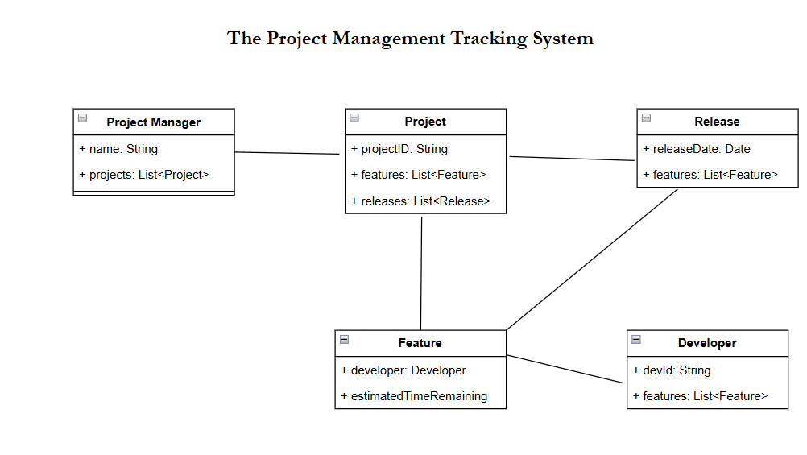

**4. Properties Management System.**

