Lab W3D1

Problem 1
Consider the following initial configuration of a Red-Black Tree:
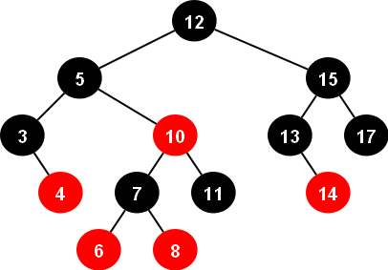
Draw the tree representation of the Red-Black tree after each of the following operations. Your operations are done in sequence, so your tree should have 17 values in it when you're done. Make sure to clearly indicate each of your final answers including retations
Insert 1
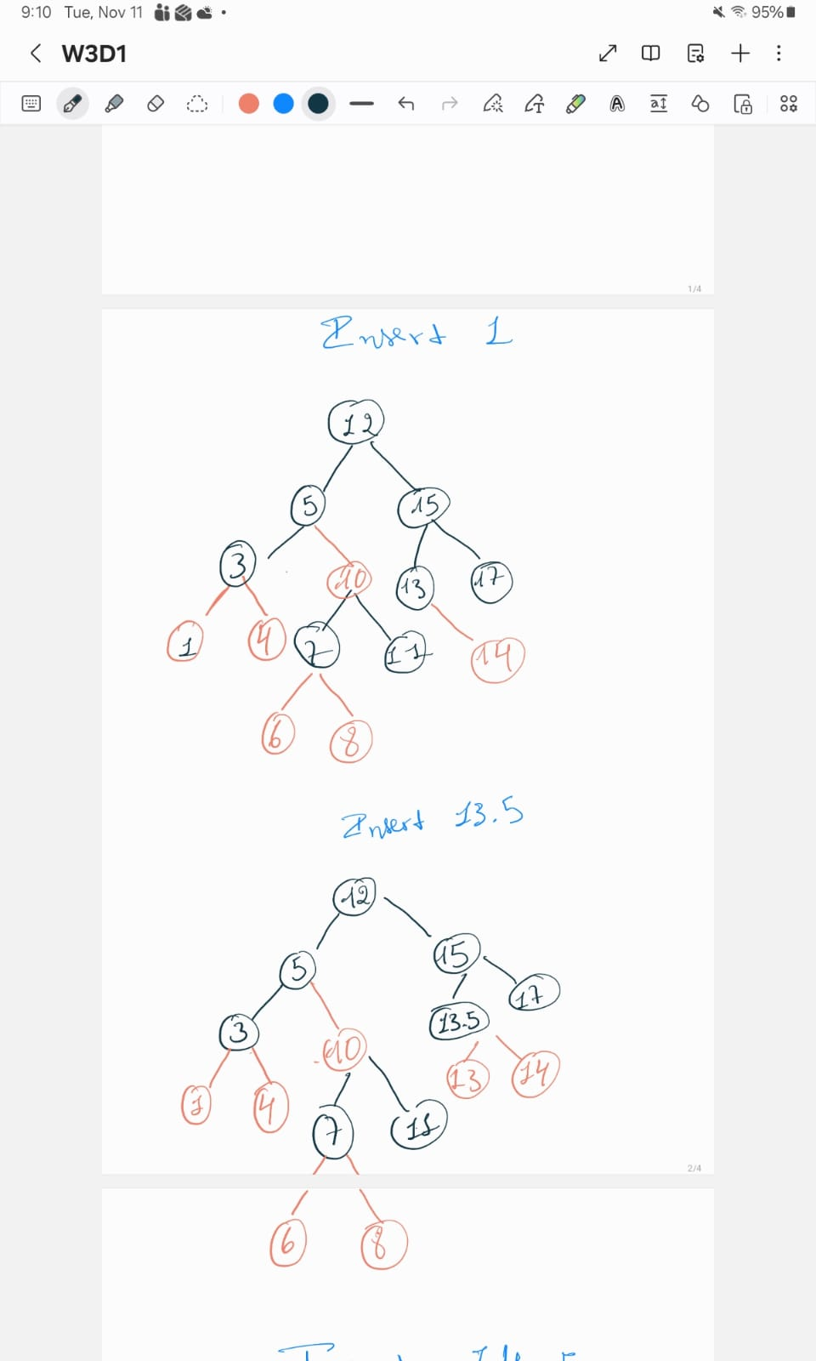

Insert 13.5

Insert 14.5
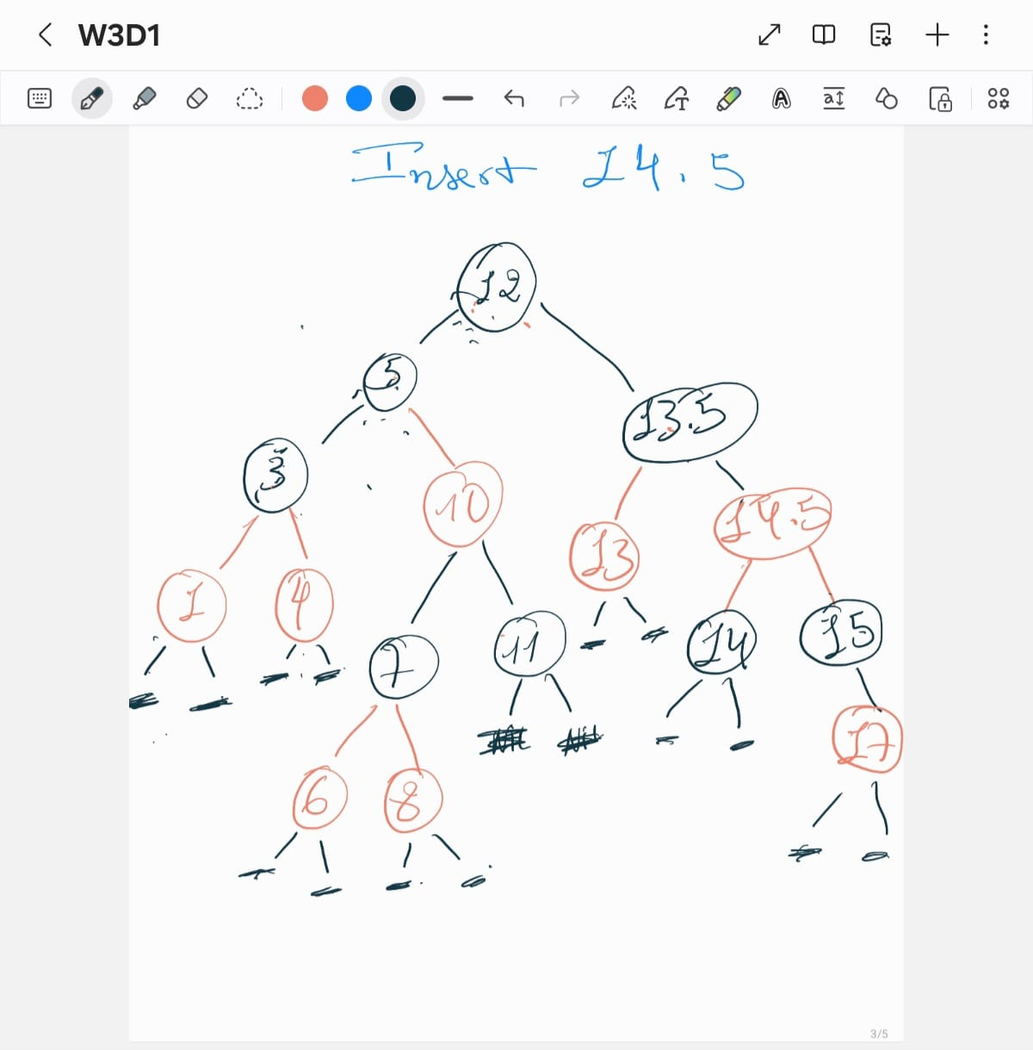

Insert 9

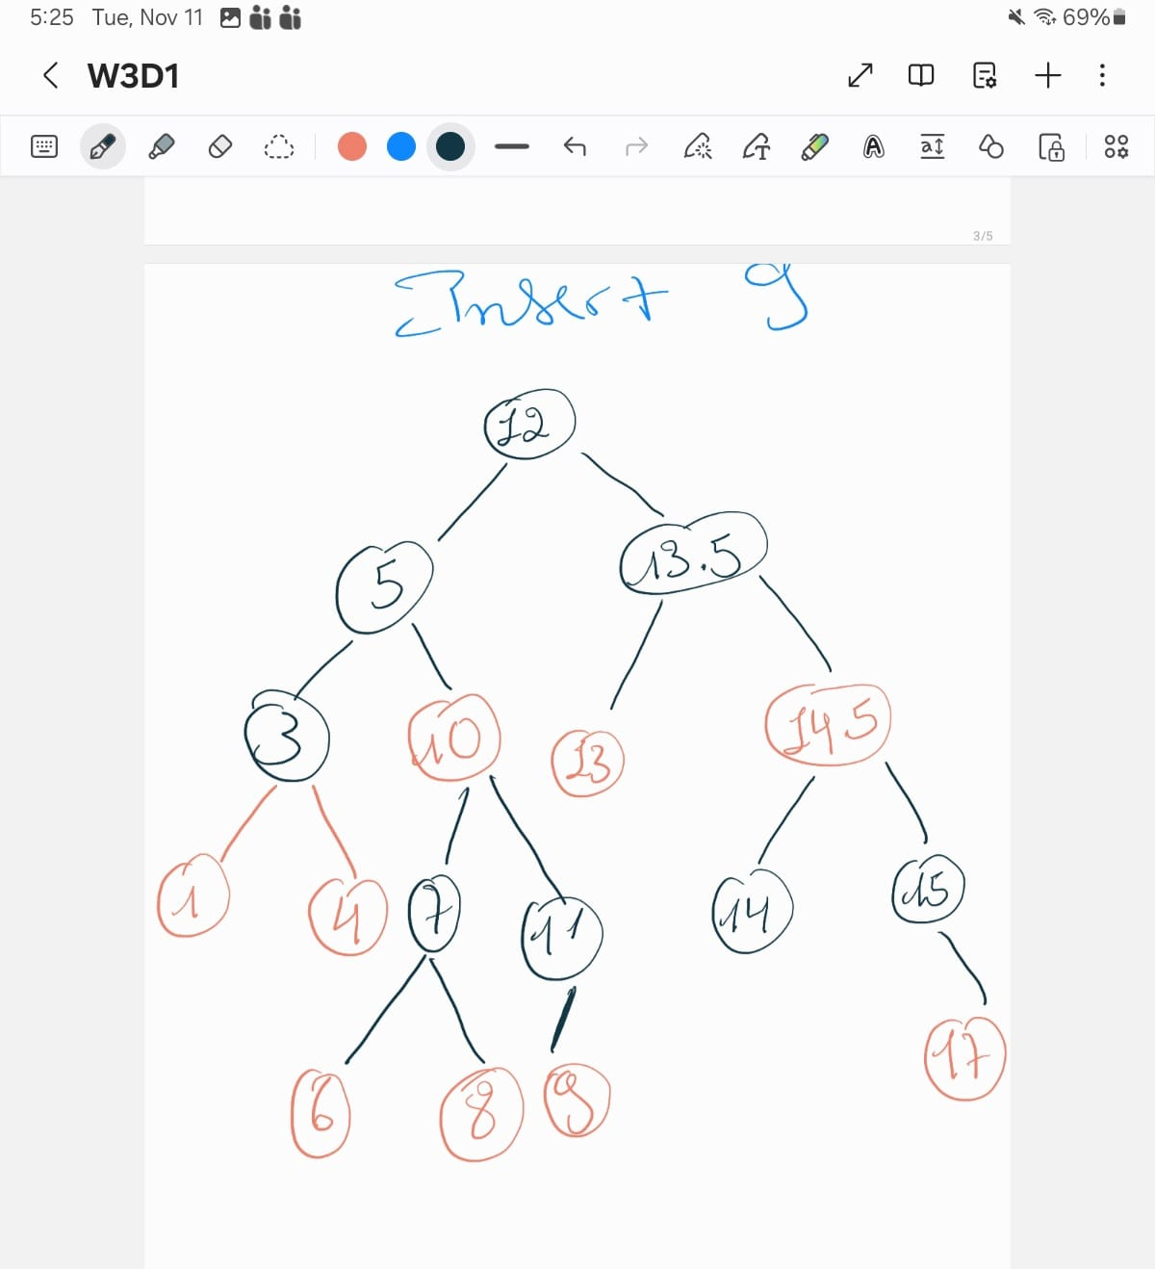

Problem 2
.

- Given the following “Red-Black tree”, indicate the color of each node with letter R or B.

25(B)
/ \
18(B) 34(R)
/ \
30(B) 36(B)
/
28(R)
- Insert the key 29.
25(B)
/ \
18(B) 34(R)
/ \
29(B) 36(B)
/ \
28(R) 30(R)

