W3D4

- What is the adjacency matrix of the graph G = (V,E) displayed below
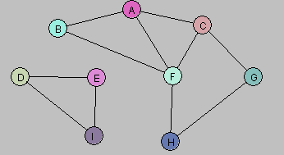

 | A | B | C | D | E | F | G | H | I
A | 0 | 1 | 1 | 0 | 0 | 1 | 0 | 0 | 0
B | 1 | 0 | 0 | 0 | 0 | 1 | 0 | 0 | 0
C | 1 |  | 0 |  |  | 1 | 1 | 0 | 0
D | 0 | 0 | 0 | 0 | 1 | 0 | 0 | 0 | 1
E | 0 | 0 | 0 | 1 | 0 | 0 | 0 | 0 | 1
F | 1 | 1 | 1 | 0 | 0 | 0 | 0 | 1 | 0
G | 0 | 0 | 1 | 0 | 0 | 0 | 0 | 1 | 0
H | 0 | 0 | 0 | 0 | 0 | 1 | 1 | 0 | 0
I | 0 | 0 | 0 | 1 | 1 | 0 | 0 | 0 | 0

- Create a Java program to find all components of a graph given the adjacency matrix through DFS. Test your program on the above graph.

- Create a Java program to find all components of a graph given the adjacency matrix through BFS. Test your program on the above graph.

