Lab W3D3

Quetion 1. Induced Graphs. Answer questions about the graph G = (V,E) displayed below.
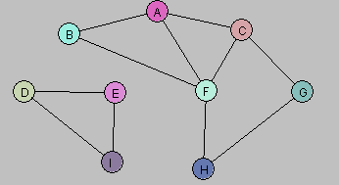

- Let U = {A, B}. Draw G[U].
A———B
- Let W = {A, C, G, F}. Draw G[W].
A
/\
C—F
|
G
- Let Y = {A, B, D, E}. Draw G[Y].
A———B D———E
- Consider the following subgraph H of G:
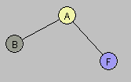
Is there a subset X of the vertex set V so that H = G[X]? Explain.
A: There is no subset of such that . In the subgraph , the vertices are and the only edges shown are A__B and A___F.
However, in the original graph , there is also an edge between and .

- Find a way to partition the vertex set V into two subsets V₁, V₂ so that each of the induced graphs G[V₁] and G[V₂] is connected and G = G[V₁] U G[V₂].
A valid partition is:
V1 = {D, E, I} connected graph(triangle)
V2 = {A, B, C, F, G, H} connected graph, since every vertex in this set is reacheable from the others.
Together they cover all vertices of G and therefore
G = G[V₁] U G[V₂].

Question 2. The following graph has a Hamiltonian cycle. Find it.

