Lab W3D5

- What is the adjacency matrix of the weighted graph G = (V,E) shown in Figure 1.
- Find the shortest path from A to all other vertices using Dijkstra’s algorithm (Slide 12). (Figure 1)
- What is the time complexity?
- Find a minimum spanning tree using Kruskal’s Algorithm (Figure 1)
- What is the time complexity?

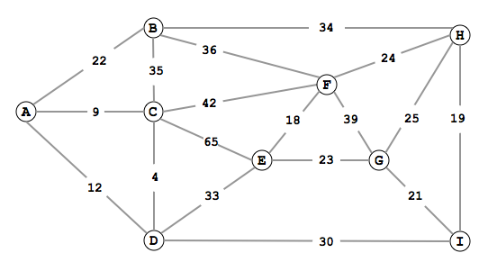
Figure 1

- What is the adjacency matrix of the weighted directed Acyclic graph G = (V,E) shown in Figure 2.
- Find the shortest path from P to U. (Figure 2). (Use the algorithm starting at slide 33).
- What is the time complexity
- Can you use Dijkstra’s algorithm (Slide 12) to find the shortest path from P to U? (Figure 2).
- If “Yes”, find the shortest path from P to U using Dijkstra’s algorithm (Slide 12) (Figure 2).

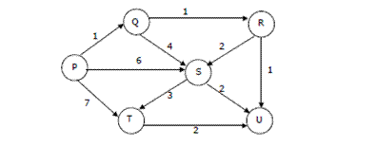
Figure 2

