ELEC 328 Project Report
Assn 2 – Enchanted VR Flashlight
Helena Wang – S01482451 – hw101

1. Concept
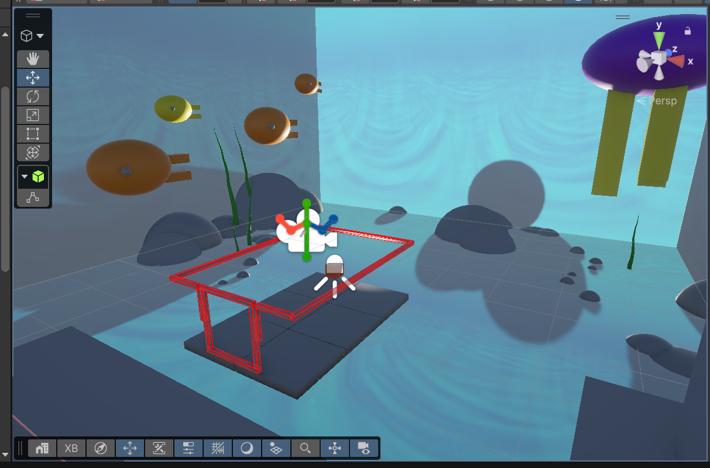
The objectives of the assignment were to learn how to use ShaderGraph to implement a shader that dynamically reacts to run-time behavior (flashlight beam), displaying a hidden texture when inside the beam. I created an underwater scene with several rocks and other items that display a hidden texture when my “flashlight” beam shines on them, with a clear edge outline defining the cone’s edges.

2. Technical overview
Explain the main system you built and the techniques that make it work. Use the prompts below that apply to your assignment.
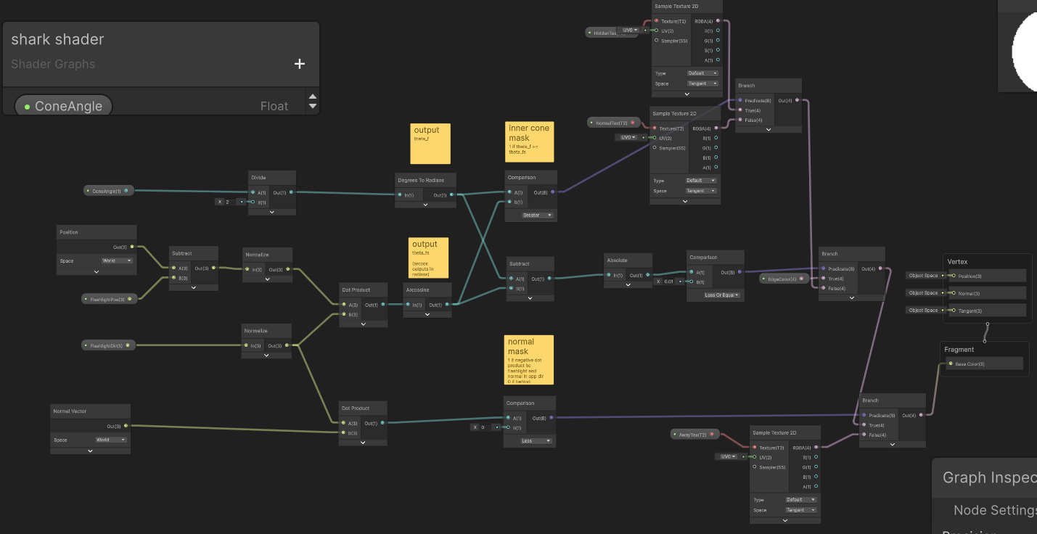
A C# script passes scene object information FlashlightPos, FlashlightDir, and ConeAngle every frame and passes them to the shader. This ShaderGraph is a per-pixel flashlight cone test that picks one of four outputs: the hidden texture, the normal texture, a yellow edge ring, or the “away” texture.
1. Angle to the flashlight from point on surface (theta_fs). For every pixel, it takes Position (World) − FlashlightPos and normalizes it, which gives the unit vector from the light to that surface point. It then takes the dot product with the normalized FlashlightDir. For unit vectors, that dot product is the cosine of the angle between the beam axis and the line to the pixel, so the Arccosine converts it into the angle theta_fs in radians.
2. Cone half-angle (theta_f). ConeAngle/ 2 converts the full cone angle into a half-angle, and Degrees To Radians puts it in the same unit as theta_fs (Arccosine outputs radians).
3. Inside/outside test. A Comparison (theta_f > theta_fs) is true when the pixel is within the half-angle of the beam axis. The first Branch uses this to choose HiddenTex (inside the cone) or NormalTex (outside).
4. Edge ring. |theta_f − theta_fs| is how far the pixel is from the cone boundary. If that’s ≤ 0.01 rad, the second Branch outputs EdgeColor over whatever the first Branch chose, which draws a thin circle where the cone meets the surface.
5. Facing test. dot(Normal, FlashlightDir) < 0 is true when the surface normal points back toward the light, meaning the surface faces the flashlight. The last Branch passes the cone and edge result through in that case, and otherwise outputs AwayTex.
6. Output. The result goes into Fragment Base Color (Unlit).
By adding both this script and ShaderGraph material component to my test objects, shining my flashlight (spot light with cone angle 45deg attached to cube object) should reveal a hidden object.

3. Evidence of requirements
Requirement | Where it is demonstrated | Screenshot
Grabbable flashlight; continuously update flashlight information to shader | Experience video 0:52 | 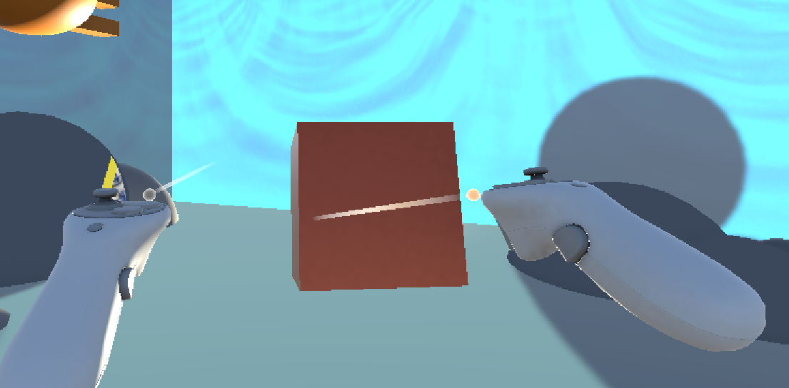
Surfaces outside flashlight beam display default texture | Experience Video 1:40 | 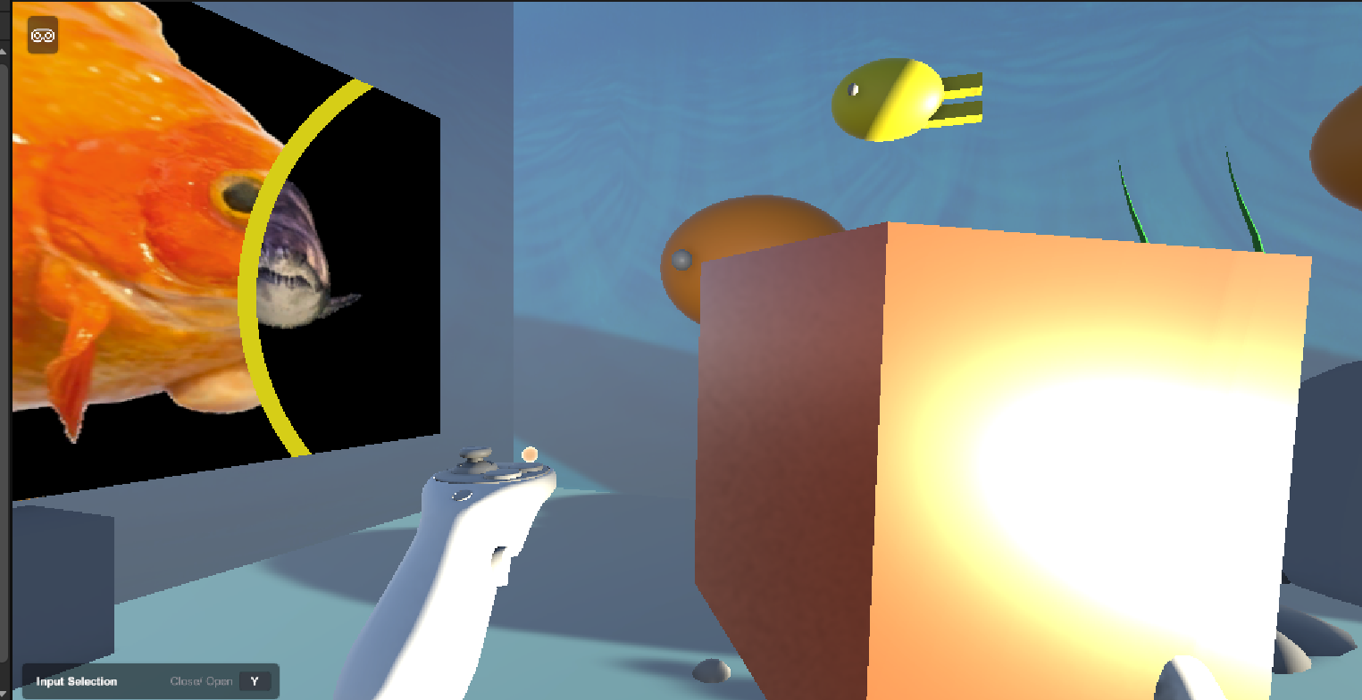
Surfaces inside flashlight beam display hidden texture | Experience Video 1:40
Surfaces facing away from flashlight should still show default texture | Experience Video 1:52 | 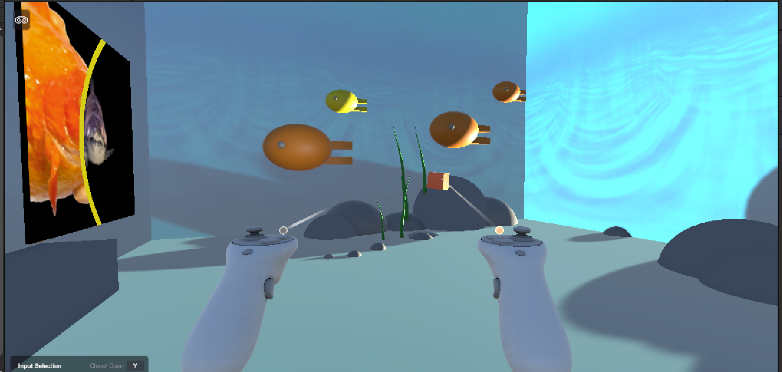
Boundary of flashlight beam outlined with solid color | Experience Video 1:40
Multiple materials | Experience Video 1:33, 1:40 | 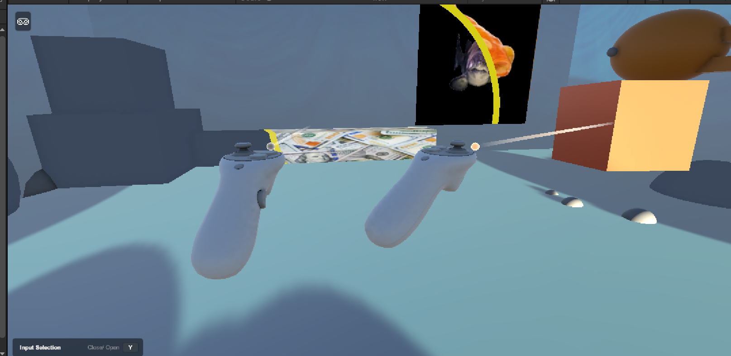

5. Assets, data, and citations
List every external asset, dataset, model, texture, sound, library, or reference used. State whether it was created by you, provided by the course, or obtained elsewhere. Provide a source link or formal citation where appropriate.
Item | Source / citation | How it was used
Roost Rails | Course-provided | Roost Rails
FlashlightContinuousInfo.cs | Referenced Prof. LiKamWa’s ShaderGraph tutorial | Used to continuously pass flashlight information to shader.
SplitCube.cs | Gemini 3.6 Flash | Split skybox faces so that I could put different textures on each face without creating a custom cube map.
Money image | https://unsplash.com/photos/a-pile-of-twenty-dollar-bills-sitting-on-top-of-each-other-knVXUA2yauo | Hidden texture
Fish image | https://unsplash.com/photos/close-up-of-an-orange-goldfish-on-a-white-background-r3D1JOC5s7U | texture
Shark image | https://unsplash.com/photos/close-up-of-gray-shark-fB2jl6Rb3l4 | Hidden texture
Water image | sirsnowy7 https://opengameart.org/content/ocean-hdriskybox | skybox
Directional Light | Course-provided | Light
Cube, sphere, tree default meshes | Unity | Parts of my larger parent meshes

6. AI-use disclosure
If you used generative AI during project development, disclose it below. If you did not use AI, write: No generative AI was used in project development.
Tool | Used for | What was incorporated, changed, or rejected
Claude Sonnet 5.5 Medium | Debugging ShaderGraph | I had it verify my comparison and branching logic by feeding in screenshots of my ShaderGraph.
Gemini 3.6 Medium | Creating SplitCube.cs | Generated full script

7. Reflection
The math of the ShaderGraph worked, and I was able to successfully create a shader that reveals a hidden texture when the flashlight beam shines on it. One challenge I had was that I kept putting my C# script that passed the flashlight information to the shader on my flashlight instead of my test object, which doesn’t work unless I use global vectors. Another thing that was difficult was that I wanted to created a skybox with a cube, but it didn’t seem like Unity supported an easy way to choose parts of images in-editor to be on each face, so I had to generate a script that separated each face of the cube. Additionally, since I was using the inside (“back”) of the cube as my skybox, the textures I put on the cube were much dimmer than if I put them on the exterior (“front”) of the cube, and I still don’t know why. I would like to explore more interesting hidden textures, and I think it would be cool to play around more with the lighting.

