**List of calculated parameters for each contraction-relaxation cycle**

pc=slope of the contraction (speed)

pr=slope of the relaxation

hc=height of the contraction

hr=height of the relaxation

tauc=contraction time

taur=relaxation time

taus=total time of the contraction+relaxation

taud=desexcitation time (xmr-xMc) (voir graph)

Aire=area under the curve

M=maximum of displacement

mmvg= minimum displacement before contraction

mmvd=minimum diplacement after contraction

Rest=xmc-xmr (resList of calculated parameters for each contraction-relaxation cycle

Yellow-blue=rai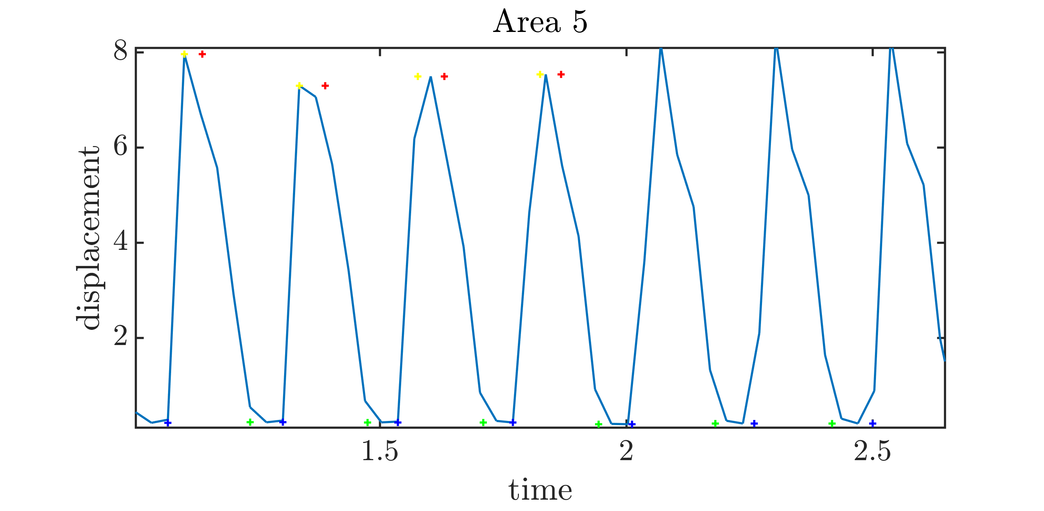sing time

Green -red=relaxation time

Blue -green= resting time

green=xmr

red=xMr

yellow=xMc

blue=xmc