Draft Quarto document

Helene Bæk Juel

## Setup and load data

targets::tar_config_set(store = here::here("_targets"))  
  
library(tidyverse)

── Attaching core tidyverse packages ──────────────────────── tidyverse 2.0.0 ──  
✔ dplyr 1.1.3 ✔ readr 2.1.4  
✔ forcats 1.0.0 ✔ stringr 1.5.0  
✔ ggplot2 3.4.4 ✔ tibble 3.2.1  
✔ lubridate 1.9.3 ✔ tidyr 1.3.0  
✔ purrr 1.0.2   
── Conflicts ────────────────────────────────────────── tidyverse_conflicts() ──  
✖ dplyr::filter() masks stats::filter()  
✖ dplyr::lag() masks stats::lag()  
ℹ Use the conflicted package (<http://conflicted.r-lib.org/>) to force all conflicts to become errors

library(targets)  
library(tidymodels)

── Attaching packages ────────────────────────────────────── tidymodels 1.1.1 ──  
✔ broom 1.0.5 ✔ rsample 1.2.0  
✔ dials 1.2.0 ✔ tune 1.1.2  
✔ infer 1.0.5 ✔ workflows 1.1.3  
✔ modeldata 1.2.0 ✔ workflowsets 1.0.1  
✔ parsnip 1.1.1 ✔ yardstick 1.2.0  
✔ recipes 1.0.8   
── Conflicts ───────────────────────────────────────── tidymodels_conflicts() ──  
✖ scales::discard() masks purrr::discard()  
✖ dplyr::filter() masks stats::filter()  
✖ recipes::fixed() masks stringr::fixed()  
✖ dplyr::lag() masks stats::lag()  
✖ yardstick::spec() masks readr::spec()  
✖ recipes::step() masks stats::step()  
• Dig deeper into tidy modeling with R at https://www.tmwr.org

source(here::here("R/functions.R"))  
  
lipidomics <- tar_read(lipidomics)

## Results

tar_read(df_stats_by_metabolite) %>%  
 dplyr::mutate(MeanSD = glue::glue("{value_mean} ({value_sd})")) %>%  
 select(Metabolite = metabolite, `Mean SD` = MeanSD) %>%  
 knitr::kable(caption = "Descriptive statistics of the metabolites")

Descriptive statistics of the metabolites

| Metabolite | Mean SD |
| --- | --- |
| CDCl3 (solvent) | 180 (67) |
| Cholesterol | 18.6 (11.4) |
| FA -CH2CH2COO- | 33.6 (7.8) |
| Lipid -CH2- | 536.6 (61.9) |
| Lipid CH3- 1 | 98.3 (73.8) |
| Lipid CH3- 2 | 168.2 (29.2) |
| MUFA+PUFA | 32.9 (16.1) |
| PUFA | 30 (24.1) |
| Phosphatidycholine | 31.7 (20.5) |
| Phosphatidylethanolamine | 10 (7.6) |
| Phospholipids | 2.7 (2.6) |
| TMS (interntal standard) | 123 (130.4) |

tar_read(fig_metabolite_distribution)

`stat_bin()` using `bins = 30`. Pick better value with `binwidth`.

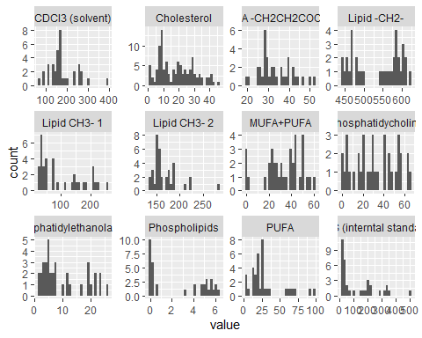

## Building the model

## Running multiple models

## Figure of model estimates

model_estimates <- tar_read(df_model_estimates)

tar_read(fig_model_estimates)

