[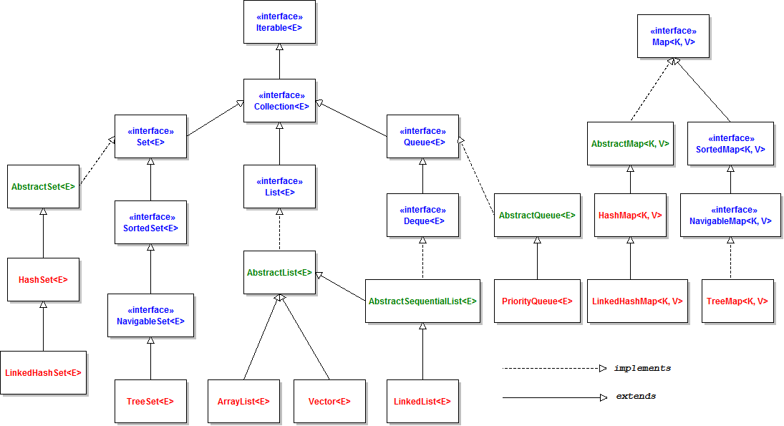](http://www.codejava.net/images/articles/javacore/collections/collections%20framework%20overview.png)