Simple document
Helen Peng
I’m an R Markdown document!

Section 0: libraries
## Warning: package 'tidyverse' was built under R version 4.4.3

Section 1
Here’s a code chunk that samples from a normal distribution:
samp = rnorm(100)
length(samp)
## [1] 100

Section 2
I can take the mean of the sample, too! The mean is 0.0955784.

Section 3: a tibble
plot_df = tibble(
x = rnorm(1000, sd = .5),
y = 1 + 2 * x + rnorm(1000)
)
head(plot_df)
## # A tibble: 6 × 2
## x y
## <dbl> <dbl>
## 1 1.05 3.00
## 2 0.484 2.59
## 3 -0.185 1.40
## 4 -0.206 -0.00157
## 5 0.484 1.45
## 6 1.12 4.32

Section 4: plots
These are plots from are random sample.
## `stat_bin()` using `bins = 30`. Pick better value `binwidth`.
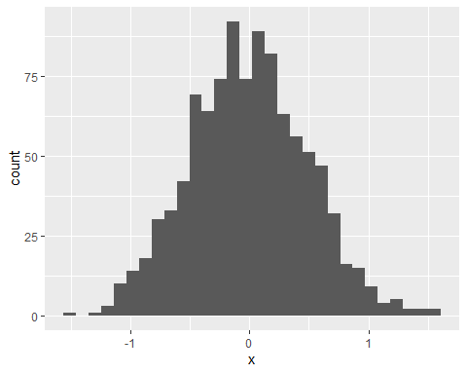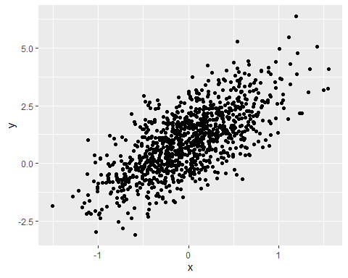

Section 5: Learning Assessment 2
Write a named code chunk that creates a dataframe comprised of: a numeric variable containing a random sample of size 500 from a normal variable with mean 1; a logical vector indicating whether each sampled value is greater than zero; and a numeric vector containing the absolute value of each element. Then, produce a histogram of the absolute value variable just created. Add an inline summary giving the median value rounded to two decimal places. What happens if you set eval = FALSE to the code chunk? What about echo = FALSE?
This plot shows the distribution of the absolute value of $X∼N(1,1)$
set.seed(0)
assessment_df = tibble(
num_var = rnorm(500, mean = 1),
log_var = num_var > 0,
abs_var = abs(num_var),
)
ggplot(assessment_df, aes(x = abs_var)) +
geom_histogram()
## `stat_bin()` using `bins = 30`. Pick better value `binwidth`.
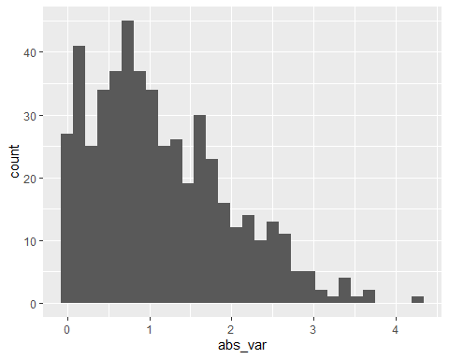
median_sample = median(assessment_df$num_var) # my solution (don't use this because using the $ there is a possibility that it goes back and edit the df so it's better to just use the function pull)
median_samp = median(pull(assessment_df, num_var)) # actual solution (tidyverse solution)
median_sample == median_samp
## [1] TRUE
median_sample
## [1] 0.9446332
The median value is 0.94
why is my in-line different from the code chunk?? (probably because i didn’t set seed? yeah that’s why)
Calculating the median value inline 0.94

Section 6: formatting

Text formatting
italic or italic bold or bold code superscript² and subscript₂
superscript³ and subscript₃

Headings

1st Level Header

2nd Level Header

3rd Level Header

Lists
- Bulleted list item 1
- Item 2
  - Item 2a
  - Item 2b
- Numbered list item 1
- Item 2. The numbers are incremented automatically in the output.

Tables
First Header | Second Header
Content Cell | Content Cell
Content Cell | Content Cell

Section 7: Learning Assessment 3
After the previous code chunk, write a bullet list given the mean, median, and standard deviation of the original random sample.
- The median value is 0.94
- The mean value is 1
- The standard deviation is 0.99

