project file description
┣ 1. process data
1.1 parsing files:
Code: process_annotated_nda.ipynb, process_unlabeled_nda.ipynb
Results: annotated_nda_para.csv, parsed_nda_para.csv
1.2 LLM labeling
Code: Preprocessing-Classification-gemini-2.5-flash.ipynb
Results: Final_Classification_gemini_2.5_flash_6000_samples.csv in Classification-Results Folder
1.3 data balance
Code: data_balancing_try.ipynb
Results: Final_NDA_with_Augmented.csv (the final training dataset

┣ 2. model training (for classification; models are saved in /3.web frontend/nda_app/models)
2.1 train_bert_balanced.ipynb
# Fine-tunes a BERT-based model with balanced sampling to improve class fairness
2.2 train_random_forest_model.ipynb
2.3 train_shallow_model.ipynb
# Trains a lightweight baseline model (e.g., NB / SVM / …)
2.4 train_xgboost_model.ipynb

┗ 3. web frontend (See README.txt in this folder
After unzipping the nda_app.zip, you get
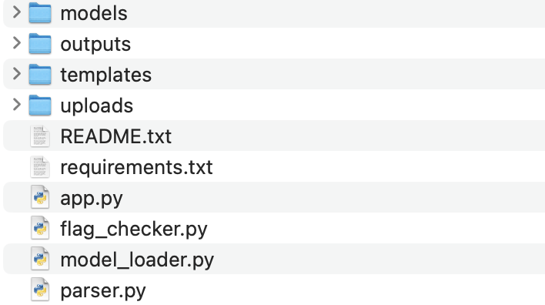
flag_checker.py # detect deal breaker keywords.
parser.py # parse the new file using the same logic as in part 1
model_loader.py # load the trained model for predicting new clauses category
app.py # web server

Next step suggestions for the next group:
- Refine dataset. (different ways in parsing the data may give different performance on the training models)
- Try other semi-supervised methods other than using LLM to categorize unlabeled data.
- Try better ways of balancing the data (because some of the categories is large, the model may perform better on these categories but not the other classes. This could be the reason why our accuracies seems high)

