Method

1.1. Bipartite Networks

In order to elicit insights into the existing scientific networks and help to identify scientific leaders for specific expertise areas we completed a network analysis and identified networks of experts working on various diagnosis relevant to particular research project. We used Science of Science (Sci2) Tool [1] to extract bipartite networks of researchers united, first, by same diagnosis and, second, by agenda categories that were cumulatively sliced by seven years according to the project funding date for the period of 1982 to 2016. To generate initial network attributes we created a property file to calculate a number of projects associated with individual researchers and diagnosis as follows:

node.countProjectsperResearcher = PROJECT_ID.count edge.count

ProjectsPerDiagnosis=USR_DIAGNOSIS_AREA.count

Preliminary analysis of network performed on USR_PRINCIPAL_INVESTIGATOR vs USR_DIAGNOSIS_AREA shown that number of nodes (references between Primary Investigators and respective diagnosis) and number of Primary Investigators was proportionally increasing during the seven year periods (Figure1).

Figure 1 demonstrates Occupation Therapy Research Activity Timeline.

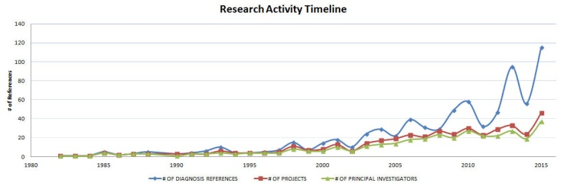

Each network time slice was further analyzed to depict the essential linkages between individual nodes (PIs and respective diagnoses) using Blondel Community Detection analysis. Each time slice was imported into Gephi [2] in order to visualize it with Fruchterman-Reingold layout [5] algorithm. Each modular community was colored by essential diagnoses and nodes sized by the number of diagnosis references. The networks were further imported into Inkscape [3] to create legends and finalize the label layouts.

To connect diagnosis descriptions with agenda we tested out several different visualization types including Fruchterman-Reingold with Annotation and Circular Hierarchy; however the Bipartite Network Graph proved to be the most precise and straightforward. The same type of time slicing on the Agenda-Diagnosis data helped to compare PI-Diagnosis with similar time slice of the Agenda-Diagnosis data and to provide more insights into the nature of Occupational Therapy research during respective time slice. Even though these networks were not included into this article, they are accessible through our github repository [4] and would be valuable assets for further discovery of the OT research community.

Results

2.1. Bipartite Networks

Figure 2 depicts a network map of 51 Principal Investigators working on 29 diagnoses for a period of 1982 through 2016.

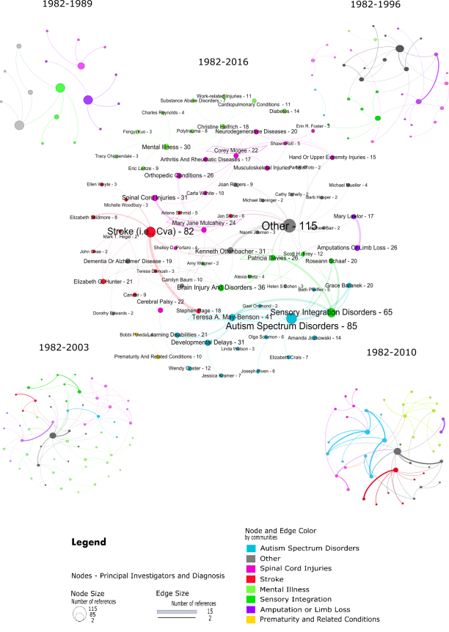

The dataset is cumulatively sliced by seven years. The nodes are assigned to eight communities of diagnoses based on the Blondel Community Detection algorithm. The nodes represent primary investigators and diagnoses. Nodes, respective labels and linkages between the nodes are sized by the number of references to diagnoses. The maximum number of references (115) is attributed to the ‘Other’ diagnosis. The maximum number of connections (15) between nodes is associated with ‘Stroke’ diagnosis and Principal Investigator Stephen Page. The top five researchers with the most number of diagnoses referenced on the final cumulative time slice outlined with the color of the respective community as follows: Theresa May-Benson – Autism Spectrum Disorders, Kenneth Ottenbacher – Other diagnoses, Patricia Davies - Sensory integration/processing disorders, and Mary Jane Mulcahey and Corey Mcgee - Spinal cord injuries.

Discussion

3.1. Bipartite Networks

According to the bipartite Primary Investigator vs. Diagnosis network, for every time slice the number of nodes tripled. . Started with only eight Diagnoses, the field significantly expanded to 29 Diagnoses by 2016. From 1982 to 1996 the research was concentrated on Amputations or limb loss, Other, and Dementia or Alzheimer's disease Diagnoses with M. Lowler and J.Rogers consistently leading the research in the respective areas, including on the Other Diagnosis. After 1996 the field of research expanded significantly and started moving to the areas of Autism spectrum disorders, lead by Teresa A. May-Benson, that is strongly connected to Sensory integration/processing disorders research community that was headed by Patricia Davies. The third largest, Stroke research community, is connected to the Other diagnosis by Kenneth Ottenbacher and is engaged in collaborations with Brain injury and disorders and Cerebral Palsy. Two more dispersed communities were identified. The first consisted of the area of diagnosis associated with various body injuries such as Spinal Cord, Upper Extremities and Musculoskeletal injuries with Corey McGee and Mary Jane Mulcahey leading the field. The second emerging community consists of Mental illness, Diabetes and Cardiopulmonary conditions field lead by Christine Helfrich.

References

[1] Sci2 Team. (2009). Science of Science (Sci2) Tool. Indiana University and SciTech Strategies, <https://sci2.cns.iu.edu>.

[2] Bastian M., Heymann S., Jacomy M. (2009). Gephi: an open source software for exploring and manipulating networks. International AAAI Conference on Weblogs and Social Media.

[3] Inkscape is a professional vector graphics editor for Windows, Mac OS X and Linux. It's free and open source. <https://inkscape.org/en/learn/tutorials/> [accessed 3/3/2016]

[4] Visualization of a Research Database in Occupational Therapy Foundation and American Occupational Therapy Association; 2016; <https://github.iu.edu/yyezeret/Viz_OTResearch/wiki>

[5] Fruchterman, T. M. J., & Reingold, E. M. (1991). Graph Drawing by Force-Directed Placement. Software: Practice and Experience, 21(11).