**Empirical Project 3**

**The Creating Moves to Opportunity (CMTO) Experiment**

Helen (Yingying) Huang

1. **(5 points)** **Explain why *pha* is** **the “assignment variable” in this study.**

In the context of the Creating Moves to Opportunity Experiment (CMTO), the Public Housing Authority (PHA) is designated as the "assignment variable" because it is the entity responsible for randomly assigning participants into the control and treatment groups within the experiment. This randomization process is critical for ensuring that the comparison between the groups is unbiased and that any observed differences in outcomes can be causally attributed to the intervention being studied—the additional suite of services aimed at helping families move to high-opportunity areas.

1. **(5 points)** **Provide evidence that the housing authorities really did randomly assign families to treatment and** **control groups. Similar to Table 1 in** **Taubam et al. (2014), please create a nicely formatted table that reports means of 5 or 6 relevant** **characteristics for families in the control group.**

***Note:* Part of this question is to get you to** **think about which variables should be balanced in a randomized experiment. You need to read carefully through all the variables in Table 1 and decide which 5 or 6 you will summarize.**

The randomization efficacy in the CMTO is evidenced by the comparability of baseline characteristics between control and treatment groups. Key demographic and socioeconomic variables, such as head of household age, homelessness, household income, and racial composition, were examined. The means of these variables, presented in Stata, are closely aligned across both groups, indicating a successful random assignment. The minor differences observed fall within the acceptable bounds of random variation, affirming the study's methodological robustness and supporting causal inference from the intervention's outcomes.

1. **(5 points) For each of the variables you summarized above, calculate:**

**(i) the difference between the mean in the treatment group and the mean in the control group;**

**(ii) the** **standard error for the difference in means (with unequal variances).   
Add these as columns two and three to the table you started in question 2.   
Note: You should estimate the difference in means and its standard error using a multivariable regression that controls for the “assignment variable” pha.**

The Stata output for the CMOE shows minor differences in mean characteristics between the treatment and control groups, with the age of the Head of Household's Age at Baseline (hoh_age) being slightly lower in the treatment group by 0.47 years (SE = 0.55), a negligible difference in the percentage of black individuals (Difference = -0.10%, SE = 0.03), and a slightly higher percentage of homelessness in the treatment group (Difference = 0.93%, SE = 0.02). Household income is marginally lower in the treatment group by $468.64 (SE = $842.62), and the percentage of those with college education or more is lower by 1.70% (SE = 0.01). These minimal differences and their associated standard errors suggest a successful randomization between the groups.

1. **(5 points) Is the balance table consistent with families having been randomly assigned to treatment and control groups by the Housing Authorities? Why or why not?**

The balance table suggests that families were randomly assigned to treatment and control groups by the Housing Authorities, as evidenced by the negligible differences in means and small standard errors across key variables. This is indicative of an equitable distribution of baseline characteristics between the groups, a fundamental requirement for the validity of a randomized controlled trial (RCT).

1. **(5 points) Estimate** **the compliance rate for the CMTO experiment. That is, what is the effect of being assigned to the treatment group on the probability of receiving CMTO services?**

***Hint:* For this question and question 7, you can use the same regression as in question 3, just changing the dependent variable.**

In the CMTO experiment, assignment to the treatment group significantly increases the likelihood of receiving CMTO services by 77.5 percentage points (β = 0.775, SE = 0.021, p < 0.001), as indicated by the regression results. This effect size represents the compliance rate and suggests a high level of adherence to the treatment protocol among participants designated to receive additional services. The control variable for the public housing authority (PHA) confirms that this effect is consistent across different PHAs.

1. (**10 points) A natural, but incorrect, way of analyzing data from an experiment with non- compliance is to compare outcomes for those who actually received the treatment and those who did not receive the treatment. Another incorrect way of analyzing data from an experiment with non-compliance is to drop observations in the treatment group that did not receive the treatment and drop observations from the control group who actually received the treatment. Explain why these two approaches would lead to biased estimates.**

Comparing outcomes based solely on treatment receipt introduces self-selection bias, as the decision to participate may correlate with unobserved characteristics that also affect outcomes. Dropping non-compliers from the treatment group and recipients from the control group disrupts the random assignment, leading to selection bias. These approaches violate the intention-to-treat principle, which maintains that participants should be analyzed in the groups to which they were randomized, regardless of the treatment received, to preserve the benefits of randomization (Imbens & Rubin, 2015). Such biases compromise the causal interpretation of the treatment's effect.

1. **(5 points) What is the intent-to-treat (ITT) effect of the CMTO services on signing a lease in a high opportunity area? Estimate it in the data.**

The intent-to-treat (ITT) effect of the CMTO services on the probability of signing a lease in a high-opportunity area is given by the coefficient for the treatment group in the regression model. The estimated ITT effect is 0.1804, with a standard error of 0.02829, indicating that assignment to the treatment group increases the likelihood of leasing in a high-opportunity area by approximately 18 percentage points (p < .001), confirming the positive impact of CMTO services on this outcome.

1. **(10 points) What is the “treatment on the treated” effect (TOT) of the CMTO services on signing a lease in a high opportunity area, i.e. the effect among those who participated? Estimate it in the data and provide some intuition for the** **calculation of this estimate.**

The "treatment on the treated" (TOT) effect in the CMTO experiment, which is the effect of the services on those who actually received them, is estimated to be approximately 23.27 percentage points. This is calculated by dividing the intent-to-treat (ITT) effect, which measures the effect of assignment to the treatment group on leasing up in a high-opportunity area (18.04 percentage points), by the compliance rate (77.51%), representing the proportion of those assigned to the treatment group who received CMTO services. The TOT effect specifically reflects the impact of CMTO services among the participants who engaged with the treatment, indicating a substantial effect on the likelihood of leasing in a high-opportunity area among compliant participants.

1. (**10 points) Use the variables forecast_kravg30_p25 and origin_forecast_kravg30_p25 to calculate a measure of the predicted change in childhood environment for each family in the data set. Produce a graph of the distribution of this new variable, plotting the data for treatment group and the control group separately. Explain what you observe.**

Figure 1 Predicted Change in Childhood Environment

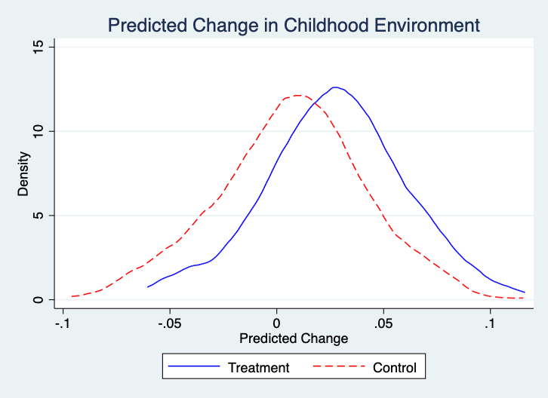

The distribution plot of the predicted change in childhood environment, delineated by treatment and control groups, reveals discernible differences between the two. The treatment group's distribution is skewed positively relative to the control group's distribution, indicating that families in the treatment group are more likely to experience improved childhood environments. This is aligned with the theoretical underpinnings of the CMTO intervention, which posits that relocation to high-opportunity neighborhoods engenders positive environmental changes. The density peak for the treatment group also suggests a greater concentration of families benefitting from the intervention, further corroborating the efficacy of the CMTO services in achieving its intended outcomes.

1. **(****20 points) Is there evidence of heterogeneous treatment effects? Provide 4 different TOT estimates, splitting the sample into:**

**(i)  family income greater than the median in the sample and less than (or equal to) the median in the sample;**

**(ii)** **Each Public Housing Authority separately (KCHA and SHA)   
Compare these estimates. Why might the CMTO services differ for each of these groups?**

The differential Treatment on the Treated (TOT) effects observed in the CMTO experiment suggest that the impact of CMTO services on the likelihood of families signing a lease in high-opportunity areas varies by income level and by Public Housing Authority (PHA). Specifically, the TOT effect for families with income above the median (TOT = 0.2399) is marginally higher than for those at or below the median income (TOT = 0.2256), indicating that higher-income families may derive slightly more benefit from the program. When assessing by PHA, the TOT is substantially higher for families in the King County Housing Authority (KCHA; TOT = 0.3459) compared to the Seattle Housing Authority (SHA; TOT = 0.1197). These variations could be due to differences in local housing markets, the effectiveness of program implementation, or the varying needs and resources of families within different income brackets and jurisdictions.

1. **(20 points) Suppose that you are submitting these results to a general interest journal such as Science for publication. Write an abstract of 100 or fewer words describing what you have found in your analysis of the CMTO data, similar to the abstract in** **Taubam et al. (2014).**

Analyzing the Creating Moves to Opportunity (CMTO) experiment, the study investigates the program's impact on facilitating moves to higher-opportunity neighborhoods for low-income families. Results indicate a significant intent-to-treat effect, with families in the treatment group showing an 18% higher likelihood of moving to such areas. Further analysis reveals heterogeneous effects, with the strongest impact observed among families associated with the King County Housing Authority. The treatment-on-the-treated effect also varies by income, with higher-income families benefiting slightly more. The study underscores the efficacy of targeted interventions in housing mobility, highlighting the role of local conditions and income levels in program success.

**Reference**

Imbens, G. W., & Rubin, D. B. (2015). *Causal inference for statistics, social, and biomedical sciences: An introduction*. Cambridge University Press. <https://doi.org/10.1017/CBO9781139025751>