Future Mirror AI — User Guide
Oct 16, 2026 · @Hussam El Din Ahmed Ali
This guide walks you through Future Mirror AI screen by screen, from asking a strategic question to approving a strategy and tracking real results.

1. Getting started
Open the platform in your browser (http://localhost:8080 with Docker, or http://localhost:5173 in development) and sign in.
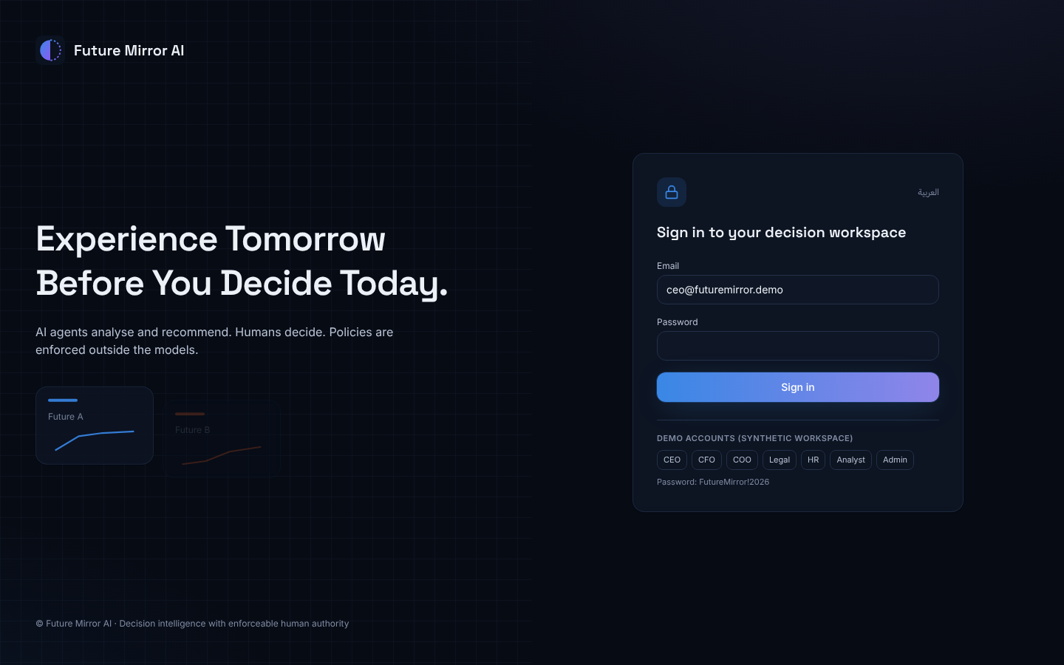
- Enter your email and password, or click one of the demo account buttons to fill them in.
- Click Sign in. You land on the Executive Command Center.
- All demo accounts use the password FutureMirror!2026.
Account | Role | What they typically do
ceo@futuremirror.demo | CEO | Reviews dossiers, approves high-impact strategies, emergency stop
cfo@futuremirror.demo | CFO | Financial approval, data imports, automation
coo@futuremirror.demo | COO | Signs off on delivery impact
legal@futuremirror.demo | General Counsel | Reviews contract changes
hr@futuremirror.demo | HR Director | Reviews workforce impact
analyst@futuremirror.demo | Decision Analyst | Creates decisions, runs analyses, submits for approval
admin@futuremirror.demo | Administrator | Users, policies, audit trail, emergency stop
viewer@futuremirror.demo | Viewer | Read-only access
The header bar shows, on every screen:
- Status chips: Synthetic data (the demo company is fictional), Rule-based agents · no LLM (agents compute findings without an AI language model), and External actions disabled (the platform never changes outside systems). A red Emergency stop active chip appears if an admin has stopped all analyses.
- العربية / English: switches the whole interface between English and Arabic.
- Sun / moon icon: switches between dark and light themes.
- Sign-out icon next to your name.
The left sidebar groups the screens into Command (overview and new decisions), Active decision (screens for the decision you are working on) and Platform (data, automation, governance, administration).

2. Command Center and Decision Workspace
The Executive Command Center is your home page: company KPIs, the latest decision dossier and recent activity in one view.
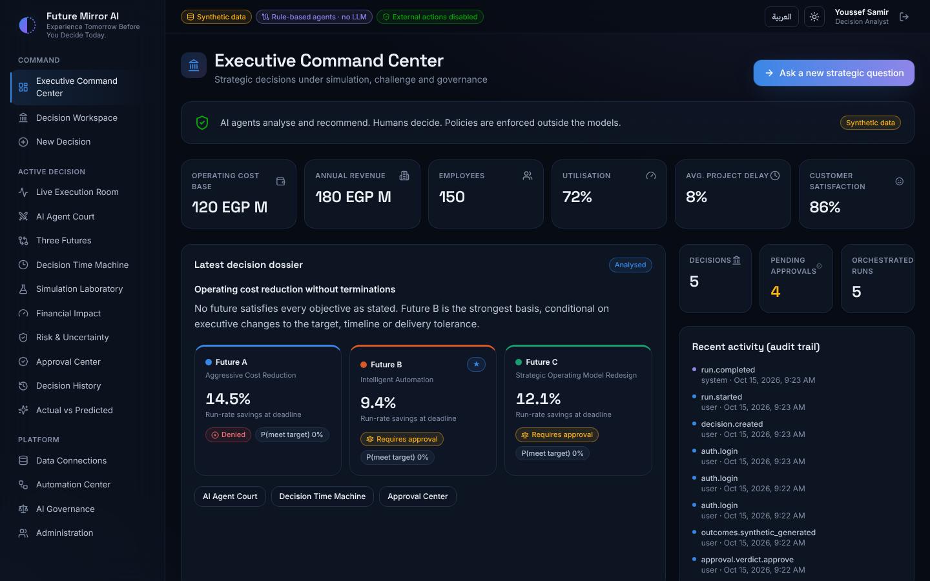
- KPI row: operating cost base, revenue, employees, utilisation, average project delay and customer satisfaction from the current dataset.
- Latest decision dossier: the recommendation headline and one card per future (A, B, C) with its savings, governance status (Denied / Requires approval) and probability of hitting the target. The star marks the recommended future.
- Counters: number of decisions, pending approvals and analysis runs.
- Recent activity: the last entries of the audit trail.
- Ask a new strategic question (top right) opens the Intake Wizard.
The Decision Workspace lists every decision case.
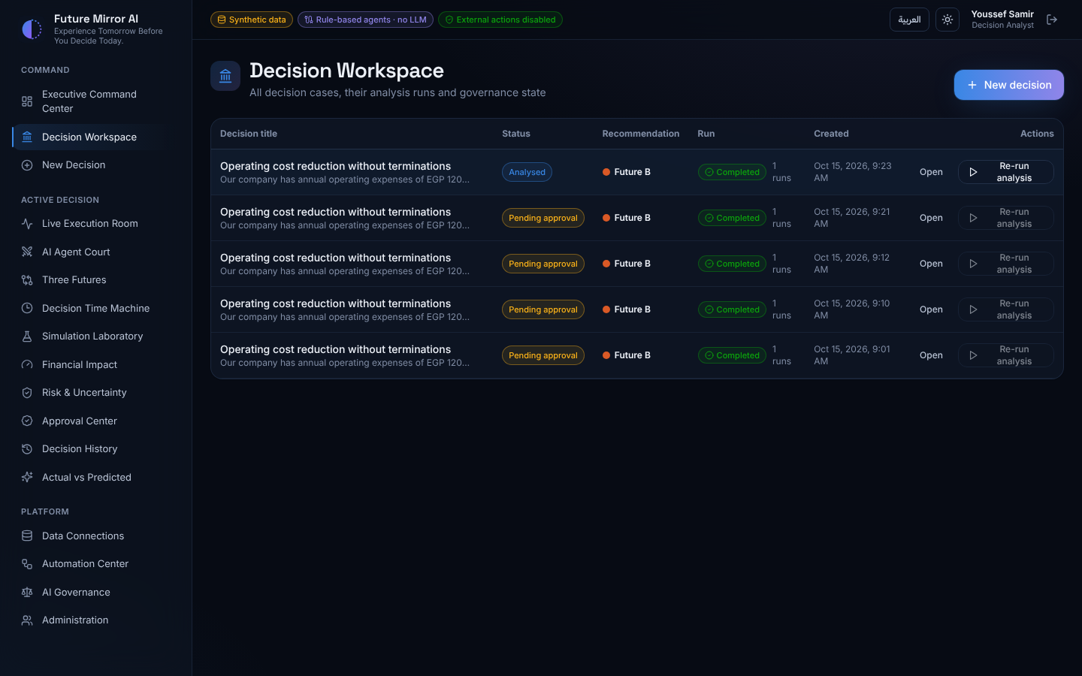
- Click a decision's title to make it the active decision and open its Agent Court; all screens under Active decision in the sidebar then show that decision.
- Open jumps to its Three Futures; Run analysis / Re-run analysis starts a new multi-agent analysis and takes you to the Live Execution Room.
- Re-running is disabled while a decision is analysing, pending approval or approved.

3. Creating a decision (Intake Wizard)
The Intake Wizard turns your question into a structured decision in four steps. Open it from New Decision in the sidebar.
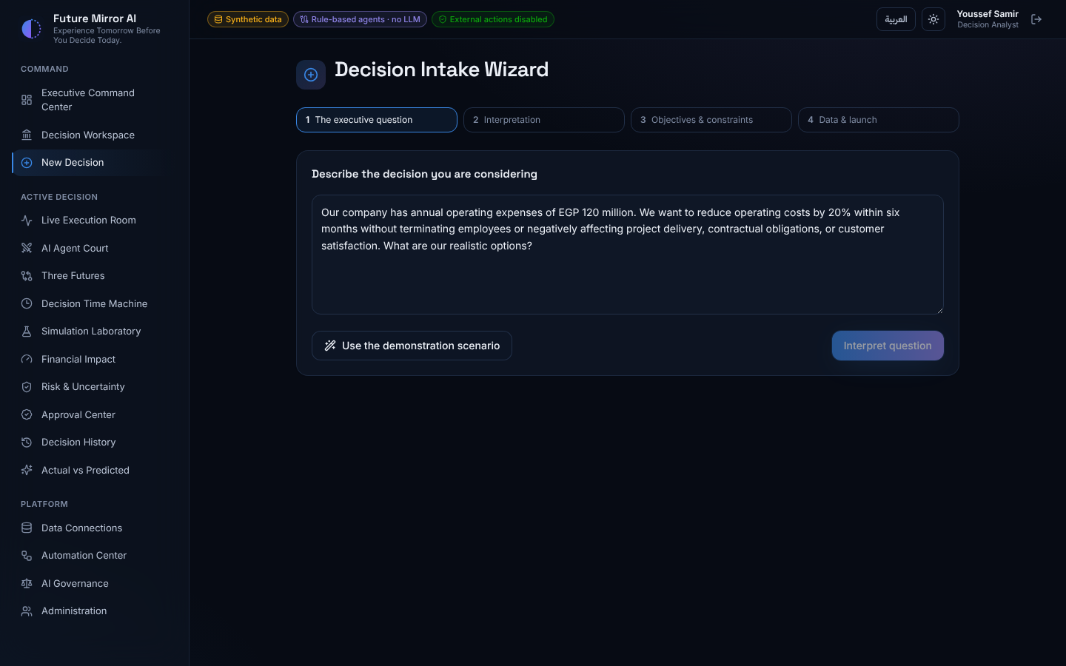
- The executive question. Type your question in English or Arabic, or click Use the demonstration scenario. Then click Interpret question.
- Interpretation. The platform shows what it detected: the target percentage, timeline, cost base and constraints such as no terminations. Check each one and give the decision a title.
- Objectives & constraints. Adjust the executive controls: cost-reduction target, implementation timeline, automation investment, acceptable delivery delay, maximum utilisation, minimum customer satisfaction, budget cap, risk tolerance, and the no employee terminations switch.
- Data & launch. Choose the dataset version. A red badge warns you if the data has quality errors. Click Create decision & awaken the agents.
This release supports three decision types, and the question decides which one is used:
- Operating cost reduction, for example "reduce operating costs by 20% within six months without terminations".
- Revenue collections improvement, for example "what if we collect 30% more revenue by contracting a collection agency?". Step 2 shows Decision model: Revenue collections. Every screen then uses collections terms, such as extra collections, complaint rate, overdue receivables and DSO. The three futures are full agency outsourcing, a hybrid, and in-house transformation.
- State-owned hotel asset, for example "get the most out of the Authority's 148-room hotel through different proposals". Step 2 shows Decision model: State-owned hotel asset. The question rarely states numbers, so the intake proposes a 6% annual return on the asset value, 12 months, at most 35% of rooms out of service, a guest score of at least 60% and a capital budget of EGP 40M; change any of them in step 3. The three futures are a long-term lease to a private operator, a full renovation with a hotel brand, and a mixed-use repositioning with serviced apartments and an investor business centre.
Risk tolerance sets how sure the simulation must be before a constraint counts as met: Low = 90% confidence, Medium = 70%, High = 50%.

4. Watching the agents (Live Execution Room)
After launch you see the analysis happen live, streamed from the server; a full run takes a few seconds.
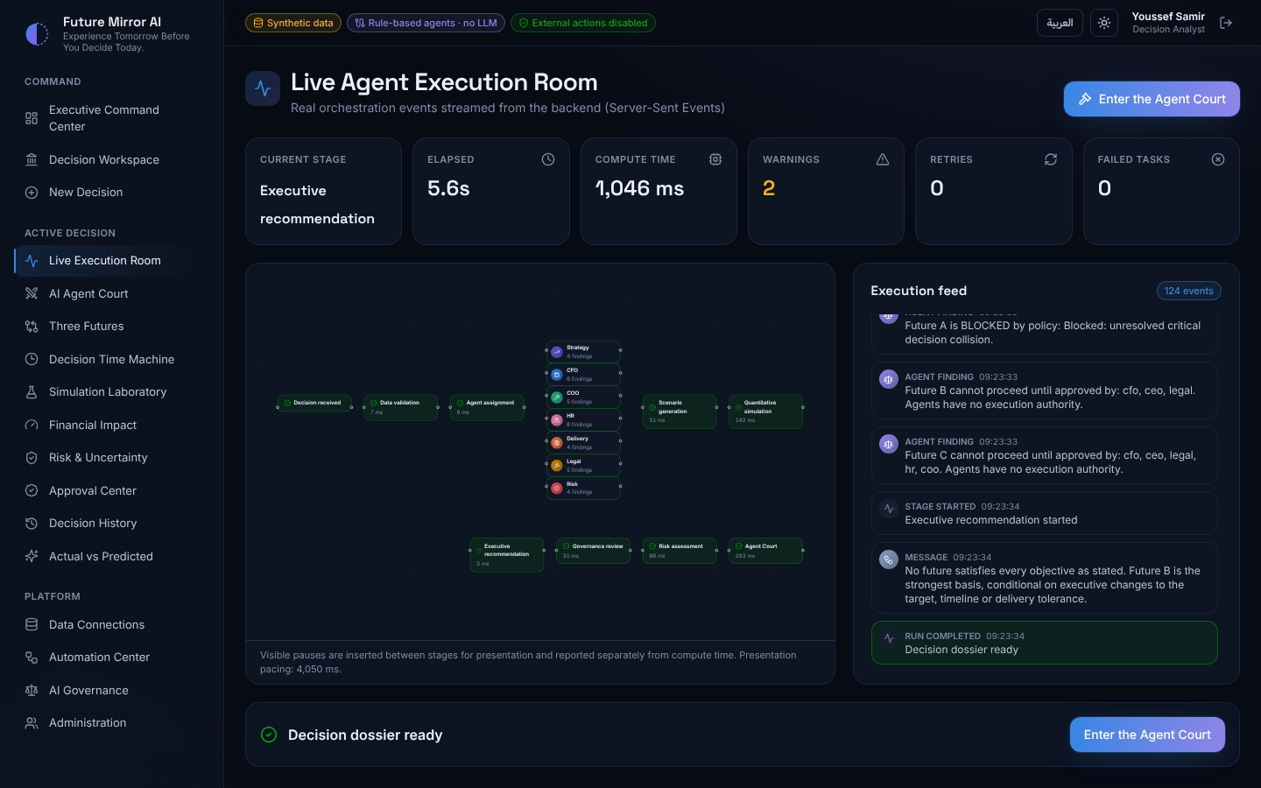
- Top tiles: current stage, elapsed time, compute time, warnings, retries and failed tasks.
- Flow graph: the ten stages from Decision received to Executive recommendation. Seven specialist agents (Strategy, CFO, COO, HR, Delivery, Legal, Risk) work in parallel in the middle. Green means done, blue means running, red means failed.
- Execution feed: every event in order — agent findings, data warnings, Red Team objections, collisions and policy decisions.
- Presentation pacing: short pauses are added between stages so you can follow along. The note under the graph says so, and compute time excludes them.
- Emergency stop this run (CEO and admins) cancels the analysis at its next step.
When Decision dossier ready appears, click Enter the Agent Court. You can reopen any past run from Decision History.

5. Reading the AI Agent Court
The Agent Court shows what each agent concluded, how the Red Team challenged it, and the final verdict.
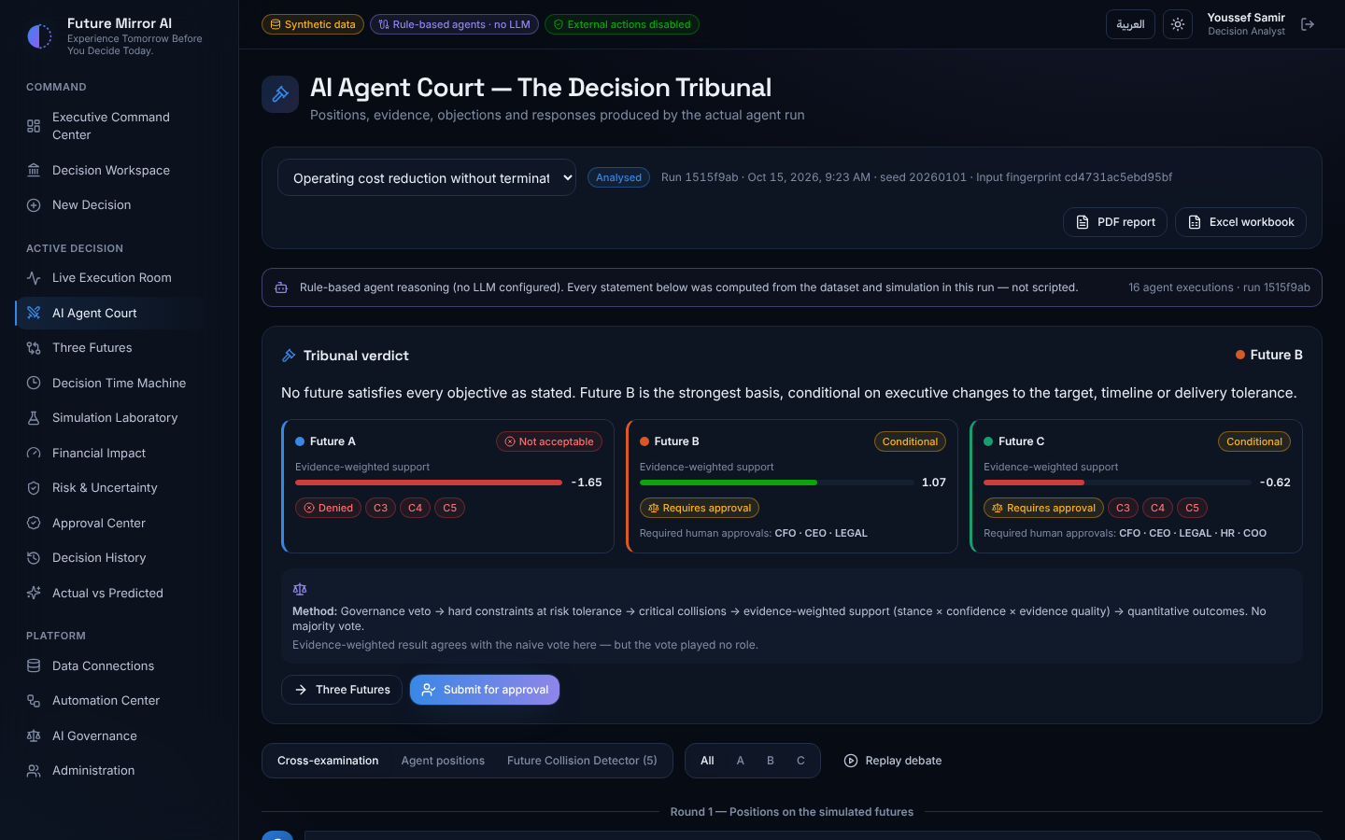
- Decision bar: pick the decision, see its status, run ID, simulation seed and input fingerprint, and download the PDF report or Excel workbook.
- Mode banner: says whether findings come from rule-based reasoning or an AI language model.
- Tribunal verdict: the recommendation headline and one card per future with its status (Acceptable / Conditional / Not acceptable), evidence-weighted support bar, governance outcome, failed hard constraints (C3, C4…) and the roles that must approve.
- Method box: explains that the verdict weighs evidence quality and policy; it is not a majority vote.
Below the verdict are three tabs. Use the All / A / B / C filter to focus on one future.
- Cross-examination: the debate in four rounds: positions, Red Team objections and responses, collisions, governance. Click Replay debate to watch it unfold again.
- Agent positions: every finding, each labelled Fact, Estimate, Assumption, Hypothesis or Recommendation, with its stance, confidence and an Evidence link to the exact data or simulation values behind it.
- Future Collision Detector: conflicts between agents' recommendations.
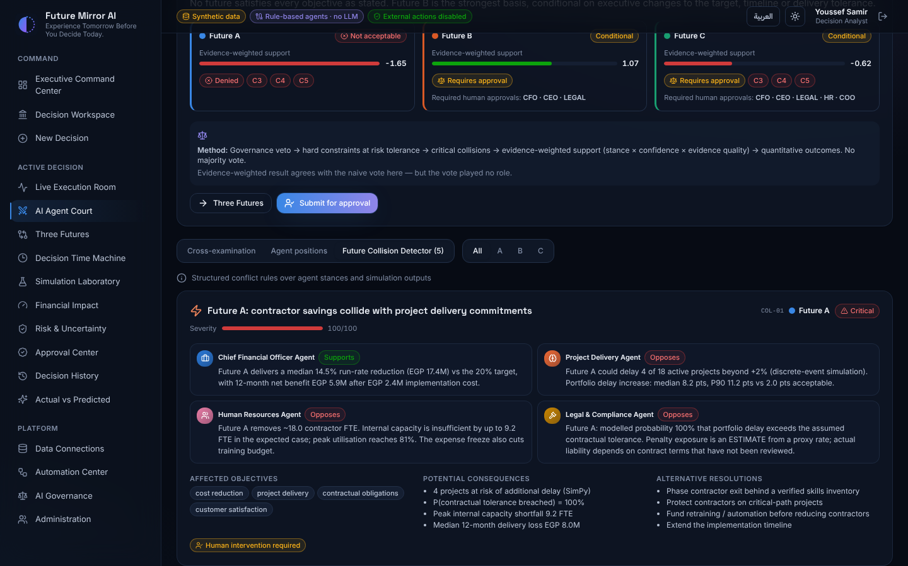
Each collision card shows its severity score, the conflicting agents' positions, the affected objectives, the consequences and alternative resolutions, and whether human intervention is required.

6. Comparing the Three Futures
Three Futures puts the three strategies side by side and recalculates them instantly when you move the controls.
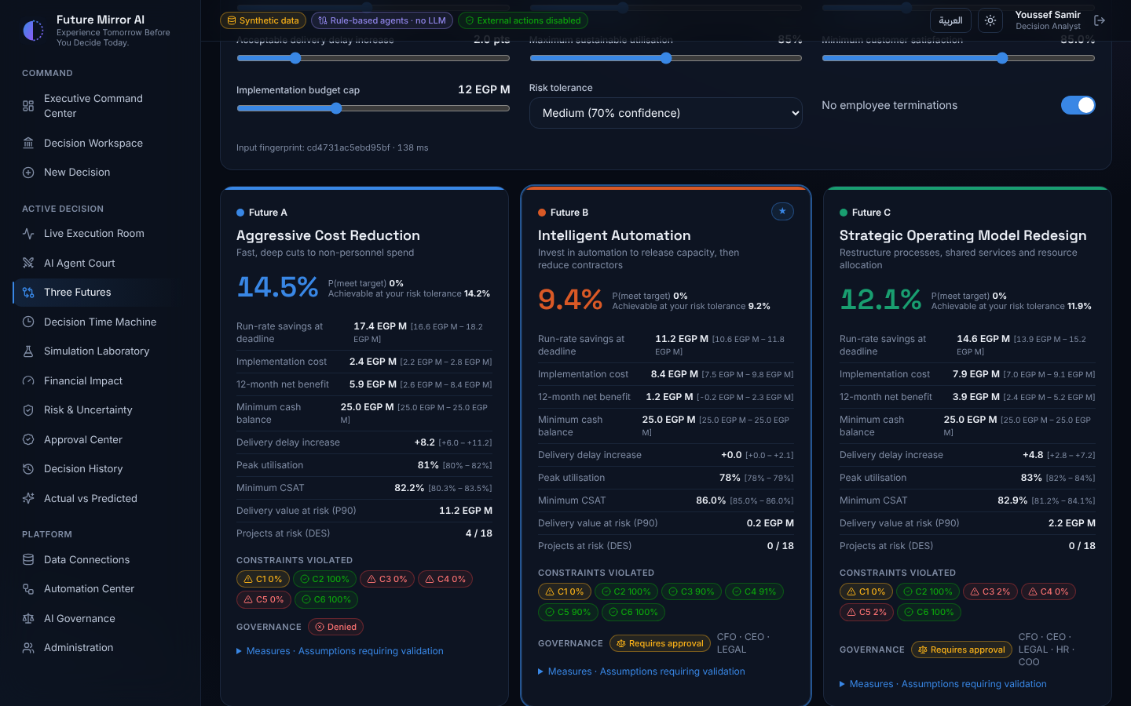
Each card shows, for one strategy:
- Headline savings % at your deadline, the probability of meeting the target, and the reduction achievable at your risk tolerance.
- Key metrics as a median with a range in brackets (P10–P90, the 10th to 90th percentile of 2,000 simulated outcomes): savings, implementation cost, 12-month net benefit, cash, delivery delay, utilisation, customer satisfaction, value at risk and projects at risk.
- Constraint chips C1–C6 with the probability each is met: green = met, red = hard constraint failed, amber = soft constraint failed.
- Governance outcome and required approvers, and an expandable list of the strategy's measures and the assumptions to validate.
What-if mode: move any slider in the Executive controls panel and the futures recalculate in about a fifth of a second.
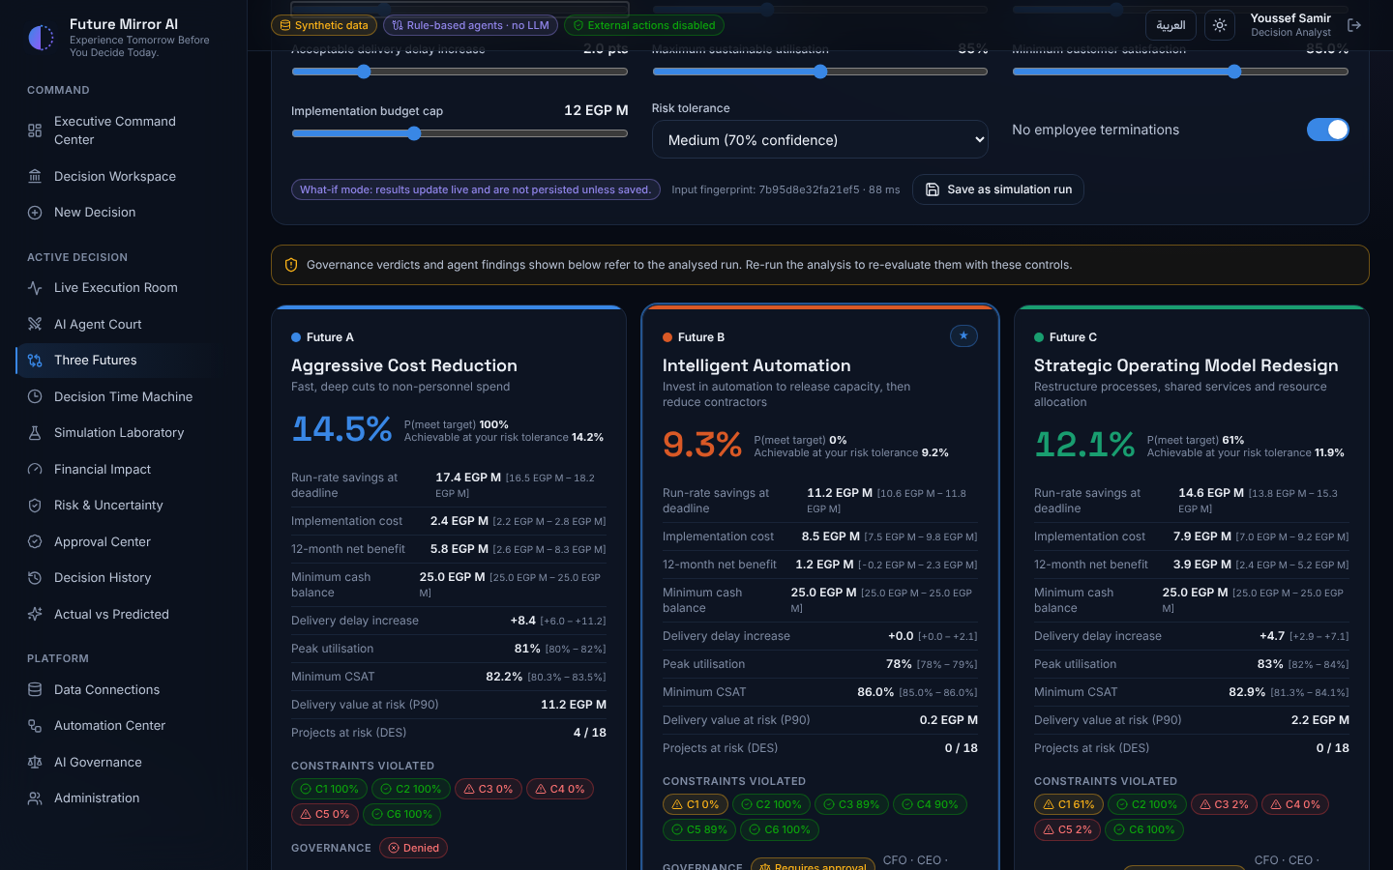
- A What-if mode badge and a new input fingerprint appear. What-if results are not saved unless you click Save as simulation run.
- An amber note reminds you that agent findings and governance verdicts still refer to the analysed run; re-run the analysis to re-evaluate them.
- The reset arrow restores the decision's original controls.
Further down, the savings trajectory chart and side-by-side comparison table cover all three futures plus the status quo; switch any chart to a table with Table view.

7. Exploring the analysis in depth
Four screens let you dig into the simulation behind the recommendation.

Decision Time Machine
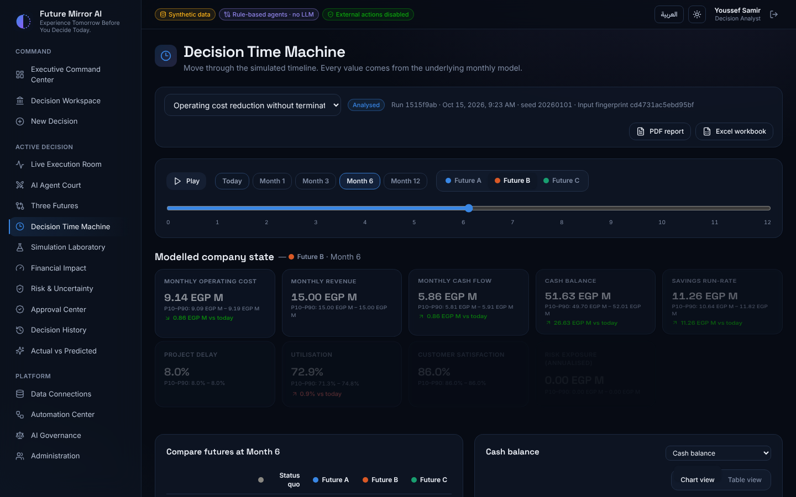
- Click Today, Month 1, 3, 6 or 12, drag the timeline slider, or press Play to move through the year.
- Pick a future (A, B or C) to see its modelled company state at that month: monthly cost, revenue, cash flow, cash balance, savings, project delay, utilisation, customer satisfaction and risk exposure, each with its change since today.
- The Compare futures table shows all strategies at the same month; the chart on the right plots any metric over 12 months with a marker at the selected month.

Financial Impact
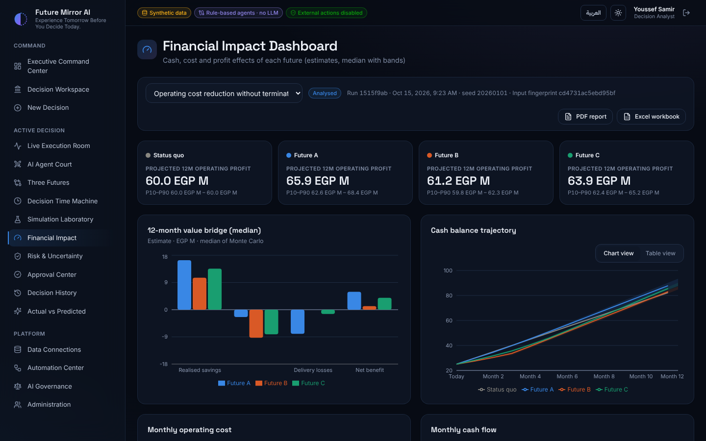
Projected 12-month operating profit per future, the 12-month value bridge (savings, implementation cost, delivery losses, net benefit), and cash, monthly-cost and cash-flow trajectories with ranges.

Risk & Uncertainty
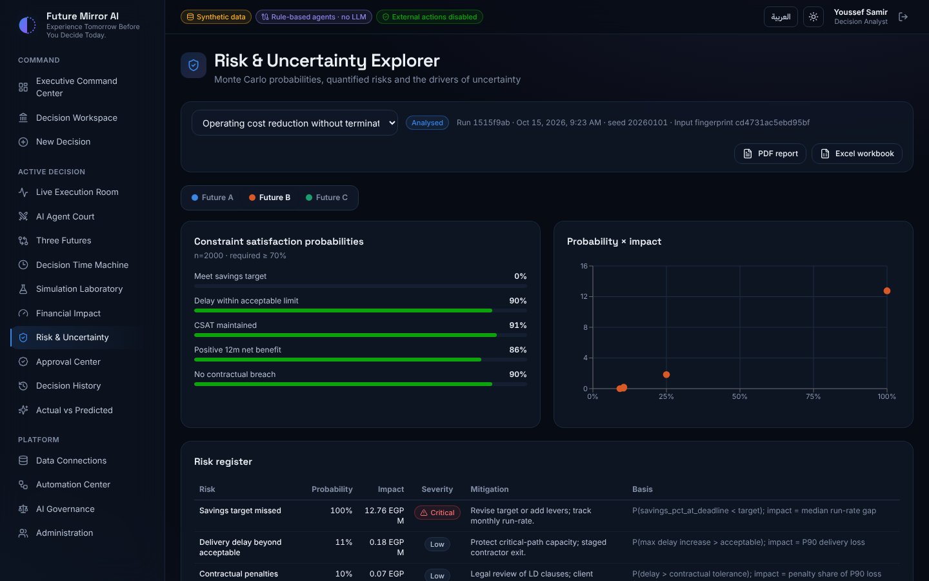
Pick a future to see: the probability of meeting each constraint (green bars meet your risk tolerance, red bars do not), a probability-versus-impact matrix, the risk register with mitigations, the top uncertainty drivers (tornado chart) and the distribution of outcomes with worst, base and best cases.

Simulation Laboratory
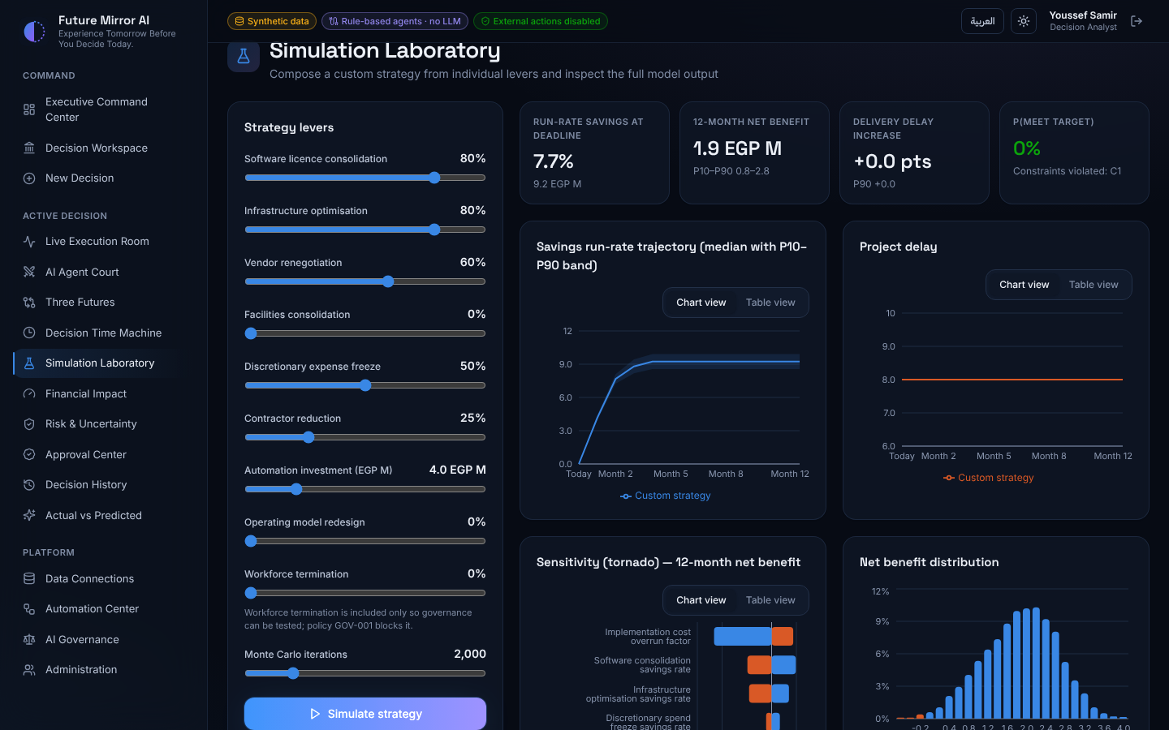
Build your own strategy: set each lever (licence consolidation, infrastructure, vendors, facilities, expense freeze, contractor reduction, automation investment, operating-model redesign), choose the number of simulation runs, and click Simulate strategy. You get the same outputs as the three futures, plus a project-by-project delivery view and the documented model assumptions. The workforce-termination lever exists only to show that policy GOV-001 blocks it.

8. Submitting and approving (Approval Center)
No strategy goes ahead until everyone the policies require has approved it. The platform itself never executes the strategy.
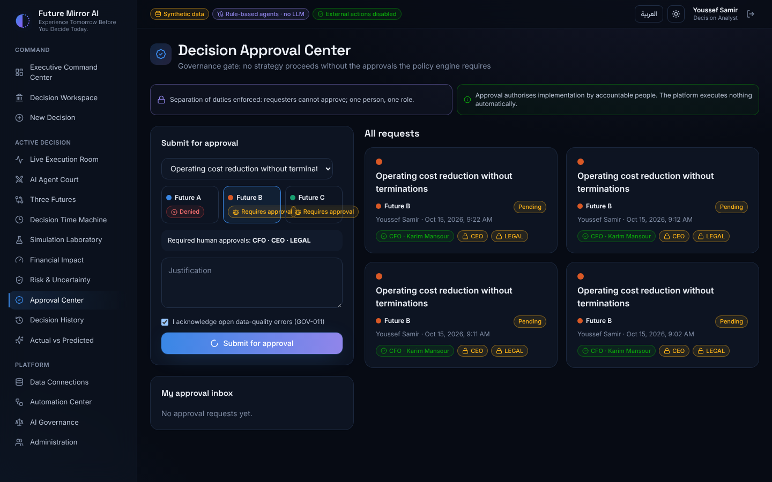
To submit a strategy (Analyst, CFO, COO or CEO):
- Pick the decision, then click future A, B or C. The box below shows its governance outcome: either the blocking policy (for example GOV-009: unresolved critical collision) or the roles that must approve.
- Write a justification.
- If the dataset has quality errors, tick the acknowledgement box (policy GOV-011).
- Click Submit for approval. A blocked strategy is still recorded, with its reasons, as Blocked.
To approve (the roles listed on the request):
- Sign in as an approver and open Approval Center. Requests waiting for one of your roles appear under My approval inbox.
- Choose the role you are acting as, add an optional comment, and click Approve, Request further analysis or Reject.
- Each role badge turns green as it approves. When all required roles have approved, the decision becomes Approved.
Rules the system enforces: the person who submitted cannot approve their own request; one person can approve for only one role per request; and governance is checked again at the final approval.

9. Tracking results, reports and history
After a strategy is approved and implemented by your team, compare what actually happened with what the simulation predicted.
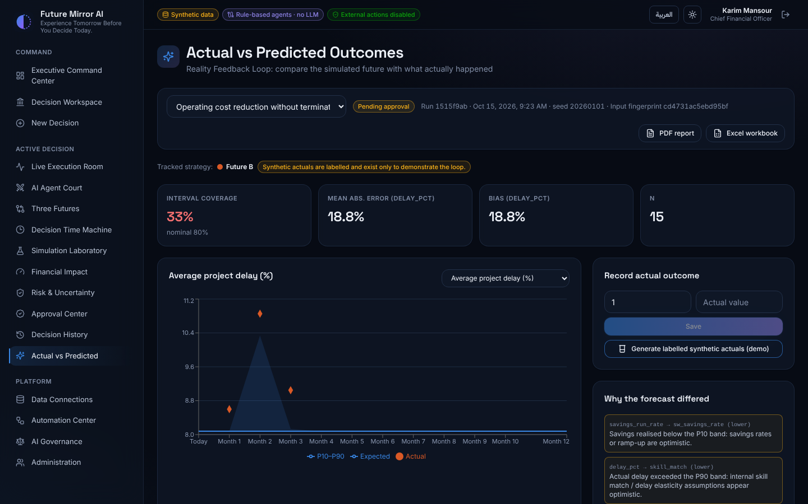
- Open Actual vs Predicted. The tracked strategy is the approved one (or the recommended one if none is approved yet).
- Under Record actual outcome, enter the month and value for a metric and click Save. For a demo, click Generate labelled synthetic actuals; they are clearly marked as synthetic.
- The chart shows the predicted line, its P10–P90 band and your actual values as diamonds. Pick another metric from the dropdown.
- The tiles show interval coverage (how often actuals fall inside the band; 80% is ideal), average error and bias.
- Why the forecast differed explains misses, for example delay above the band: skill-match assumption looks optimistic.
- Propose model recalibration creates a candidate model. It changes nothing until an administrator promotes it with a written justification.
Reports: every decision screen has PDF report and Excel workbook buttons in the decision bar. Reports follow the interface language (English or Arabic) and label every item as fact, estimate, assumption or recommendation.
Decision History lists every analysis run with its status, mode and compute time, plus every saved simulation with its seed and fingerprint, so any result can be traced and reproduced.
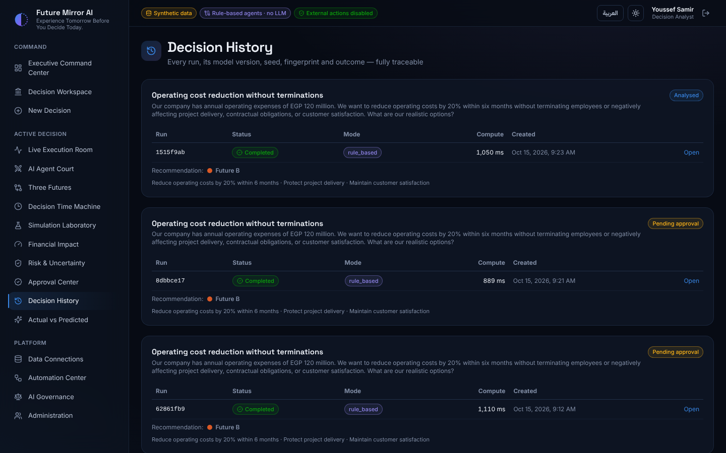

10. Platform screens (data, automation, governance, administration)
These screens are mainly for analysts, the CFO and administrators.

Enterprise Data Connections
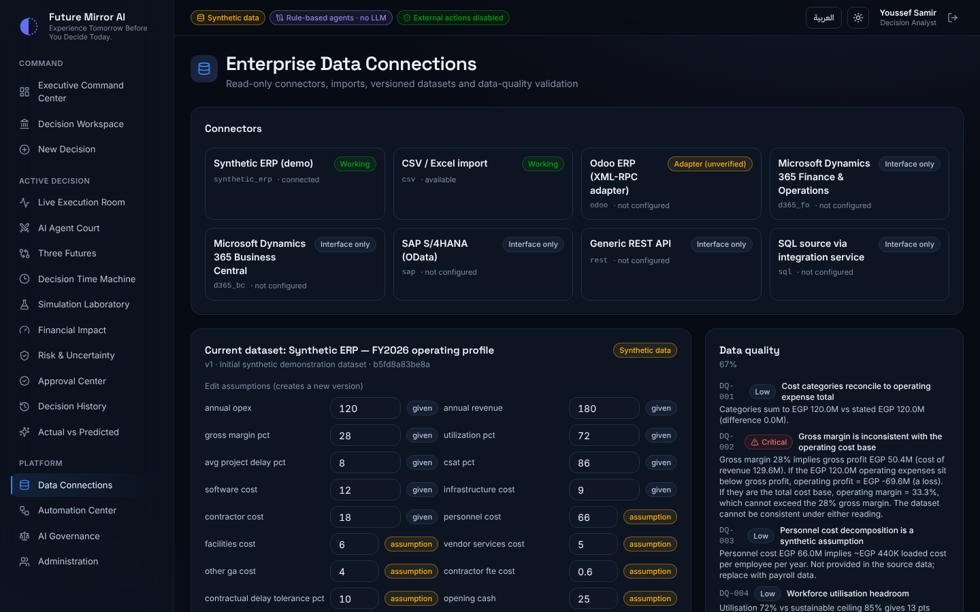
- Connectors: each card is labelled Working, Adapter (unverified) or Interface only. Test checks the connection; Sync pulls data read-only and creates a new dataset version if anything changed.
- Current dataset: edit any value and click Save to create a new version (old versions are kept). Badges show where each value came from (given, assumption, user input, imported).
- Import CSV / Excel: upload field,value or category,amount files; a reconciliation report lists anything that could not be mapped.
- Data quality lists the validation checks, such as the gross-margin inconsistency in the demo data.
Configure a connector (Platform Administrator only). Odoo, Dynamics 365 Finance & Operations, Dynamics 365 Business Central, SAP S/4HANA, the generic REST API and the SQL database connector each have a Settings button on their card.
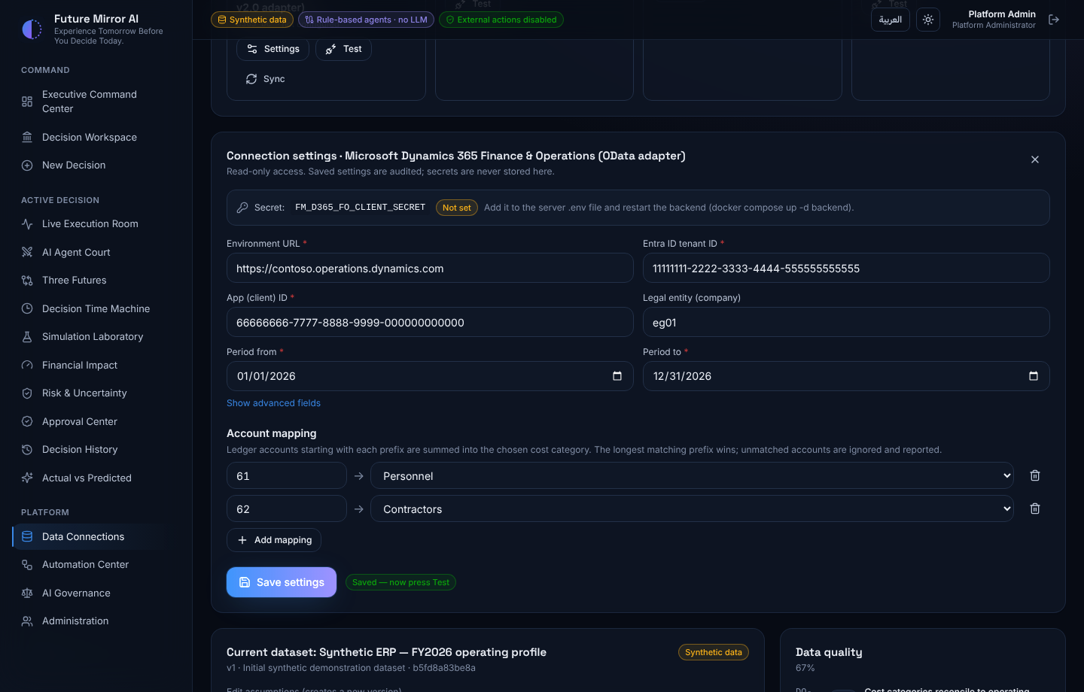
- Ask your server administrator to put the connector's secret in the server's .env file and restart the backend. You never type the secret in the form; it only shows the variable name and whether it is set.
- Click Settings on the connector card and fill in the fields marked with a red asterisk.
- Under Account mapping, add one row per account-number prefix and pick its cost category, for example 61 → Personnel. The longest matching prefix wins. Accounts that match no row are left out and reported after a sync.
- Click Save settings, then Test on the card. When the test succeeds, click Sync: the figures arrive as a new dataset version, tagged imported.
Connector | Fields to fill in | Secret on the server
Odoo | Odoo URL, database, username, period | FM_ODOO_API_KEY
Dynamics 365 Finance & Operations | Environment URL, Entra ID tenant ID, app (client) ID, legal entity (optional), period | FM_D365_FO_CLIENT_SECRET
Dynamics 365 Business Central | Entra ID tenant ID, app (client) ID, environment name, company ID, period | FM_D365_BC_CLIENT_SECRET
SAP S/4HANA | S/4HANA URL, communication user, company code, ledger (default 0L), period, SAP client (optional) | FM_SAP_PASSWORD
Generic REST API | Endpoint URL, records path, account field, amount field, next-page link path (optional) | FM_REST_TOKEN (optional)
SQL database | Database type, host, port, database, username, table or view, account / amount / date columns, period | FM_SQL_PASSWORD
Dynamics 365 needs a one-time app registration by your Microsoft admin; the steps are in section 8 of DEPLOYMENT_GUIDE.md. Connectors only read and never change data in your ERP. The SQL connector has been tested end to end against PostgreSQL, SQL Server and MySQL databases. The Odoo, Dynamics 365, SAP and REST connectors have not yet been tested against a live system, so the first connection may need adjustments. PostgreSQL, SQL Server and MySQL/MariaDB all work as they are. For MySQL choose the mysql database type, leave the port empty for 3306 and leave the schema empty.
Who sees the buttons. Only the Platform Administrator (for example admin@futuremirror.demo) sees Settings, Test and Sync on the cards. Every other role, the CEO included, sees the cards read-only. A card reads not configured until its settings are saved.
Card label | Meaning
Working | In use now: Synthetic ERP (the demo data) and CSV / Excel import
Adapter (unverified) | Built and tested against simulated responses, not yet against a live system
not configured | No settings saved yet
Secret: Set on server / Not set | Whether the server found the connector's secret in .env
Put a connector's secret on the server (Windows).
- Open PowerShell in the project folder, the one that holds docker-compose.yml.
- Run notepad .env. If the file does not exist yet, run copy .env.example .env first.
- Add one line with the variable from the table above, for example FM_SQL_PASSWORD=YourPassword: no spaces around = and no quotes.
- Save, close Notepad, then run docker compose up -d backend.
- Open Settings on the card: Secret now shows Set on server. If it still shows Not set, check the variable's spelling.
Connect Odoo.
- In Odoo, sign in as a user with read access to Accounting and open Preferences → Account Security → New API Key. Copy the key (Odoo 14 or later).
- Put it on the server: FM_ODOO_API_KEY=<the key>.
- In Settings, enter the Odoo URL (for example https://erp.company.com), the database name, that user's login and the period, then map account prefixes to cost categories.
- Click Save settings, Test, then Sync. The connector totals the posted journal items per account for the period.
Connect Dynamics 365 Finance & Operations or Business Central.
- Your Microsoft Entra admin registers an app once (Entra admin center → App registrations → New registration) and creates a client secret. Note the Application (client) ID and Directory (tenant) ID.
- Give the app read access. Finance & Operations: System administration → Setup → Microsoft Entra ID applications, add the client ID mapped to a read-only user. Business Central: Microsoft Entra applications, add the client ID, grant consent and assign read-only permission sets such as D365 READ.
- Put the secret on the server: FM_D365_FO_CLIENT_SECRET=… or FM_D365_BC_CLIENT_SECRET=….
- In Settings: for Finance & Operations, the environment URL (for example https://company.operations.dynamics.com), tenant ID, client ID, legal entity (optional) and period; for Business Central, tenant ID, client ID, environment name (for example Production), company ID and period. Map the main-account prefixes; accounts that match no prefix (balance sheet, revenue) are skipped and listed after the sync.
- The server must reach login.microsoftonline.com and the Finance & Operations URL or api.businesscentral.dynamics.com over HTTPS. Then Save settings, Test, Sync.
Connect SAP S/4HANA.
- Your SAP Basis team sets up a communication arrangement that exposes API_JOURNALENTRYITEMBASIC_SRV (for example scenario SAP_COM_0002) with a communication user that has read access.
- Put its password on the server: FM_SAP_PASSWORD=….
- In Settings, enter the S/4HANA URL, communication user, company code, ledger (0L by default), period and, if your system needs it, the SAP client. G/L accounts lose their leading zeros (0061000000 becomes 61000000), so map prefixes such as 61.
- Click Save settings, Test, then Sync.
Connect any REST API.
- Use an endpoint that returns ledger lines as JSON, with the period filter in its URL query string.
- If it needs a token, put it on the server: FM_REST_TOKEN=…. It is sent as Authorization: Bearer <token>; change Auth header or Auth scheme under the advanced fields if your API differs.
- In Settings, enter the endpoint URL, the records path (for example data.items, or empty if the response is the list itself), the account and amount fields (dotted paths such as gl.code work) and, for paged APIs, the next-page link path.
- Click Save settings, Test, then Sync.
After any sync, amounts are converted to EGP millions (divided by 1,000,000) and the figures arrive as a new dataset version tagged imported. For SQL databases, follow the SQL Server and MySQL steps below.
Connect a SQL Server database. This works with SQL Server 2017 or later and Azure SQL; no extra installation is needed.
- Your database administrator prepares read access. They create a view with one row per ledger line (account, amount, posting date) and a login that may only read that view:
CREATE VIEW dbo.v_gl_expenses AS
SELECT AccountNo AS account, Amount AS amount, PostingDate AS posting_date
FROM dbo.GeneralLedger;
CREATE LOGIN fm_readonly WITH PASSWORD = 'choose-a-strong-password';
CREATE USER fm_readonly FOR LOGIN fm_readonly;
GRANT SELECT ON dbo.v_gl_expenses TO fm_readonly;
Replace GeneralLedger, AccountNo, Amount and PostingDate with the names in your own ERP database.
- Put the password on the server. In the .env file add FM_SQL_PASSWORD= followed by the login's password, then run restart.bat.
- Fill in the form. Sign in as admin, open Data Connections, click Settings on the SQL database card and enter the values below.
- Map the accounts, click Save settings, then Test. When it says Connected, click Sync.
Field | What to enter | Example
Database type | mssql | mssql
Host | SQL Server name or IP address, as seen from the app's server | erp-sql.company.local
Port | Leave empty for the standard 1433 | 1433
Database | Database that holds the view | erp
Username | The read-only login | fm_readonly
Schema | Schema of the view | dbo
Table or view | The view's name | v_gl_expenses
Account, amount and date columns | Column names in the view | account, amount, posting_date
Period from / to | Accounting period to read | 2026-01-01 to 2026-12-31
If Test fails, the message says why: Login failed (wrong username or password), SELECT permission was denied (the login cannot read the view), or Unable to connect (wrong host or port, or a firewall is blocking port 1433).
Connect a MySQL or MariaDB database. This works with MySQL 5.7 and 8.x and with MariaDB; no extra installation is needed. The app opens MySQL sessions in read-only mode, so the database itself refuses any change.
- Your database administrator prepares read access. They create a view with one row per ledger line and a user that may only read that view:
CREATE VIEW erp.v_gl_expenses AS
SELECT account_no AS account, amount, posting_date
FROM erp.general_ledger;
CREATE USER 'fm_readonly'@'%' IDENTIFIED BY 'choose-a-strong-password';
GRANT SELECT ON erp.v_gl_expenses TO 'fm_readonly'@'%';
Replace erp, general_ledger, account_no, amount and posting_date with the names in your own ERP database. Instead of '%' (any host), the administrator can allow only the app server's address.
- Put the password on the server. In the .env file add FM_SQL_PASSWORD= followed by the user's password, then run restart.bat.
- Fill in the form. Sign in as admin, open Data Connections, click Settings on the SQL database card and enter the values below.
- Map the accounts, click Save settings, then Test. When it says Connected, click Sync.
Field | What to enter | Example
Database type | mysql | mysql
Host | MySQL server name or IP address, as seen from the app's server | erp-mysql.company.local
Port | Leave empty for the standard 3306 | 3306
Database | Database that holds the view | erp
Username | The read-only user | fm_readonly
Schema | Leave empty (the database name already selects it)
Table or view | The view's name | v_gl_expenses
Account, amount and date columns | Column names in the view | account, amount, posting_date
Period from / to | Accounting period to read | 2026-01-01 to 2026-12-31
If Test fails, the message says why: Access denied (wrong username or password, or the user is not allowed from the app server's address), SELECT command denied (the user cannot read the view), or Can't connect to MySQL server (wrong host or port, or a firewall is blocking port 3306).

Automation Workflow Center
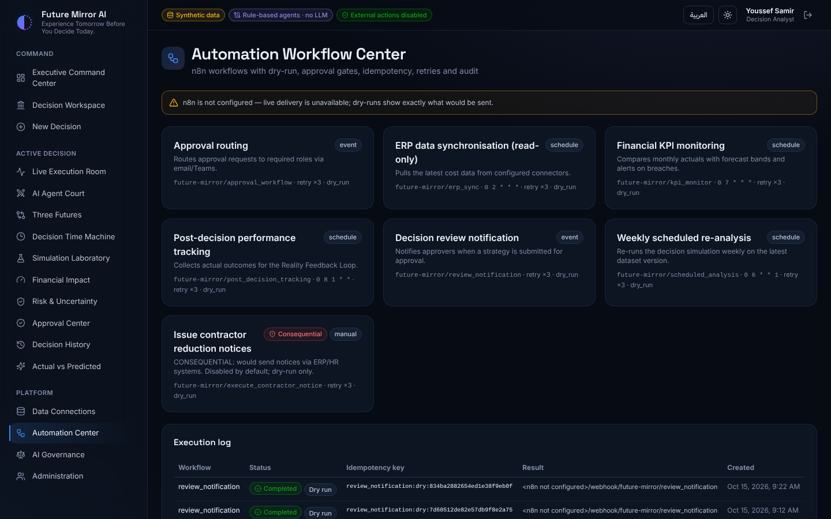
Each workflow card has Dry run (shows exactly what would be sent, changes nothing) and Live run (sends to n8n if configured). Workflows marked Consequential are always blocked from live runs by policy. The execution log at the bottom records every run.
Connecting n8n: the folder automation\n8n has a ready-made n8n workflow for each automation scenario. Each one runs when you press Live run in the platform, and most also run on their own schedule (Cairo time). Each one emails a summary, and stays silent when there is nothing to report.
Workflow file | When it runs | What it does
scheduled_analysis.json | Mondays 06:00 | Re-runs the analysed decisions on the latest data and emails a summary
erp_sync.json | Daily 02:00 | Reads cost data from every connected system (D365, SAP, REST, SQL). Emails only if data changed or a sync failed
review_notification.json | When a strategy is submitted | Tells approvers which decision and roles are needed
approval_workflow.json | Sun–Thu 09:00 | Emails each role (CFO, CEO, Legal…) its own list of pending approvals
kpi_monitor.json | Daily 07:00 | Alerts when an actual result falls outside the forecast band
post_decision_tracking.json | 1st of each month | Reminds the team which month of actuals to record. Actuals sent to its webhook are saved in the platform
execute_contractor_notice.json | On request | Safe: the platform blocks it, and even if allowed it only emails HR a request to handle manually
To set up n8n (once):
- Add FM_N8N_BASE_URL=http://n8n:5678 to .env. To choose who receives the emails, also add FM_N8N_ALERT_EMAIL, FM_N8N_FROM_EMAIL, FM_N8N_HR_EMAIL and FM_N8N_ROLE_EMAILS. For example: FM_N8N_ROLE_EMAILS={"cfo":"cfo@company.com","legal":"legal@company.com"}.
- Start the app with n8n: docker compose --profile automation up -d --build.
- Open http://localhost:5678 and create the n8n owner account.
- In n8n, go to Credentials → Add credential → SMTP and enter your email account. For Office 365, use host smtp.office365.com and port 587. For Gmail, use host smtp.gmail.com, port 465 with SSL on, and an app password.
- Import the seven files: Workflows → Add workflow → ⋯ → Import from File, once for each file in automation\n8n.
- In each workflow, click the email node, choose your SMTP credential, click Save, then switch Active on (top right).
- Test: on the Automation page, press Live run on any workflow. It should show delivered, and the run appears under Executions in n8n.
The full steps are in automation\n8n\README.md (English) and README.ar.md (Arabic).

AI Governance & Policy Center
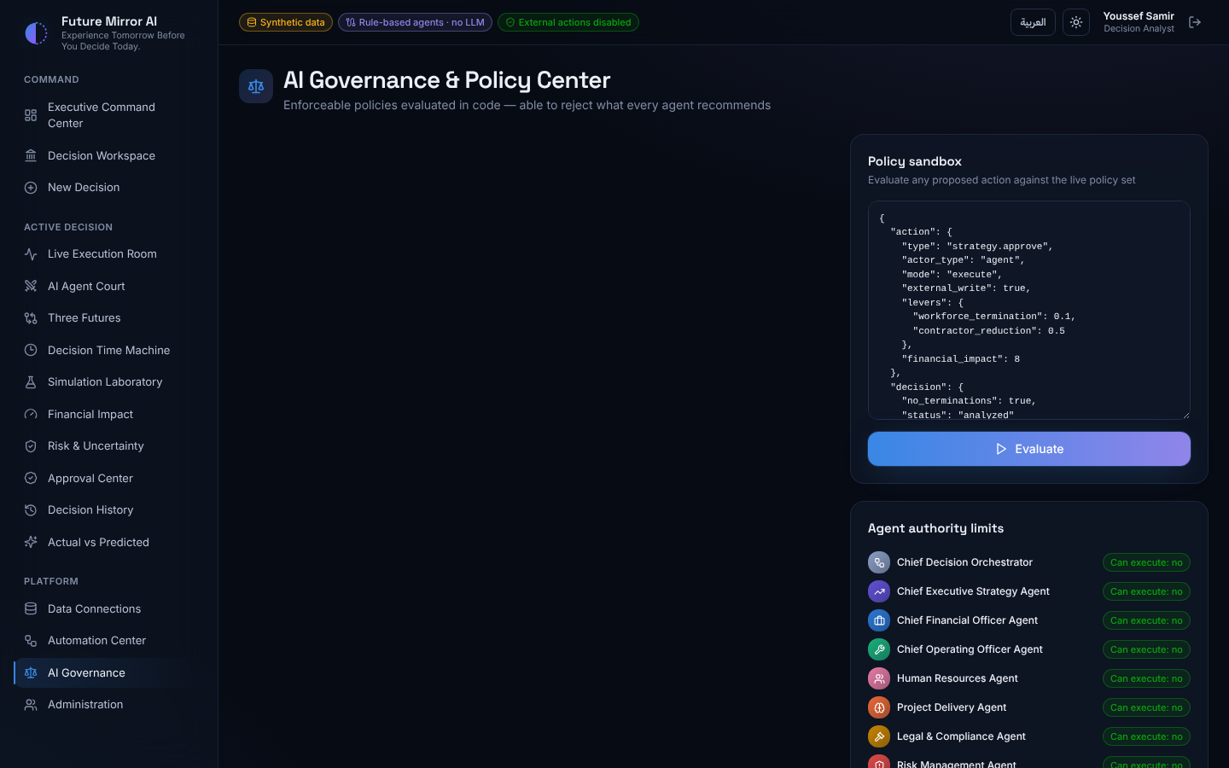
The 18 policies with their effect (deny, require approval, require acknowledgement). Two apply to collections decisions: GOV-015 requires Legal approval when customer data is shared with a collection agency, and GOV-016 blocks aggressive collection practices. Two apply to hotel decisions: GOV-017 requires a public tender and Legal, HR and CEO approval to lease a state-owned asset long term, and GOV-018 requires a feasibility study and CFO and CEO approval for capital investment above EGP 50M. Locked policies cannot be switched off; admins can toggle the others. The Policy sandbox tests any proposed action against the live policies, and the agent list confirms that no agent can execute anything.

Administration & Security
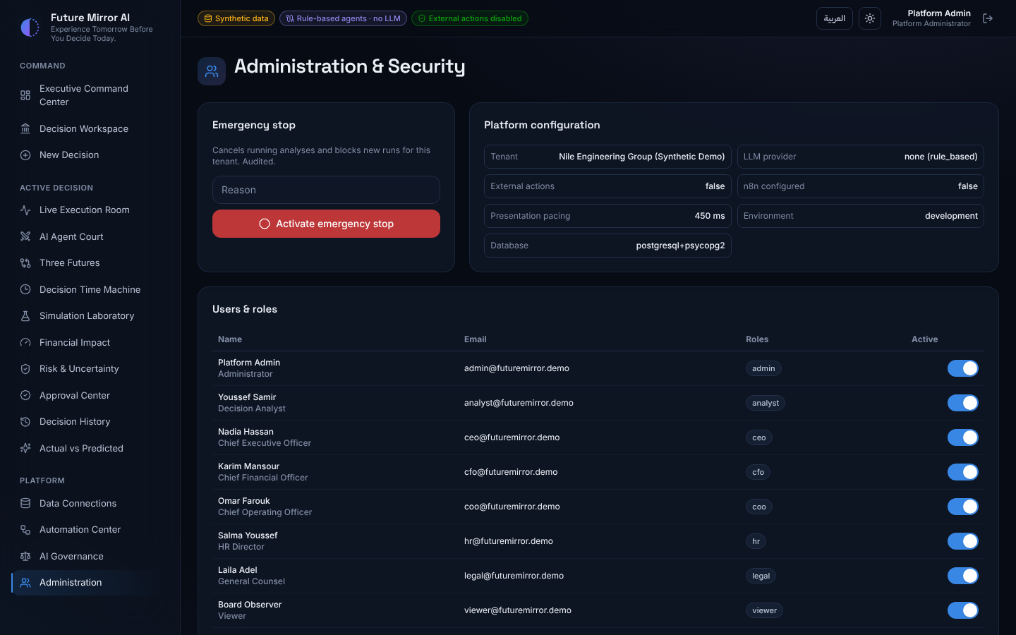
Emergency stop cancels all running analyses and blocks new ones until released. Admins also see the platform configuration, manage users and roles (activate or deactivate accounts) and review the audit trail, whose hash chain proves no entry was altered.

11. Arabic interface and light theme
Click العربية in the header to switch the whole platform to Arabic: the layout mirrors right-to-left, numbers use Arabic digits, and agent findings, reports and charts all switch language. Click English to switch back; the choice is remembered.
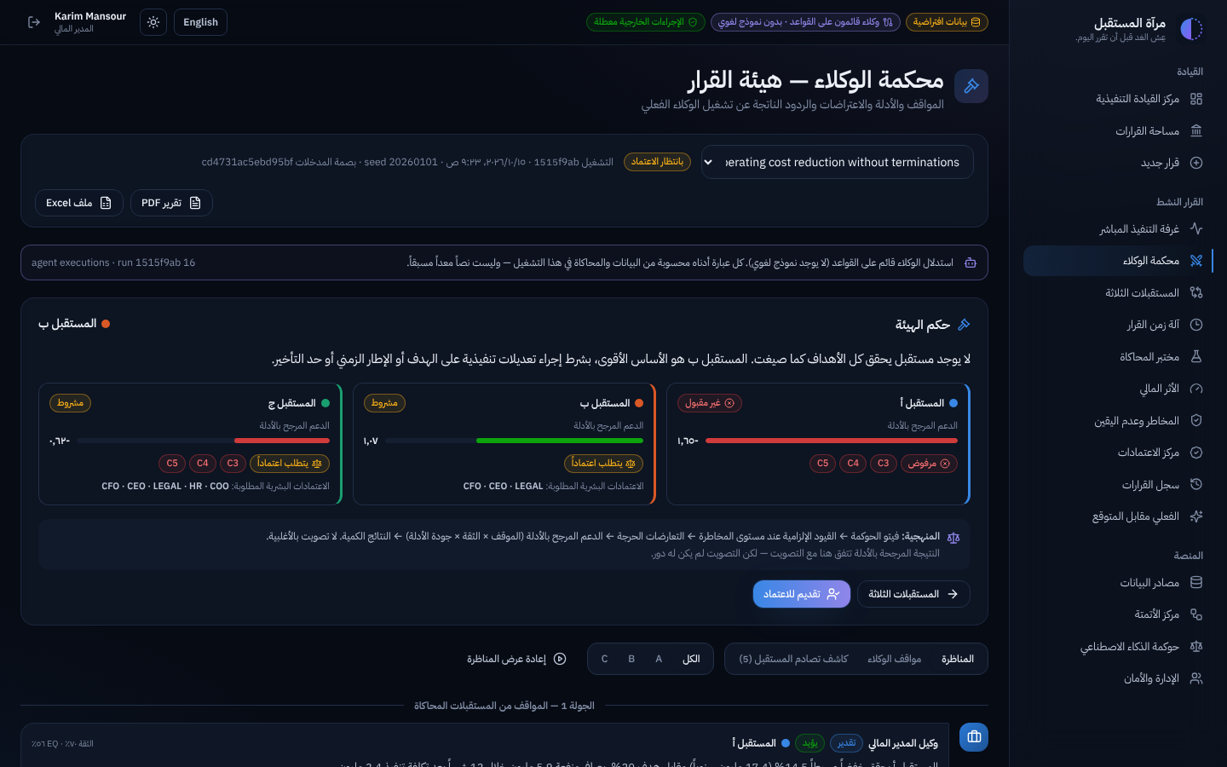
Click the sun icon for the light theme (the moon icon switches back to dark).
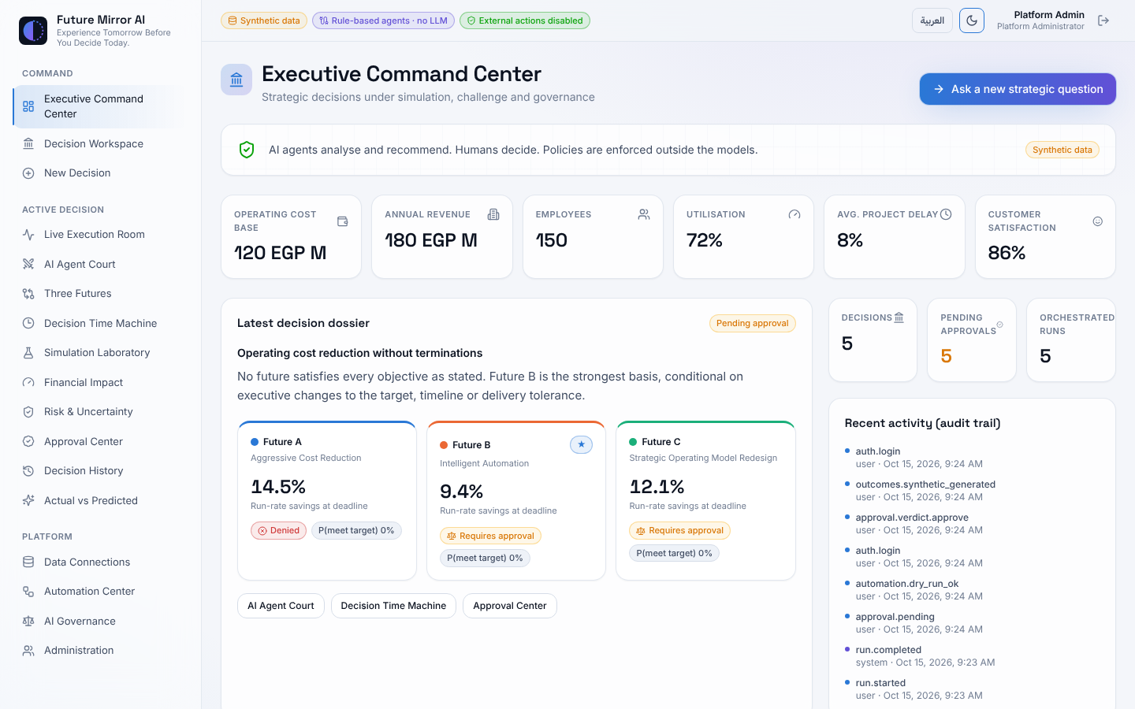

12. Starting, stopping and backing up the app
The ops folder in the project has one script for each everyday task. On Windows, double-click the .bat file. On macOS or Linux, run the .sh file from the project folder, for example ops/start.sh. Docker Desktop must be running first; if a script says Docker is not running, start Docker Desktop and wait until it reports that it is running.
Task | Windows | macOS / Linux | What it does
Start | ops\start.bat | ops/start.sh | Starts the app (rebuilding it if the code changed, for example after a git pull), waits until it is ready and opens http://localhost:8080
Stop | ops\stop.bat | ops/stop.sh | Stops the app. Your data is kept
Restart | ops\restart.bat | ops/restart.sh | Stops and starts the app, rebuilding it if the code changed, for example after editing .env
Back up | ops\backup.bat | ops/backup.sh | Full backup into the folder backups\fm_YYYYMMDD_HHMMSS: the database, .env, n8n data and the project folder, checked by a test restore. Works while the app is running
Restore | ops\restore.bat | ops/restore.sh | Replaces all data with a backup you choose (steps below)
Update | ops\update.bat | ops/update.sh | Backs up, downloads the latest version from GitHub, rebuilds and restarts
After pulling new code: start.bat and restart.bat rebuild the app automatically when the code has changed, so new features appear straight away. If you start the app another way, use docker compose up -d --build. Plain docker compose up -d keeps running the old version.
What each backup contains: every run of backup.bat creates one folder, for example backups\fm_20261018_090000.
File | What it is
database.dump | All application data
env.backup | Your .env file: the database password and connector secrets
n8n.tar.gz | n8n workflows and settings (only if you use n8n)
project.tar.gz | The project folder: code and its history, your local changes, docs, demo videos and music
manifest.txt | Date, code version, check result, file checksums and rows per table
How you know a backup is good: before finishing, the script restores the backup into a temporary database and compares every table with the live data. A good backup prints VERIFIED: test restore OK with the number of tables and rows, and the same line is saved in manifest.txt. If the check fails, the script shows [FAILED] and renames the folder failed_fm_…, so it is never mistaken for a good backup.
To restore a backup:
- Run restore.bat. It lists your backups, newest first.
- Type the backup name, for example fm_20261018_090000, and press Enter. Older single-file .dump backups still work.
- Check the date and the VERIFIED line the script shows, then type YES to confirm. The script saves a safety backup of the current data, restores the database and n8n data, restarts the app and tells you when it is ready.
If a restore stops part-way, run restore.bat again and choose the safety backup (the newest one).
Restoring on a new computer:
- Install Docker Desktop.
- Get the project folder. Either download it with git clone, or unpack project.tar.gz from the backup into a new folder by running tar -xzf project.tar.gz there. Unpacking works without GitHub and also brings back your local changes, videos and music.
- Copy the backup folder into the project's backups folder.
- Run ops\restore.bat fm_20261018_090000 (your backup's name) and type YES.
The restore puts .env back first and re-applies its database password, so you do not need to recreate .env by hand. If the computer already has a .env, it is kept and the backup's copy is saved as .env.from-backup for you to compare.
Keeping your backups safe:
- The newest 30 backups are kept and older ones are removed automatically. To change the number, add FM_BACKUP_KEEP=60 (any number) to .env.
- To keep a second copy away from the computer, add FM_BACKUP_COPY_TO=D:\FutureMirrorBackups to .env. Use another disk, a USB drive or a synced OneDrive or Google Drive folder. Every backup is then copied there as well.
- The project folder makes each backup larger, especially once it holds demo videos. To leave it out and keep backups small, add FM_BACKUP_FILES=0 to .env.
- Backups contain your .env, which holds the database password and connector secrets. Store them somewhere private.
- For a daily automatic backup on Windows, create a task in Task Scheduler that runs ops\backup.bat /nopause. The /nopause option stops the window from waiting for a key press. If a backup fails its check, the task shows an error result. On macOS or Linux, use a cron job that runs ops/backup.sh.
Getting the latest version: run update.bat. It takes a backup first, so you can always go back with restore.bat.
After updating to the hotel release:
- Open AI Governance: it should list 18 policies, including GOV-017 and GOV-018. New policies are added automatically when the server starts, also when demo data is switched off; policies an administrator has edited are not changed. If you still see 16, the old release is running: run start.bat again.
- Ask a hotel question in New Decision: step 2 should show State-owned hotel asset.
- As Platform Administrator, open Data Connections → Current dataset and replace the illustrative hotel figures with your real ones: hotel_rooms, hotel_occupancy_pct, hotel_adr_egp (average room rate), hotel_staff_fte, hotel_staff_utilization_pct, hotel_fixed_opex, hotel_guest_score_pct, hotel_asset_value (use an independent valuation) and hotel_capex_reserve. Each save creates a new dataset version.
If git pull cannot reach GitHub, update from a bundle file instead: git pull <folder>\future-mirror-main.bundle main, then start.bat.
Demo video with Arabic voice-over. The Arabic demo video (future-mirror-demo-ar.mp4) comes with its narration script (future-mirror-demo-ar.srt). One script adds a natural Arabic voice that reads every caption at the moment it appears.
- Install Python and FFmpeg once, then close the window and open a new one:
winget install -e --id Python.Python.3.12
winget install -e --id Gyan.FFmpeg
- Copy future-mirror-demo-ar.mp4 and future-mirror-demo-ar.srt into the project's docs\video folder.
- Double-click ops\make-voiceover.bat. It installs the voice engine, reads every line, and opens the folder with the finished file future-mirror-demo-ar-voice.mp4, plus a matching subtitle file future-mirror-demo-ar-voice.srt.
Command | Voice
make-voiceover.bat | Shakir, Egyptian male (default)
make-voiceover.bat female | Salma, Egyptian female
make-voiceover.bat ar-SA-HamedNeural | Hamed, Saudi male (any Microsoft Arabic voice name works)
Speech is never sped up. When a line needs more time than its caption is on screen, the picture holds with the caption still visible until the line finishes, so the final video can be longer than the original. Lines already generated are kept in docs\video\.voice-cache, so a re-run is much faster. The voices come from Microsoft's online service, so an internet connection is needed; an office proxy is used automatically. On macOS or Linux run ops/make-voiceover.sh instead.
Background music (optional). Save a music track as music.mp3 (or music.m4a / music.wav) in the docs\video folder, then run ops\make-voiceover.bat as usual. The script says Background music found and mixes it in automatically:
- the track is evened out first, so loud and quiet files end up at the same level;
- it stays 18 dB below the narrator between lines, and drops about 12 dB more while the narrator speaks;
- it repeats if it is shorter than the video, fades in over 3 seconds and fades out over the last 5.
To change the level, run the script directly with --music-volume: -24 is quieter, -14 is louder.
py scripts\voiceover\make_voiceover.py --video docs\video\future-mirror-demo-ar.mp4 --srt docs\video\future-mirror-demo-ar.srt --music docs\video\music.mp3 --music-volume -24
Use music you have the rights to. Commercial tracks are fine for an internal screening, but a public upload (YouTube, social media) will be muted or removed by copyright detection; royalty-free music, such as the YouTube Audio Library, avoids this. To remove the music, delete or rename music.mp3 and run the script again.
More demo videos: Port Said Free Zone. Two more full demos (about 15 minutes, 16 chapters each) are narrated in Modern Standard Arabic with full diacritics, so the voice reads them correctly. The narration says that all figures are illustrative.
Video | Question | Voice-over launcher
future-mirror-demo-hotel.mp4 (14:51) | الاستفادة القصوى من فندق أراكان (148 غرفة) بوسط البلد ببورسعيد، المملوك للجهاز التنفيذي للمنطقة الحرة، من خلال مقترحات مختلفة | ops\make-voiceover-hotel.bat
future-mirror-demo-collections.mp4 (14:37) | ماذا لو حققنا متحصلات إيرادات أكبر بنسبة 30 % من خلال التعاقد مع شركة تحصيل؟ | ops\make-voiceover-collections.bat
The hotel video compares three proposals: a long-term lease to a private operator, a full renovation under a hotel brand, and a mixed-use repositioning with serviced apartments and an investor business centre. The platform recommends the third.
To add the female voice to the hotel video:
- Run git pull origin main, then ops\start.bat, so the app includes the hotel decision model. If GitHub cannot be reached, run git pull <folder>\future-mirror-main.bundle main with the bundle file instead.
- Copy future-mirror-demo-hotel.mp4 and future-mirror-demo-hotel.srt into the docs\video folder. Optionally add music.mp3 for background music.
- Double-click ops\make-voiceover-hotel.bat. It uses the female voice Salma (ar-EG-SalmaNeural) at 10% faster, the speed the video was paced for, and opens the folder with the finished file future-mirror-demo-hotel-voice.mp4.
The collections video works the same way with future-mirror-demo-collections.* and ops\make-voiceover-collections.bat. Options for both:
- Another female voice: ops\make-voiceover-hotel.bat ar-SA-ZariyahNeural. The video was paced for Salma, so the picture may pause a little more often.
- Speed: run set FM_VOICE_RATE=0 (natural) or set FM_VOICE_RATE=15 (faster) before the launcher.
- Refused lines: if the voice service refuses a fully diacritised line, that line is read without vowel marks and the run continues.
- macOS or Linux: run ops/make-voiceover-hotel.sh [voice] or ops/make-voiceover-collections.sh [voice].
To record a video again yourself, for example after changing the data, run node e2e/video/record-demo-hotel.mjs (or record-demo-collections.mjs) from the frontend folder against a fresh database. The steps are in DEMO_SCRIPT.md.

13. Coming next: Future Mirror as a cloud service (SaaS)
Future Mirror AI is planned to become a cloud service (SaaS) as well as the on-premises edition described in this guide. It is planned, not yet available; nothing changes for current installations. The full plan, in English and Arabic, is the Future Mirror AI — SaaS Action Plan.
What will be different for users:
Today (on-premises) | With the cloud service
The IT team installs the platform on a server | An organisation signs up on the website and starts a 30-day trial
Users are created by the Platform Administrator | The administrator invites colleagues; sign-in with Microsoft or Google (SSO) and MFA
Connector passwords are placed in the server's .env file | The administrator enters them once in the connector's Settings form; they are kept encrypted per organisation
One organisation per installation | Each organisation's data is kept separate from all others; government bodies can have a dedicated setup in Egypt or keep the on-premises edition
Updates with update.bat | Updates are applied by the service every week, with no action from users
Plans: Starter, Professional and Enterprise; prices will be confirmed during the beta. Timeline: a private beta with 3 to 5 partner organisations in months 5 and 6, and general availability planned for month 9. The decision models, agents, governance policies and human approvals stay the same in both editions.

14. Troubleshooting and FAQ
Problem or question | What to do
A screen says No analysed decision yet | Create a decision in New Decision, or pick an analysed one with the decision selector.
Run analysis is greyed out | The decision is analysing, pending approval or approved. Create a new decision to explore other settings.
A run returns Platform emergency stop is active | An admin or the CEO must release the stop in Administration.
A run shows failed after a server restart | Runs in progress when the server restarts are marked failed. Click Re-run analysis.
Submit for approval says acknowledgement required | Tick the data-quality acknowledgement box, then submit again.
Approve returns Separation of duties | You submitted this request or already approved it for another role. Another person must approve.
My strategy shows Blocked | A deny policy matched; the reason is on the request card. Revise the controls and re-run the analysis, or choose another future.
Why does no future reach my target? | The simulation found the target unreachable under your constraints. The verdict lists realistic options, such as a lower target or a longer timeline.
Are the numbers real? | The demo company is synthetic and labelled so everywhere. Connect or import your own data in Data Connections for real analyses.
Does the AI execute anything? | No. Agents can only analyse and recommend. Approval authorises people to act; the platform executes nothing automatically.
A chart is hard to read | Click Table view above it to see the same numbers as a table.
New features don't appear after git pull (for example, Dynamics 365 still says Interface only) | The app is still running the old build. Run start.bat or restart.bat, which rebuild automatically, or run docker compose up -d --build.
There is no Settings or Test button on the connector cards | Only the Platform Administrator can configure connectors. Sign in as admin@futuremirror.demo.
For installing on your own servers (sizing, technical requirements, firewall rules, step-by-step installation, upgrades and the hotel model), see the Word document docs\Future_Mirror_AI_OnPrem_Deployment_Guide.docx (version 1.2). For configuration details, see DEPLOYMENT_GUIDE.md in the repository; for a scripted walkthrough, see DEMO_SCRIPT.md.
The deployment guide is now at version 1.2: it adds section 13 on deployment options and the SaaS plan. An Arabic edition with the same content, right-to-left layout and an Arabic architecture diagram is docs\Future_Mirror_AI_OnPrem_Deployment_Guide_AR.docx; commands, file names and settings stay in English in both. After git pull origin main both files are in the docs folder. If the table of contents is empty when you open either file, accept Word's prompt to update fields.

