Feasibility Study: Future Mirror AI as SaaS vs On-Premises
Nov 12, 2026 · @Hussam El Din Ahmed Ali

Summary and recommendation
Recommended decision: start with the on-premises edition now, and do not build a full SaaS platform at this stage. Treat a move to the cloud as a deferred option that opens only when paid demand at defined prices has been proven (see the go/stop gates at the end of the study).
In short: the product is ready for on-premises installation today. The customers closest to it (government bodies such as the Port Said Free Zone Executive Authority, and public business sector companies) prefer to keep their data inside their own premises. SaaS needs a large up-front investment, and at the assumed prices in the Egyptian market it does not recover that investment within five years.

Probability of loss for each option
A loss means that cumulative net cash is still negative, so the project has not yet recovered everything spent on it by that date. Figures are in EGP million and come from 20,000 simulated scenarios per option:
Option | Probability of loss after 3 years | Probability of loss after 5 years | Expected net cash after 3 years (median) | Maximum funding you may need (90% pessimistic case)
SaaS only | 100% | 97% | −36.1 | 41.2
On-premises only (recommended) | 43% | 24% | +3.0 | 16.9
Hybrid (on-premises, then SaaS if a gate is met) | 53% | 30% | −1.3 | 19.5
Reading the table:
- SaaS only loses money in almost every scenario under the current assumptions. It becomes viable only if one of two things happens: about 3 new customers a month at a subscription of around EGP 70k, or 2 new customers a month at around EGP 100k. No actual demand has confirmed these numbers yet.
- On-premises only is not risk-free: the probability of loss after 3 years is 43%. The deciding factor is the number of deals per year:
  - 2 deals a year: 79% probability of loss.
  - 3 deals a year: 48%.
  - 4 deals a year: 23%.
- Hybrid is slightly worse than on-premises over 5 years, because building the cloud edition consumes part of the on-premises profit before it pays back. Its value is that it keeps the SaaS door open, which is possible at lower cost by deferring the decision until demand is proven.
Note: every input is an assumption to be validated, not confirmed market data. The results show which option is safer and what decides success; they are not a precise forecast. Update the assumptions after the first 3 months of real proposals.

The three options
 | SaaS only | On-premises only | Hybrid
What we sell | A monthly subscription; the platform runs on our servers for all customers | A one-off licence + implementation + annual support; the platform runs on the customer's servers | On-premises from day one, then a cloud build at month 12 if a gate is met
Work needed before the first revenue | Turn the platform into a multi-tenant service: customer isolation, billing, 24/7 monitoring, security and compliance. About 9 months | Harden and document the current package. The platform already runs on-premises with Docker Compose | As on-premises, then about 6 months for the cloud with a smaller team that reuses the code
Revenue shape | Small and recurring; builds up slowly | Large and lumpy: one or two deals can change the year | Lumpy at first, then recurring revenue is added
Who carries the running cost | Us (cloud, language model, support) | The customer (their servers and team) | Both
Best-fit customer | Mid-size and large private companies that accept the cloud | Government bodies, public business sector companies and banks | Both groups
The hybrid option's gate is at least two paid on-premises installations by month 12. If the gate is not met, the project stays on-premises only and nothing is spent on the cloud. In the simulation the gate was met in only 23% of scenarios.

Market and target customers
Future Mirror AI is a platform for simulating strategic decisions before they are taken: cost reduction, collections improvement, asset utilisation. The buyer is senior management, and a single decision it supports can be worth tens of millions. So the product sells through slow enterprise deals, not fast self-service subscriptions.
Segment | Examples | Preferred model | Notes
Government bodies and public authorities | Port Said Free Zone Executive Authority, governorates, economic authorities | On-premises | Usually require data to stay on their premises; buy through tenders and annual budgets
Public business sector companies | Hotel, port and utility companies | On-premises | Asset utilisation, restructuring and collections decisions: exactly the models built today
Banks and financial institutions | Banks and finance companies | On-premises or private cloud | Central Bank oversight and high security requirements
Large and mid-size private companies | Industrial and trading groups | SaaS | The segment closest to a subscription, but with smaller budgets for decision tools
Gulf organisations | Authorities and companies in Saudi Arabia and the UAE | On-premises or in-country cloud | Much higher prices, but require data localisation and a local vendor presence
Three facts drive the decision:
- Data protection. Egypt's Personal Data Protection Law (No. 151 of 2020) restricts transferring and processing data outside Egypt. The platform handles financial, employee and customer data, so SaaS needs hosting inside Egypt or additional approvals.
- The sales cycle is long. A government deal takes 6 to 12 months from first presentation to contract, on-premises or cloud. This removes the speed advantage a subscription is known for.
- We have a likely reference customer now. The demos already built (Port Said collections and the Arakan hotel) are aimed at a specific government body. A first on-premises deal with it is the fastest path to revenue and a reference to build on.
This study does not size the market in numbers, because there is no reliable data on Egyptian organisations' spending on decision tools. Instead, the model relies on the number of deals, which can be checked against the real sales pipeline.

Assumptions
Every uncertain variable is entered as three numbers: low, most likely and high. Each scenario draws a value from that range (triangular distribution). Amounts are in Egyptian pounds; the SaaS prices are the plan prices in the SaaS action plan.

SaaS option
Variable | Low | Most likely | High
Build time to commercial launch (months) | 7 | 9 | 13
New customers per month after launch (reached over 6 months) | 0.4 | 1.2 | 2.5
Average monthly subscription per customer (EGP thousand) | 25 | 45 | 80
Monthly churn | 1% | 2% | 4%
Cloud, language model and support cost (% of revenue) | 20% | 28% | 40%
Share of government bodies that refuse the cloud (reduces new customers) | 30% | 50% | 70%
Development and operations team (EGP million per month, fixed) |  | 0.95
Base cloud infrastructure + marketing after launch (EGP million per month, fixed) |  | 0.47

On-premises option
Variable | Low | Most likely | High
Deals per year | 1 | 3 | 6
Month of the first deal | 5 | 8 | 12
Licence value per deal (EGP million) | 1.5 | 3.0 | 5.0
Implementation and integration fees (EGP million) | 0.5 | 1.0 | 2.0
Implementation margin |  | 40%
Annual support (% of licence) |  | 20%
Product, support and sales team (EGP million per month, fixed) |  | 0.75

Hybrid option
- The on-premises part uses the same assumptions as the on-premises option.
- Gate at month 12: at least two paid installations.
- If the gate is met, the cloud build starts with a team 75% the size of the SaaS team, because it reuses the code. Launch follows 5 to 9 months later (most likely 6).
- The cloud part uses the same demand and price assumptions as above.
Not in the model: taxes, inflation and exchange-rate changes, discounting of cash, and late payment by government bodies. The last one does increase the funding the on-premises option needs, and must be handled in the payment terms (an advance payment at contract signature).

Costs and investment
The core difference between the options is how much is spent before the first pound of revenue, and the fixed monthly cost that must be covered after that. Figures are in EGP million:
Item | SaaS only | On-premises only | Hybrid
Spend before first revenue (most likely) | About 8.6 (9 months of build, then 6 months for demand to ramp) | About 6 (8 months to the first deal) | As on-premises
Fixed annual cost after launch | About 17 | About 9 | About 9, rising to about 23 after the gate
Variable cost | 20–40% of each subscription (cloud, language model, support) | 60% of implementation fees; the customer carries operations | Both
Peak funding needed within 3 years: middle case | 36.1 | 9.8 | 10.5
Peak funding needed within 3 years: pessimistic case (90%) | 41.2 | 16.9 | 19.5
Extra cost items in SaaS that do not exist on-premises:
- Customer data isolation and regular penetration testing.
- A billing and subscription system.
- A 24/7 operations rota and a service-level commitment.
- Security certifications such as ISO 27001.
- Hosting inside Egypt or inside the Gulf customer's country.
On-premises, these burdens move to the customer, which is why its fixed cost stays at about half the cloud's.

Financial results: cumulative cash over 36 months
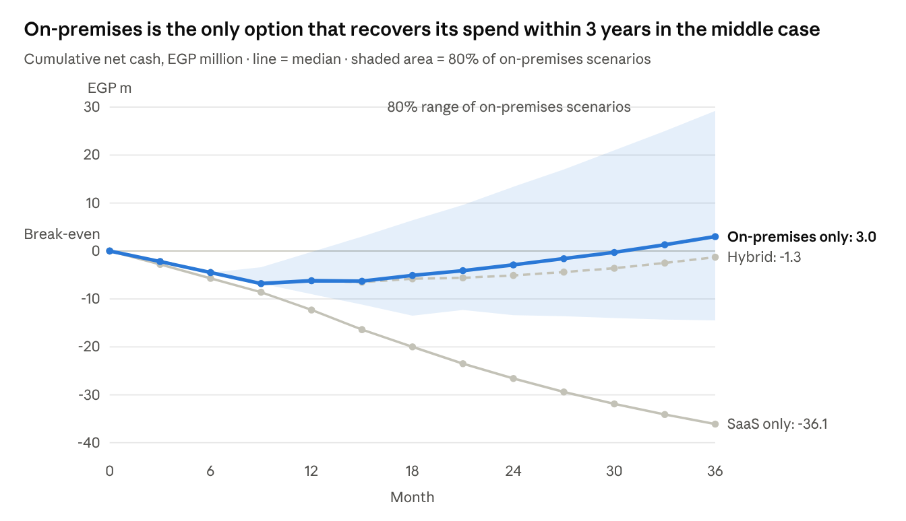
This study's Monte Carlo model · 20,000 scenarios per option · inputs in the Assumptions section
All three options start with roughly the same decline, then diverge after month 9. On-premises starts to climb with the first deal. SaaS keeps falling because small subscriptions do not cover a fixed cost of about EGP 1.4 million a month. Hybrid follows on-premises until month 12, then falls behind it in the scenarios where the gate opens and cloud spending starts.
The shaded area is wide: in the worst 10% of on-premises scenarios the project is still about EGP 14.5 million in debt after 3 years. So continuing must be tied to the actual number of deals, not to forecasts.

Probability of loss: Monte Carlo simulation
Method: each option was run 20,000 times, month by month, for 60 months. In each run the variables are drawn from their ranges, and deals and new customers arrive randomly around their rate (Poisson distribution), because one late deal really does change the outcome. The model is kept in a Python file that can be re-run with new assumptions (scripts/feasibility_model.py).
Measure | SaaS only | On-premises only | Hybrid
Probability of loss after 3 years | 100% | 43% | 53%
Probability of a loss above EGP 10 million after 3 years | 100% | 19% | 27%
Probability of loss after 5 years | 97% | 24% | 30%
Net cash after 3 years: worst 10% / median / best 10% (EGP million) | −41 / −36 / −28 | −15 / +3 / +29 | −18 / −1 / +23
Net cash after 5 years (median, EGP million) | −44 | +21 | +15
Probability that monthly cash flow is positive in year 3 | 9% | 57% | 54%
Probability of recovering the investment within 5 years | 3% | 77% | 70%
Payback month (median, in scenarios that pay back) | 55 | 27 | 31

When does SaaS become viable?
We varied demand and price in the SaaS option alone and held the other assumptions fixed. Each cell is the probability of loss after 5 years:
New customers per month | EGP 45k subscription | EGP 70k subscription | EGP 100k subscription
1.2 (current assumption) | 100% | 93% | 65%
2 | 90% | 48% | 14%
3 | 51% | 12% | 1%
4 | 21% | 2% | 0%
SaaS becomes an acceptable risk (below 15%) under one of two conditions:
- About 3 new customers a month at a EGP 70k subscription.
- Or 2 new customers a month at a EGP 100k subscription, which is closer to Gulf prices.
So the real question is not “cloud or on-premises” but “is there paid demand at this level?”. That is measured with signed letters of intent before anything is built.

Sensitivity: what decides success
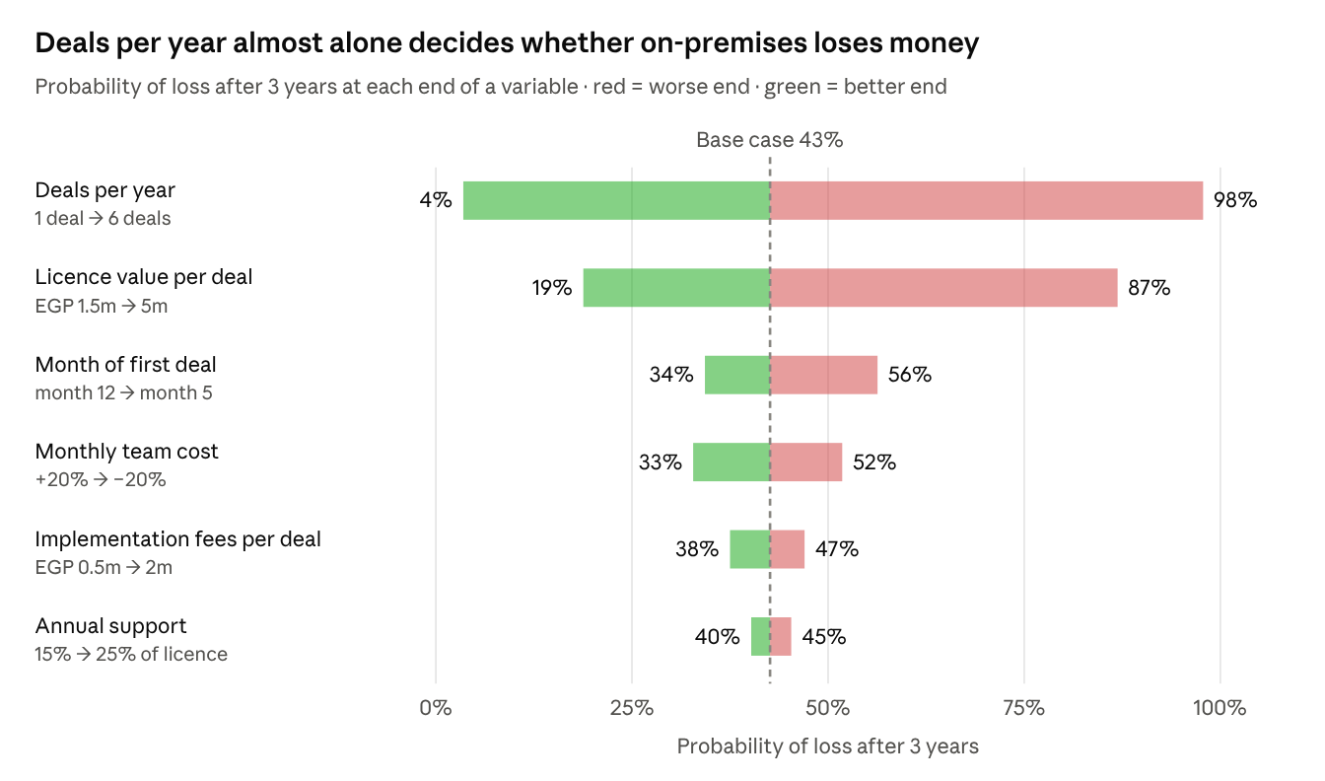
This study's Monte Carlo model · on-premises option · each variable fixed at its two ends, the others drawn from their ranges
The risk in the recommended option is a sales risk, not a technical or operational one. Cutting team cost or raising the support rate moves the result by only a few points. The gap between one deal and six deals a year is the gap between an almost certain loss and an almost certain profit. The second driver is licence price: selling at EGP 1.5 million instead of 3 million roughly doubles the probability of loss.
In practice, the most important investment in year one is an enterprise sales lead with relationships in government bodies, not more developers. Holding the licence price matters more than winning a deal at any price.

Non-financial risks
Risk | Affects | Likelihood | Impact | Mitigation
Dependence on one customer: the first government deal is delayed by a tender or budget | On-premises and hybrid | Medium | High | A paid pilot at a reduced price instead of a free demo. Build a pipeline of at least 5 organisations in parallel
Late payment by government bodies | On-premises | High | Medium | A 30–40% advance payment at contract signature; tie the rest to defined delivery milestones
Data security and leakage between customers | SaaS and hybrid | Low | Very high (reputation and legal liability) | Independent penetration test before launch; tenant isolation at database level
Compliance with data protection and localisation law | SaaS | Medium | High | Hosting inside Egypt; legal review before the first customer
Dependence on an external language-model provider (price, availability, data transfer) | All options | Medium | Medium | The platform works without a language model (rule-based reasoning by default) and supports Ollama locally
Version sprawl: each on-premises install becomes a different version that is hard to update | On-premises | High | Medium | One version for all customers; customise through settings, not code changes. The existing update script (ops/update)
Loss of trust in simulation outputs if they diverge from reality | All options | Medium | High | The reality feedback loop already exists in the platform. Start by calibrating the models on the first customer's real data
Dependence on the founder alone for sales and delivery | All options | High | High | Hire an enterprise sales lead and an implementation engineer early; document installation steps (already in the on-premises deployment guide)
A non-financial advantage of on-premises: every installation gives us real data to calibrate the models, and a reference for the next sale. That is exactly what the cloud will later need to convince customers to subscribe.

Recommended decision and go/stop gates
Decision: start with the on-premises edition. Set a funding cap of EGP 17 million, the funding needed in the 90% pessimistic case, and do not exceed it without a review. The cloud is not part of the funded plan; it is an option that opens on conditions written down in advance. This differs from the hybrid option in the model, which opens the cloud as soon as there are two on-premises installations, without checking cloud demand.
The direct answer to your question: yes, it is better to go on-premises now. Its probability of loss is about 43% after 3 years and about 24% after 5 years, against an almost certain loss for SaaS under the current assumptions. The on-premises probability of loss falls to about 23% if you show you can sell 4 deals a year.

Decision gates
When | Condition to continue | If not met
Month 3 | A pipeline of at least 5 organisations that have seen the demo, two of which have asked for a commercial proposal | Revisit pricing and the target segment; do not grow the team
Month 6 | A first signed contract with an advance payment (paid pilot or full licence) | Cut spend to a minimum team
Month 12 | At least two paid installations, and an average licence price of EGP 2.5 million or more | Stop or change the model: for example, sell through a systems-integration partner instead of selling direct
Month 24 | Positive monthly cash flow for three consecutive months | Do not expand until it is met

Conditions for opening the SaaS door
Nothing is spent on building the cloud unless all three conditions are met:
- Proven demand: signed letters of intent from at least 10 companies that accept cloud hosting, at EGP 70k a month or more. Or letters from Gulf organisations at a price equal to EGP 100k or more. That is the demand level that brings the probability of loss below 15%.
- A stable product: three on-premises installations running the same version with no custom changes.
- Separate funding: on-premises covers its own costs, or additional funding of at least EGP 25 million is available and earmarked for the cloud.
When the conditions are met, the existing SaaS action plan is carried out with its own gates.

Next steps within 30 days
- Turn the demo for the Port Said Free Zone Executive Authority into a paid pilot proposal with a defined scope, duration and deliverables.
- A list of 15 target organisations (government and public business sector), with the decision-maker in each.
- Fix a price list for licence, implementation and support, with payment terms that include an advance payment.
- Re-run this financial model after 90 days with the real number of proposals and prices instead of the assumptions.

