Problem Solving & Algorithms

Helgurd Aziz Mirza

Initial sate

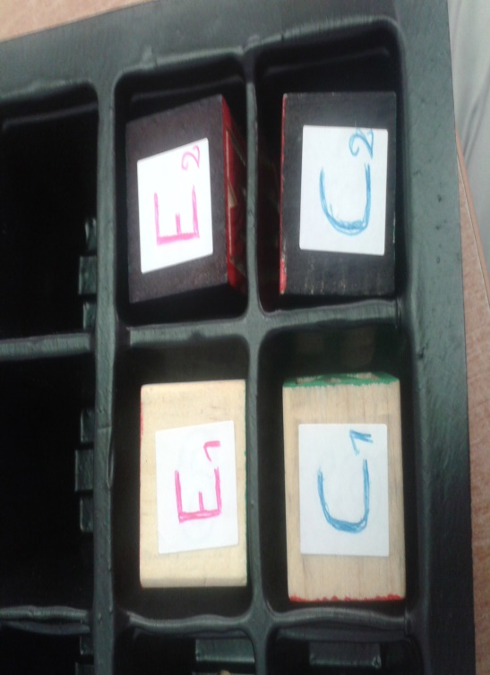

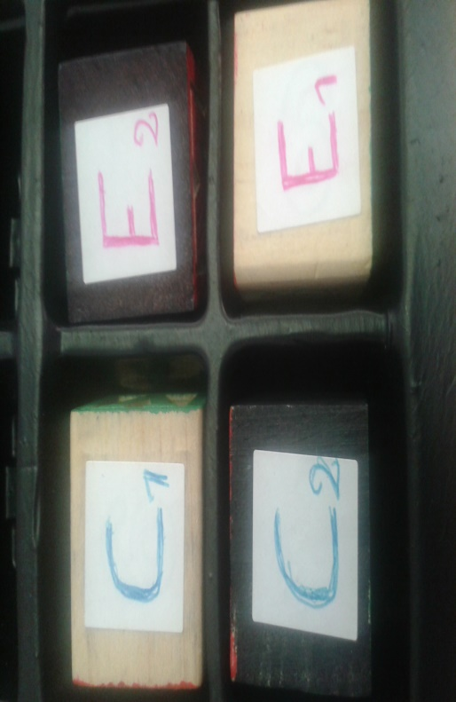E1 and E2 represent empty cells. C1 and C2 contain characters. C1 to E1, C2 to E2

State1

In state1 C1 overwrites E1; C1 takes over E1

State2

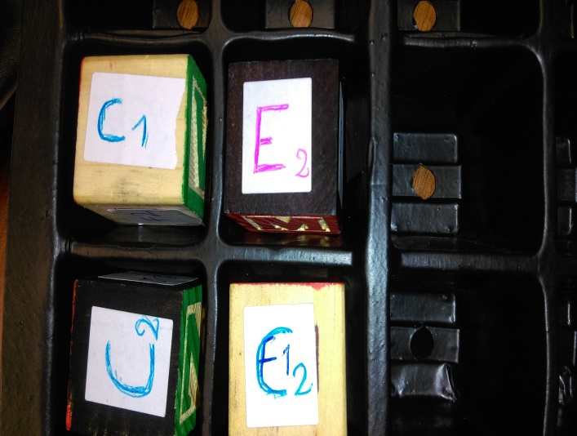

State 3

In state2 C2 overwrites C1; C2 takes over C1 and leaves an empty space in original space of C2.

State3

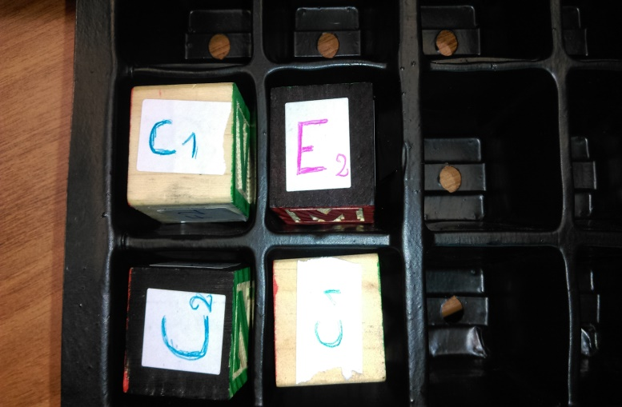

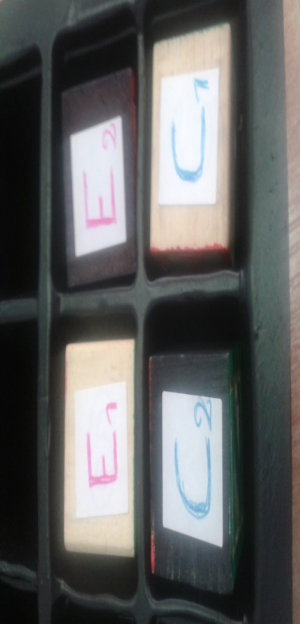In state3 C1 overwrites C2; C1 occupies both its original space and that of empty state E1

State4

In state4 C1 becomes an empty cell called E1; C1 back to its initial position.

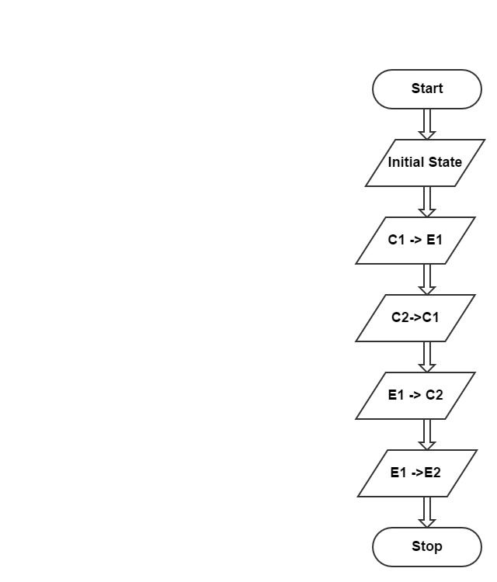

Flowchart

Question8

The problem challenging that can be properly dealt with by using the techniques learned in problem solving strategy. It gives the opportunity to put into practice the learned knowledge of identifying the unknows, knows and conditions.

It made me reflect on how to write an algorithm, draw a flowchart with in mind the farmer, the fox, the goose and corn story and come out with a solution to the problem. Though not easy but it was a positive experience.