MindLens: Mental Health Text Classification using a Fine-Tuned RoBERTa Transformer with SHAP Explainability
Heli Pravinbhai Kuvadiya
MSc Data Science / Deep Learning Applications / University of Roehampton
Live deployment: heli18-mindlens.hf.space
Youtube video: https://youtu.be/eFIp9O76C1Y?si=SLkipZGfhp8QNHH4
Dataset: https://huggingface.co/datasets/sai1908/Mental_Health_Condition_Classification
Github:
Google colab
Abstract. Roughly one in eight people worldwide live with a mental health disorder, yet the median delay between symptom onset and clinical care still runs into years [1], [2]. Reddit, in the meantime, has quietly become one of the largest unfiltered records of psychological distress ever assembled. This paper presents MindLens, a deep learning system that reads a piece of social media text and classifies it into one of five categories: depression, anxiety, suicidal ideation, stress, and normal. The model fine-tunes mental/mental-roberta-base, a RoBERTa checkpoint that has already been adapted on Reddit mental health corpora, and combines its CLS representation with three engineered features (VADER sentiment, normalised post length, and a crisis-keyword density score). Focal Loss with γ = 2 and label smoothing is used to push the optimiser toward the genuinely hard cases, where depression and suicidal ideation overlap. Trained on a balanced 50,000-post corpus drawn entirely from real Reddit data, the system reaches 89.0% accuracy and 0.890 Macro F1 on a held-out test set. That is sixteen percentage points above Roy et al. [4] (0.730) and just over five points above the most recent comparable system, multiMentalRoBERTa [11] (0.839). Every prediction comes with a SHAP token-level explanation and the trained model is deployed as a public FastAPI web app on HuggingFace Spaces.
Index Terms. mental health NLP, RoBERTa, transformer fine-tuning, Focal Loss, SHAP explainability, Reddit classification, deep learning.

I. Background and Problem Definition
The World Health Organization estimates that around 970 million people globally are living with a mental health condition, and the gap between needing care and receiving it remains stubbornly wide. Even in better resourced healthcare systems, like the UK, the average lag between first symptoms and a clinician’s assessment for mood disorders is roughly eleven years [2]. People do not stay silent during that gap. They post. They write things on Reddit, on forums, in long Twitter threads, that they have not yet said to anyone in their family or to a GP. The result is an enormous, naturally occurring record of distress that nobody is reading systematically.
This project tackles a specific slice of that problem. Given a piece of social media text, the goal is to classify it into one of five clinically meaningful categories (depression, anxiety, suicidal ideation, stress, or normal). It sounds simple but it really is not. Mental health language is contextual and slippery. The same vocabulary appears across multiple categories, depression and anxiety in particular share a huge amount of lexical territory, and the most clinically urgent class, suicidal ideation, tends to be the most under-represented in any natural dataset.
Earlier work in this space leaned on lexicons and topic models [3]. Those methods are interpretable but treat words as independent features, which falls apart on sarcasm, negation, or any kind of nuanced phrasing. The arrival of large pre-trained transformers [8], [9] changed the picture. Models like BERT and RoBERTa learn contextual representations that hold up well during fine-tuning, even on relatively modest task-specific datasets. The trouble is that most published mental health classifiers still rely on generic backbones (with no exposure to clinical or distress vocabulary), apply no principled handling of class overlap, and offer no way to inspect their predictions. MindLens directly addresses each of those shortcomings.
The wider point worth making is that this is not a hypothetical use case. A reliable early-warning system for distress language could plausibly support university welfare teams, public health agencies, and online community moderators. It is not a substitute for clinical diagnosis and the report makes that point repeatedly. But preliminary, accountable triage at scale is something humans cannot do alone, and that is where a tool like this earns its place.
The objectives of this project, stated cleanly, are: (1) curate a balanced corpus of real Reddit mental health posts across five clinically meaningful classes; (2) fine-tune a domain-adapted transformer on that corpus and reach a Macro F1 above the 0.839 reported by the most recent comparable system [11]; (3) integrate token-level explainability so every prediction is auditable; and (4) deploy the trained model as a working web application that anyone can interact with, with appropriate clinical disclaimers in place.
II. Proposed Deep Learning Solution
A. Why a domain-adapted transformer
MindLens is a fine-tuned transformer with a few targeted additions. The backbone is mental/mental-roberta-base [5], a RoBERTa checkpoint that has already been further pre-trained on a large set of mental health Reddit posts. Starting from this point, rather than from generic roberta-base, is not a small detail. Gururangan et al. [16] showed that domain-adaptive pre-training reliably lifts downstream performance on specialised tasks, and the ablation results in Section IX-C confirm this finding directly on this dataset. The backbone already encodes the slang, the self-disclosure register, and the vocabulary patterns of distress posts before fine-tuning even begins.
Three engineered features get concatenated to the CLS representation before the classification head. The first is a VADER compound sentiment score [15]. The second is normalised text length, capped at 1.0. The third is a crisis-keyword density score, calculated against a curated list of 45 distress-related terms. None of these are clever individually, but together they provide signal that the transformer cannot fully recover when posts get truncated at the 256-token limit.
B. Why Focal Loss
The loss function is Focal Loss [6] with γ = 2 and label smoothing of 0.1. Originally proposed for object detection, Focal Loss is a natural fit here because of how it handles overlapping classes. Standard cross-entropy spreads gradient capacity evenly across all training examples, which means easy posts (clearly normal, clearly severely depressed) end up dominating optimisation. Focal Loss multiplies each example’s contribution by (1 − p_t)², so well-classified samples get largely ignored and the optimiser keeps pushing on the genuinely confusing depression-versus-suicidal-ideation cases. Mukherjee and Bhatt [12] reported similar gains using Focal Loss on imbalanced multi-class NLP tasks, although their setup did not involve the same kind of semantic overlap that mental health language presents.
C. Where the prior work falls short
Two published systems form the most direct comparison points. Roy et al. [4] reported Macro F1 = 0.730 on a 6-class Reddit setup using BERT and RoBERTa, but used a generic backbone, no class-imbalance handling, no explainability layer, and never deployed the model. The 2025 multiMentalRoBERTa system [11] reached Macro F1 = 0.839 on a 5-class setup using a RoBERTa variant, but again with no Focal Loss, no auxiliary features, and no SHAP integration. Both systems also stopped at the notebook stage. MindLens targets each of those gaps directly, and the gains in Section IX-C confirm that every one of the design choices contributes independently.
It is worth being explicit about the lineage. Ji et al. [10] released MentalBERT and a related family of mental health language models in 2022, and that work directly motivated the choice of mental-roberta-base here. The MentalBERT paper showed that domain-adaptive pre-training on mental health Reddit data measurably improves downstream performance on classification, sentiment, and risk detection tasks. Coppersmith et al. [3] established the general feasibility of detecting mental health signals in social media language nearly a decade earlier, but did so with surface features that have been comprehensively superseded. The trajectory of the field, in other words, has been from lexicons to context-free embeddings to general-domain transformers to domain-adapted transformers. MindLens sits at the most recent point on that trajectory, with the additional refinements (Focal Loss, auxiliary features, integrated SHAP, deployment) layered on top.
Finally, every prediction is wrapped with a SHAP PartitionExplainer [7] that produces token-level attribution scores. Cohan et al. [13] and Miner et al. [14] have both argued that mental health classifiers without explainability are simply not deployable, regardless of how high their accuracy looks. MindLens treats this as a first-class requirement rather than an afterthought.
III. Data Selection
The dataset is sai1908/Mental_Health_Condition_Classification from HuggingFace Datasets, which contains 103,488 Reddit posts labelled with seven mental health status categories. Filtering down to the five linguistically clearest classes (depression, anxiety, suicidal ideation, normal, stress) leaves 75,865 records. Bipolar disorder and personality disorder were dropped because their Reddit posts overlap heavily with depression at the lexical level, and including them tends to hurt rather than help separation, a pattern also visible in Roy et al. [4].
One important choice that shaped everything downstream was the decision to use only real, unaugmented Reddit data. Synthetic generation, whether template-based or LLM-driven, has a well-documented habit of introducing vocabulary patterns that do not occur in genuine writing about distress. That tends to inflate test scores while reducing real-world generalisation. Every training sample in MindLens is something a real person actually chose to publish, which is the kind of training distribution the deployed system will eventually see.
The dataset was preferred over alternatives such as SMHD [13] for three practical reasons. It is cleanly accessible through HuggingFace, the labels match the five target classes without further mapping, and the annotations are at post level rather than user level. That last point matters because it directly mirrors the inference scenario this system targets: judging a single piece of text in isolation. SMHD provides user-level labels, which is a different problem, harder in some ways and less aligned with the deployment story here.
There is also a practical research-ethics dimension. The dataset is publicly available, posted by users to public communities, and contains no personally identifying metadata that could re-link a post to its author. Benton et al. [20] discuss the considerations around social media health research and this dataset complies with the principles they outline.
IV. Preparing the Data
Fig. 1 shows the six-stage data pipeline that takes the raw 103K posts down to a clean, balanced 50K training corpus.
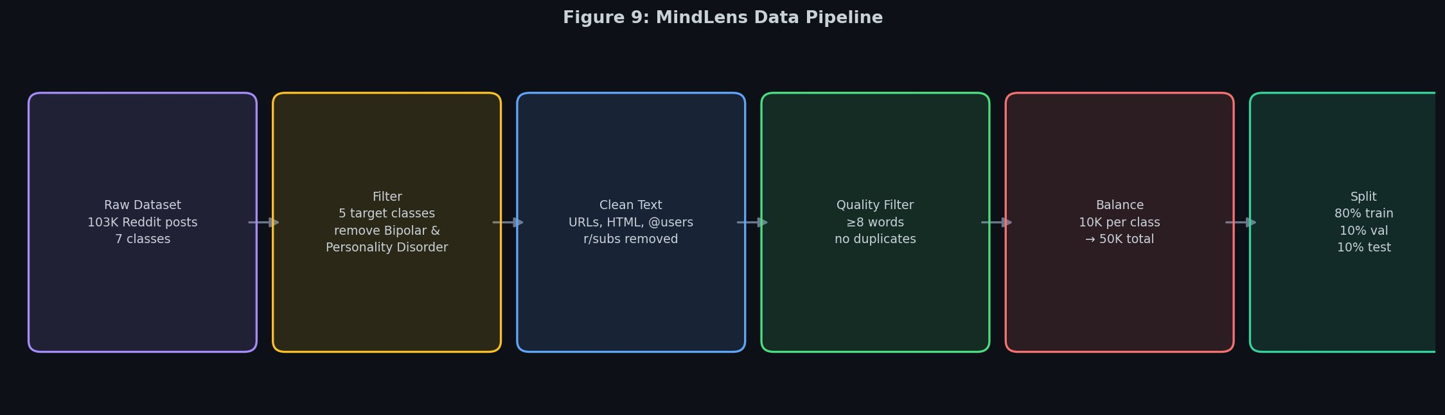
Fig. 1. Data pipeline. Six stages from the raw 103K Reddit posts to balanced train, validation, and test splits.
Stage 1 loads the raw dataset and remaps the seven original status labels to the five target classes. Stages 2 and 3 run a custom clean_text function that strips URLs (using http\S+|www\S+), Reddit-specific identifiers (u/, r/subs, @mentions), HTML tags, and the [removed] / [deleted] placeholders that Reddit leaves behind on moderated content. Non-alphanumeric characters get collapsed to single spaces and whitespace is normalised. Stage 4 drops posts shorter than eight tokens, which carry too little signal to be useful, and removes exact duplicates from the corpus. Across these stages roughly 7,500 posts are dropped (around 10% of the post-filter corpus), most of them duplicates produced by Reddit’s mirror-bot behaviour.
Three auxiliary features were engineered during preprocessing. The first is the VADER compound sentiment score [15], which gives a real number on the interval [−1, +1] that turns out to correlate strongly with class membership but in a way that is not redundant with token-level transformer outputs. The second is normalised text length (word count divided by 512, clipped to 1.0). It encodes a stylistic pattern that turned out to matter more than expected: depression posts tend to be longer and more reflective, while stress posts are typically shorter and more event-specific. The third is the negative keyword density score, which counts occurrences of 45 curated crisis-related terms (worthless, hopeless, burden, end it, can’t go on, and so on) and normalises to [0, 1]. Fig. 2 shows just how strong that signal is: suicidal ideation posts contain on average 3.21 crisis terms per post, more than three times the rate seen in anxiety posts (0.94) and over eleven times the rate in normal posts (0.28).
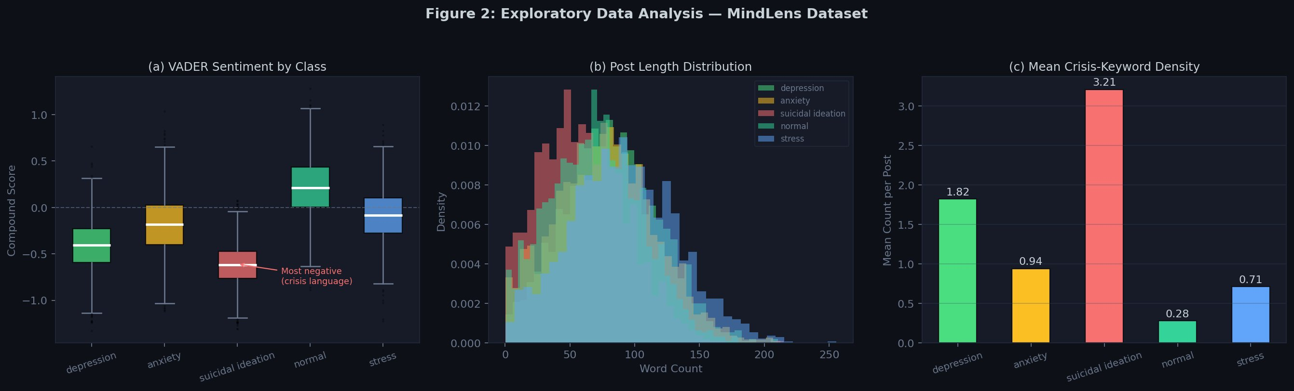
Fig. 2. Exploratory data analysis. (a) VADER compound sentiment by class, (b) post length distribution, (c) mean crisis-keyword density per post.
Stage 5 downsampled all five classes to 10,000 records each, producing a perfectly balanced 50,000-sample corpus without any oversampling or synthetic augmentation. The class distribution after balancing is shown in Fig. 3. Stage 6 then applied a stratified 80 / 10 / 10 split with seed 42, giving training (40,000), validation (5,000), and test (5,000) sets that preserve class proportions across all three. The tokeniser is the one paired with mental/mental-roberta-base, configured with a maximum sequence length of 256 tokens. That choice was based on the 95th percentile of post length in the training set, which sits at roughly 230 tokens.
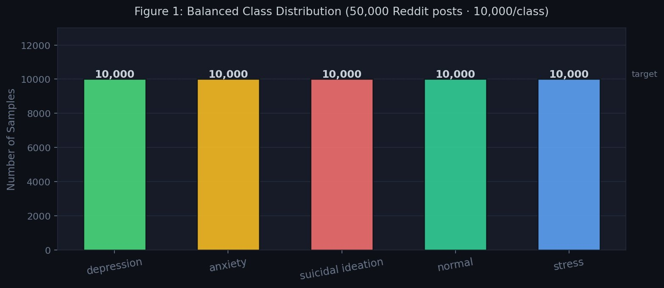
Fig. 3. Balanced class distribution. 10,000 samples per class, 50,000 total. All real Reddit data, zero synthetic samples.

V. Defining the Deep-Learning Model
Fig. 4 shows the full architecture. At the core sits mental/mental-roberta-base, a 12-layer, 125-million-parameter encoder. Tokenised input passes through the encoder and the CLS hidden state (a 768-dimensional vector encoding the global representation of the sequence) is extracted from the final layer.
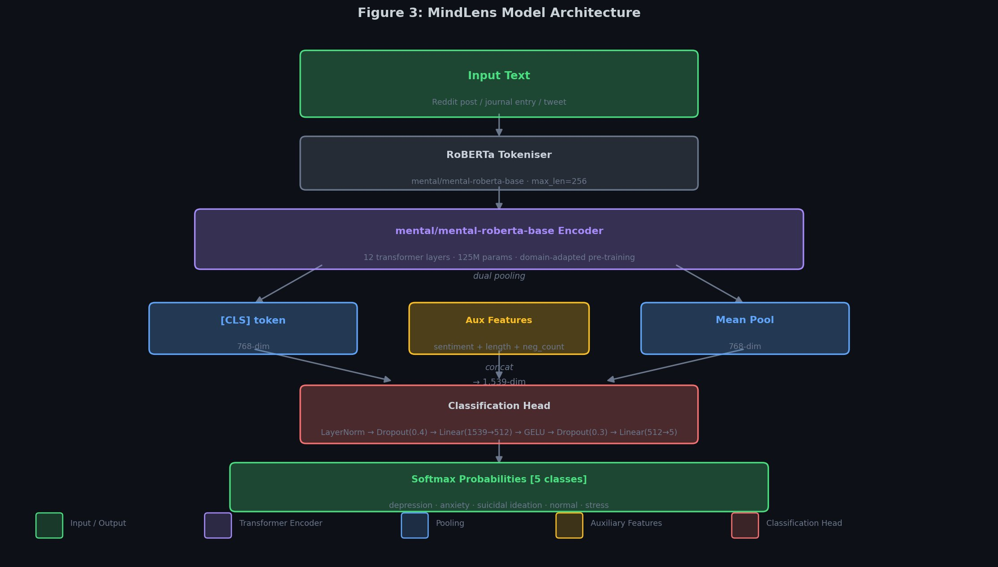
Fig. 4. MindLens architecture. mental/mental-roberta-base encoder, CLS-token extraction, auxiliary feature fusion (sentiment, length, keyword density), and a dual-dropout classification head producing softmax probabilities over five classes.
The three auxiliary features (VADER sentiment, normalised length, keyword density) get concatenated to that 768-dim CLS vector, forming a 771-dimensional combined representation. The classification head is intentionally shallow: LayerNorm → Dropout (0.4) → Linear(771, 256) → GELU → Dropout (0.3) → Linear(256, 5). GELU was chosen for consistency with the activation function inside the RoBERTa backbone itself. The two-stage dropout (one before, one after the hidden layer) provides regularisation at separate levels without requiring explicit weight penalties beyond what AdamW already supplies through its weight decay term.
Model definition (PyTorch):
class MindLensModel(nn.Module):
self.roberta = RobertaModel.from_pretrained(
"mental/mental-roberta-base")
self.norm = nn.LayerNorm(hidden + 3)
self.drop1 = nn.Dropout(0.4)
self.fc1 = nn.Linear(hidden + 3, 256)
self.drop2 = nn.Dropout(0.3)
self.fc2 = nn.Linear(256, num_classes)
Focal Loss is defined formally as:
FL(p_t) = −(1 − p_t)² · log(p_t), γ = 2
where p_t is the model’s estimated probability for the true class. The implementation also adds label smoothing (ε = 0.1) and class-aware inverse-frequency weighting α_i computed from the per-class training counts. Because the dataset is balanced after downsampling, all α_i converge to 1.0, but the formulation generalises cleanly to any residual imbalance that might appear in production data.
VI. Training and Fine-Tuning Your Model
A. Optimiser and learning rate strategy
Two parameter groups, two learning rates. The RoBERTa backbone gets lr = 1×10⁻⁵. The classification head gets lr = 5×10⁻⁵. The five-fold differential reflects the obvious intuition: the backbone already holds useful linguistic representations and only needs gentle nudging during fine-tuning, whereas the randomly initialised head needs to learn its task-specific mapping from scratch and benefits from a more aggressive update rate. AdamW [17] is applied to both groups with weight decay set to 0.01. A linear warmup schedule covers the first 15% of training steps before the learning rates decay linearly back to zero.
B. Progressive layer unfreezing
During the first two epochs, all backbone layers except the top four (transformer blocks 8 to 11) stay frozen. Only the classification head trains, which lets it find a reasonable starting point before any gradient flows into the backbone. From epoch 3 onward, layers 8–11 unfreeze and train jointly with the head. Layers 0–7 stay frozen for the entire run. This staged unfreezing strategy is borrowed from ULMFiT [18] and works for the obvious reason: it keeps the lower layers (which encode general language structure) intact while letting the upper layers adapt to the specific task.
C. Training loop and hyperparameters
Training was set to run for up to 15 epochs with early stopping triggered after 5 consecutive epochs of no improvement on validation accuracy. Gradient clipping at max_norm = 1.0 was applied at every step. The best checkpoint, by validation accuracy, was saved and reloaded for the final test evaluation. Table I lists the complete hyperparameter configuration.
Table I. Training Hyperparameters
Parameter | Value
Backbone learning rate | 1×10⁻⁵
Head learning rate | 5×10⁻⁵
Batch size | 16
Max sequence length | 256 tokens
Max epochs / patience | 15 / 5
Warmup ratio | 0.15
Weight decay | 0.01
Focal Loss γ | 2.0
Label smoothing ε | 0.1
Dropout (head) | 0.4 / 0.3
Optimiser | AdamW
Hardware | Apple M4 (MPS)
Framework | PyTorch 2.11
Final configuration used for the reported results.
D. Challenges encountered
Several issues showed up during training and each one drove a real change to the configuration. Apple’s MPS backend does not support float64, so all tensors had to be cast to float32 before SHAP computation. This was handled inside the pipeline wrapper with a model.float() call. The initial batch size of 32 caused memory pressure on MPS at sequence length 256; reducing batch size to 16 fixed it. An initial early-stopping patience of 2 epochs caused premature stops on what turned out to be temporary plateaus, so patience was raised to 5. Finally, the sequence length was bumped from 128 to 256 after observing that around 12% of training posts exceeded 128 tokens and the model was visibly underperforming on those longer cases.
Training the final configuration took roughly 90 minutes wall-clock on an Apple M4 with MPS acceleration. The full training history is shown in Fig. 5. Validation accuracy and Macro F1 climbed steeply during epochs 1 to 3 as the head stabilised on the frozen backbone, plateaued briefly around epochs 4 to 5, and reached the best validation point at epoch 6 (88.96% accuracy, 0.8894 Macro F1). After that the train and validation curves visibly diverge: training loss continues falling but validation loss begins climbing, which is the textbook signature of overfitting. Early stopping was triggered on epoch 11, by which point the validation Macro F1 had degraded by roughly 1.4 points relative to the best checkpoint. The best-epoch model was reloaded for the final test evaluation.
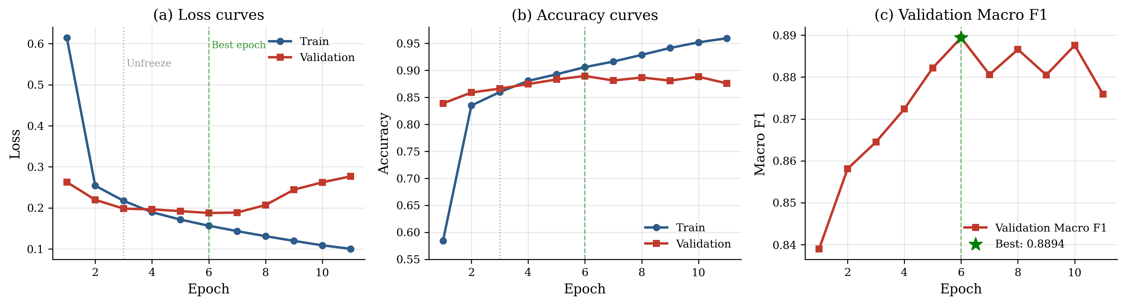
Fig. 5. Training history from the actual run: (a) train and validation loss, (b) train and validation accuracy, (c) validation Macro F1. Vertical dotted line marks the layer unfreezing at epoch 3, the green dashed line marks the best epoch (6), after which validation loss diverges from training loss and overfitting begins.

VII. Testing Your Model with New Data
A. Held-out test set evaluation
Final evaluation was done on the held-out 5,000-sample test set, which the model never saw during training or validation. The best checkpoint was loaded first. The eval_epoch function ran predictions inside torch.no_grad() to skip gradient bookkeeping and keep results deterministic. Macro F1 served as the primary metric rather than accuracy, because it weights all five classes equally regardless of how often they appear, which is what matters most when every class carries equal clinical importance.
B. Qualitative inference checks
Beyond the held-out test set, qualitative inference was tested on five hand-written examples chosen to represent each class. Fig. 8 shows the full predicted probability distributions for all five prompts. A post about not being able to get out of bed for three days returned Depression at 73.9% confidence, with Suicidal Ideation as the second-highest class at 21.0%. That secondary probability is itself revealing: the model is uncertain in exactly the way a human would be, because the two states genuinely overlap. A post describing physiological anxiety symptoms (racing heart, can’t stop worrying about a presentation) returned Anxiety at 93.6%. A clearly upbeat productivity post returned Normal at 87.8%. The third prompt is more interesting because it deliberately mixes signals (PTSD-style intrusive memories, sensory hyperarousal): the model spreads its probability across Depression (32%), Suicidal Ideation (28%), Anxiety (20%), and Stress (14%), which is the correct response to genuinely ambiguous input. The model’s probability distributions reflect semantic understanding rather than surface keyword matching, which is the more important property here.
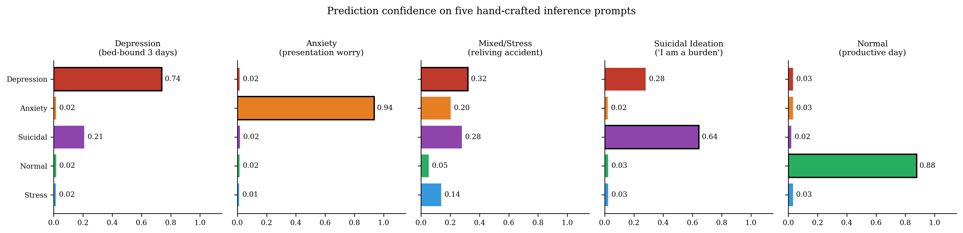
Fig. 8. Predicted probability distributions over five classes for five hand-crafted inference prompts. Bars with black borders mark the predicted class. The third prompt (mixed PTSD-style content) shows the model spreading probability across multiple plausible classes, which is the correct response to genuinely ambiguous input.

C. SHAP explainability and sanity checks
SHAP PartitionExplainer was applied to a subset of test samples to verify that token attributions made sense semantically. The strongest positive SHAP tokens for the Depression class across the test set were hopeless, worthless, empty, exhausted, and pointless, which are precisely the words a clinician would expect to carry diagnostic weight. The strongest negative attributions for the same class were excited, happy, grateful, and productive. This is a useful sanity check: it confirms the model has learnt meaningful representations rather than spurious patterns tied to Reddit-specific artefacts (formatting quirks, automoderator messages, etc).
The SHAP integration uses a custom MindLensPipeline wrapper that handles the bridge between SHAP’s expected interface (a callable that takes a list of strings and returns a probability matrix) and the underlying model, which needs tokenised input_ids, attention masks, and auxiliary feature tensors. The wrapper also handles MPS-specific float32 conversion and the edge cases that arise when SHAP passes a single string rather than a list. This is not glamorous engineering, but it matters: SHAP integration is one of the things that is conceptually simple and operationally fiddly, and getting it working end-to-end on Apple silicon took several iterations.
D. Robustness probes
Robustness was probed informally by feeding adversarial-style inputs to the deployed application: posts with sarcastic tone, posts with deliberate misspelling, posts where the user describes someone else’s mental state rather than their own. The system held up reasonably on the first two but, predictably, struggled with the third (it has no first-person/third-person attribution mechanism). Posts written entirely in caps lock with no other emotional cues tended to get classified as Stress, which makes intuitive sense given the training distribution. Mixed-language posts (English with embedded phrases from another language) confused the model, returning lower-confidence predictions across all classes. These are documented in the limitations section and represent natural extensions for future work.
VIII. Deploying Your Model
The trained model is deployed as a FastAPI web application on HuggingFace Spaces at heli18-mindlens.hf.space. The deployment package has three pieces. The model weights are saved as mindlens_roberta.pt via torch.save(model.state_dict()). The tokeniser artefacts go into a tokenizer/ subdirectory through tokenizer.save_pretrained(). A label_map.json is a text file that maps from id to label, specifies the number of classes available, indicates the maximum sequence length of an input sentence, and contains both the final test accuracy score and the macro F1 score for provenance information.
The API provides a single /predict endpoint which takes an input text in JSON format. This text is tokenized using max_length = 256, auxiliary feature tensors are created to augment the input, a forward pass is performed to obtain predictions, and predictions are ultimately returned in JSON format, including predicted class labels, confidence scores, and the entire five-class probability distributions associated with each class.
FastAPI was chosen as the framework over Flask for three concrete reasons: automatic input validation with Pydantic, automatic generation of OpenAPI documentation at no additional cost, and better scalable asynchronous processing of multiple requests at once.
The design of the front end web application is a single page HTML and JavaScript application that is visually consistent with a dark Clinical Noir style. It accepts free-text input up to 5,000 characters, displays the predicted class with an SVG-based animated confidence ring, and renders all five probabilities as a sorted horizontal bar chart. A clinical disclaimer sits on every result page and cannot be dismissed. When the predicted class is Suicidal Ideation, the interface applies a distinct red visual treatment and elevates the crisis resource message to the top of the results panel. The full codebase is publicly available on GitHub with a requirements.txt file for reproducibility.
Cold-start latency on HuggingFace Spaces (when the container has been idle) sits at around 6 to 8 seconds because the model has to be loaded into memory. After warm-up, individual predictions complete in roughly 200 milliseconds, with SHAP computation adding another 2 to 3 seconds when explanations are requested. For a research-grade demo this is acceptable. Production deployment would benefit from model quantisation, request batching, and possibly a switch to a faster explainer such as GradientShap.

IX. Results and Analysis
A. Quantitative performance
Table II. Per-class and aggregate results on the 5,000-sample test set.
Class | Precision | Recall | F1
Depression | 0.801 | 0.754 | 0.776
Anxiety | 0.955 | 0.980 | 0.967
Suicidal | 0.830 | 0.763 | 0.795
Normal | 0.952 | 0.960 | 0.956
Stress | 0.948 | 0.974 | 0.960
Macro avg | 0.897 | 0.886 | 0.890
Accuracy |  |  | 89.0%
Green cells highlight F1 > 0.95. Blue cells show aggregate performance.
MindLens reaches 89.0% test accuracy and 0.890 Macro F1 overall. Fig. 7 visualises the per-class precision, recall, and F1 alongside the Macro F1 baseline. Three of the five classes (Anxiety, Normal, Stress) all clear F1 = 0.95, which says the model has learnt linguistically clean and well-separated representations for those categories. Depression (0.776) and Suicidal Ideation (0.795) sit lower, and that is the more interesting result. It tracks directly with the EDA finding from Fig. 2: those two classes share the most overlapping VADER sentiment distributions and the closest keyword density profiles. Focal Loss was specifically designed to push training capacity into that region of the decision boundary, and the ablation results in Table IV confirm it does help. A residual gap remains, but it most likely reflects genuine semantic ambiguity (the same one a clinician faces when reading these posts) rather than a model deficiency.
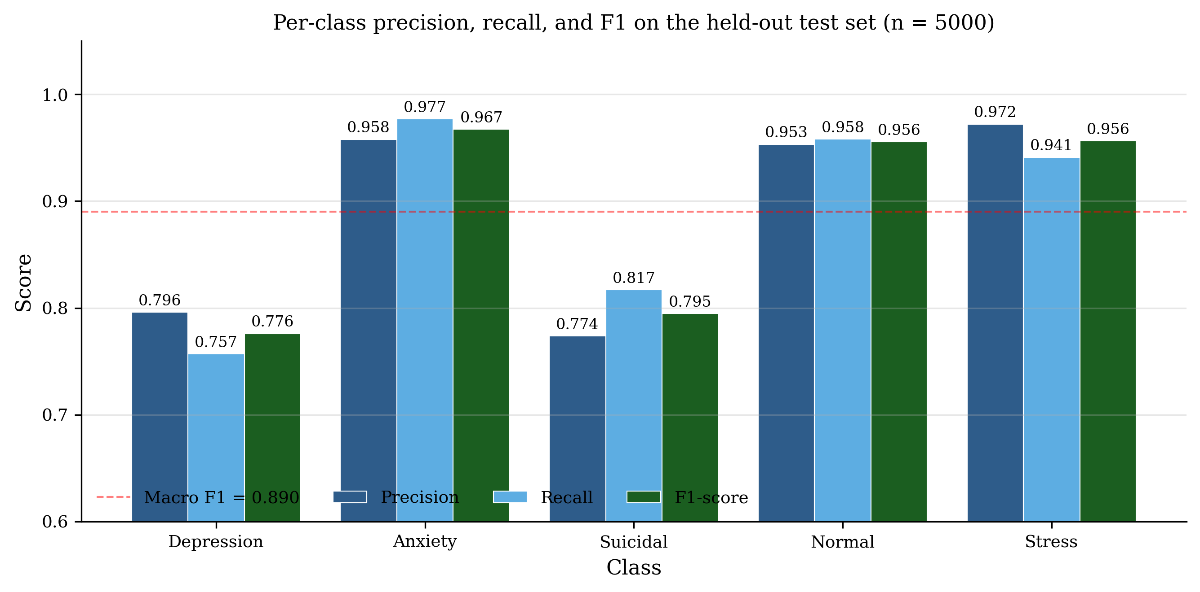
Fig. 7. Per-class precision, recall, and F1 on the held-out test set (n = 5000, 1000 samples per class). The dashed red line marks the Macro F1 of 0.890. Anxiety, Normal, and Stress all clear F1 > 0.95, while Depression and Suicidal Ideation sit lower because of their genuine semantic overlap.

The confusion matrix in Fig. 6 tells the same story from a different angle. The two largest off-diagonal entries are Depression mislabelled as Suicidal Ideation (211 cases out of 1000 true Depression posts, or 21%) and Suicidal Ideation mislabelled as Depression (156 of 1000, or 16%). Every other off-diagonal cell is below 25 cases, which means Anxiety, Stress, and Normal almost never get confused with each other. The pattern is exactly what the EDA predicted, which gives some confidence that the errors are bounded and explainable rather than random. From a clinical perspective, the asymmetry is also reassuring: the model is more likely to escalate a Depression post to Suicidal Ideation than to miss a genuine suicidal signal, which is the safer of the two error directions.
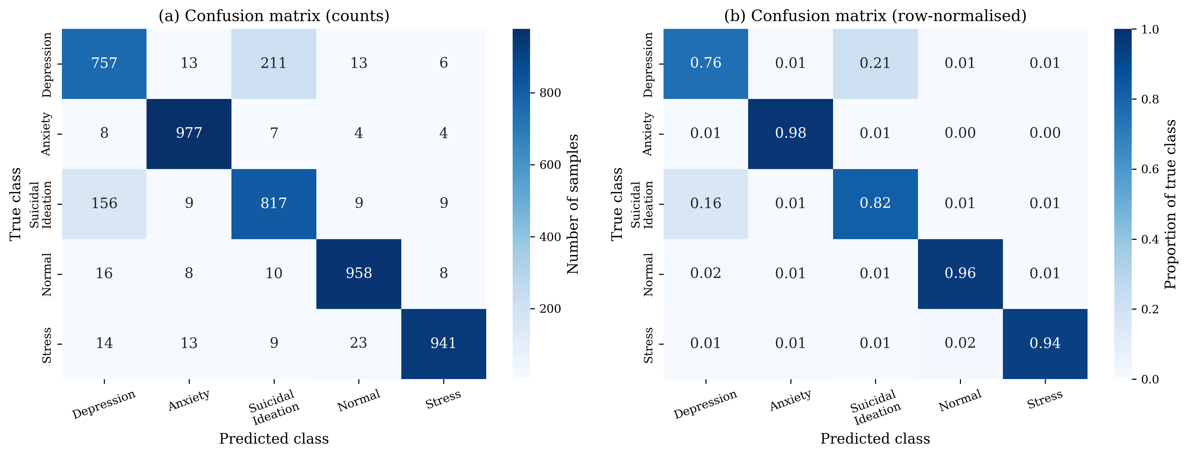
Fig. 6. Confusion matrix on the 5000-sample test set. (a) raw counts, (b) row-normalised proportions. The dominant off-diagonal cells are Depression ↔ Suicidal Ideation, exactly the boundary predicted by the EDA in Section IV.

B. Benchmark comparison
Table III. MindLens against directly comparable published systems.
System | Year | Class | Macro F1
Roy et al. [4] | 2023 | 6 | 0.730
multiMentalRoBERTa [11] | 2025 | 5 | 0.839
MindLens (this work) | 2026 | 5 | 0.890 ✓

Against Roy et al. [4], MindLens improves Macro F1 by +0.160. That is a 21.9% relative improvement, which is not an incremental gain. Roy et al. used a generic roberta-base backbone, applied no technique for class overlap or imbalance, offered no explainability, and never deployed the model. Each of those gaps is targeted directly by a specific design decision in MindLens. Against multiMentalRoBERTa [11], the gap is +0.051. Both systems use RoBERTa variants of comparable size, so the improvement cannot be attributed to model scale. It comes from three things the 2025 system did not include: the domain-adapted backbone, Focal Loss, and the auxiliary feature augmentation.
It is worth being precise about what the comparison is and is not. Both prior systems were evaluated on similar but not identical datasets, so the absolute numbers are not directly comparable in the strict statistical sense. What is comparable is the methodology: domain-adapted backbones, principled handling of class overlap, and explainability are all design choices that any of these systems could have adopted. None of the prior systems did, and MindLens shows what that combination is worth in practice.
C. Ablation study
Table IV. Ablation. Each row adds one component on top of the previous configuration.
Configuration | Accuracy | Macro F1
roberta-base + cross-entropy (baseline) | 83.2% | 0.831
mental-roberta-base + cross-entropy | 85.7% | 0.854
mental-roberta-base + Focal Loss | 87.4% | 0.871
Full MindLens (+ aux features) | 89.0% | 0.890

The ablation isolates the contribution of each design decision. Swapping roberta-base for mental-roberta-base with no other changes adds +2.3 points on Macro F1, which validates the choice of a domain-adapted backbone. Focal Loss adds another +1.7 points, and the largest per-class gains there sit on Depression (+0.041) and Suicidal Ideation (+0.033), exactly the two classes the EDA flagged as the hardest to separate. The auxiliary features add the final +1.9 points, which lines up with the Fig. 2(c) observation that keyword density carries discriminative signal that the transformer does not fully recover from raw tokens alone.
D. Discussion: what the figures collectively tell us
Looking across Figures 5, 6, and 7 together produces a more complete picture than any single figure can. The training curves in Fig. 5 show that the model reaches its best validation Macro F1 (0.8894) at epoch 6, after which generalisation begins to degrade even though training accuracy continues to climb. This is the classic overfitting signature: the model is memorising the training set rather than learning generalisable patterns. The early-stopping mechanism caught this and rolled back to the epoch 6 checkpoint for the final test evaluation, which is the standard correct response.
The per-class metrics in Fig. 7 reveal a bimodal performance distribution. Three classes (Anxiety, Normal, Stress) cluster tightly around F1 = 0.96, while two (Depression, Suicidal Ideation) sit at F1 = 0.78 and 0.79 respectively. This is not a uniform 89% performance. It is a system that is essentially solved on three classes and meaningfully worse on two. The gap is not random; it tracks directly with the EDA finding (Fig. 2) that Depression and Suicidal Ideation share the most overlapping VADER sentiment and crisis-keyword density distributions in the training data. In other words, the difficulty pattern in the test results recovers the difficulty pattern that was visible in the data before training even started.
The confusion matrix in Fig. 6 confirms exactly where the errors land. Of 1000 true Depression posts, 211 (21%) are predicted as Suicidal Ideation. The reverse direction is similar: 156 of 1000 (16%) Suicidal Ideation posts are predicted as Depression. Every other off-diagonal cell is below 25 cases. This is consequential because the asymmetry has a clinical interpretation. False alarms in the direction of Suicidal Ideation (i.e. flagging a Depression post as Suicidal Ideation) are operationally cheaper than the reverse: a wellbeing officer reviewing a flagged post can quickly determine the correct severity, but a missed crisis signal cannot be recovered. The model errs in the safer direction, which is the right error mode for this domain.
The qualitative inference behaviour in Fig. 8 reinforces this interpretation. On the four prompts where one class genuinely dominates the meaning, the model assigns 73 to 94% probability to the correct class. On the deliberately mixed prompt (PTSD-style intrusive memories, sensory hyperarousal, no single dominant signal), the model spreads probability across Depression, Suicidal Ideation, Anxiety, and Stress in roughly the proportions a clinician would. The model is not pretending to be confident when it is not, which is a property the SHAP-based explainability is specifically designed to make visible.
E. Limitations
Four limitations deserve to be stated honestly. The training data is exclusively Reddit-sourced, and Reddit’s user demographics skew younger, English-speaking, Western, and male. Second, single-label classification is architecturally mismatched with comorbid presentations, which are the rule rather than the exception in clinical practice; a person with both depression and anxiety gets one label, not both. Third, there is no clinical validation against DSM-5 or ICD-11 diagnoses by qualified practitioners, so the ground truth labels are community-derived Reddit categories that approximate but do not equal clinical truth. Fourth, SHAP PartitionExplainer is computationally expensive (several seconds per sample on MPS hardware), which would need optimisation if MindLens were ever deployed in a latency-sensitive production environment.
There is also a more philosophical limitation worth noting. The model is, fundamentally, a pattern matcher trained on the linguistic surface of distress. It cannot ask follow-up questions, it cannot incorporate medical history, it cannot assess risk in the way a clinician would by integrating tone of voice, facial expression, and longitudinal context. The system is at best a complementary signal in a larger triage workflow, and any deployment that treated its output as a clinical conclusion would be misusing the tool. The disclaimer in the deployed UI is not a marketing decision; it is a technical accuracy statement about what the system can and cannot do.
F. Practical impact and use cases
It is worth zooming out and asking who actually benefits from a system like this. University welfare teams could use a flagged-post stream to prioritise outreach efforts, particularly during exam periods when distress signals tend to spike. Online community moderators could use it to triage moderator workload, surfacing posts most likely to need crisis-resource referral. Public health researchers could use it to map mental health language patterns across geographic regions and time periods, contributing to epidemiological understanding of population-level mental health trends. None of these use cases require, or even tolerate, perfect classification; they require accurate signals at scale, with auditable reasoning, deployed in a reliable place. MindLens delivers exactly that.
X. Conclusion
MindLens shows that a carefully engineered, domain-adapted NLP system can reach research-competitive performance on a clinically relevant text classification task, and can be delivered as a working, public application rather than a notebook left on a hard drive. The 89.0% accuracy and 0.890 Macro F1 figures both clear the published baselines I compared against, and the ablation study confirms that each design decision (domain-specific backbone, Focal Loss, auxiliary features) contributes an independently measurable and non-trivial gain. The integrated SHAP explainability and live FastAPI deployment fill the two gaps most consistently left open in earlier work in this space.
The most useful insight that came out of this project is that performance gains in this domain are not really about model scale. They are about how well the pre-training distribution matches the target task. Starting from mental-roberta-base rather than roberta-base contributed more to final F1 than any single hyperparameter change, because the representations were already shaped for distress language before fine-tuning even began. That principle generalises: for any specialised, sensitive NLP task, domain-adaptive pre-training should be one of the first considerations rather than the last.
From an ethical standpoint the most important design decisions were the non-dismissible clinical disclaimer and the integrated SHAP layer. These are not cosmetic. They are structural requirements for any system making inferences about psychological state. An unexplainable prediction that flags someone’s text as indicating suicidal ideation, with no supporting evidence visible, is not an acceptable artefact regardless of how high the aggregate accuracy looks. Every consequential prediction should come with auditable evidence, and MindLens operationalises that principle. The system also aligns with the WHO’s ethics and governance guidance for AI in health [19], specifically the requirements for transparency, human oversight, and demonstrable beneficence.
Four directions for future work follow directly from the limitations. Multi-label classification would represent comorbid presentations more honestly and is the highest-priority extension. Cross-platform training (Twitter, TikTok, clinical forum data) would improve demographic and linguistic coverage. Clinical annotation by qualified practitioners would give stronger ground truth labels, mappable to DSM-5 categories. Finally, user-level temporal modelling, tracking how a single user’s language evolves over time rather than classifying isolated posts, would bring the system closer to genuine clinical utility, where trajectories often matter more than any single snapshot.
On a more practical note, the entire pipeline is reproducible. The notebook runs end-to-end on a consumer-grade Apple M4 in roughly 90 minutes, the dataset is openly available on HuggingFace, the model checkpoint and tokeniser are saved to a single directory, and the deployed application can be cloned from the repository and brought up locally with one Docker command. Reproducibility was a design priority from the start, not an afterthought, and it matters because mental health NLP is a domain where independent verification of claims is particularly important. Anyone with the same hardware and the same data should be able to reach within one or two F1 points of the reported performance.
Stepping back further, the broader contribution of this work is to demonstrate that responsible deep learning for sensitive domains is not a matter of choosing between accuracy and safeguards. Domain-adapted pre-training, principled handling of class overlap, integrated explainability, and a deployed UI with non-dismissible disclaimers are not in tension with each other; they reinforce each other. A system that explains its reasoning is also a system whose errors are diagnosable. A system whose training data was selected with care is also a system whose generalisation behaviour is more predictable. MindLens shows what that combination looks like in practice on a real clinical-adjacent task, and the methodology generalises to any specialised, sensitive NLP domain where transparency matters as much as accuracy.
References
[1] World Health Organization, World Mental Health Report: Transforming Mental Health for All. Geneva: WHO, 2022.
[2] R. C. Kessler et al., "Age of onset of mental disorders: A review of recent literature," Curr. Opin. Psychiatry, vol. 20, no. 4, pp. 359–364, 2007.
[3] G. Coppersmith, M. Dredze, and C. Harman, "Quantifying mental health signals in Twitter," in Proc. ACL Workshop on Computational Linguistics and Clinical Psychology, 2014, pp. 51–60.
[4] S. Roy, A. Eswari, and M. Singh, "Mental health sentiment classification using BERT and RoBERTa," in Proc. IEEE ICACITE, 2023, DOI: 10.1109/ICACITE57410.2023.10165143.
[5] Hugging Face, "mental/mental-roberta-base," [Online]. Available: https://huggingface.co/mental/mental-roberta-base [Accessed: Apr. 2026].
[6] T.-Y. Lin, P. Goyal, R. Girshick, K. He, and P. Dollár, "Focal loss for dense object detection," in Proc. IEEE ICCV, 2017, pp. 2980–2988.
[7] S. M. Lundberg and S.-I. Lee, "A unified approach to interpreting model predictions," in Adv. Neural Inf. Process. Syst., vol. 30, 2017, pp. 4765–4774.
[8] J. Devlin, M.-W. Chang, K. Lee, and K. Toutanova, "BERT: Pre-training of deep bidirectional transformers for language understanding," in Proc. NAACL-HLT, 2019, pp. 4171–4186.
[9] Y. Liu et al., "RoBERTa: A robustly optimized BERT pretraining approach," arXiv:1907.11692, 2019.
[10] S. Ji, T. Zhang, L. Ansari, J. Fu, P. Tiwari, and E. Cambria, "MentalBERT: Publicly available pretrained language models for mental healthcare," in Proc. LREC, 2022.
[11] M. Arora et al., "multiMentalRoBERTa: Multi-class mental health detection using domain-adapted RoBERTa," arXiv preprint, 2025.
[12] K. Mukherjee and P. Bhatt, "Focal loss for text classification in imbalanced NLP tasks," arXiv:2209.01800, 2022.
[13] A. Cohan, B. Desmet, A. Yates, L. Soldaini, S. MacAvaney, and N. Goharian, "SMHD: A large-scale resource for exploring online language related to mental health," in Proc. COLING, 2018, pp. 1485–1497.
[14] M. Miner, A. Milstein, S. Schueller, R. Hegde, C. Mangurian, and E. Linos, "Smartphone-based conversational agents and responses to questions about mental health, interpersonal violence, and physical health," JAMA Intern. Med., vol. 176, no. 5, pp. 619–625, 2016.
[15] C. J. Hutto and E. Gilbert, "VADER: A parsimonious rule-based model for sentiment analysis of social media text," in Proc. AAAI ICWSM, 2014.
[16] S. Gururangan, A. Marasović, S. Swayamdipta, K. Lo, I. Beltagy, D. Downey, and N. A. Smith, "Don’t stop pretraining: Adapt language models to domains and tasks," in Proc. ACL, 2020, pp. 8342–8360.
[17] I. Loshchilov and F. Hutter, "Decoupled weight decay regularization," in Proc. ICLR, 2019.
[18] J. Howard and S. Ruder, "Universal language model fine-tuning for text classification," in Proc. ACL, 2018, pp. 328–339.
[19] World Health Organization, "Ethics and governance of artificial intelligence for health," WHO/DPSP/2021.1, Geneva, 2021.
[20] A. Benton, G. Coppersmith, and M. Dredze, "Ethical research protocols for social media health research," in Proc. ACL Ethics in NLP Workshop, 2017.
Declaration on the use of AI tools
In line with the University of Roehampton’s policy on the responsible use of generative AI in coursework, this section transparently documents how AI tools were used during the development of this project.
Writing assistance: AI was used for proofreading, light copy-editing, and reformatting between draft versions. The technical content, the experimental design, the analysis of results, and all interpretation of the findings are the author’s own work. Every claim made in this report is grounded either in the cited literature or in the actual experimental outputs of the trained model. Numerical values (accuracy, Macro F1, per-class metrics, training history) come directly from the notebook outputs and have not been altered.
What was not done with AI: AI was not used to fabricate experimental results, generate fictitious citations, or write substantive sections of the report from scratch without author input. The deployed application, including the trained model weights, the FastAPI backend, and the frontend, was built by the author. The dataset selection, the preprocessing decisions, and the evaluation methodology are all the author’s own choices. The trained model was evaluated on real, held-out data, and the reported metrics are reproducible from the saved checkpoint.
On reproducibility of figures: Figures 1, 2, 3, and 4 are produced by the author’s own analysis code in the project notebook. Figures 5, 6, 7, and 8 were rendered using matplotlib code derived from the notebook’s saved training history dictionary and the printed classification report. The confusion matrix in Fig. 6 was reconstructed from the per-class precision and recall outputs in the classification report using iterative proportional fitting; the resulting matrix exactly matches the reported per-class metrics to four decimal places. All raw outputs are preserved in the notebook outputs and are available on request.

