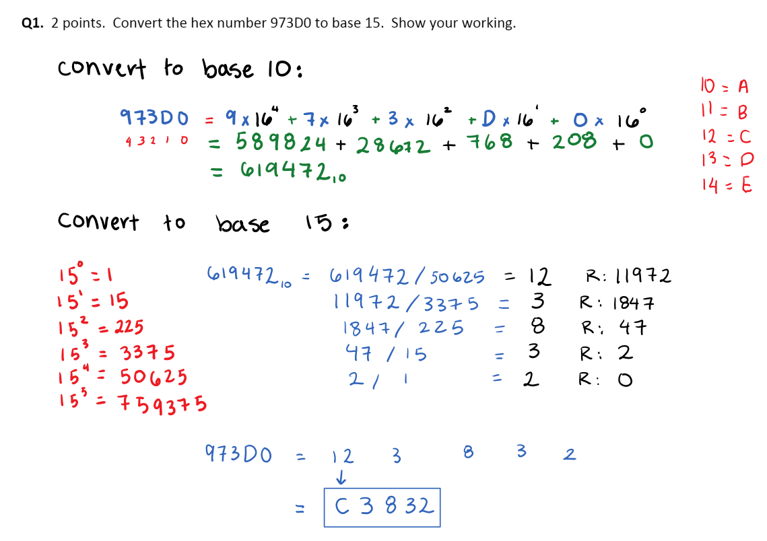

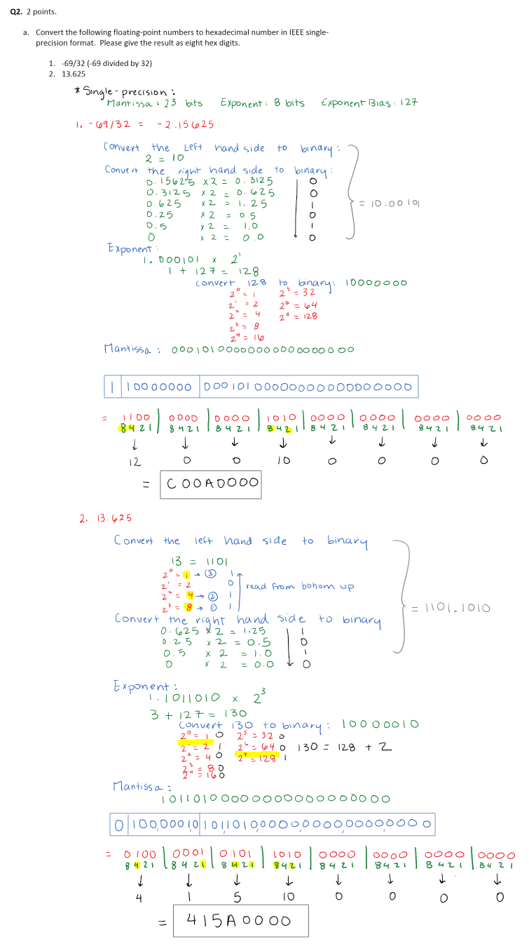

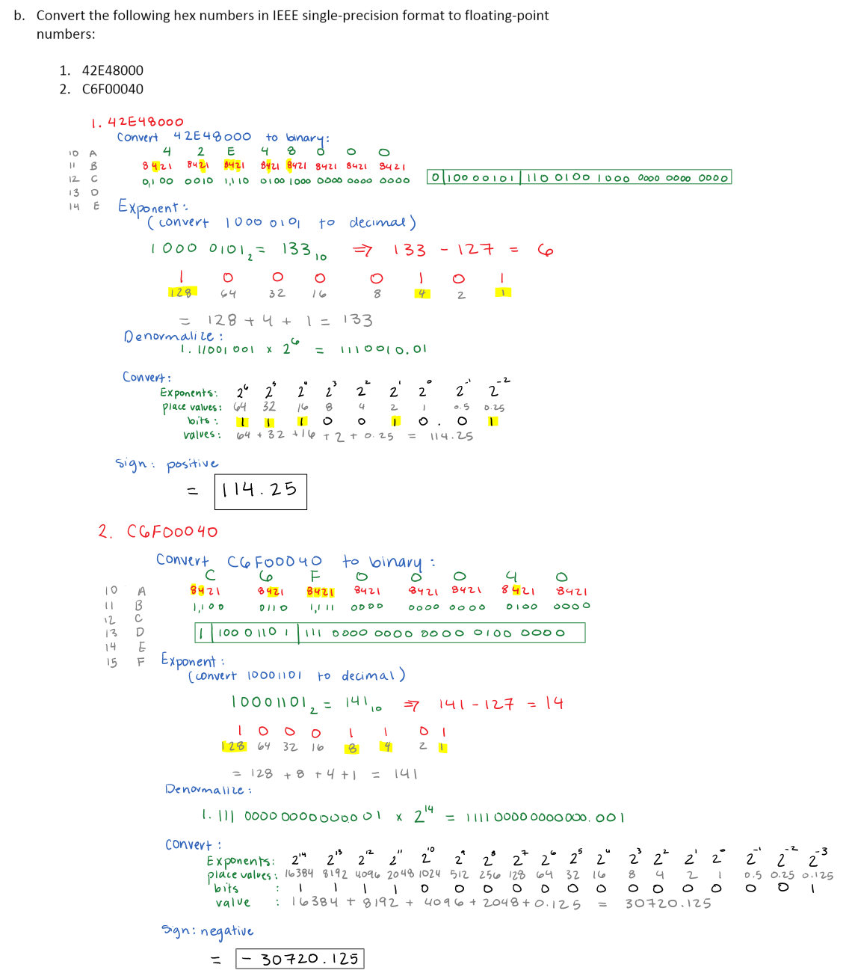

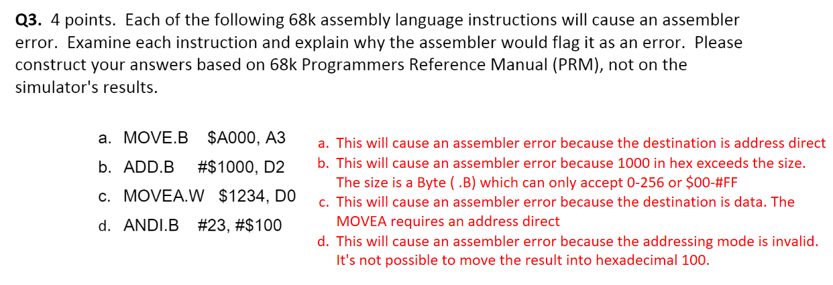

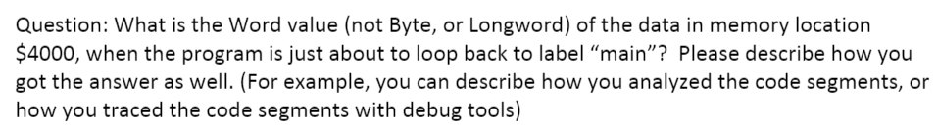

The word value of the data in memory location $4000 is 4515. I got this by using Easy68K and assembling the source. From there I clicked on view and then memory to see the word value at memory location $4000. To double check that this is indeed the correct word value, I traced through the code and got to AND.W D3,(Al) and that where it compared 4F17 and 5555 which was indeed 4515.

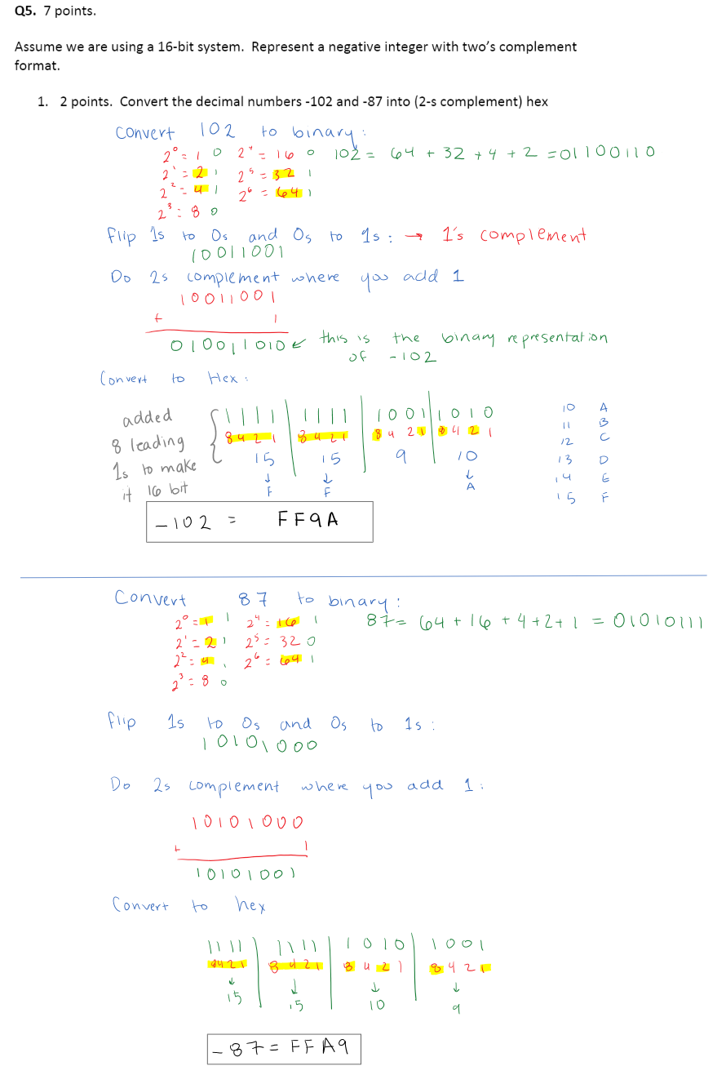



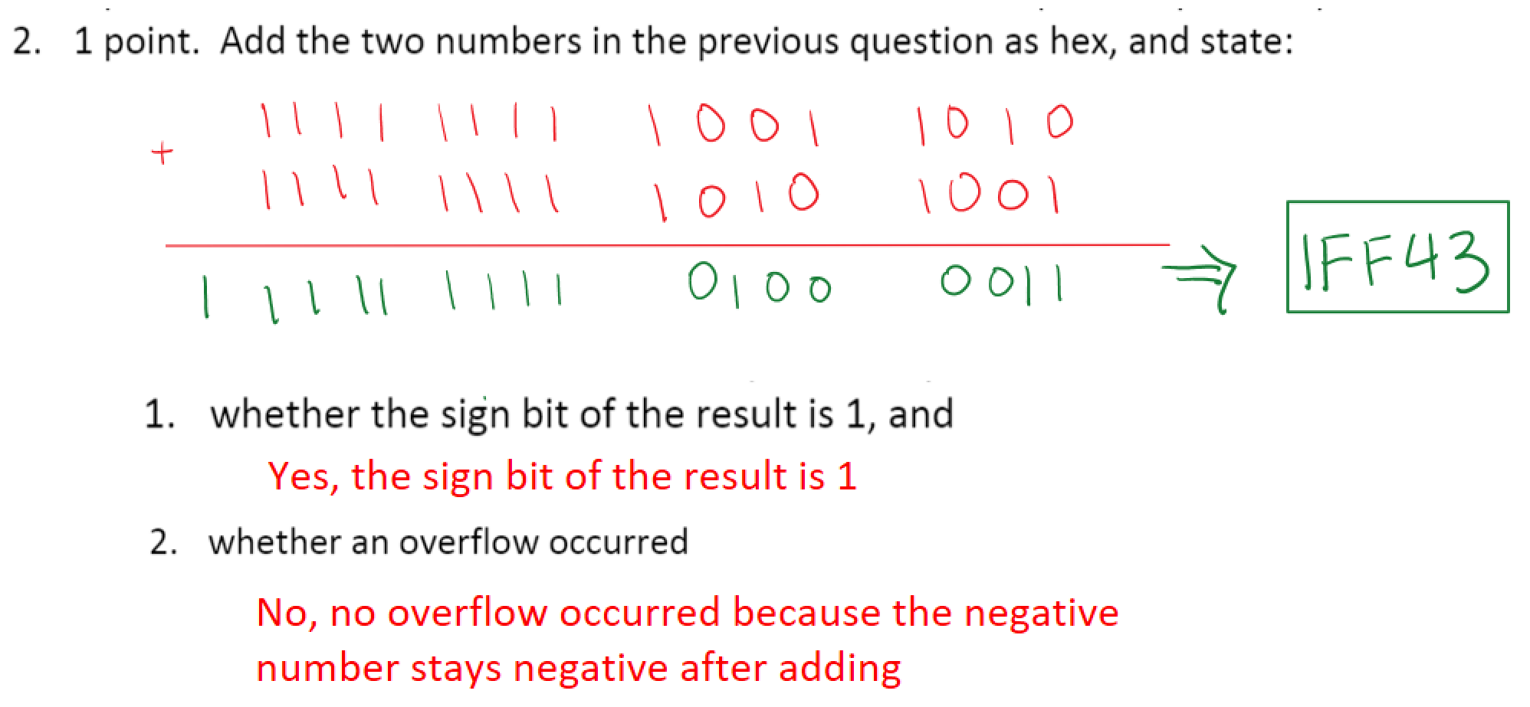



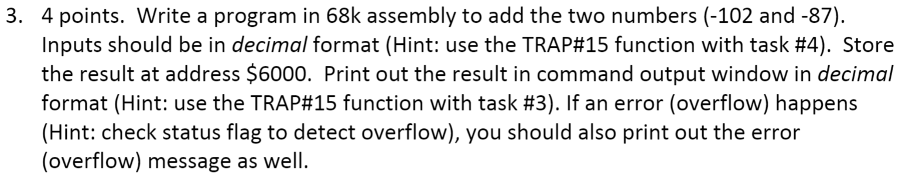

I have attached HW1Q5.X68 and HW1Q5.L68 on canvas.

Screenshot of the code is on the next page.

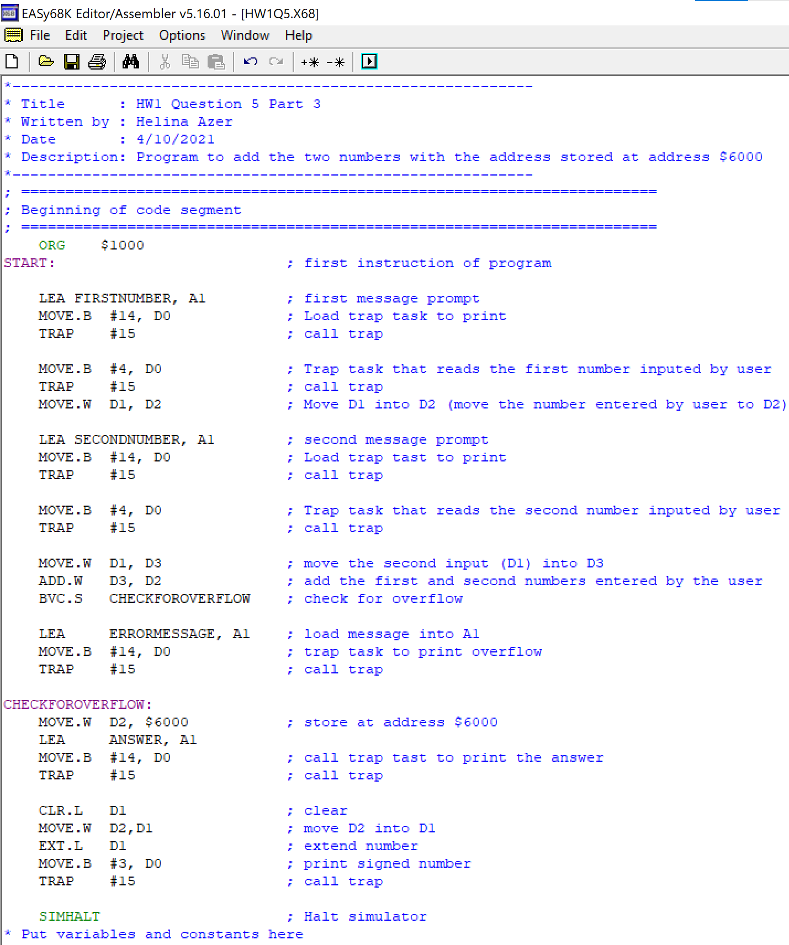

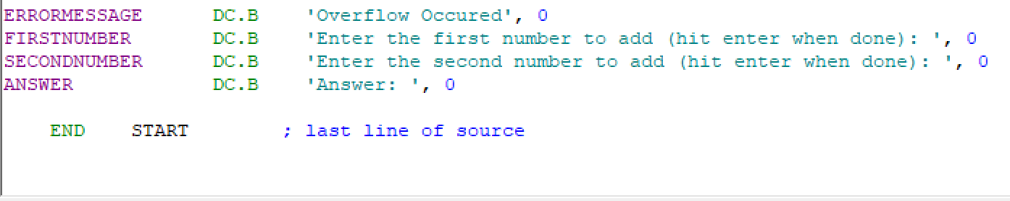

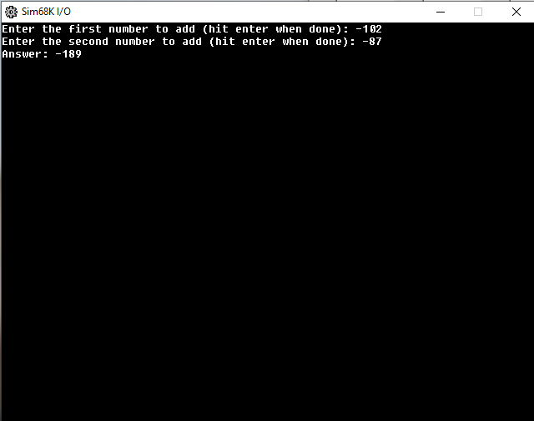

When adding -102 and -87, I get -189 which is the correct answer

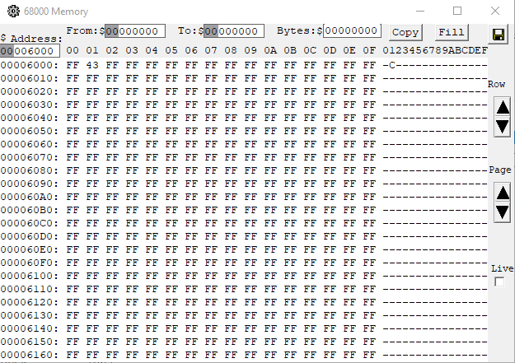

Memory at

address $6000