 | Quality Assurance |  |  | Document #: TRV-  Rev #:0  Rev Date:
TITLE: Traveler
Issued by:  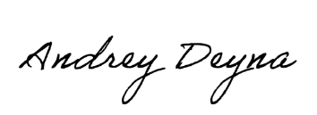  General Forman | Reviewed by:  Project Manager | Approved by:  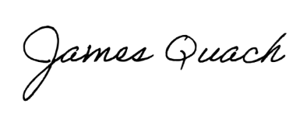  General Manager | DATE: |  | Page 1 of 2
Project Name: N/A | Customer:
Job Number / P.O.#: | Structure #:
Part / Assembly / Catalog ID: | Start Date:

Step  # | Process Description | Checkpoint | Task Completion Initial & Date | Verification Initials & Date | Pass / Fail  If Fail –  NCR #  Initial & Date
1 | Material Receiving & Verification | - Verify material test reports (MTRs)  - Verify/Record correct heat numbers  - Verify current customer specifications  - Identify existing material if applicable
2 | CNC Processing  (Burn Table /  Angle Master /  Beamline) | - Verify program according to shop drawings  - Verify processed materials according to shop drawings and proper tolerances  - label part numbers  - Full dimensional check of 1st and last piece mark  - Verify marking depth
3 | Pre-Fabrication  (Punching / Drilling / Clipping / Chamfer/ Bevel / Stamping / Sawing/ Shearing) | - Check hole size, chamfer size, bevel size, location, pattern  - Deber sharp edges  - Verify stamp location, depth, and size  - Double check layout when removing material
4 | Additional Pre-Fabrication  Hot and Cold Bending | - Open/Close Bends  - Hot Bend  - Press break operations
5 | Fabrication / Welding | - Layout, layout check, fit-up, fit check, mark weld symbols  - Weld following the proper WPS, In process visual weld inspection  - Use markings to identify welder I.D. of completed welds  - Post weld straightness, and dimensional check  - Mark customer, P.O., line item, total QTY on welded assembly
6 | Final Clean-up | - Weld pick-up  - Break edges  - Preliminary visual inspection
 | QC HOLD | - Weld QC Inspection
7 | Prototype / Assembly/ Dis-Assembly / Final Inventory | - Inventory  - Assembly per erection drawings  - Inspect assembly for interferences, non-conformances, and engineered drawing errors  - Take Photos
 | CUSTOMER INSPECTION HOLD | - Notify customer of project completion (if applicable)
8 | Pre-Galvanizing | - Inventory  - Bundle and tag for galvanizing  - Take photos when shipping to galvanizing
9 | Post-Galvanizing Inspection | - Separate, final inventory, and temporary label materials  - Galvanize touch ups  - Tap & die any threaded bolts & holes (if applicable)  - Inspect stamped marking’s legibility  - Stencil spray piece markings
10 | Bundling and Labeling | - Verify tags, packaging, and bundling documentation  - Follow bundling list and bundle accordingly  - Create boxes per bundling list  - Mark and tag all boxes and bundles according to documentation
11 | Final Shipping Inspection | - Verify all material reflects documentation and tags  - Final visual inspection  - Take photos when loaded on shipping truck

 | Quality Assurance | Document #: TRV-  Rev #:0
TITLE: Traveler |  |  | Page 2 of 2

Heat Number’s:

