USTHB University – Faculty of Computer Science
Algiers, 2025/2026
Master 1 SII – Module: Agents Technology
Instructor: B. Dellal-Hedjazi

Lab Report – Practical Work 4 (TP4)

Agent Behaviours in JADE

1. Objectives
The objective of this practical work is to study and implement the different types of agent behaviours provided by the JADE (Java Agent Development Framework) multi-agent platform. A behaviour in JADE represents a task that an agent executes. JADE provides a rich hierarchy of behaviour classes, ranging from simple one-shot actions to complex composite structures that can run sub-behaviours in parallel or in sequence.
This session is divided into three exercises:
- Exercise 1 – Agent Migration: create an agent in a remote container and migrate it to the Main-Container using the JADE GUI, printing a message before, during, and after the move.
- Exercise 2 – Primitive Behaviours: implement and test each primitive behaviour class in isolation (Behaviour, OneShotBehaviour, CyclicBehaviour, WakerBehaviour, and TickerBehaviour).
- Exercise 3 – Composite Behaviours: create two agents that each run multiple sub-behaviours in parallel, each sub-behaviour printing a greeting in a different language and repeating three times.

2. Theoretical Background

2.1 JADE Behaviour Architecture
In JADE, an agent's activity is entirely driven by behaviours. When an agent is started, its setup() method is called, during which the programmer registers one or more behaviours by calling addBehaviour(). JADE's internal scheduler then calls the action() method of each active behaviour in a round-robin fashion. This cooperative multi-tasking model means that a behaviour should never block the execution thread (e.g., never call Thread.sleep()); instead, blocking behaviours call block() to suspend themselves until a relevant event (such as an incoming message) occurs.
The key distinction between primitive and composite behaviours is:
- Primitive behaviours encapsulate a single task and are directly scheduled by JADE.
- Composite behaviours contain other behaviours as sub-behaviours and coordinate their execution according to a defined policy (parallel, sequential, or state-machine-based).

2.2 Behaviour Class Summary
Behaviour Class | Description
Behaviour | Base abstract class. Requires implementing action() and done(). Runs indefinitely until done() returns true.
OneShotBehaviour | Executes action() exactly once. done() always returns true immediately after the first execution.
CyclicBehaviour | Executes action() in an infinite loop. done() always returns false; the behaviour never terminates on its own.
WakerBehaviour | Fires onWake() once after a specified delay (in milliseconds). Useful for delayed initialization or timed shutdown.
TickerBehaviour | Fires onTick() repeatedly at a fixed interval (in milliseconds). Useful for periodic monitoring or polling.
ParallelBehaviour | Composite behaviour that runs multiple sub-behaviours concurrently (interleaved by JADE's scheduler). Terminates based on a configurable policy (ALL, ANY, or a specific number).
SequentialBehaviour | Composite behaviour that runs sub-behaviours one after another in the order they were added. Moves to the next only when the current reports done() = true.
FSMBehaviour | Finite State Machine behaviour. Transitions between named states (sub-behaviours) based on registered transition rules, allowing complex control flow.

2.3 Agent Migration in JADE
JADE supports agent mobility through the doMove(Location) method defined in the Agent base class. When this method is called, the agent is serialised, transferred to the target container, and reinstantiated there. The lifecycle callbacks beforeMove() and afterMove() allow the agent to perform cleanup before departure and initialisation after arrival respectively. Migration can also be triggered manually through the JADE GUI by right-clicking an agent and selecting the Move option.

3. Exercise 1 – Agent Migration (Mobile Agent)

3.1 Exercise Description
This exercise demonstrates JADE's agent mobility feature. An agent is created inside a secondary container named container_2. It then migrates to the Main-Container (the JADE platform's default container) using the doMove() method. Three console messages are printed to trace the agent's state: one before the migration is initiated, one during the transition (in beforeMove()), and one after the agent has arrived (in afterMove()).

3.2 How Agent Migration Works in JADE
When doMove(Location) is called, JADE intercepts the request between two behaviour executions, serialises the agent's state, transfers it to the target container over the network, and reinstantiates it there. The agent's AID (Agent Identifier) is preserved throughout the migration. The lifecycle flow is:
- setup() — runs once when the agent is first created in container_2.
- beforeMove() — called by JADE just before serialisation begins; the agent is still in the source container.
- afterMove() — called by JADE after the agent has been reinstantiated in the destination container.
- takeDown() — called when the agent terminates (calls doDelete()).

3.3 Implementation
The agent uses a OneShotBehaviour registered in setup() to trigger the migration. This ensures the move is initiated only after the agent is fully initialised. The DoMove() method (as required by the lab skeleton) wraps the doMove() call and prints a migration message.

package behavpack;

import jade.core.Agent;
import jade.core.Location;
import jade.core.ContainerID;
import jade.core.behaviours.OneShotBehaviour;

public class MobileAgent extends Agent {

protected void setup() {
System.out.println("[BEFORE MOVE] Agent " + getLocalName()
+ " is running in container: " + here().getName());

// Schedule migration to Main-Container after setup
addBehaviour(new OneShotBehaviour(this) {
public void action() {
Location destination = new ContainerID("Main-Container", null);
doMove(destination);
}
});
}

protected void beforeMove() {
System.out.println("[DURING MOVE] Agent " + getLocalName()
+ " is migrating from " + here().getName()
+ " to Main-Container...");
}

protected void afterMove() {
System.out.println("[AFTER MOVE] Agent " + getLocalName()
+ " has arrived in container: " + here().getName());
}

public void DoMove(Location L) {
System.out.println("Migration of agent to " + L.getName());
doMove(L);
}

protected void takeDown() {
System.out.println("Agent " + getLocalName() + " terminated.");
}
}

3.4 JADE GUI – Launching the Agent in container_2
To test agent migration via the JADE GUI:
- Start JADE with the Main-Container and an additional container_2 (using the -container flag with a separate JVM, or by launching a second instance with -container -container-name container_2).
- In the JADE GUI, right-click on container_2 and select New Agent.
- Enter the agent name (e.g., mobileAgent) and the fully qualified class name (e.g., behavpack.MobileAgent), then click OK.
- The agent appears in container_2 and immediately initiates migration to Main-Container.
- Alternatively, right-click on the agent in the GUI and select Move to trigger manual migration.

Screenshots:
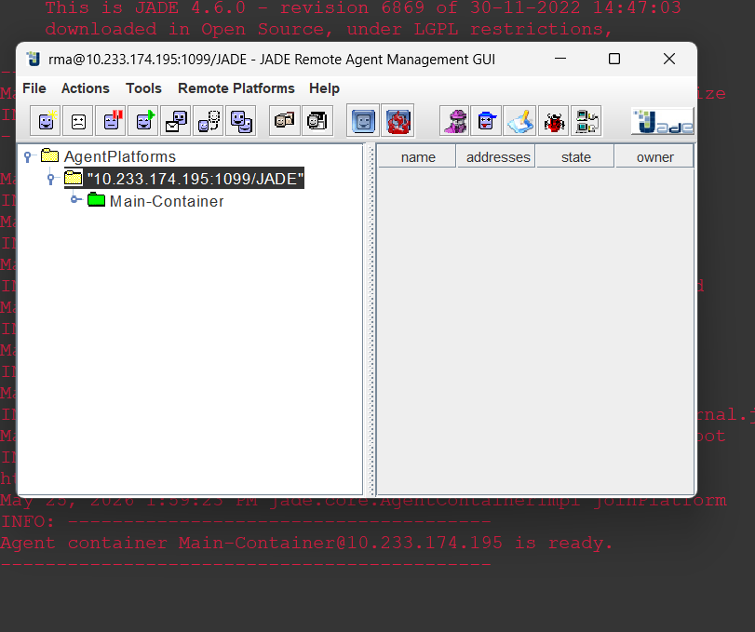
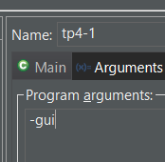
1ST configuration:

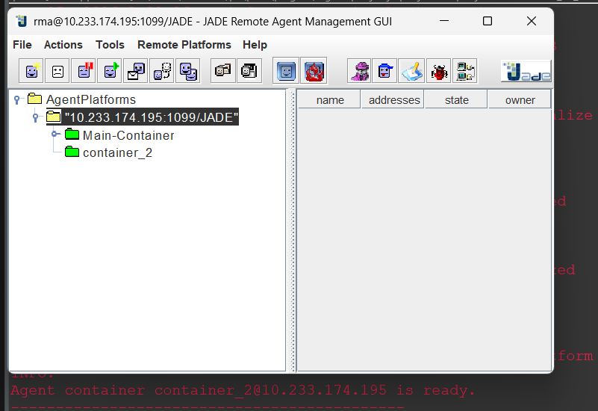
2nd configuration:
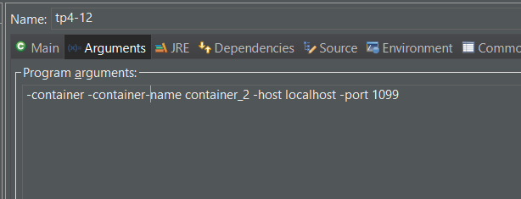

container_2 appear in the JADE GUI automatically.

Creating the agent inside container_2 via GUI:
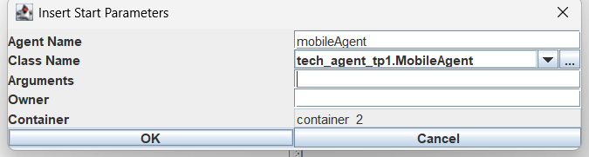
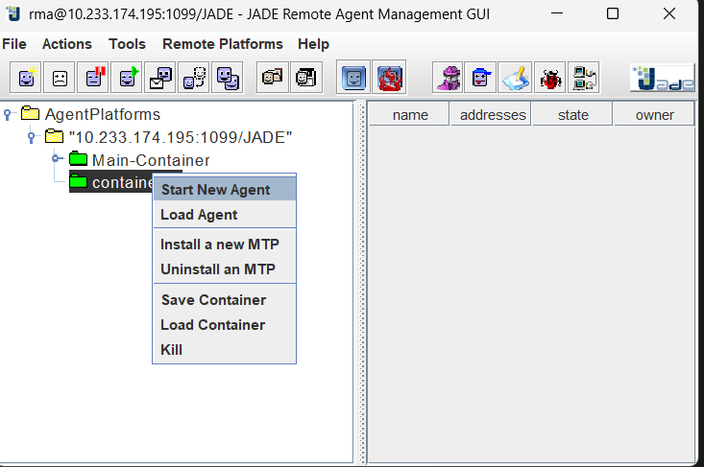

3.5 Output
-- Console 2 (container_2) --
[BEFORE MOVE] Agent mobileAgent is running in container: container_2
[DURING MOVE] Agent mobileAgent is migrating from container_2 to Main-Container...

-- Console 1 (Main-Container) --
[AFTER MOVE] Agent mobileAgent has arrived in container: Main-Container

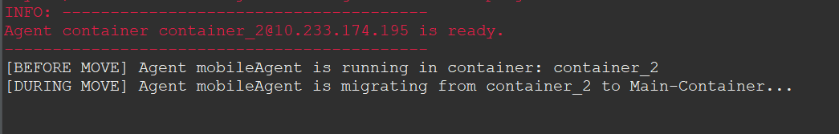
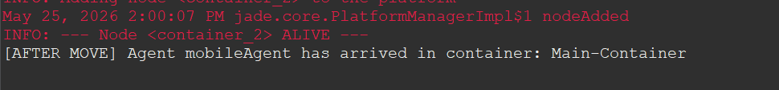
Screenshots:

4. Exercise 2 – Primitive Behaviours

4.1 Exercise Description
This exercise tests each primitive JADE behaviour class individually. A single agent (AgentBehaviour) registers one or more behaviours in its setup() method. Each behaviour prints a descriptive console message so that its scheduling pattern can be observed. Behaviours that run indefinitely (CyclicBehaviour, TickerBehaviour) are commented out in the combined version to avoid interfering with the WakerBehaviour termination; they are each activated alone during individual testing.

4.2 Behaviour-by-Behaviour Analysis
4.2.1 Behaviour (Base Class)
The base Behaviour class requires the programmer to implement both action() (the task to perform) and done() (the termination condition). JADE calls action() repeatedly as long as done() returns false. In the implementation below, a local counter limits execution to three iterations. This pattern is useful for any finite task where the number of repetitions or a completion criterion is known.
4.2.2 OneShotBehaviour
OneShotBehaviour is a specialisation of Behaviour where done() permanently returns true. JADE executes action() exactly once and then removes the behaviour from the agent's active list. This is appropriate for one-time initialisation steps or single actions that do not need to repeat.
4.2.3 CyclicBehaviour
CyclicBehaviour overrides done() to always return false, making the behaviour run indefinitely. The agent's action() method is invoked at every scheduler cycle. To avoid busy-waiting (which would consume 100% CPU), a call to block() suspends the behaviour until an event (such as a new message) wakes it up. This behaviour is ideal for message listeners.
4.2.4 WakerBehaviour
WakerBehaviour takes a delay in milliseconds in its constructor. After the specified delay, JADE calls the onWake() method once, and the behaviour terminates. In the implementation, onWake() calls doDelete() to terminate the entire agent after 6 seconds. This behaviour is useful for watchdog timers, timeouts, or delayed initialisation that must occur after other agents are ready.
4.2.5 TickerBehaviour
TickerBehaviour calls onTick() at a fixed interval specified in milliseconds. Unlike WakerBehaviour, it does not terminate on its own; it continues ticking until the agent itself is terminated or the behaviour is explicitly removed with removeBehaviour(). It is appropriate for periodic tasks such as monitoring the environment, checking for updates, or sending heartbeat signals.

4.3 Comparison Table
Behaviour Type | Terminates? | Typical Use Case
Behaviour | When done() = true | Finite task with explicit end condition
OneShotBehaviour | After first action() | Initialisation, single setup task
CyclicBehaviour | Never (manual) | Continuous listening, monitoring
WakerBehaviour | After timer fires | Delayed one-time action
TickerBehaviour | Never (manual) | Periodic polling or heartbeat

4.4 Implementation
package behavpack;

import jade.core.Agent;
import jade.core.behaviours.*;

public class AgentBehaviour extends Agent {

private int counter = 0;

protected void setup() {
System.out.println("Starting the agent: " + this.getAID().getName());

// --- (1) Base Behaviour: runs until done() returns true ---
addBehaviour(new Behaviour() {
int count = 0;
public void action() {
System.out.println("[Behaviour] Executing action #" + (++count));
}
public boolean done() {
return count >= 3; // stops after 3 executions
}
});

// --- (2) OneShotBehaviour: executes exactly once ---
addBehaviour(new OneShotBehaviour() {
public void action() {
System.out.println("[OneShotBehaviour] This action is executed once.");
}
});

// --- (3) CyclicBehaviour: runs indefinitely ---
// (commented out to avoid blocking; uncomment to test alone)
/*
addBehaviour(new CyclicBehaviour() {
public void action() {
System.out.println("[CyclicBehaviour] This action repeats forever.");
}
});
*/

// --- (4) WakerBehaviour: fires once after 6 seconds ---
addBehaviour(new WakerBehaviour(this, 6000) {
public void onWake() {
System.out.println("[WakerBehaviour] " + getLocalName()
+ " – timer expired, terminating agent.");
doDelete();
}
});

// --- (5) TickerBehaviour: fires every 2 seconds ---
// (commented out; uncomment to test alone)
/*
addBehaviour(new TickerBehaviour(this, 2000) {
protected void onTick() {
++counter;
System.out.println("[TickerBehaviour] Tick #" + counter);
}
});
*/
}

protected void takeDown() {
System.out.println("Agent " + getLocalName() + " terminated.");
}
}

4.5 Execution and Output

INFO: --------------------------------------
Agent container Main-Container@10.233.174.195 is ready.
--------------------------------------------
[Behaviour] Executing action #1
[OneShotBehaviour] This action is executed once.
[Behaviour] Executing action #2
[Behaviour] Executing action #3
[WakerBehaviour] agentBehav – timer expired, terminating agent.
Agent agentBehav terminated.

Screenshot:

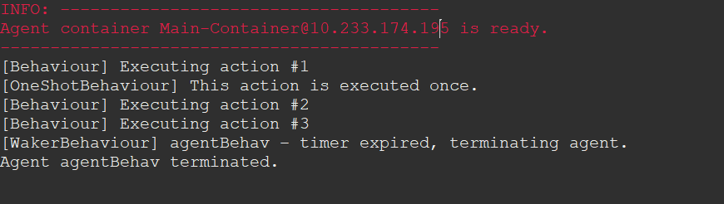

4.6 Key Implementation Notes
- CyclicBehaviour and TickerBehaviour are commented out in the combined agent to prevent them from running indefinitely and interfering with the WakerBehaviour shutdown. Each should be enabled alone for individual testing.
- The DoMove(Location L) method from the lab skeleton is kept in AgentBehaviour to satisfy the lab worksheet requirement; it delegates to JADE's native doMove() and prints the target container name.
- The WakerBehaviour timer (6000 ms) gives the other behaviours enough time to complete several cycles before the agent shuts down.

5. Exercise 3 – Composite Behaviour (Parallel Greetings)

5.1 Exercise Description
This exercise creates two identical agents (a1 and a2), each of which runs seven greeting sub-behaviours in parallel using a ParallelBehaviour. Each sub-behaviour prints a greeting in a different language — Arabic, French, German, Italian, Spanish, Portuguese, and Esperanto — three times before terminating. Because JADE interleaves the sub-behaviours of both agents on the same JVM thread, the console output shows messages from a1 and a2 appearing in an interleaved, non-deterministic order that illustrates concurrent execution.

5.2 ParallelBehaviour and Sub-Behaviour Design
The ParallelBehaviour is configured with the WHEN_ALL termination policy, meaning the parent behaviour (and therefore the agent's main task) is considered complete only when every sub-behaviour has finished. Each sub-behaviour is created by the helper method langHelloBehaviour(String msg), which returns an anonymous Behaviour with:
- action(): prints the greeting in the format agentName -> greeting (iteration/3) and increments the counter i.
- done(): returns true when i reaches 3, causing JADE to remove the sub-behaviour from the parallel scheduler.
Because all seven sub-behaviours are added before the ParallelBehaviour is registered, they start concurrently from the first scheduler cycle.

5.3 Implementation
package behavpack;

import jade.core.Agent;
import jade.core.behaviours.Behaviour;
import jade.core.behaviours.ParallelBehaviour;

public class parallel_behav extends Agent {

@Override
protected void setup() {
System.out.println("I, Agent " + getLocalName()
+ ", my address is " + getAID());
System.out.println("I execute several behaviors in parallel");

// Create a parallel behaviour that terminates when ALL sub-behaviours finish
ParallelBehaviour paraB =
new ParallelBehaviour(ParallelBehaviour.WHEN_ALL);

// Register one sub-behaviour per greeting language
paraB.addSubBehaviour(langHelloBehaviour("\u0627\u0644\u0633\u0644\u0627\u0645 \u0639\u0644\u064a\u0643\u0645"));
paraB.addSubBehaviour(langHelloBehaviour("bonjour"));
paraB.addSubBehaviour(langHelloBehaviour("hallo"));
paraB.addSubBehaviour(langHelloBehaviour("buongiorno"));
paraB.addSubBehaviour(langHelloBehaviour("buenos dias"));
paraB.addSubBehaviour(langHelloBehaviour("Ola"));
paraB.addSubBehaviour(langHelloBehaviour("saluton"));

addBehaviour(paraB);
}

/**
* Creates a sub-behaviour that prints the given greeting message
* three times, then terminates.
*/
private Behaviour langHelloBehaviour(final String msg) {
return new Behaviour(this) {
int i = 0;
@Override
public void action() {
System.out.printf("%s -> %s (%d/3)%n",
getLocalName(), msg, (i + 1));
i++;
}
@Override
public boolean done() {
return i >= 3;
}
};
}

protected void takeDown() {
System.out.println("Agent " + getLocalName() + " terminated.");
}
}

5.4 JADE GUI – Launch Configuration
Both agents use the same class (parallel_behav). They are launched with different names (a1 and a2) via the agent arguments string. In IntelliJ IDEA or Eclipse, this is entered in the Program Arguments or Agent Arguments field of the run configuration.

# IntelliJ IDEA / Eclipse – Agent Arguments field:
-gui a1:behavpack.parallel_behav;a2:behavpack.parallel_behav

# Or programmatically via jade.Boot main class:
java jade.Boot -gui a1:behavpack.parallel_behav a2:behavpack.parallel_behav

5.5 Output
The exact ordering of lines varies between runs because JADE's scheduler interleaves sub-behaviours in a round-robin fashion and both agents compete for the same thread. The output below is representative of one execution:

I, Agent a1, my address is ( agent-identifier :name a1@10.233.174.195:1099/JADE :addresses (sequence http://Amanda:7778/acc ))
I execute several behaviors in parallel
I, Agent a2, my address is ( agent-identifier :name a2@10.233.174.195:1099/JADE :addresses (sequence http://Amanda:7778/acc ))
I execute several behaviors in parallel
INFO: --------------------------------------
Agent container Main-Container@10.233.174.195 is ready.
--------------------------------------------
a2 -> السلام عليكم (1/3)
a1 -> السلام عليكم (1/3)
a2 -> bonjour (1/3)
a1 -> bonjour (1/3)
a1 -> hallo (1/3)
a2 -> hallo (1/3)
a2 -> buongiorno (1/3)
a2 -> buenos dias (1/3)
a1 -> buongiorno (1/3)
a2 -> Ola (1/3)
a2 -> saluton (1/3)
a1 -> buenos dias (1/3)
a2 -> السلام عليكم (2/3)
a2 -> bonjour (2/3)
a1 -> Ola (1/3)
a1 -> saluton (1/3)
a2 -> hallo (2/3)
a2 -> buongiorno (2/3)
a2 -> buenos dias (2/3)
a2 -> Ola (2/3)
a1 -> السلام عليكم (2/3)
a1 -> bonjour (2/3)
a2 -> saluton (2/3)
a1 -> hallo (2/3)
a2 -> السلام عليكم (3/3)
a1 -> buongiorno (2/3)
a2 -> hallo (3/3)
a2 -> buenos dias (3/3)
a2 -> saluton (3/3)
a2 -> buongiorno (3/3)
a2 -> bonjour (3/3)
a2 -> Ola (3/3)
a1 -> buenos dias (2/3)
a1 -> Ola (2/3)
a1 -> saluton (2/3)
a1 -> السلام عليكم (3/3)
a1 -> hallo (3/3)
a1 -> buenos dias (3/3)
a1 -> saluton (3/3)
a1 -> buongiorno (3/3)
a1 -> bonjour (3/3)
a1 -> Ola (3/3)

5.6 Analysis of the Interleaving
The interleaved output pattern is a direct consequence of JADE's cooperative scheduling model. JADE maintains a behaviour queue per agent. At each scheduling cycle, it picks one behaviour, calls its action() method, and moves to the next. Since two agents (a1 and a2) are running in the same container, their behaviour queues are both served by the same scheduler thread. This produces the observed mixing of a1 and a2 outputs within a single run.
Key observations:
- Both agents print their address and the 'I execute several behaviors in parallel' message before any greeting output, because setup() runs atomically for each agent before behaviours start.
- Within a single agent, sub-behaviours are also interleaved: a1 does not print all greetings for one language before moving to the next; it cycles through all sub-behaviours.
- Greeting (1/3) for all languages appears before (2/3) for all languages within the same agent, reflecting the round-robin sub-behaviour scheduling.

6. Analysis and Discussion

6.1 JADE's Cooperative Scheduling Model
A fundamental constraint in JADE is that all behaviours within a single agent run on the same thread. This means that if a behaviour's action() method takes a long time or calls Thread.sleep(), all other behaviours of that agent (and potentially other agents in the same container) are blocked until it returns. This cooperative scheduling model requires that programmers write short, non-blocking action() methods. The correct alternative to Thread.sleep() is block(), which suspends the behaviour and allows JADE to schedule others.

6.2 Choosing the Right Behaviour Type
Choosing the wrong behaviour type is a common source of bugs in JADE applications:
- Using a base Behaviour with done() always returning false is equivalent to a CyclicBehaviour but adds unnecessary complexity.
- Using a CyclicBehaviour without block() for message listening wastes CPU by spinning in a tight loop.
- Using a OneShotBehaviour for a task that should repeat silently discards subsequent invocations.
- Using WakerBehaviour inside a composite behaviour that may be removed before the timer fires can lead to the onWake() method being called on a detached behaviour — this should be handled defensively.

6.3 Practical Relevance of ParallelBehaviour
In real multi-agent applications, ParallelBehaviour is frequently used to model agents that must simultaneously monitor multiple channels, interact with several other agents, or perform background tasks while processing foreground requests. The three-repetition greeting example, while simple, demonstrates the key property: sub-behaviours are independent and progress asynchronously relative to one another, as evidenced by the interleaved console output.

6.4 Agent Migration Considerations
Agent migration is a powerful but rarely used feature in practical JADE deployments because it requires all containers to be part of the same JADE platform and the agent's state to be fully serialisable. Fields that reference non-serialisable resources (open sockets, database connections) must be re-initialised in afterMove(). In most production systems, agent migration is replaced by message-based coordination, but it remains valuable in scenarios such as load balancing across computing nodes or bringing an agent close to the data it needs to process.

7. Conclusion
This practical work provided a comprehensive exploration of JADE's behaviour framework. Exercise 1 demonstrated agent mobility, showing how an agent can migrate between containers while preserving its identity and printing lifecycle messages at each stage of the move. Exercise 2 examined each primitive behaviour type in isolation, clarifying the practical differences between base, one-shot, cyclic, waker, and ticker behaviours in terms of their execution model and termination conditions. Exercise 3 combined seven greeting sub-behaviours inside a ParallelBehaviour, demonstrating how JADE's cooperative scheduler interleaves concurrent tasks and produces non-deterministic output ordering across two agents.
Together, these exercises establish the foundational programming model for agent behaviour in JADE: every agent activity is a behaviour, behaviours should be non-blocking, and composite behaviours provide the compositional power needed to build complex agent logic from simple, testable sub-tasks.

