USTHB University – Faculty of Computer Science
Algiers, 2025/2026
Master 1 SII – Module: Agents Technology
Instructor: B. Dellal-Hedjazi

Lab Report – Practical Work 5 (TP5)
Directory Facilitator (DF) Agent and Services
1. Objectives
The objective of this practical work is to explore the role of the Directory Facilitator (DF) agent within the JADE multi-agent framework. The DF is a standard FIPA agent that provides a Yellow Pages service: agents can register their capabilities (services) in the DF, and other agents can search for agents that provide a specific type of service. This mechanism decouples agents from one another, since a buyer no longer needs to know the identity of a seller in advance — it discovers it dynamically at runtime.
This session is divided into two exercises:
- Exercise 1: A single buyer agent and a single seller agent communicate directly after both register in the DF (no service description is published; the DF is used purely for registration awareness).
- Exercise 2: A buyer agent dynamically discovers the correct seller by querying the DF using a service type descriptor, out of multiple registered agents offering different services.
2. Theoretical Background
2.1 The Directory Facilitator (DF)
In the FIPA (Foundation for Intelligent Physical Agents) standard, the DF is one of the mandatory components of an Agent Management System (AMS). It acts as a yellow pages service: agents register descriptions of themselves, including the services they offer, and other agents query the DF to discover which agents can fulfil a given need.
In JADE, the DF is accessed through the DFService utility class, which provides static methods to register, deregister, modify, and search agent descriptions. An agent description is represented by a DFAgentDescription object, which can contain one or more ServiceDescription objects. Each ServiceDescription specifies a service type (a string identifier such as "car-selling") and a human-readable service name.
2.2 Key JADE Classes Used
Class | Role
DFAgentDescription | Represents the full description of an agent to be registered in or searched from the DF.
ServiceDescription | Describes a specific service offered by an agent (type, name, properties).
DFService | Static utility class providing register(), deregister(), search() methods.
ACLMessage | FIPA-compliant message exchanged between agents (INFORM, REQUEST, etc.).
CyclicBehaviour | Behaviour that runs repeatedly in a loop, used to continuously listen for incoming messages.
MessageTemplate | Filters incoming messages; e.g., MatchPerformative(ACLMessage.INFORM) accepts only INFORM messages.
AID | Agent Identifier; uniquely identifies an agent on the platform (by local name or full name).

3. Exercise 1 – Car Buyer and Car Seller with DF Registration
3.1 Exercise Description
This exercise implements a two-agent system in which a BuyerAgent and a SellerAgent both register in the JADE Directory Facilitator. The interaction proceeds as follows:
- The BuyerAgent starts, prints its name, and registers in the DF.
- It sends an INFORM message with content "Request for car lists" to the SellerAgent (identified by its local name "seller1").
- It then enters a cyclic behaviour that blocks while waiting for a reply.
- Upon receiving an INFORM message containing a Java serialized object (the car list), it sends a "Bye" reply, prints the car list, and terminates.
- The SellerAgent starts, prints its name, and registers in the DF.
- It enters a cyclic behaviour waiting for messages.
- On receiving "Request for car lists", it serializes an Object array of car brands and sends it back as an INFORM message.
- On receiving "Bye", it replies with "Bye" and terminates.
3.2 Agent Interaction Diagram
The communication flow between the two agents is sequential and straightforward:

BuyerAgent SellerAgent
| |
|--- INFORM ("Request for car lists") -->|
| |
|<-- INFORM (Object[]: car list) --------|
| |
|--- INFORM ("Bye") ------------------->|
| |
|<-- INFORM ("Bye") --------------------|
| |
[terminates] [terminates]

3.3 Implementation – BuyerAgent
The BuyerAgent registers a minimal DFAgentDescription (containing only its AID, no service type). It then immediately sends the car list request to the seller by name. The cyclic behaviour uses setContentObject() and getContentObject() for Java object serialization over ACL messages, which allows passing structured data (arrays, objects) rather than plain strings.

package tech_agent_tp1;
import jade.core.AID;
import jade.core.Agent;
import jade.core.behaviours.CyclicBehaviour;
import jade.domain.DFService;
import jade.domain.FIPAException;
import jade.domain.FIPAAgentManagement.DFAgentDescription;
import jade.lang.acl.ACLMessage;
import jade.lang.acl.MessageTemplate;
import jade.lang.acl.UnreadableException;
public class BuyerAgent extends Agent {
private Object[] cars = null;
protected void setup() {
System.out.println("Starting of agent: " + this.getAID().getName());
try {
DFAgentDescription afd = new DFAgentDescription();
afd.setName(getAID());
DFService.register(this, afd);
System.out.println(getLocalName() + " Registration in the DF directory");
} catch (FIPAException e) { e.printStackTrace(); }
ACLMessage msg = new ACLMessage(ACLMessage.INFORM);
msg.setContent("Request for car lists");
msg.addReceiver(new AID("seller1", AID.ISLOCALNAME));
send(msg);
System.out.println(getLocalName() + " --> Request for car lists");
addBehaviour(new CyclicBehaviour(this) {
public void action() {
ACLMessage msg = receive(
MessageTemplate.MatchPerformative(ACLMessage.INFORM));
if (msg != null) {
try {
if (msg.getContentObject() != null) {
ACLMessage reply = msg.createReply();
reply.setContent("Bye");
send(reply);
cars = (Object[]) msg.getContentObject();
System.out.println("The list of products is: ");
for (int i = 0; i < cars.length; i++)
System.out.println(cars[i]);
} else if ("Bye".equalsIgnoreCase(msg.getContent())) {
System.out.println(getLocalName()+" received Bye, terminating.");
doDelete();
}
} catch (UnreadableException e) { e.printStackTrace(); }
doDelete();
} else { block(); }
}
});
}
protected void takeDown() {
try {
DFService.deregister(this);
System.out.println(getLocalName()+" cancellation of registration with DF");
} catch (FIPAException e) { e.printStackTrace(); }
}
}

3.4 Implementation – SellerAgent
The SellerAgent registers similarly with a basic DFAgentDescription. Its cyclic behaviour reads incoming INFORM messages and branches on the message content: it responds to "Request for car lists" with a serialized Object array, and to "Bye" with a "Bye" reply before terminating.

package tech_agent_tp1;
import java.io.IOException;
import jade.core.Agent;
import jade.core.behaviours.CyclicBehaviour;
import jade.domain.DFService;
import jade.domain.FIPAException;
import jade.domain.FIPAAgentManagement.DFAgentDescription;
import jade.lang.acl.ACLMessage;
import jade.lang.acl.MessageTemplate;
public class SellerAgent extends Agent {
protected void setup() {
System.out.println("Starting of agent: " + this.getAID().getName());
try {
DFAgentDescription afd = new DFAgentDescription();
afd.setName(getAID());
DFService.register(this, afd);
System.out.println(getLocalName() + " Agent registered in DF");
} catch (FIPAException e) { e.printStackTrace(); }
addBehaviour(new CyclicBehaviour() {
public void action() {
ACLMessage msg = receive(
MessageTemplate.MatchPerformative(ACLMessage.INFORM));
if (msg != null) {
if (msg.getContent().equalsIgnoreCase("Request for car lists")) {
ACLMessage reply = msg.createReply();
Object[] cars = {"PORSCHE","LAMBORGHINI","MASERATI",
"CHEVROLET","LAGUNA","ROMEO"};
try { reply.setContentObject(cars); }
catch (IOException e) { e.printStackTrace(); }
myAgent.send(reply);
System.out.println("Sending the list of cars to the customer");
} else if (msg.getContent().equalsIgnoreCase("Bye")) {
ACLMessage reply = msg.createReply();
reply.setContent("Bye");
myAgent.send(reply);
System.out.println(getLocalName() + " replied Bye");
myAgent.doDelete();
}
} else { block(); }
}
});
}
protected void takeDown() {
try {
DFService.deregister(this);
System.out.println(getLocalName()+" cancellation of registration with DF");
} catch (FIPAException e) { e.printStackTrace(); }
}
}

3.5 Key Implementation Points
- Object serialization: The car list is passed as an Object[] via setContentObject() / getContentObject(). This requires the object to implement Serializable — Java arrays are serializable by default.
- MessageTemplate filtering: The CyclicBehaviour filters incoming messages using MessageTemplate.MatchPerformative(ACLMessage.INFORM) to ignore irrelevant messages.
- block() vs doDelete(): The behaviour calls block() when no message is available (suspends the behaviour without consuming CPU), and the agent calls doDelete() to terminate cleanly, which triggers takeDown().
- DF deregistration: The takeDown() method always deregisters from the DF to keep the directory consistent.

4. Exercise 2 – Dynamic Service Discovery with Two Sellers
4.1 Exercise Description
This exercise extends Exercise 1 by introducing a second seller agent that provides a different service (book selling). The goal is for the buyer to automatically discover the correct seller by querying the DF directory, rather than knowing the seller's identity in advance. This demonstrates the true purpose of the DF as a dynamic service registry.
The system involves three agents:
- SellerAgent1: Registers a service of type "car-selling" in the DF and responds to car list requests.
- SellerAgent2: Registers a service of type "book-selling" in the DF. It does not respond to car requests; it acts purely as a decoy to verify that the buyer correctly selects only the car seller.
- BuyerAgent2: Queries the DF for an agent offering a "car-selling" service, retrieves the matching agent's AID, and initiates the car list request interaction as in Exercise 1.
4.2 Agent Interaction Diagram

BuyerAgent2 DF (Directory Facilitator) SellerAgent1 SellerAgent2
| | | |
|--[search car-selling]->| | |
|<--[AID: seller1]-------| | |
| | | |
|---INFORM("Request for car lists")-------------------->| |
| | | |
|<--INFORM(Object[]: car list)--------------------------| |
| | | |
|---INFORM("Bye")------------------------------------------->| |
|<--INFORM("Bye")----------------------------------------------| |
| |
[terminates] [terminates] [unaffected]

4.3 Implementation – SellerAgent1 (Car Selling)
SellerAgent1 registers a ServiceDescription with type set to "car-selling" and name set to "Car Sales Service". The rest of its behaviour is identical to Exercise 1's SellerAgent: it waits for car list requests and responds with a serialized array of car brands.

package tech_agent_tp1;
import java.io.IOException;
import jade.core.Agent;
import jade.core.behaviours.CyclicBehaviour;
import jade.domain.DFService;
import jade.domain.FIPAException;
import jade.domain.FIPAAgentManagement.DFAgentDescription;
import jade.domain.FIPAAgentManagement.ServiceDescription;
import jade.lang.acl.ACLMessage;
import jade.lang.acl.MessageTemplate;
public class SellerAgent1 extends Agent {
protected void setup() {
System.out.println("Starting of agent: " + this.getAID().getName());
try {
DFAgentDescription afd = new DFAgentDescription();
afd.setName(getAID());
ServiceDescription sd = new ServiceDescription();
sd.setType("car-selling");
sd.setName("Car Sales Service");
afd.addServices(sd);
DFService.register(this, afd);
System.out.println(getLocalName()+" registered with service: car-selling");
} catch (FIPAException e) { e.printStackTrace(); }
addBehaviour(new CyclicBehaviour() {
public void action() {
ACLMessage msg = receive(
MessageTemplate.MatchPerformative(ACLMessage.INFORM));
if (msg != null) {
if (msg.getContent().equalsIgnoreCase("Request for car lists")) {
ACLMessage reply = msg.createReply();
Object[] cars = {"PORSCHE","LAMBORGHINI","MASERATI",
"CHEVROLET","LAGUNA","ROMEO"};
try { reply.setContentObject(cars); }
catch (IOException e) { e.printStackTrace(); }
myAgent.send(reply);
System.out.println(getLocalName()+" sent car list to buyer");
} else if (msg.getContent().equalsIgnoreCase("Bye")) {
ACLMessage reply = msg.createReply();
reply.setContent("Bye");
myAgent.send(reply);
myAgent.doDelete();
}
} else { block(); }
}
});
}
protected void takeDown() {
try { DFService.deregister(this); }
catch (FIPAException e) { e.printStackTrace(); }
}
}

4.4 Implementation – SellerAgent2 (Book Selling)
SellerAgent2 registers a ServiceDescription with type "book-selling". It does not handle any messages (its cyclic behaviour simply calls block()). This agent exists solely to demonstrate that the buyer correctly discriminates between agents based on their declared service type, and does not contact unrelated agents.

package tech_agent_tp1;
import jade.core.Agent;
import jade.core.behaviours.CyclicBehaviour;
import jade.domain.DFService;
import jade.domain.FIPAException;
import jade.domain.FIPAAgentManagement.DFAgentDescription;
import jade.domain.FIPAAgentManagement.ServiceDescription;
import jade.lang.acl.ACLMessage;
public class SellerAgent2 extends Agent {
protected void setup() {
System.out.println("Starting of agent: " + this.getAID().getName());
try {
DFAgentDescription afd = new DFAgentDescription();
afd.setName(getAID());
ServiceDescription sd = new ServiceDescription();
sd.setType("book-selling");
sd.setName("Book Sales Service");
afd.addServices(sd);
DFService.register(this, afd);
System.out.println(getLocalName()+" registered with service: book-selling");
} catch (FIPAException e) { e.printStackTrace(); }
addBehaviour(new CyclicBehaviour() {
public void action() { block(); }
});
}
protected void takeDown() {
try { DFService.deregister(this); }
catch (FIPAException e) { e.printStackTrace(); }
}
}

4.5 Implementation – BuyerAgent2 (Service Discovery)
The critical difference in BuyerAgent2 is the DF search step that occurs before any message is sent. A DFAgentDescription template is built containing only a ServiceDescription with the type "car-selling". This template is passed to DFService.search(), which returns all registered agents whose descriptions match. The first matching result's AID is extracted and stored for use as the message recipient.
A key practical issue arose during execution: JADE launches all agents concurrently, so the buyer could search the DF before the sellers had finished registering, yielding no results. This was resolved by wrapping the entire search-and-send logic inside a WakerBehaviour set to fire after 1000 milliseconds.
A second issue was the order of message content checks: calling getContentObject() on a plain-string "Bye" message throws an UnreadableException. The fix is to check msg.getContent() for "Bye" first, and only attempt getContentObject() if that check fails.

package tech_agent_tp1;
import jade.core.AID;
import jade.core.Agent;
import jade.core.behaviours.CyclicBehaviour;
import jade.core.behaviours.WakerBehaviour;
import jade.domain.DFService;
import jade.domain.FIPAException;
import jade.domain.FIPAAgentManagement.DFAgentDescription;
import jade.domain.FIPAAgentManagement.ServiceDescription;
import jade.lang.acl.ACLMessage;
import jade.lang.acl.MessageTemplate;
import jade.lang.acl.UnreadableException;
public class BuyerAgent2 extends Agent {
private AID carSeller = null;
protected void setup() {
System.out.println("Starting of agent: " + this.getAID().getName());
// Wait 1 second to ensure sellers have registered in DF before searching
addBehaviour(new WakerBehaviour(this, 1000) {
protected void onWake() {
DFAgentDescription template = new DFAgentDescription();
ServiceDescription sd = new ServiceDescription();
sd.setType("car-selling");
template.addServices(sd);
try {
DFAgentDescription[] results = DFService.search(myAgent, template);
if (results.length > 0) {
carSeller = results[0].getName();
System.out.println(getLocalName()+" found car seller: "
+ carSeller.getName());
} else {
System.out.println(getLocalName()+" no car seller found in DF!");
doDelete(); return;
}
} catch (FIPAException e) { e.printStackTrace(); }
ACLMessage msg = new ACLMessage(ACLMessage.INFORM);
msg.setContent("Request for car lists");
msg.addReceiver(carSeller);
send(msg);
System.out.println(getLocalName()+" --> sent request to "
+ carSeller.getLocalName());
addBehaviour(new CyclicBehaviour(myAgent) {
public void action() {
ACLMessage msg = receive(
MessageTemplate.MatchPerformative(ACLMessage.INFORM));
if (msg != null) {
try {
// Check for plain string first to avoid UnreadableException
if ("Bye".equalsIgnoreCase(msg.getContent())) {
System.out.println(getLocalName()+" received Bye, terminating.");
doDelete();
} else if (msg.getContentObject() != null) {
Object[] cars = (Object[]) msg.getContentObject();
System.out.println("The list of cars received:");
for (Object car : cars)
System.out.println(" - " + car);
ACLMessage reply = msg.createReply();
reply.setContent("Bye");
send(reply);
}
} catch (UnreadableException e) { e.printStackTrace(); }
} else { block(); }
}
});
}
});
}
protected void takeDown() {
System.out.println(getLocalName() + " terminated.");
}
}

4.6 Key Implementation Points
- ServiceDescription usage: The key addition in Exercise 2 is the ServiceDescription object added to the DFAgentDescription. The service type string (e.g., "car-selling") is the identifier used for matching during DF searches.
- DFService.search() template matching: The search template does not need to be fully populated — only the fields that should match need to be set. Here, only the service type is specified; JADE performs a partial match against all registered descriptions.
- Dynamic AID discovery: The buyer never hardcodes the seller's name. This is the principal advantage of the DF mechanism: if a new car seller is deployed, the buyer would discover it automatically on its next search.
- Graceful absence handling: If DFService.search() returns an empty array (no matching seller found), the buyer calls doDelete() immediately and prints a diagnostic message, avoiding a null pointer exception.
- Scalability: This pattern scales naturally — adding a third seller of type "car-selling" would cause the buyer to contact the first result. More advanced implementations could contact all matching sellers and select based on price or reputation.
5. Execution Instructions
5.1 Exercise 1
Launch JADE with the following agent arguments in the IntelliJ/Eclipse run configuration:

-gui seller1:tech_agent_tp1.SellerAgent buyer:tech_agent_tp1.BuyerAgent

Expected console output:

Starting of agent: seller1@...
seller1 Agent registered in DF
Starting of agent: buyer@...
buyer Registration in the DF directory
buyer --> Request for car lists
Sending the list of cars to the customer
The list of products is:
PORSCHE
LAMBORGHINI
MASERATI
CHEVROLET
LAGUNA
ROMEO
buyer sent Bye
seller1 replied Bye
buyer cancellation of registration with DF
seller1 cancellation of registration with DF

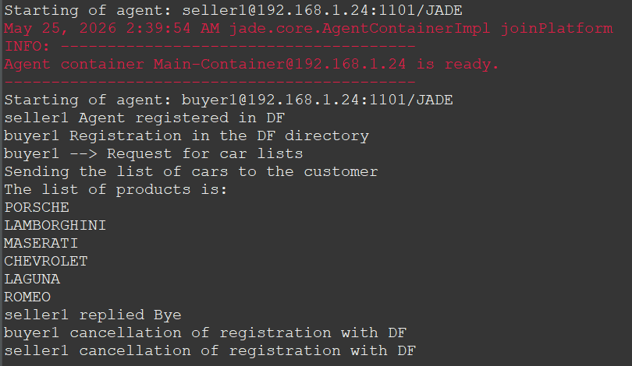
Screenshot :

5.2 Exercise 2
Launch JADE (Eclipse) with three agents separated by semicolons — Eclipse requires semicolons between agent specifications without spaces:

-gui seller1:tech_agent_tp1.SellerAgent1;seller2:tech_agent_tp1.SellerAgent2;buyer:tech_agent_tp1.BuyerAgent2

Important note on timing: JADE starts all agents roughly simultaneously. Without precaution, the BuyerAgent2 may execute its DF search before the sellers have finished registering, resulting in an empty search result. To address this, BuyerAgent2 uses a WakerBehaviour with a 1-second delay before performing the DF search, guaranteeing that both sellers are fully registered by the time the buyer queries the directory.

Actual console output obtained during execution:

Starting of agent: buyer@192.168.1.24:1099/JADE
Starting of agent: seller1@192.168.1.24:1099/JADE
Starting of agent: seller2@192.168.1.24:1099/JADE
seller2 registered with service: book-selling
seller1 registered with service: car-selling
buyer found car seller: seller1@192.168.1.24:1099/JADE
buyer --> sent request to seller1
seller1 sent car list to buyer
The list of cars received:
- PORSCHE
- LAMBORGHINI
- MASERATI
- CHEVROLET
- LAGUNA
- ROMEO
buyer received Bye, terminating.
buyer terminated.

Screenshot:

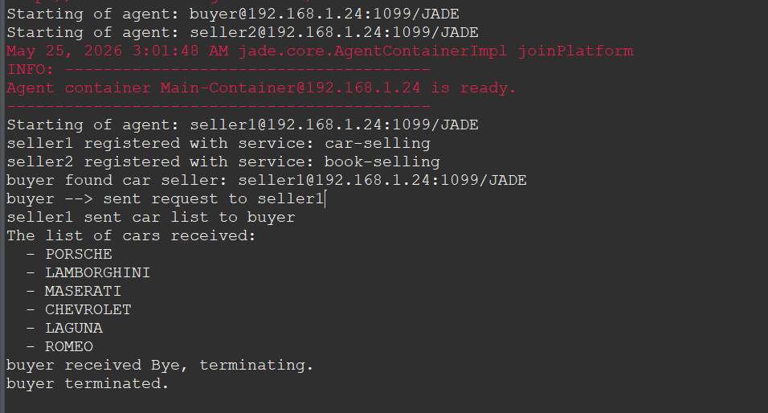

6. Analysis and Discussion
6.1 Difference Between the Two Exercises
The fundamental difference between Exercise 1 and Exercise 2 is the level of coupling between agents. In Exercise 1, the buyer agent hardcodes the seller's local name ("seller1") in the AID constructor. This is a tightly coupled design: if the seller changes its name or is replaced by a different agent, the buyer breaks. In Exercise 2, the buyer uses the DF as an intermediary, querying it for agents that match a functional description. The buyer only knows the service type it needs ("car-selling"), not the identity of who provides it.
6.2 Role of the DF in Multi-Agent Systems
The DF provides the yellow pages functionality described in the FIPA Agent Management specification. In real-world multi-agent systems, agents are often deployed in large, dynamic environments where agents join and leave frequently. The DF allows such systems to remain functional without manual reconfiguration: new agents register their services, and existing agents discover them on demand. This is analogous to a service registry pattern in distributed computing (e.g., Consul, Eureka in microservices architectures).
6.3 Limitations Observed
- No service-level filtering by quality: The DF matches on service type strings only. There is no ranking or quality-of-service negotiation built into the DF itself; that must be implemented at the application level.
- Single-result selection: In Exercise 2, if multiple agents offered "car-selling" services, the buyer would contact only the first one returned by DFService.search(). A more robust buyer would query all matches and select based on additional criteria.
- Timing dependency: The buyers in both exercises assume the sellers are already registered in the DF before they start. In a fully asynchronous deployment, the buyer would need to retry the DF search if no results are returned initially.
7. Conclusion
This practical work demonstrated the use of the JADE Directory Facilitator (DF) to implement dynamic service discovery between agents. Exercise 1 established the basic communication pattern between a buyer and a seller using INFORM messages and Java object serialization for structured data exchange. Exercise 2 extended this pattern by introducing service-typed DF registration and dynamic AID discovery via DFService.search(), fully decoupling the buyer from the specific identity of the seller.
The DF mechanism is a cornerstone of open multi-agent systems: it allows agents to advertise their capabilities and enables other agents to discover service providers without prior knowledge of their identities. This pattern is essential in scalable, dynamic agent environments and is directly aligned with the FIPA Agent Management architecture.

