Issue#1: On updating Phone Number in the template file, Phone Number is not getting stored with + icon.
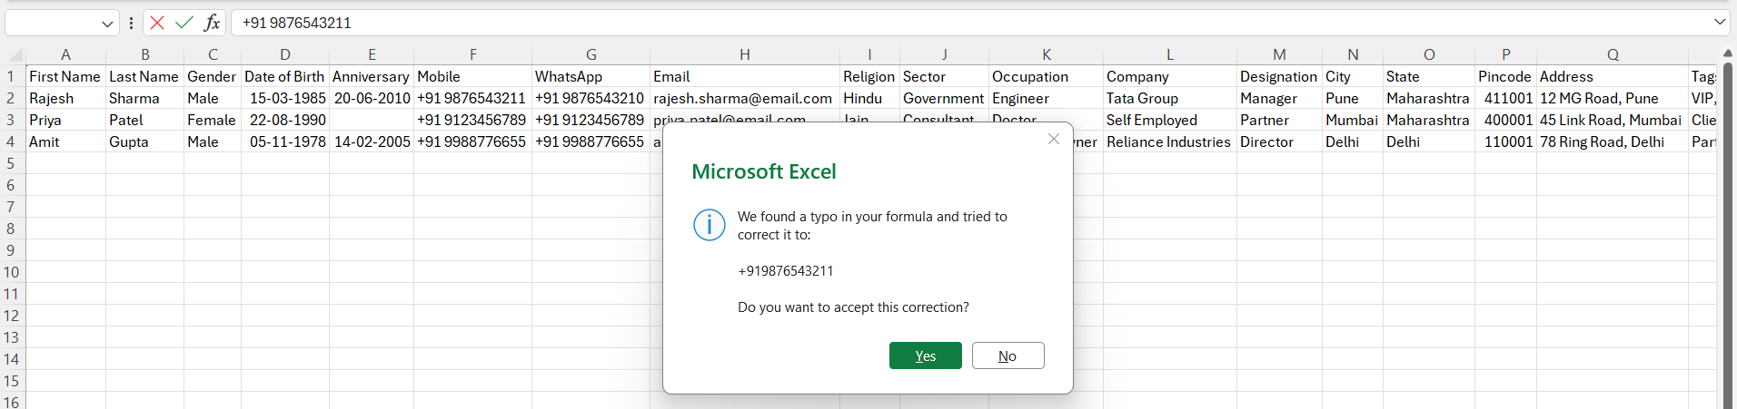

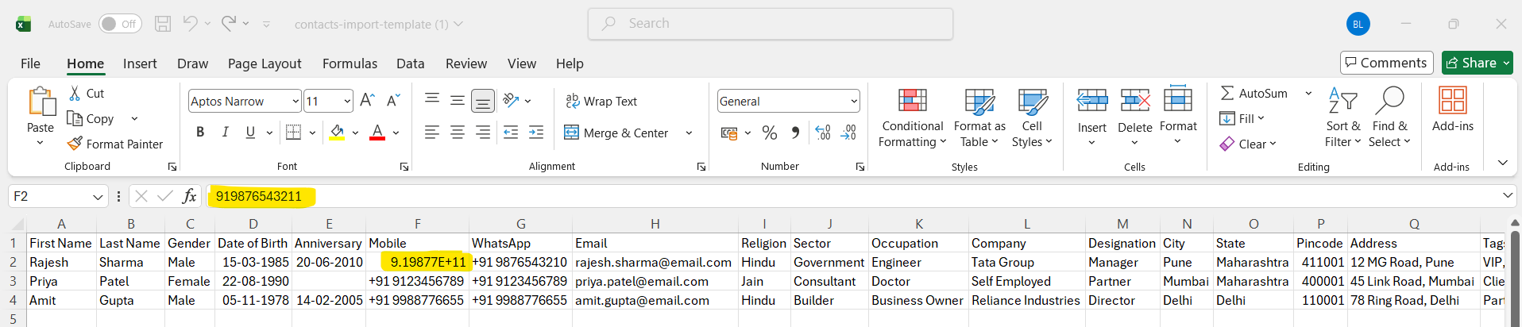

Issue#2: Field values are case sensitive. On uploading contacts with case insensitive values, contacts are not getting created.
Note: This issue is observed for all the dropdown fields when uploaded with case insensitive values.
Add 7 contact details in the csv template. 2 contacts are having Status as ‘Vip’ instead of ‘VIP’:
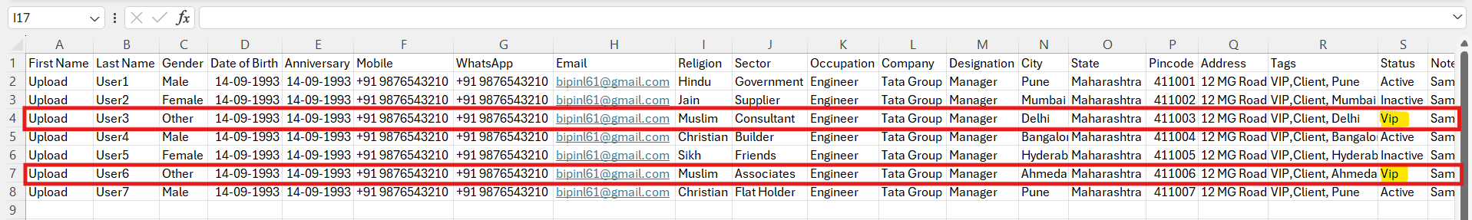

Upload shows success message as- Successfully imported 5 contacts.
The 2 contacts having Status as ‘Vip’ are not created. 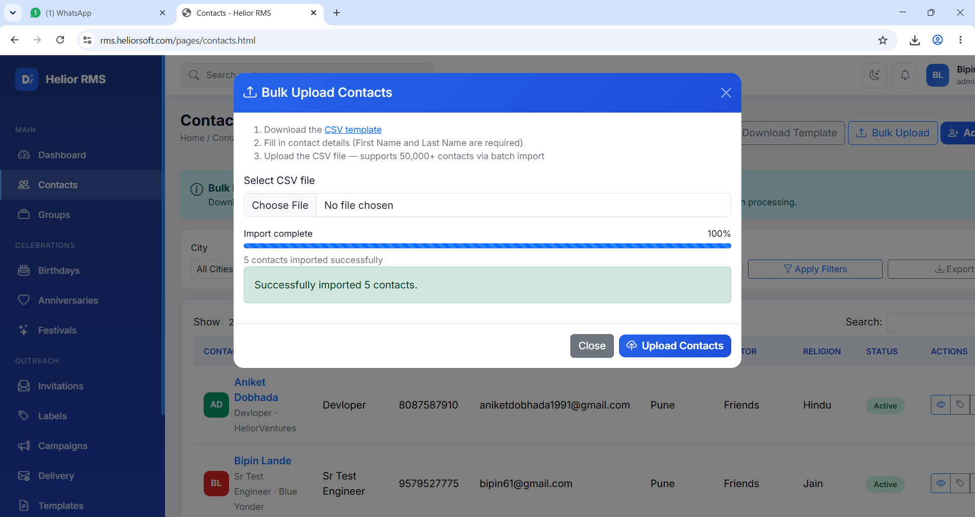

Contacts having status as ‘VIP’ are not created.
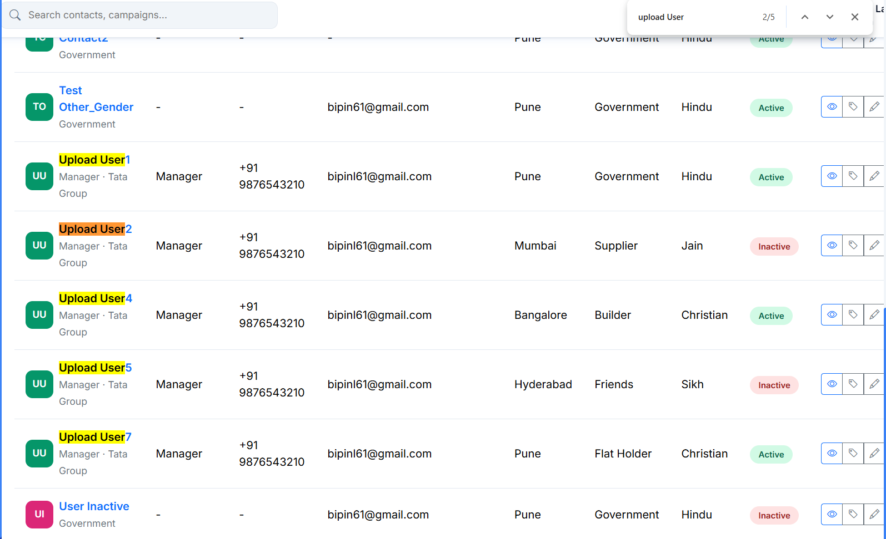

Issue#3: Date field values are showing blank after bulk upload.
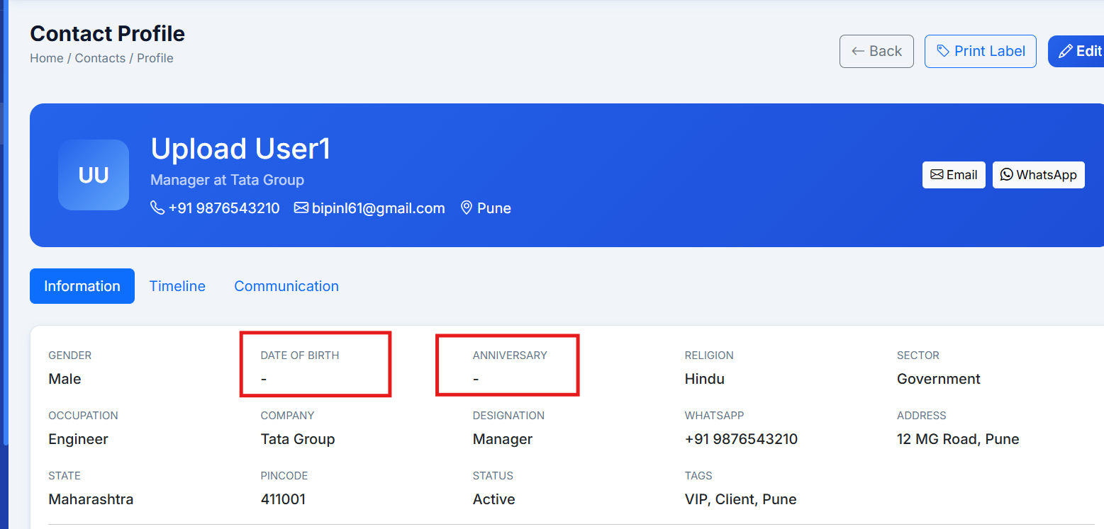

Issue#4: On uploading a blank, contact template file, upload pop-up shows incorrect message.
Upload a blank contact template file.
Pop-up shows correct error message at the top but also it shows import complete as 100% and an incorrect error message as- ‘3 contacts imported successfully’
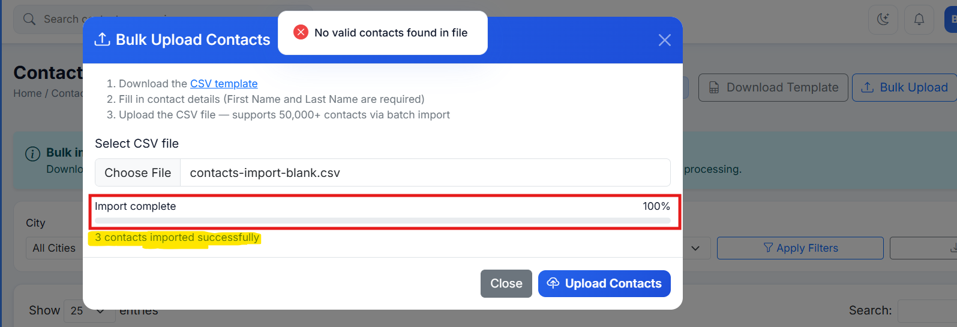

Issue#5: When user tries to upload a blank contacts file, on opening the Bulk Upload pop-up, the blank file remain selected on the Bulk Upload Contacts pop-up.
Upload a blank, contact file. Error gets displayed.
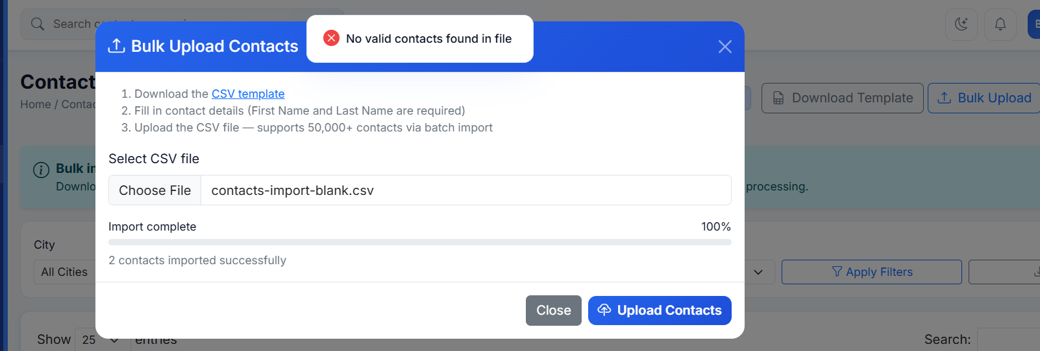
Close the pop-up and open again.
Pop-up still shows the blank contacts file name.
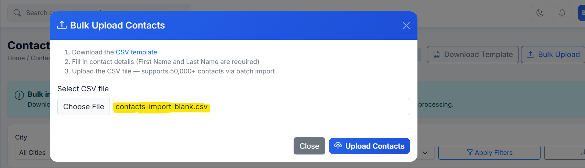

Issue#6: Issues on uploading contact file with incorrect values:
i. On uploading contact file with invalid values, contact is not created but success message is displayed.

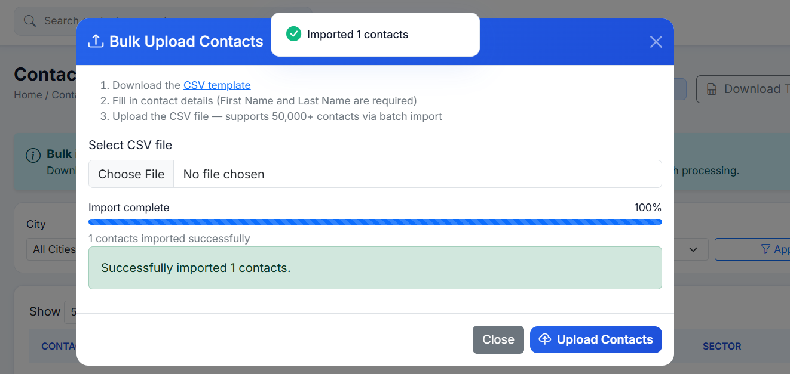
ii. When contact file is uploaded with invalid Email, incorrect error is displayed as- No valid contacts found.
Instead, an error message stating which field is having invalid value can be mentioned in the error message.
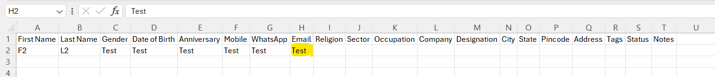
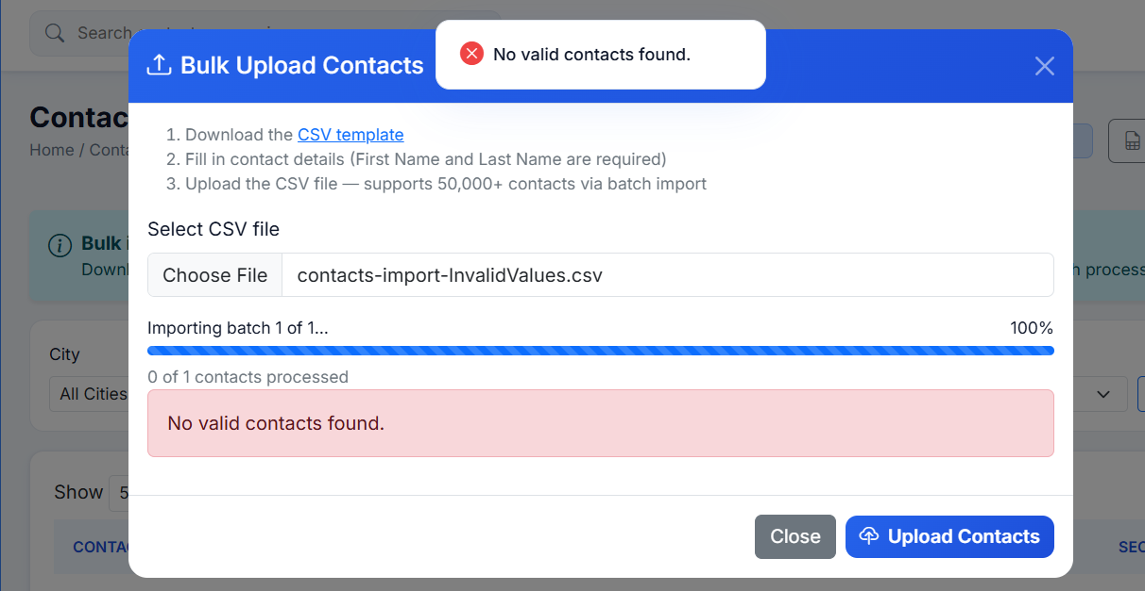

Issue#7: On exporting the Contacts, fields not having value are represented as ‘null’. It can be kept blank.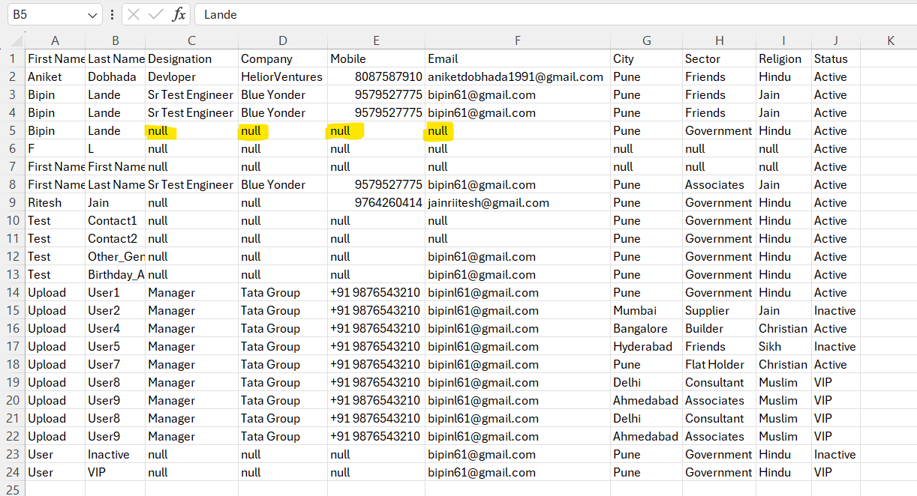

Issue#8: ‘Edit’ action from the Contact Profile is not working.
Select a contact and click on the Edit button.
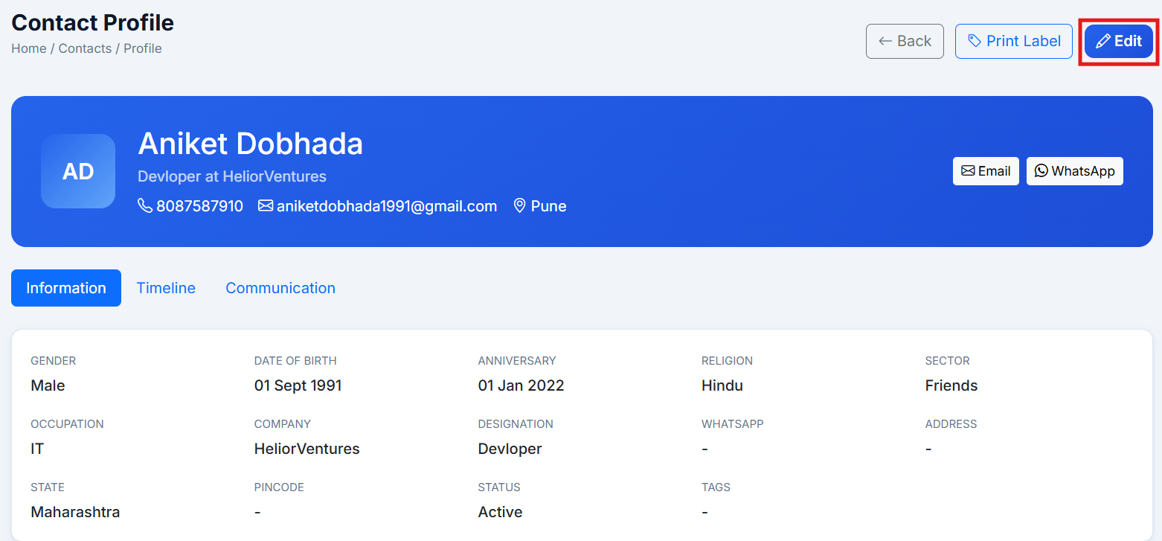

User gets redirected to Contact Management report.
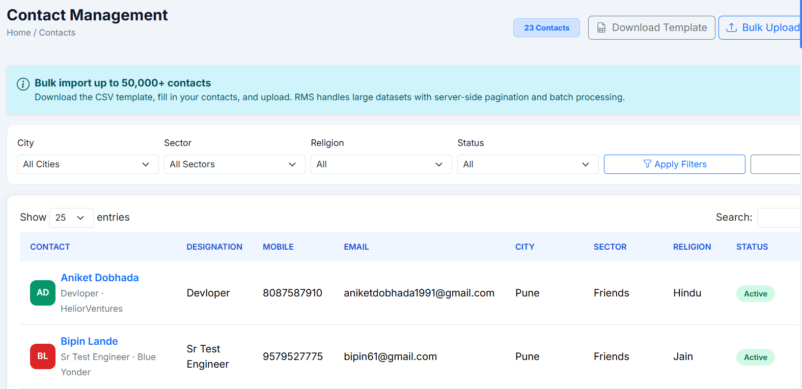

Issue#9: Print Preview can have better spacing.
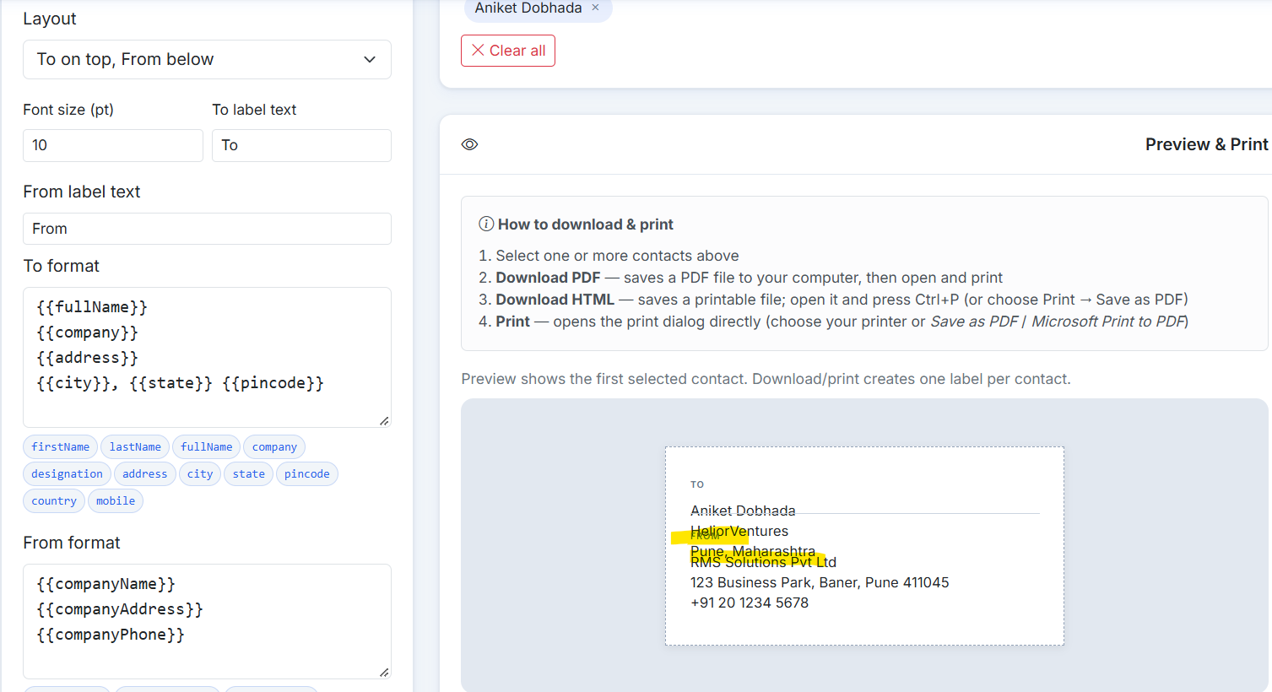

Issue#10: On downloading the pdf, no data is displayed in the pdf.
Click on the ‘Print Label’ button available for a contact and click on the Download PDF button.
A blank pdf gets downloaded.
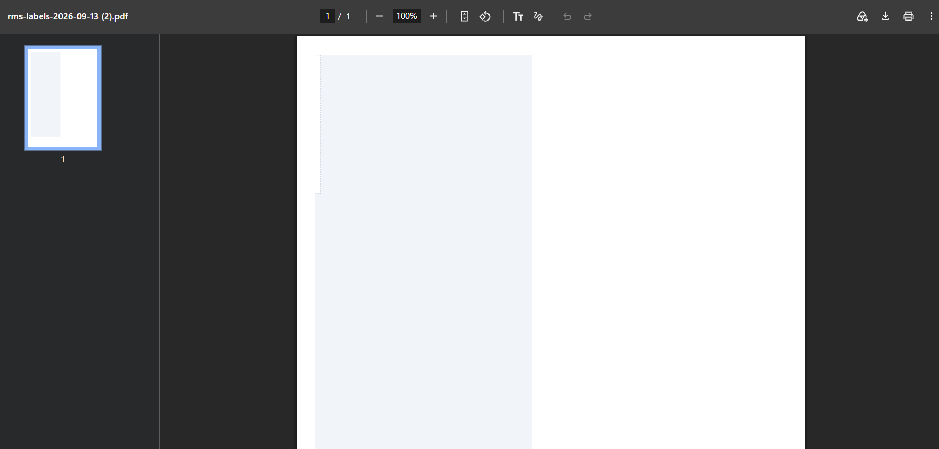
Issue#11: When the HTML is downloaded for a contact not having all the data, a comma is displayed for the fields not having data.
Contact not having all the data.
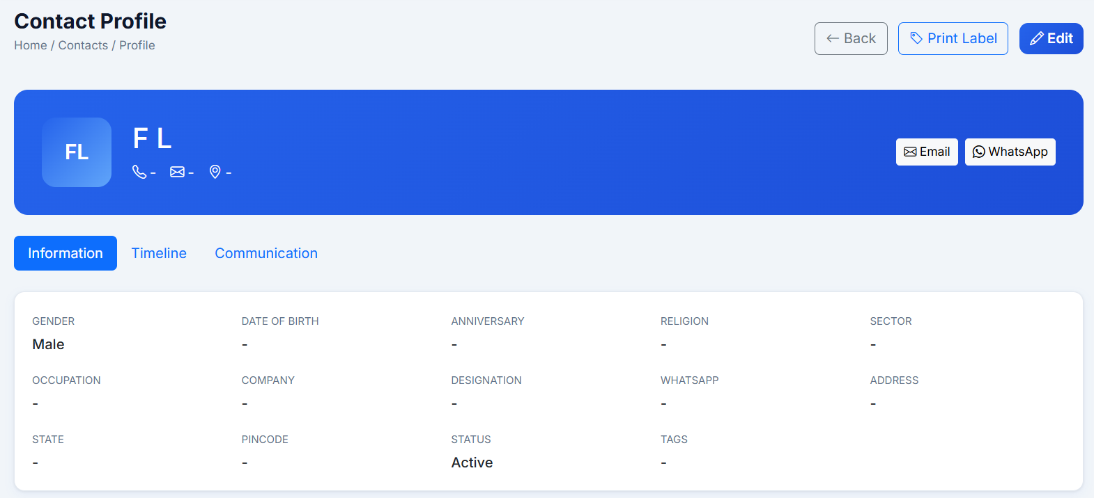

Click on Print Label > Download HTML.
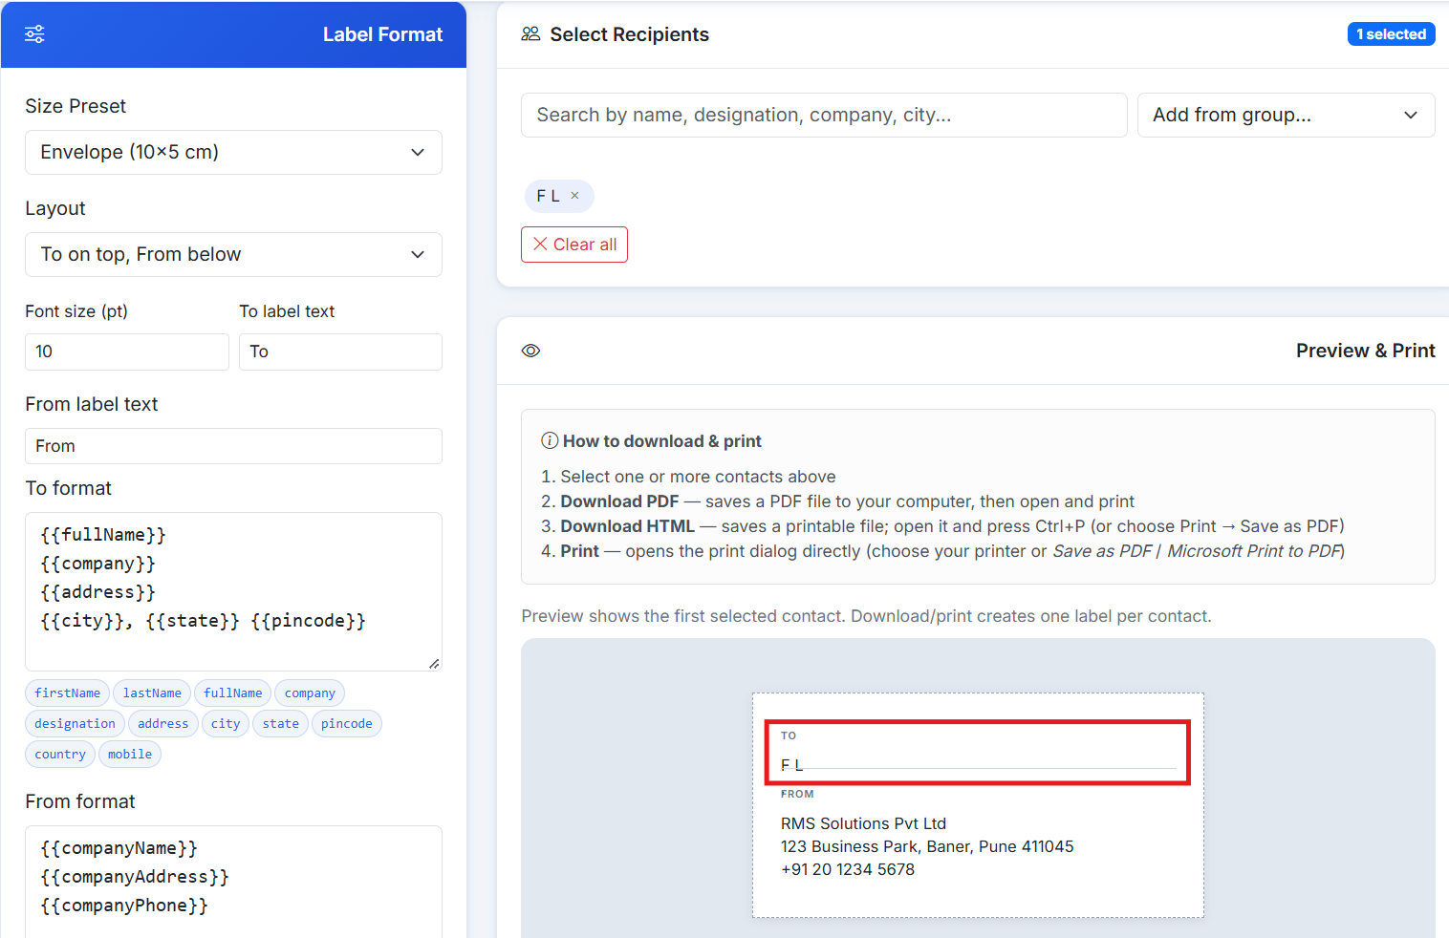

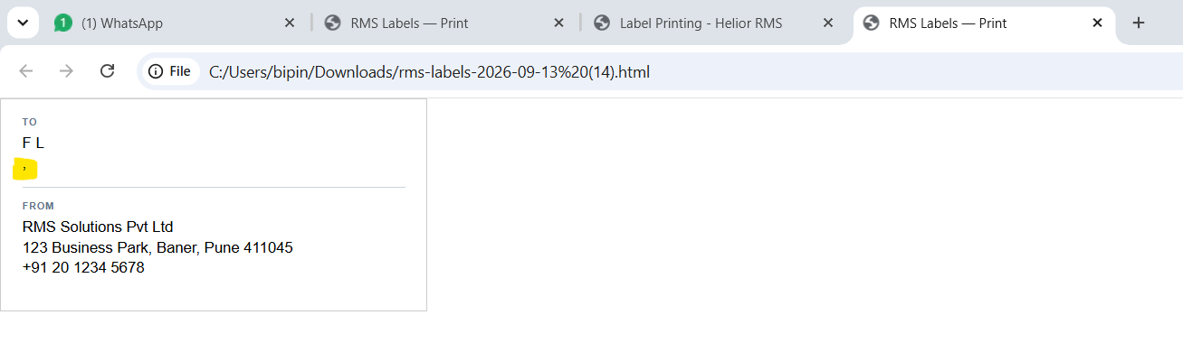

Issue#12: While any report gets loaded, a notification count gets displayed but once the report gets loaded successfully, the notification count gets removed.
Click on the ‘Contacts’, Notification count gets displayed as 3 till the report gets loaded successfully.
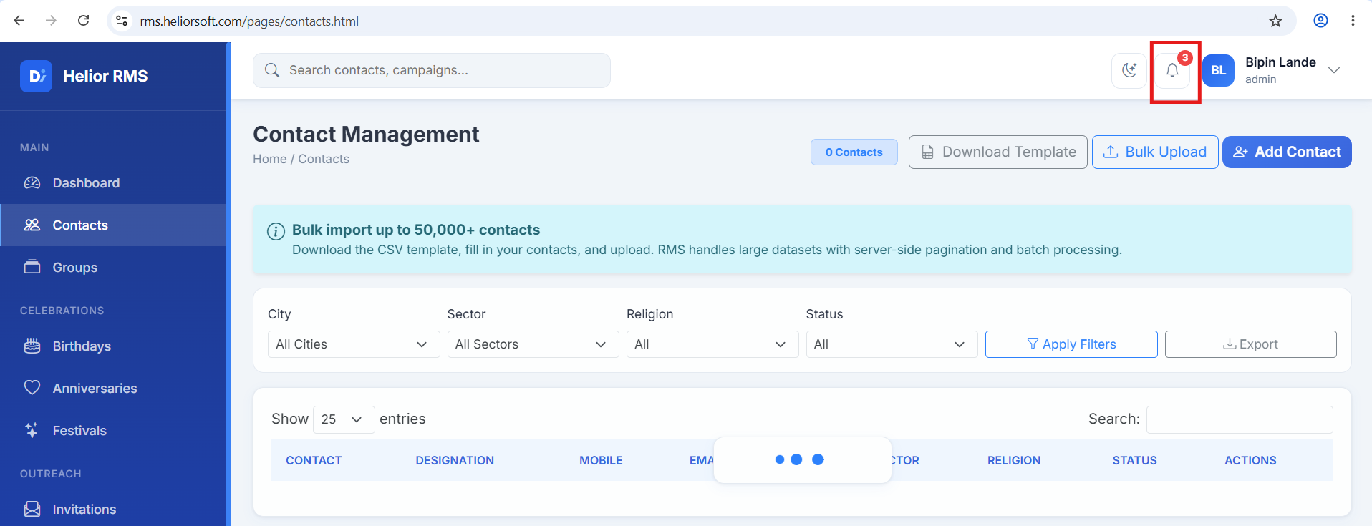

Once the report load successfully, Notification count gets removed.
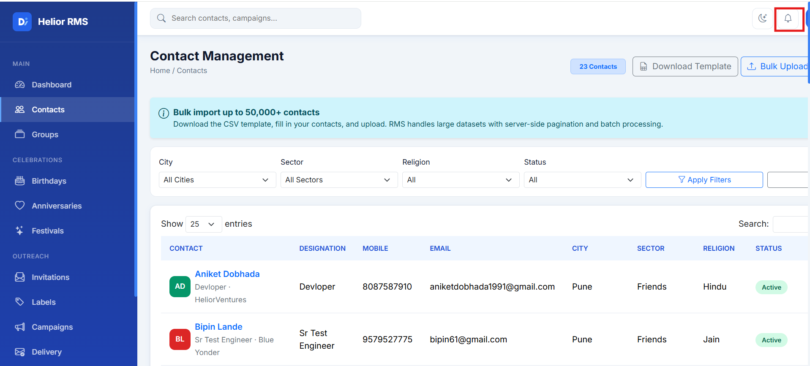

Issue#13: Nothing happens when user clicks on ‘Email’/’WhatsApp’ buttons available under the Contact Profile.
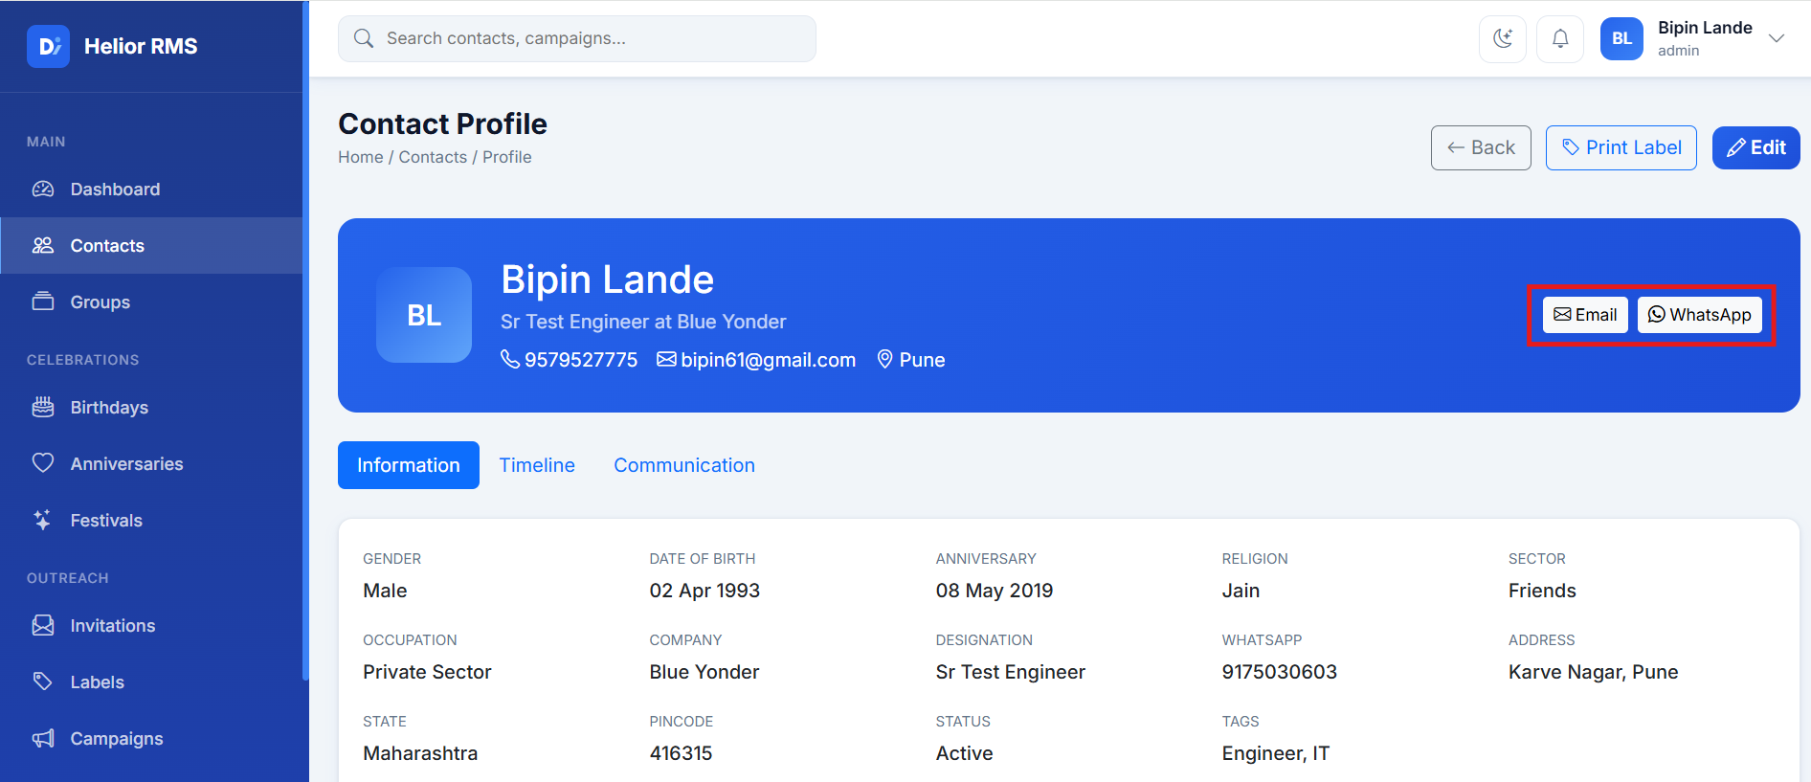

Issue#14: Timeline section under Contact Profile is blank.
What data should be displayed under this section.
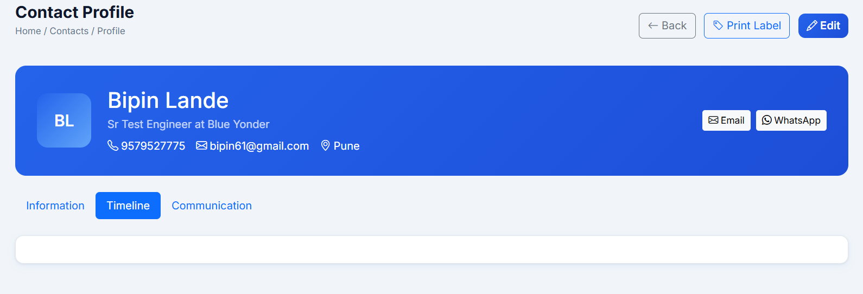

Issue#15: When a group is updated, a message ‘No members in this group’ is displayed on the Group Details pop-up, even if the Group has members/contacts.
Navigate to Groups menu and click on a Group.
Remove a member from the group and click Save Changes.
Group details pop-up gets displayed and it do not show the members from the Group.
