Issue#1: Under ‘Delivery Jobs’, detailed status is not shown for the 1st entry.
Send birthday wishes for a contact.
Message delivery gets failed but the detailed status stating the delivered/Failed/pending is not displayed for the 1st entry.
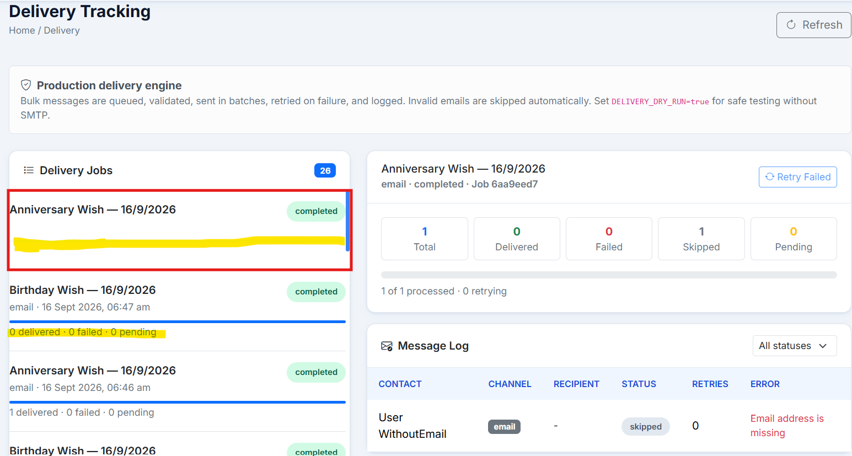
Issue#2: Actions ‘Refresh’ on the Delivery Tracking report are not working.
On clicking the ‘Refresh’ button on the Delivery Tracking report, nothing happens.
We can at least show ‘Loading’ animation to let the user know that report is getting refreshed.
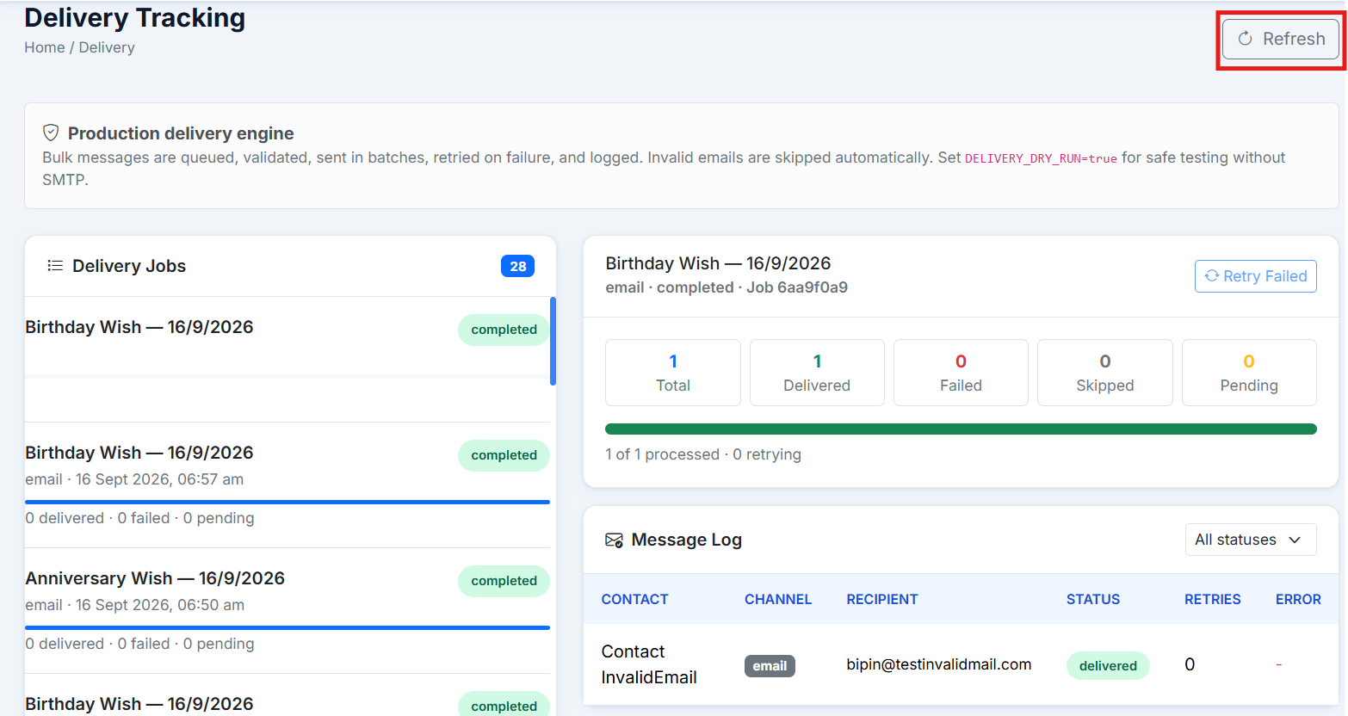

Issue#3: When user tries to send wishes to the user not having an email address, message ‘Queued 1 message for delivery’ gets displayed.
Since this user do not have email address, can we show an error message here?
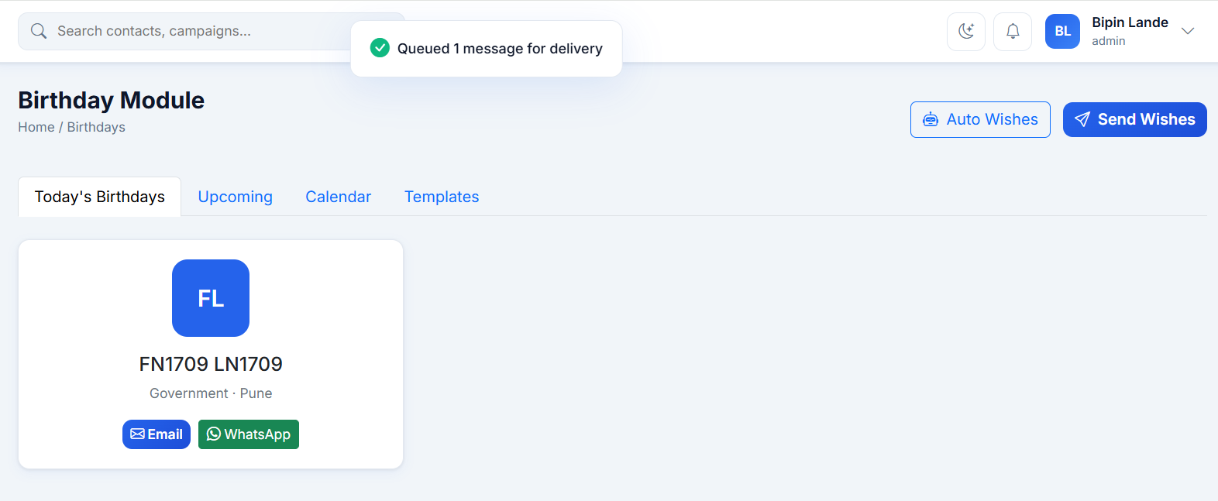

Issue#4: When the Template has placeholders but the contact do not have data for those placeholders, email shows blank space for these place holders.
Template:
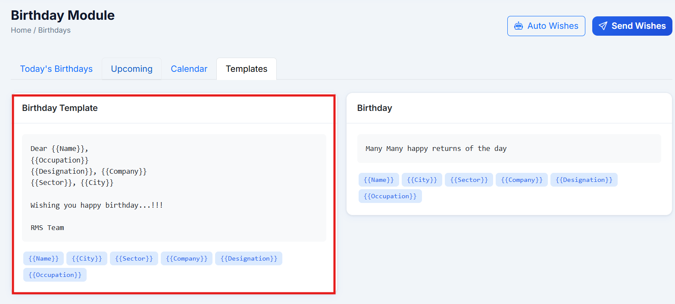

Email has blank space for the place holders not having data for the contact.
Also, there was a comma present between the placeholders and since the data is not available for placeholders but the comma still displays.
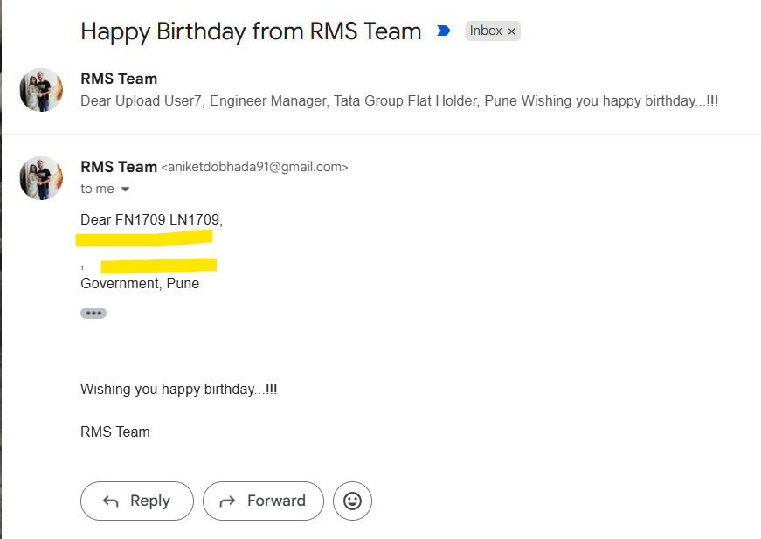
Issue#5: When a template is not available and user tries to send email, Template field layout is broken.
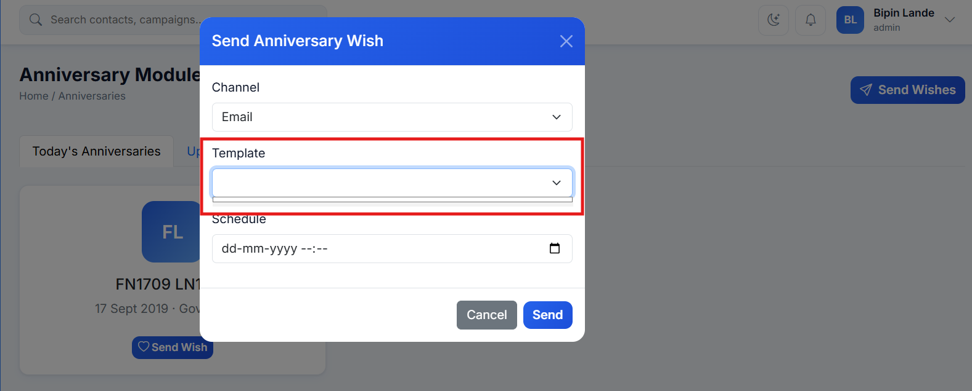

Issue#6: Send wishes using ‘Schedule’ field is not working. Instead of the scheduled time, the email is triggered immediately.
Navigate to Birthdays and click on the Send Wishes button.
Enter date and time 15 mins later than the current time and click on Send Now.
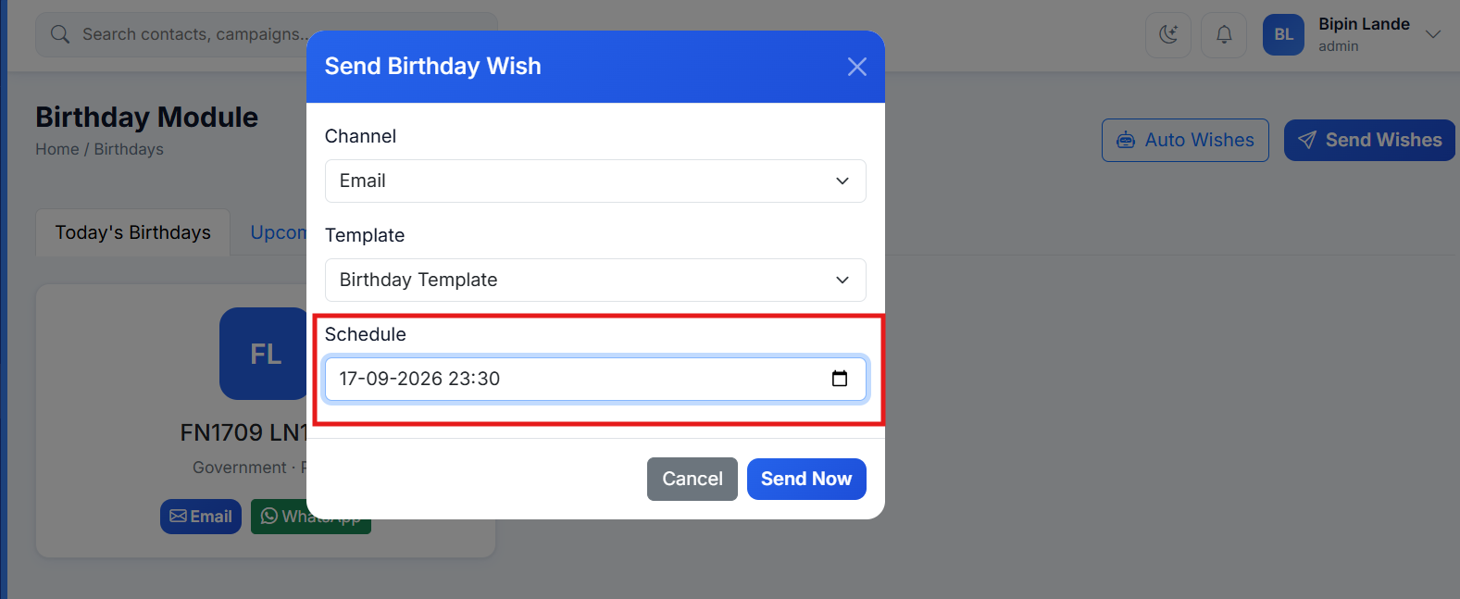
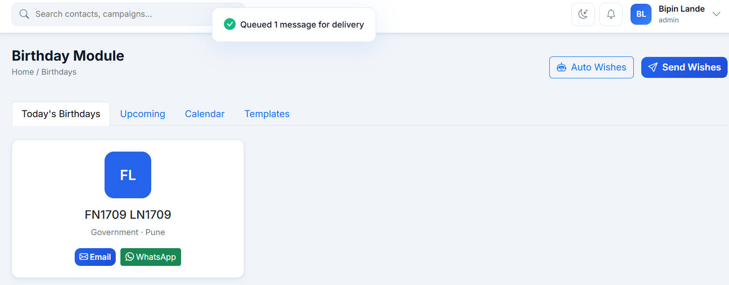
Email is triggered immediately.
