Issue#1: An option should be available to clear the filters.
If user has applied multiple filters, user need to remove each filter one by one to see all the data.
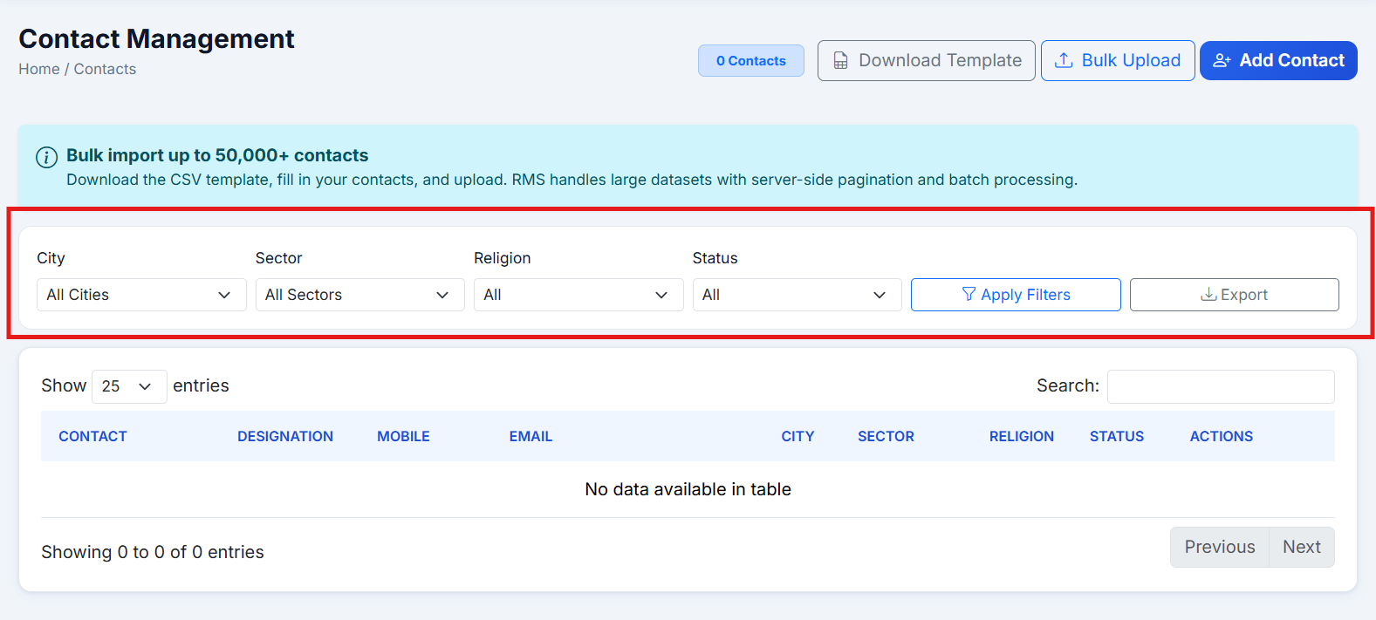
Issue#2: Field validations are not available for the text fields available on the
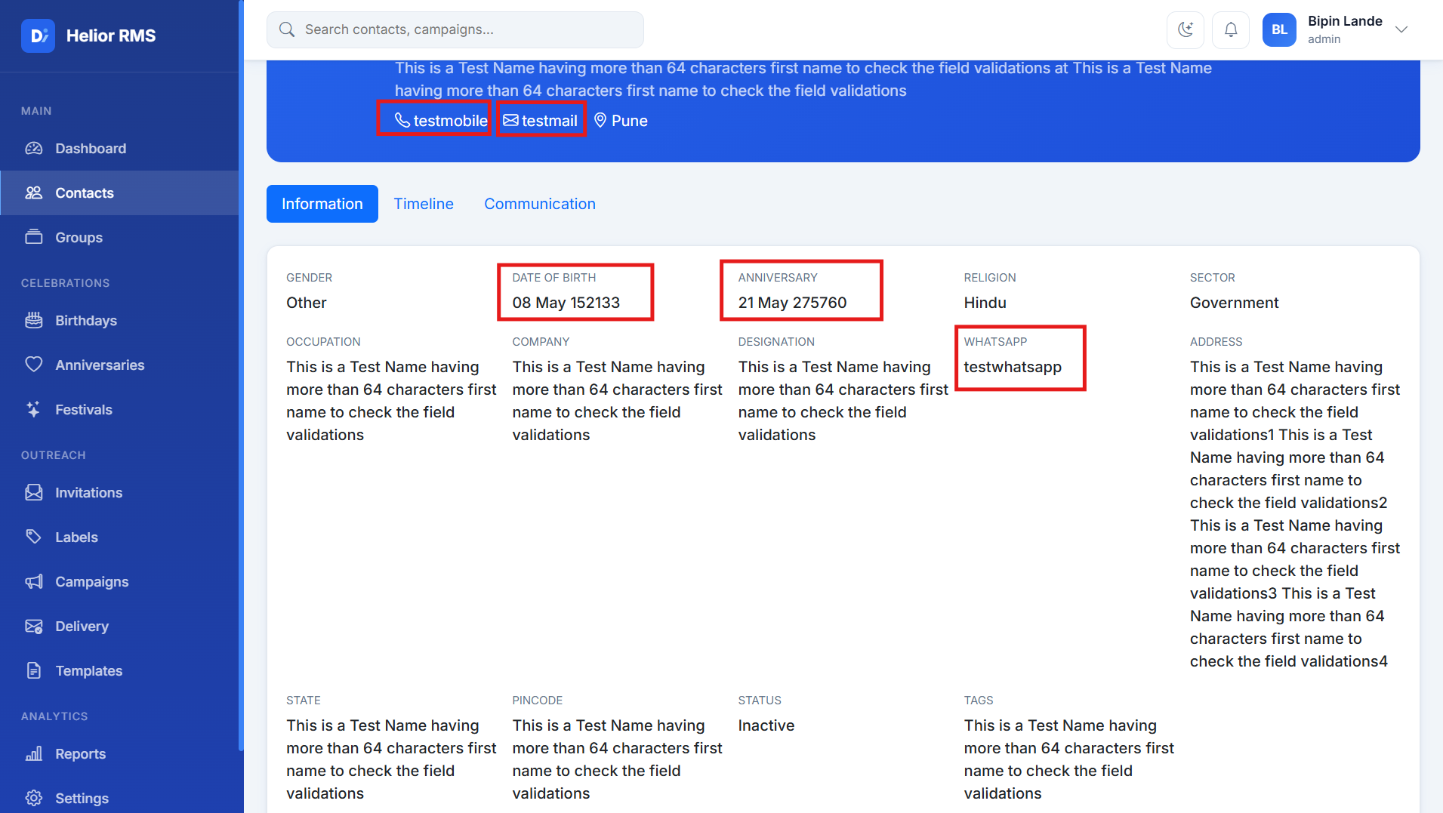

Issue#3: Dashboard is not showing the data.
There are multiple contacts added having birthday/anniversary dates falling today/current month but the dashboard is not getting updated.
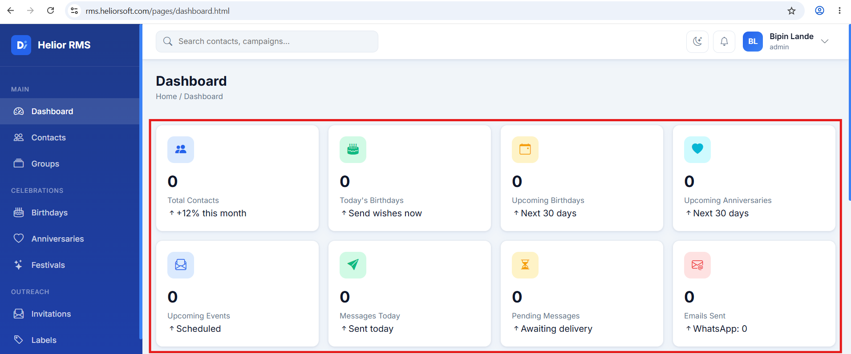

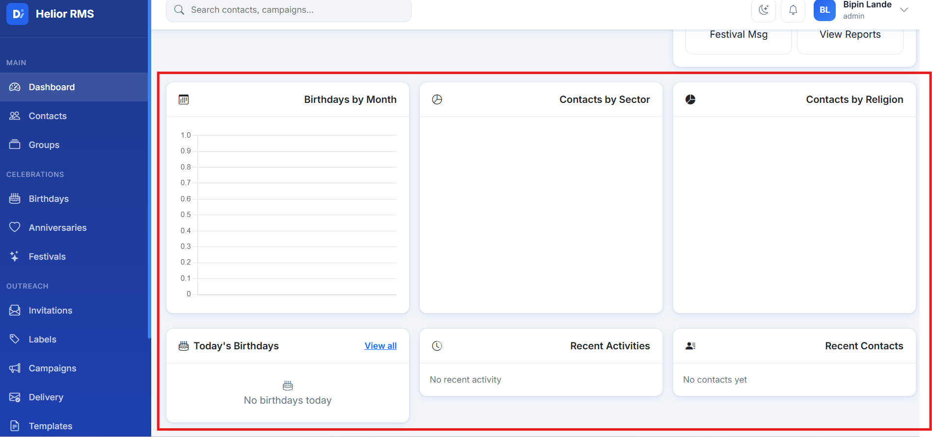

Issue#4: Quick Actions ‘Add Contact’, ‘New Campaign’ redirects user to the respective reports and not on the page to create a new contact/campaign.
Click on Add Contact redirect to Contact Management report:
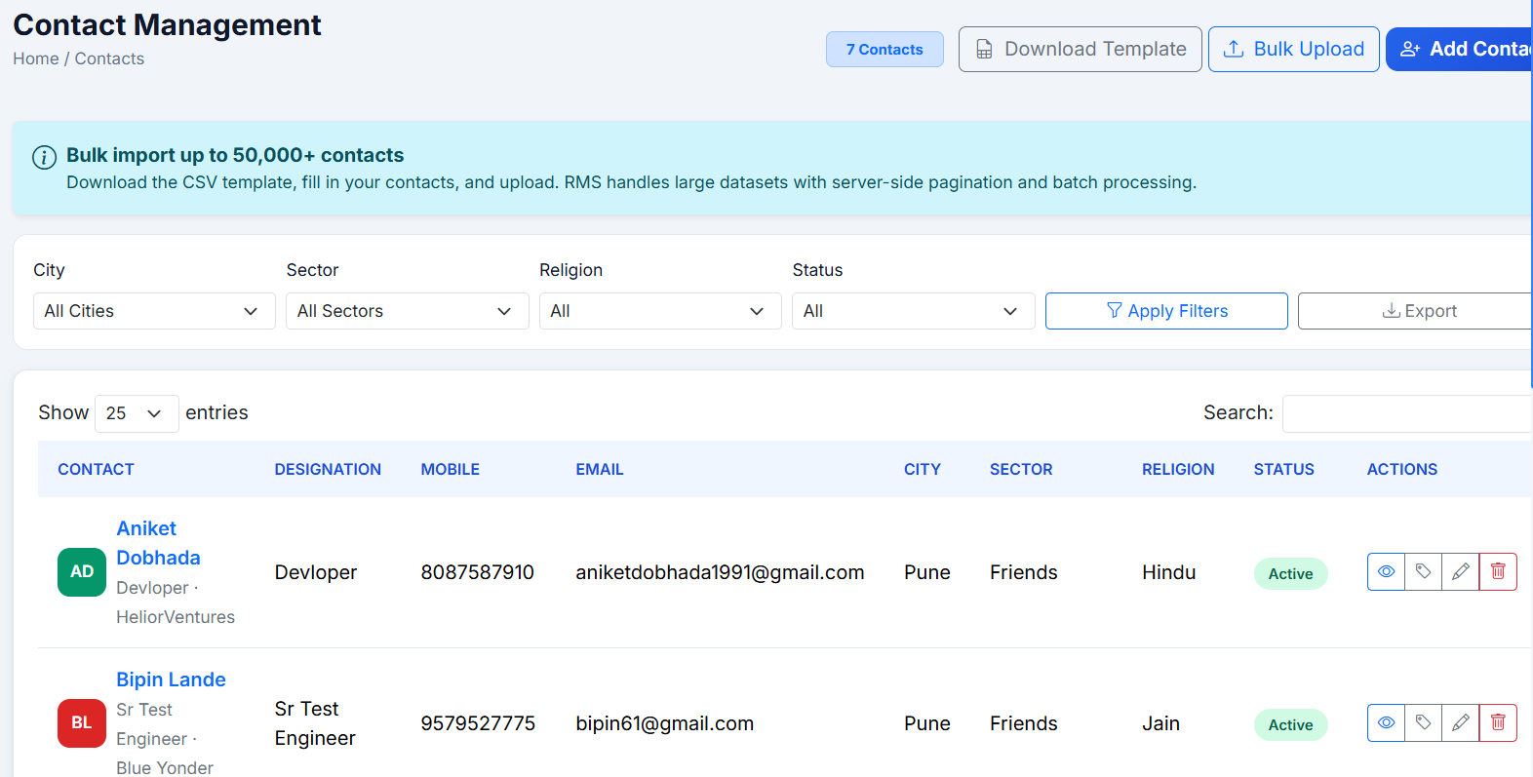
Click on New Campaign redirect to Campaign Management report:
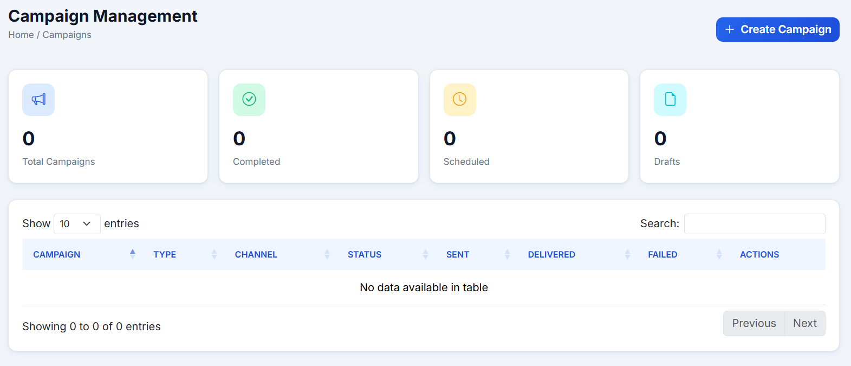

Issue#5: How to edit/update the Campaign.
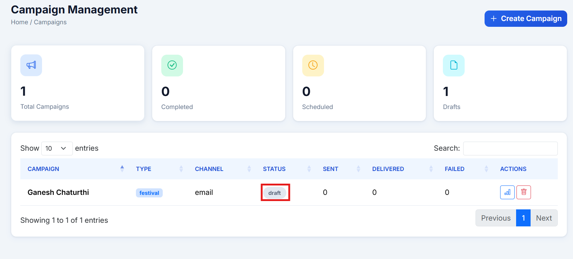

Issue#6: For the campaign having ‘Draft’ state, on performing ‘Delivery’ action, success message gets displayed but the Delivery job is not executed.
If it is expected to not run the delivery for the Campaign having Draft state, this action can be removed for such campains.
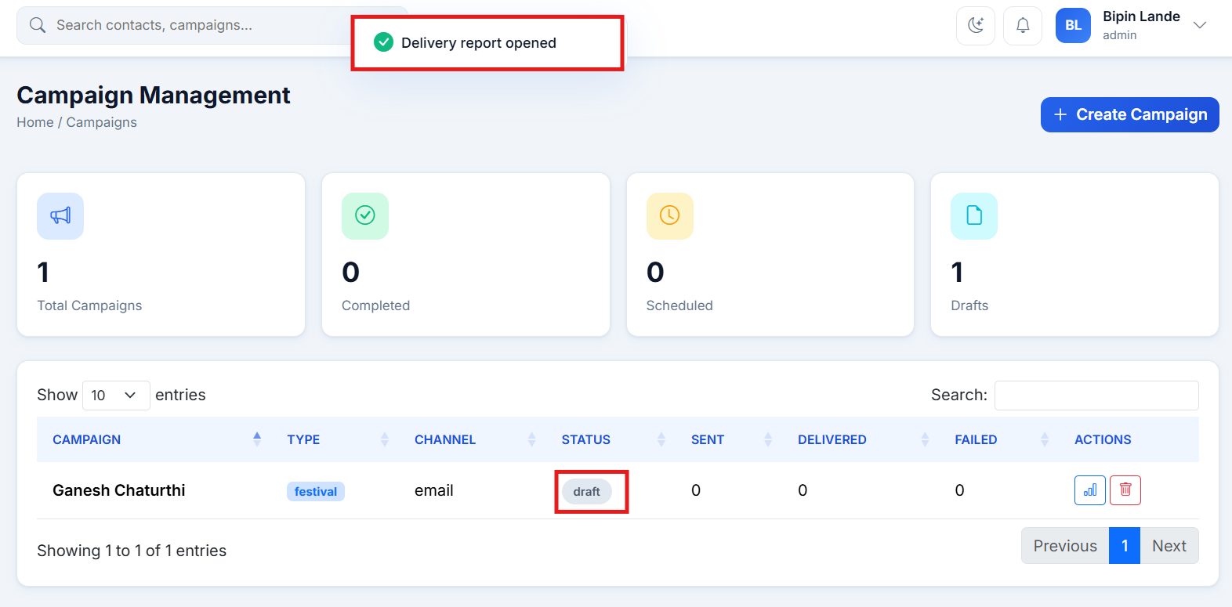

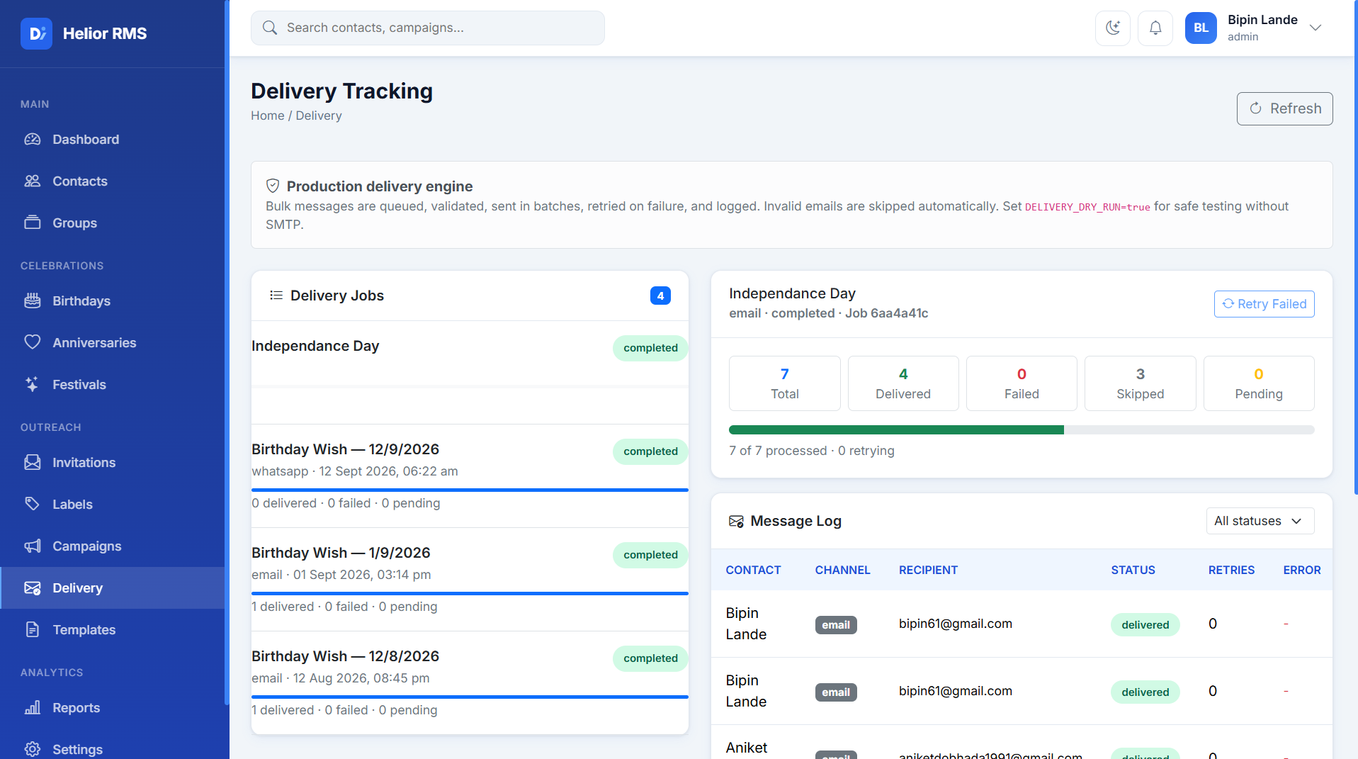

Issue#7: Reports are not showing any data.
