Issue#1: Attachments are not sent as part of the Invitation email.
Create an Invitation by adding an image and a pdf.
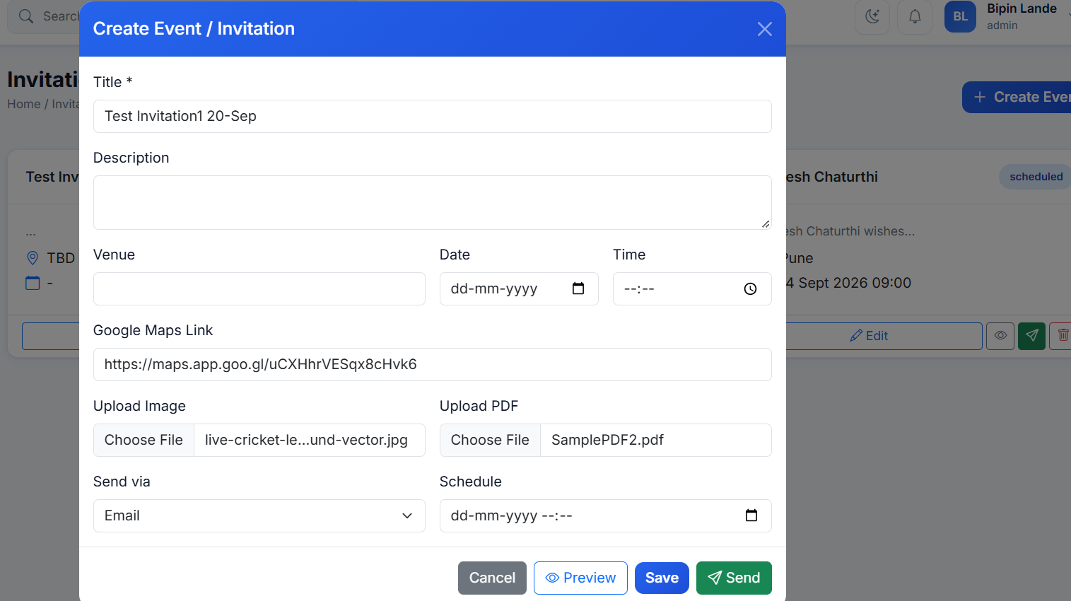
Click on the Send Invitation on this invitation.
Received invitation email do not include the attachments.
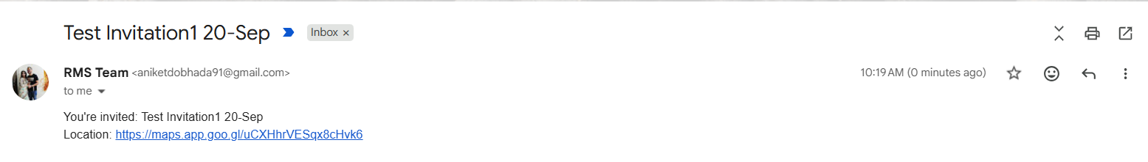

Issue#2: Attachments added for the Event/Invitation are not retained. Same issue is observed for the ‘Send via’ field. Send via field always shows only the ‘Email’ value.
Create an Invitation by adding an image and a pdf.

On sending the Invitation when user click on the Edit button, the attachments are not displayed.
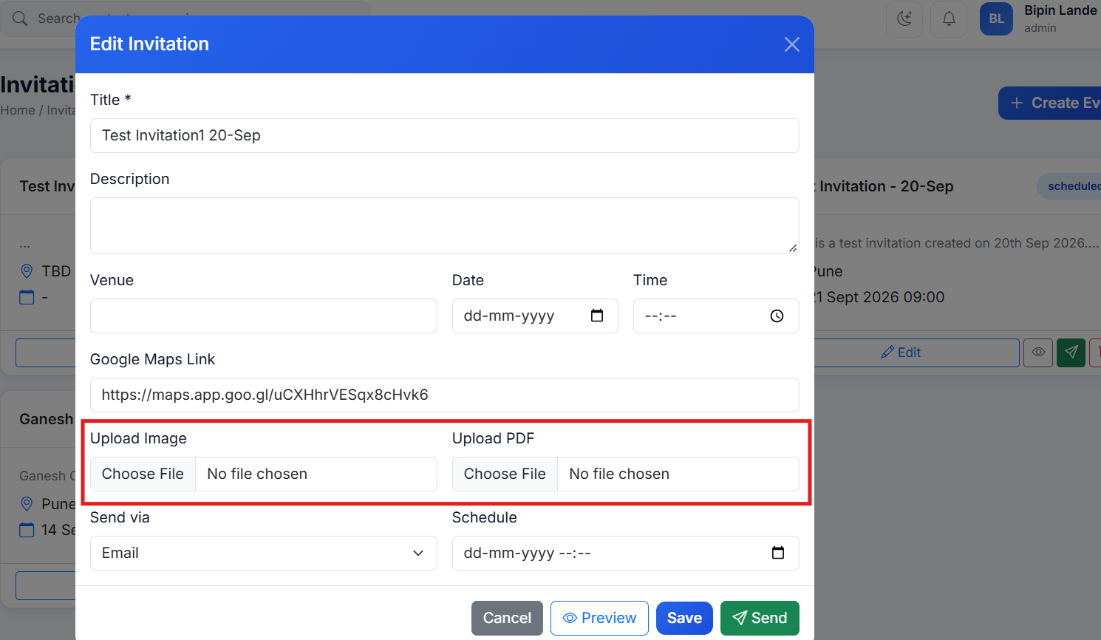

Send via field:
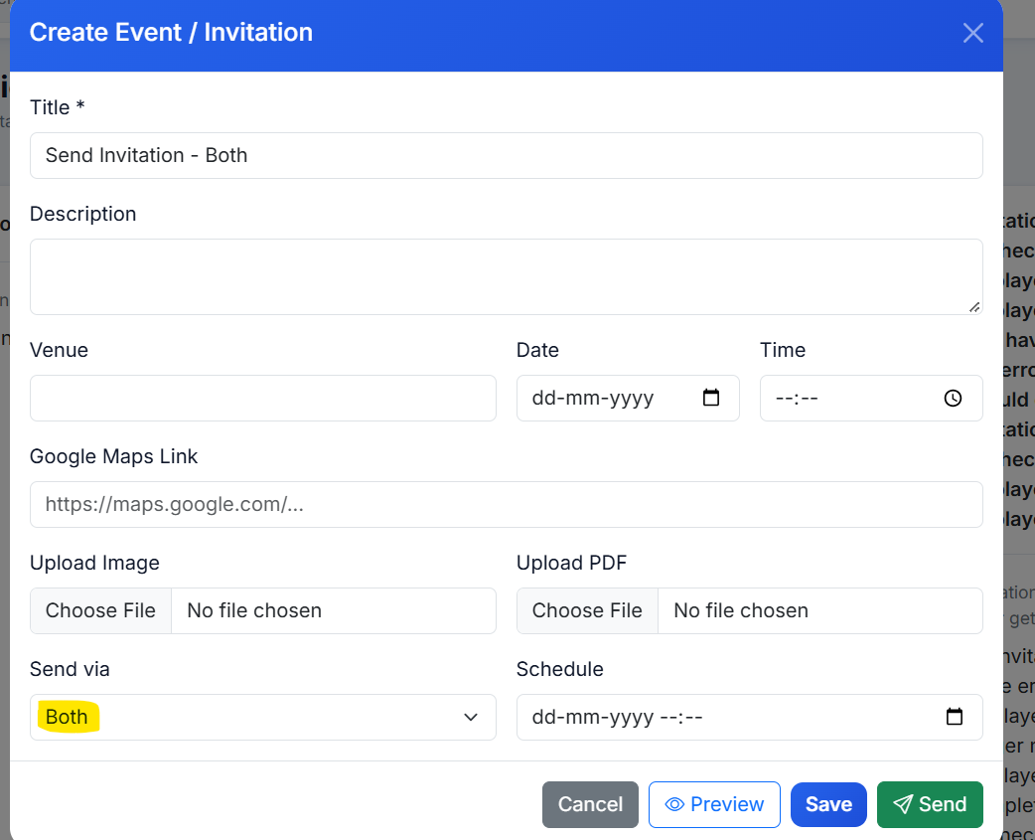

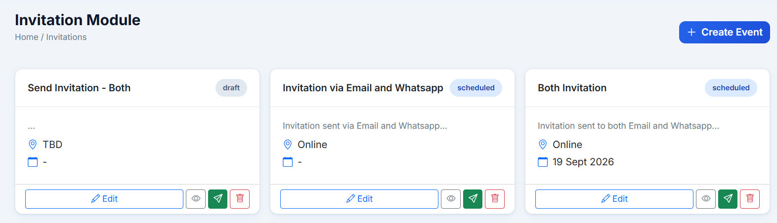

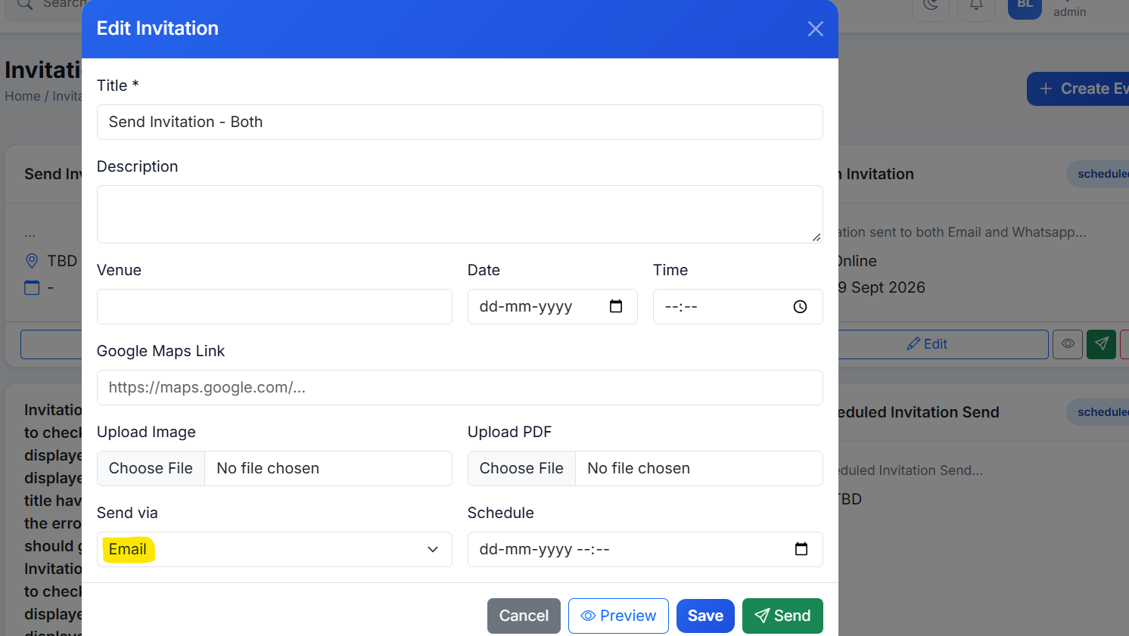

Issue#3: On sending invitation via Invitations Module, invitation gets sent to all the contacts.
Is this expected?
Issue#4: On sending the Invitation via Whatsapp, success message gets displayed and Delivery Job gets created in Completed state.
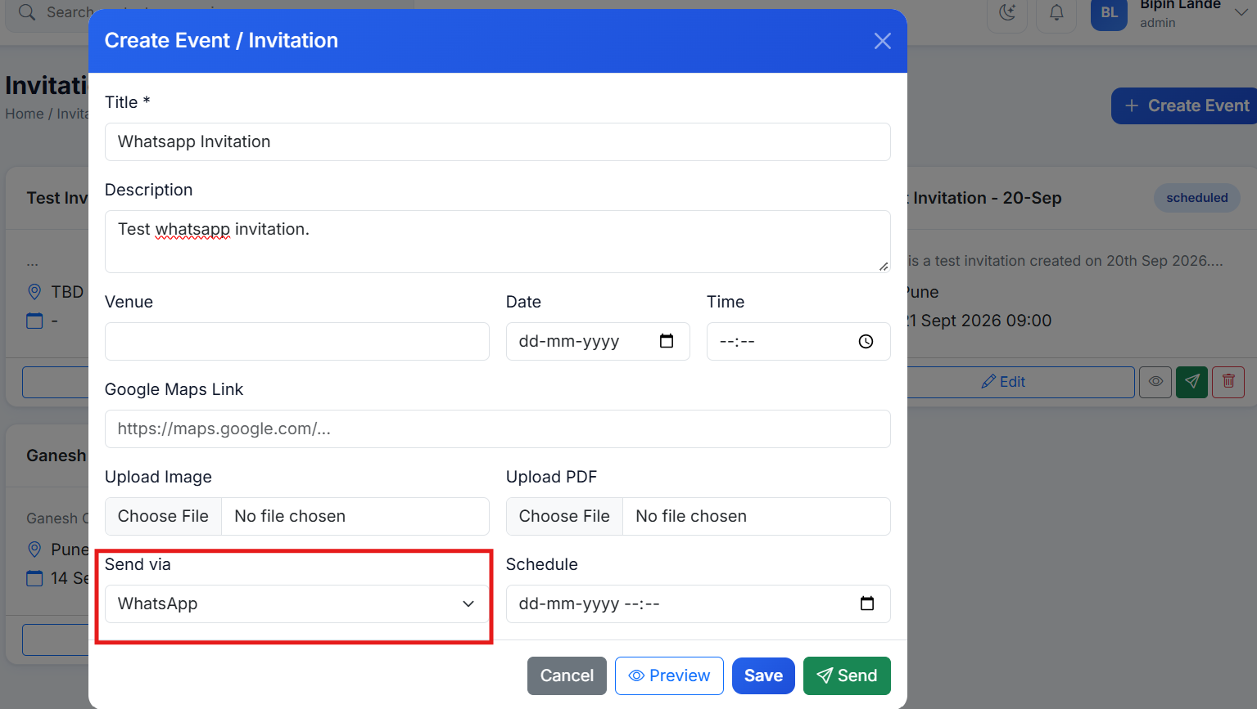

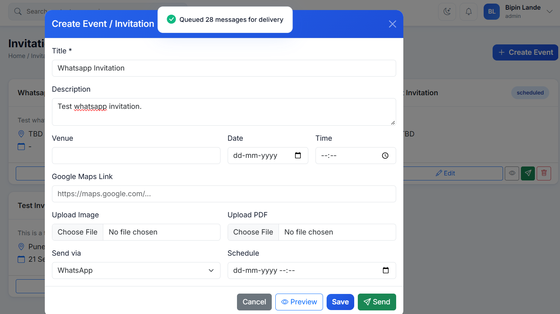

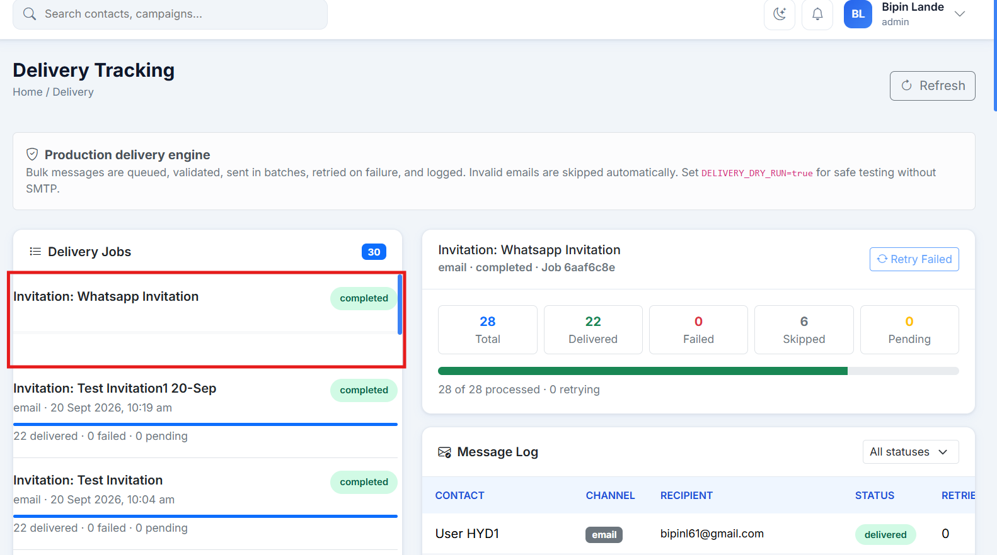

Issue#5: Invitations are not getting sent at the scheduled time.
Create an Invitation with Schedule time and clicked on Send Invitation button.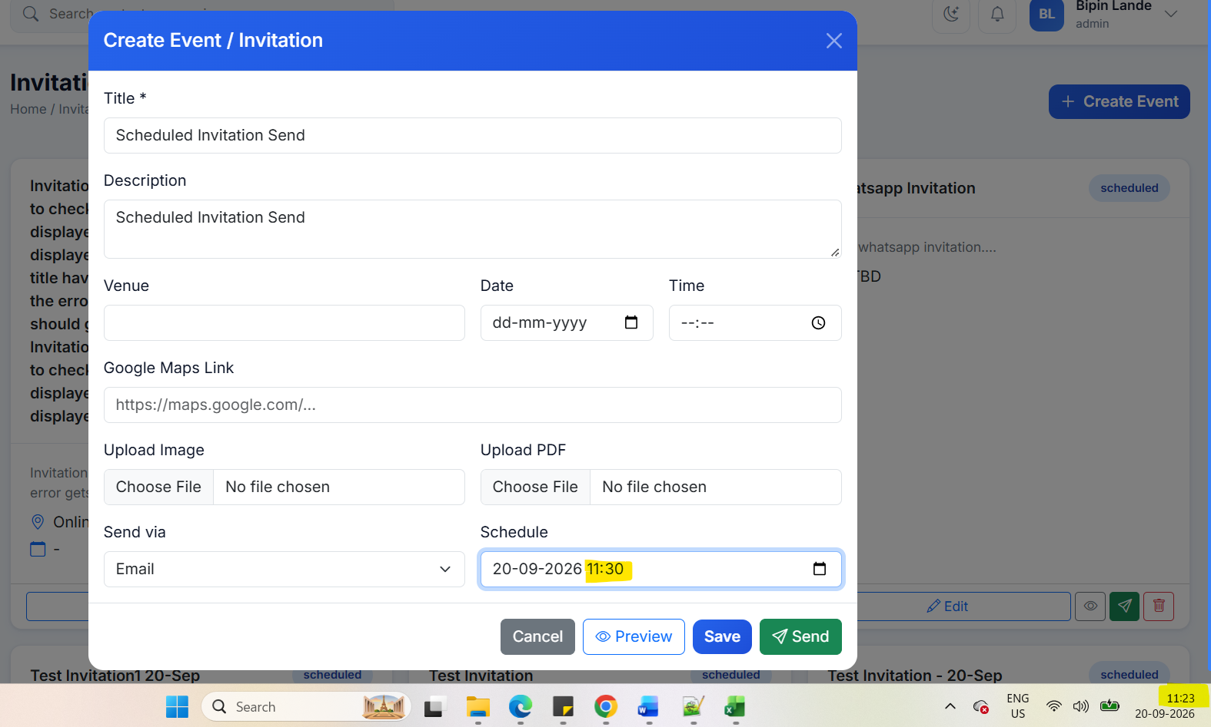

Delivery job shows Status ‘Completed’ immediately. But email is not received even at the scheduled time.
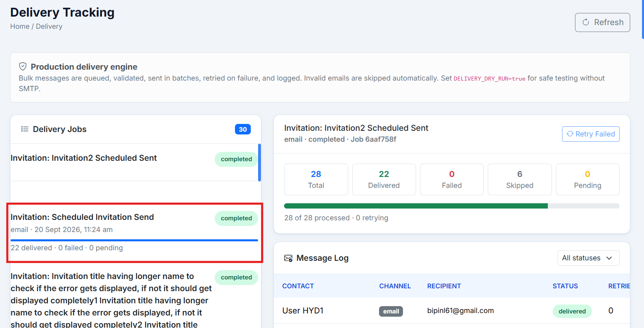

Emails are not sent on clicking the Send Invitation button for the Invitation after the Scheduled time gets passed.
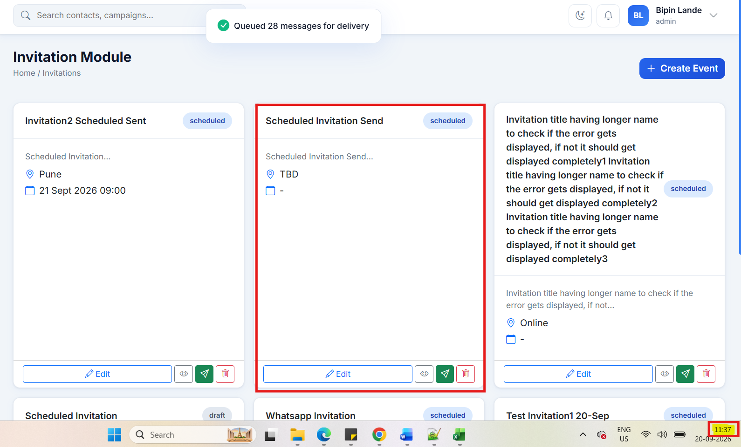

Issue#6: On entering incorrect year for the date fields on the Create Invitation page, error is not displayed.
Enter invalid dates in the date field and click on the Save button.
Nothing happens, no error message is displayed.
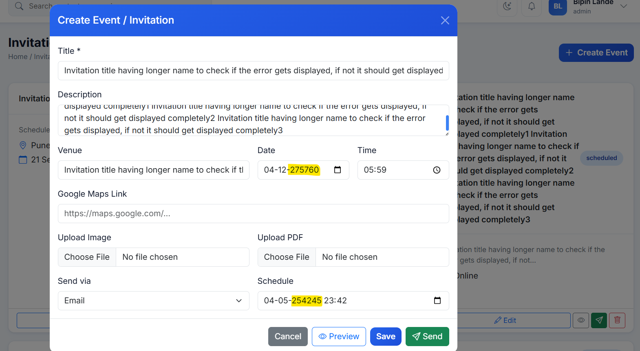

Issue#7: Email Invitation is not sent when ‘Both’ option is selected in the ‘Send Via’ field on Create Invitation page.
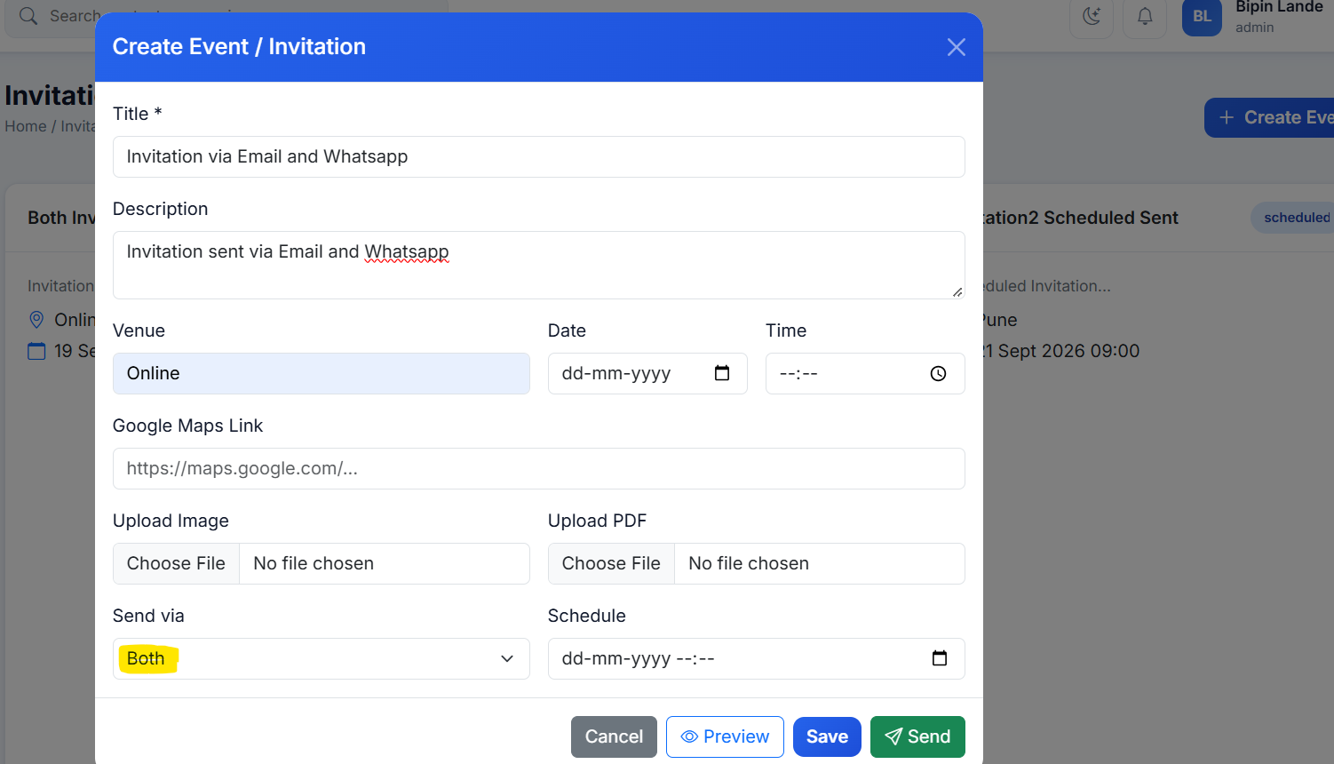

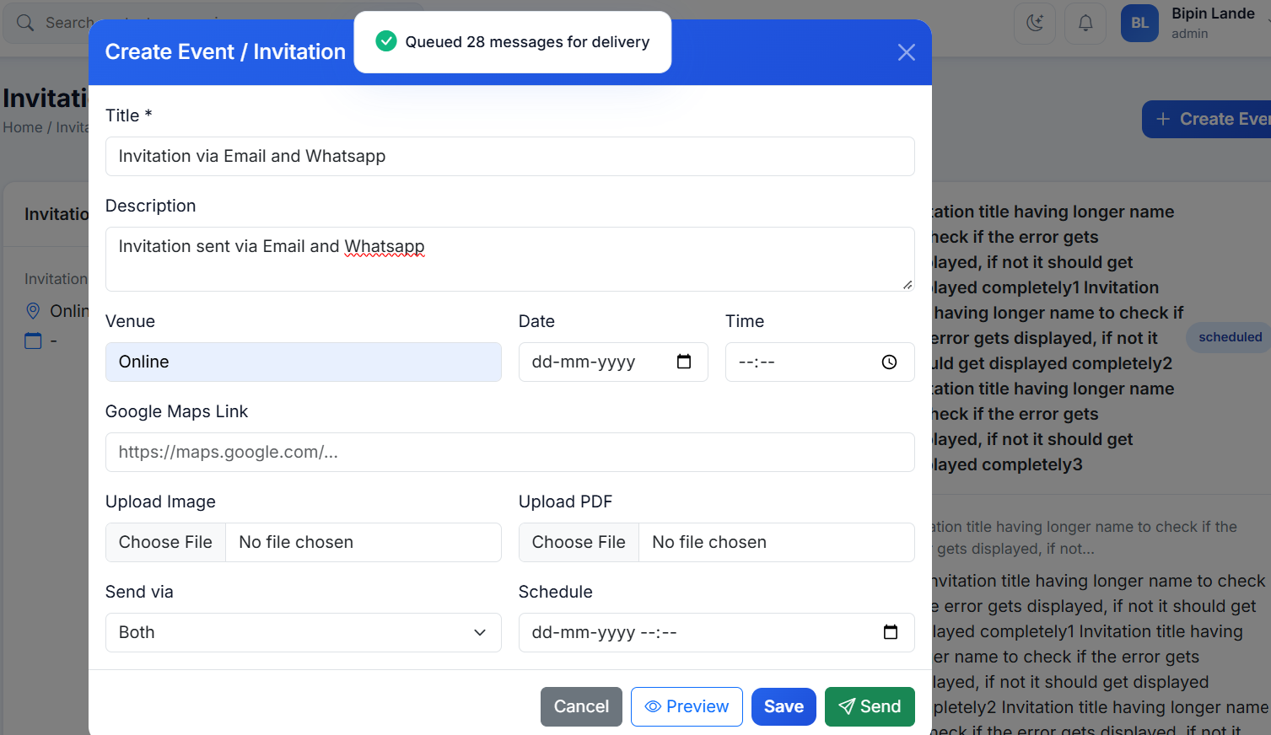
Delivery job shows ‘Completed’ but email is not sent.
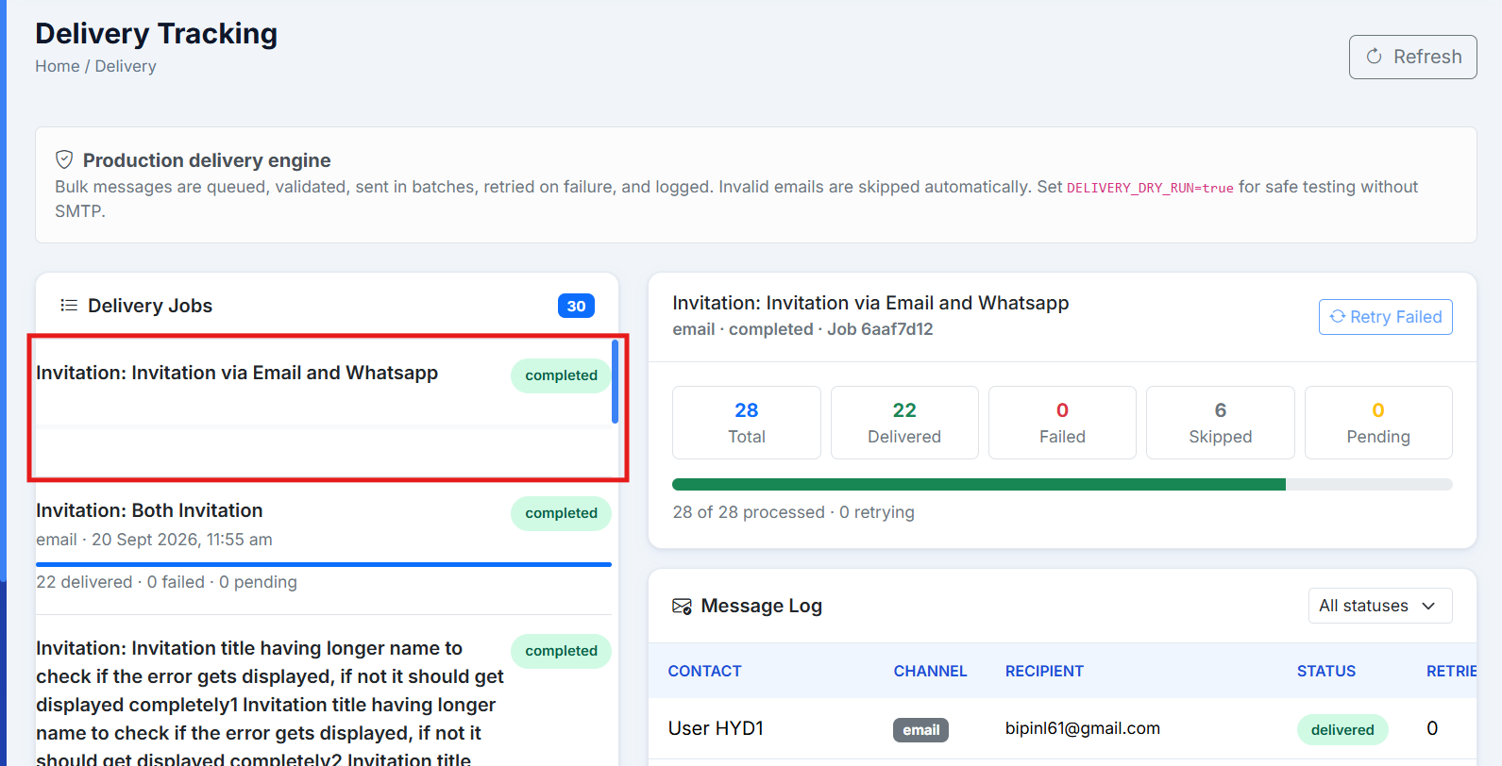

Issue#8: On sending an invitation with a text in the ‘Google Maps Link’, field, success message gets displayed but email is not received.
Enter a plain text in ‘Google Maps Link’, field and click Send.
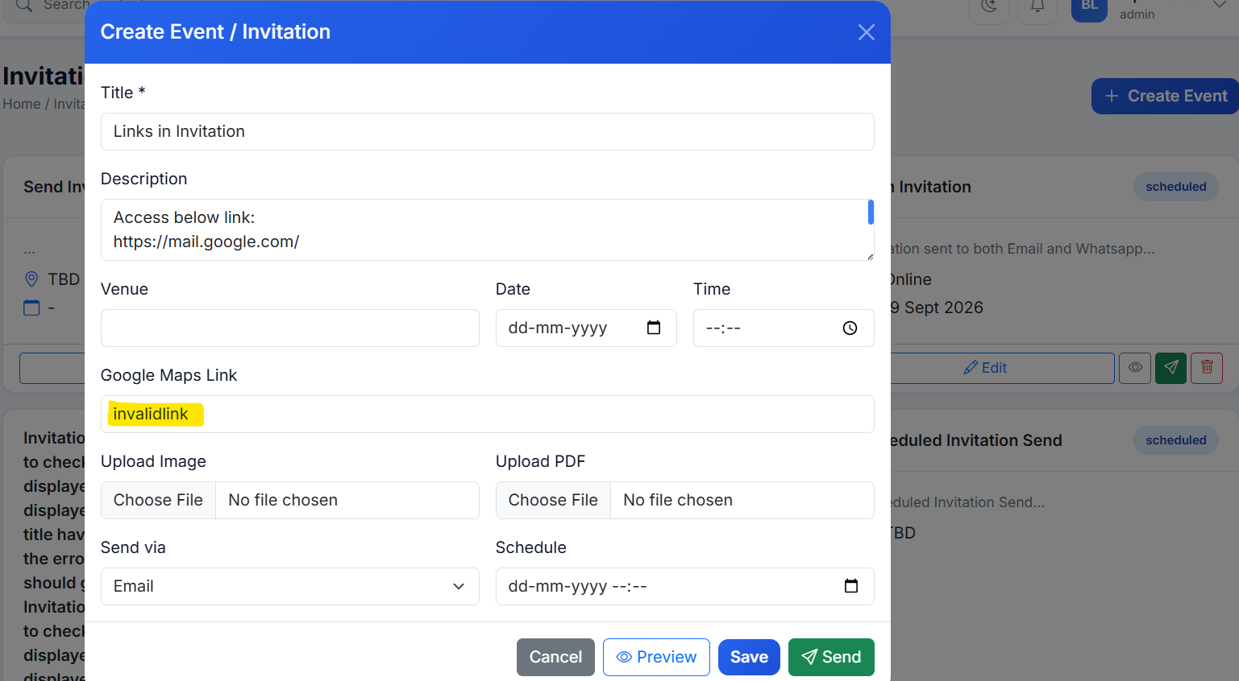
Delivery Job shows ‘Completed’ but email is not received.
