Issues#1: When a leave is already approved, still user is allowed to apply for another leave for the same day.
Already applied leave is highlighted in green and user is allowed to apply for another leave for the same day which is highlighted in red.
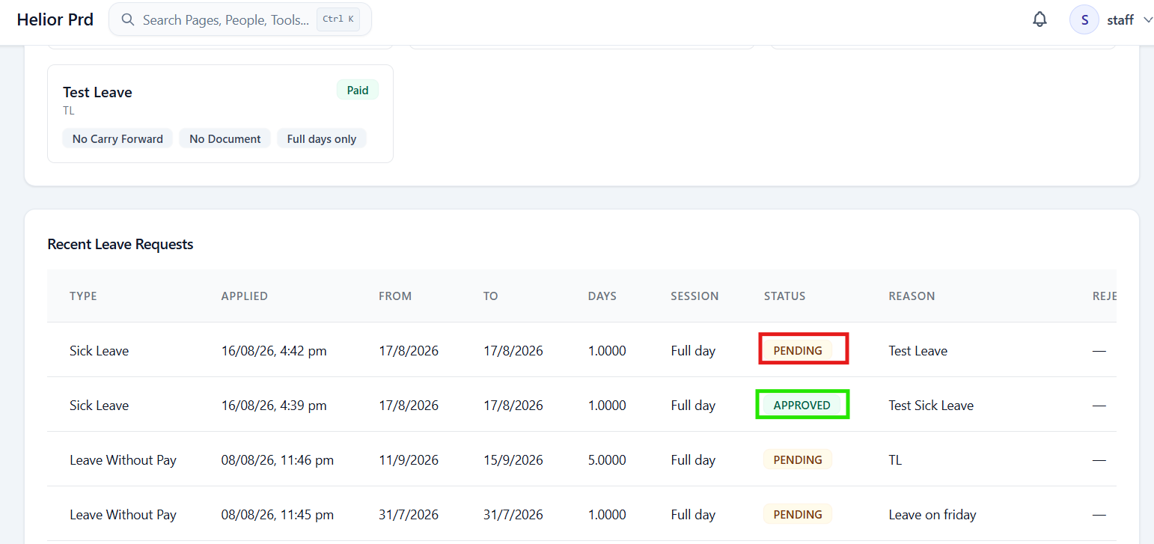

Issue#2: ‘Show Unread’ button available under ‘Notifications’ is not working.
On clicking ‘Show Unread’ button, nothing happens. It still shows all available notifications.
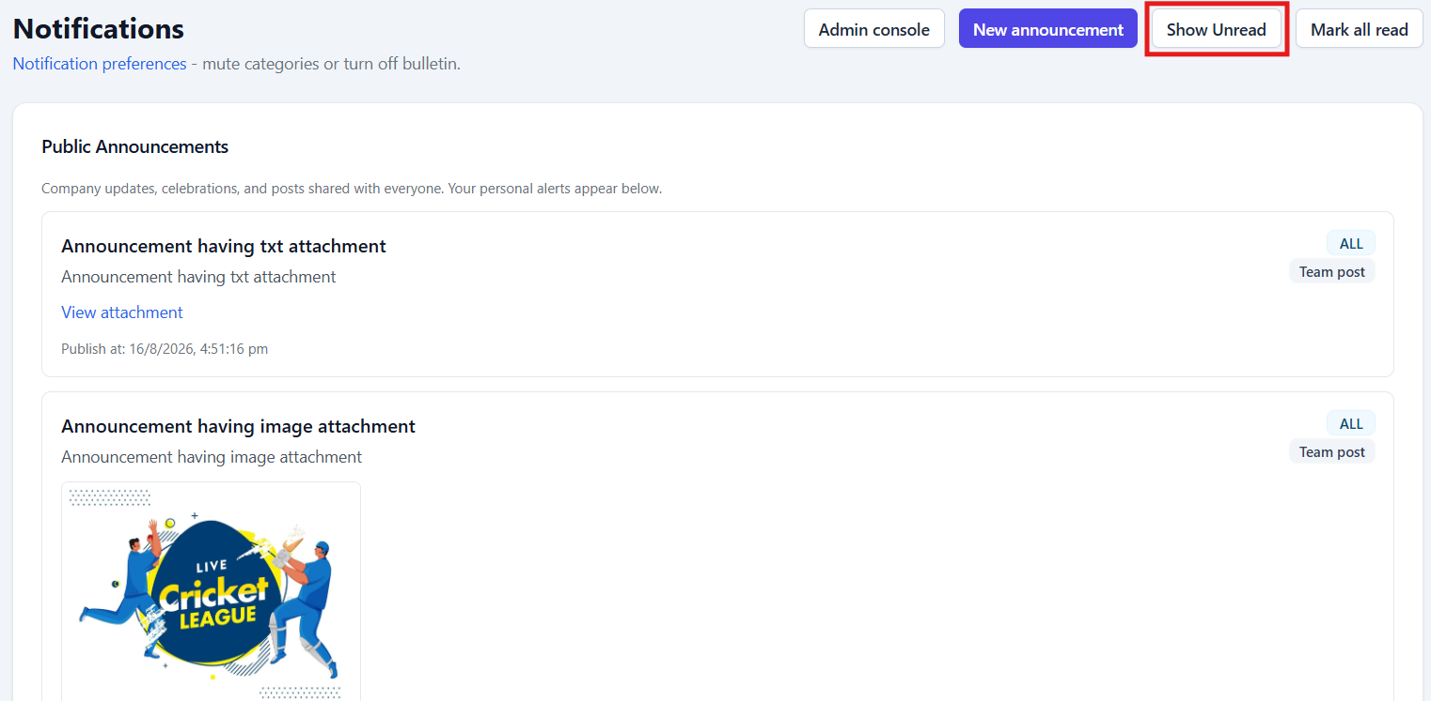

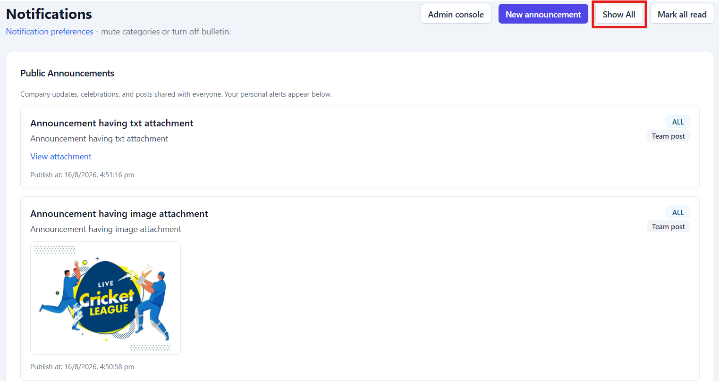

Issue#3: What is the use of ‘Action URL’ field available under ‘Direct Notifications’ section?
On sending Direct Notification by entering an URL for this field, this URL is not shown in the notification to the receiver.
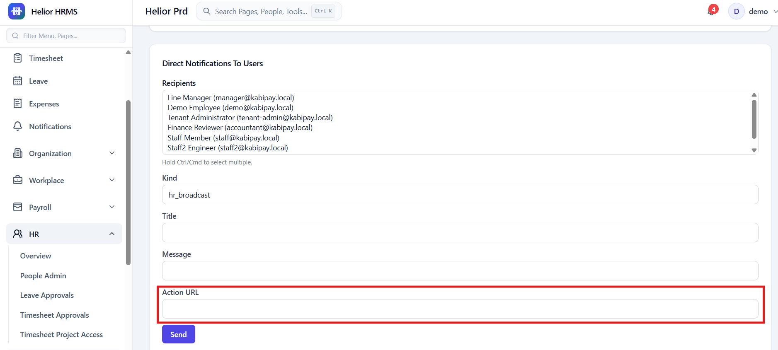

On sending Direct Notification by entering an URL for this field, this URL is not shown in the notification to the receiver.
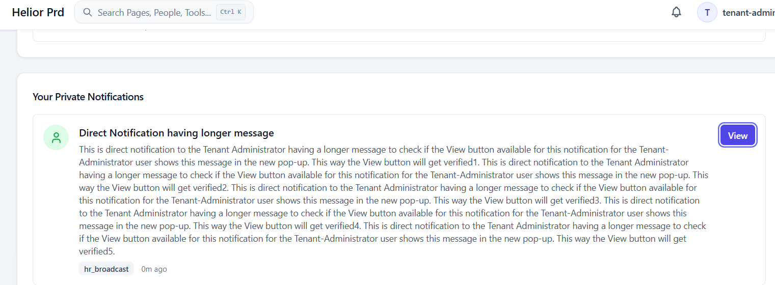

Issue#4: Widget to Punch-In is not displayed on the Dashboard for the accountant user.
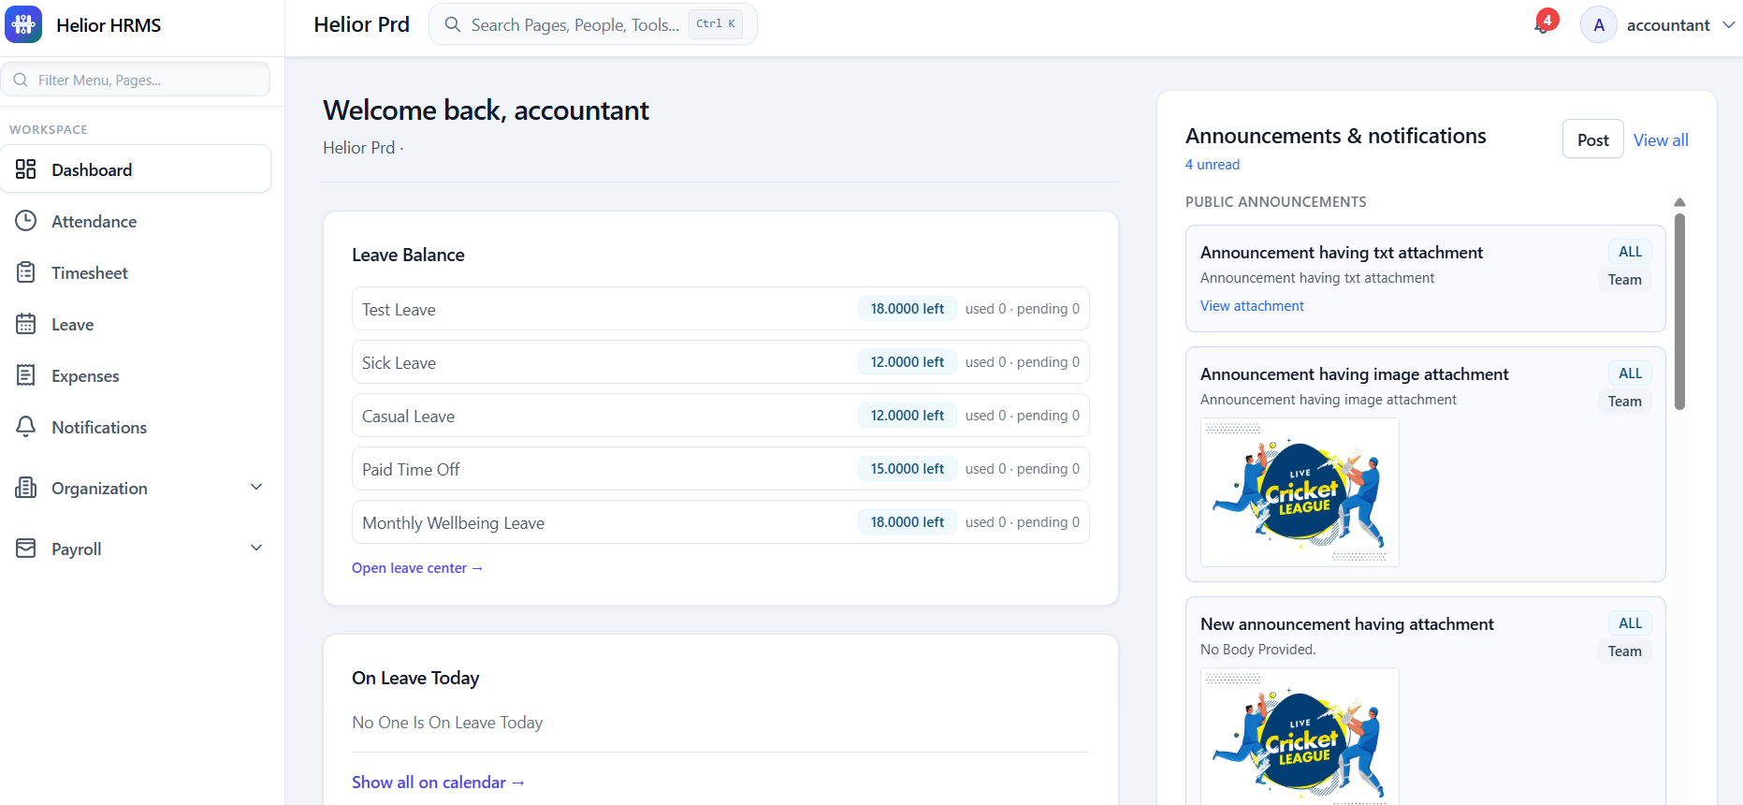

Issue#5: After logging in with temporary password, when new user enters incorrect ‘Current Password’ and try to set new password, incorrect error is displayed as- ‘Your session has expired. Sign in again.’
Steps: Enter incorrect Current Password
Enter valid new Password and same Confirm New Password and click Change Password.
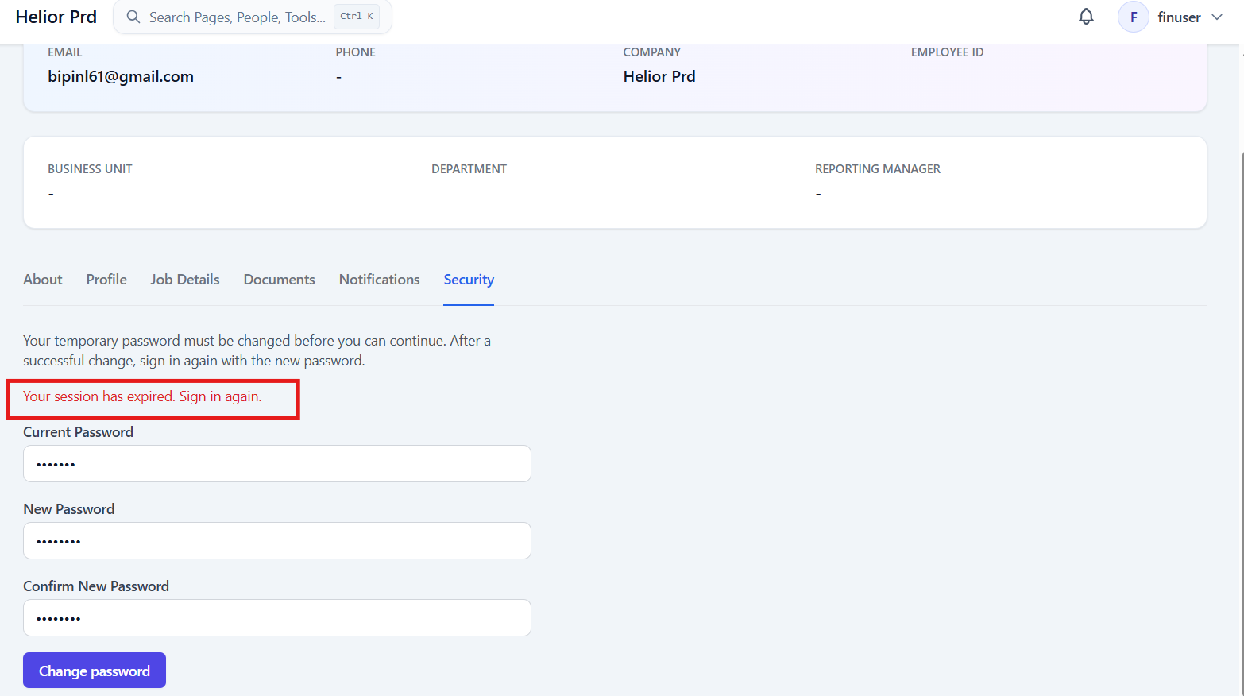
Issue#6: When the Current Password and the New Password/Confirm New Password are same, error message is displayed as- ‘Check the entered details and try again.’
It should show user friendly error message saying both the passwords are same.
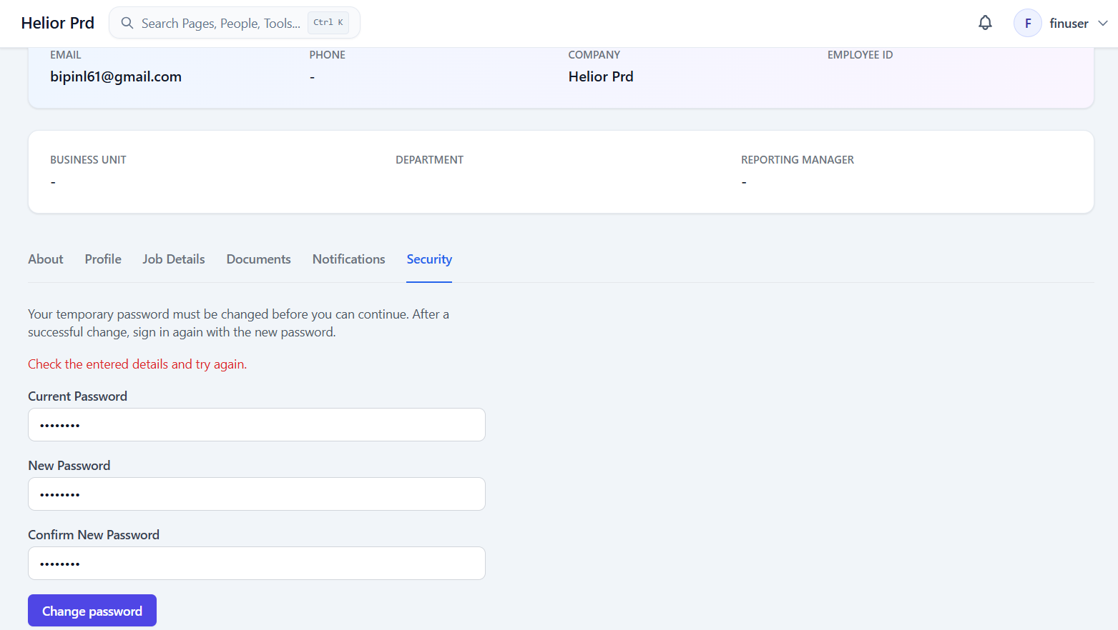
Issue#7: When new user set the new password, the user gets logged out so quickly that the user is not able to read the displayed message completely.
Suggestion: We can show the message on the pop-up and logout the user from application.
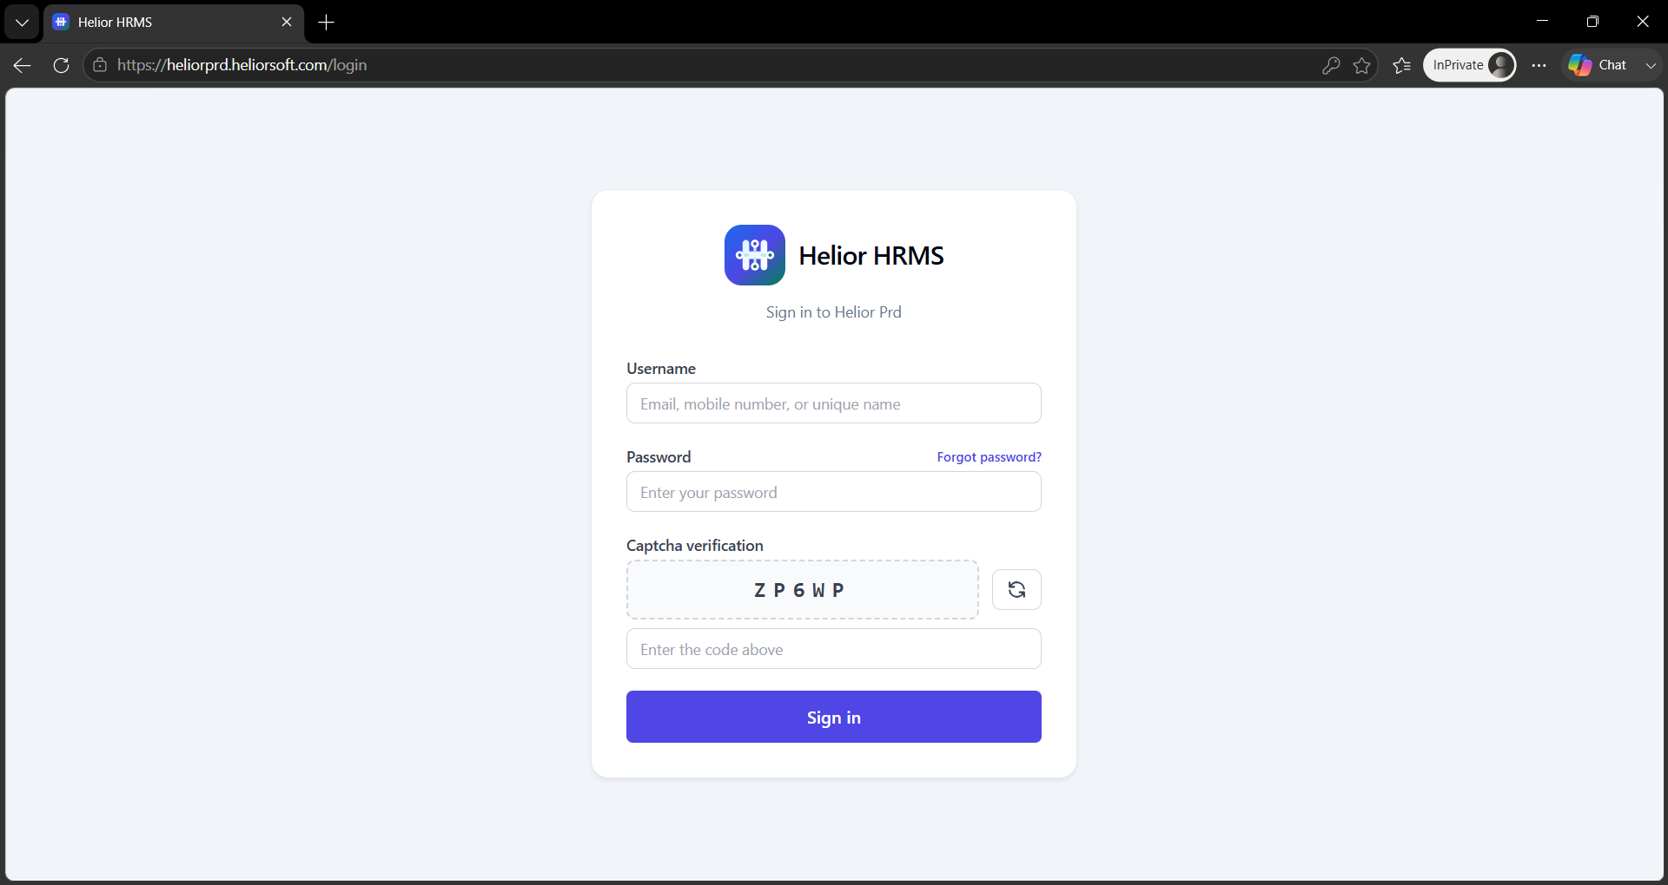

Issue#8: On exporting attendance report, ‘Employee Id’ column is not showing correct data.
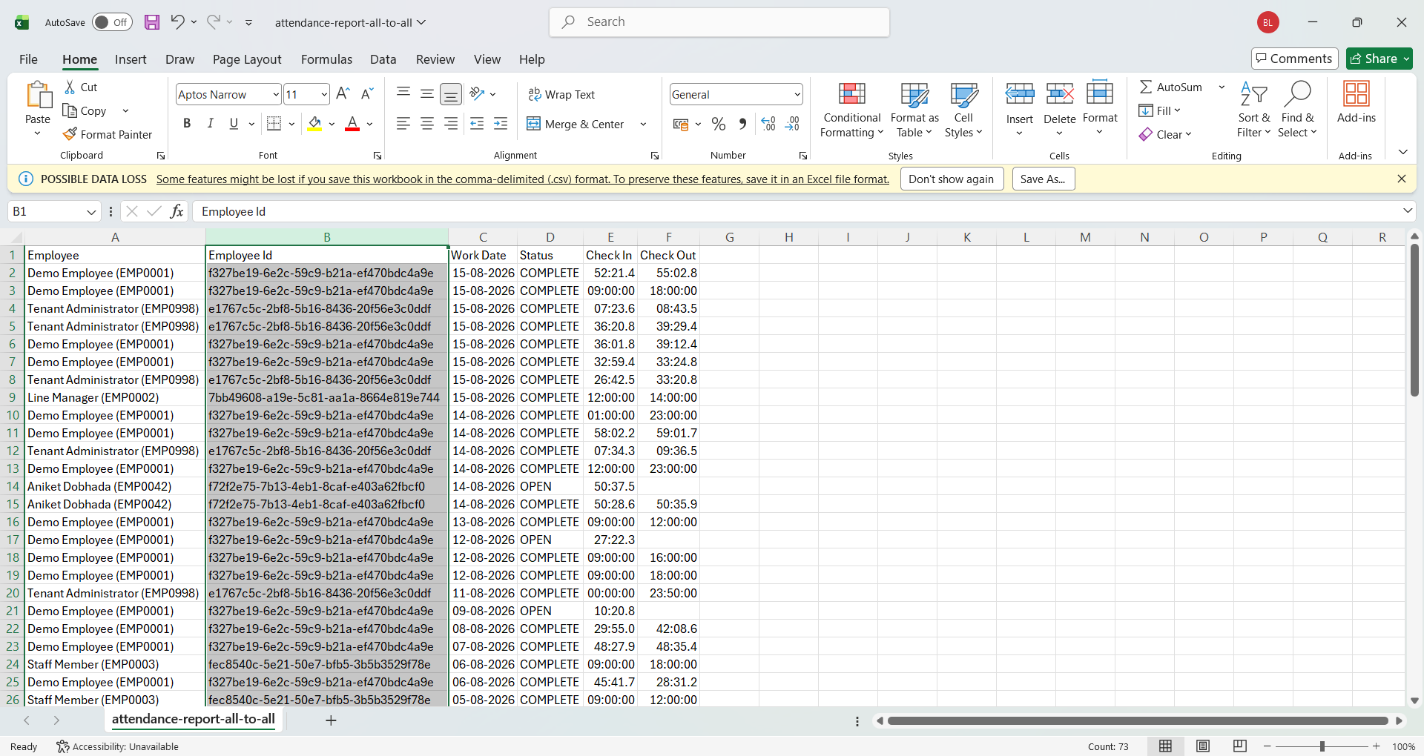

ii. Check In and Check Out columns are not showing correct data.
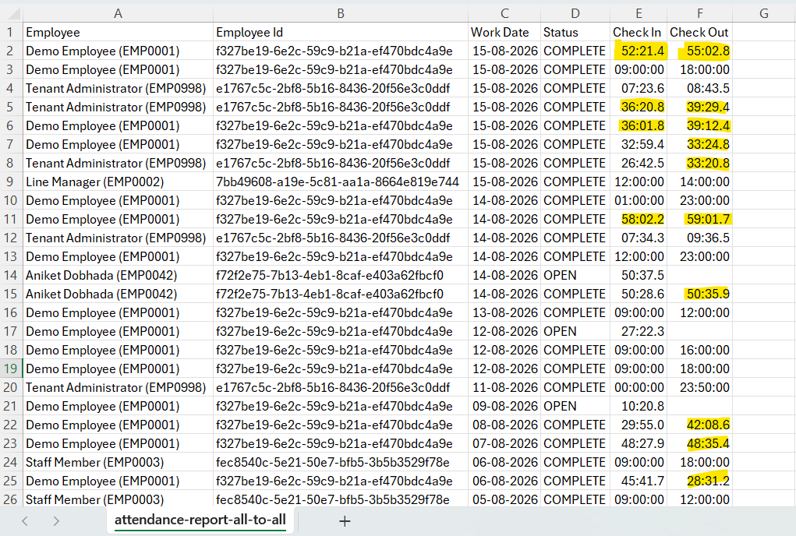
Issue#9: When an Expense Category is selected and currency is removed, web page gets blank.
Steps: Select a Category on Submit Expense pop-up.
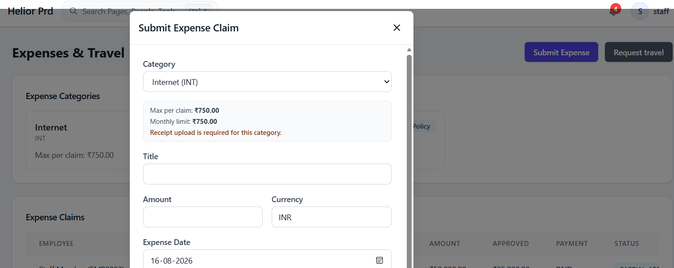

Remove the currency from the pop-up, webpage gets blank.
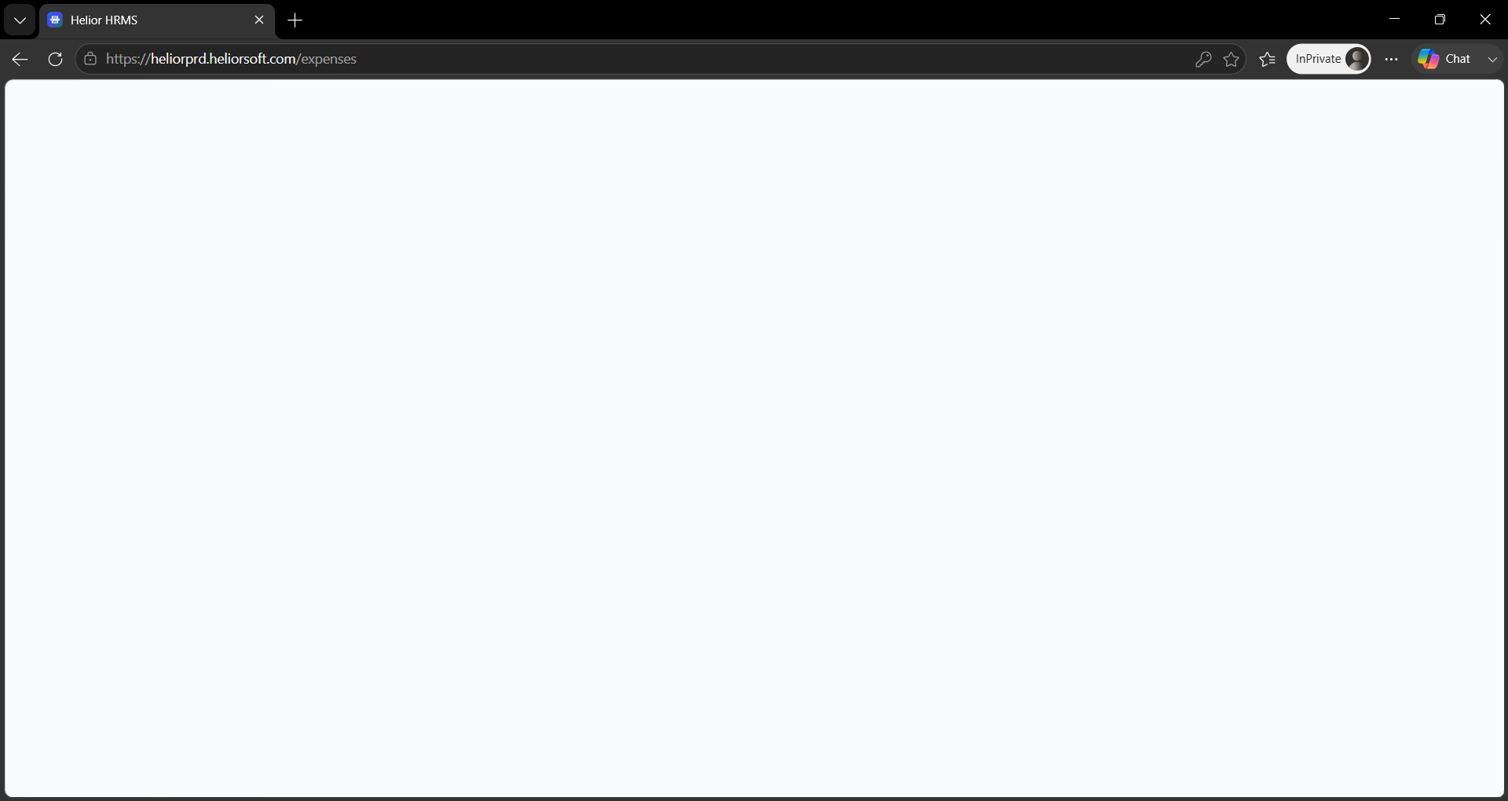

Issue#10: On entering expense amount greater than maximum allowed amout, error is displayed as- Something went wrong. Please try again.
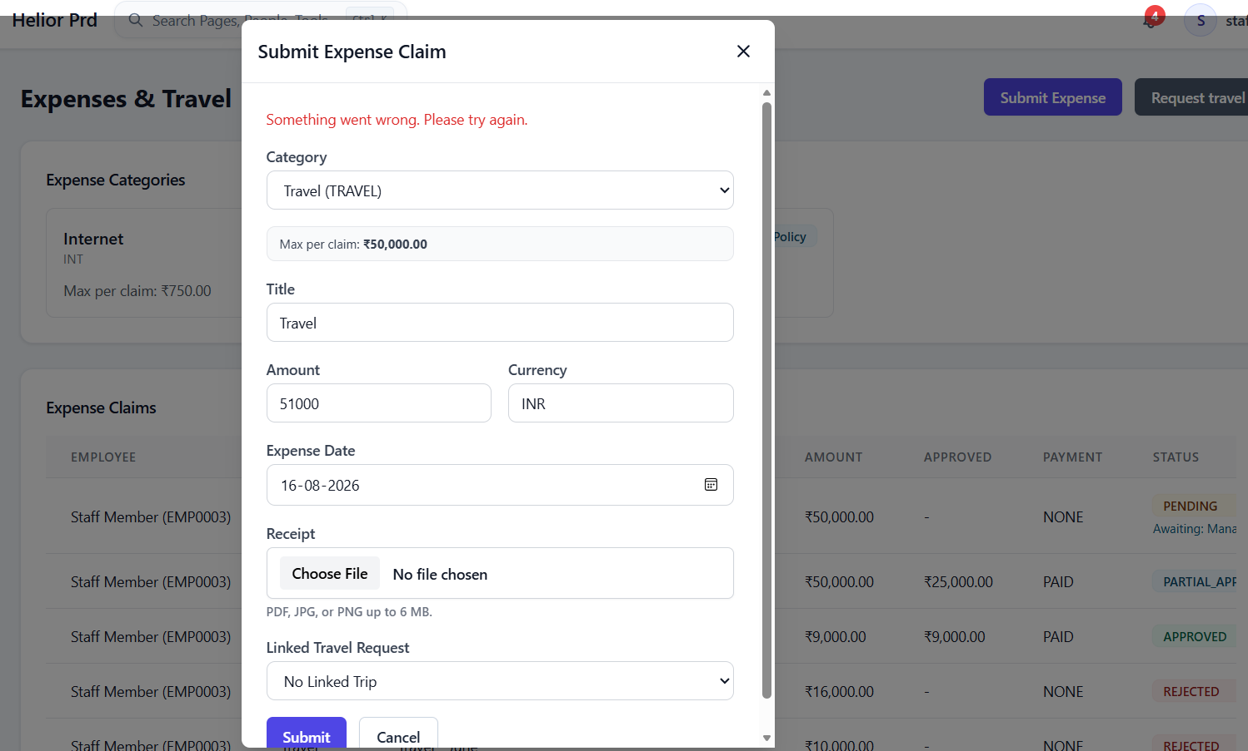

Issue#11: When accountant user tries to add attendance via ‘Add Missed Punches’, error is displayed as- You do not have permission to do this.
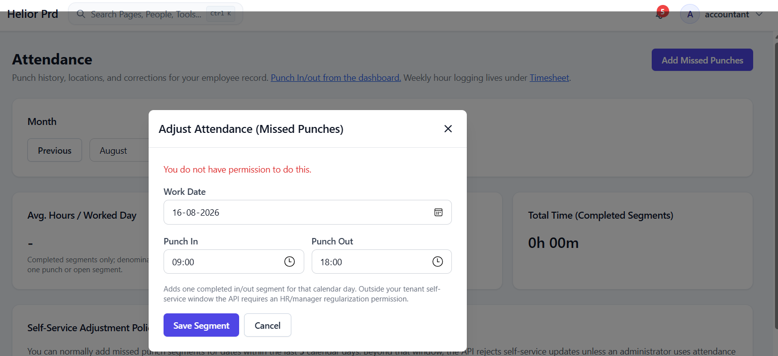

Issue#12: Profile setting page do not show all the data.
Below highlighted data is available for the employee but it’s not displayed under Profile Settings.
