Issue#1: Only 2 decimals can be shown on the Edit Entry pop-up and Delete Timesheet Entry
Pop-up.
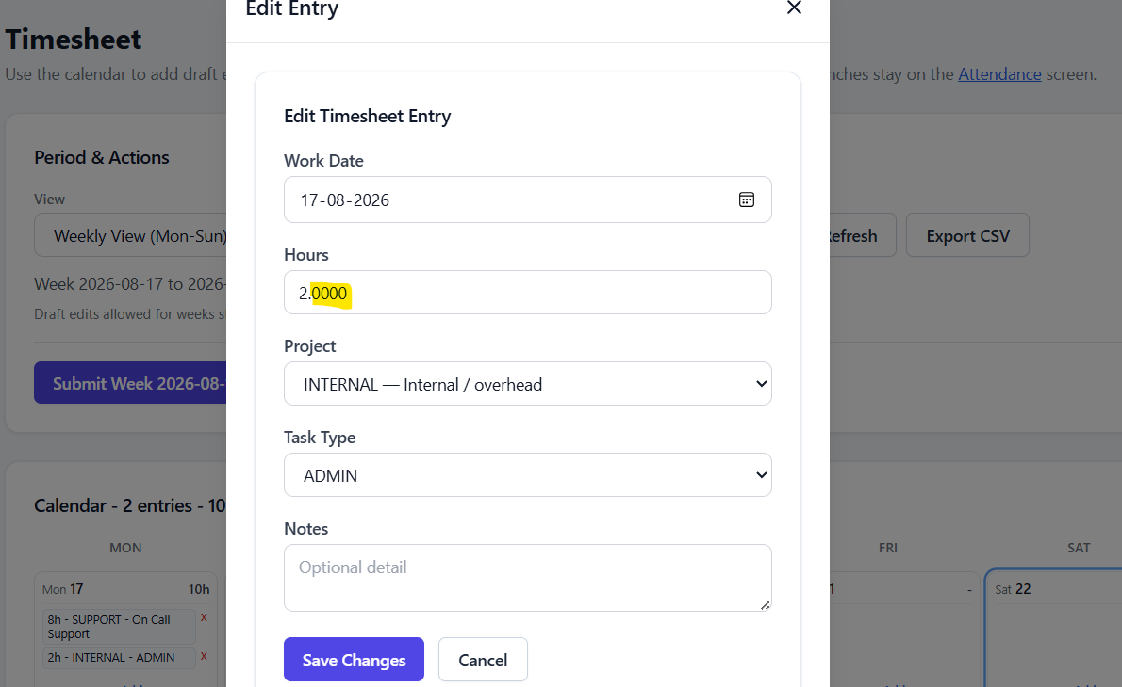

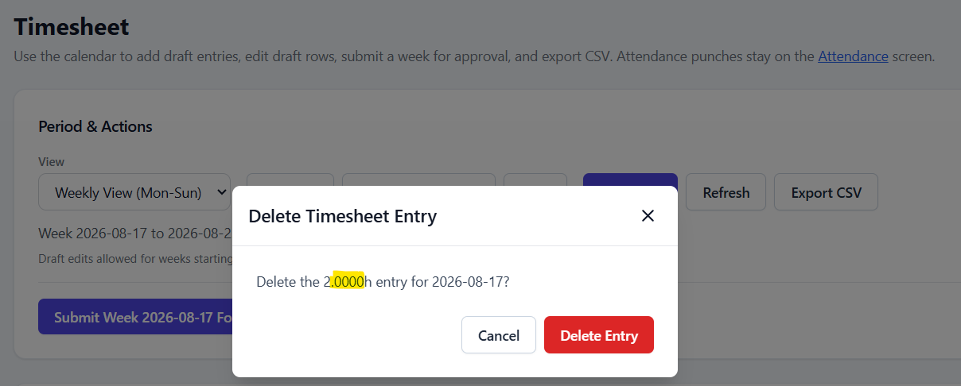

Issue#2: Suggestion: Mandatory fields can be indicated with the asterisk icon (*)
Note: This is applicable at all the places.
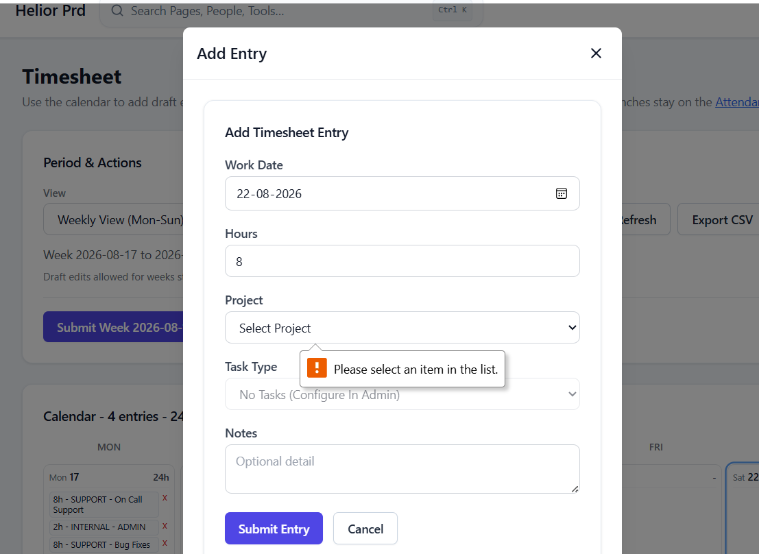

Issue#3: Report Summary do not show correct data when report type ‘Attendance Report’ is selected.
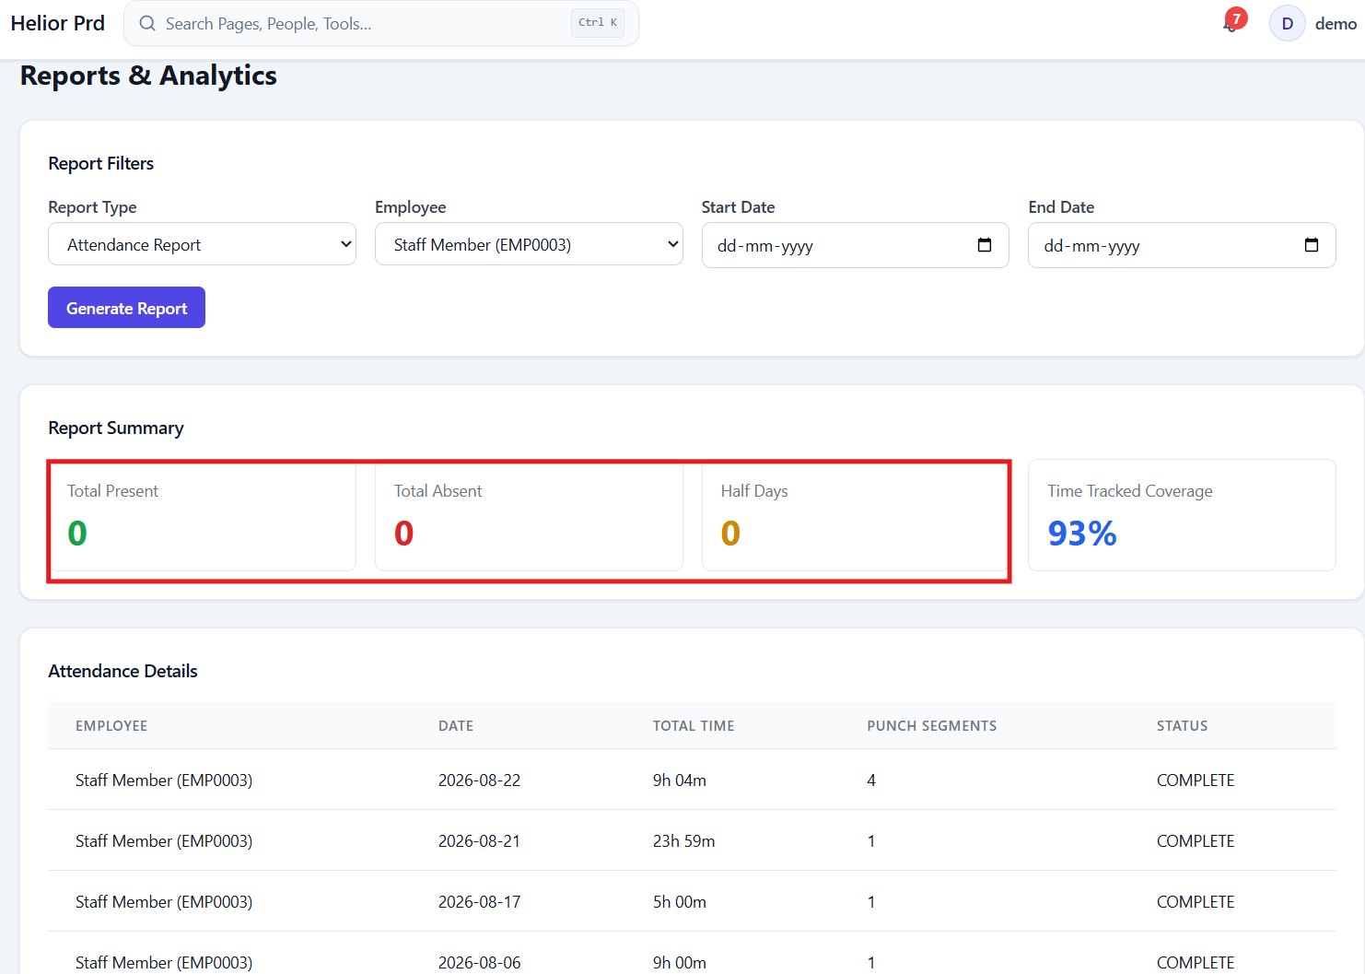

Issue#4: For all the employees, some ID is getting displayed on the dashboard.
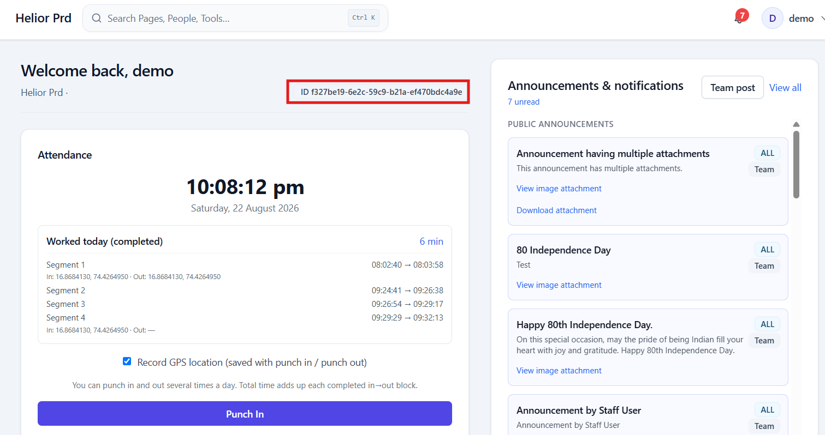

Issue#5: On refreshing the browser, user gets logged out from the application.
Demo user is logged in. Refresh the browser.
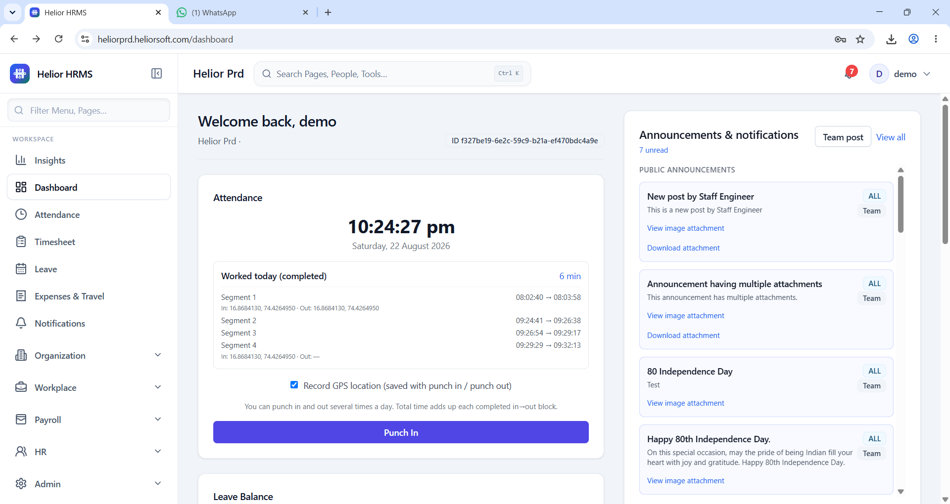
User gets logged out and gets redirected to login page.
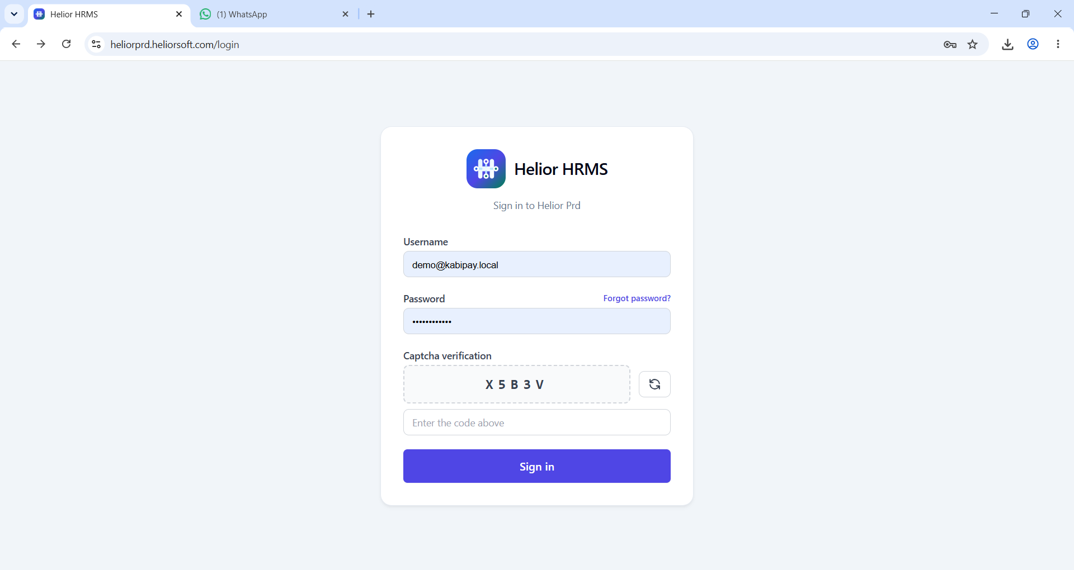

Issue#6: When existing leave request for a specific date is not available and user tries to apply the leave, still error is displayed as-
Existing leave requests of the Demo user:
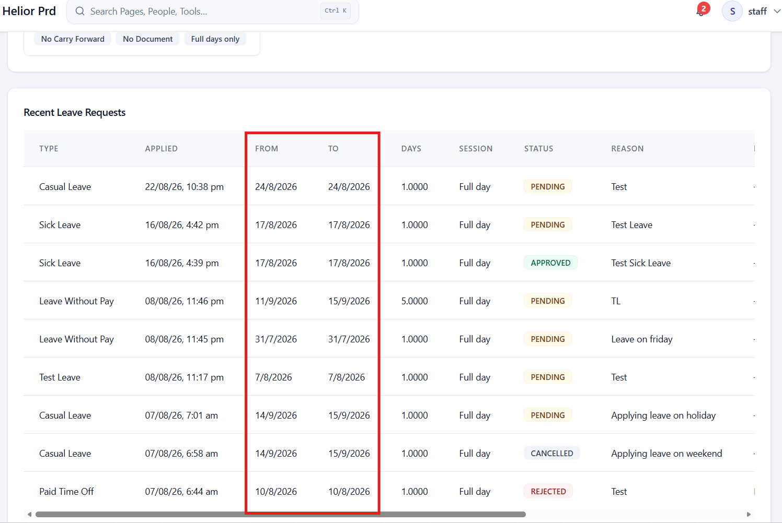

Issue#7: Nothing happens on clicking ‘View’ button available for the unread direct notification.
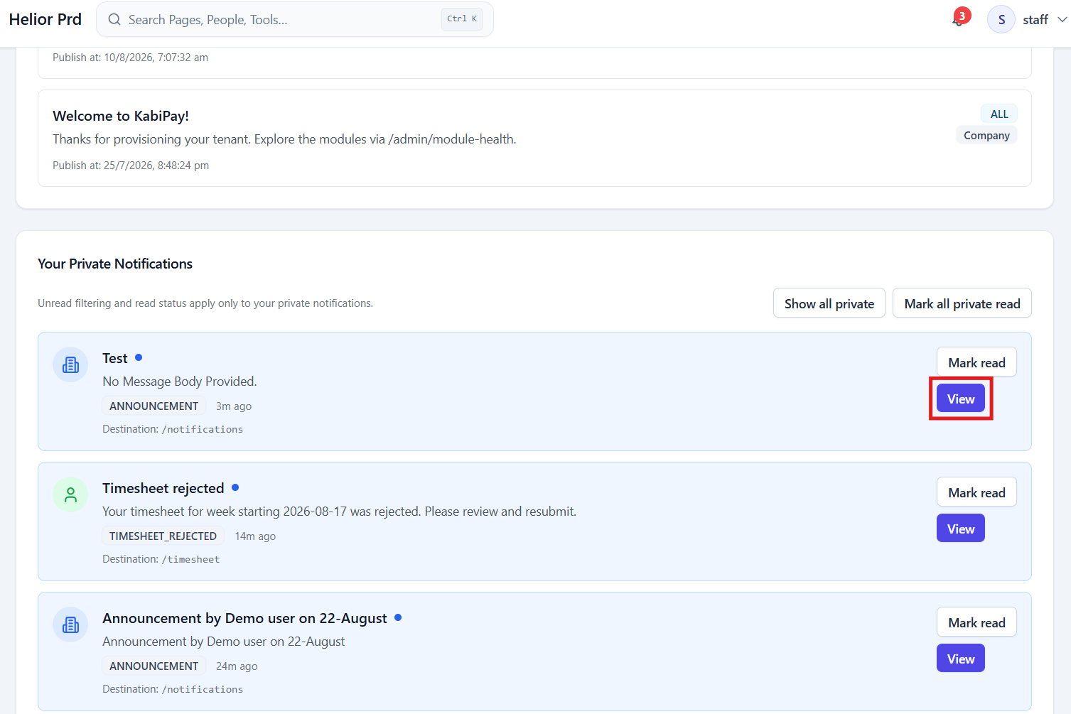
Issue#8: On clicking ‘View’ button for the already read direct notification, user gets redirected to the Dashboard.
Click on the View icon available for the already read direct notifications.
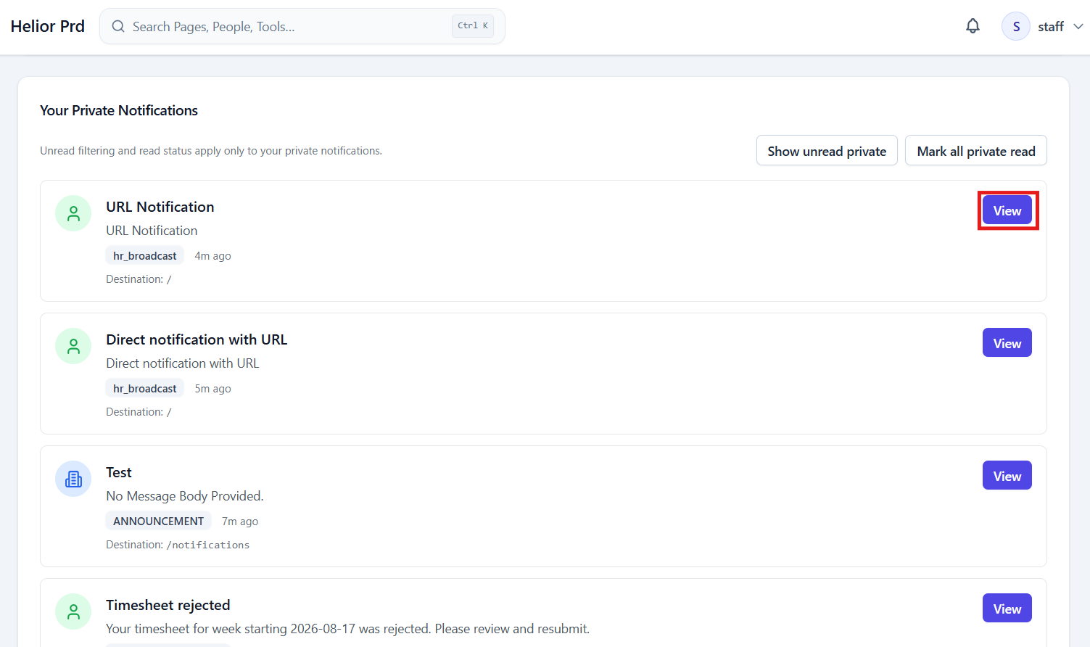
User gets redirected to Dashboard.
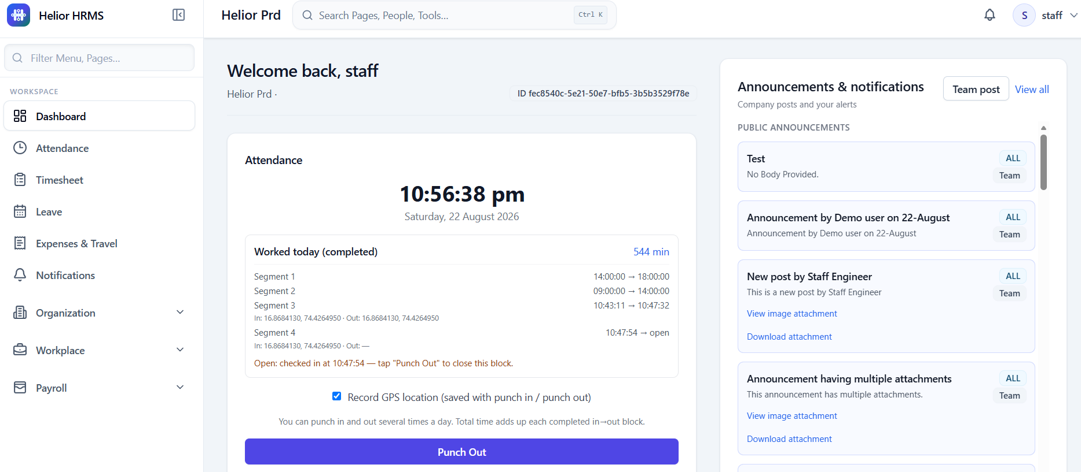

Issue#9: On re-opening the ‘Add Employee’ pop-up again after once the error is already generated on this pop-up, the pop-up still shows the older details and the error on the pop-up.
Generate error on the Add Employee pop-up.
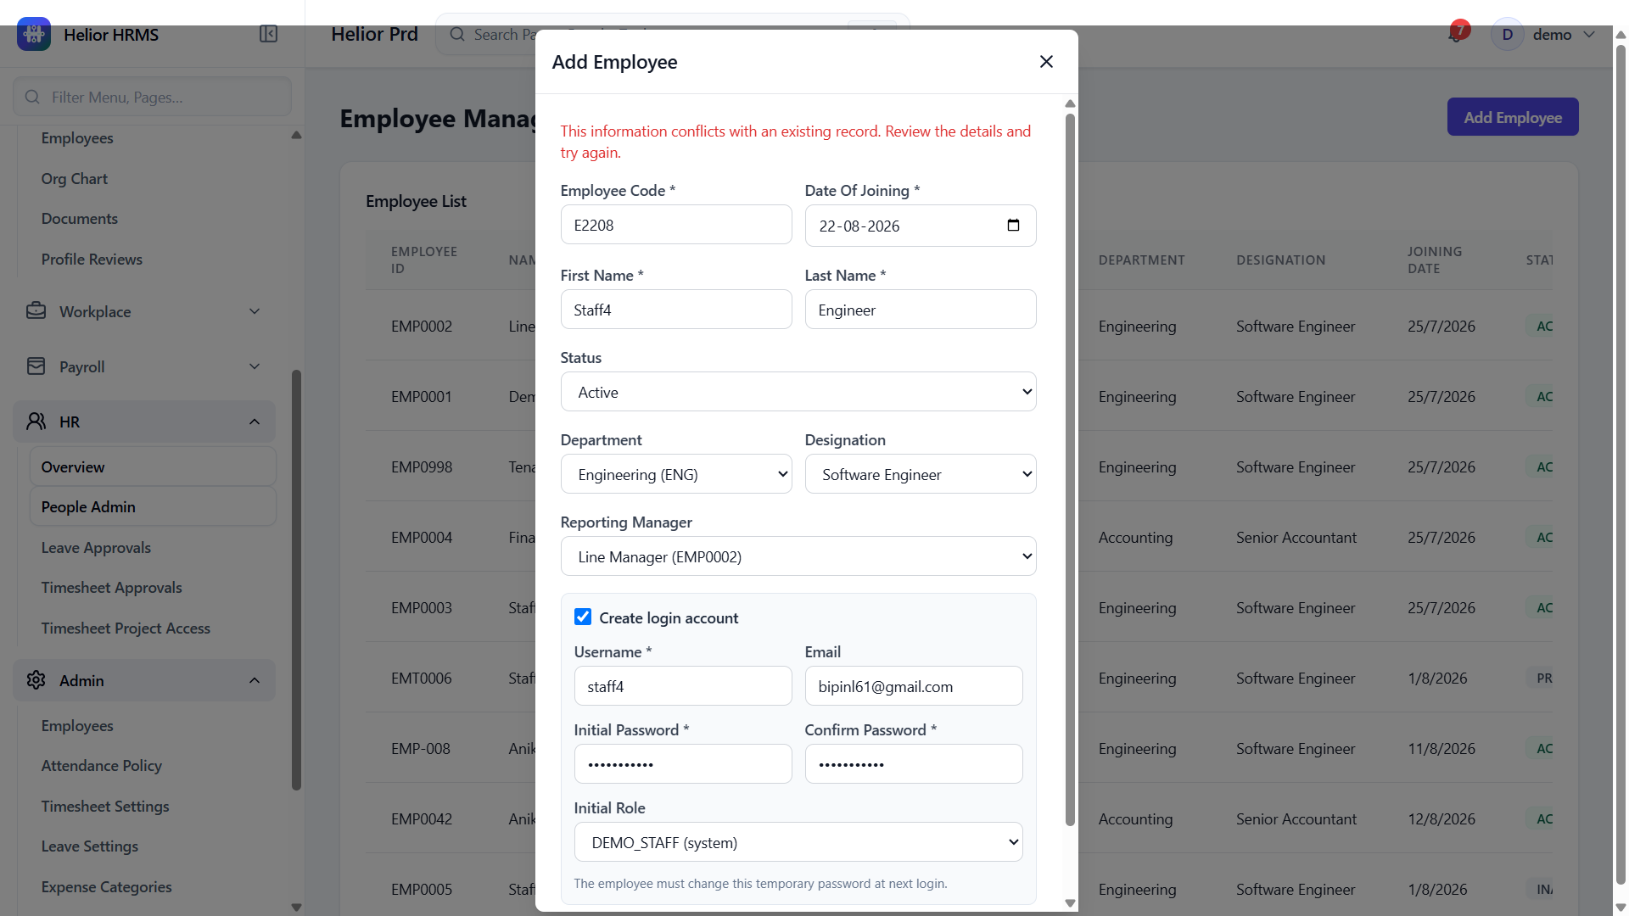

Close the pop-up and open again. Pop-up shows same details and the error.
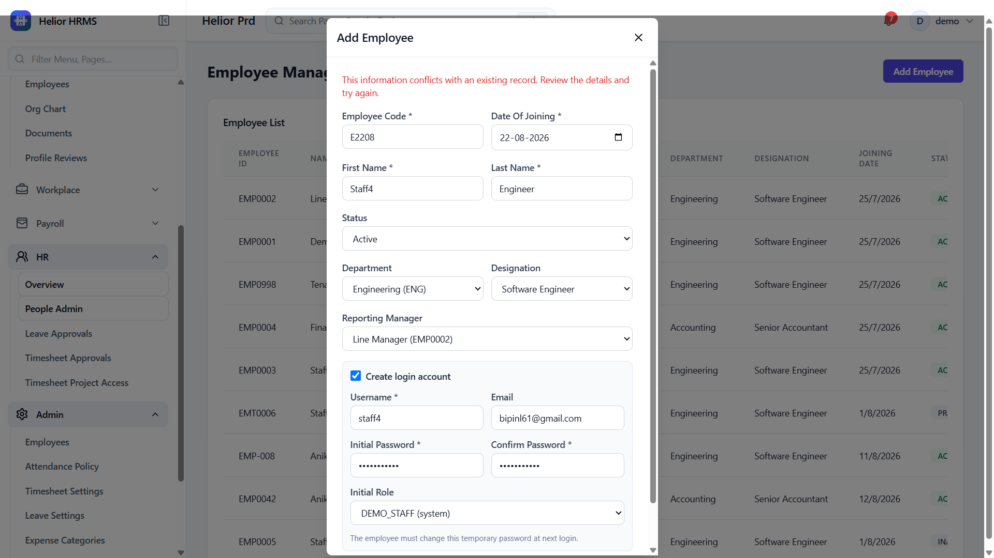

Issue#10: On trying to add new user with email address same as the existing employee, error is displayed as- ‘This information conflicts with an existing record. Review the details and try again.’
