Issue#1: Inactive employee’s access is not removed from the application.
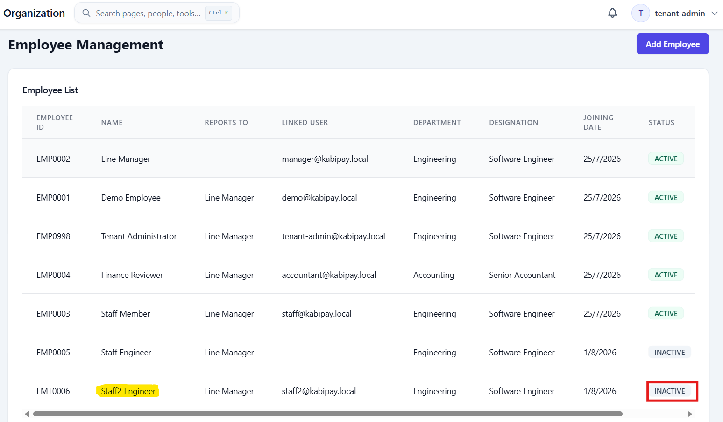

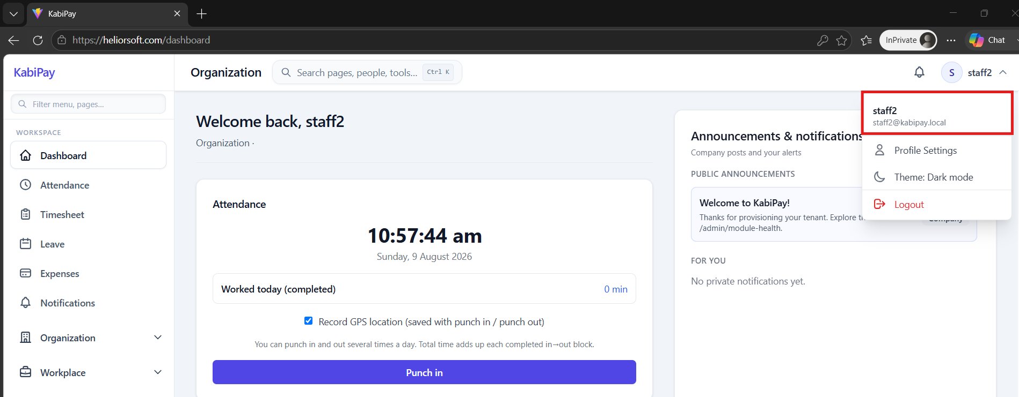

Issue#2: Once new Employee is added, it’s email address is non-editable.
Added new Employee without email address.
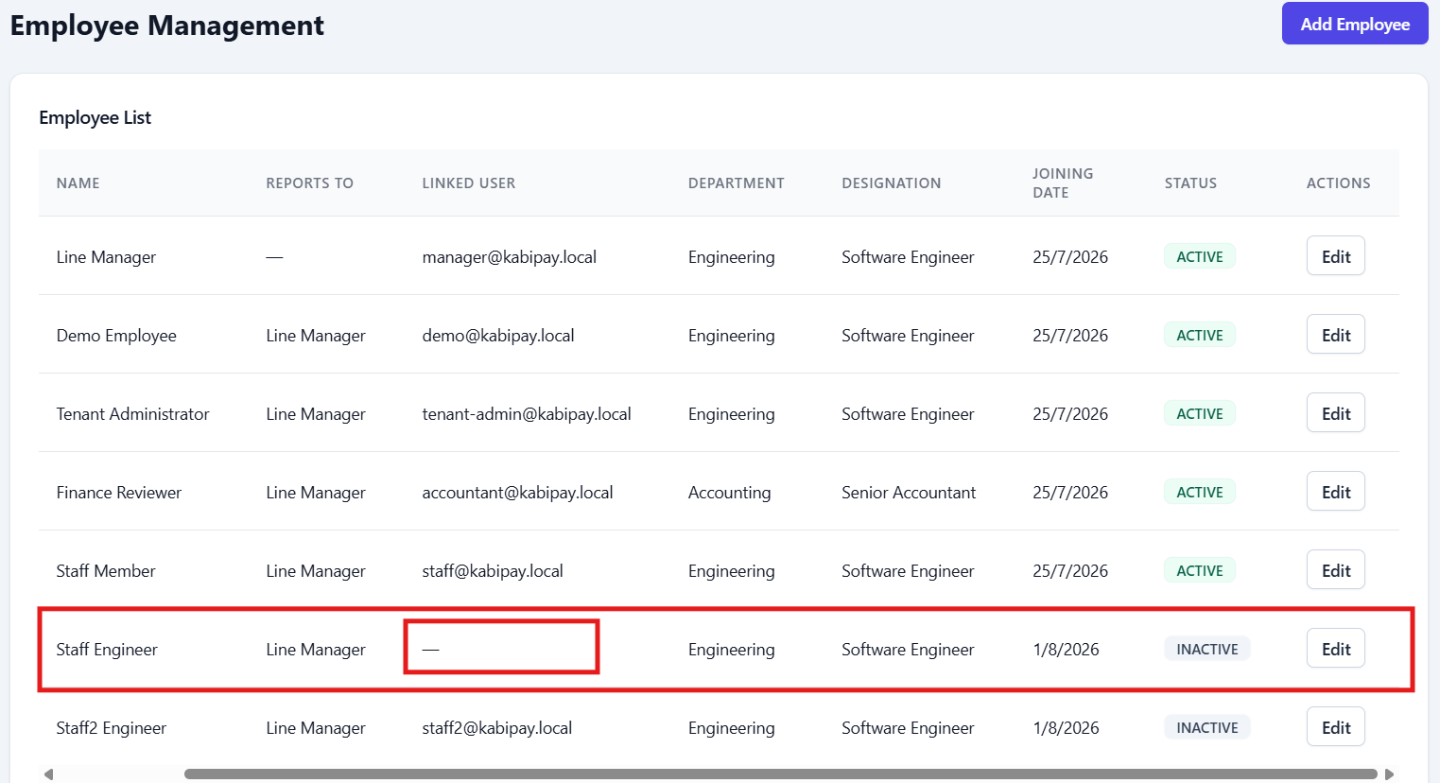

Click on Edit action. Email address field is not available.
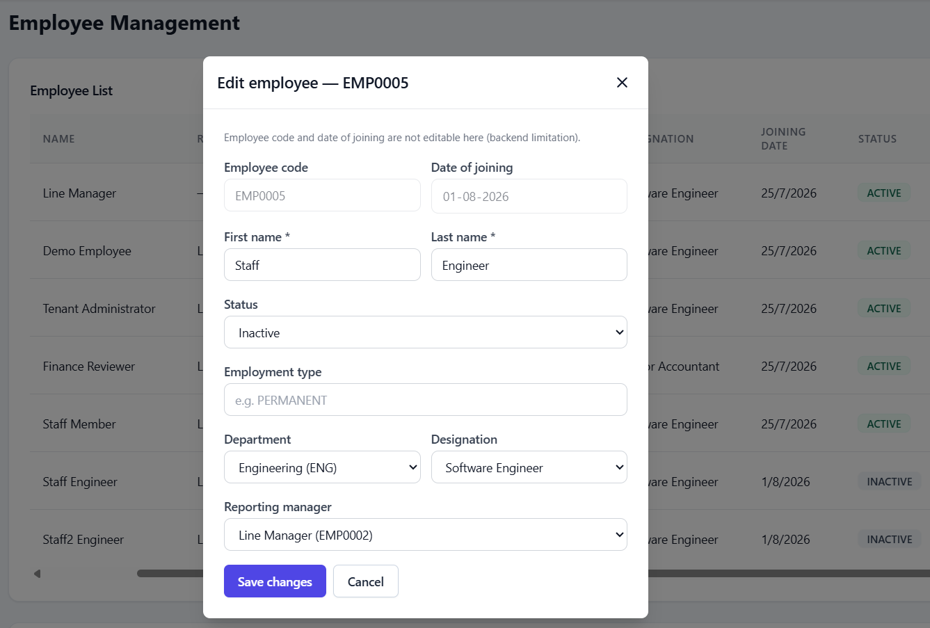

Issue#3: Generate report is yet not enabled.
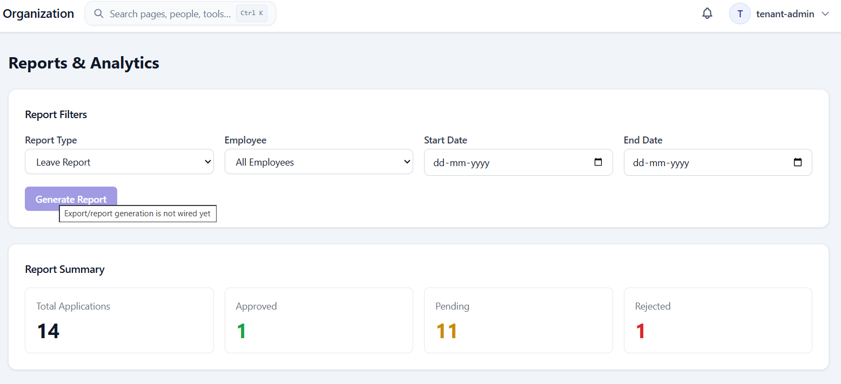

Issue#4: On re-opening Submit expense claim pop-up, the existing data on the pop-up is not cleared.
Generate error on the Submit expense claim pop-up.
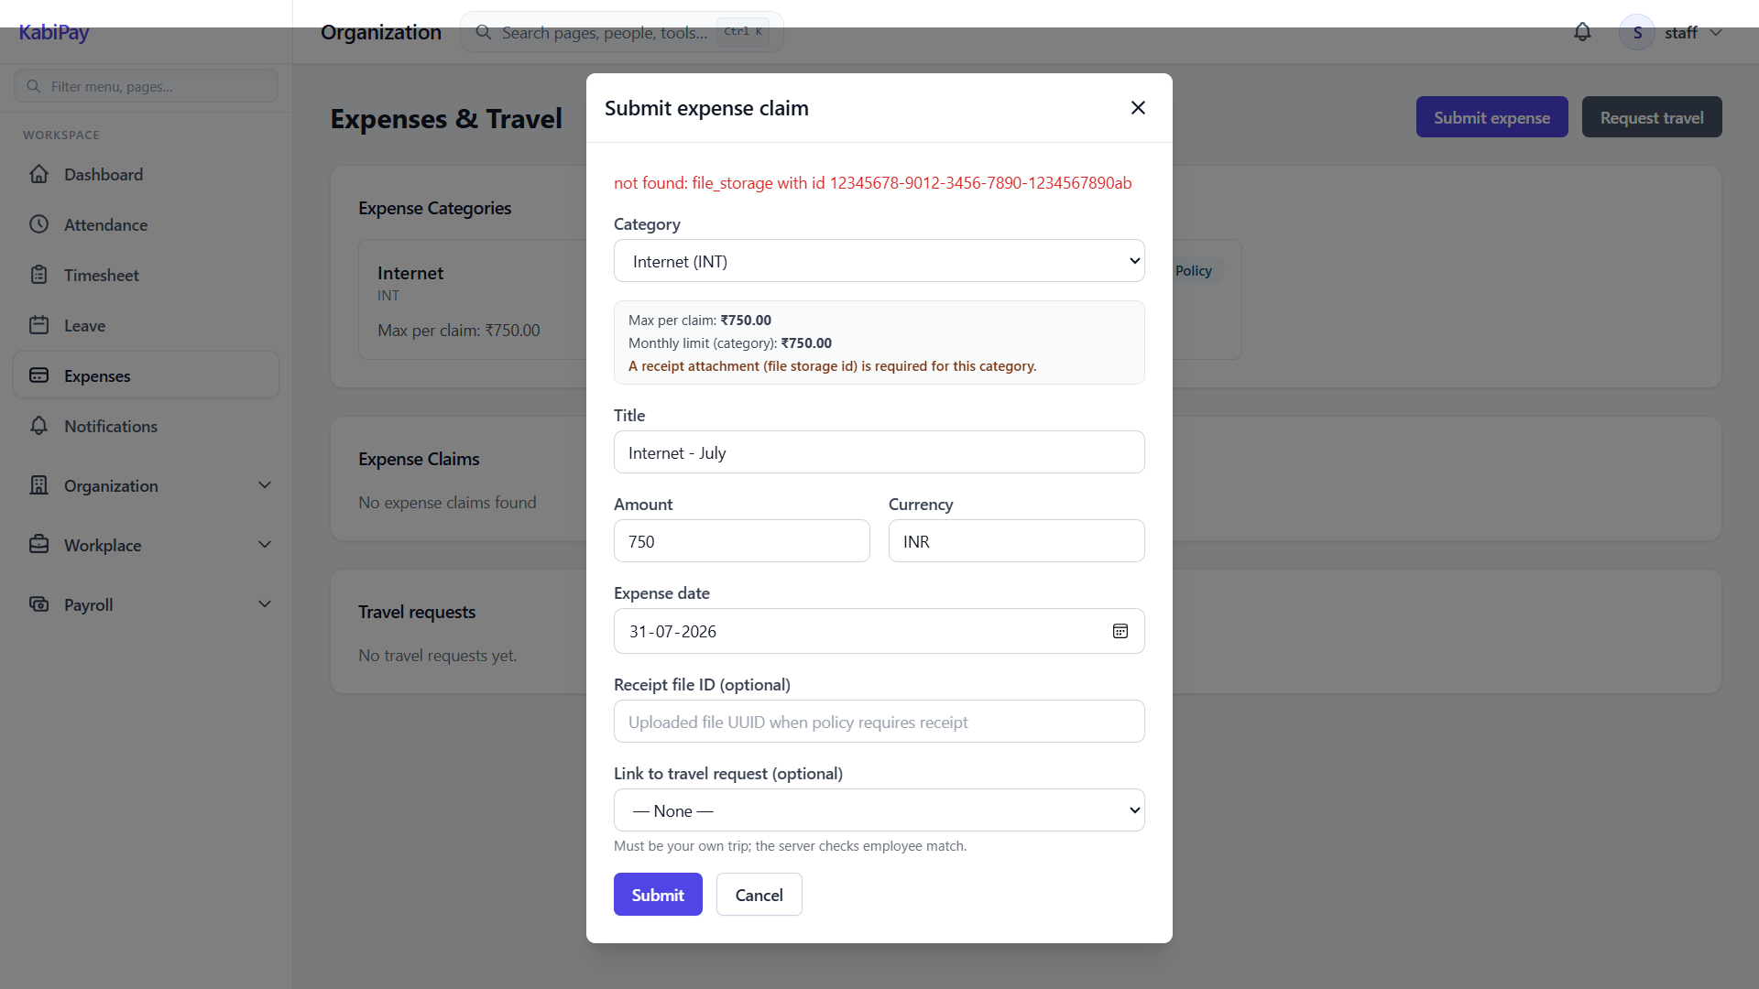
Close the pop-up and open again. Pop-up gets opened with same error/details.
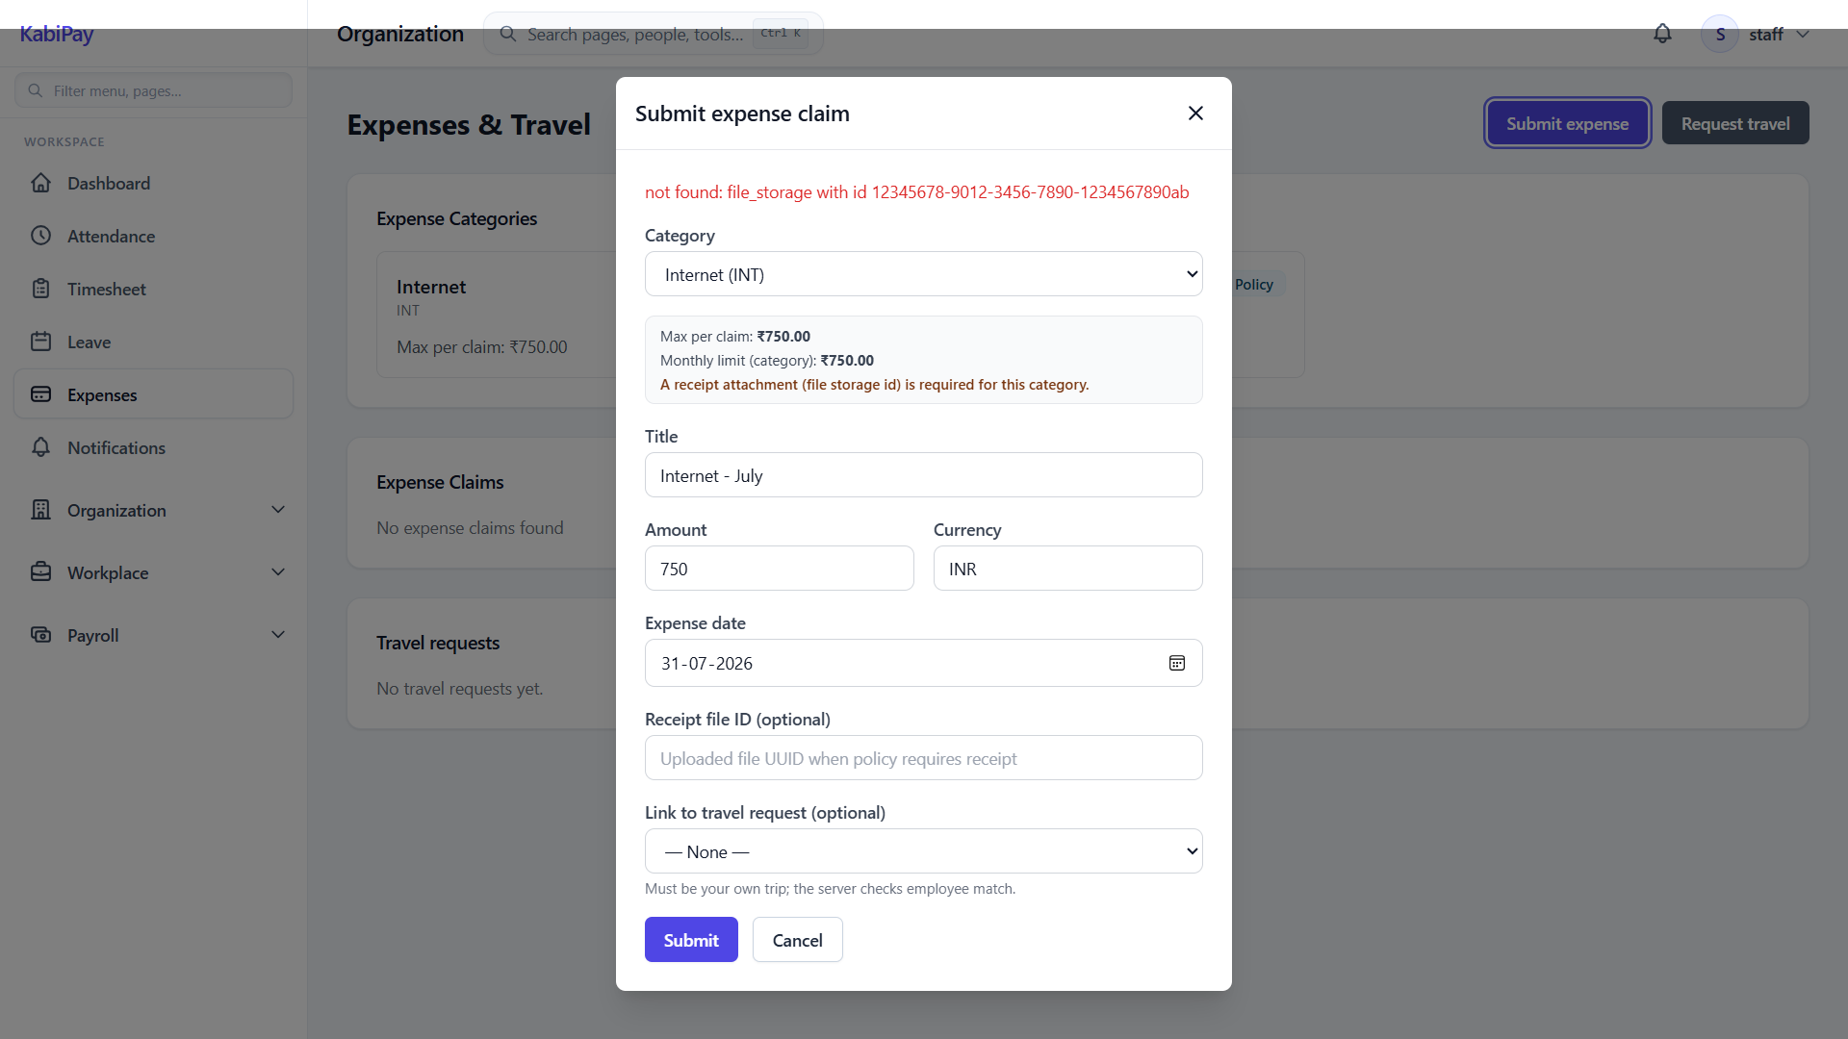

Issue#5: For manager, employee name is not shown under ‘Recent Leave Requests’.
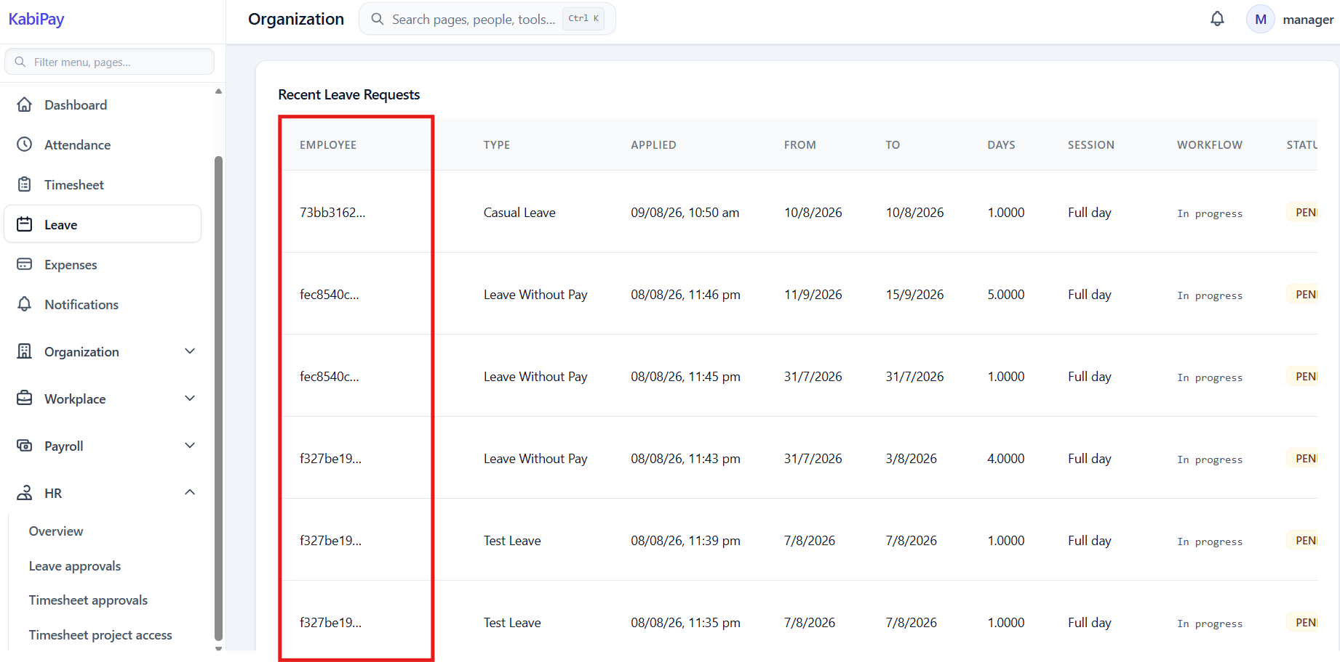

Issue#6: For Tenant-Admin/HR user, Approve/Reject actions are not available under Expense Claims and Travel requests.
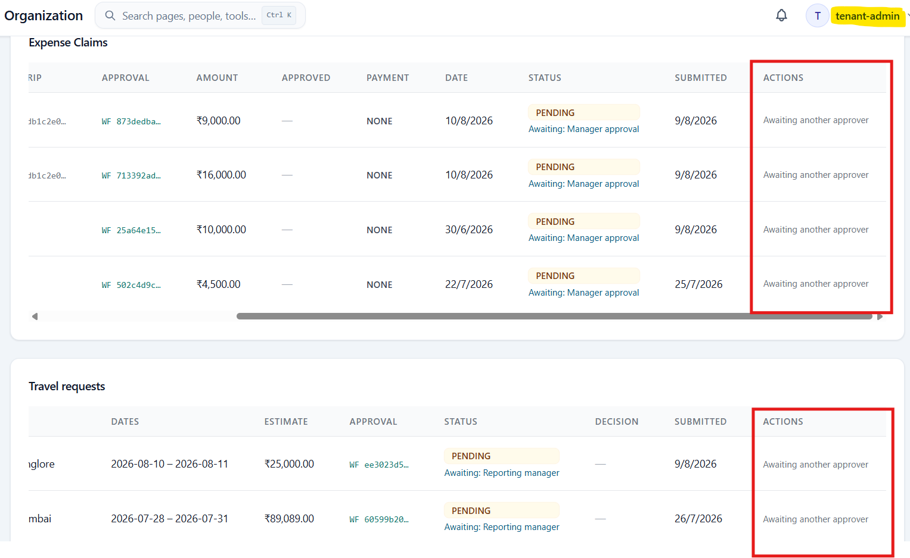
Tenant-Admin/HR user’s has permission to approve/reject the claims.
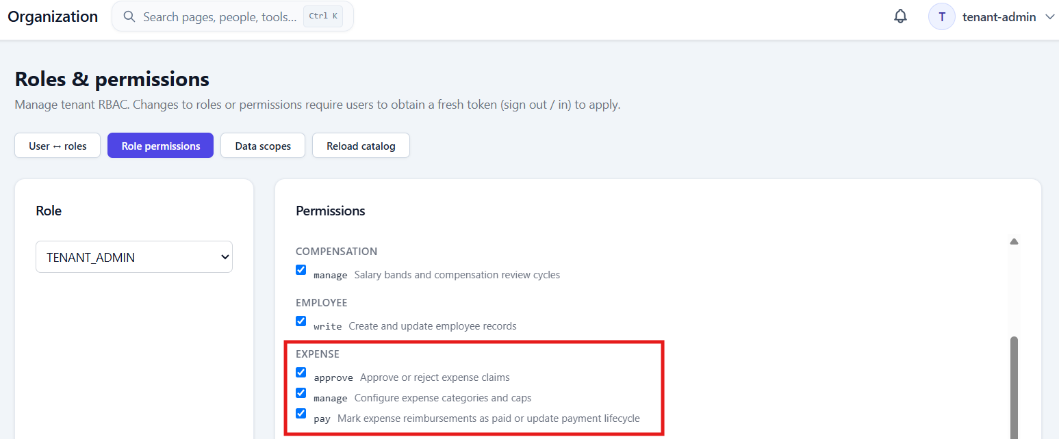

Issue#7: Employee name is not available on the Expense Claim and Travel Requests reports.
Also, columns Trip and Approval shows random values which can be either have some readable names those can be removed.
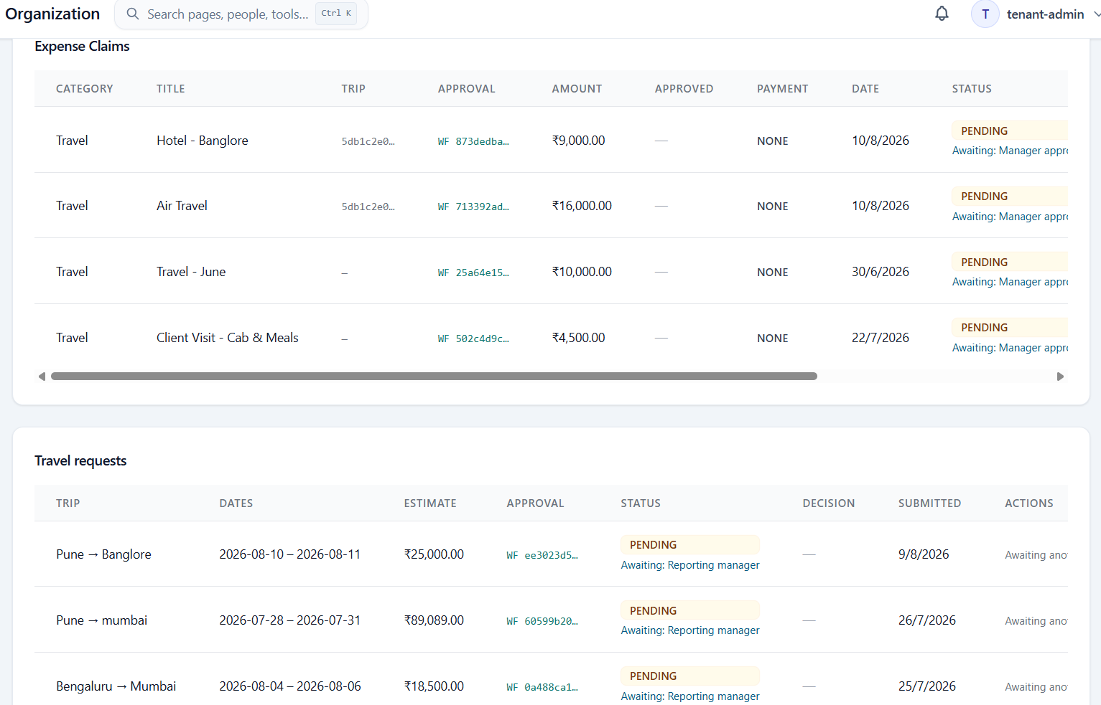

Issue#8: When an expense is approved by Manager and Accountant, Mark Paid action is shown for the Manager, HR and Tenant-Admin users. Is it expected?
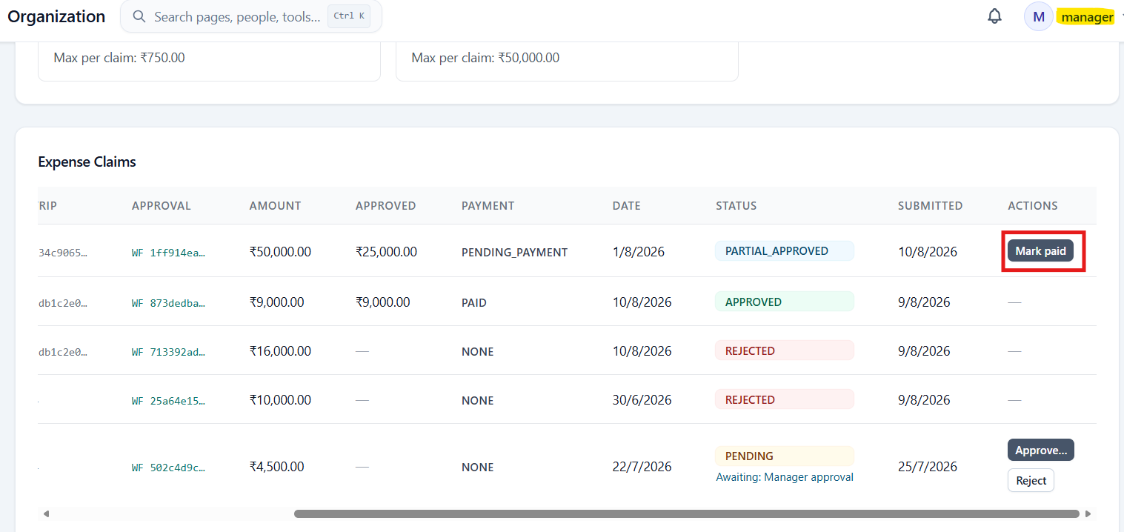

Issue#9: New Announcement pop-up is not completely visible for HR user.
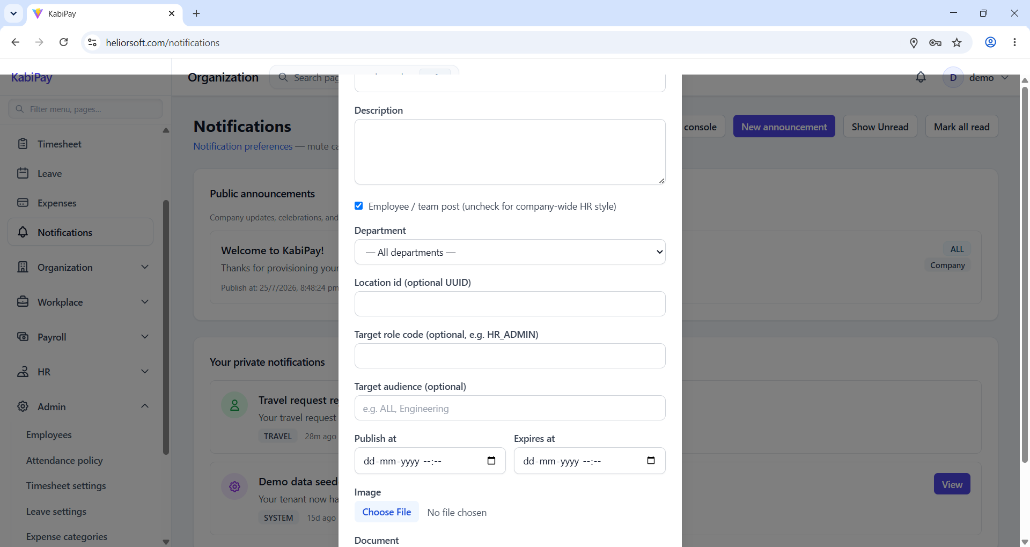

Issue#10: When an new announcement is made by HR user, a notification is not shown for the announcement.
New announcement.


Notification alert is not generated.
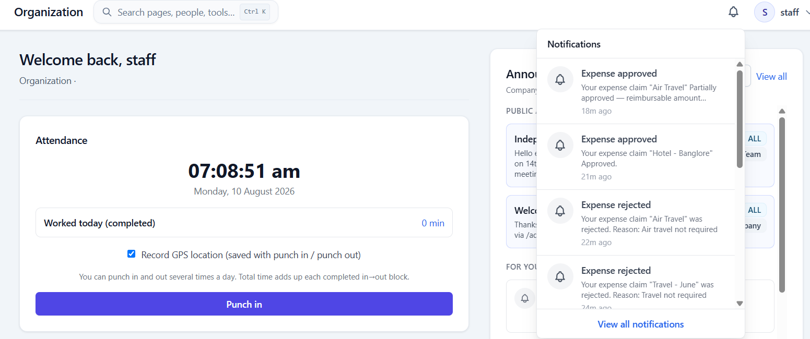

Issue#11: For accountant user, error is displayed for attendance module on the dashboard.
