Issue#1: When ‘Lock approved timesheet rows from edits’ is unchecked, still user is not allowed to edit the entries from the already approved timesheet.
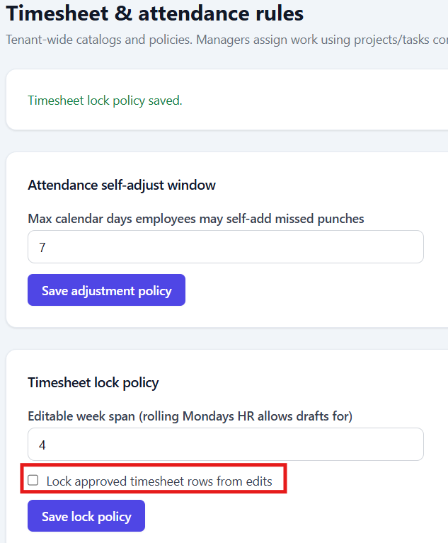
On hovering mouse over the approved timesheet’s entry, below tooltip gets displayed.
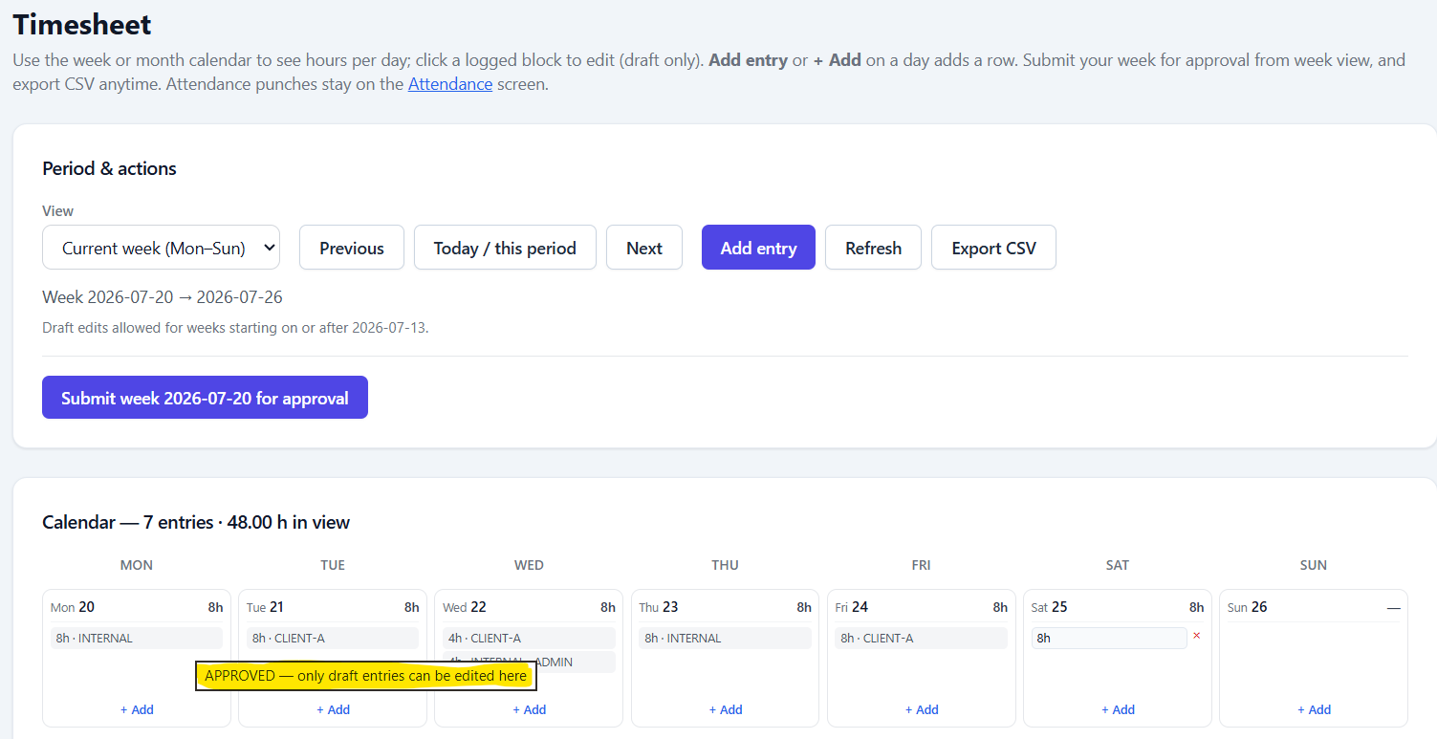

Issue#2: When the ‘Timesheet lock policy’ is updated from 3 to 4 and Editable week span and Staff user logs time for 4th past week and the ‘Timesheet lock policy’ is updated from 4 to 3 again, the 4th past week still shows the Submit button enabled.
Steps:
1. Log in with HR/Tenant-Admin and navigate to Admin> Timesheet Setting.
2. Update Editable week span available under ‘Timesheet lock policy’ from 3 to 4
3. Login with Staff user navigate to Timesheet.
4. Navigate back to the 4th past editable timesheet and enter data for a day.
5. Repeat steps #1 to #2 and update Editable week span available under ‘Timesheet lock policy’ from 4 to 3 back.
6. Login with Staff user and navigate to Timesheet and check the state of the Submit button for the 4th past week.
Actual Result: Submit button for the 4th past timesheet is enabled.
But for other user’s, Submit button is disabled for the 4th past week.
Screenshots when the Editable week span is 3:
Current week
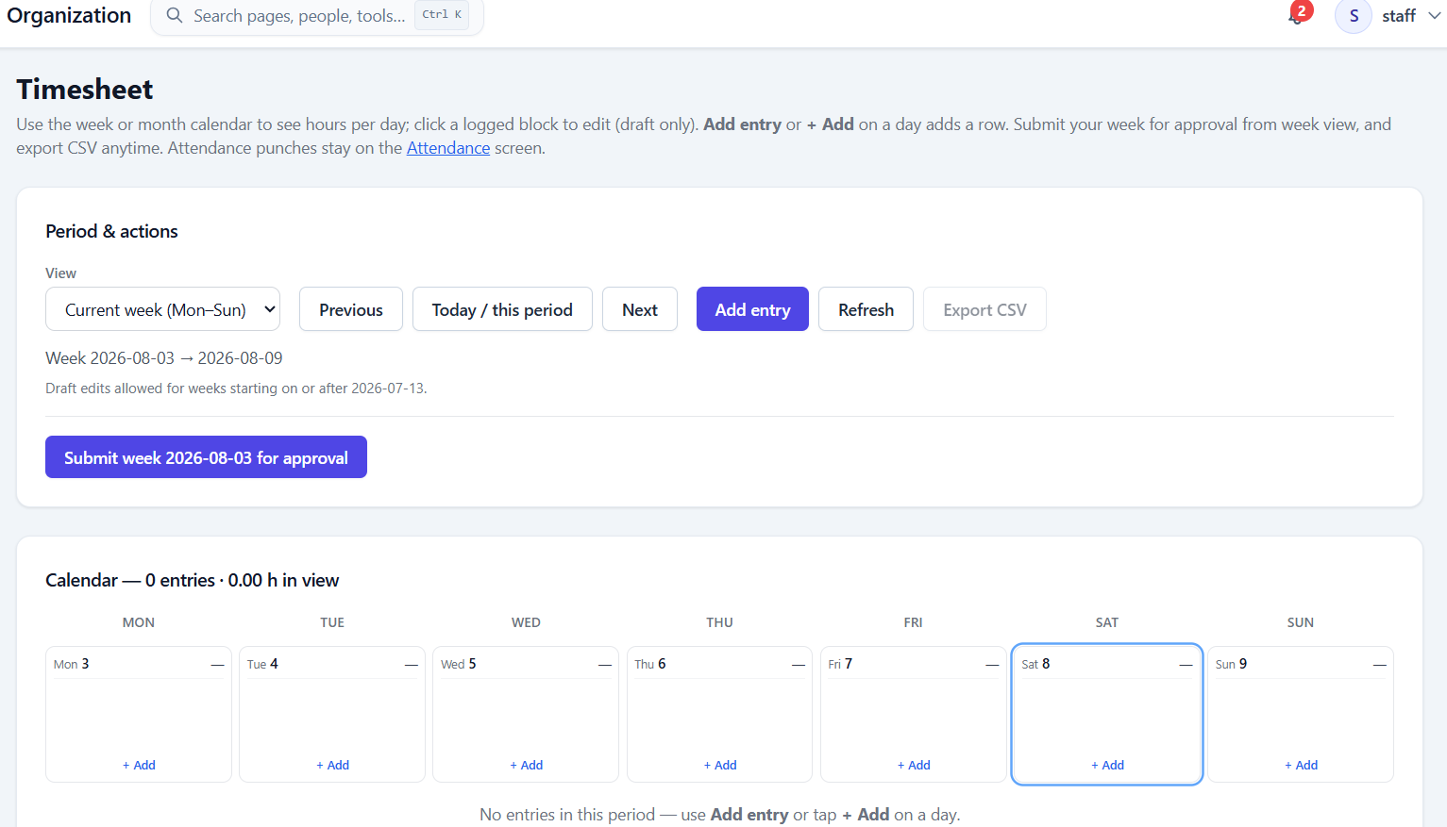

2nd past week:
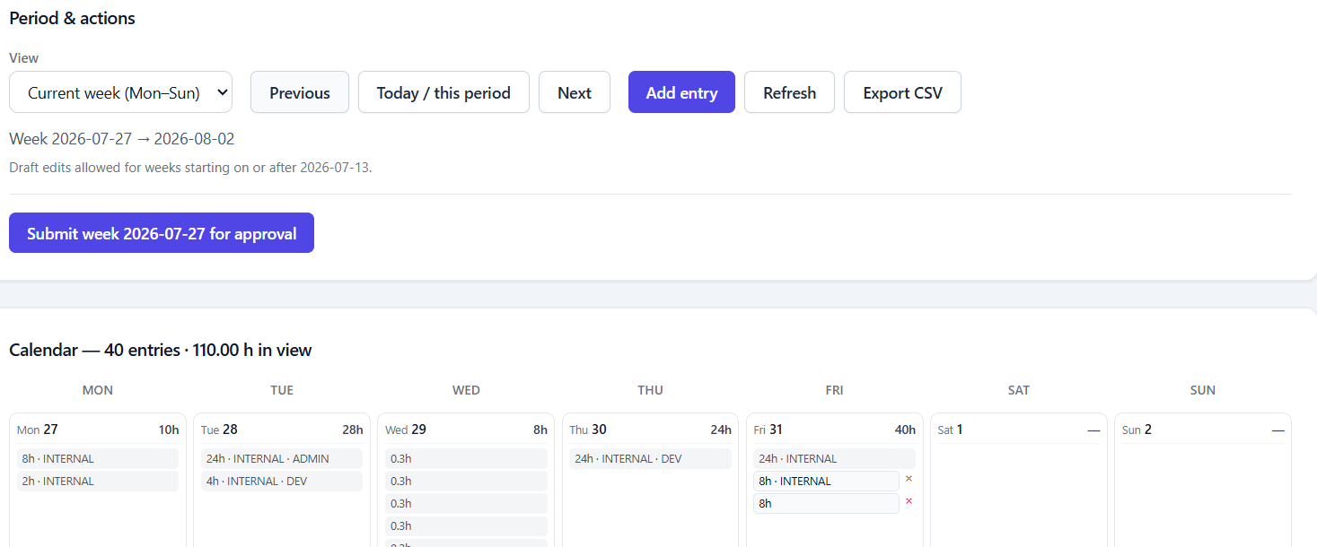

3rd past week:
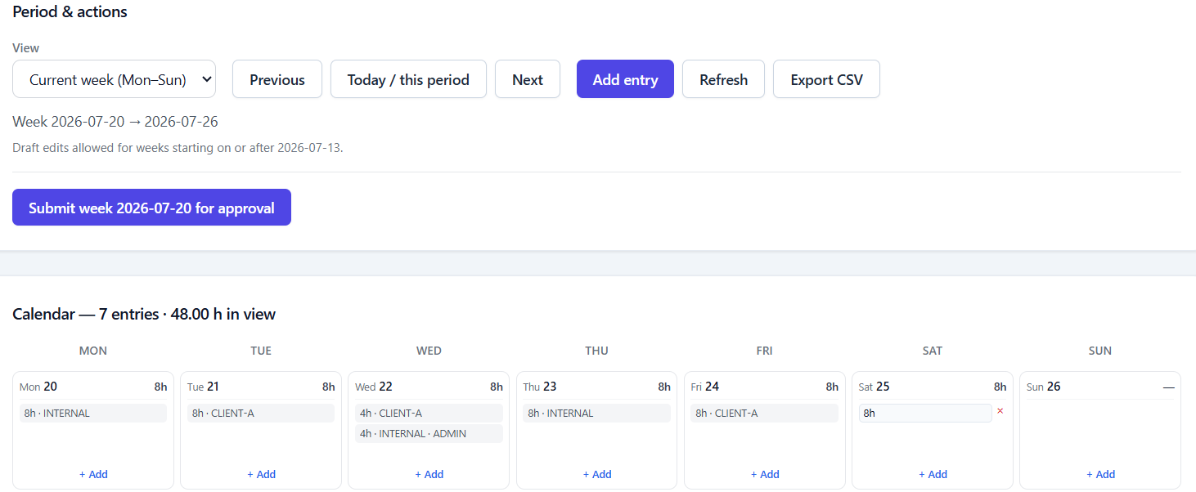

4th past week:
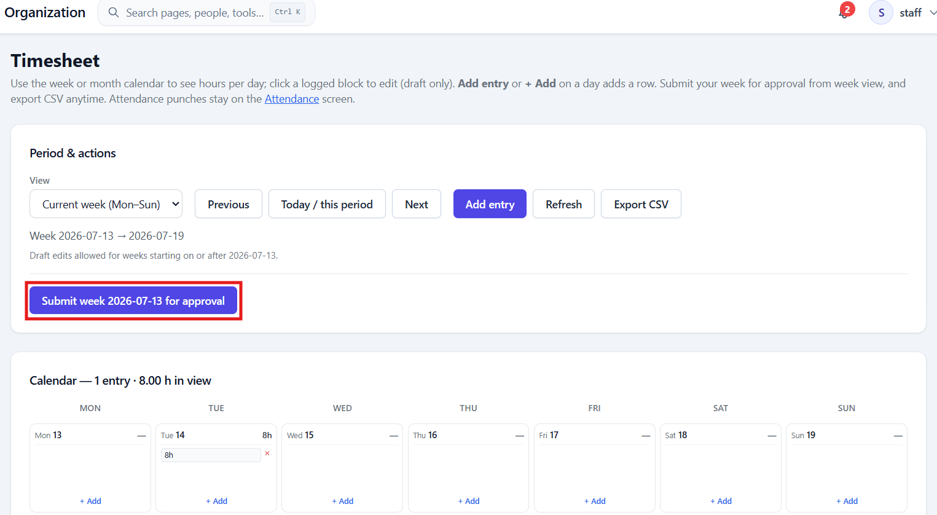

Same period for HR user:
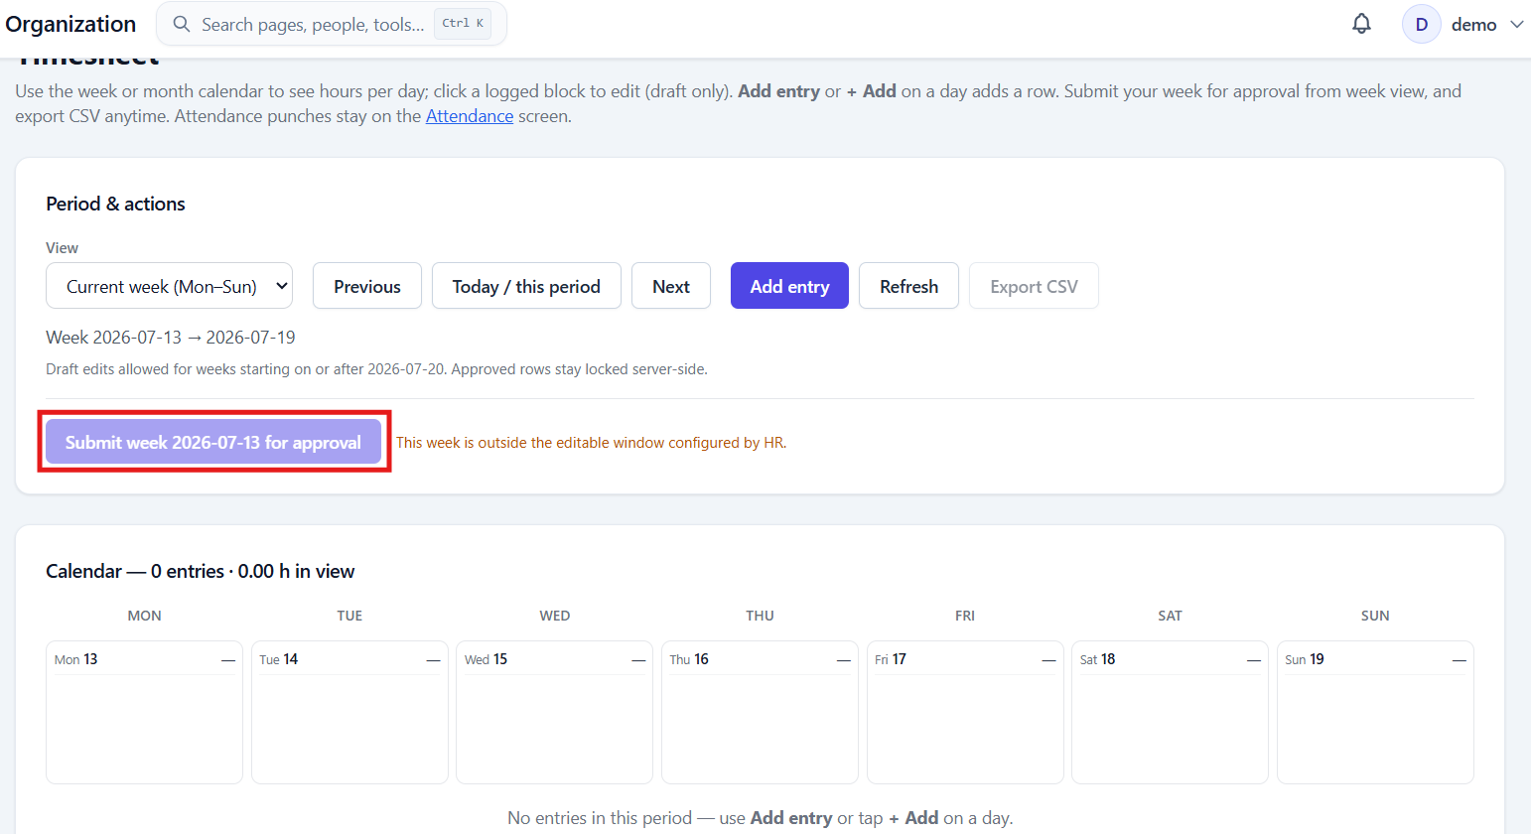

Issue#3: When a new leave type is added, the leave type is not shown ‘Leave Balances’ report unless that type of leave is applied at least once.
Admin user adds a new leave type ‘Test Leave’
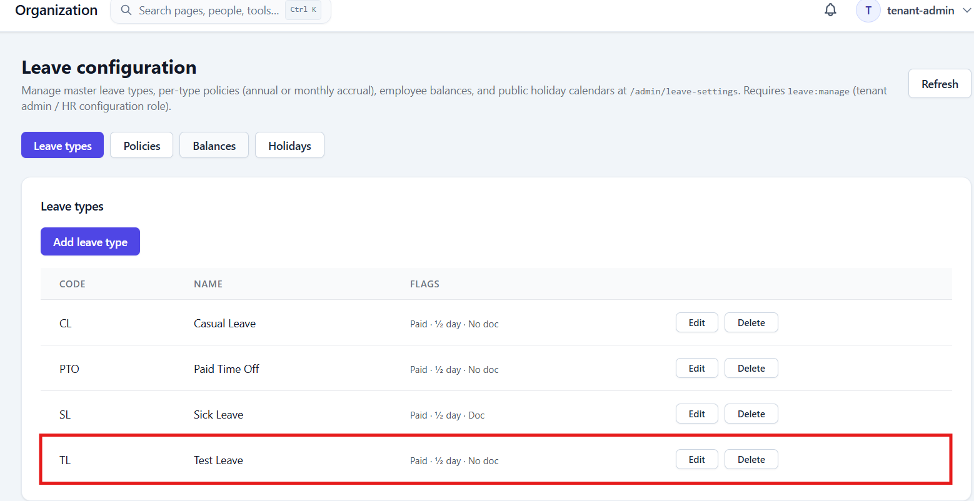

This leave type is not shown under ‘Leave Balances’ section of HR user.
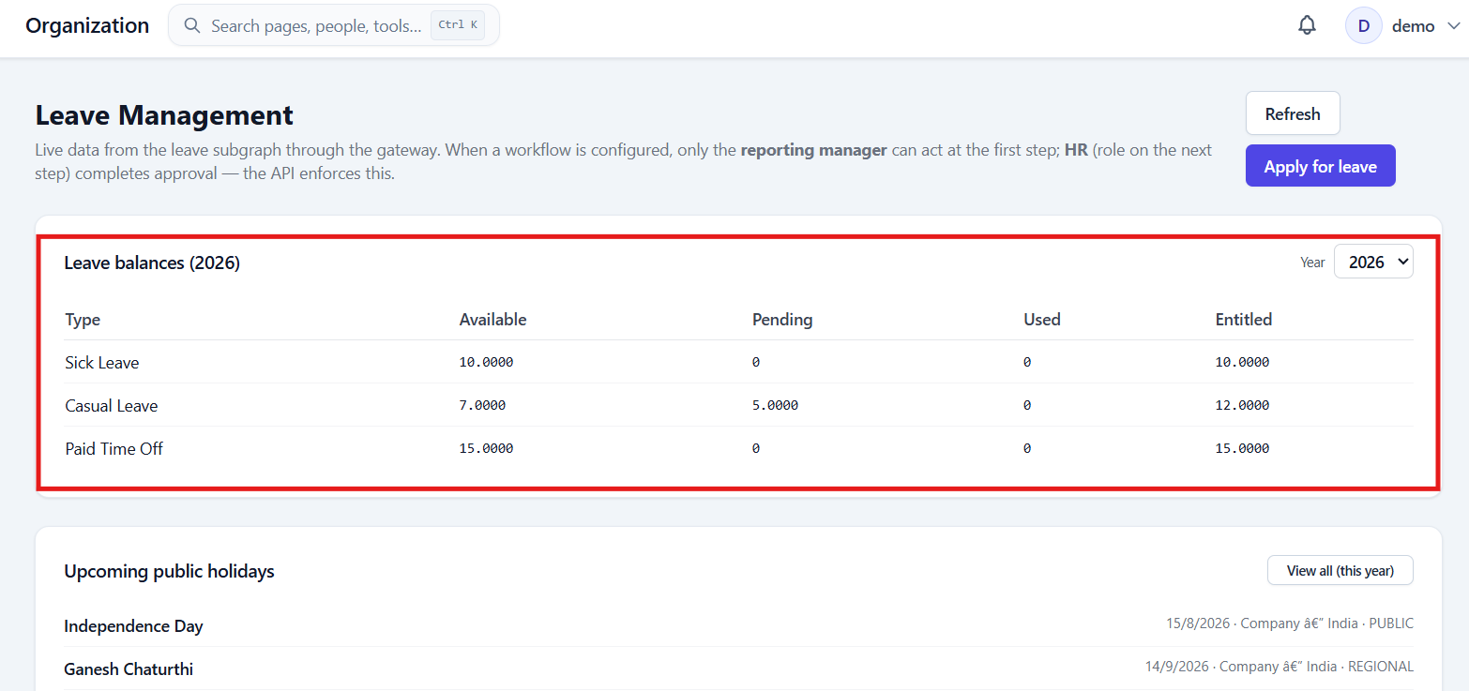

If HR user applies this type of leave then only this leave type is displayed under Leave Balances.
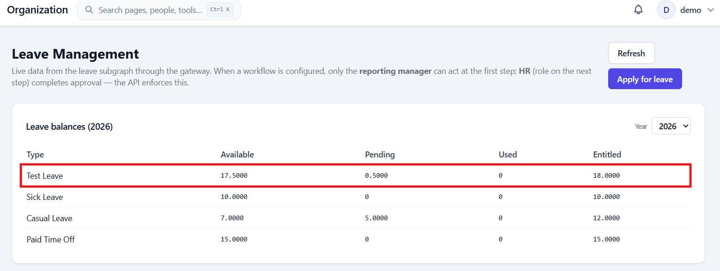

Issue#4: User session is getting timed out/logged out even when the application is in user and on performing any action, unexpected error gets displayed.
Application should not get time-out when in use. Application should get logged out only if the user is not active.
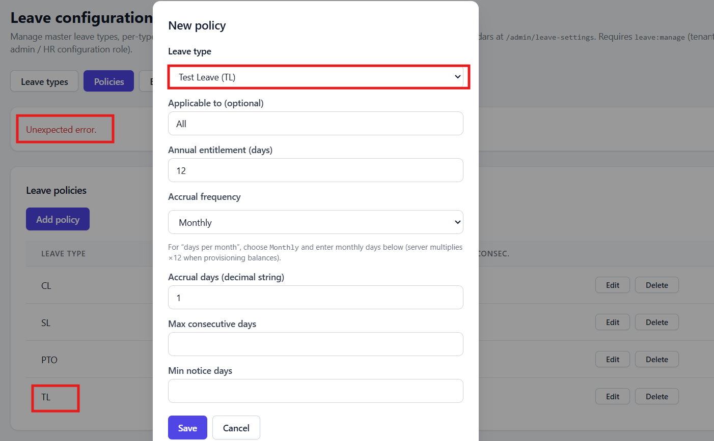

Issue#5: User is allowed to add multiple policies to the same Leave type.
What is the use of adding multiple policies to 1 leave type?
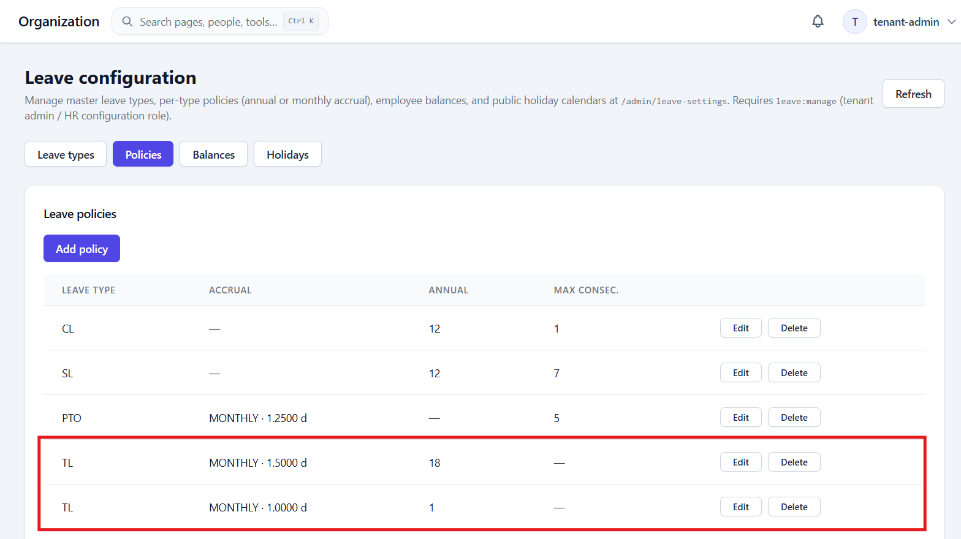
Issue#6: On adding new leave type ‘Leave Without Pay’ without adding the Leave Balance, when the user tries to apply this leave, error is displayed saying ‘no leave balance for this leave type and year — configure a leave policy with entitlement or ask HR to provision balances’
Also, the completed pop-up is not visible on UI.
To allow user to apply for a LWP leave, we need to add Leave Balance to this leave type and if the Leave Balance is added then this leave type is displayed on the Leave Balances section available under Leave Management.
