Issue#1: Under Attendance report, Punch-in Punch-out made by HR user is displayed for the Tenant_Admin user and vice-versa.
Basically, the Attendance report of HR Admin and Tenant_Admin shows attendance for all the employees. Following are the issues here:
i. Are we going to show reports of all the employees to both HR_Admin as well as Tenant_Admin user?
If yes, then we need to mention the name of the employee against the attendance record.
ii. Are we allowing both HR_Admin and Tenant_Admin users to update the attendance of all the employees including each other’s attendance?
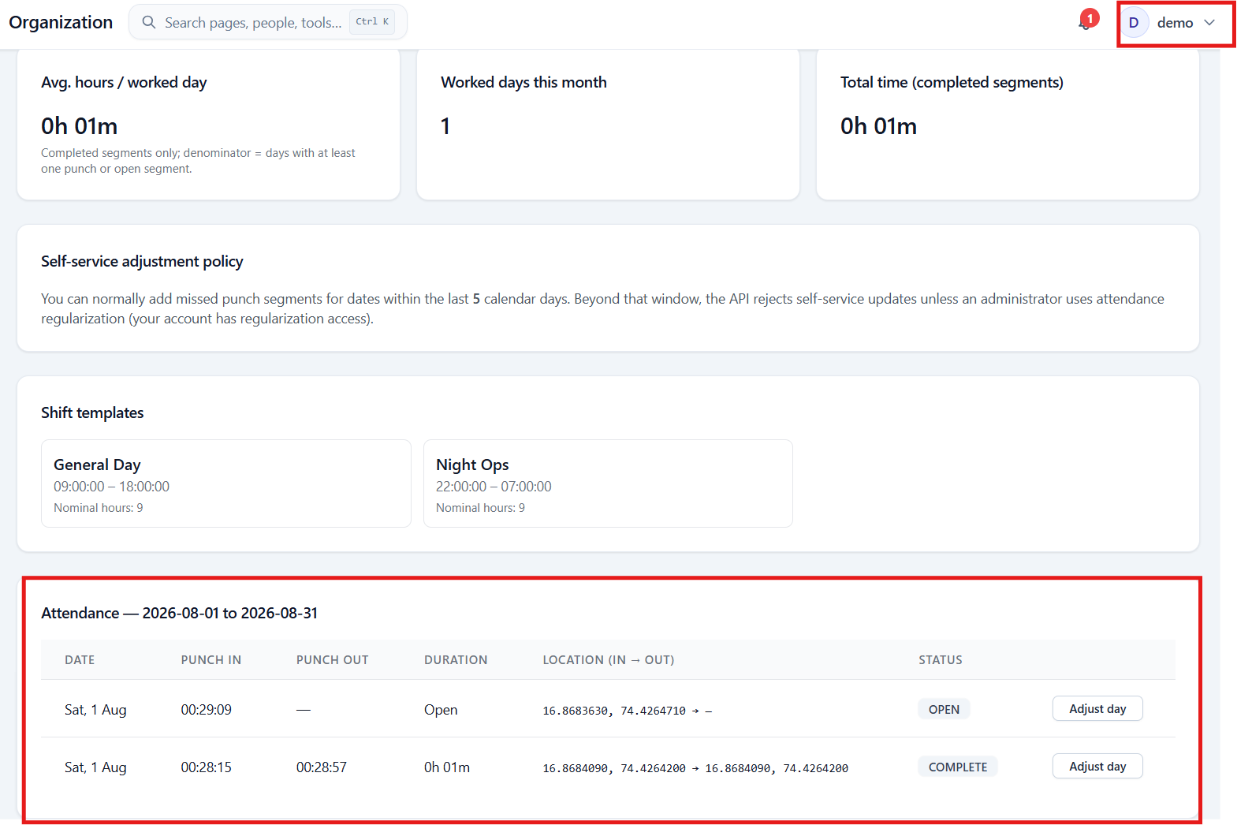
Same attendance is displayed for the Tenant_Admin user.
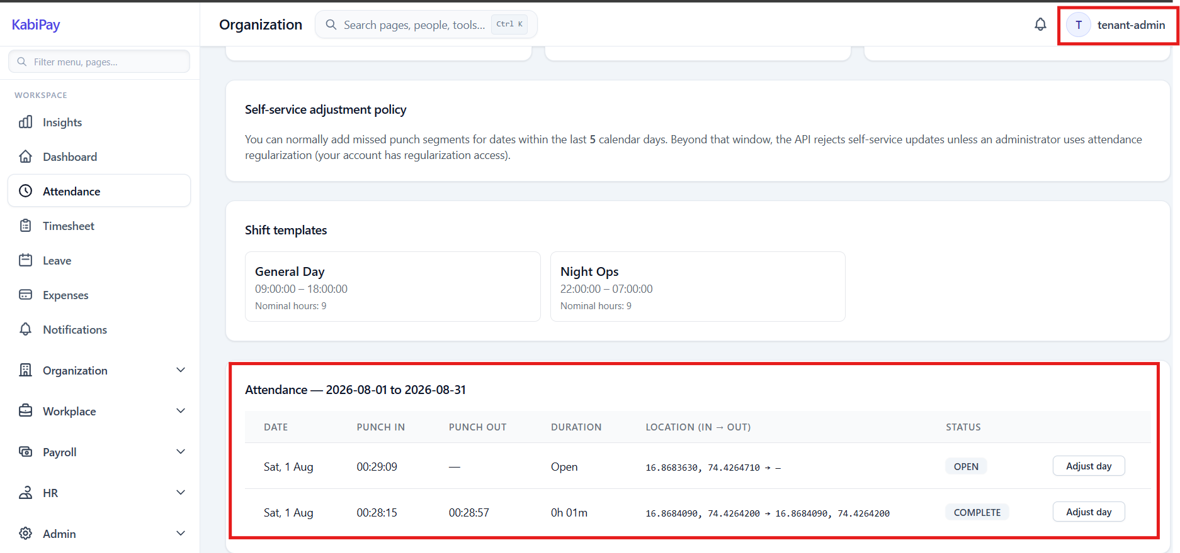

Dashboard do not show these entries which is correct.
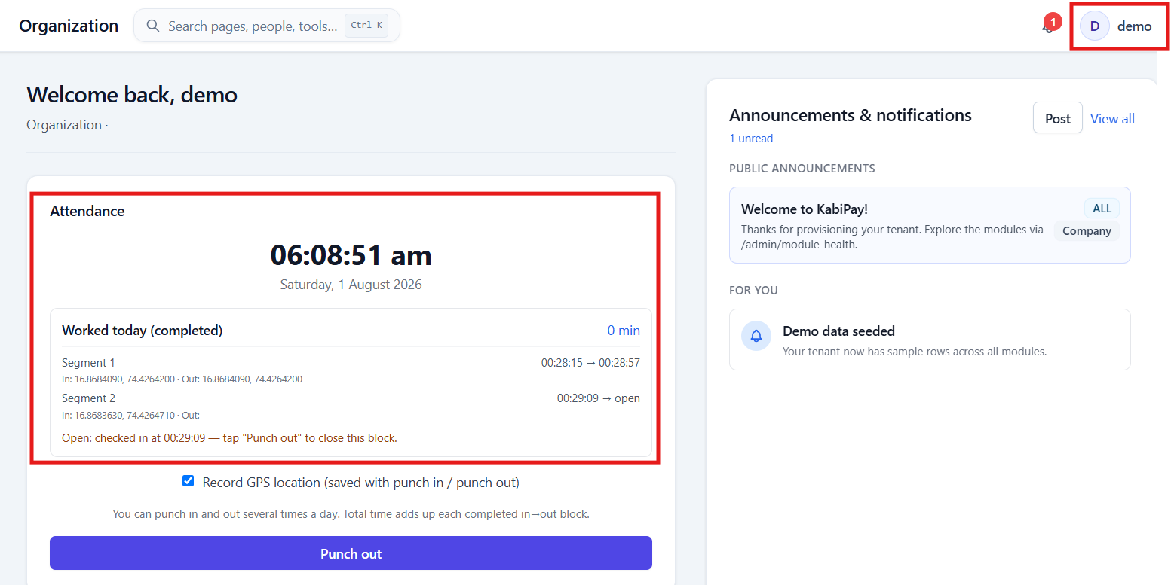

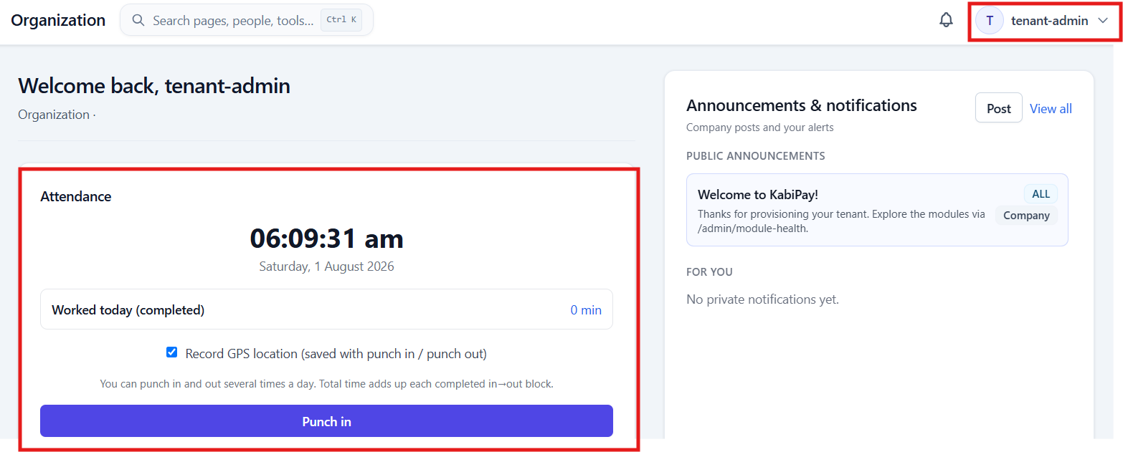

Perform punch-in using tenant admin user.
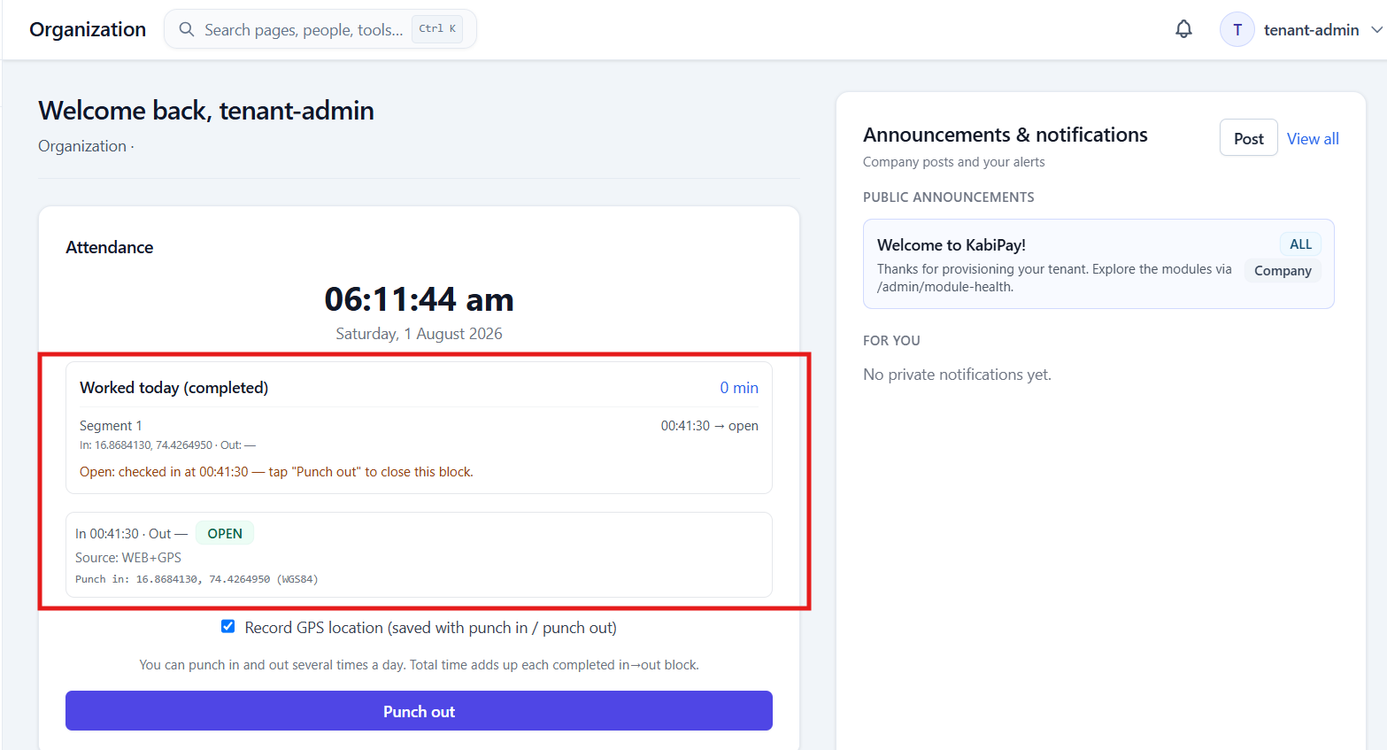

Atendance report of HR user as well as Tenant Admin user shows this entry.
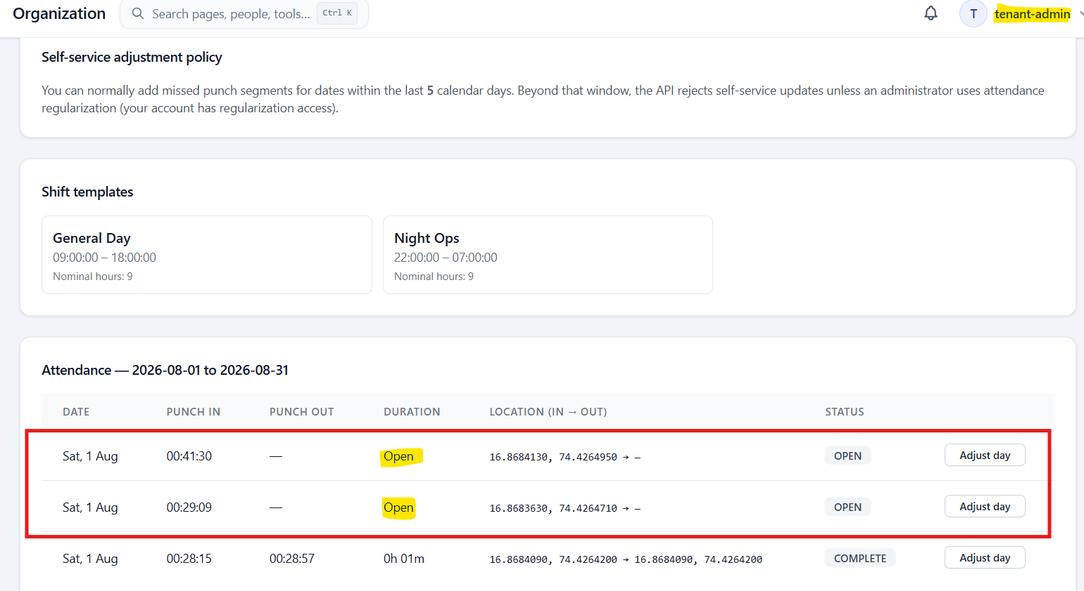

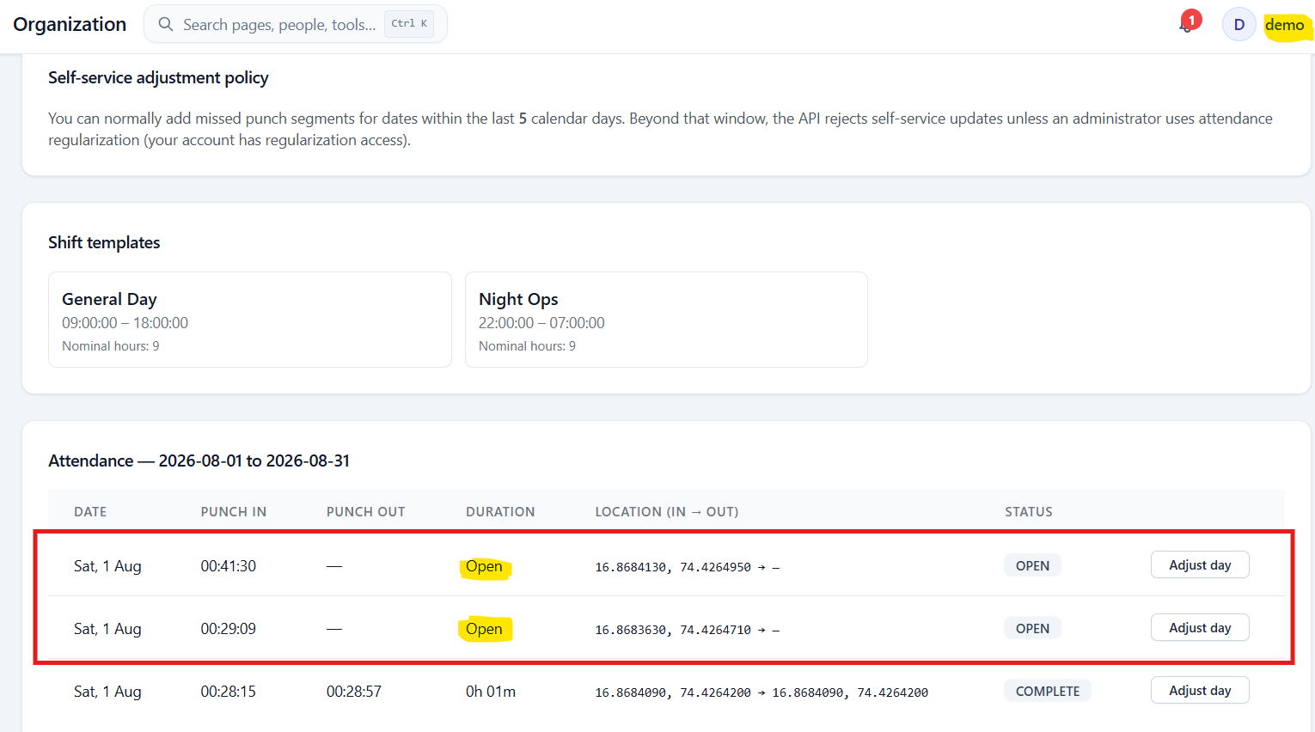

Issue#2: When user click on the ‘Adjust Pay’ action, the pop-up by default shows Punch-In time as 9:00 and Punch-Out time as 12:00.
It do not show the Punch-In, Punch-Out time already available for this entry.
Existing record:
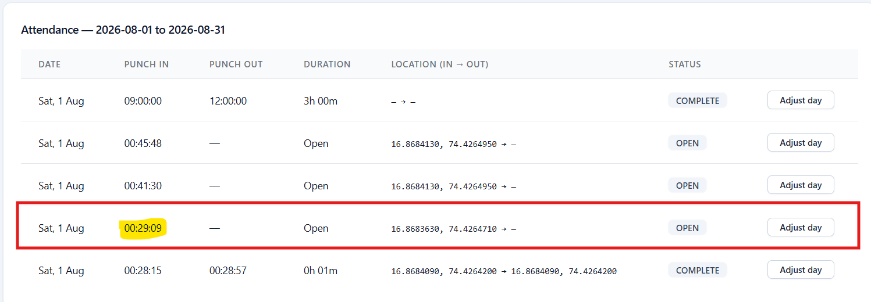

Click Adjust Pay:
Default values are displayed.
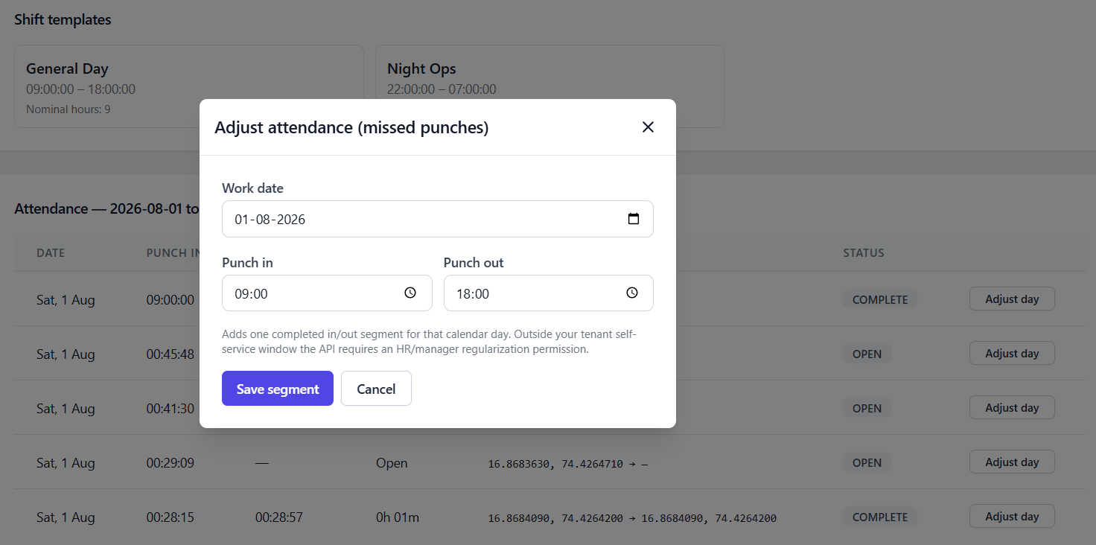

Issue#3: User is allowed to update the attendance which is in Complete state.
This includes attendance from past month as well.
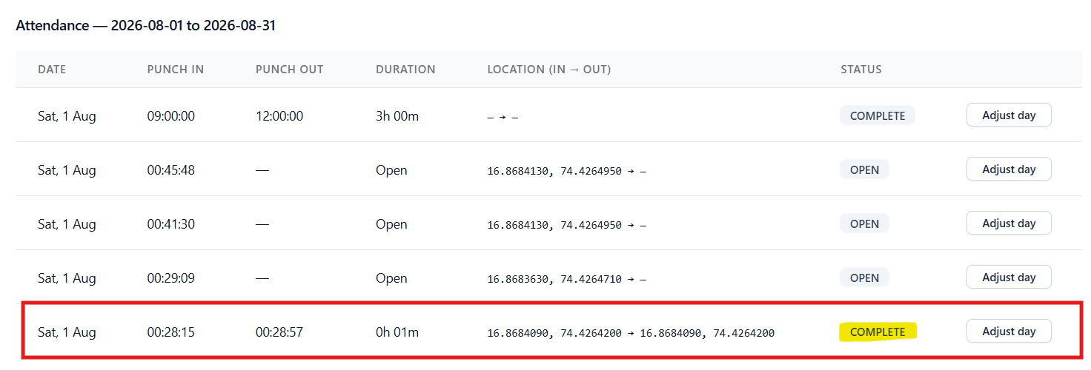

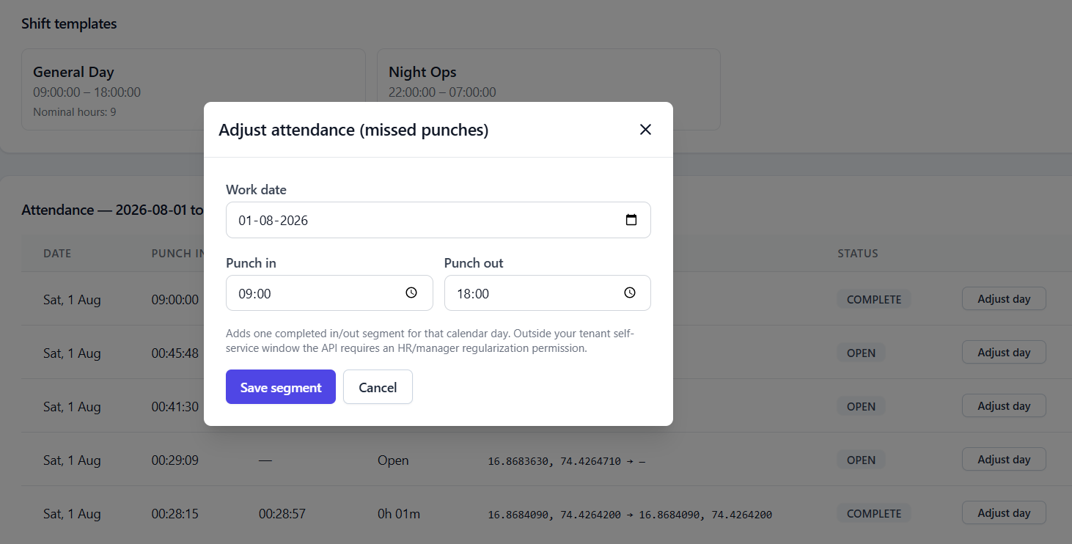

Instead of updating existing Entry, new entry gets added.
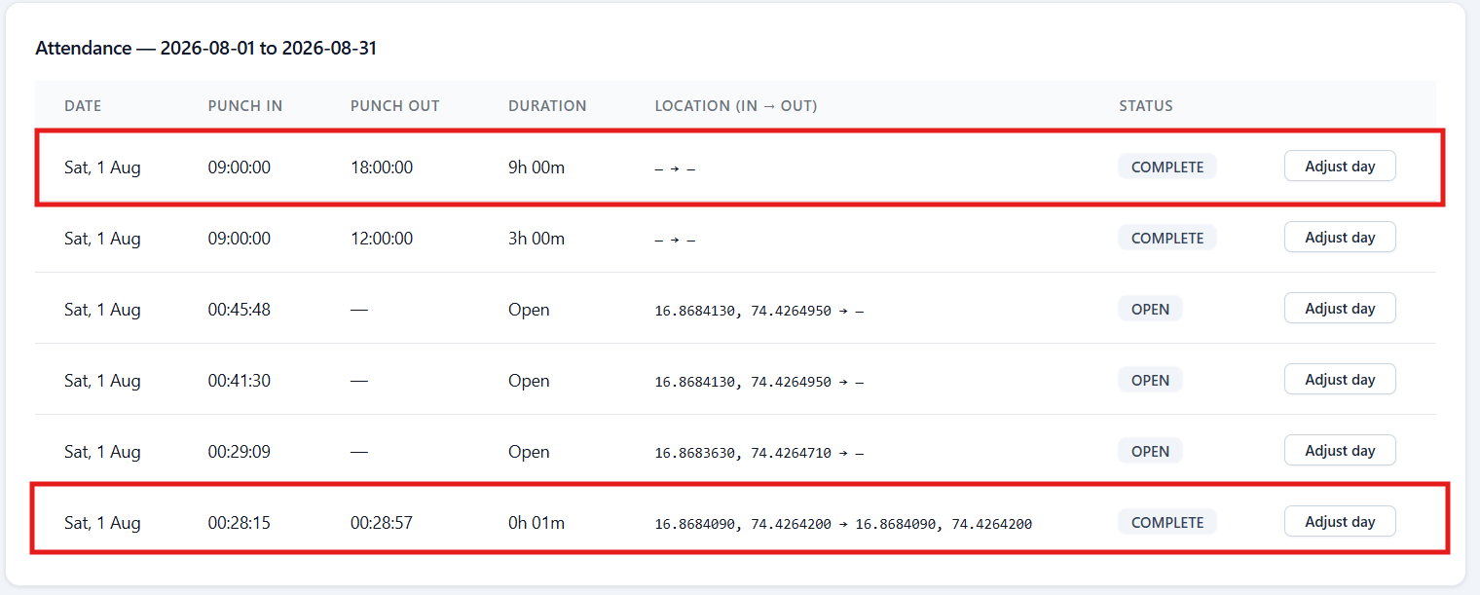

Issue#4: Attendance report do not show the consolidate time logged for the current/any day.
When we have multiple Punch-In and Punch-Out entries for a day, there is no way user can get the total logged time for the day. User need to manually calculate the time according to the Punch-In, Punch-Out durations.
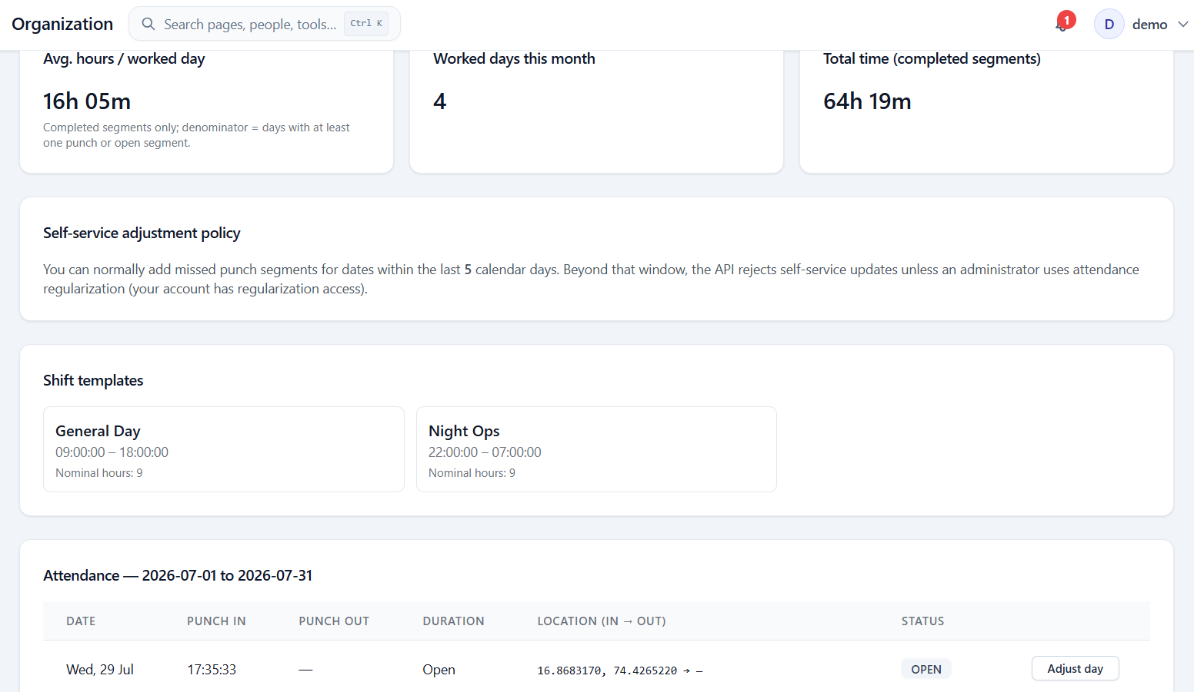

Issue#5: User is allowed to enter 24 hrs attendance for a day.
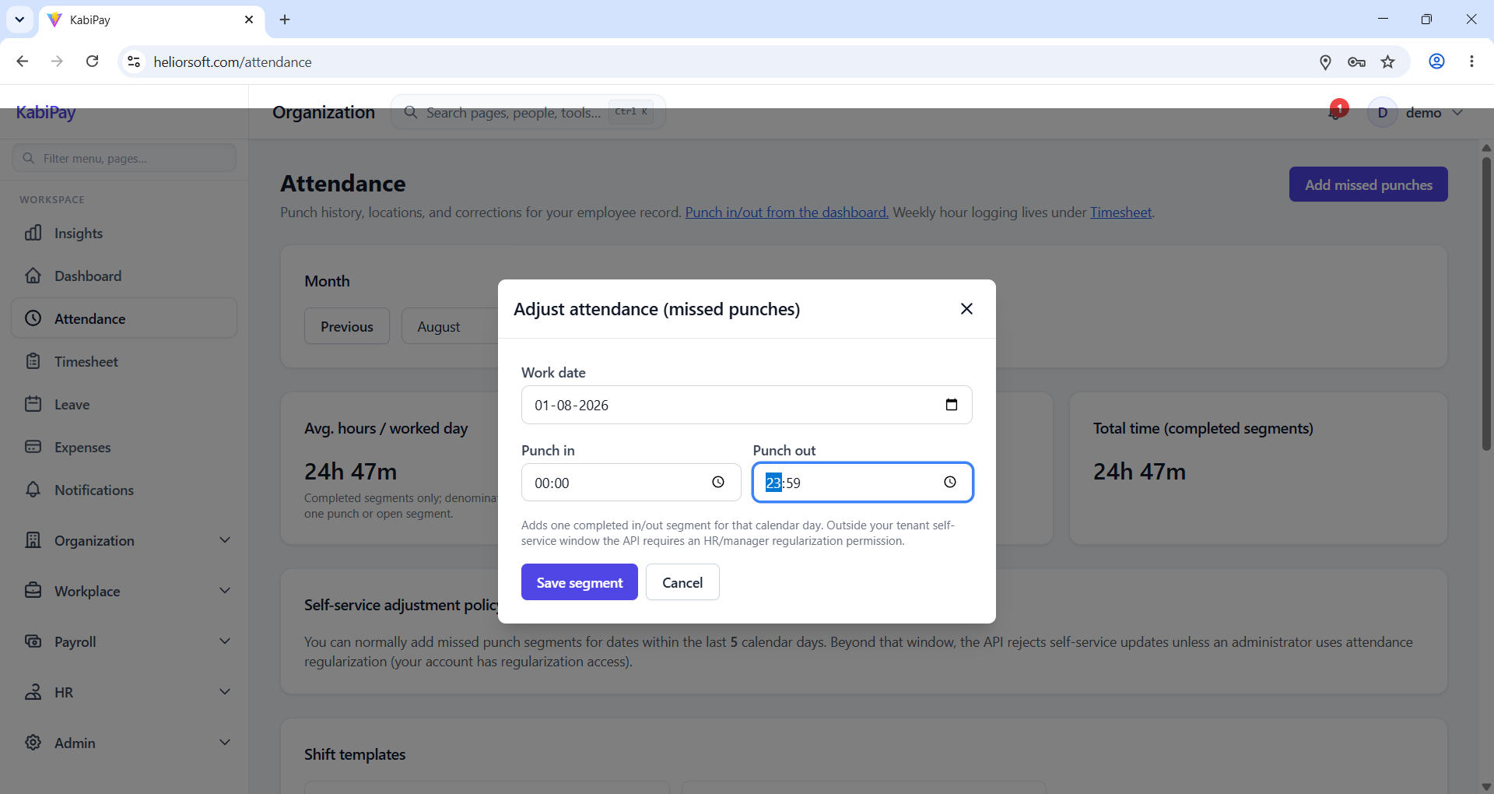

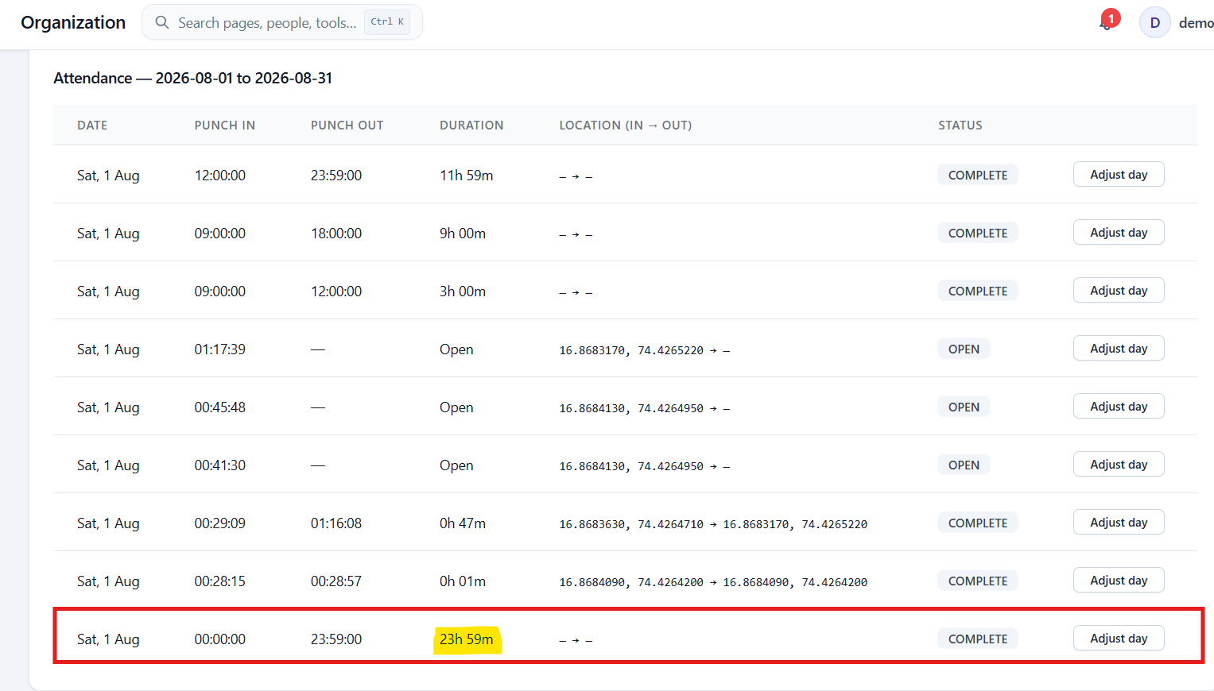

Including multiple attendance entries, user can add more than 24 hrs for a day.
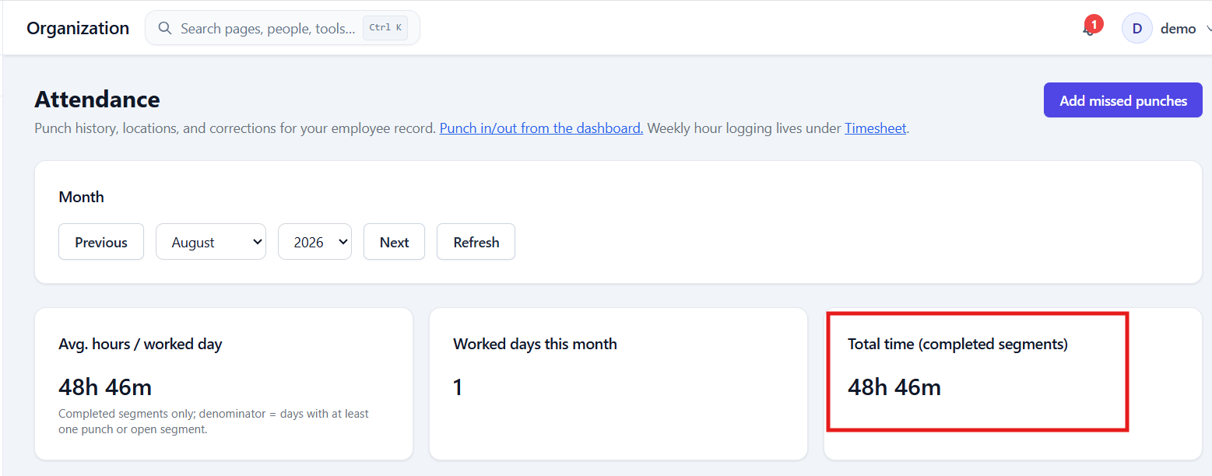
Issue#6: Loading icon and a success message should be displayed on clicking Refresh button on the Attendance report.
Currently on clicking Refresh button, report gets updated but UI do not show any success message to let the user know that report is refreshed.
