Issue#1: On clicking Sign In without entering the captcha, error is not shown. Instead, the captcha gets refreshed.
Same issue is observed when user enters wrong captcha and click Sign In.
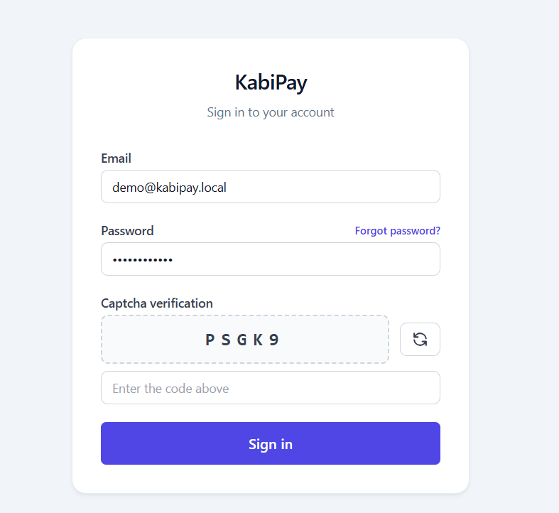
Issue#2: Punch-in punch-out time should show the time from same time zone.
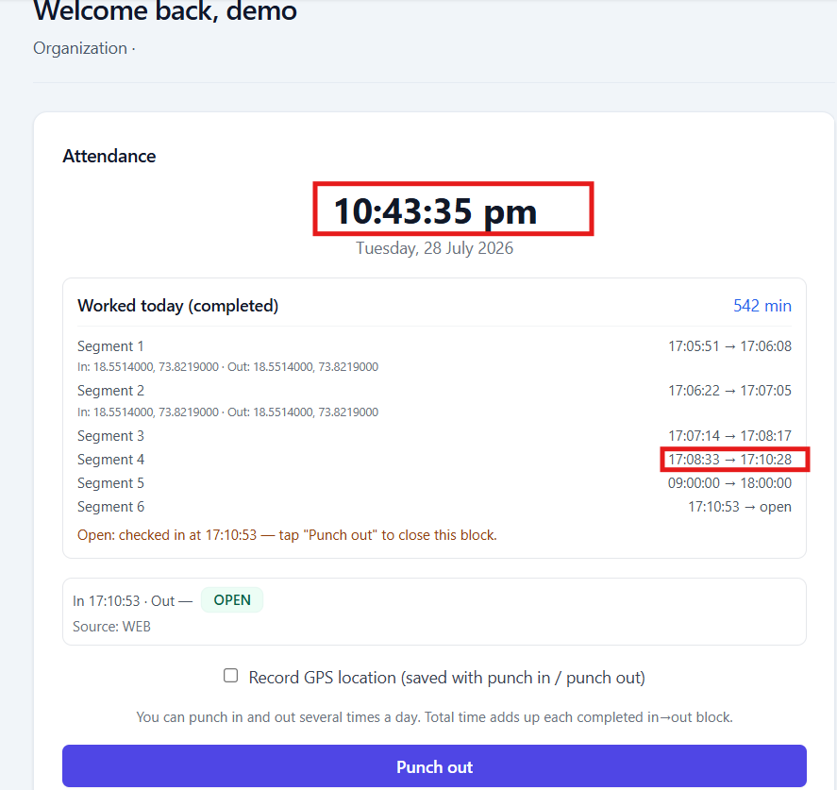

Issue#3: Do we need to show the GPS location co-ordinates in the highlighted format?
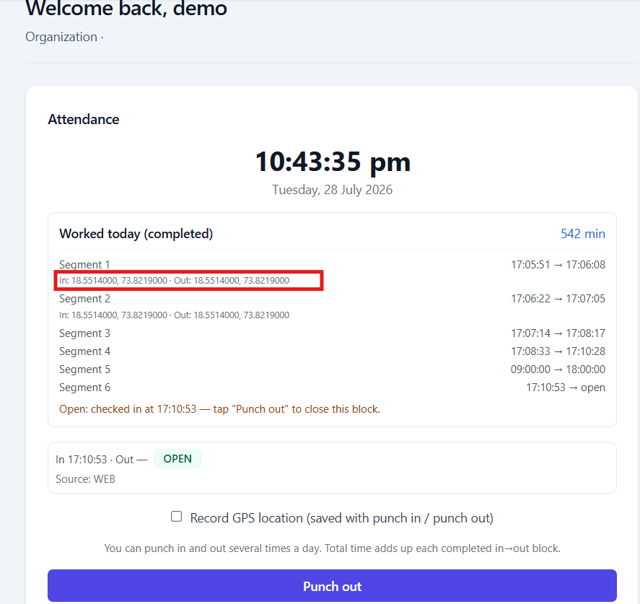

Issue#4: On performing ‘djust Pay/Add missed punches actions available Attendance report by entering Puch In and Punch Out time with invalid values, user friendly error should be displayed.
The error messages needs to be user friendly at all the places.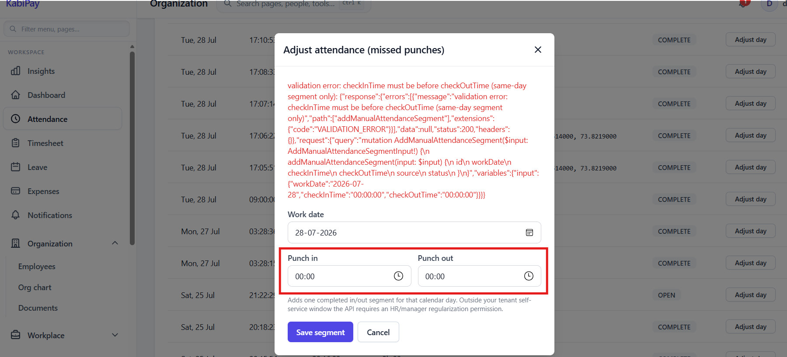
Error on trying to enter time for the future date.
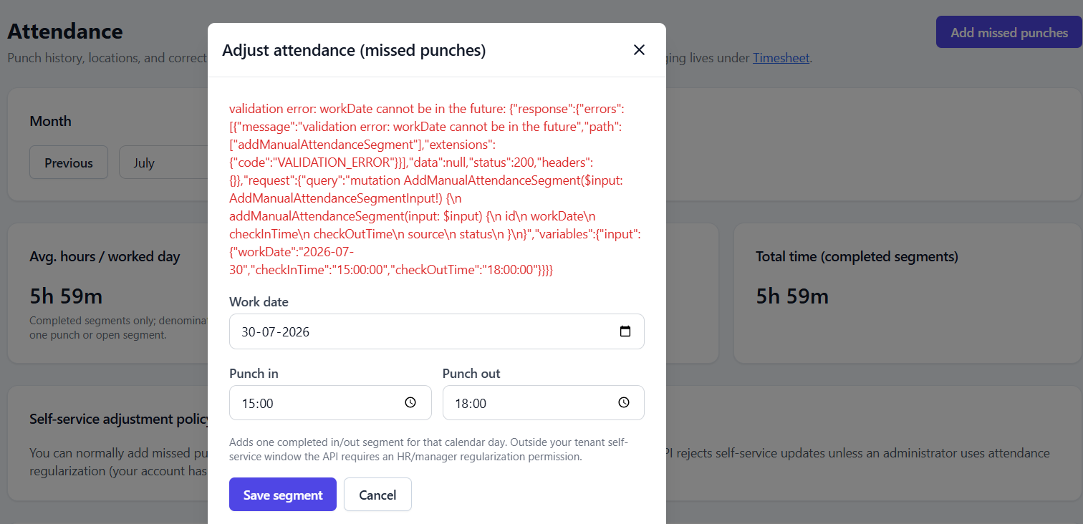

Issue#5: On adjusting an existing attendance in Complete state, new attendance entry gets created for the same day instead of updating the existing entry.
Screenshots:
Existing attendance: Click on Adjust day button. 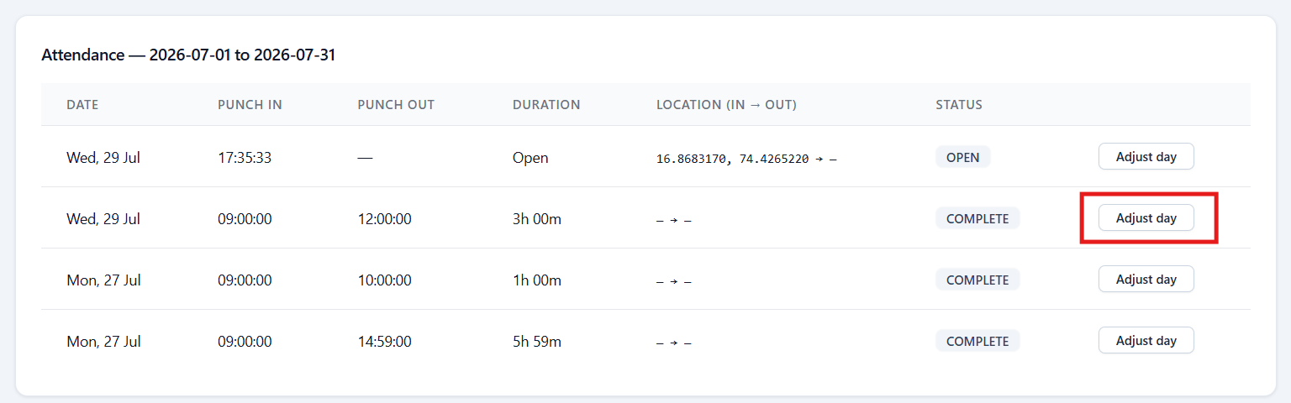
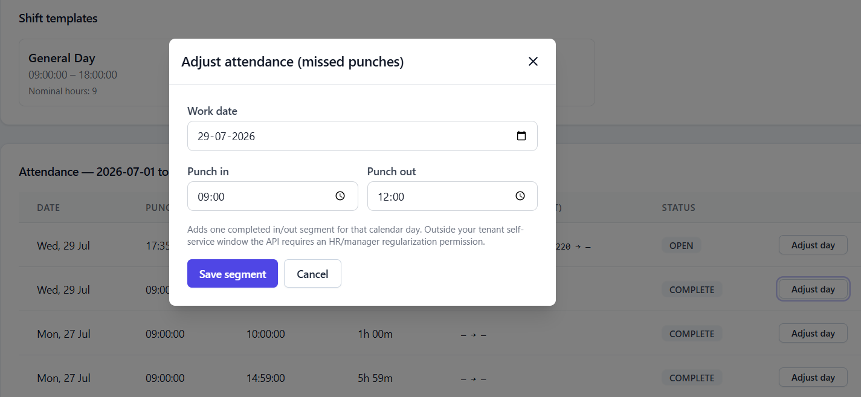
Update punch-ou time.
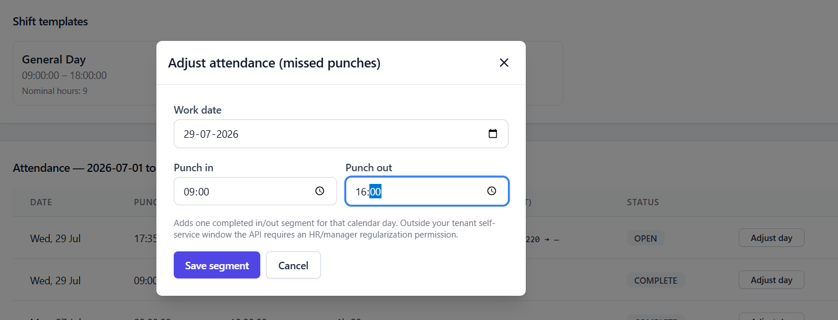

Instead of updating the existing entry, new attendance gets added. 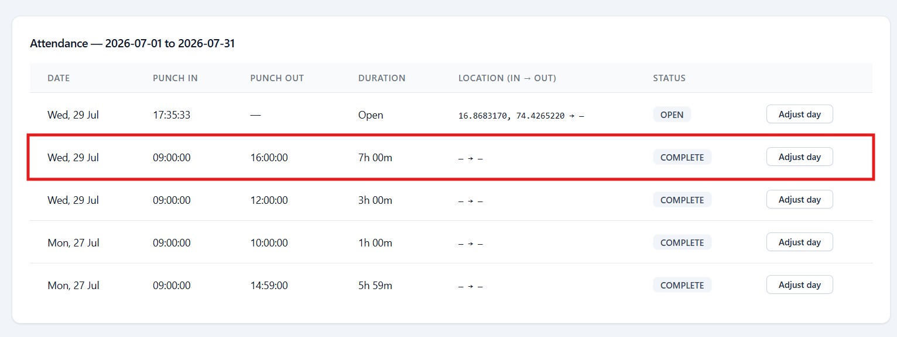
Issue#6: User is allowed to add missed punches/adjust day by adding time for the overlapping period of time. Even it allows to add multiple attendance for the same time-period of the day.
e.g. below multiple entries has puch in time same as 9 AM and puch out time differs.
