Issue#1: Timesheet of HR user and Manager user are displayed to themselves for approval.
These users can Approve/Reject their own timesheets.
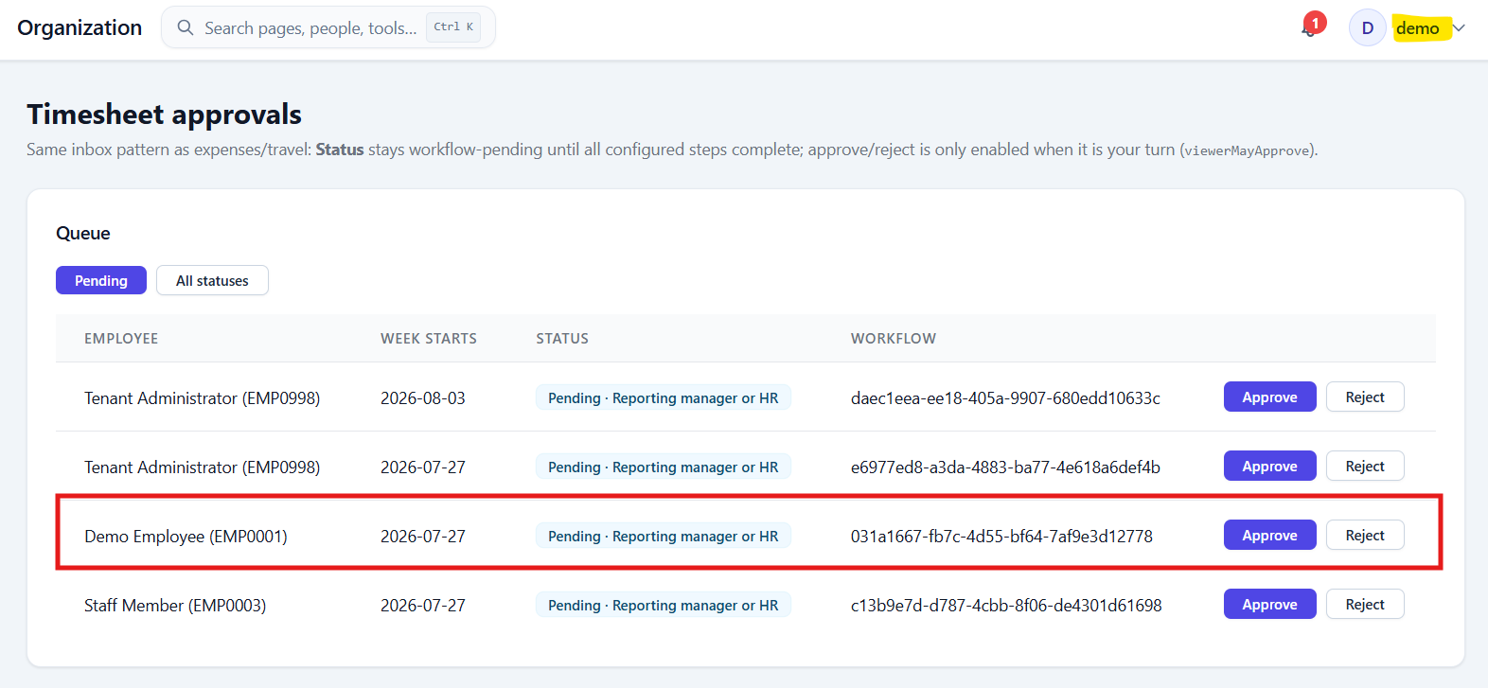

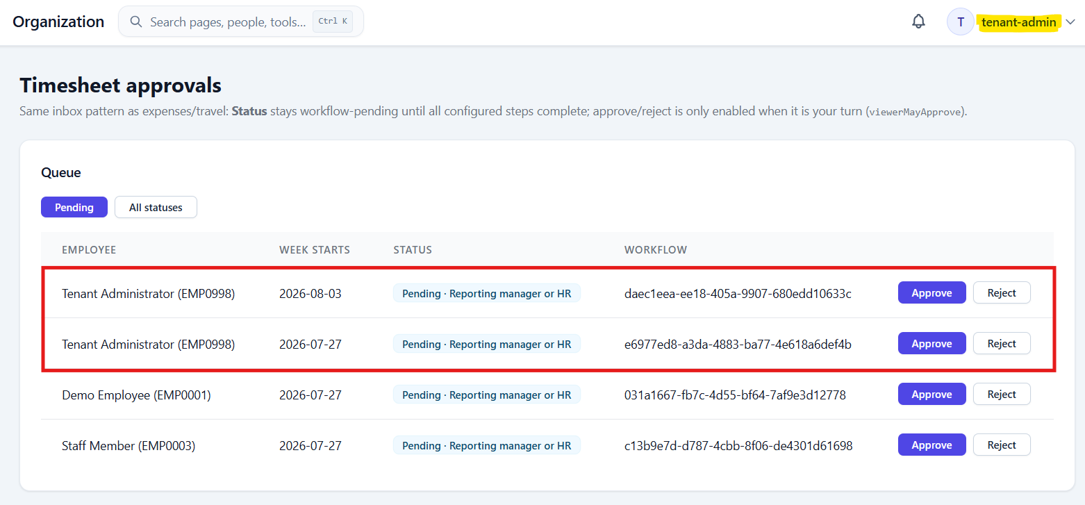

Issue#2: For HR/Manager, there are is no way to view the timesheet before performing Approve/Reject.
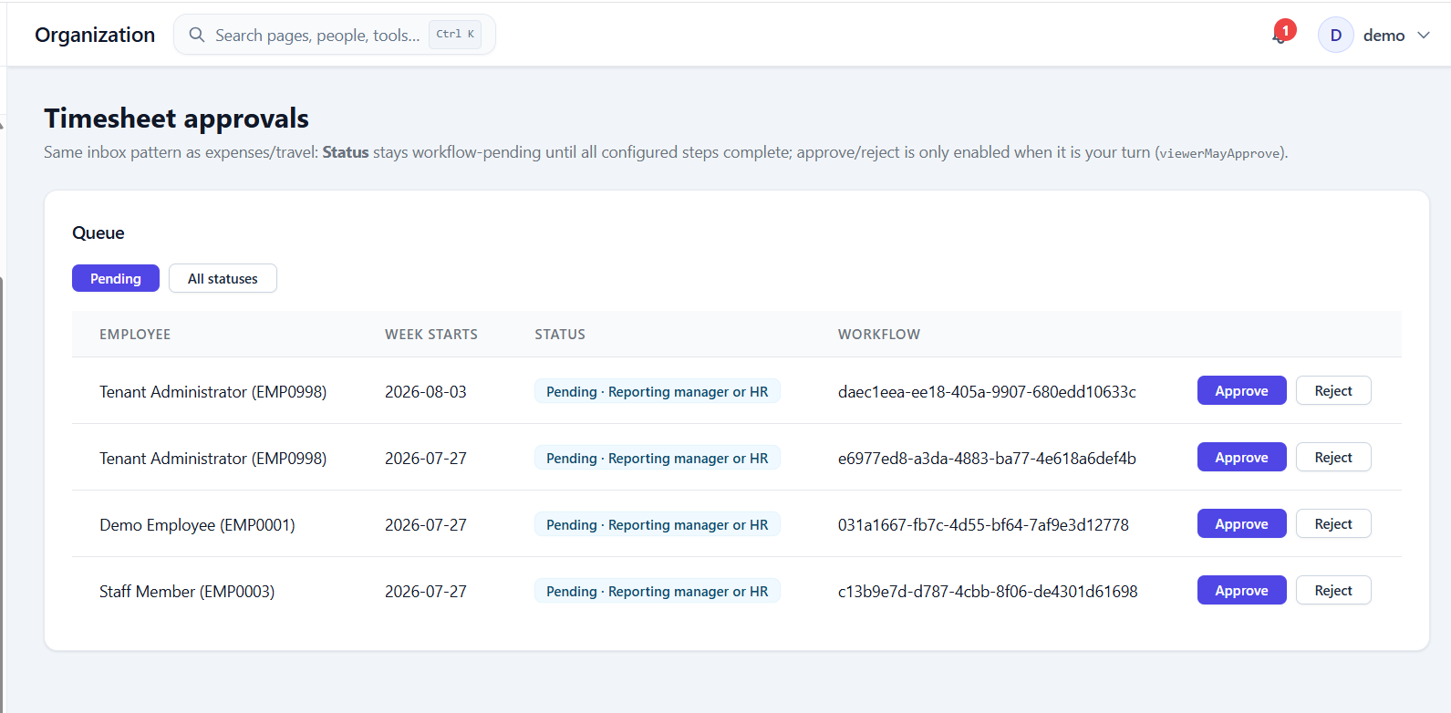

Issue#3: Workflow column should be removed from the Timesheet Approvals since that information is not relevant to the user.
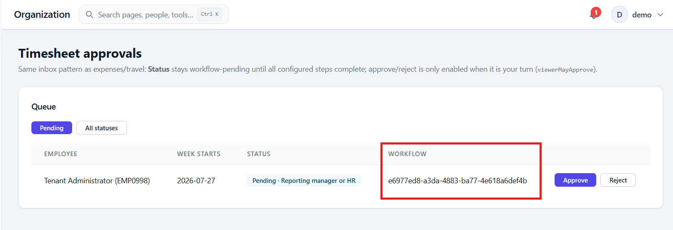

Issue#4: On approving/rejecting a timesheet, success message is not displayed, just the entry gets removed from the queue.
ii. The Rejected timesheet is not displayed under ‘All Statuses’ section.
iii. No notification is sent to the employee whose timesheet is rejected.
Perform Reject.
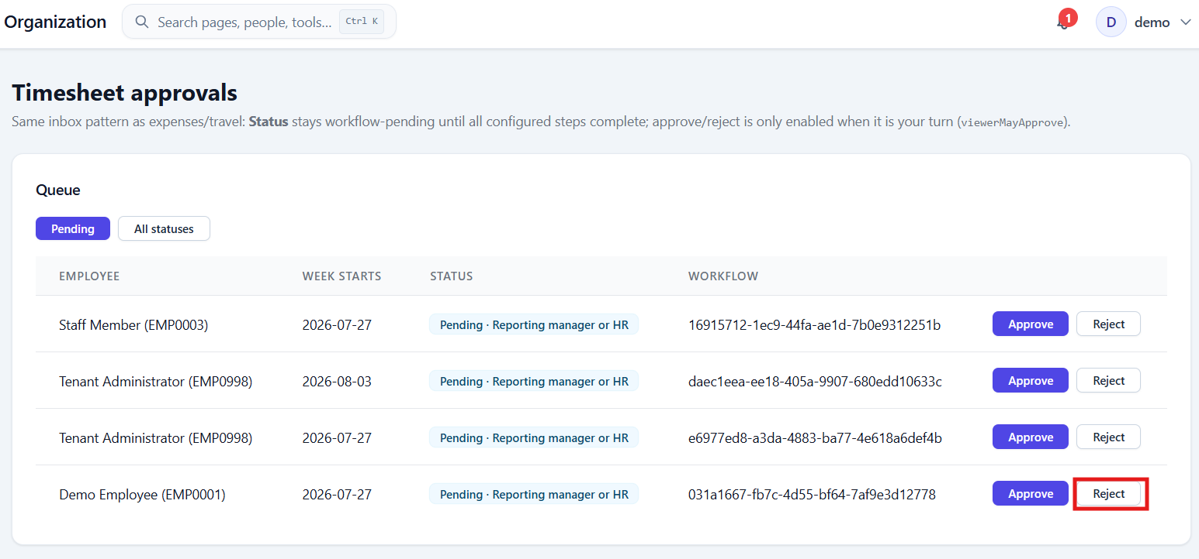

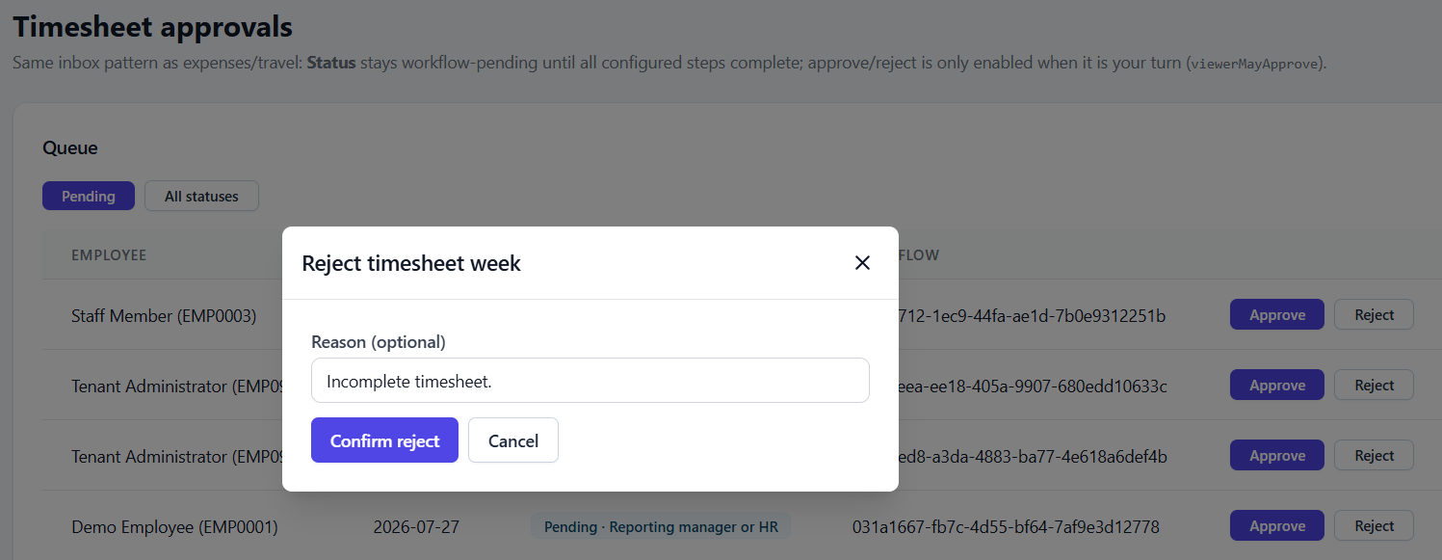

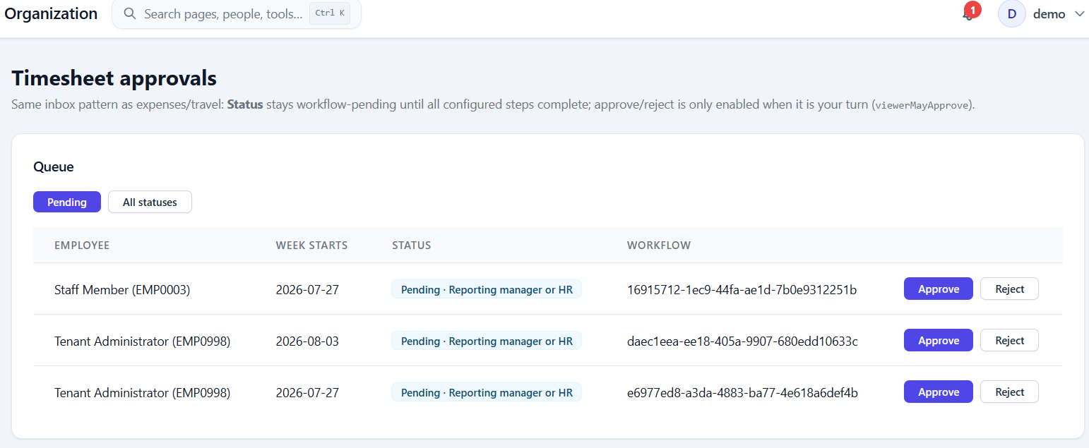

The timesheet is not displayed under All Statuses.
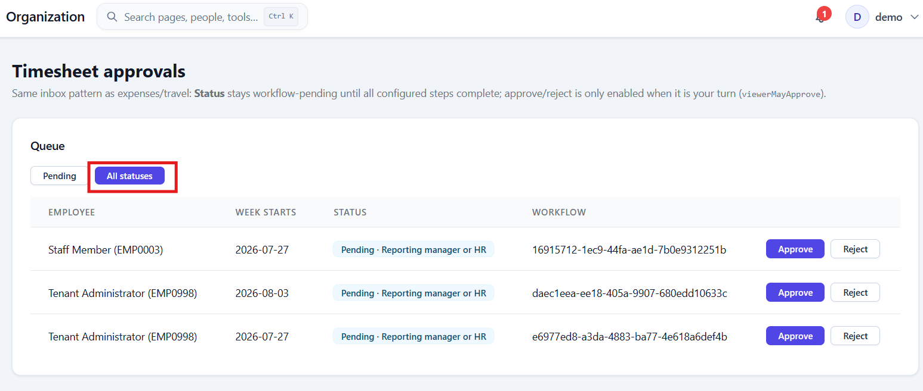

Issue#5: User is allowed to add timesheet for more than say 40 hrs and HR can approve the timesheet.
Submit timesheet with 94 hrs time log.
