Issue#1: When username and password is saved and user access the application URL on the next day, user gets logged into application automatically without entering the captcha.
It should ask user to first enter the captcha then only allow user to log in.
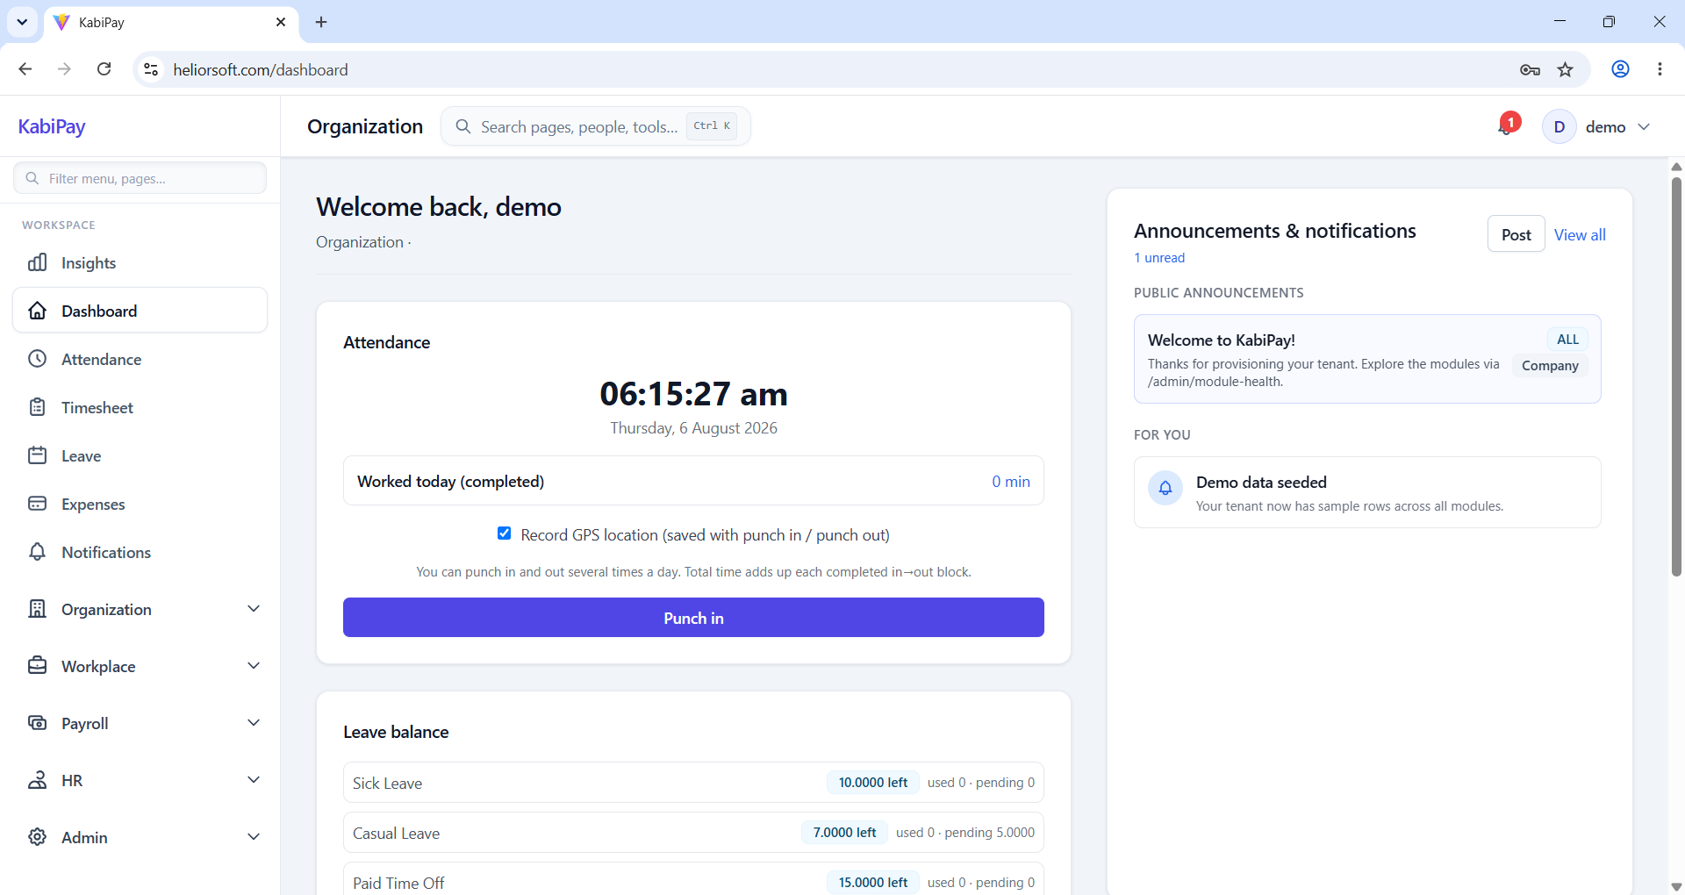
Issue#2: On logging time for 15min as ‘0.25’ in timesheet, it gets round up to 0.3h.
But in total hours calculation, it’s considered as 15mins correctly.
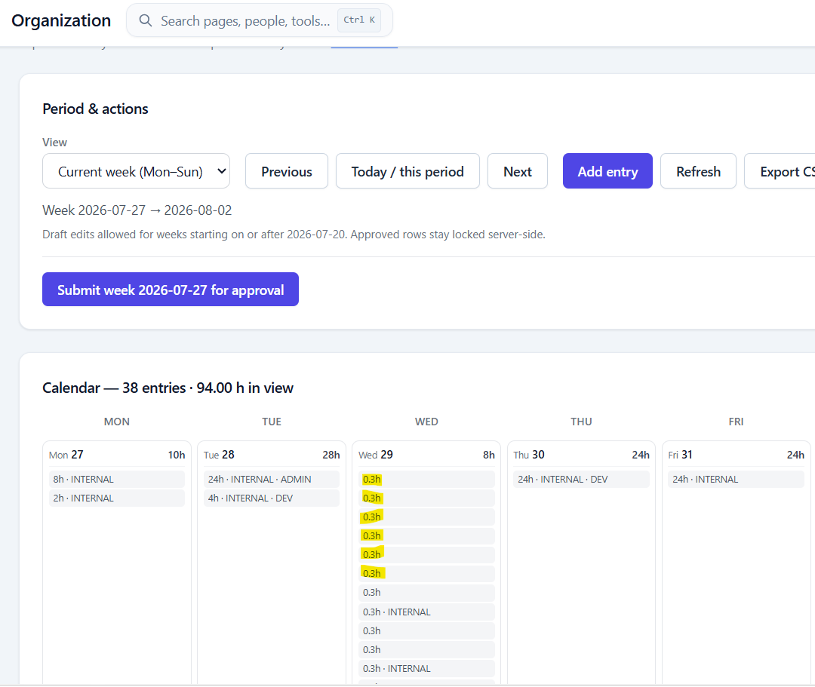

Issue#3: In overall application, Title Case is not used consistently.
At some places, Title Case used and most of the places only first letter of the first word of capital.
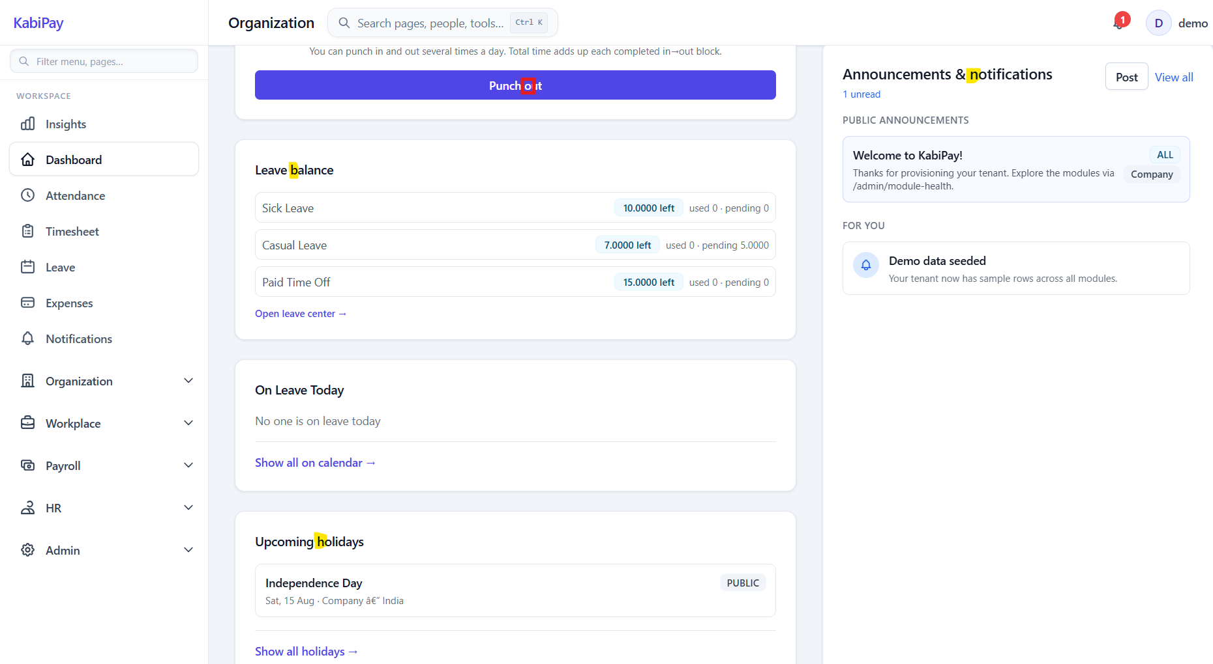
Issue#4: Issues with the CSV exported from Timesheet report:
i. Pascal Case need to be used for the column names in the csv
ii. Space needs to be there between two words in the column name
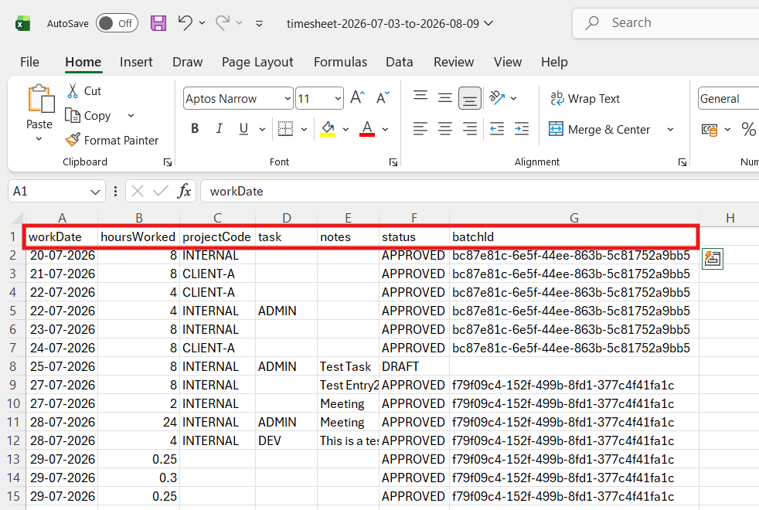

Issue#5: Minor UI issue: On trying to enter the custom date manually, the From Date gets reset to the first day of current week.
Select Custom Dates on Timesheet report. By default the date range shows current week.
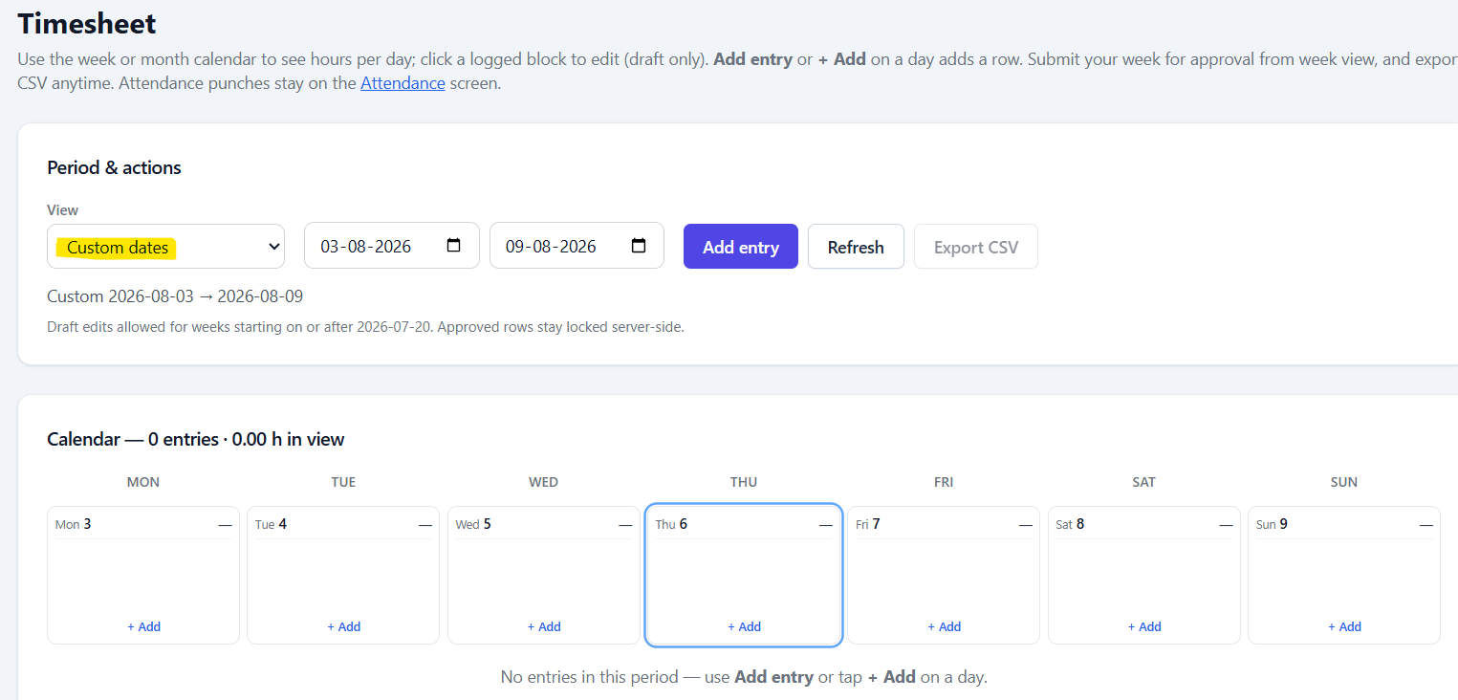
Click on the From Date and enter date manually as 20-07-2026
It accepts ‘20’ but on entering ‘0’ from ‘07’ the date 20 gets reset to current week start date i.e. 03
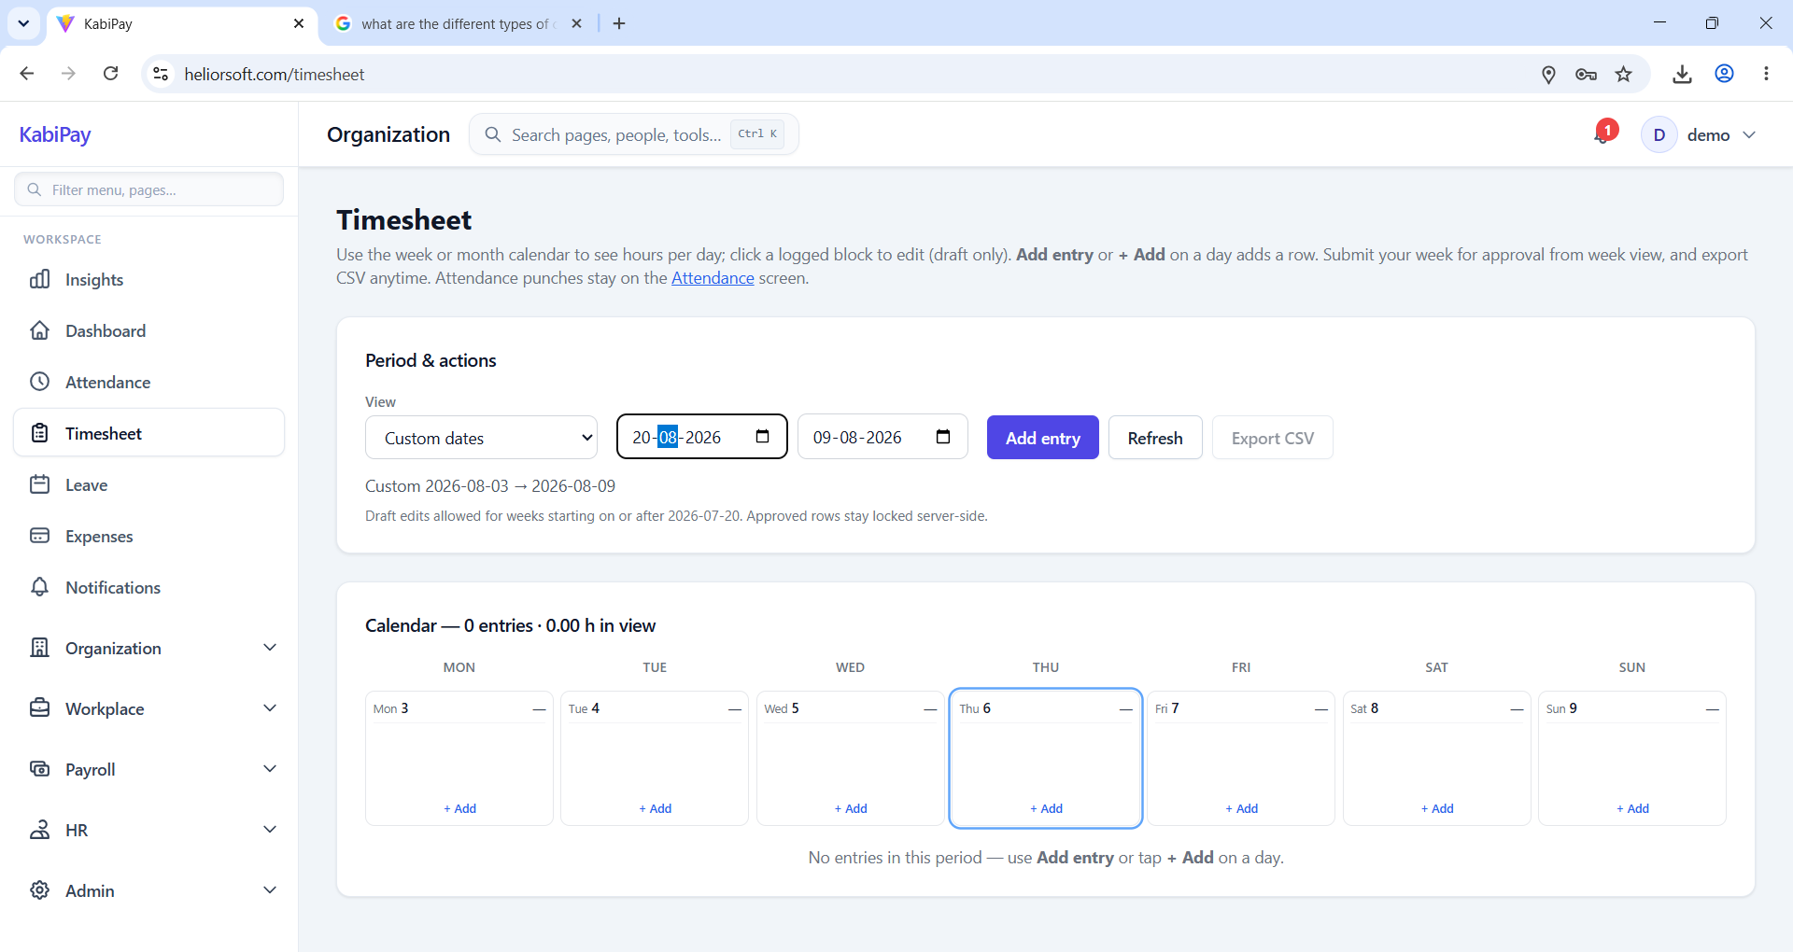

On entering ‘0’ from ‘07’ the date 20 gets reset to current week start date i.e. 03
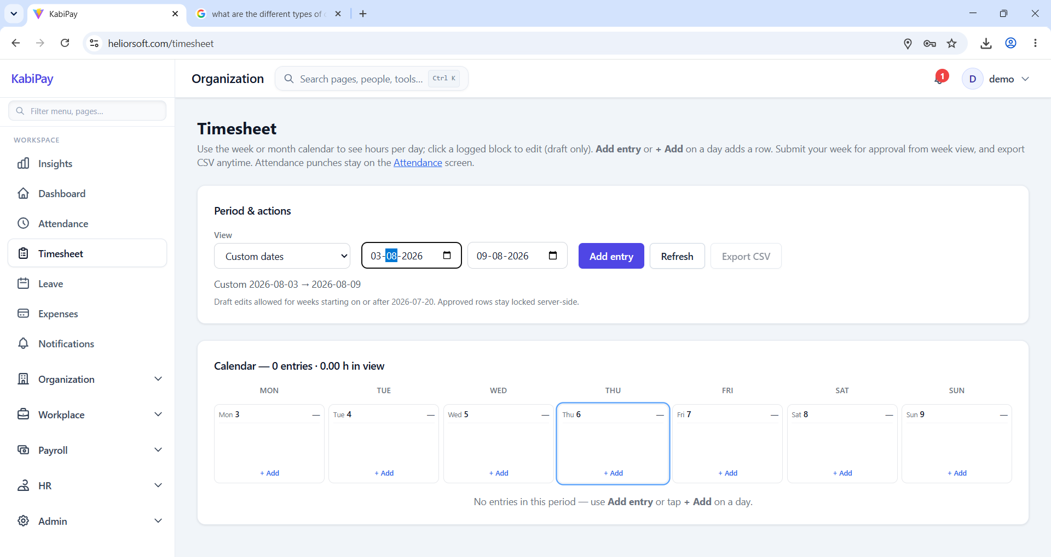
Issue#6: User is allowed to add the time log for the Timesheet which is already submitted and approved.
Though on submitting the timesheet, error is displayed.
Already submitted and approved timesheet:
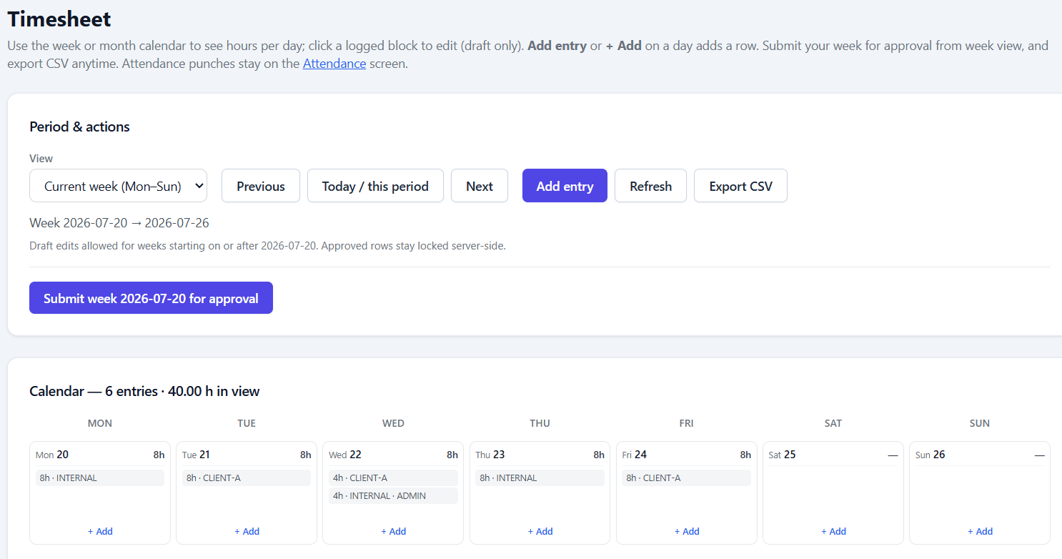

Add time for Sat 25-July.
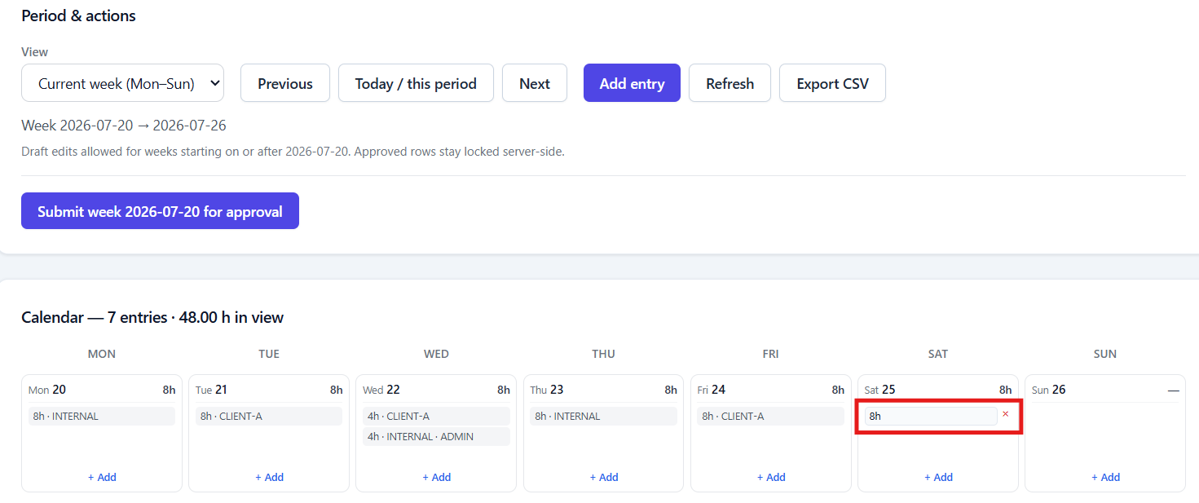

Click Submit.
