Issue#1: PTO leave type accrual frequency is 1.25 per month but still 15 PTO leaves are available for all the employees.
Leave setting:
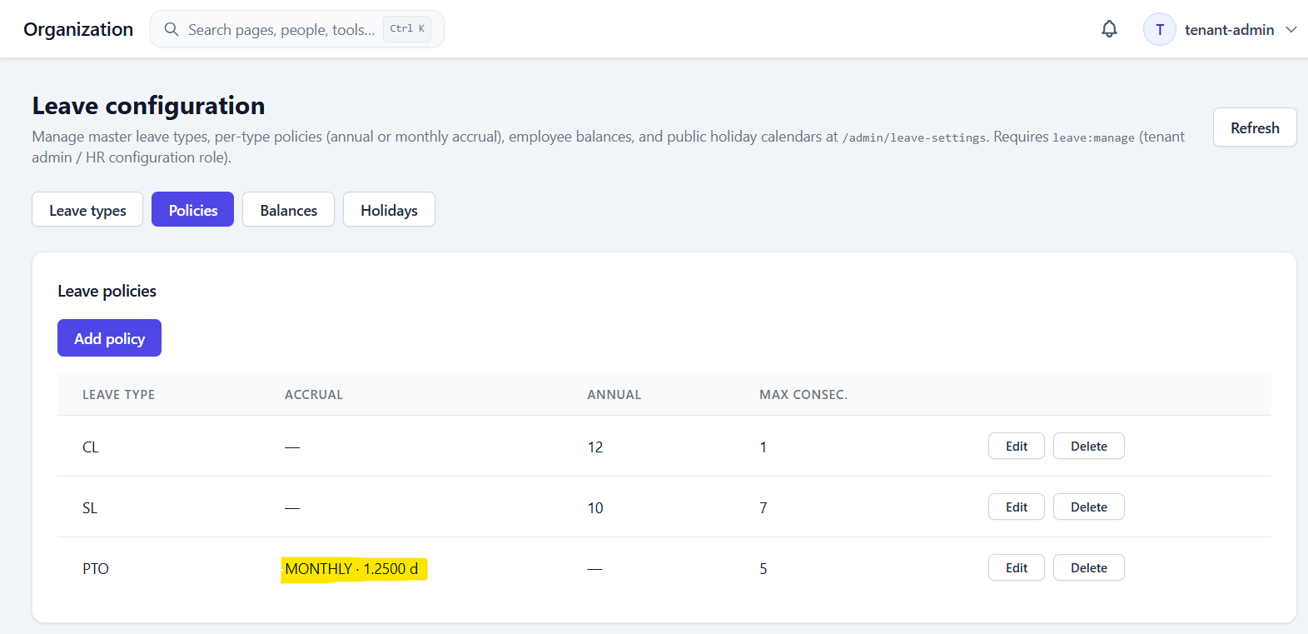

For the Staff member user, initially only Casual Leave was available but still it allowed to apply for the PTO leave and after that 15 PTO leaves started showing up.
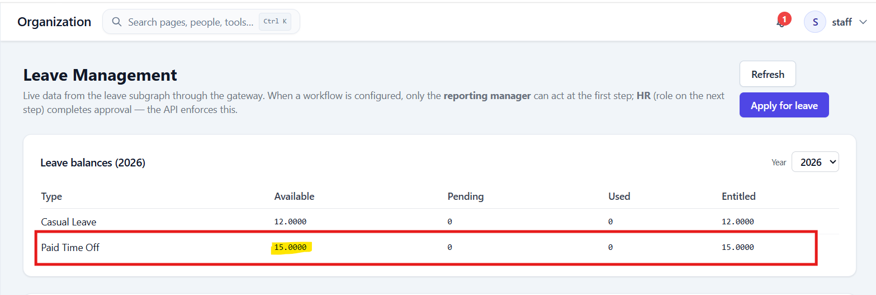

Issue#2: For the Staff user, Sick leave balance is not showing up under Leave Balances.
On applying for the Sick leave, it may gets displayed.
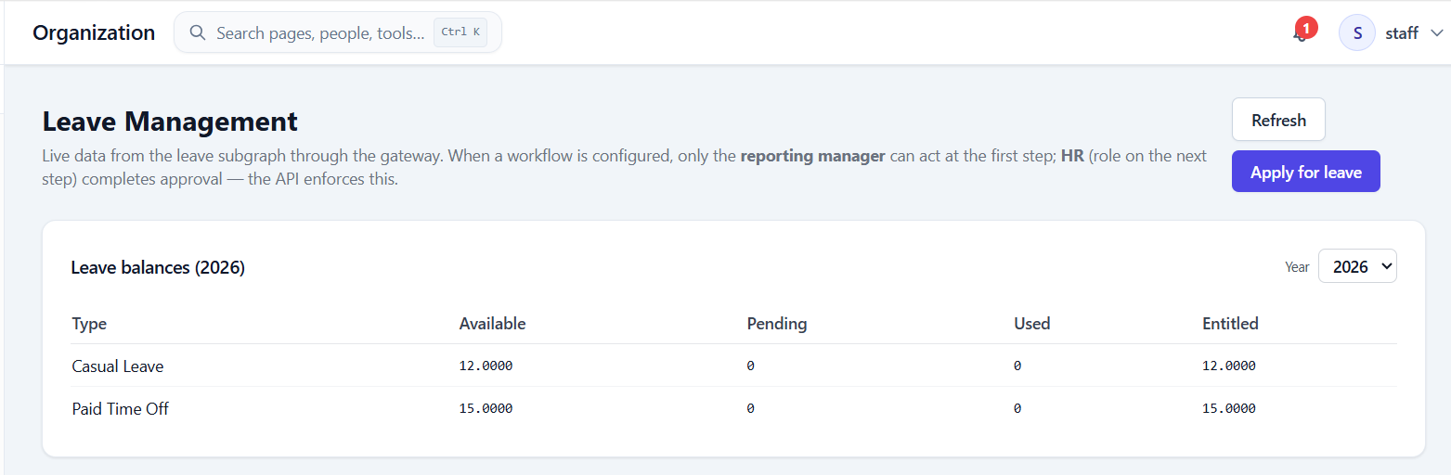

Issue#3: When a leave is rejected, the workflow still shows ‘In Progress’.
When we already have the ‘Status’ field, do we need this Workflow field?
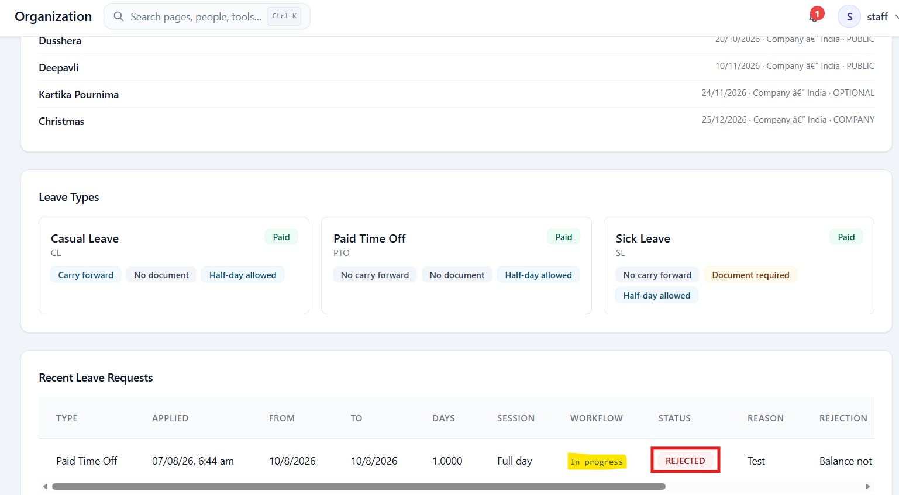

Issue#4: On applying sick leave without uploading the document, error displayed on the pop-up is not visible as the pop-up is not completely visible even after scrolling up.
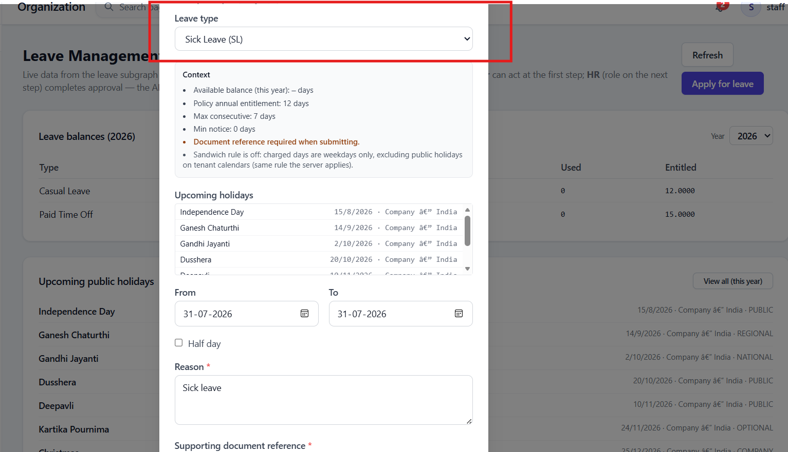
On full-scale window, the error is visible.
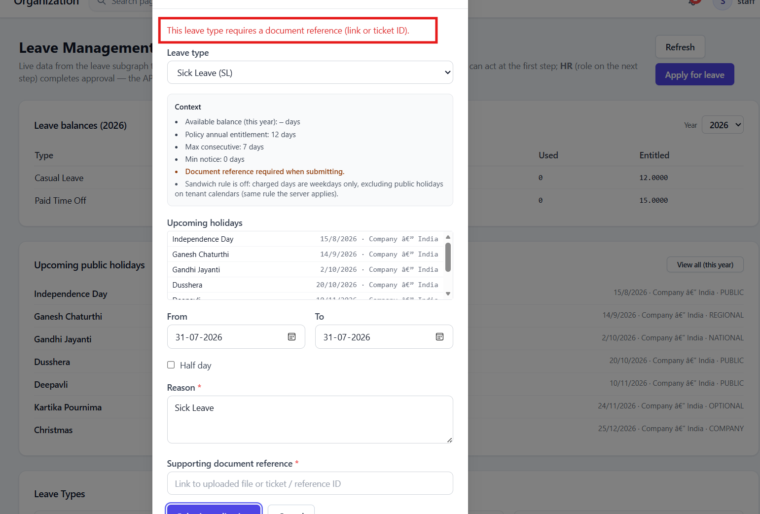

Issue#5: In continuation with above error, when the leave type is changed to CL/PTO, the error message is still displayed.
