Issue#1: When user tries to submit a rejected timesheet, error is displayed- ‘We could not complete this action right now. Please try again in a moment.’
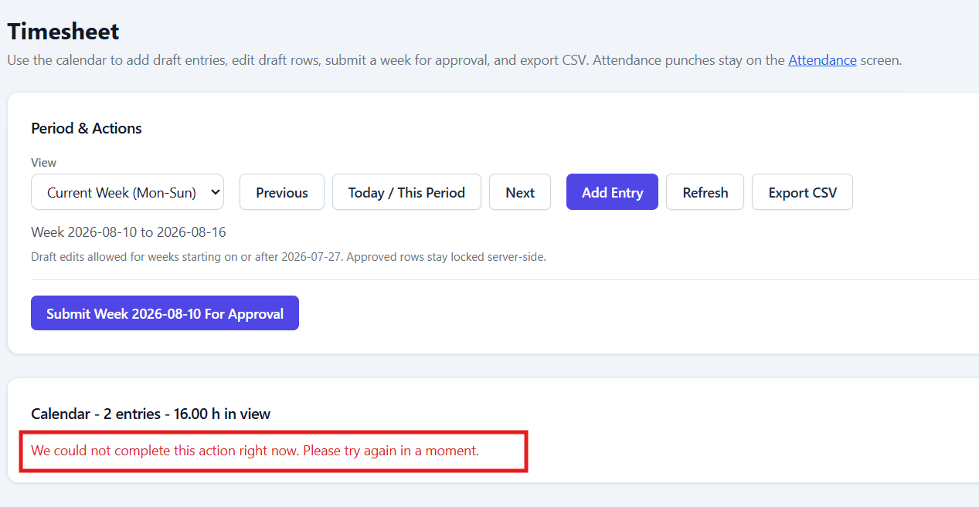

Issue#2: On entering the time for the already submitted timesheet, error is displayed as- ‘Check the entered details and try again.’
Either it should not allow to enter the time as the timesheet is already submitted or it should show an error saying the timesheet is already submitted for this week.
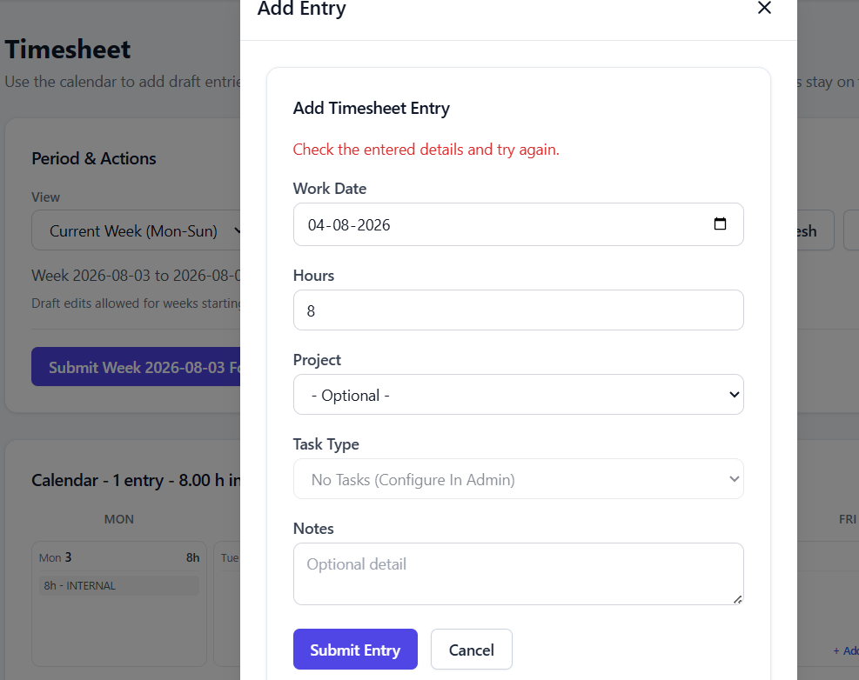

Issue#3: On performing Reject action from ‘Timesheet Details’ pop-up, ‘Reason’ pop-up is not displayed on top of ‘Timesheet Details’ pop-up.
Steps:
Login with Admin user and click on View button for a Pending timesheet in queue.
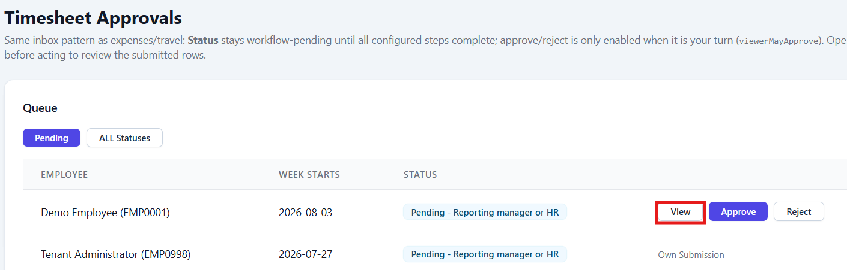
Click on Reject button.
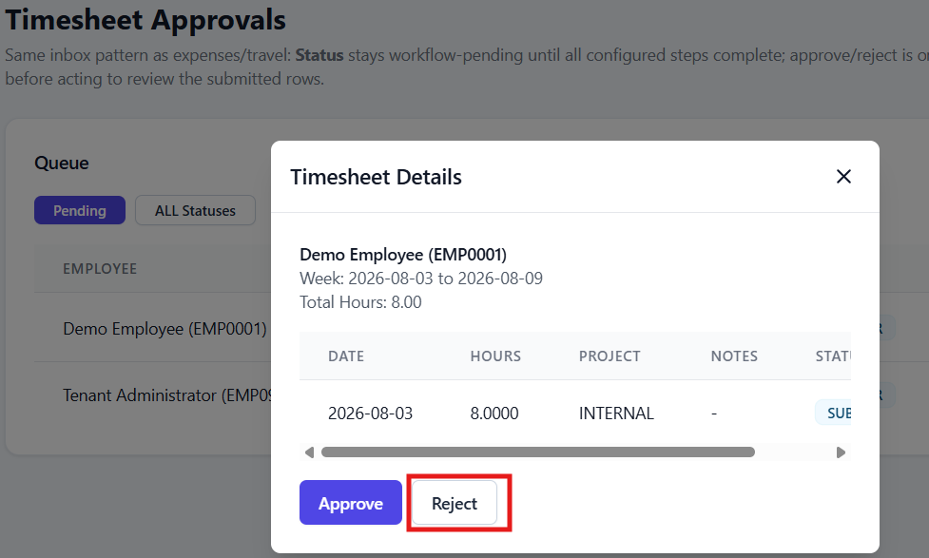

Still Timesheet Details pop-up is displayed. Reason pop-up is displayed behind Timesheet Details pop-up.
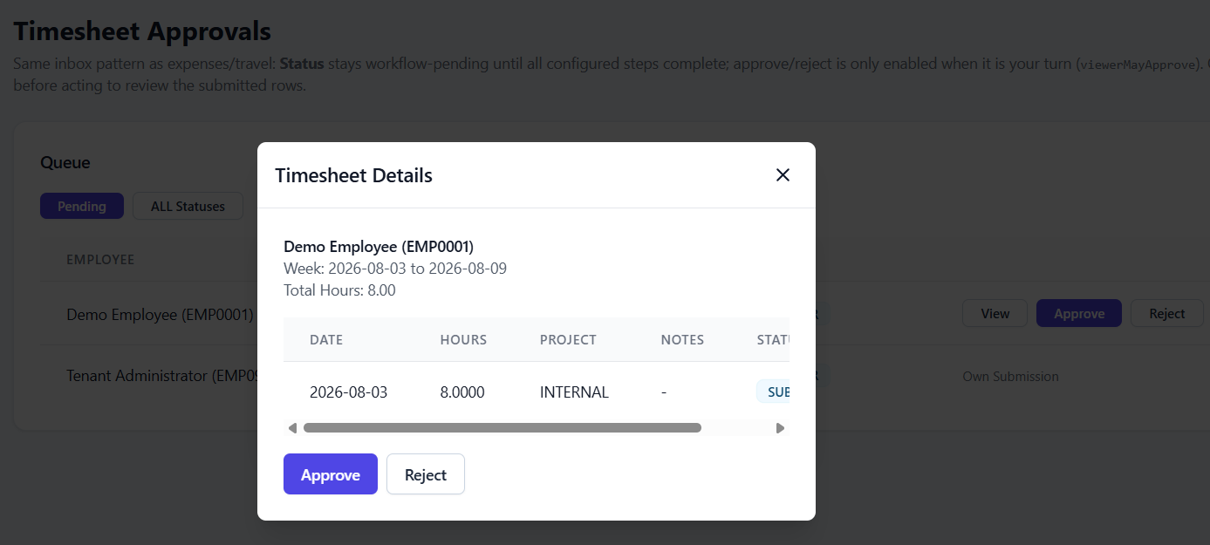
Close the pop-up by click on on X icon.
Reject Timesheet Week pop-up is displayed.
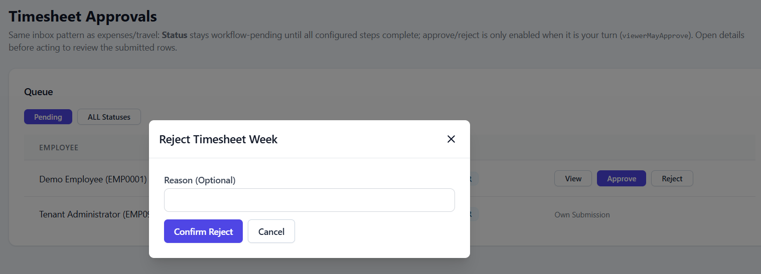
Issue#4: ‘Current Week’ option from View dropdown on Timesheet should be renamed.
‘Current Week’ sounds like it will show current week but this option is to show the weekly view.
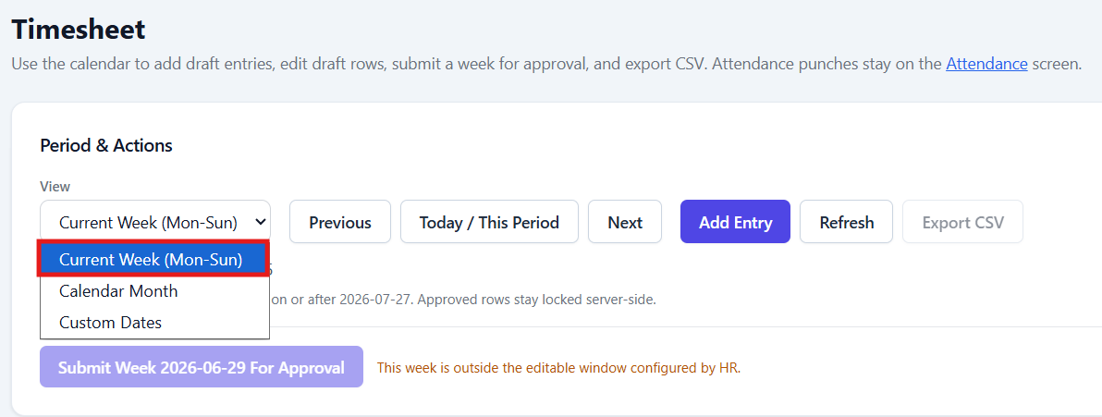
Issue#5: Issues with Timesheet approval for Manager user:
i. Employee column is not showing employee name, instead it is showing random value.
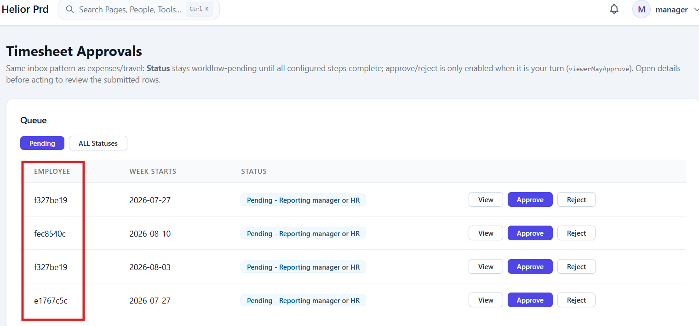

ii. Timesheet Details pop-up is not showing details for Manager user.
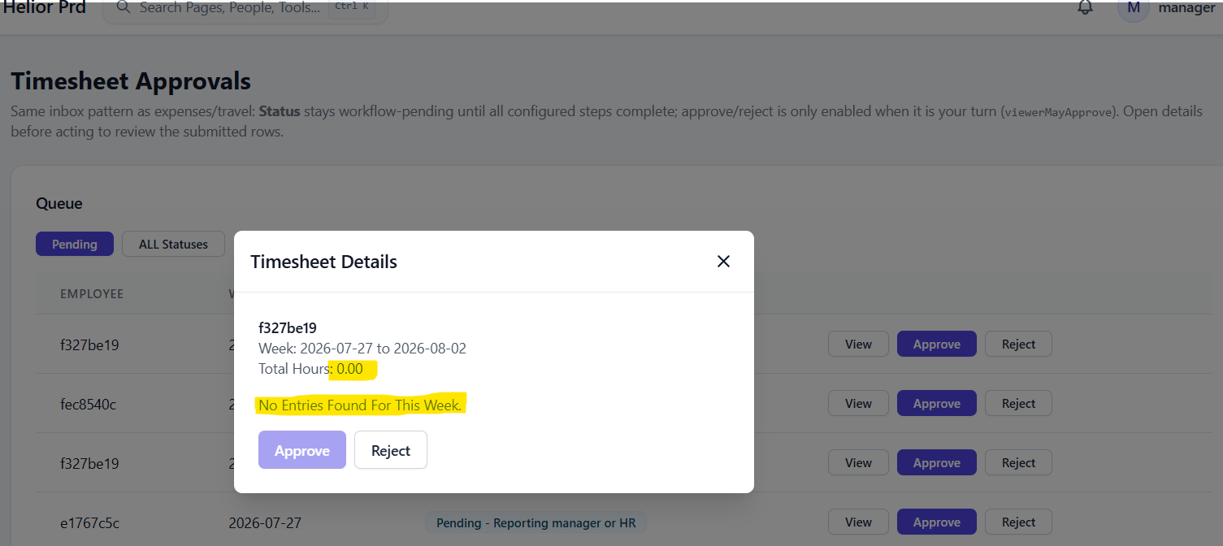

Issue#6: When user tries to log the time and the time for the week cross 40hrs, error is displayed as- ‘Check the entered details and try again.’
User friendly error should be displayed saying time for the week exceeding 40 hrs.
