Issue#1: ‘Post’/’New Announcement’ actions are available for the Staff user but when user tries to post the announcement, error is shown.
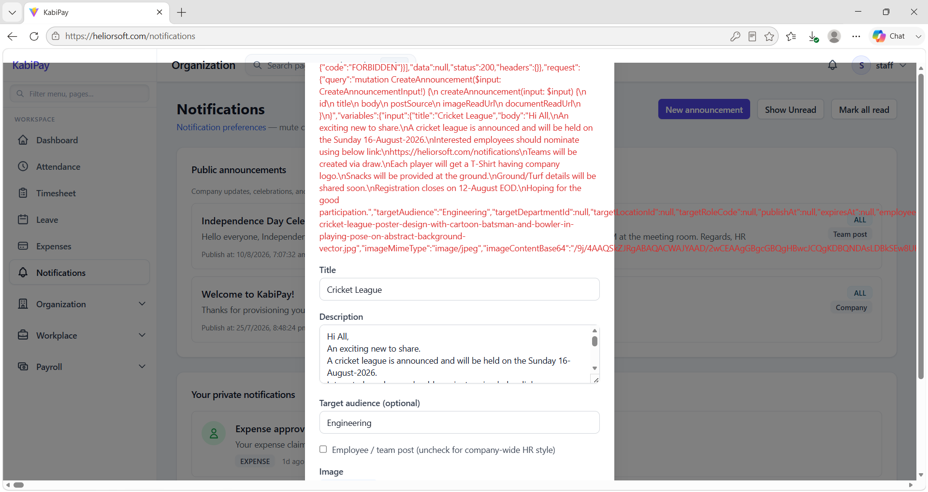
Issue#2: Attachment added for the announcement is not getting downloaded.
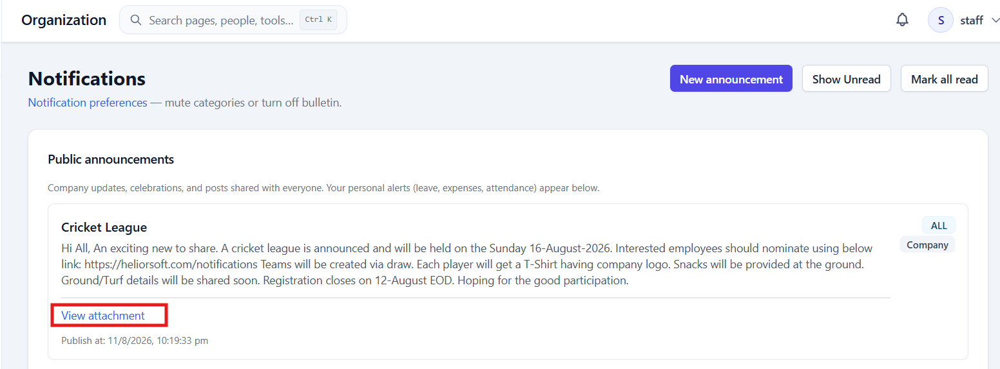
On clicking ‘View attachment’ Error is displayed.
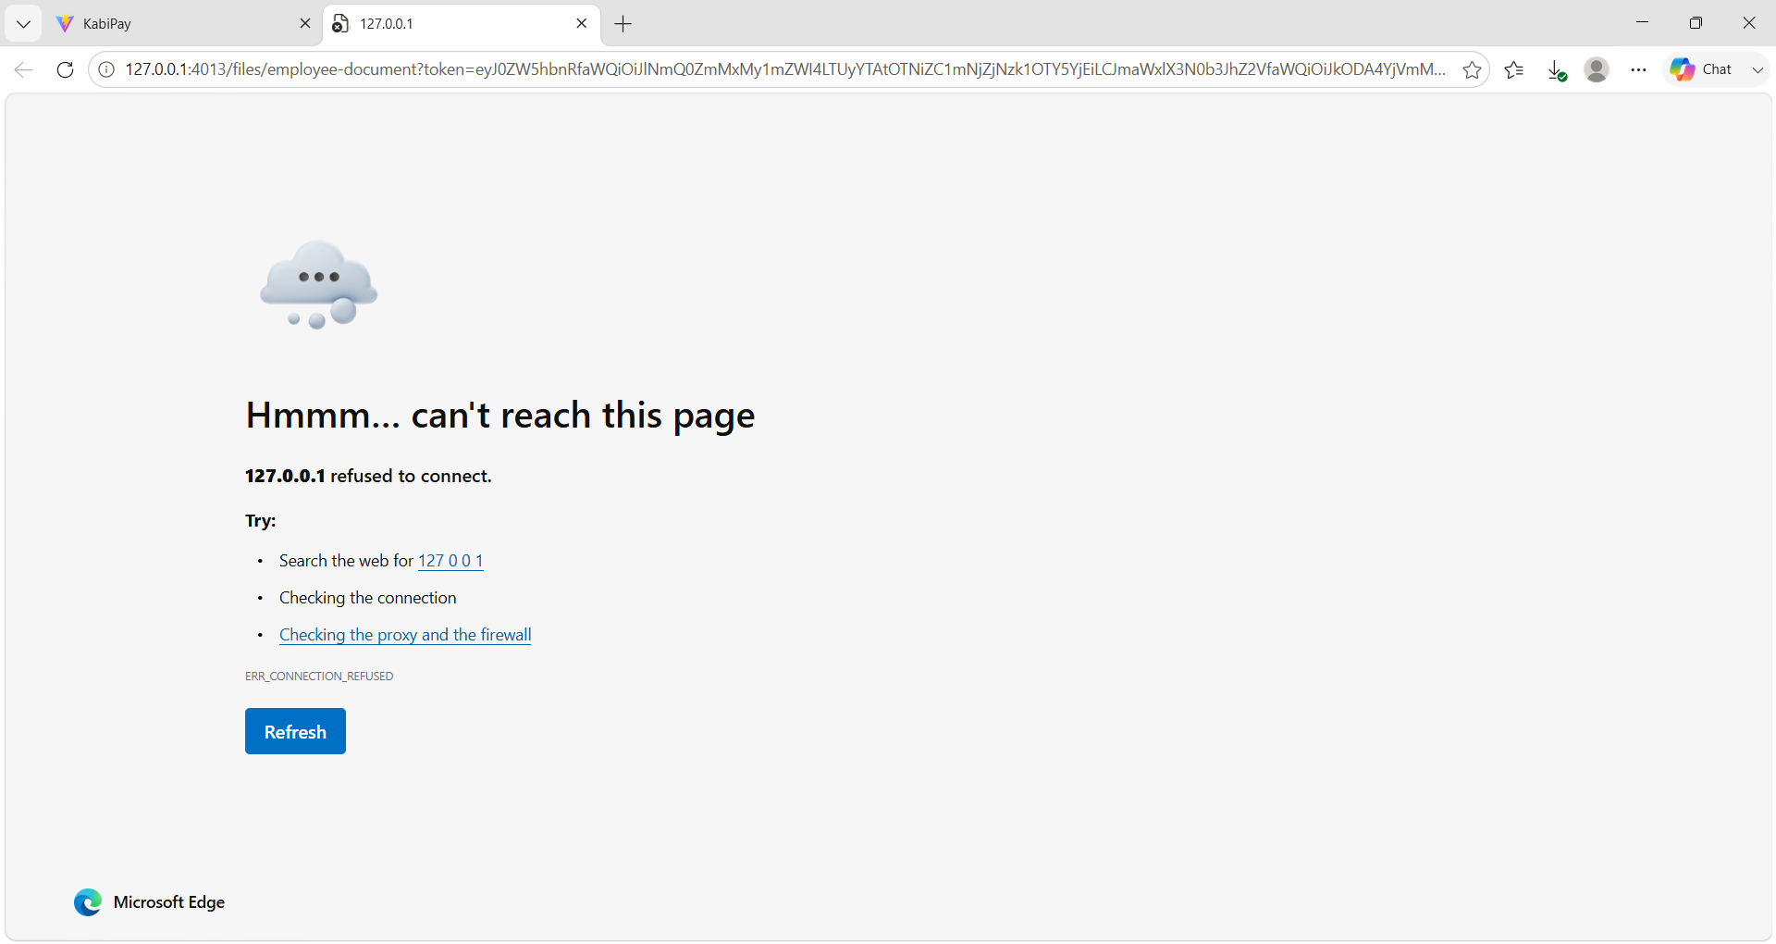

Issue#3: On sending a ‘Direct notifications to users’, success message is not shown.
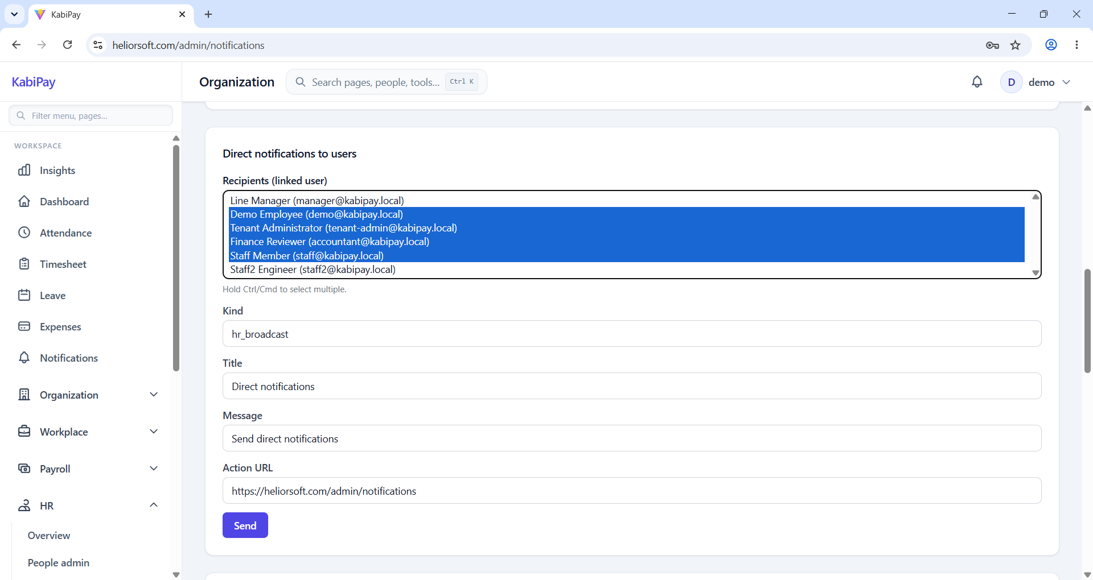

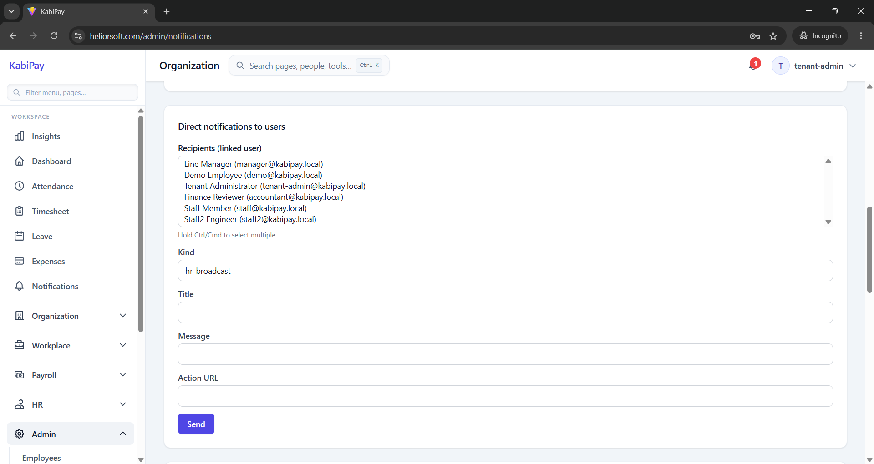

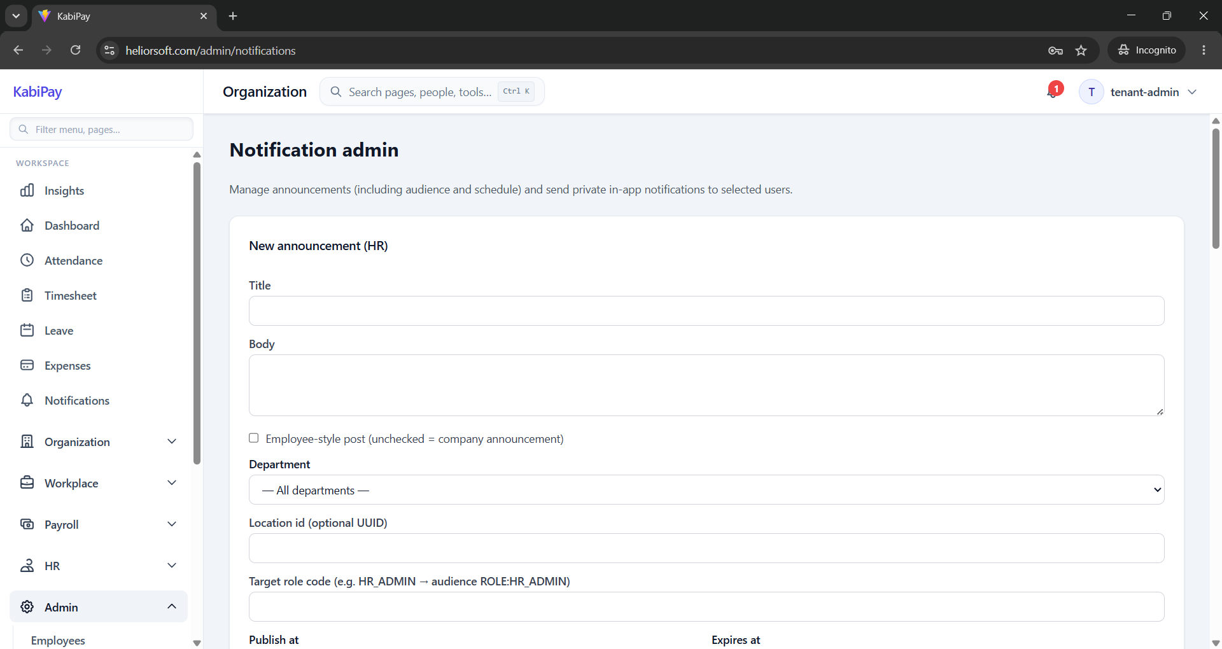

Issue#4: On clicking the Notification icon, user gets redirected to the ‘Dashboard’ in a new tab.
User should redirect to the Notifications section in the same tab.
