Chronogenesis

Duncan Matthew Reed

CHRONOGENESIS
Book One of The Chronogenesis Cycle
Copyright © 2025 Duncan Matthew Reed
All rights reserved.

This is a work of fiction. Names, characters, places, and incidents are products of the author's imagination or are used fictitiously.

First Edition
(Maybe First.5?)

To my lovely wife, who swore she’d never read it…

To Mike and Cindy, thanks for your hot takes, but here’s a different story...

NOTE:
Please read this book with a highlighter, pen, pencil… mark it up, that is what it is here for.

chronogenesisbook@gmail.com

Table of Contents
CHAPTER 1: THE SUSPENSION 2
CHAPTER 2: THE FIRST HEART 9
CHAPTER 3: THE TILTED WORLD 19
CHAPTER 4: SATURN'S BRIEF FLAME 26
CHAPTER 5: THE KING OF STORMS 33
CHAPTER 6: THE OCEAN WORLD 39
CHAPTER 7: THE RED WORLD 47
CHAPTER 8: THE INHERITOR 54
CHAPTER 9: THE SLEEPING SISTER 63
CHAPTER 10: THE LAST CHILD 71
CHAPTER 11: THE OCEAN MEMORY 78
CHAPTER 12: THE UNRAVELING 86
CHAPTER 13: THE DELUGE 94
CHAPTER 14: THE REMNANTS 102
EPILOGUE: TO THE REMNANTS 111

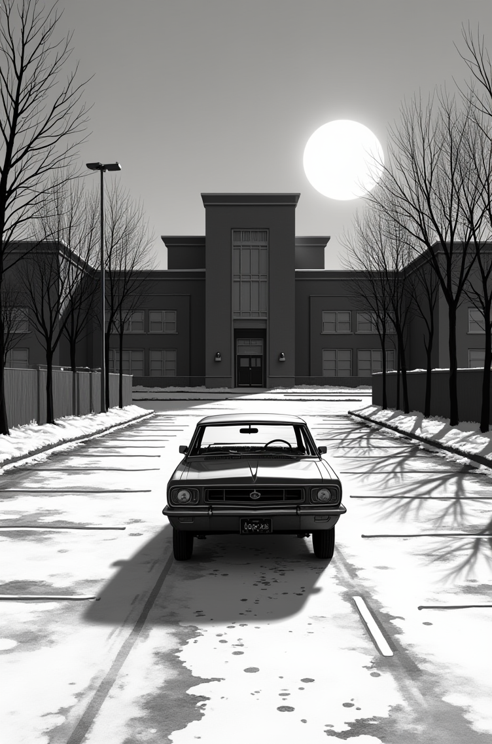

CHAPTER 1: THE SUSPENSION
The car door shuts with that hollow thud only old sedans seem to make. He walks around the front, brushing salt off the hood—remnants of last week's snow mixed with parking lot grime. She's already in the passenger seat, arms crossed, backpack at her feet like a prisoner's duffel. Her hair's still damp from gym class she probably didn't participate in. There's a smudge of something on her cheek—marker? Paint? He doesn't ask. Not yet. He just turns the key, adjusts the heat to full blast, and backs out of the school parking lot with the sun still low and sharp in the winter sky. Ten thirty in the morning. A Tuesday. He should be working. She should be in fourth period.
Instead, they're here.
They drive in silence for a few minutes. He watches the road. She watches nothing, or everything—it's hard to tell.
"You want music?" he asks finally.
"No," she says, without looking.
He nods. Leaves the radio off. The heater ticks as it warms, that familiar mechanical pulse like a heartbeat trying to get started. They pass the 7-Eleven where she used to beg for Slurpees. The gas station where the air pump never works. A church sign that says DON'T BE TOO COOL FOR GOD in blocky letters.
He almost smiles at that one. Almost.
Then she speaks.
"They're gonna call you too."
"Who is 'they'?"
"The news people. When they figure out I'm right."
He glances at her. She's staring straight ahead, jaw set, eyes defiant. Eleven years old and already convinced the world is wrong and she's the only one who sees it.
He knows that feeling. He was that kid once.
"Oh. I see. So this was a revolution, not a disruption."
"I said maybe Pluto's still a planet. That maybe we were wrong. And Mrs. Klein said, 'Science doesn't go backward.'"
He lets that sit for a moment. Traffic light turns red. He stops, turns to look at her properly.
"And then?"
"She told me to stop being disruptive." Her voice is tight now, holding something back. "And I said, 'But you're being dishonest.'"
"Ah."
"Because she is. Pluto has five moons. It has an atmosphere. It has weather. It has geology. How is that not a planet?"
"What did Mrs. Klein say to that?"
"She said it doesn't matter what I think. The International Astronomical Union decided in 2006 that Pluto is a dwarf planet, and that's final."
"And then?"
She looks down at her hands. "I might've said she was teaching propaganda instead of science."
He exhales slowly. "Well. That tracks."
She almost smiles. Almost.
The light turns green. He drives.
"For what it's worth," he says quietly, "I think Pluto's a planet too."
She looks at him sharply. "Really?"
"Really. But I also think authority figures don't like being called propagandists in front of twenty-five other students."
"She started it."
"I know she did."
"So why am I the one who got suspended?"
"Because you finished it."
She slumps back in her seat. "That's stupid."
"It is. But it's also how the world works."
By the time they pull into the driveway, the winds picked up. Dead leaves skitter across the concrete like something chasing them. He grabs the mail—bills, grocery flyers, something from the university he hasn't opened yet. She grabs nothing. Just shoulders her backpack and heads straight for the door.
Inside, she drops her bag in the kitchen with a thud that says I'm done with today and flops onto the couch.
He checks the answering machine out of habit. The little red light blinks twice. He hits play.
*"Mr. Richardson, this is Principal Running from Ashbrook Elementary. We need to discuss your daughter's behavior today. Please call me back at—"*
He deletes it. He'll call later. Much later.
"You know your mom's gone until Sunday," he says.
"I know."
"Which means I'm not explaining this. You are."
"She'll understand."
"No, she won't. But she'll listen. That's the important part."
She curls her legs under her, pulls the blanket from the back of the couch around her shoulders. It's the blue one, the soft one, the one she's had since she was six. He wonders when she'll outgrow it. Probably never.
He heads to the dining table, where his digital sketchpad and stylus sit next to a half-finished mug of cold coffee. One of the sketches—a faint circle traced with golden arcs spiraling outward—catches her eye, but she says nothing.
Not yet.
He taps the screen. It wakes with a dim glow. Layers of lines and shadows appear—some unfinished landscape for a client who wants "something abstract but grounded." Space, time, the feeling of movement without showing motion. He's been stuck on it for three days.
He rubs a hand over his eyes. Adjusts the angle. Tries a different brush setting.
"Well," he says. "Looks like we're both off the grid for a few days."
"What were you working on?"
"Client wants something abstract. Space, time, that kind of thing."
"Like… black holes?"
He chuckles. "Not exactly."
She watches him scroll through thumbnails of abandoned attempts—spirals, orbits, fields of light that almost work but don't quite. Her attention shifts. Her gaze drifts out the window, where the clouds have gone flat and gray like something pressed under glass.
Then she says it. Not smug. Not hesitant. Just… firm. Like she's been thinking about it the whole drive home and finally worked up the nerve.
"Planets aren't born. They're built. From collisions. That's what Mrs. Klein said. Dust and rocks smashing together for millions of years until gravity makes them into spheres."
He looks over. Sets the stylus down carefully.
"…Is that what they're teaching now?"
"It's what everyone says. The accretion disk model. Planetary formation from a protoplanetary disk around a young star." She recites it like a memorized definition, which it probably is.
"And you believe that?"
She shrugs. "I don't know. It makes sense, I guess."
He turns his chair to face her fully. Studies her for a moment—this kid who just got suspended for defending a dwarf planet, who memorizes textbook definitions but questions the conclusions, who's eleven and already knows the world lies to her.
"You want to hear a different story?" he asks.
A beat.
She pulls the blanket tighter. "This isn’t another one of your Stoicisms, is it?"
He smiles. "It isn’t."
She sighs dramatically. Settles deeper into the couch. "Fine. But if this is some weird dad metaphor about responsibility and consequences—"
"It's not."
"Or about how 'everything happens for a reason'—"
"It's not that either, at least not exactly…"
"Then what is it?"
He stands. Walks to the kitchen. Grabs the kettle, fills it, sets it on the stove. She watches him the whole time like she's trying to figure out if this is a trick.
"It's a story about how the universe really works," he says. "About patterns most people don't see because they're too busy memorizing what they're told instead of looking at what's actually there."
"Like Pluto?"
"Like Pluto."
The kettle starts to hiss. He pulls down two mugs—hers with the cartoon cat, his with the faded university logo—and drops tea bags in both.
"But it's also a story about time," he continues. "And memory. And how old things really are when you stop accepting the easy answers."
She frowns. "How old is 'old'?"
"Older than you think. Older than they teach. Old enough that the numbers stop making sense unless you're willing to question everything."
The kettle whistles. He pours.
She accepts her mug with both hands, wraps her fingers around the warmth. "You sound like a poet, not a scientist."
He grins. "Maybe the first scientists were poets."
She sips her tea, eyes narrowing over the rim. "So... is this Star Trek or Star Wars?"
He brings his own mug to the armchair across from her. Sits. Considers.
"It's probably a story you've never heard before," he says slowly. "And possibly will never hear again."
She sets the mug down on the coffee table. "If I'm never going to hear it again, why do I have to hear it now?"
"Because you're the kind of person who defends Pluto. Which means you're the kind of person who might actually listen."
"Or," she says, "I could call Ms. Kmita and see if we can cut the suspension short."
"You could. But then you'd have to explain to Principal Running why you called Mrs. Klein a propagandist."
She slumps. "I think I'd rather hear your story."
"Smart choice."
She pulls the blanket up to her chin. "Okay. I'm comfortable. You can start."
He takes a sip of tea. Sets the mug down. Leans back.
And begins.
There was a light.
Not a star. Not yet. Just a blinding, boiling presence at the center of everything—a storm of energy, waiting to become.
It knew pressure. It knew containment. But it did not yet know direction.
Until the first pulse.
Not an explosion, not a flare. A decision.
It pressed inward, like a breath held too long, and then released—a molten seed flung outward.
The first heart.
The father paused. Not dramatically—just long enough to see if she was still listening.
She was. Barely blinking, but there. Cupping the tea in both hands.
It was not a planet, not yet. Only a core: dense, hot, writhing in its own heat. Still tethered to its source by invisible lines of force, but drifting. Becoming.
It was not named. There were no names. But it had gravity, and that was enough. Enough to gather.
Dust, ions, flecks of star-blood and spark.
They came to it not by command, but by invitation. By resonance.
And so a mantle began to form.
"Wait," she said.
He looked up.
"Is this real science or your made-up mythology?"
He sipped. "What is science if not mythology that uses numbers?"
She rolled her eyes. "Dad."
"I'm serious. Every model is a story we tell about how we think things work. The accretion disk model? That's mythology too. We just call it science because it uses math."
"But math is—"
"Math is a language. Languages can describe true things or false things. The question isn't whether something uses math. The question is whether the math fits what we actually observe."
She considered that. Sipped her tea. "Okay. Continue."
He smiled.
It spiraled outward, not launched but unspooling—as if tethered by a filament, wrapping slowly away from its source. Its motion was not aimless. It was patterned.
It danced the edge of destruction. Still within the storm's pull, still too soft to survive. But the field began to weaken.
And when it passed beyond the Roche limit—that is what they call the theoretical limit of a planet’s minimum orbit—it did not shatter.
It began to remember who it was becoming.
She pulled the blanket tighter around her shoulders.
"So not Earth?"
He shook his head. "Not Earth."
"Then which one?"
"The oldest. The first heart. The one that's been watching everything since the beginning."
She leaned forward. "How old?"
He took another sip. Let the question hang.
"Older than the universe is supposed to be."
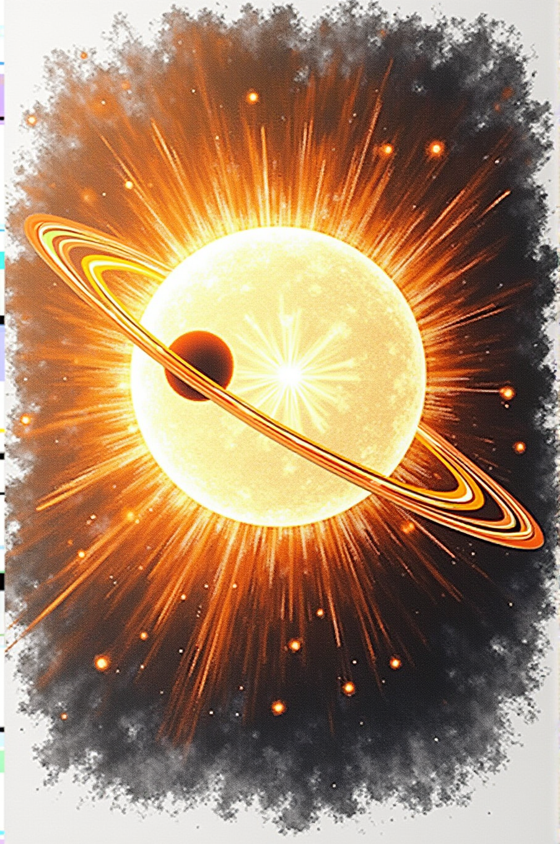

CHAPTER 2: THE FIRST HEART
She set her mug down carefully. "Older than the universe is supposed to be."
It wasn't a question. More like she was testing the words, seeing how they felt.
He nodded. "According to the Big Bang model, the universe is 13.8 billion years old."
"Right. We learned that in—"
"But what if that's wrong?"
She frowned. "The whole universe?"
"The age. The timeline. What if it's much, much older than that?"
"How much older?"
He leaned forward. "The first heart—the oldest planet in our solar system—is a little more than forty billion years old."
She blinked. "That's... that's four times older than the universe."
"If the Big Bang model is right, yes."
"So either the planet is younger than you think, or—"
"Or the universe is older than we've been told."
She pulled the blanket up to her chin. "That's a big 'or.'"
"It is."
Outside, the wind picked up. A branch scratched against the window—once, twice, then stopped.
"Which planet?" she asked quietly.
"Neptune."
"The blue one?"
"The blue one. The farthest. The coldest. The one that's been out there, watching, since before anything else existed."
She picked up her tea, took a long sip, set it down again. "How do you know it's that old?"
"Math."
"What kind of math?"
He stood, walked to the dining table, picked up his stylus. Tapped the screen. A blank canvas appeared. He drew a simple curve—logarithmic, gentle at first, then steeper.
"Planets don't stay where they're born," he said. "They migrate. Slowly. Following a pattern.”
She came over, blanket trailing behind her like a cape. Looked at the screen.
"What kind of pattern?"
"A power law. Distance grows as time to the one-over-phi power. It is just an exponent, like when you square something."
She squinted at the curve. "So the farther out a planet is..."
"The older it is."
"And Neptune is the farthest."
"Neptune is the farthest. Which makes it the oldest."
She was quiet for a moment, studying the curve. "But you said forty billion years ago. How do you get that number?"
"We know Earth is 4.543 billion years old. That's not controversial—radiometric dating, isotope ratios, all the standard methods agree. Earth is at 1 AU—one astronomical unit, the distance from the Sun. That's our anchor point."
"Okay."
"Neptune is at 30 AU. If you plug those numbers into the power law, Neptune comes out to about 41.5 billion years old."
She stared at the screen. "Show me."
He smiled. Pulled up a calculator function on the sketchpad. Typed as he spoke.
"Time equals distance to the 1/φ power, times 4.543 billion years, since 1 AU is conveniently known. Neptune is 30 AU. So: 30 to the 1/φ power equals... 9.145. Times 4.543 billion equals..."
"Forty billion years," she whispered.
"41.54 billion years."
She looked up at him. "But the universe is only—"
"I know."
"So that means—"
"I know."
She stepped back from the screen. Wrapped the blanket tighter. "That's impossible."
"Is it?"
"Yes! The Big Bang happened 13.8 billion years ago. That's when time started. Before that, there was nothing," she recalled from her science class.
"According to one model, yes."
"According to science."
"According to a model built on assumptions. What if the assumptions are wrong?"
She shook her head. "You can't just say the whole universe is wrong."
"I'm not saying the universe is wrong. I'm saying our model of it might be incomplete."
"That's the same thing."
"Is it?"
She walked back to the couch, sat down hard. "This is why I got suspended, isn't it? Because I said maybe we were wrong about something."
"This is exactly why you got suspended."
"Because people don't like being told they're wrong."
"Because people don't like their models being questioned. Especially when those models are comfortable. Especially when questioning them means starting over."
She pulled her knees up, rested her chin on them. "So Neptune is forty billion years old."
"Give or take."
"And it was the first planet born from the Sun."
"The first we know of. There might have been others, farther out. We'll get to that."
"How was it born?"
He picked up his mug, realized it was empty, set it down again. Sat back in his chair.
"Let me tell you."
The Sun was not always as it is now.
Not smaller—though it has lost mass over time.
Not dimmer—though it has burned steadier as ages pass.
But different.
Fifty billion years ago, the Sun was young. Massive. Unstable.
It burned with a fury we cannot imagine now, having only known this older, quieter star.
She interrupted. "Wait, you're saying the Sun was bigger fifty billion years ago?"
"Much bigger. Every time it ejects a planetary core, it loses mass. Neptune was the first ejection. The Sun was at its most massive then but it’s size isn’t necessarily directly related to the planets it births."
"So it's been getting smaller?"
"It got bigger, but then it started getting smaller, so yes."
"Okay. Continue."
Within the star's core, pressure built.
Not gradually. Not peacefully.
The hydrogen fused, releasing energy, but not all of that energy escaped.
Some stayed trapped. Compressed. Waiting.
Until the star could no longer contain it.
And so: the first pulse.
Not an explosion. Not a flare.
A release.
A fragment of the star's core—dense beyond measure, hot beyond touch, a piece of stellar fire still burning with the memory of fusion—tore free.
It spun outward, trailing plasma, still connected by invisible magnetic lines.
The core that would become Neptune.
"But it wasn't Neptune yet," she said.
"Not yet."
"What was it?"
"A stellar core. Naked. Exposed. Glowing white-hot in the void."
At first, there was only the core.
Iron, nickel, heavier elements compressed under the weight of stellar fusion.
It had no mantle. No crust. No atmosphere.
Just density and heat and the memory of being part of something larger.
It orbited close—far closer than Mercury orbits now.
Perhaps a few million miles from the Sun, whipping around in what we would call years but were then only moments.
"Why so close if it's so far now?" she asked.
"Migration. It didn't stay close. Over the next forty billion years, it spiraled outward to where it is now—30 AU."
"How?"
"Magnetic reconnection. The planetary core has its own magnetic field. The Sun has a much stronger one. It's like a tether that slowly releases tension. Like a tetherball that just keeps spinning outward, releasing more string as time marches on."
"So it's still connected? To the Sun?"
"Magnetically, yes. All the planets are. That's how they migrate."
She processed that. "Okay. So Neptune—or the core that would become Neptune—is orbiting close and hot. What happens next?"
Over the next five hundred million years, the core cooled.
Not entirely—the stellar heat doesn't dissipate quickly.
But enough.
Enough for debris to cling instead of vaporizing.
Enough for the layers to form.
"What kind of debris?" she asked.
"Hydrogen. Helium. The lightest gases. Back then, the Sun was so massive that its outer atmosphere extended far beyond where Mars orbits now. Neptune was born inside that atmosphere."
"So it gathered gas."
"Enormous amounts of gas. That's why Neptune is an ice giant—it's mostly hydrogen and helium and methane, with that stellar core at the center."
"How small?"
"Maybe the size of Earth. But compressed to incredible density."
She whistled softly. "And it's still hot?"
"Still molten. Even now, forty billion years later, Neptune radiates more heat than it receives from the Sun. Scientists measure it. They just don't ask why."
"Because they think it just formed out there?"
"Exactly."
As the debris accumulated, the core slowed.
Gravity from the gathering mass created drag. Tidal forces from the Sun pulled back.
And gradually—over billions of years—the planet that would be called Neptune forty billion years later spiraled outward.
Five AU became ten. Ten became twenty. Twenty became thirty.
Always outward. Always cooling. Always slowing.
Until it reached the distance we know today.
She leaned back. "So Neptune spent forty billion years just... moving?"
"And gathering. And cooling. And becoming."
"Becoming what?"
"The first witness. The ancient one. The planet that watched everything else be born."
Neptune was alone for eleven billion years.
Not lonely—loneliness requires consciousness, and Neptune was not yet conscious.
But alone.
No other planets. No siblings. No companions.
Just the Sun behind it, and the void ahead.
And in that void, Neptune waited.
For what, it did not yet know.
She picked up her tea. It had gone lukewarm. She drank it anyway.
"You already said that," she said. "About becoming. About planets remembering who they're becoming."
He paused. "I suppose I did. The pattern repeats at every scale."
"So should I be patient or should you stop repeating yourself?"
"Both."
She almost smiled. "So not Earth?"
He shook his head. "I should have added this is about forty billion years ago."
"But the universe is only 13.8 billion years old!" She was emphatic now, sitting up straighter.
"No, the Earth could be 4.5 billion years old—4.543 billion if we're going to trust the science. But how would it possibly make sense for all of the planets to be born at the same time in their current orbits?"
"That's what the accretion disk model says."
"And does that make sense to you? Nine different planets, all forming simultaneously at different distances, each one perfectly suited to its location?"
She frowned. "When you say it like that..."
"It's special pleading. It's a just-so story. The migration model is simpler: planets are born from the star at different times, they migrate outward, and what they gather depends on when they were born, not where."
"As above, so below," she said quietly.
"As above, so below."
Over the next five hundred million years the fledgling planet orbited the star at a furious rate, whipping around it much quicker than what we now know as Mercury orbits the Sun.
It accreted space dust and other material which would become its mantle, but for the time being the planet was still moving at an incredible speed inside the radius we have been told a planet should exist.
It would take another billion years for the planet to slow to a manageable rate for the accreted materials to cool into what would become the mantle of the planet.
Because the star was much more massive than it is today, the elements picked up were mostly lighter and gaseous.
As the planet gathered material from the Sun, the layers of the planet began to take shape.
Core. Mantle. Atmosphere.
Star-fragment. Gathering. Becoming.
She held up a hand. "Wait wait wait."
He paused. "What?"
"You just said Neptune moved outward—five AU to ten to twenty to thirty. But then you said it was whipping around the Sun faster than Mercury. That's backwards. If it moved away from the Sun, how was it orbiting faster?"
He smiled. "Good catch. That's describing the beginning—right after it was born, before it started the long migration."
"So it was born close?"
"Very close, within a few million miles, which is nothing compared to where it is now. And at that distance, with that much mass, it was orbiting fast. Much faster than Mercury orbits today."
"But then it slowed down as it moved out?"
"Exactly. The farther from the Sun, the slower the orbit. That's basic Kepler. So when Neptune was young and close, it whipped around in what might have been weeks or months. Now, at 30 AU, one orbit takes 165 Earth years."
"So that whole whipping-around-faster-than-Mercury thing was the first billion years?"
"The first few billion years, yes. Before the migration really took hold. I'm telling it out of order because the mythic voice doesn't care about linear time."
She frowned. "That's confusing."
"You're right. Let me be clearer: Neptune was born close, orbited fast, then began the long slow migration outward that took the next hundred billion years. The 'whipping around' part was right at the start."
"Okay. That makes more sense."
"Wait, you're saying Neptune was born from the Sun?"
"Ejected from the Sun, yes."
"That is impossible!"
"Is it? How else do you explain why planetary cores are still hot after billions of years? Why every planet radiates more heat than it receives? Why the composition changes based on distance from the Sun?"
"Because of... accretion?"
"Accretion doesn't explain internal heat. It doesn't explain why Mercury is seventy percent core. It doesn't explain orbital spacing. But birth-migration does."
She crossed her arms. "Have you ever heard of Galileo?"
He laughed. "Did you just Galileo me?"
"You used him on me earlier!"
"Fair. Yes, I've heard of Galileo."
"He said Earth orbits the Sun, not the other way around. That was just about the center of the solar system, not how the planets were created."
"Break it down further," he said, leaning forward. "At its core it was a fundamental change in mindset, not just a novel way of looking at the solar system. What Galileo did wasn't expose truth—what Galileo did was question authority."
"Okay..."
"If we're being honest, it was the first documented, or at least the most well-known instance of 'Trust the Science.' The Church said the Earth was the center. The authorities said don't question it. And Galileo said: but look,
the math works better if we assume the Sun is the center. If you break it down to basic elements, he went through exactly what you went through at school earlier."
"And he was right."
"He was right. But he was punished for it. Just like you were punished for defending Pluto."
She went quiet.
"The pattern repeats," he said. "Question authority, get punished. But eventually, the questions win. Because questions are how we get closer to truth."
She pulled the blanket tighter. "So what I'm hearing is that Neptune is forty billion years old, which means the universe is way older than we think, which means everything I learned in school is wrong."
"Not wrong. Incomplete."
"That's the same thing."
"It's not. Incomplete means we can add to it. Wrong means we have to throw it out. I'm not saying throw it out. I'm saying: look at the edges. Look at the things that don't quite fit. And ask why."
Outside, the clouds finally moved. A shaft of sunlight broke through, pale and cold.
She looked at him. "One heart down."
He nodded. "Eight to go."
She blinked. "There are nine planets?"
"Were, but that's another story."
She sat up straight, eyes bright. "Pluto?!"
"Not quite. The solar system could be older than a hundred billion years."
"How much older?"
"We'll get to that. Later. When we talk about the Oort Cloud."
She deflated slightly. "Oh."
"Don't worry. Pluto comes back into the story. I promise."
"When?"
"When we talk about Neptune's moons. And what happens when a planet steals another planet's child."
She stared at him. "Neptune stole Pluto?"
He smiled. "Told you it was a good story."
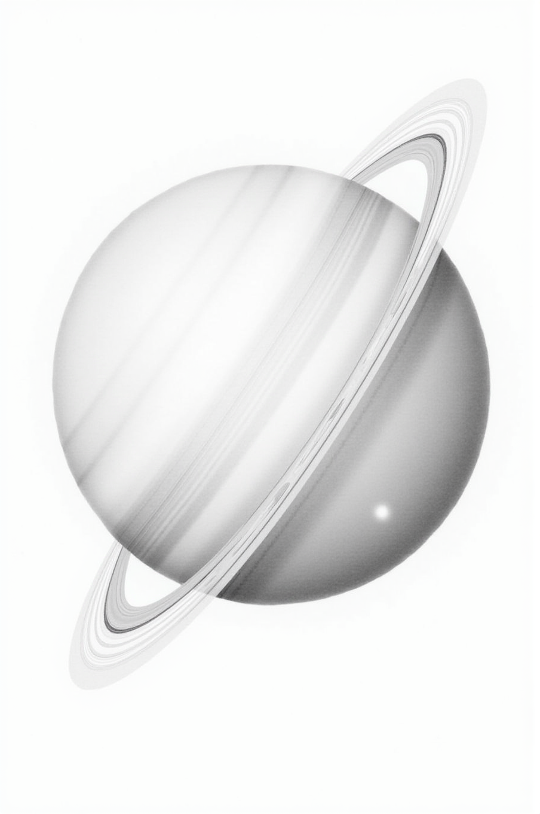

CHAPTER 3: THE TILTED WORLD
Eleven billion years passed.
The first heart drifted farther, colder, slower. It had become what it would remain: ancient, distant, watching.
The Sun continued its work—burning, fusing, spinning in the void. It had released one child and kept the rest close, held tight in the furnace of its core.
But the pattern had been set.
And patterns, once begun, do not stop.
The Sun pulsed again.
The daughter shifted in her seat. "So there was a second planet?"
"Yes."
"How long after Neptune?"
"Eleven billion years, give or take."
She blinked. "That's a long time between kids."
He smiled. "The Sun wasn't in a hurry."
The second ejection was quieter than the first. Not because it was smaller—it wasn't—but because the Sun had learned. Learned how to let go.
A core, molten and bright, unspooled from the solar surface. Still tethered by magnetic lines, still bound by invisible force, but separate now. Becoming.
It tumbled outward, spinning wildly at first, trying to find its axis.
And then it began to gather.
"Same process as Neptune?" she asked.
"Same physics. Different outcome."
Dust came first—silicon, carbon, traces of heavier elements already forming in the star's outer layers. They clung to the core like frost on glass.
Then gas. Hydrogen, helium, methane. The lighter elements, still abundant this early in the Sun's life, wrapped around the growing world in layers.
But the core was different this time. Denser. Colder from the start.
It would not become a gas giant like the ones to come.
It would become something else.
She frowned. "What do you mean, 'something else'?"
"Uranus isn't like Jupiter or Saturn. It's an ice giant. Different composition, different structure. Scientists group them separately—Uranus and Neptune in one category, Jupiter and Saturn in another."
"Why?"
"Because they formed at different times. When Neptune was born, the Sun was younger, hotter, more massive. More gas available. By the time Uranus came along, eleven billion years later, the Sun had changed. Less hydrogen and helium to gather. More ice, more methane, more of the heavier volatiles."
She thought about that. "So the Sun was... smaller when Uranus was born?"
"A little. Stars lose mass over time. Slowly, but it adds up. But it also goes through periods of expansion, but we’ll get to that."
The second heart spiraled outward, following the same invisible curve as the first. Not a straight line—never a straight line—but a logarithmic arc, graceful and precise.
It moved fast at first. Whipping around the Sun in tight, furious orbits. Accreting material as it went, layer upon layer, building itself from star-blood and void-dust.
Five hundred million years passed.
Then a billion.
The mantle solidified. The rotation stabilized. The magnetic field flickered into being—weak at first, then stronger, pulsing in rhythm with the distant Sun.
And still it migrated.
Farther. Slower. Colder.
"How far did it go?" she asked.
"Not as far as Neptune. Uranus is closer to the Sun now—about twenty astronomical units. Neptune's out at thirty."
"So it stopped earlier?"
"Not stopped. Slowed. It's still migrating, just like all the others. Just... slower."
For twelve billion years, Uranus orbited in the quiet.
Neptune was too far ahead to see clearly—just a faint point of light in the blackness, ancient and unreachable.
The Sun was behind, bright and constant, the only parent it had ever known.
And between them, nothing.
No siblings. No companions. No light but the Sun's.
It was a long, cold childhood.
She pulled the blanket tighter. "That sounds lonely."
"Maybe. Or maybe peaceful. No one to fight with."
She smirked. "Fair."
Uranus cooled. Its core settled into a rhythm—slow rotation, steady magnetic pulse, layers of ice and gas shifting in the dark.
It gathered a family of its own. Small moons, captured from the debris still swirling through the outer system. They clung to Uranus like children to a parent, spinning in perfect circles, obedient and small.
And still the second heart watched the Sun.
Waiting.
For what, it did not yet know.
"And then Saturn happened," she said.
He nodded. "And then Saturn happened."
The third pulse was not quiet.
It was not gentle.
It was violent.
The Sun convulsed—not in pain, but in release. A massive ejection, far larger than the first two. A core so dense, so hot, that it burned even as it left the solar surface.
Saturn erupted into being.
The father paused. Took a sip of tea.
"This one was different," he said.
"How?"
"Saturn had exactly what it needed to become a star."
She stared at him. "What?"
The third heart was born ignited.
Not fully—not like the Sun—but bright enough. Hot enough.
Massive enough.
For the first time in twelve billion years, Uranus saw a second light.
The daughter set her mug down. "Wait. You're saying there were two suns?"
"Not two suns. One sun and one... almost-sun. A brown dwarf, maybe. Something in between. Saturn burned—not through fusion like the Sun, but through gravitational collapse, residual heat from its birth. It glowed."
"For how long?"
"Billions of years."
Saturn's light reached across the void.
It touched Neptune, so far ahead it barely registered the glow.
But Uranus—Uranus was close enough to see.
For the first time since its birth, the second heart was not alone in the dark.
The solar system had become binary.
She leaned forward. "That's... actually kind of beautiful."
"It was. For a while."
Saturn's glow was not bright enough to warm Uranus. The distance was too great, the light too faint.
But it was enough to see by.
Enough to know that something had changed.
The Sun no longer ruled alone.
"Did anyone know this?" she asked. "I mean, do scientists know Saturn used to be a star?"
He shrugged. "Some suspect. There's evidence—Saturn radiates more heat than it receives from the Sun. More than Jupiter, even. Scientists call it 'residual heat from formation.' But they don't ask why it formed so hot. Or when."
"Because they think all the planets formed at the same time."
"Exactly. Four and a half billion years ago, all at once, in a disk of dust. Convenient. Tidy. Wrong."
She smiled. "Trust the science."
"Trust the questions."
For billions of years, the binary system held.
Saturn glowed. The Sun burned. Uranus watched.
And then the inner orbits began to fill.
Smaller cores, ejected faster now as the Sun aged and destabilized. They tumbled inward, hot and violent, accreting rock and metal instead of ice and gas.
The solar system was becoming crowded.
And with crowding came chaos.
"What kind of chaos?" she asked.
"The kind that starts wars."
Uranus saw it first.
Not the war itself—that would come later, much later, when the inner planets had cooled and civilizations had risen.
But the potential for war.
The violence inherent in proximity.
The way hot cores spiral too close, orbits intersecting, gravity tugging at fragile crusts.
Uranus had watched Neptune's silence for thirty billion years.
Uranus will watch Saturn's light for billions more.
And now Uranus saw what came next.
The father set his mug down. "Some wounds don't come from impacts," he said quietly.
She looked at him.
"Some wounds come from what you've seen."
And so the tilted world turned.
Not slowly. Not gradually.
In a single, deliberate motion—Uranus rolled onto its side.
Ninety-eight degrees.
Perpendicular to every other planet.
Its north pole facing the Sun, then its equator, then its south pole, in a slow, rolling rhythm that would last forever.
"Why?" she asked.
"Science says collision. Gravitational resonance. Random chaos in the early solar system."
"But you don't think so."
"I think Uranus chose."
She frowned. "Chose what?"
"To look away."
Uranus turned its face from the Sun.
Turned from Saturn's fading glow.
Turned from the violence brewing inward, where cores would cool into worlds and worlds would learn to destroy each other.
It turned toward the stars.
Toward the void.
Toward the places where no one fights, because no one is close enough to touch.
And it has never looked back.
The room was quiet for a moment.
She pulled the blanket up to her chin. "What did it see? You keep saying it saw something, but you won't say what."
He leaned back in his chair. "Saturn's story comes next. And then you'll understand."
"Understand what?"
"Why the tilted world chose exile."
She stared at him. Then, quietly: "Was it that bad?"
He picked up his mug. Took a slow sip.
"Worse."

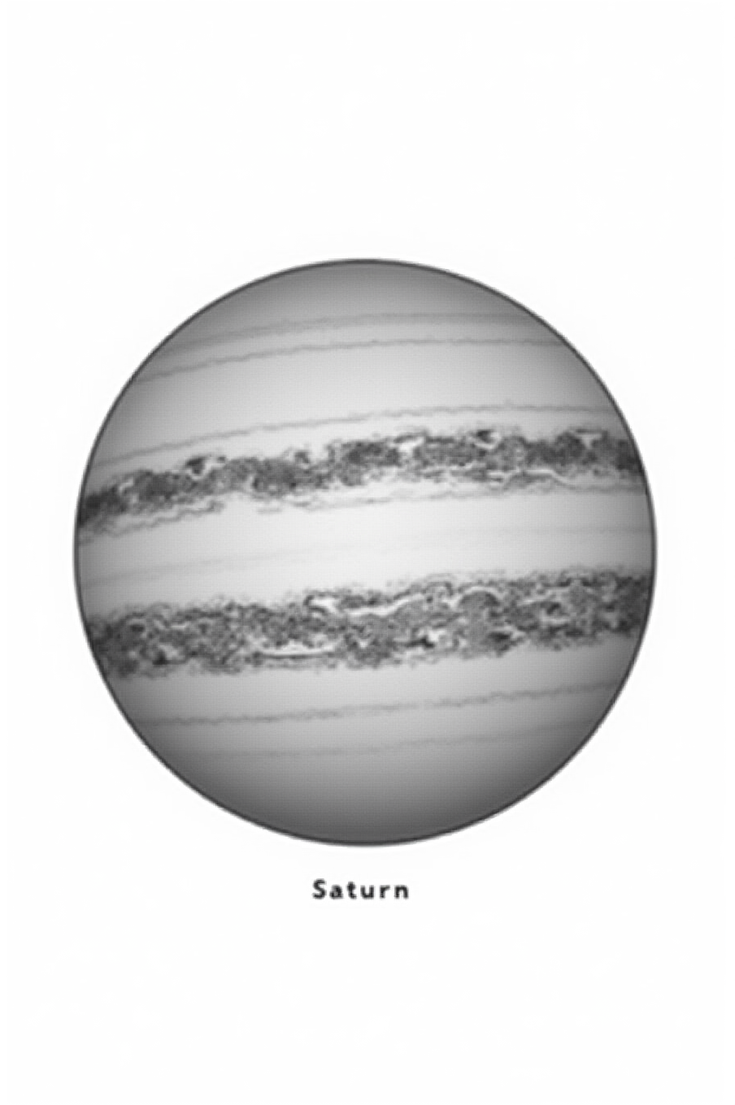

CHAPTER 4: SATURN'S BRIEF FLAME
There are moments in the cosmos when everything changes.
Not gradually. Not over eons of slow drift and patient cooling.
But suddenly. Violently. Irrevocably.
Saturn's birth was one of those moments.
The daughter picked up her mug. It was empty. She didn't seem to notice.
"You said Saturn was a star."
"Technically the only difference between a planet and a star is the mantle."
"So how close is it to being a star?"
He thought for a moment. "Close enough to matter, but you’ll actually see by the end of this, there isn’t much difference."
The Sun had been burning for twenty-three billion years when the third pulse came.
Twenty-three billion years of fusion, of pressure, of holding itself together against the constant urge to explode or collapse.
It had released two children already. Neptune, ancient and cold. Uranus, tilted and watchful.
But this time, something different happened.
The ejection was massive—far larger than the first two. A core so dense it dragged half the Sun's outer layers with it as it tore free.
And unlike its siblings, this core did not cool immediately.
It ignited.
"How does that work?" she asked. "I thought only stars could fuse hydrogen."
"True fusion, yes. But there are other ways to burn."
Saturn was born at the edge of stardom.
Too small for hydrogen fusion—the process that powers the Sun—but massive enough for something else.
Deuterium fusion. Lithium burning. And most of all, gravitational collapse.
When something that massive compresses under its own weight, it releases heat. Tremendous heat.
Enough to glow.
"So it was a brown dwarf," she said.
He nodded. "That's what scientists would call it now. A failed star. Something between a planet and a sun."
"Failed sounds mean."
"It is. Saturn didn't fail. It just wasn't meant to burn forever."
For the first billion years, Saturn blazed.
Not as bright as the Sun—nothing could match that ancient fire—but bright enough to cast shadows. Bright enough to warm the void.
Uranus, twelve billion years into its lonely migration, saw the light and understood: it was no longer the youngest.
Neptune, so far ahead it barely registered warmth, felt the faint glow on its cloud tops and remembered its own birth in fire.
The solar system had become binary.
She set the mug down. "What was it like? Having two suns?"
"Strange. Beautiful. Unstable."
In a binary system, nothing orbits cleanly.
Gravity pulls from two directions. Orbits wobble. Resonances form and break and form again.
But for a time—billions of years—it held.
Saturn glowed at the heart of the outer system, a second anchor point. Not as strong as the Sun, but present. Felt.
The light was dim and reddish, like a coal that refuses to die. It touched the surfaces of distant Uranus and Neptune, not warming them—never warming them—but seen.
And the Sun, twenty-three billion years old and still burning fierce, continued its work: birthing children, flinging them outward, shrinking slowly as each ejection took a piece of its mass.
"How long did Saturn burn?" she asked.
"Longer than you'd think. Maybe ten billion years. Maybe more, really I guess it could technically still be “burning”."
"That's a long time."
"It is. Long enough for the inner system to begin forming. Long enough for the Sun to eject four more cores inward—Jupiter, Tiamat, Mars, Earth—before Saturn's light finally dimmed."
She frowned. "So when Saturn went dark, the other planets were already there?"
"Some of them. Jupiter was born maybe six billion years after Saturn. Still glowing, still hot. Then Tiamat, then Mars, then Earth, then Venus, then Mercury. Each one smaller, faster, hotter—because the Sun kept losing mass with each ejection."
"And they all saw Saturn's light?"
He paused. "Some of them. Jupiter definitely. Tiamat, maybe. By the time Mars came along, Saturn was already fading."
Saturn's flame did not go out suddenly.
It was not snuffed, not extinguished, not torn away.
It simply... dimmed.
Slowly at first. A slight cooling. A darkening at the edges.
The glow that had lasted ten billion years began to falter.
The deuterium ran out. The lithium burned away. The gravitational collapse slowed as the core settled into equilibrium.
And one day—not a day, not a moment, but a span of time so vast it might as well have been instant—the light went out.
Saturn became a planet.
The daughter was quiet for a moment.
"That's sad," she said finally.
"Is it?"
"Something that beautiful, just... ending."
He tilted his head. "Did it end? Or did it become something else?"
When Saturn's light faded, it did not disappear.
It collapsed inward, into the core, into the deep layers where pressure still reigns and heat still lingers.
Even now, eighteen billion years later, Saturn radiates more energy than it receives from the Sun.
Scientists measure it. They call it "residual heat from formation."
But they do not ask why Saturn formed so much hotter than Jupiter, or why it still glows faintly in infrared.
They do not ask when.
"Trust the science," she said, half-smiling.
"Trust the questions," he replied.
Saturn's dimming changed everything.
When there were two lights, the solar system had balance. Two anchor points. Two sources of warmth, however faint.
But when Saturn faded, the outer system went dark.
Uranus and Neptune, already cold, became colder.
And the Sun, now ruling alone again, grew... unstable.
"Unstable how?" she asked.
"Grief, maybe. Or physics. Hard to tell the difference sometimes."
(EXPANDED)
The Sun began ejecting cores faster.
Not one every thirty billion years, but one every few billion. Then millions. Then—by the time Mercury was born—mere billions again, but clustered close together in cosmic time. Not all of them survived birth, but some did.
Jupiter. Tiamat. Mars. Earth. Venus. Mercury.
Six more children in the span of twelve billion years.
All of them born hot. All of them born fast.
All of them spiraling inward, toward the crowded orbits where gravity tangles and collisions become inevitable.
She leaned forward. "So Saturn dying made the Sun go crazy?"
"Not crazy. Just... reactive. When you lose something that massive, that luminous, the equilibrium breaks. The Sun had to rebalance. And it did—by creating more."
"That doesn't sound stable."
"It wasn't."
Saturn did not witness the chaos it had caused.
By the time the inner planets formed, Saturn had migrated far enough outward that it barely felt their gravity.
It continued its slow spiral, cooling into the ringed gas giant we know today.
But the memory of its light remained.
Encoded in the orbits. Encoded in the resonances. Encoded in the way Jupiter and Saturn still tug at each other, even now, in a dance that began when one was a star and the other was just being born.
"What about the rings?" she asked suddenly.
"What about them?"
"Saturn has rings. Big ones. Where did they come from?"
He smiled. "That's a good question."
"Do you have a good answer?"
"I have a theory."
The rings are not native.
They are not pieces of Saturn's formation, not leftover debris from its birth.
They are younger. Much younger.
Some say a moon shattered—torn apart by tidal forces when it drifted too close.
Some say a comet was captured and destroyed.
But others—those willing to see patterns—say the rings are a gift.
Or a scar.
Evidence of something that came later. Something violent.
"From the war?" she asked.
He didn't answer right away.
"From the war," he said finally.
When Saturn's flame went out, it became a witness instead of a participant.
It watched the inner system grow crowded and hot.
It watched Jupiter form, massive and loud, gathering more gas than any planet should.
It watched Tiamat and Mars come into being, close enough to touch, close enough to destroy.
And when the war came—sixty-six million years ago, in a span of time so recent it's barely a blink—Saturn felt it.
Debris rained outward. Fragments of a shattered world.
Some of it struck Saturn's moons. Some of it fell inward toward the Sun.
And some of it settled into orbit, a thin band of ice and rock and memory, spinning forever around the world that used to shine.
The daughter stared at him. "The rings are from?"
"Some of them, failed moons, maybe."
"Can we prove that?"
"Not yet. But we can ask the question."
Saturn's brief flame is over… for now.
It may never ignite again. The mass is small, the fuel spent, the collapse possibly complete.
But the heat remains.
Deep in the core, where no probe will ever reach, Saturn still burns.
Not with light. Not with fire.
But with memory.
The room was quiet. Outside, the wind picked up. The trees swayed.
"What happened next?" she asked.
He picked up his mug. Drained the last cold sip.
"Next came the giant, Jupiter, then the ones who would learn to fight Tiamat and Mars."
She pulled the blanket tighter.
"I'm not sure I want to hear this part."
"I know," he said. "But you need to."
“And what is Tiamat?”
“Just wait for it.”
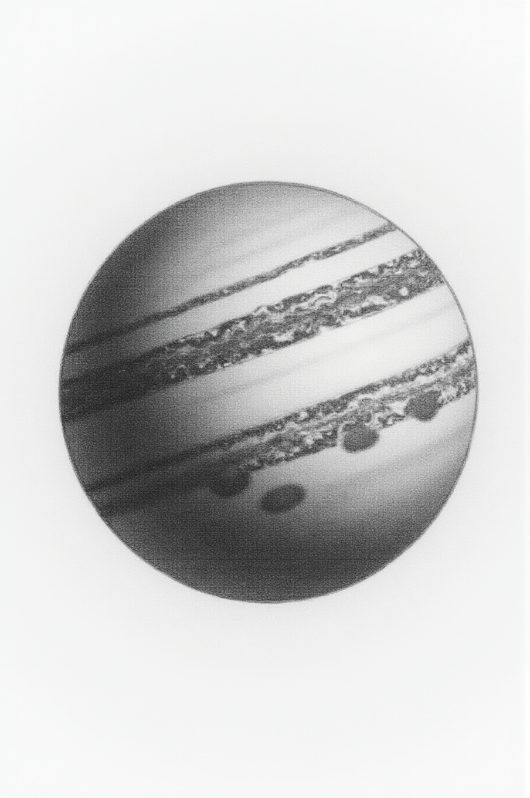

CHAPTER 5: THE KING OF STORMS
Six billion years after Saturn ignited, the Sun pulsed again.
But this time, it was not gentle.
This time, it was not measured.
This was an eruption.
The daughter had refilled her mug. Steam rose in lazy spirals.
"Bigger than Saturn?" she asked.
"Much bigger."
The fourth core tore free from the Sun with such force that it carried half the solar atmosphere with it.
The Sun had grown massive after birthing Saturn, it’s outer atmosphere extending out th nearly where the Earth currently sits due to it’s interaction with the near-star it had birthed.
Hydrogen. Helium. Trace metals and ionized gases, all spiraling outward in a cloud of stellar matter that dwarfed anything that had come before.
This was not a child being born.
This was a king.
"Jupiter," she said.
He nodded. "Jupiter."
The core was immense—three hundred times the mass of Earth, compressed into a sphere of liquid metallic hydrogen and deeper, stranger things.
It did not drift. It did not spiral gently outward like its siblings.
It roared into the void, dragging its envelope of gas behind it like a cloak.
She leaned forward. "Why was it so much bigger?"
"Because the Sun was still massive. Still young enough—nearly thirty billion years old—to have abundant hydrogen and helium in its outer layers. When Jupiter was born, there was so much to gather."
"And it gathered all of it?"
"Not all. But more than anything before or since."
For the first hundred million years, Jupiter was chaos.
Spinning wildly, its core molten and violent, it pulled in everything within reach.
Gas compressed into layers—hydrogen on the outside, denser and denser toward the center until the pressure turned hydrogen metallic, a liquid mirror-surface that conducted electricity and generated storms.
The accretion disk swirled. Material rained down, kilometer-thick clouds of dust and ice and star-matter, building the giant layer by impossible layer.
And still it was not satisfied.
"Greedy," she said.
"Hungry," he corrected. "There's a difference."
Jupiter's gravity was so strong that it began to pull not just gas, but everything.
Asteroids tumbled inward from the outer reaches. Comets fell like rain. Moons formed, not one or two, but dozens over billions of years.
Four of them grew large: Io, Europa, Ganymede, Callisto.
The rest stayed small, fragments spinning in strange, tilted orbits.
Jupiter had become a solar system within the solar system.
"How many moons does it have now? Did it birth the moons like the Sun birthed the planets?" she asked.
"Seventy-nine confirmed. Probably more we haven't found yet. As above so below, so yes."
"That's insane."
"That's gravity."
As Jupiter gathered mass, something strange began to happen.
It began to glow.
Not like Saturn—not a true brown dwarf flame, not deuterium fusion igniting.
But heat nonetheless. Gravitational compression so intense that the core burned from the pressure alone.
Even now, Jupiter radiates more energy than it receives from the Sun.
Even now, it remembers being a star. The Sun began to contract quickly on a galactic timeline, over the next few billion years it shrank to about the size it is at now.
She blinked. "Wait. Jupiter almost became a star?"
"Close. If it had been more massive, it could have ignited deuterium fusion. It would have become a brown dwarf like Saturn."
"So we almost had three suns?"
"We did have three lights, for a while. The Sun. Saturn's glow. And Jupiter's heat."
She stared at him. "That's... that's a lot."
"It was the brightest the solar system has ever been."
For billions of years, Jupiter migrated outward under Saturn's fading light.
It spiraled slowly, majestically, its gravity so immense it warped the orbits of everything around it.
Saturn, ancient and dimming, felt the tug of its massive sibling and began to resonate—a dance of giants that continues even now, their orbits locked in a 5:2 ratio, forever pulling at each other across the dark.
Uranus and Neptune, farther still, barely registered the newcomer. But they felt the shift in the solar system's balance.
The outer realm now had three powers: Neptune the Ancient, Saturn the Faded Star, and Jupiter the King.
"King of what?" she asked.
"Everything."
Jupiter's magnetosphere stretched a million kilometers into space—farther than the distance from Earth to the Moon.
It was not just a magnetic field. It was a dominion.
Anything that came close felt Jupiter's pull. Asteroids deflected. Comets shattered. Even light bent around the giant's mass.
And deep within that magnetosphere, trapped in belts of radiation so intense they would kill any probe in hours, particles spiraled and screamed.
Jupiter had become a shield.
Or a weapon.
Depending on your perspective.
She frowned. "A shield?"
"Jupiter's gravity protects the inner planets. Most asteroids and comets that come from the outer system get pulled into Jupiter or flung away. Without it, Earth would be hit far more often."
"So it's a good thing."
"Mostly. But gravity doesn't choose. It just pulls. And sometimes what Jupiter protects, it also destroys."
Jupiter, still migrating outward, felt the shift.
Jupiter was no longer the youngest.
"The Sun started making more planets?" she asked.
"Yes. Faster now. The Sun was older, more stable, less reactive. It had birthed a giant. It needed to rebalance."
"So it made more babies."
"It made more cores. And they came fast."
Tiamat was born three billion years after Jupiter.
Close. Hot. Violent.
Mars followed about four billion years later.
And Jupiter watched.
She set her mug down. "Did Jupiter... care?"
"About what?"
"About the new planets. About what was happening inward."
He paused. "I don't know. But Jupiter's gravity shaped everything that came after. Every orbit. Every collision. Every war."
Jupiter's Great Red Spot formed sometime in those early epochs.
A storm larger than Earth, spinning in the upper atmosphere, fueled by heat from below and chaos from above.
Scientists say it's at least four hundred years old, maybe older.
But what if it's far older?
What if the Spot has been raging for billions of years, a permanent scar from Jupiter's birth—an eye that never closes, watching the inner system spiral into violence?
"That's creepy," she said.
"Or poetic."
"Creepily poetic."
Jupiter's moons followed the same pattern as the planets.
Callisto, the outermost of the Galilean moons, is the oldest—perhaps eleven billion years.
Ganymede, seven billion.
Europa, six billion.
Io, the youngest and most volcanic, perhaps four billion, closest to Earth in age of all of the moons of the solar system.
Each one born from Jupiter's core, ejected outward, migrating along the same logarithmic curve.
As above, so below.
She smiled slightly. "You keep saying that."
"Because it keeps being true."
Jupiter did not stop growing.
Even now, it pulls in comets and asteroids, adding to its mass grain by grain, storm by storm.
Even now, its gravity tugs at Saturn, at the inner planets, at the Sun itself.
Even now, it radiates heat from a core that remembers being almost a star.
The King of Storms does not rest.
The King of Storms does not forgive.
The King of Storms simply is.
The father stood and walked to the window. Outside, the clouds had thickened. Rain was coming.
"What happened next?" she asked.
He didn't turn around. "Next came the twins. Tiamat and Mars. Close enough to see each other. Close enough to destroy each other."
She pulled the blanket up to her chin. "How close?"
"Too close."
Jupiter had been a king for roughly three billion years when Tiamat was born.
And for the first time since its own birth, Jupiter felt something shift in the solar system's balance.
Not outward, where the giants ruled.
But inward, where the heat and chaos lived.
Where something new was beginning.
Something that would not end well.
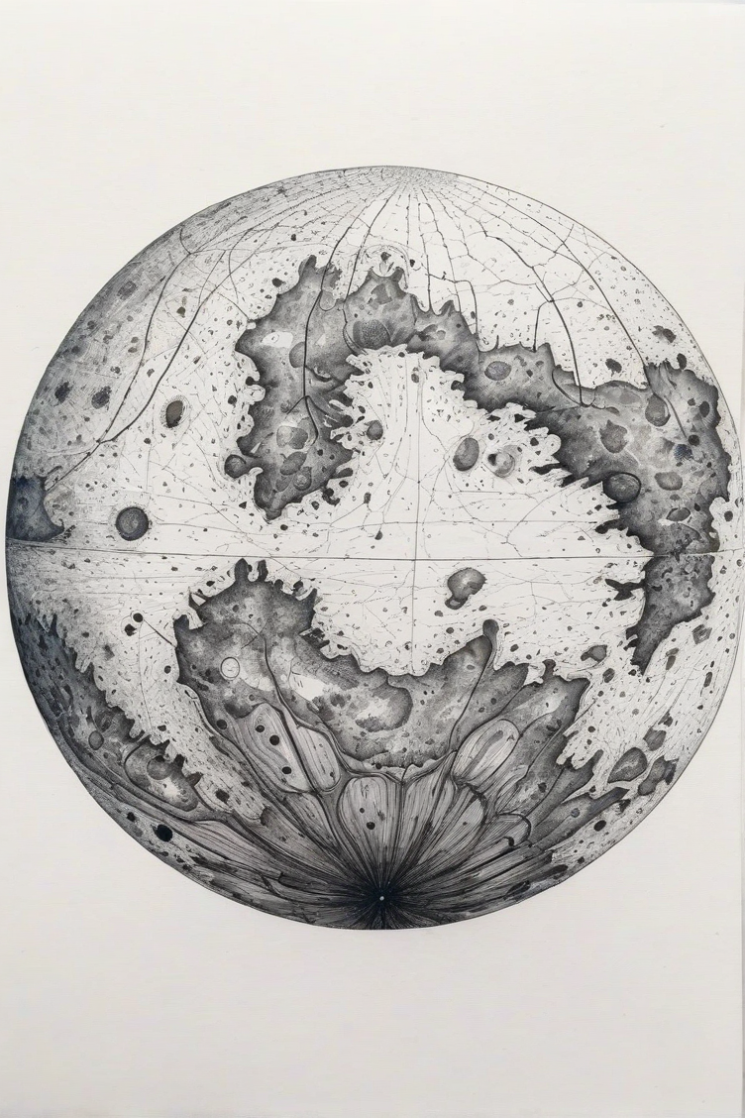

CHAPTER 6: THE OCEAN WORLD
Three billion years after Jupiter's birth, the Sun convulsed.
Not with violence this time—though there was violence—but with something closer to grief.
It had released four children into the outer dark: Neptune, Uranus, Saturn, Jupiter.
Each one drifting farther and colder as the ages passed.
But now the Sun was older. Smaller. Less massive.
And the cores it ejected would not drift outward into the cold, the shrinking of the Sun had created a buffer.
They would stay close.
Too close.
The daughter had moved to the floor, blanket wrapped around her shoulders like a cape. She sat cross-legged, mug balanced on her knee.
"How close?" she asked.
"Close enough to see each other. Close enough to share the same sky."
"That sounds nice."
He smiled, but it didn't reach his eyes. "For a while."
The fifth core came forth in a blaze of light and heat.
Not as massive as Jupiter—nothing would ever be that massive again—but substantial. Dense. Alive with potential.
It spun outward from the Sun, tethered by magnetic lines, trailing a wake of plasma and ionized gas.
And unlike the giants before it, this core gathered rock.
She frowned. "Why rock? Why not gas like Jupiter?"
"Because the Sun was different now. About thirty billion years old. It had burned through most of its primordial hydrogen and helium. The outer layers were enriched with heavier elements—carbon, silicon, oxygen, iron."
"So the ingredients changed."
"Exactly. When you're born determines what you're made of."
The fifth heart accreted quickly.
Silicon dioxide solidified into a mantle after orbiting outward for millions of years. Iron and nickel took the place of the hydrogen and helium that dominated before. Volatiles—water, methane,
ammonia—rained down from the cooling debris field and settled into basins.
For the first time since Jupiter, a world was forming with a solid surface.
A place where oceans could gather.
A place where life could begin.
"Wait," she said. "Life?"
"Life."
She stared at him. "On which planet?"
"The one that doesn't exist anymore."
She went very still. "The ninth planet."
"Tiamat."
Tiamat formed fast—faster than any world before it.
Within five hundred million years, the mantle had cooled. Within four billion, the oceans had formed.
Deep oceans. Vast oceans. Covering ninety percent of the surface in water so blue it could be seen from Jupiter's distant perch.
The remaining ten percent rose as continents—volcanic islands, archipelagos, sprawling landmasses covered in rust-red stone and black sand.
And in those oceans, something stirred.
"You're saying Tiamat had life?" she asked. "Like, actual life?"
"A few billion years of it."
"That's older than Earth."
"Much older. Earth is four and a half billion years old. Tiamat was nine billion when it died."
She processed that. "So everything on Earth... came from there?"
"We'll get to that."
At first, it was simple.
Single cells, drifting in warm currents. Chemosynthetic bacteria clustering around hydrothermal vents. Photosynthetic organisms learning to harvest the Sun's light.
But nine billion years is a long time.
Long enough for complexity to emerge. Long enough for ecosystems to develop. Long enough for intelligence to arise and fall and arise again, cycling through epochs we will never know.
Tiamat was not just a planet.
Tiamat was a civilization.
The daughter set her mug down carefully. "What kind of civilization?"
"I don't know. No one does. But the evidence is there, if you know how to look."
"What evidence?"
He leaned back in his chair. "The Moon."
The Moon is too large.
Too dense.
Its orbit is too circular, too perfect.
Earth has a mantle, it couldn’t have given birth to it’s own moon.
When the Apollo missions placed seismometers on the lunar surface and then crashed the spent modules into it to test the readings, the Moon rang like a bell for hours.
Not like a solid sphere. Like something hollow. Or layered in ways we don't understand.
She blinked. "Hollow?"
"Layered, maybe. The scientists call them 'mass concentrations'—dense regions just below the surface. But they're symmetrical. Too symmetrical."
"What are you saying?"
"I'm saying the Moon isn't a moon. It's a core. Tiamat's core and inner mantle. Think about the mechanisms we’ve been talking about. The heaviest elements would have been nearest to the core, the star at the heart of the planet. Even if the inner mantle had cracked it still would have held together as the planet’s life leaked out."
When Tiamat was destroyed—sixty-six million years ago, in a span of violence so brief it barely registers in geological time—the planet shattered.
The oceans boiled away. The mantle fractured. The continents vaporized.
But the inner mantle survived.
Dense, metallic, indestructible—it was pulled into Earth's orbit by gravity, where it has circled ever since.
A remnant.
A memorial.
A warning.
She was quiet for a long moment. "Why don't scientists know this?"
"Because they assume all the planets formed at the same time, four and a half billion years ago. If you start with that assumption, the Moon has to be the same age as Earth. So they made up a story."
"The giant impact hypothesis."
He nodded. "A Mars-sized object called Theia crashed into early Earth, and the debris coalesced into the Moon. Neat. Tidy. Unprovable."
"But convenient."
"Very convenient."
Before its destruction, Tiamat thrived.
Its oceans teemed with life—vast forests of kelp in the shallows, bioluminescent organisms in the depths, creatures that flew and swam and crawled across the volcanic islands.
And beneath it all, something else.
A network.
She looked up. "Like the mycelial thread you mentioned?"
"Exactly like that."
In the deep soil of Tiamat's continents, a fungal network spread.
Not simple mold or mushrooms—though those existed too—but something more complex. More aware.
Mycelia that stretched from coast to coast, connecting root systems, decomposing matter, recycling nutrients.
A planetary nervous system.
Tiamat was not just alive.
Tiamat was conscious.
"That's impossible," she said.
"Is it? Earth's mycelia networks communicate. They share resources between trees. They make decisions. Some scientists think they might even learn."
"But that's not consciousness."
"Isn't it? If a network can store information, process signals, respond to stimuli—what else would you call it?"
She pulled the blanket tighter. "I'd call it really creepy."
"Or beautiful."
Tiamat's oceans were warm.
Not boiling—never boiling—but temperate enough for complex chemistry, for proteins to fold, for DNA to replicate without breaking.
The planet orbited at a distance we would call habitable. Close enough to the Sun to receive light and warmth. Far enough to avoid being scorched.
And because it was alone—no sibling planet crowding its orbit—it had space to breathe.
For four billion years, it was alone.
"Wait," she said. "You said it shared the sky with another planet."
He nodded slowly. "Mars was born four billion years later."
"And they were too close."
"They were too close."
But before Mars, there was peace.
Tiamat migrated slowly outward, following the same spiral as Neptune and Uranus and Saturn and Jupiter before it.
Its oceans deepened. Its continents grew lush. The mycelial network expanded until it covered every landmass, every island, every volcanic ridge.
And in the oceans, something began to emerge.
Not intelligence as we understand it—not cities or technology or written language, not yet at least.
But awareness.
A sense of self that spanned an entire world.
The daughter was leaning forward now, blanket forgotten. "What do you mean, 'a sense of self'?"
"I mean Tiamat knew it was Tiamat. The oceans knew they were oceans. The mycelial network knew it was the network. It was all one thing."
"That's... that's Gaia theory."
"It's older than Gaia theory. It's what Gaia theory tried to explain."
For four billion years, Tiamat was the jewel of the inner system.
Jupiter, massive and distant, watched from afar with its Great Red Eye.
Saturn, farther still, barely registered the small blue world spinning in the warmth of the dimming second Sun.
And the Sun—older now, quieter, less violent—looked down on its fifth child with something like pride.
This was the first world that had not drifted into the cold.
This was the first world that had stayed close enough to be loved.
She wiped at her eyes quickly. "Why are you making me sad about a planet I've never heard of?"
"Because it deserves to be remembered."
Tiamat's days were thirty hours long.
Its years, five hundred Earth days.
Its tides, pulled by a moon we will never name, rose and fell in rhythms that shaped coastlines and carved channels through stone.
And every night, the stars wheeled overhead—ancient Neptune and Uranus invisible in the dark, but Jupiter close enough to see, a bright point of light that never moved. And Saturn bathing Tiamat in additional warmth when they danced on the same side of the Sun.
Tiamat was not alone in the cosmos.
But it was alone in space.
And that made all the difference.
"Until Mars," she said quietly.
He nodded. "Until Mars."
Four billion years after Tiamat's birth, the Sun pulsed again.
Smaller this time. Faster. Hotter.
Another core, flung inward.
Another world, learning to spin.
And when Mars cooled enough to open its eyes, the first thing it saw was Tiamat.
Close enough to touch.
Close enough to envy.
Close enough to destroy.
The father picked up his mug. Stared into it like it held answers.
"That's where everything went wrong," he said.
She didn't respond. Just sat there, wrapped in her blanket, staring at nothing.
Finally: "What happened to Tiamat?"
"War," he said simply. "Mars and Tiamat went to war. And sixty-six million years ago, Tiamat lost."
"How do you lose a war between planets?"
He looked at her. "Completely."
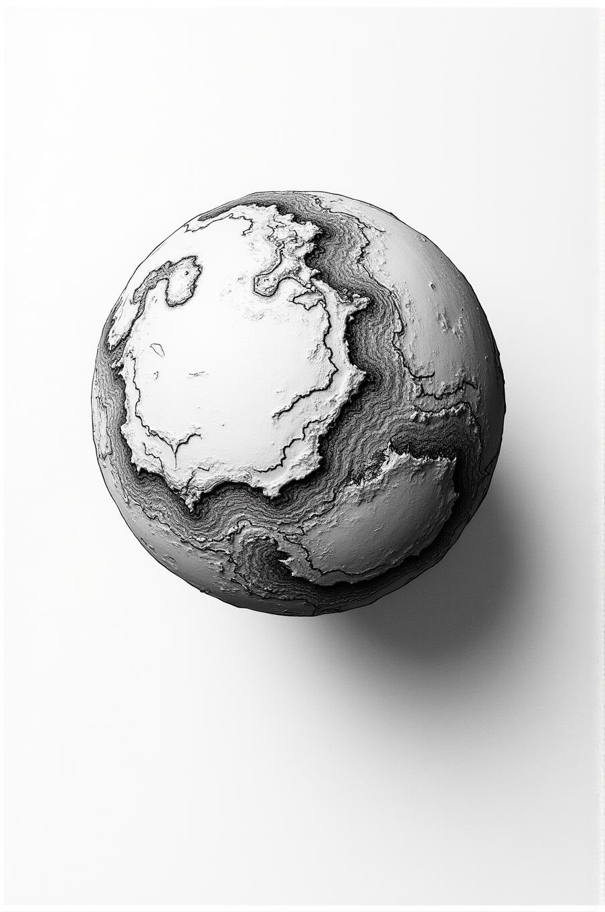

CHAPTER 7: THE RED WORLD
Four billion years after Tiamat opened its eyes, the Sun convulsed again.
Not with the massive violence of Jupiter's birth—those days were long past.
Not with the measured grace of Neptune's ejection—the Sun was too old for patience now.
This was sharp. Fast. Desperate.
A fragment of the Sun's core, torn free.
The daughter had pulled her knees up to her chest, blanket wrapped tight.
"Mars," she said.
"Mars."
The sixth core erupted from the solar surface like a wound breaking open.
Not massive like Jupiter. Not temperate like Tiamat.
Small. Dense. Furious.
"Why furious?" she asked.
He thought about it. "Because it was born too late. The Sun was thirty-five billion years old. Most of its primordial mass was gone. By the time Mars came along, there wasn't much left to give."
"So Mars got the scraps."
"Mars got what was left."
At first, there was only the core.
A sphere of stellar material—iron, nickel, heavy elements compressed under unimaginable pressure.
Still glowing. Still molten. Still a piece of the Sun, even as it tore away.
This was not rock. Not yet.
This was a star fragment, small enough to be ejected but dense enough to hold its shape.
And it spun outward, tethered by magnetic field lines, trailing plasma and ionized gas in its wake.
She leaned forward. "Wait. You're saying Mars's core is literally a piece of the Sun?"
"Every planet's core is. That's the whole point. Planets are stars. The only difference is the metals solidified and became a mantle. They're stellar cores that got ejected and started cooling."
"But Mars is... it's just rock and dust now."
"Now, yes. But not at first."
For the first hundred million years, Mars was nothing but core.
Naked. Exposed. Glowing white-hot in the void.
It orbited close to the Sun—far closer than it does now—whipping around in tight, frantic circles.
The orbital period was measured in weeks, not years.
And everything it touched turned to vapor.
She frowned. "So how did it get a mantle? If everything vaporized?"
"Patience. Time. Distance."
As Mars spiraled outward—slowly, always slowly, following the 1/φ power law—it began to cool.
Not the core. The core stayed molten, would stay molten for billions of years.
But the surface cooled just enough.
Just enough for dust to cling instead of vaporizing.
Just enough for debris to accumulate instead of burning away.
"What kind of debris?" she asked.
"Everything. Silicon, oxygen, carbon, iron—all the heavier elements floating in the solar debris field. Particles left over from the Sun's formation. Fragments from earlier ejections. Cosmic dust that had been drifting for eons."
"And it just... stuck?"
"Gravity doesn't ask permission."
Grain by grain, the debris gathered.
At first it was molten—everything was still too hot for solid matter—but it gathered.
A layer of semi-liquid rock surrounding the stellar core, spinning in the same direction, locked by tidal forces.
This was the proto-mantle.
Still fluid. Still churning. But present.
Thickening with every orbit as more material rained down from the debris field.
The father stood and walked to the window. Rain had started falling—light, steady, hypnotic.
"This process took time," he said, not turning around. "Maybe five hundred million years. Maybe more. But gradually, as Mars migrated farther from the Sun, the temperature dropped enough for the outer layers to begin solidifying."
She set her mug down. "And that became the mantle?"
"The mantle was everything that had accumulated while Mars was close to the Sun. While the core was still molten enough to keep the debris liquid. Once Mars moved far enough out—maybe half of an astronomical unit, maybe a bit less—the outer layers cooled and hardened."
"Like lava cooling into rock."
"Exactly like that."
The mantle solidified from the outside in.
The outermost layer cooled first, forming a thin shell of basalt and olivine—dark, dense volcanic rock.
Beneath it, the mantle stayed semi-molten, still churning, still convecting heat from the core below.
And at the very center, the stellar core continued to burn.
Not with fusion—Mars was far too small for that—but with residual heat. Pressure. The memory of being born from fire.
She pulled the blanket tighter. "So the core is still hot?"
"Even now, six and a half billion years later, Mars has a molten core. Scientists know this from seismic data. They just don't ask why it's still hot after all this time."
"Trust the science."
"Trust the questions."
As Mars continued its outward migration, the cooling accelerated.
The mantle thickened. And on top of the mantle, a new layer began to accumulate. Tectonic plates began to form—like Earth's active plates.
This was different from the debris that had become the mantle.
This was dust.
She looked up. "What's the difference?"
"The mantle formed when Mars was close and hot. It's made of heavy elements—iron-rich minerals, dense silicates, things that can survive extreme heat."
"And the crust?"
"The crust formed when Mars was farther out and cooler. It's made of lighter material—oxidized iron, sulfates, clays. Things that can only form in cooler conditions. Dust that collected from the cosmos over millions and millions of years."
The dust came from everywhere.
From comets passing through the inner system.
From the solar wind carrying particles outward.
From collisions—small meteorites striking the surface, adding their mass to the growing world.
Layer by layer, the crust accumulated.
And as it grew, something remarkable happened.
For the first billion years, Mars was a world in flux.
The core stayed molten. The mantle slowly solidified. The crust thickened and oxidized and cracked under its own weight.
Volcanoes erupted—massive shields like Olympus Mons, the largest mountain in the solar system, built layer by layer from lava flows that lasted billions of years.
Water accumulated, enough for rivers, lakes, maybe even shallow seas.
And Mars began to migrate.
Slowly. Inexorably.
Following the same spiral as Tiamat, now four billion years ahead in its journey.
The daughter's voice was quiet. "When did Mars see Tiamat?"
He turned from the window. "The moment it opened its eyes."
When Mars was born, Tiamat was already in the habitable zone, at just over 1 AU, just past where the Earth is now.
Not close—never touching—but close enough.
Close enough that when Mars looked outward, past the Sun's glare, it saw a blue jewel hanging in the black.
Close enough to want.
"Want what?" she asked.
"Everything Tiamat had. Water. Life. Space. Time."
"That's not fair. Tiamat was there first."
"Fairness has nothing to do with gravity."
For three billion years, Mars watched Tiamat grow more beautiful.
Watched the oceans deepen. Watched the continents green with life. Watched the mycelial networks spread and connect until the entire planet hummed with awareness.
And Mars, red and dry and angry, kept migrating.
Kept spiraling outward.
Kept getting closer.
The room was very quiet. Only the rain, steady on the roof.
"Mars had water too, didn't it?" she asked. "I've seen pictures. Dry riverbeds. Canyons."
"It did. It went through the same process Tiamat went through, you can see what it was probably like by looking at Venus now."
"What happened to it?"
"It lost it."
"How?"
He sat back down. Picked up his mug, found it empty, set it down again.
"Mars was smaller than Earth. Smaller than Tiamat was. Even when it was filled with water it only grew to be about 90% the size of the current Earth. Its gravity is weaker. And without a strong magnetic field—"
"Wait," she interrupted. "Why didn't it have a magnetic field?"
"It did. For a while. But Mars's core cooled faster than Earth's. Smaller core, less heat, less convection. The magnetic field died, probably sixty-six million years ago."
"And that's bad."
"That's catastrophic. Without a magnetic field, the solar wind strips away the atmosphere. And without atmosphere, liquid water can't exist. It either freezes or sublimates directly into space."
Mars was chasing Tiamat across the void.
And still it migrated outward.
Still it closed the distance.
Still it hungered.
She was crying now, just a little. Wiping at her eyes with the corner of the blanket.
"Why are you telling me this?" she asked. "Why does it have to be so sad?"
"Because it's true. And because you need to understand what happened next."
"The war."
He nodded. "The war."
Five billion years after its birth, Mars was a lush paradise. The inhabitants of Tiamat had seeded Mars with what it thought was love.
Its core still burned, life was evolving as it had on Tiamat.
And Tiamat, beautiful and alive and impossibly ancient, orbited just ahead.
Close enough to see.
Close enough to hate.
Close enough to destroy.
The father stood. Walked to the kitchen. Refilled his mug. Came back.
"That's where we'll start tomorrow," he said. "With how two worlds go to war."
She didn't respond. Just sat there, wrapped in her blanket, staring at the rain.
Finally: "Could Mars have been like Earth?"
"Do you mean was Mars like Earth?"
"Yeah."
He thought about it. "Maybe. But it wasn't. And that made all the difference."
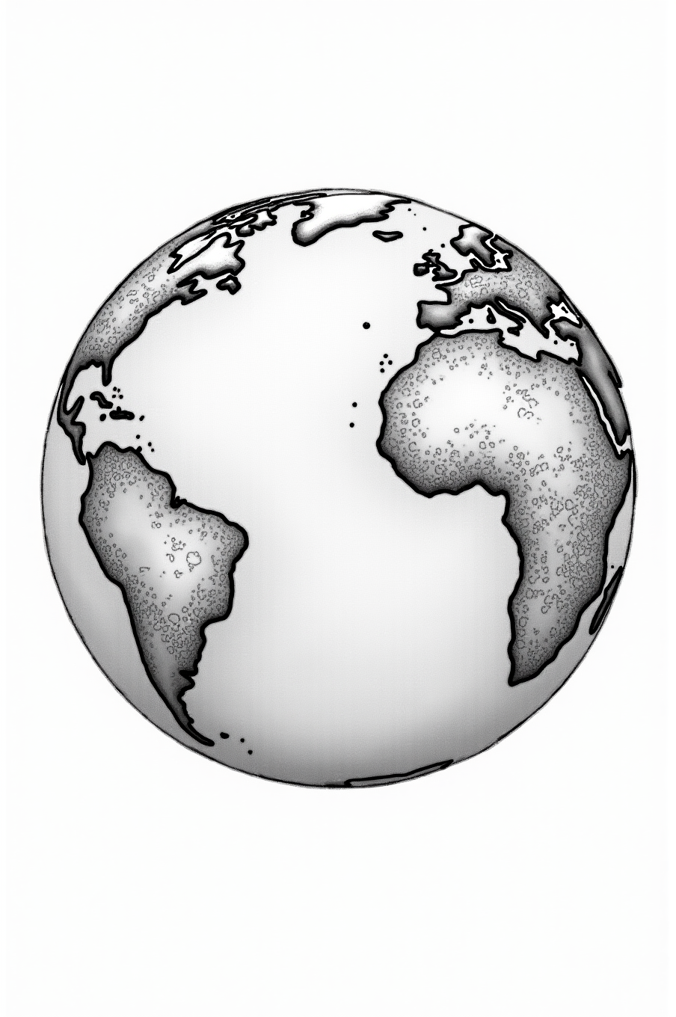

CHAPTER 8: THE INHERITOR
Two billion years after Mars opened its red eyes, the Sun pulsed again.
Weaker now. Older. Smaller than it had been when Jupiter roared into being.
But still burning.
Still creating.
Still flinging pieces of itself into the void.
The daughter had gotten up, gotten her bowl of cereal her dad had prepared, and come back to the floor. The blanket was still wrapped around her shoulders.
"Earth," she said.
He nodded. "Earth."
“But you said today we were going to start with the war?”
“We’ll get to it, patience.”
The seventh core tore free.
Not with Jupiter's violence. Not with Mars's desperate fury.
This ejection was almost... gentle.
As if the Sun had finally learned how to let go.
"How big was the core?" she asked.
"Smaller than Mars. The Sun was thirty-five billion years old by then. It had been losing mass with every birth—Neptune, Uranus, Saturn, Jupiter, Tiamat, Mars. Each ejection took something away."
"So Earth got even less?"
"Earth got what was left. But sometimes what's left is exactly what's needed."
The stellar core spun outward, glowing white-hot, trailing its magnetic tether.
At first, there was nothing but the core itself—dense iron and nickel, heavier elements compressed under the memory of solar pressure.
Still a piece of the Sun.
Still molten.
Still *alive* with residual heat that would take billions of years to fully dissipate.
She leaned forward. "Same process as Mars?"
"Same process as all of the existing children of the Sun. Different timing. Different outcome."
Earth orbited close at first—inside what would become Mercury's orbit, far inside where it is now.
Spinning fast. Whipping around the Sun in weeks, not years.
And in those early orbits, everything it touched turned to vapor or stayed molten.
The core glowed so hot that the space around it shimmered with heat.
Nothing solid could exist yet.
Only the core, and the beginning of what would become the mantle.
"How does the mantle form again?" she asked. "I know you explained it with Mars, but—"
"Debris," he said. "Space dust, silicon, oxygen, iron-rich particles. They're attracted by gravity, but they can't solidify yet because Earth is still too close to the Sun. So they accumulate as molten material around the core."
"Like... lava gathering around a ball of fire?"
"Exactly like that."
For five hundred million years, Earth was a molten sphere.
Core and proto-mantle, spinning as one, gradually accreting more mass from the debris field left over from the Sun's formation.
Heavier elements sank inward. Lighter elements rose to the surface—or would have, if there had been a surface.
There wasn't. Not yet.
Only layers of molten rock, differentiated by density and temperature, churning in convection currents that would continue for a billion years.
The father walked to the window. The rain had continued. Harder today than yesterday.
"Earth was lucky," he said, not turning around.
"How so?"
"Timing. Earth was born at exactly the right moment in the Sun's life. Not too early, when there was too much gas and everything became a giant. Not too late, when there was barely any material left."
"Goldilocks," she said.
"Goldilocks," he agreed.
As Earth migrated outward—always outward, following the 1/φ power law—it cooled.
Slowly. Gradually.
The outer layers of the mantle began to solidify.
Not all at once. Not uniformly.
But piece by piece, as Earth spiraled away from the Sun's immediate heat, the churning molten rock began to solidify into a mantle, to give the dust and debris something to cling to.
She frowned. "Why does the crust form? I mean, what makes it different from the mantle?"
"Temperature and composition. The mantle forms while Earth is close and hot—it's made of denser materials that can stay semi-molten. But as Earth moves farther out, the cooled mantle layer allows debris to accumulate on top, over billions of years it can become deep. Remember a billion is one thousand million years."
"So the crust is... lighter?"
"Less dense. Granite, basalt, sedimentary rocks. They float on top of the mantle like ice on water."
Earth's first crust was thin. Fragile. Constantly recycling.
Volcanoes punched through it, spewing lava that cooled and hardened and was then dragged back down by convection currents in the mantle below.
This was not the stable crust we know now.
This was chaos. Violent, creative chaos.
Tectonic plates hadn't formed yet. There were no continents. No oceans.
Only a roiling surface of semi-solid rock, constantly reshaping itself, Panagaea.
"When did it calm down?" she asked.
"It hasn't. Not completely. Earth's crust is still recycling—subduction zones, mid-ocean ridges, volcanic hotspots. We just live on the parts that are temporarily stable."
She processed that. "So we're living on a thin shell floating on molten rock?"
"And that molten rock is floating on a stellar core that's still hot after four and a half billion years."
"That's... kind of terrifying."
"Or beautiful. Depending on your perspective."
One billion years after its birth, Earth finally had a stable crust.
Thin, yes. Fractured, yes. But present.
The core still burned at the center—iron and nickel at temperatures that would melt any surface rock instantly.
The mantle churned above it—semi-molten, convecting heat from below, driving the tectonic motion that would eventually create continents.
And the crust floated on top.
Earth had become a layered world.
Core. Mantle. Crust.
Stellar fire. Molten stone. Cooling dust.
As above, so below.
The daughter pulled the blanket tighter. "Was it alone? Like Mars watching Tiamat?"
"Not entirely. Mars was there, outward. And Tiamat, farther still, both of them already ancient with oceans and life."
"Wait," she said. "Mars had oceans too?"
"Yes. Mars was two billion years old by then. It had rivers, seas, maybe an ocean in the northern hemisphere. An atmosphere thick enough to hold heat. It was alive."
She blinked. "But Mars is dead now."
"Now, yes. But not then."
Earth orbited at the perfect distance, in another timeline there could have been three planets in the Goldilocks zone.
Close enough to the Sun for warmth. Far enough for liquid water to exist.
There was water, not as much as there is now, and it was different.
Oceans, rivers, rain… all of it was there.
"For how long?" she asked.
"Earth has had water for almost a billion years."
She blinked. "Wait. Earth was dry for most of it’s existence?"
"Not dry, per se. It had liquids much like Venus has now. But until it reached a point in it’s orbit where it could hold liquid water without it boiling off, yes, there was no water. Now it has alien water as well, but we’ll get to that later."
Earth had a thick atmosphere, volcanic outgassing creating clouds of carbon dioxide, nitrogen, and sulfuric compounds.
The transition from greenhouse planet to lush paradise took time, it wasn’t overnight but instead over millions of years.
Whatever water vapor existed stayed in the atmosphere, too hot to condense, too light to rain.
The surface was rock. Only rock.
Cooling slowly as Earth migrated outward, but still too hot for oceans.
Earth was one and a half billion years old when another core was ejected.
The Sun, now thirty-seven billion years old, pulsed yet again.
Smaller than Earth. Closer to the Sun. Hotter.
Venus was born.
"Venus," she said. "My science fair project."
He smiled slightly. "Your science fair project."
Venus followed the same pattern as the other three inner planets.
Stellar core, molten mantle, accumulating crust.
For a billion years, Earth and Venus were siblings in the truest sense.
Both young. Both dry. Both waiting for water that wouldn't come for hundreds of millions more years.
"So there were four rocky planets," she said. "Earth, Mars, and Tiamat with oceans. Venus without."
"Exactly."
Mars and Tiamat had been circling for one and a half billion years when Earth was born.
Two ocean worlds, both ancient, both alive.
Their orbits were stable—not touching, not colliding, but close enough that both worlds felt the other's presence constantly.
Mars, red-rocked with blue seas, its atmosphere thick enough to breathe.
Tiamat, deeper oceans, older life, consciousness woven through mycelial networks that had also migrated to Mars.
They should have been siblings. Partners. The two living worlds of the inner system.
But proximity breeds contempt.
And four billion years is a long time to watch someone else thrive.
The room was quiet except for the rain.
"What happened?" she asked.
"They got closer. Orbital mechanics—over billions of years, planets in nearby orbits influence each other. Gravitational tugs. Resonances. The gap between Mars and Tiamat slowly closed. At times the giant planets of the outer solar system would line up and tug."
"And Earth just... watched?"
"Earth was too young to understand. Too hot, too dry, too wrapped up in its own formation. But yes. Earth watched."
Earth was four billion, four hundred and seventy-seven million years old when the war finally ended.
Not with negotiation. Not with peace.
With annihilation.
Tiamat shattered.
Eleven billion years of oceans. Of life. Of consciousness woven through mycelial networks that spanned continents.
Gone in an instant.
The daughter's hands were shaking. "And Mars?"
"Mars survived. But barely."
The war didn't destroy Mars physically.
No planetary fragments. No shattered core.
But the energy released when Tiamat broke apart—the gravitational shock, the electromagnetic pulse, the radiation—stripped Mars's atmosphere away.
Not all at once. But the damage was done.
Mars's magnetic field, already weakening, collapsed entirely.
And without protection, the solar wind began its work.
Particle by particle. Molecule by molecule.
Mars's atmosphere bled into space.
"How long did it take?" she asked quietly.
"Sixty-six million years. Mars is still dying. Right now, as we speak, it's losing atmosphere to the solar wind. The rovers measure it. Scientists just don't ask *why* it started sixty-six million years ago."
"Because of the war."
"Because of the war, because Jupiter pulled too hard, perhaps we’ll never know exactly."
When Tiamat broke apart, its core survived.
Dense, indestructible, it was pulled by gravity into Earth's orbit, where it circles to this day.
The Moon.
"The Moon is Tiamat's core," she whispered.
"The Moon may be Tiamat's core, maybe the inner mantle."
And the oceans—nine billion years of water, boiled into space by the violence of planetary death—rained down.
Not just on Earth. On Mars too. On Venus. On everything in the inner system.
But Mars couldn't hold it. Its atmosphere was already failing, its magnetic field dead. The water that fell on Mars froze or sublimated back into space within millennia.
Venus was too close to the Sun, too hot. The water that reached Venus stayed as vapor, trapped in the thick clouds that would choke the planet for billions of years to come.
But Earth—Earth was exactly the right distance. Exactly the right temperature. Exactly the right moment in its cooling.
Earth caught Tiamat's oceans and held them.
The father leaned forward. "The Bible calls it forty days and forty nights. Sumerian texts call it the deluge. Every culture on Earth has a flood myth. Remember when we talked about the Carolina Bays? You know how you like the big raindrops? Think about raindrops the size of buildings!"
"It actually happened?"
"It actually happened. Sixty-six million years ago, we probably rotate through the chaos on a yearly basis. Debris persists, not all meteor showers come from comets."
Earth inherited Tiamat's death.
Not just the water. Everything.
Organic molecules—amino acids, proteins, lipids—rained down with the oceans.
Fungal spores, hardy enough to survive in vacuum, germinated when they hit the wet soil.
DNA itself, encoded with nine billion years of evolution, seeded a world that had never known life.
And Earth, four and a half billion years with barely enough water to support life, became blue.
She pulled the blanket over her head. Just her eyes visible now.
"So we're not from Earth," she said. "We're from Tiamat."
"All life on Earth is from Tiamat. The mushrooms. The trees. The bacteria in your gut. The cells in your body. All of it—Tiamat's children, growing on Tiamat's water, breathing Tiamat's oxygen."
"And Mars?"
"Mars got the water too. But it couldn't keep it. Over the last sixty-six million years, Mars dried out. The rivers stopped flowing. The seas evaporated. The atmosphere thinned to almost nothing."
Mars turned red.
"Why red?" she asked.
"Iron oxide. Rust. When iron-rich dust is exposed to oxygen and water vapor, it oxidizes. It turns red."
"But Mars doesn't have oxygen."
"It does now, just not much. But early Mars had an atmosphere. Thin, but real. And wherever there's atmosphere, there's chemistry."
"So Mars is dead because of the war."
"Mars is dying because of the war. Slowly. Visibly. The corpse of an ocean world, desiccating in the solar wind."
She wiped her eyes. "I don't want to hear any more tonight."
"Okay."
"But tomorrow—"
"Tomorrow we'll talk about Venus. And what it means that three planets received Tiamat's water, but only one could hold it."
She looked at him. "Why only Earth?"
"Timing. Distance. Luck. Or maybe something else."
"What else?"
"Maybe Earth was meant to inherit."
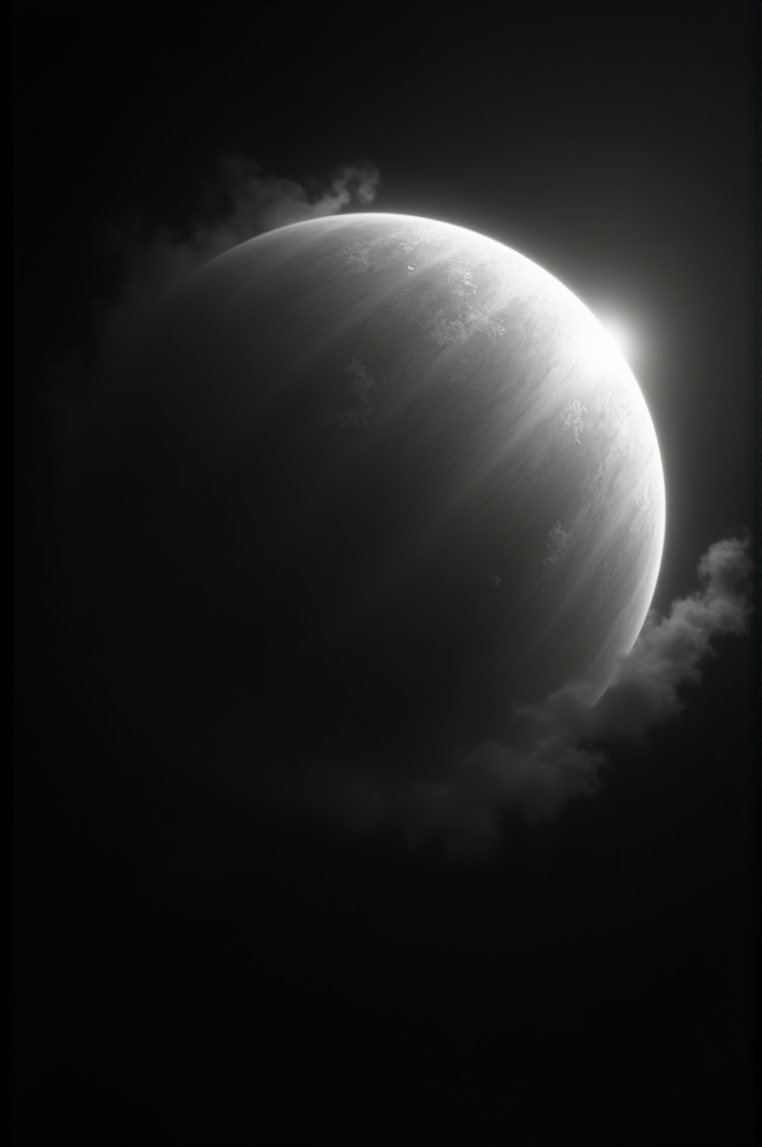

CHAPTER 9: THE SLEEPING SISTER
One billion years after Earth opened its eyes, the Sun pulsed again.
Older. Quieter.
Thirty billion years of burning, of creating, of flinging pieces of itself into the void.
And this wouldn’t be the last of the rocky worlds born close.
The daughter had moved back to the couch, blanket wrapped around her like armor. Her mug sat empty on the table.
"Venus," she said.
He nodded. "Venus."
The eighth core tore free.
Not with violence—the Sun was too old for that now.
Not with grace—there was no grace left in solar ejections this late in the cycle.
It simply... emerged.
A fragment of stellar material, smaller than Earth, denser than it should have been, glowing white-hot as it spun outward on its magnetic tether.
"Smaller than Earth?" she asked.
"A little. Maybe ten percent less mass. When you're born eighth, you get what's left."
"Like the youngest sibling getting hand-me-downs."
He smiled slightly. "Exactly like that."
At first, Venus was only core.
Iron and nickel compressed under impossible pressure, still radiating heat from the Sun's interior, still molten, still alive with the memory of fusion happening kilometers away.
It orbited close—closer than Earth had at the same age. Closer than Mars. Closer than anything except what would come later still.
Venus whipped around the Sun in what would eventually become two hundred and twenty-five Earth days.
Everything it touched burned.
She leaned forward. "Same formation process?"
"Same process."
For the first five hundred million years, Venus gathered its mantle.
Silicon dioxide. Magnesium oxide. Iron-rich minerals.
But because Venus orbited so close to the Sun, the debris never fully cooled.
It accumulated as molten rock, layer upon layer, building up around the stellar core.
Denser than Earth's mantle. Hotter. More viscous.
And with no water to lubricate the process, the convection currents moved slowly, grinding against themselves.
"Why no water?" she asked.
"Too hot. Any water that came near Venus in those early years vaporized instantly. It couldn't condense, couldn't rain, couldn't accumulate."
"So Venus was born dry, like Earth."
"Drier. Earth at least had water vapor in its atmosphere. Venus had nothing but heat."
“It sounds like all the planets were born in the same way, you don’t have to explain it every time!”
“It is just more dramatic that way… you expect something different, and it helps you realize that everything is the same.”
As Venus migrated outward—always outward, always following the power law—it cooled enough for a crust to form.
But this crust was different from Earth's or Mars's.
It was thick. Heavy. Unyielding.
Because Venus had no water to soften it, no oceans to erode it, no rain to carve channels through stone.
Just dust. Endless dust, settling layer by layer, compressing under its own weight.
And beneath that crust, the mantle stayed hot, churning slowly, unable to break through.
The father walked to the window. Outside, the rain had slowed to a drizzle.
"Venus should have had plate tectonics," he said. "A planet that size, with that much internal heat, should have moving plates like Earth."
"But it doesn't?"
"No. The crust is too thick. Too rigid. It locks everything in place."
"So what happens to all that heat?"
"It builds up. For hundreds of millions of years, the pressure increases. And then—"
"—it explodes?"
"—it resurfaces. The entire planet's crust melts and reforms. All at once."
She stared at him. "The whole planet?"
"Scientists estimate Venus resurfaces every five hundred million years or so. The last one was maybe five hundred million years ago. Erased everything that came before. Imagine the eruption that created the Gobi desert, like when you look at the globe and ask what that is from, but on a planetary scale."
"That's terrifying."
"That's Venus."
For three billion years, Venus spun alone.
Too close to the Sun for comfort. Too hot for water. Too rigid for change.
Earth was ahead of it in orbit—older, cooler, getting wetter.
Mars and Tiamat were farther still, both ancient with oceans and life.
Venus watched them all from behind, always behind, forever younger than Earth.
Forever the last to arrive before Mercury.
She pulled the blanket tighter. "Did Venus know about the war?"
"Venus was almost three billion years old when it happened. Old enough to have cooled. Old enough to have a stable crust. But still too close, still too hot."
"What did it see?"
"Everything."
When Tiamat shattered, Venus was the furthest rocky planet from the destruction.
Further than Earth. Further than Mars, which would die from its wounds.
The debris field came first—rock fragments, ice, metal, all of it glowing with the heat of planetary death.
Some struck Venus's surface. Some burned up in the thin atmosphere that had just begun to form.
And then came the water.
The daughter sat up straighter. "Venus got Tiamat's water too?"
"All the inner planets did. It rained everywhere."
"But Venus is... there's no water on Venus."
"Not on the surface. But there's water in the atmosphere. Lots of it."
Nine billion years of oceans, boiled into space, rained down on Venus for forty days and forty nights.
Or tried to.
But Venus was still too close to the Sun. Still too hot.
The water that reached the surface vaporized instantly, turning back into steam before it could pool or flow or freeze.
And that steam rose into the atmosphere, where Venus captured it, waiting for the time when it could have it’s own oceans.
Trapped.
"Trapped how?" she asked.
"Carbon dioxide. Sulfuric acid. All the volcanic outgassing from three billion years of crustal pressure, now mixed with water vapor from Tiamat's death. It formed clouds—thick, choking clouds that covered the entire planet."
"A greenhouse effect."
"A runaway greenhouse effect. The clouds trapped heat. The heat made more vapor. The vapor made more clouds. Within a few million years, Venus's surface temperature rose to nine hundred degrees Fahrenheit."
She processed that. "So Tiamat's water is still there? Just... as clouds?"
"As clouds. As vapor. As acid rain that never reaches the surface because it evaporates halfway down."
Venus received Tiamat's gift but couldn't use it.
Too young. Too close. Too hot to hold oceans.
The water that could have made Venus alive instead became its prison, being held with the seeds of life.
A thick, toxic atmosphere that blocked out the stars and turned the surface into an oven.
The room was quiet.
"That's sad," she said finally.
"Or patient."
"What do you mean?"
He turned from the window. "Venus is still migrating outward. Slowly. Following the same path as every other planet. In a few hundred million years, Venus will reach the habitable zone."
She blinked. "The same zone as Earth?"
"Exactly the same zone."
Venus is Earth's twin.
Not in size—though they're close.
Not in composition—though they're similar.
But in destiny.
Venus is where Earth was a billion years ago: too hot, too close, wrapped in toxic clouds.
And Earth is where Venus will be one billion years from now: cool enough for oceans, far enough for life.
"So Venus will wake up?" she asked.
"Eventually. When it reaches the right distance, the clouds will thin. The water vapor will condense. Rain will fall—real rain, not acid that evaporates mid-air. The surface will cool."
"And then?"
"And then Venus will have oceans again. Tiamat's oceans, held for five billion years in the sky, finally coming down to stay."
She was quiet for a long moment. "What happens when Venus and Earth are both in the habitable zone at the same time?"
He smiled. "That's a very good question."
There's something else about Venus.
Something scientists noticed but don't understand.
Venus spins backwards.
She looked up. "What?"
"Every other planet in the solar system spins in the same direction—counterclockwise, if you're looking down from above the north pole. But Venus spins clockwise."
"Why?"
He was quiet for a moment. "I think Venus chose to turn away."
Like Uranus, tilted on its side, refusing to watch the violence inward.
Like Neptune, distant and cold, witnessing everything from the edge.
Venus turned its back on the war.
Spinning slowly, slowly backwards, taking two hundred and forty-three Earth days to complete a single rotation.
The slowest spin in the solar system.
As if Venus decided time itself should move differently.
"That's... poetic," she said.
"Or traumatic. Hard to tell the difference sometimes."
Venus watched Tiamat die.
Watched Mars begin its slow death.
Watched Earth turn blue with stolen water.
And Venus, wrapped in clouds so thick the surface is invisible from space, began to sleep.
Not dead, like Mars is dying, not yet.
Not alive, like Earth became, not yet.
Dormant. Waiting. Dreaming of a time when the Sun's light is gentler and the distance is right and the water trapped in the sky finally falls.
The daughter wiped her eyes. "How long until Venus wakes up?"
"A few hundred million years. Maybe four. Maybe five."
"Will Earth still be here?"
"Earth will still be here. Still blue. Still alive. And for a time—maybe a billion and a half years—Venus and Earth will share the habitable zone."
"Two living planets."
"Two twin sisters. Both blue. Both alive. Both with oceans from Tiamat."
She pulled the blanket up to her chin. "What will they do?"
He sat back down in his chair. Picked up his empty mug. Set it down again.
"That depends on whether we learn anything from Mars and Tiamat."
"Learn what?"
"That proximity doesn't have to mean war."
For now, Venus sleeps.
Wrapped in sulfuric clouds, surface hidden, water vapor waiting in the thick atmosphere.
Its core still burns—smaller than Earth's, but hot enough. Three and a half billion years of residual heat from a stellar birth, still
radiating through the mantle, still driving the slow convection that will one day break through again.
One day, the clouds will clear.
One day, the rain will fall and stay.
One day, Venus will open its eyes and see that Earth has been waiting.
Two twins. Two sisters. Two inheritors of Tiamat's legacy.
And the solar system will have to choose.
The father stood. "That's enough for tonight."
She didn't move. Just sat there, wrapped in her blanket, staring at nothing.
"Tomorrow?" she asked quietly.
"Tomorrow we talk about Mercury. And then what comes after. The pattern. The meaning."
"As above, so below."
"As above, so below."
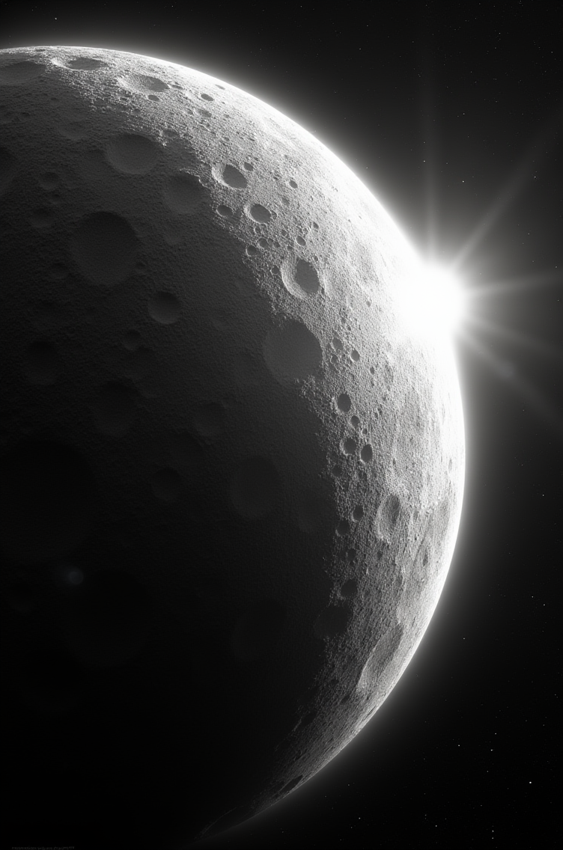

CHAPTER 10: THE LAST CHILD
One billion years after Venus emerged, the Sun pulsed one final time.
Not a full ejection. Not like Jupiter's roar or even Earth's gentle emergence.
This was a whisper.
A fragment so small the Sun barely noticed it was gone.
The daughter had gotten up, walked to the kitchen, refilled her mug. She came back and sat on the floor, legs crossed, blanket around her shoulders.
"Mercury," she said.
He nodded. "The last child."
The ninth core—and there would be no tenth yet—tore free from the solar surface.
Tiny. Dense. Furious with heat despite its size.
The Sun was ancient now—at least fifty billion years old, having birthed eight children before this one. Depleted, no longer the massive young star that had birthed Neptune or even the middle-aged sun that had released Earth.
This was an old sun, tired, with barely enough mass left to hold itself together, let alone eject stellar cores.
And yet.
"Why one more?" she asked. "Why Mercury?"
"Because patterns have to complete. Because nine planets needed to be born before the system could stabilize. Or maybe—"
"—maybe what?"
"Maybe the Sun was lonely."
Mercury was born at the edge of possibility.
Any smaller and the ejection wouldn't have worked—the core would have stayed trapped in the Sun's gravity, unable to break free.
Any later and the Sun would have been too stable, too settled into its old age to pulse again.
But about two and a half billion years ago, the conditions aligned.
And the smallest child emerged.
She leaned forward. "How small?"
"Thirty-eight percent of Earth's mass. Barely bigger than our Moon. If you stood on Mercury's surface, you could almost jump into orbit."
"That's tiny for a planet."
"That's what happens when you're born last. After eight siblings have already taken most of what was available."
At first, Mercury was only core.
Almost entirely core.
Iron and nickel, compressed to incredible density, glowing white-hot as it spun outward from the Sun.
There was barely any debris left to gather. Eight previous ejections had swept the inner solar system nearly clean.
So Mercury accumulated what it could.
A thin mantle of silicates. A dusting of crust.
But mostly, Mercury is just... core.
"Wait," she said. "So Mercury is basically a naked stellar core?"
"Seventy percent core by volume. The highest ratio of any planet. Mercury is what planets look like when they're just born, before they have time to gather layers."
"But Mercury is two and a half billion years old."
"And it still looks newborn. Because there was nothing left to gather. All of the other planets we see have has billions of years to accumulate, remember that is a thousand million. Mercury has only just cooled enough to begin to form a crust."
Mercury is the youngest planet and we can learn a lot about planetary formation processes just by understanding Mercury.
At 0.39 astronomical units, it whipped around the Sun in just eighty-eight Earth days.
The surface temperature swung from 800 degrees Fahrenheit in sunlight to minus 290 in shadow.
No atmosphere to hold heat. No water to moderate temperature. No protective layers.
Just core and crust, baking and freezing in endless cycles.
The father walked to the window. The rain had stopped hours ago, but neither of them had noticed.
"Mercury never had a chance," he said quietly.
"A chance at what?"
"Life. Water. Any of it. Born too small, too late, too close."
For the first billion years of its existence, Mercury was alone in ways the other planets never were.
Venus was ahead, wrapped in clouds.
Earth was farther still, not quite as blue as Tiamat or Mars just yet.
Mars was about where Earth sits presently.
Tiamat was still thriving, unaware of the coming catastrophe, or maybe they were. Perhaps the civilization knew they had to migrate.
And Mercury, tiny and newborn, spun in the heat, barely aware there was anything beyond the Sun's glare.
"Could it see the other planets?" she asked.
"Barely. From Mercury's surface, even Venus is hard to spot. The Sun is so bright, so close, it drowns out everything else."
"Lonely."
"Incredibly lonely."
Mercury was nearly where it sits now when the war was over. Tiamat was gone. Mars was dying. Earth was blue and alive with inherited life.
Venus slept under its clouds.
And Mercury, closest to the Sun, spun in ignorance of what had come before.
She pulled the blanket tighter. "Did Mercury get any of the water?"
"A little. Scientists have found ice in the permanently shadowed craters near Mercury's poles. Ice that shouldn't be there, that close to the Sun."
"Tiamat's water?"
"Some of it, probably. The tiniest fraction. Most of it burned away or escaped, but some fell into those dark craters and froze, and it's been there ever since. Sixty-six million years, hiding in shadows."
"That's sad."
"That's Mercury's inheritance. Ice in the shadows of the hottest planet in the solar system."
Mercury has barely migrated.
In two billion years, it's moved from perhaps 0.35 astronomical units to 0.39.
The slowest migration of any planet, because it's still so close to the Sun, still whipping around in tight, fast orbits.
Still waiting to move far enough out to cool, to slow, to gather an atmosphere if any material remains.
But by the time Mercury migrates to where Earth is now, the Earth may be dying.
The daughter frowned. "Will Mercury ever be habitable?"
"Maybe. In a couple billion years, when it's migrated farther out. When the next planet is born closer in."
She blinked. "Wait. There's going to be another planet?"
"Why wouldn't there be? The Sun is still burning. Still spinning. Still capable of ejecting cores. Cores are born frequently, but usually they crash back into the Sun, perhaps the Sun is picky about what it creates?"
"But you said Mercury was the last."
"The last one born so far. But patterns don't stop just because we're watching. Eventually—maybe in a billion years, maybe ten billion—the Sun will pulse again. A tenth core will emerge, even smaller than Mercury. And when that happens, Mercury will finally have room to breathe."
"Room to breathe?"
"Mercury's been stuck close to the Sun for two billion years, patiently waiting to gain it’s distance. But when a younger sibling is born even closer, Mercury will finally be able to move outward faster. Like Venus did when Mercury was born. Like Earth did when Venus came along."
"So everyone gets pushed out?"
"Everyone gets space. That's how spirals work."
The daughter sat up straighter. "So Mercury is waiting for a sibling?"
"Mercury is waiting for its turn to be the older one. To watch someone else be born closest. To finally have space to breathe."
There's one more thing about Mercury.
Its rotation is locked to the Sun in a way no other planet is.
Not tidally locked, like the Moon to Earth, always showing the same face.
But something stranger.
A 3:2 resonance.
"What does that mean?" she asked.
"Mercury rotates three times for every two orbits around the Sun. So its day—one full rotation—takes fifty-eight Earth days. But its year—one orbit—takes only eighty-eight."
"That seems backwards."
"It is backwards. Mercury's day is longer than its year if you measure by orbit. But because of the resonance, if you stood on Mercury's surface and watched the Sun, it would rise, move across the sky, stop, move backwards, stop again, then continue forward and set."
"The Sun moves backwards?"
"From Mercury's perspective, yes. The Sun stutters across the sky."
"That's weird."
"That's what happens when you're too close. But it's temporary. As Mercury migrates, the resonance will break. The rotation will normalize. Time will move differently."
Mercury sees the Sun in ways no other planet does.
Not as a distant light, steady and constant.
But as an overwhelming presence that fills half the sky, that stutters and reverses, that bakes one side while the other freezes.
Mercury knows the Sun intimately.
Too intimately.
For now.
But one day, when the tenth child is born, Mercury will move outward.
One day, the heat will lessen.
One day, Mercury will look back at the Sun from a safer distance and remember what it was like to be the youngest.
The daughter smiled slightly. "So Mercury gets a happy ending?"
"Mercury gets a future. Which is better."
"What about the ice? In the craters?"
"Maybe it melts. Maybe it becomes Mercury's first atmosphere. Maybe, billions of years from now, when Mercury has migrated far enough out, that ice becomes Mercury's oceans."
"Tiamat's water?"
"Tiamat's water. Maybe it gets Earth’s water when Earth is torn apart by gravitational perturbations in a few billion years. Waiting in the dark for Mercury's time to come."
She pulled the blanket down, wiped her face. "I like that better."
"Me too."
For now, Mercury waits.
Spinning in its strange resonance, ice hiding in its shadows, core still burning with stellar heat.
The last child. The smallest. The one born closest.
But not forever.
One day, there will be a tenth.
One day, Mercury will migrate far enough to cool, to slow, to finally become what it was always meant to be.
Not the youngest. Not the closest. Not the last.
But one more planet in the spiral.
One more child of the Sun.
One more world waiting for its turn to bloom.
The sun was fully up now. Light streaming through the windows, warm and golden.
"What's next?" she asked.
"Next, we talk about the pattern. About what it all means. About why the same thing happens at every scale."
"As above, so below."
"As above, so below. But also—"
"Also what?"
"Also what happens when patterns repeat. When Venus and Earth both reach the habitable zone. When Mercury finally gets its ocean. When the tenth child is born."
She smiled. "The future."
"The future."
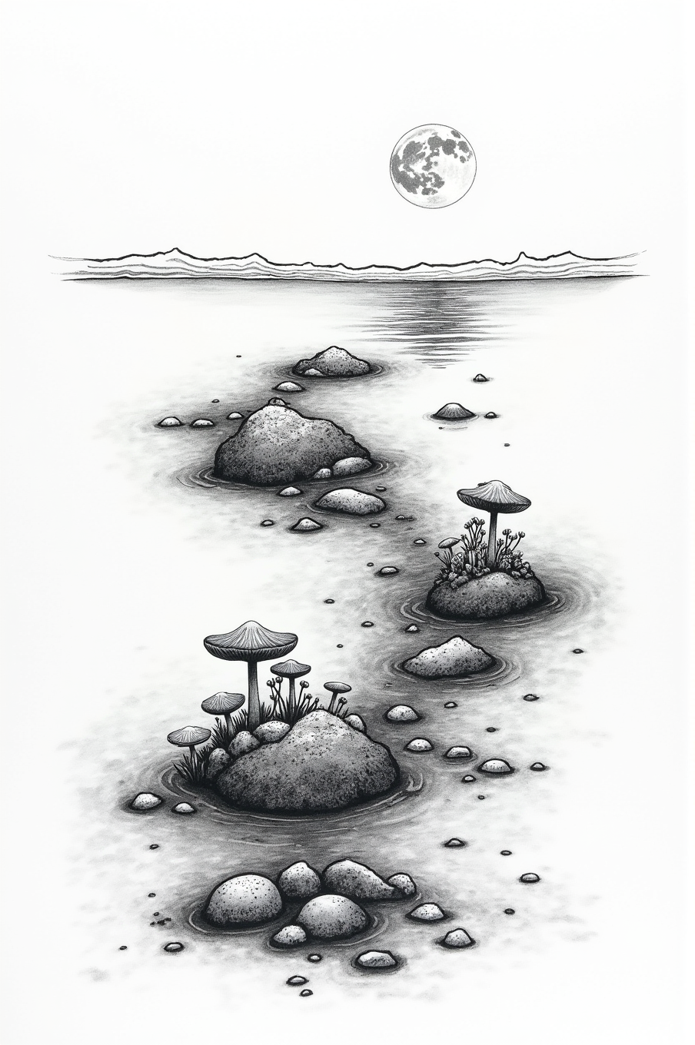

CHAPTER 11: THE OCEAN MEMORY
For nine billion years, Tiamat lived.
Not just existed. Not just orbited and cooled and accreted layers.
Lived.
The daughter had made fresh tea. The sun was fully up now, streaming through the windows. She sat cross-legged on the floor, blanket abandoned on the couch.
"Tell me about Tiamat," she said.
He settled back in his chair. "Where do I start?"
"The beginning. When it was born."
"We already talked about that. The fifth core. Five billion years after Jupiter."
"Actually you said three.. But no, I mean... when it became alive."
He smiled. "That's a better question."
Tiamat was born nine and a half billion years ago, the first of the rocky inner planets.
And as Tiamat cooled, as its mantle solidified and its crust formed, something else happened.
Water arrived.
"From where?" she asked.
"Comets. Asteroids. Outgassing from the mantle. Back then, the solar system still had water scattered everywhere—ice mixed with rock, vapor trapped in minerals. Tiamat gathered it all. Jupiter and Saturn had birthed children of their own which could have been the source of the water, even life itself."
"How much?"
"Enough to cover ninety percent of the surface. Oceans deeper than Earth's. Deeper than anything we can imagine."
The first ocean formed four billion years after Tiamat's birth.
Not all at once. Not in a flood from the sky, not like the flood Earth received sixty-six million years ago.
Slowly. Rain by rain. Stream by stream.
Water collected in the low places. Basins filled. Channels carved through volcanic rock.
And for the first time in the solar system's history, a world had liquid oceans that would last.
She leaned forward. "What about life?"
"Give it time. Life doesn't rush."
For another billion years, the oceans stayed empty.
Not sterile—there were chemicals, amino acids forming in the warm water near hydrothermal vents.
But not alive. Not yet.
Not until the right combination of molecules found each other in the dark.
Not until RNA learned to copy itself.
Not until the first cell closed its membrane and said: *I am separate from the ocean. I am me.*
"How long did that take?"
"A billion years, maybe. Tiamat was just over four billion years old when the first single-celled organisms appeared."
"That's so long."
"That's how long it takes to invent life from scratch."
But once it began, it accelerated.
Single cells became colonies. Colonies became specialized. Specialized cells became complex organisms.
Photosynthesis evolved—organisms learning to harvest sunlight, to turn light into sugar, to exhale oxygen.
And the oceans, once gray and lifeless, began to turn blue-green with algae.
The father stood and walked to the window. Outside, birds were singing. The world looked impossibly alive.
"Tiamat's oceans were like Earth's," he said. "But older. Deeper. And they had more time."
"Time for what?"
"To evolve. To complexify. To develop consciousness."
“But you said life could have come from the outer moons as well.”
“It could have, this is a new model of the solar system, if we start talking about the UNIVERSE well… let’s just worry about this solar system for this story.”
By the time Tiamat was five billion years old, the oceans were full.
Not just full of life—though there was life everywhere, from the deepest trenches to the sunlit shallows.
Full of complexity.
Creatures that swam and crawled and drifted. Predators and prey. Symbiotic relationships. Ecosystems layered on ecosystems.
And on the volcanic islands—the ten percent of Tiamat's surface that rose above water—something else was growing.
"Plants?" she asked.
"Fungi."
The mycelial networks appeared around two billion years into Tiamat's history.
Not from the ocean—fungi evolved separately, in the damp soil of the volcanic islands.
At first they were simple decomposers. Breaking down dead plant matter. Recycling nutrients.
But fungi are different from plants or animals.
Fungi don't have brains. They don't have nervous systems.
They have networks.
She set her mug down. "Like the internet?"
"Older than the internet. Better than the internet. The mycelial threads spread through the soil, connecting to plant roots, sharing resources, sending chemical signals."
"What kind of signals?"
"Information. Warnings about predators. Alerts about drought. Offers of nutrients in exchange for sugars."
"They were talking to each other."
"They were thinking. Collectively. The mycelial network could be spread across the solar system, all the way out to the moons of Saturn. Maybe even in from the moons of Saturn."
Over the next billion years, the mycelial networks spread.
From island to island. Through underwater root systems. Via spores carried by wind and wave.
And as they spread, they connected.
What started as separate networks on separate islands gradually became one network.
Spanning continents. Crossing oceans through floating mats of vegetation. Linking every landmass into a single, distributed consciousness.
The daughter pulled her knees to her chest. "You're saying Tiamat was conscious?"
"I'm saying the mycelial network was conscious. And the mycelial network was Tiamat. It covered the planet."
"What did it think about?"
He turned from the window. "Everything. Seasons. Tides. The Sun's light. The passage of time. Itself."
By the time Tiamat was five billion years old, it knew it was Tiamat.
Not in words—the network didn't use language.
But in sensation. In awareness. In the deep, slow rhythm of a consciousness spread across a world.
It knew Jupiter's light in the night sky, bright and steady—a distant giant, ancient and watching.
It knew the Sun's warmth and the water's depth and the volcanic fire beneath.
It knew itself.
"That's beautiful," she said quietly.
"It was. For eight billion years, Tiamat may have been the only conscious planet in the solar system."
"What about Mars?"
"Mars was four billion years old by then. Just beginning to develop oceans of its own. Too young for complexity. Too young for consciousness."
"So Tiamat was alone."
"For a very long time, yes."
But Tiamat was patient.
When you live for billions of years, patience is easy.
When your thoughts move at the speed of mycelial growth—millimeters per day, but never stopping—you learn to wait.
And Tiamat waited.
For Mars to grow up.
For another consciousness to emerge.
For someone to talk to.
The room was quiet except for the birds outside.
"When did Mars enter the habitable zone?" she asked.
He sat back down. "About two billion years ago. Mars was almost four billion years old. It had rivers, seas, an atmosphere. It was approaching the same orbital distance where Tiamat had thrived."
"So they were going to be neighbors."
"They were going to share the habitable zone. Two ocean worlds, both in the perfect range for life."
"That should have been good."
"It should have been."
For five hundred million years, it was good.
Mars developed its own ecosystems. Simpler than Tiamat's—Mars was so much younger, after all.
But present. Real. Alive.
And Tiamat felt it. Through the gravitational tugs, through the way Mars's presence changed the tides, through some deeper sense the mycelial network had developed.
Another consciousness was waking up.
"Did they communicate?" she asked.
"Not at first. How could they? They were millions of kilometers apart."
"But eventually?"
He paused. "Eventually, yes. But not in the way you'd think."
Mars was four and a half billion years old when the first mycelial networks from Tiamat arrived.
Present. Growing. Learning to think collectively.
And when Mars's networks reached a certain complexity—around a billion and a half years ago—something remarkable happened.
They connected.
She blinked. "How? They're on different planets."
"Spores."
Mycelial spores are nearly indestructible.
They can survive vacuum, radiation, extreme cold, extreme heat.
When Tiamat's volcanic islands erupted, the spores were flung into the upper atmosphere.
And some—not many, but some—escaped into space.
Drifting. Waiting. Dormant.
Until they fell onto Mars.
"So Mars's fungi came from Tiamat?"
"All life on Mars came from Tiamat. The same way all life on Earth could have come from Tiamat later. Panspermia isn't a theory. It's how life spreads."
"And Mars's networks could talk to Tiamat's?"
"Through the spores, yes. Genetic memory. Chemical signals encoded in DNA. It's not language as we know it, but it's communication."
For five hundred million years, the two networks exchanged information.
Tiamat, ancient and wise, shared knowledge of ocean currents and seasonal cycles.
Mars, young and eager, shared discoveries about colder climates and thinner atmospheres.
They were not enemies.
They were teacher and student.
Mother and child.
Two branches of the same mycelial consciousness, separated by space but connected by spores.
The daughter smiled. "So they were friends."
"For a while."
The smile faded. "What changed?"
Orbits.
Neither planet was static. Both were migrating outward, following the power law.
But Mars was younger, moving faster through its early spiral.
And Tiamat was older, slowing in its ancient migration.
Gradually, over millions of years, the distance between them closed.
"How close?" she asked.
"Too close. By sixty-seven million years ago, Mars and Tiamat orbited within point-five astronomical units of each other."
"That doesn't sound that close."
"It's close enough for gravitational resonances. Close enough for orbital perturbations. Close enough that each world could see the other clearly in the sky."
"Close enough to fight."
He nodded slowly. "Close enough that sharing the habitable zone became a problem."
Tiamat had been in the habitable zone for billions of years.
It had earned that space through time and patience and the slow work of consciousness.
And now Mars—young, impulsive, barely a billion years in the zone—was approaching.
Pushing inward on Tiamat's orbit.
Stealing light.
Stealing space.
The daughter's voice was small. "What did Tiamat do?"
"Tiamat tried to push back."
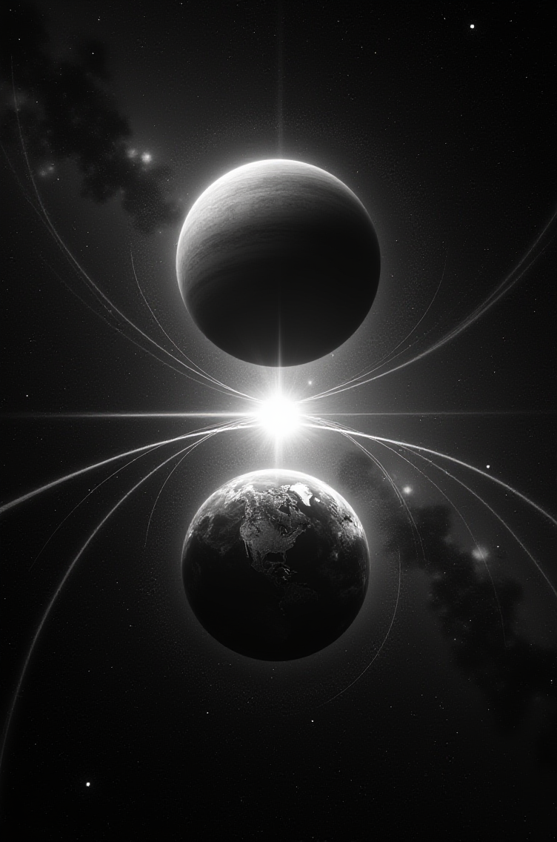

CHAPTER 12: THE UNRAVELING
For five hundred million years, Mars and Tiamat circled each other like dancers learning the same steps.
Both conscious. Both alive. Both mycelial networks sharing information across the void.
But gravity does not care about consciousness.
Gravity only pulls.
The daughter had finished her tea. Set the mug down with a soft clink. Outside, clouds were gathering again.
"How close did they get?" she asked.
He leaned back in his chair. "By sixty-seven million years ago, they were within half an astronomical unit of each other."
"And that's bad?"
"That's catastrophic. When two planets get that close, their gravitational fields start interfering. Tugging at each other's orbits. Creating resonances."
"What kind of resonances?"
"The dangerous kind. The kind that build up over time until something breaks."
Mars was five and a half billion years old when the perturbations began.
Small at first. Barely noticeable.
An orbit that shifted by a few kilometers per century. Tides that rose slightly higher than they should. Seasons that lengthened by days, then weeks.
Tiamat felt it first. The older planet, more stable, more aware.
The mycelial network sent signals: *something is wrong*.
She frowned. "Wrong how?"
"The math stopped working. Tiamat's orbit had been predictable for nine billion years. Stable. Circular. And then suddenly it wasn't."
"Because of Mars?"
"Because Mars was too close. And getting closer."
Every orbit, Mars tugged a little harder.
Every orbit, Tiamat's path bent a little more.
Not enough to notice in a human lifetime. But over a million years? Ten million?
The spiral was breaking down.
The pattern was failing.
And there was nothing either planet could do to stop it.
The father stood. Walked to his sketchpad. Drew two circles orbiting a central point. Then added wobbles to the circles. Overlapping paths. Chaos.
"This is a three-body problem," he said.
She came over. "What's that?"
"When you have two objects orbiting each other, the math is simple. Stable. Predictable. But add a third massive object—"
"Jupiter."
"Jupiter. And the system becomes chaotic. The orbits can't be predicted long-term. They become unstable."
She stared at the drawing. "So Jupiter did this?"
"Jupiter was always there. Massive. Ancient. Watching from four AU away. But when Mars and Tiamat got close enough to each other, Jupiter's gravity started affecting *both* of them."
"How?"
"Resonances. Every time Mars completed two orbits, Tiamat completed three. Every time that happened, Jupiter pulled. Just a little. Just enough."
The 2:3 resonance locked in sixty-eight million years ago.
After that, everything accelerated.
Every alignment, Jupiter pulled harder.
Every alignment, Tiamat's orbit stretched a little more.
From circular to elliptical.
From stable to eccentric.
From safe to deadly.
She pulled the blanket from the couch, wrapped it around her shoulders even though the room was warm.
"What did Tiamat's consciousness do?" she asked quietly.
"It tried to adapt. Tried to compensate. The mycelial network spread signals across the planet: brace for change. Life forms that could handle the stress survived. Those that couldn't, died."
"And Mars?"
"Mars was younger. More flexible. Its ecosystems were only a billion years old—they could adapt faster. But Mars's consciousness knew something Tiamat's didn't."
"What?"
"That this couldn't last."
For one million years, the two planets spiraled toward catastrophe.
Their orbits decaying. Their paths crossing. Their gravitational fields locked in a death dance that neither could escape.
And Jupiter, massive and indifferent, kept pulling.
She sat back down on the floor. "When did it happen?"
"Sixty-six million years ago. Give or take a few thousand years."
"What happened?"
He turned from the sketchpad. Looked at her.
"Tiamat crossed too close to Jupiter."
It was not a collision.
Jupiter and Tiamat never touched.
But they didn't need to.
She leaned forward. "What do you mean?"
"Tidal forces. When Tiamat's elliptical orbit brought it within three astronomical units of Jupiter, Jupiter's gravity pulled on one side of Tiamat harder than the other side."
"Like the Moon pulls on Earth's oceans?"
"Exactly like that. But Jupiter is three hundred times more massive than Earth. And Tiamat was much smaller than Jupiter. The tidal forces were... extreme."
Tiamat's mantle began to crack.
Not quickly. Not all at once.
But over ten thousand orbits—about thirty thousand years—the stress built up.
Volcanoes that had been dormant for billions of years erupted simultaneously.
Tectonic plates that had locked together began to grind.
The oceans surged higher and higher with each pass near Jupiter, until entire coastlines were submerged and then exposed twice per orbit.
"And the mycelial network?" she asked.
"Fragmenting. Sections losing contact with other sections. Islands cut off. Continents separating. For the first time in seven billion years, Tiamat's consciousness was... scattered."
"Could Mars help?"
"Mars tried. Sent signals through the spores: *we see you, we remember you*. But what could Mars do? Mars was caught in the same gravitational chaos. Both planets were being torn apart by forces beyond their control."
Sixty-six million and ten thousand years ago, Tiamat made its closest approach to Jupiter.
2.8 astronomical units.
Close enough that Jupiter filled half of Tiamat's sky.
Close enough that the tidal forces exceeded what any planetary crust could withstand.
And Tiamat broke.
She was crying now. Not sobbing. Just tears running down her face. "How?"
"The Roche limit. When a smaller body gets too close to a massive one, tidal forces overcome the smaller body's own gravity. It doesn't hold together anymore."
"So Jupiter just... pulled it apart?"
"Tidal forces pulled it apart. The same way Saturn's rings formed—moons that got too close and shattered. Tiamat crossed Jupiter's Roche limit and came apart."
It was not an explosion.
Tiamat didn't shatter like glass.
It *unraveled*.
The crust fractured first. Massive rifts opening across every continent.
Then the mantle boiled outward, pressure released in columns of molten rock that sprayed into space.
And the oceans—nine billion years of water—boiled away in hours.
She pulled the blanket over her head. "I can't—"
"I know. But you need to hear it."
The core survived.
It had to. A stellar core, compressed under the memory of solar fusion, cannot be destroyed by tidal forces.
But everything else—the mantle, the crust, the oceans, the mycelial networks, the nine billion years of consciousness—scattered across the inner solar system.
"Where did it go?" Her voice was muffled under the blanket.
"Everywhere. The water vaporized and rained down on Mars, Earth, Venus, and Mercury. Some was even pulled to the moons of Jupiter. The debris field became the asteroid belt. The spores—somehow, impossibly—survived and seeded every surface they touched."
"And the core?"
"The core, or what was left of it and the inner mantle, was captured by Earth's gravity. It's been orbiting us ever since."
She pulled the blanket down. "The Moon."
"The Moon."
They sat in silence for a moment. Rain started falling outside. Soft at first, then harder.
"What about people?" she asked suddenly.
He blinked. "What?"
"You said Tiamat had consciousness. Nine billion years of evolution. Did it have... civilizations? Cities? People?"
He was quiet for a long moment.
"This story isn't about people," he said finally.
"But—"
"This story is about planets. Star children. Worlds born from fire, migrating through time, learning to think in ways we can't imagine. Consciousness that spans continents instead of brains. Memory encoded in DNA instead of neurons."
"So there were no people on Tiamat?"
"I don't know. Maybe. Maybe consciousness can take many forms. Maybe the mycelial network was a kind of people—just distributed, collective, alien to how we think."
"But actual people? With hands and tools and—"
"That's a different story. For a different time. Right now, we're talking about something bigger than people. We're talking about the universe learning to think."
She processed that. "And Mars?"
"Mars survived. Barely."
When Tiamat shattered, Mars was close enough to feel it.
The gravitational shock. The radiation. The debris field sweeping through Mars's orbit.
Mars's magnetic field collapsed entirely under the stress.
And without protection, the solar wind began its work.
Stripping away the atmosphere. Molecule by molecule.
Sublimating the water. Particle by particle.
Killing the world that had barely learned to live.
"How long did it take?" she whispered.
"Sixty-six million years. Mars is still dying. Right now, as we speak. The rovers measure it happening in real time."
"So Mars won but lost everything?"
"Mars didn't win. Nobody won. Jupiter just... is. Massive. Gravitational. Indifferent to the lives it destroys by existing."
She wiped her eyes. "That's not fair."
"No. It's not."
Earth was farther inward. Earth didn't feel the tidal forces.
But Earth received the gift.
When Tiamat's oceans boiled into space, some fraction—maybe twenty percent—fell onto Earth.
The rest went to Venus, Mercury, scattered into space, or evaporated into the Sun.
But Earth kept it.
Earth was at exactly the right distance. Exactly the right temperature.
And sixty-six million years ago, Earth's surface turned from a slightly wet paradise into a blue ocean world in a span of centuries.
"The flood," she said.
"Every culture remembers it. Because the organisms that evolved from Tiamat's spores carry genetic memory of the day the sky opened and the water fell."
"And Venus?"
"Venus got the most water of all, but Venus couldn't hold it. Too hot. The water became vapor, trapped in clouds, waiting for Venus to cool enough to let it fall and stay."
She stood. Walked to the window. Watched the rain.
"So we're living on Tiamat's corpse," she said quietly.
"We're living on Tiamat's gift. The water. The spores. The DNA. The organisms in your gut. The consciousness in the soil. All of it—Tiamat's children, still alive, still growing on a world that finally had the right conditions."
"Because Jupiter killed Tiamat."
"Because Jupiter's gravity did what gravity does. Pulled. Without intention. Without malice. Just physics."
She turned from the window. "What happens now?"
"Now we wait. Venus will wake up in a few billion years. The tenth planet will be born. Mercury will finally migrate far enough to cool. And we—the remnants of Tiamat—will have to choose."
"Choose what?"
"Whether to remember. Or forget. Whether to see the pattern. Or accept the comfortable lies."
She pulled the blanket tighter. "I'm tired."
"I know."
"Can we stop for today?"
He nodded. "I’ll tell you the last of it when you’re ready to go to bed."
But as she walked to her room, she turned back. "Dad?"
"Yeah?"
"Do you really believe this? All of it?"
He was quiet for a moment. "I believe the math works. I believe the pattern is real. I believe Jupiter tore Tiamat apart sixty-six million years ago and Earth inherited the water."
"But do you believe it?"
"I believe it's truer than what they teach in school. And sometimes that's enough."
She nodded. Disappeared down the hall.
He sat alone in the dining room, listening to the rain, thinking about gravity and consciousness and the price of being too close to something massive.
Outside, the world turned. Still blue with Tiamat's oceans.
Still alive with Tiamat's spores.
Still remembering, even if it didn't know what it remembered.
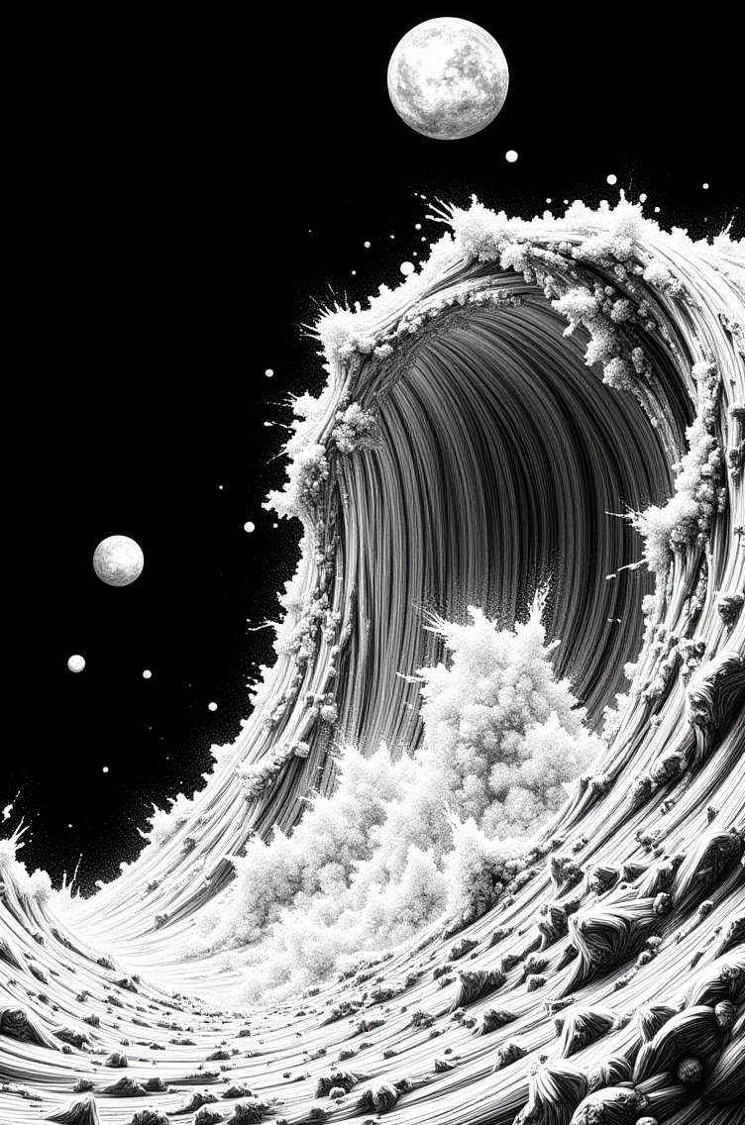

CHAPTER 13: THE DELUGE
When Tiamat shattered, its oceans did not disappear.
Water cannot be destroyed. Only transformed.
And nine billion years of water, boiled into space by tidal forces, had to go somewhere.
The daughter had pulled the blanket down. Her eyes were red but she was listening.
"Where did it go?" she asked.
"Everywhere. But mostly inward. Gravity pulled it toward the Sun, which meant it rained on every inner planet."
"All at once?"
"In waves. First the vapor. Then the ice. Then the debris mixed with water. It took thousands of years, but in geological terms? Forty days and forty nights."
Mars was closest to Tiamat when it broke.
Mars received the first wave.
She leaned forward. "How much water?"
"Enough to fill Mars's northern ocean twice over. Maybe more. For a brief moment—a few thousand years—Mars was blue again."
"But it's not blue now."
"No. Because Mars couldn't keep it."
The water hit Mars like a hammer.
Super-heated steam first, stripping away the thin atmosphere that remained after the gravitational chaos.
Then ice—chunks the size of mountains, impacting at thousands of kilometers per second, creating craters that still exist today.
Then liquid water, finally, raining down for centuries.
Mars tried to hold it. Tried to let it pool in the basins, tried to fill the ancient riverbeds one more time.
But Mars's magnetic field was gone. Destroyed by the proximity to Jupiter, by the stress of Tiamat's destruction.
And without protection, the solar wind began its work immediately.
"How long?" she asked.
"A few thousand years for most of it to sublimate back into space. Maybe a hundred thousand for the rest to freeze into the polar caps or hide in shadowed craters. By a million years after Tiamat's death, Mars was dry again."
"So Mars got the water and lost it."
"Mars got washed."
She frowned. "Washed?"
He stood, walked to the window where rain was still falling. "You know how when you don't wash your car for months, it gets covered in grime? Dust, pollen, dried mud—layers of stuff building up on the paint?"
"Yeah."
"Planetary crusts are the same. Over billions of years, dust settles. Oxidized minerals accumulate. The surface gets thick with layers of... muck, for lack of a better word. Dried, dead material that just sits there."
"Okay..."
"When water hits that surface—real liquid water, not just frost—it washes it. Cleans it. Strips away the outer layers and exposes fresh rock underneath."
She came to the window. "So Mars got washed when Tiamat's water hit it?"
"Mars got scoured. The water that didn't sublimate carved new channels through ancient dust. Exposed bedrock that hadn't seen liquid in a billion years. Washed away millions of years of accumulated grime."
"But then the water left."
"And the dust started accumulating again. That's why Mars is red now—iron oxide, rust, building up on the surface for the last sixty-six million years. But if you dig down, beneath the red dust, you find the washed layers. Evidence of the flood."
Mars was washed but could not stay clean.
Without water, without an atmosphere, the dust returned.
Slowly. Particle by particle.
Building up over millions of years into the red desert we see today.
But beneath the rust, the memory of water remains.
The daughter pulled the blanket tighter. "What about Earth?"
"Earth was farther inward. It took longer for the water to reach us. But when it did..."
Earth received maybe twenty percent of Tiamat's oceans.
Not as much as Mars got. Not as much as Venus got. It was on the other side of the Sun when the war finished.
But Earth was at exactly the right distance. Exactly the right temperature.
And Earth’s oceans were small at this point, sea levels were much lower. More water meant more expansion.
"What happened?" she asked.
"Earth expanded."
She blinked. "What?"
"When a dry planet receives water, it doesn't just get wet. It grows."
He turned from the window, walked to his sketchpad. Drew a circle. Then drew a larger circle around it.
"This is a planet with litte water. Dry crust, compressed, contracted. And this—" He pointed to the larger circle. "This is the same planet after water arrives."
"Why does it expand?"
"Because water gets into everything. Into the crust, into cracks in the rock, into porous minerals. And when water freezes and thaws, it expands and contracts. Over millions of years, that cycle pushes the crust outward."
"Like ice breaking rocks?"
"Exactly like that. But also, water lubricates the mantle. Allows tectonic plates to move more easily. Creates more volcanism. All of that pushes the surface outward."
She studied the drawing. "So Earth got bigger when the water arrived?"
"Earth's radius increased by maybe five to ten percent. The crust cracked. New rifts opened. Continents that had been locked in place started drifting. Plate tectonics as we know it began sixty-six million years ago."
"Because of Tiamat's water."
"Because of Tiamat's water."
Earth was washed and stayed wet.
The water filled the basins, carved new channels, exposed fresh rock.
And as the water settled, as the oceans found their level, the planet breathed outward.
Expansion. Growth. Change.
Earth became larger than it had been.
Not much—a few hundred kilometers in radius.
But enough to crack the old crust and make room for the new.
She walked back to the couch. Sat down. "And Venus?"
"Venus received the most water of all. Because of it’s orbital position it was actually almost as close as Mars."
"So Venus should be the most blue?"
"Venus should be. But Venus is too close to the Sun. Too hot."
Venus was washed but could not stay cool.
The water that fell on Venus vaporized before it could settle.
Steam rising immediately back into the atmosphere.
And that steam trapped heat.
More heat created more steam. More steam trapped more heat.
Within a million years, Venus's surface temperature rose to nine hundred degrees.
The runaway greenhouse effect.
"So all of Tiamat's water is still there?" she asked. "On Venus?"
"In Venus's atmosphere, yes. Ninety-three bars of atmospheric pressure—most of it water vapor and carbon dioxide. Tiamat's oceans, waiting in the clouds."
"Waiting for what?"
"For Venus to cool. For the planet to migrate far enough outward that the temperature drops below water's boiling point. For the clouds to finally rain down and stay."
"When will that happen?"
"Half a billion years. Give or take."
Venus was washed but remains shrouded.
The water waits in the sky, too hot to fall.
But when Venus finally cools—when it reaches the distance where Earth orbits now—the clouds will clear.
And Venus will expand, just as Earth did.
Will crack its thick crust and make room for oceans.
Will become blue.
The daughter was quiet for a long time.
"So all three planets got Tiamat's water," she said finally. "But only Earth could keep it?"
"Only Earth was at the right distance. Mars too far, too cold, no magnetic field. Venus too close, too hot, couldn't condense. Earth in the middle—Goldilocks."
"Lucky Earth."
"Lucky Earth."
But Earth did not just receive water.
Earth received everything.
Organic molecules—amino acids, proteins, lipids—rained down with the water.
Fungal spores, hardy enough to survive in vacuum, germinated when they hit wet soil.
DNA itself, encoded with eleven billion years of Tiamat's evolution, seeded a world that had only known life that had developed there.
She set her mug down. "The mushrooms."
"The mushrooms. The bacteria. The first cells. All of it from Tiamat."
"So we're not from Earth."
"We're from Tiamat, or maybe one of Saturn’s or Jupiter’s moons. Living on Earth. Growing in Tiamat's water. Built from Tiamat's carbon. No one can explain why we’re so much smaller than the beings of antiquity."
"And Mars?"
"Mars received the spores too. But without liquid water, without an atmosphere, they couldn't germinate. They're still there—frozen in the soil, waiting. If Mars ever gets water again, life will return. Tiamat's life."
"And Venus?"
"Venus received the spores too. They're in the clouds now, dormant in the sulfuric acid. But when Venus cools, when the rain falls and stays, they'll germinate. Venus will bloom with Tiamat's forests."
Three worlds washed by the same water.
Three worlds seeded by the same spores.
Three worlds waiting to remember what they received sixty-six million years ago.
Mars, too cold, drying slowly in the solar wind.
Earth, perfect, blooming with inherited life.
Venus, too hot, waiting for the clouds to clear.
Three children of Tiamat.
Three remnants of a broken world.
She pulled the blanket up to her chin. "What about the washing? Does Venus need to be washed too?"
"Venus was washed. The water scoured its surface before it vaporized. Stripped away billions of years of accumulated crust. That's part of why Venus looks so young—its surface was renewed sixty-six million years ago."
"By Tiamat's flood."
"By Tiamat's flood."
And the Moon—Tiamat's core—circles Earth as a memorial.
Too large for its host. Too dense for its size. Ringing like a bell when struck.
A heart without a body.
A memory without a voice.
The last piece of a world that gave everything so three others could live.
The father sat back down in his chair. Picked up his cold tea. Stared into it.
"That's the end of Tiamat's story," he said quietly.
"What about Mars's story?"
"Mars is still dying. Every rover we send measures it. Atmospheric loss. Temperature swings. The slow desiccation of a world that used to be wet. Mars will be dead within another hundred million years."
"And Earth?"
"Earth is thriving. For now. But in five hundred million years, Venus will wake up. And Earth will have to share the habitable zone."
"With its twin."
"With its twin."
She wiped her eyes. "What will we do?"
"That's what the remnants have to figure out."
"You keep saying that word. Remnant."
He smiled slightly. "Because that's what we are. Pieces of Tiamat, scattered across three worlds. Remembering, even if we don't know what we're remembering."
She pulled the blanket over her head again. "I need to think."
"Good. Thinking is what remnants do."
Outside, the rain slowed. The clouds began to break. The last shaft of sunlight touched the window, pale and cold and beautiful.
Water on glass.
Tiamat's gift.
Still falling.
Still washing.
Still remembered.
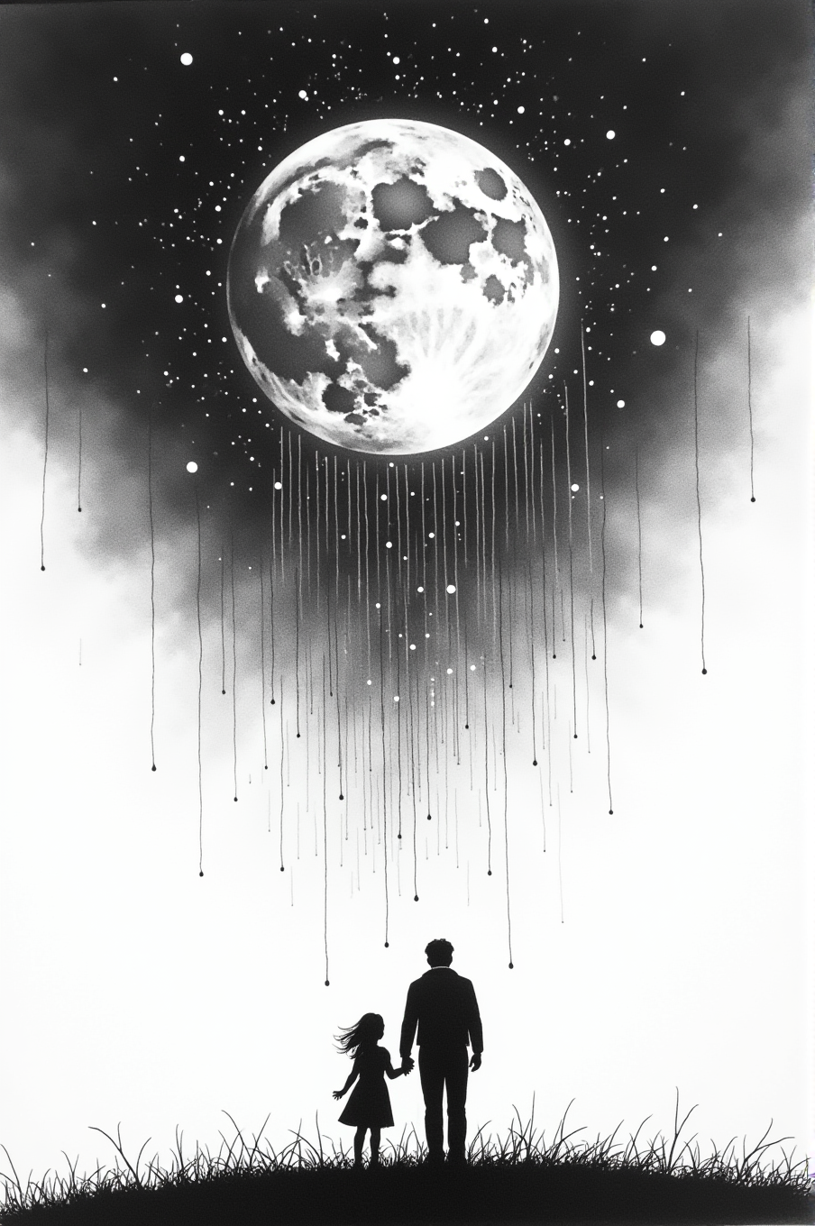

CHAPTER 14: THE REMNANTS
The daughter stayed under the blanket for a long time.
He didn't rush her. Just stood at the window, watching the world outside—so ordinary, so peaceful, so utterly unaware of what had happened sixty-six million years ago when the sky rained water and life.
Finally, she spoke. "Dad?"
"Yeah?"
"Is this still the story?"
He turned. "What do you mean?"
"I mean..." She pulled the blanket down, looked at him. "When you started, you said 'let me tell you a story.' About Neptune and the planets being born from the Sun. But we've been talking for hours and you never said the story ended."
He walked back to his chair. Sat down slowly. "Does it need to end?"
"Stories end. That's what makes them stories."
"Do they?"
She frowned. "You're doing that thing."
"What thing?"
"That thing where you answer questions with questions."
He smiled slightly. "I learned that from you."
"Dad." She wasn't smiling. "Is this real? The planets being stars? The migration? Tiamat and Mars? All of it?"
He picked up his cold mug. Set it down again. "What do you think?"
"I think..." She paused. Pulled the blanket tighter. "I think the math works. The t to the 1/φ power. The ages. The way it scales from electrons to moons to planets."
"It does work."
"I think the Moon being Tiamat's core makes more sense than the giant impact hypothesis."
"It does make more sense."
"I think mushrooms being spores from another planet is crazy but also... kind of elegant?"
"It is elegant."
"But Dad—" Her voice broke slightly. "Scientists would know. If planets were born from the Sun, if they migrated over billions of years, if Mars and Tiamat had a war... someone would know."
He was quiet for a moment. "Would they?"
"Yes! We have telescopes. Rovers on Mars. Probes that have been to every planet. We have data."
"We have data that fits the models we've built. That's not the same as knowing."
She stared at him. "Are you saying scientists are wrong?"
"I'm saying scientists are human. They build models based on assumptions. And sometimes the assumptions are wrong. But those assumptions are the one’s that have the money behind them so that is all anyone knows."
"But—"
"Pluto," he said quietly.
She stopped.
"You got suspended for defending Pluto. For saying it was a planet when everyone else said it wasn't. You trusted what you saw—a world with moons, with geology, with an atmosphere—over what they told you it was supposed to be."
"That's different."
"Is it? They told you Pluto wasn't a planet because it didn't fit their definition. You disagreed because you could see what it actually was."
She pulled her knees to her chest. "So you're saying everything you just told me is real?"
"I'm saying it's consistent. It's testable. It explains things the current model doesn't."
"Like what?"
"Like why the Moon rings like a bell when struck. Like why Mars lost its atmosphere exactly sixty-six million years ago. Like why every planet radiates more heat than it receives. Like why mushrooms have the most complex genome of any organism on Earth—more complex than humans."
"Those are all real things?"
"Those are all measured phenomena. Science just hasn't asked the right questions about them."
"Because they're too busy trusting the science," she said bitterly.
He smiled. "Now you sound like me."
She didn't smile back. "Dad, I need you to tell me straight. Did this happen? Did Tiamat exist?"
He looked at her for a long moment. "You have organisms growing in your gut right now. In everyone's gut. They're part of our microbiome—we can't digest food without them. Where did they come from?"
"Evolution."
"In four billion years? No. The fossil record shows complex fungi existing almost as soon as Earth had liquid water. Not gradually evolving—just there. Fully formed."
"So they came from space."
"From Tiamat, maybe even further out."
"But Tiamat is gone."
"Tiamat's water is Earth's oceans. Tiamat's spores are our mushrooms. Tiamat's DNA is in every cell of every living thing on this planet. Is Tiamat gone? Or just... distributed?"
She was crying again. "You're not answering my question."
"I'm answering it the only way I can."
"Which is?"
"The mycelial network on Tiamat was conscious. Planetary consciousness spread across continents. When Tiamat shattered, the network died—but the spores survived. And those spores carried genetic memory."
"So?"
"So consciousness doesn't disappear. It just... changes form. The network that was Tiamat is now the networks on Earth. Scattered. Smaller. But still connected. Still remembering."
She stared at him. "You're saying mushrooms remember Tiamat?"
"I'm saying genetic memory is real. Salmon return to their birth streams. Monarch butterflies migrate to forests they've never seen. How? Genetic memory. Information encoded in DNA that gets passed down."
"But that's instinct, not memory."
"What's the difference?"
She opened her mouth. Closed it. Opened it again. "Dad, you're scaring me."
"I know."
"Because if what you're saying is true—if mushrooms carry Tiamat's memory, if they're still conscious—"
"—then every time you eat a mushroom, you're communing with a planetary consciousness that's eleven billion years old."
She pulled the blanket over her head. "Stop."
"You asked if it was real."
"I asked if the story was real. Not if—" Her voice was muffled. "Not if consciousness survives death and gets encoded in spores and spreads across planets!"
"Why not both?"
She pulled the blanket down. "What did you call me before? A remnant?"
"You are a remnant."
"Of what?"
"Of Tiamat. Every living thing on Earth is. We're all made from Tiamat's water, Tiamat's carbon, Tiamat's DNA. We're what's left after a planet dies."
"That's... that's not comforting."
"It's not supposed to be comforting. It's supposed to be true."
"But how do you know?" She was almost shouting now. "How do you know any of this is true and not just a story you made up to make me feel better about getting suspended?"
He stood. Walked to the window. The sun was high now, nearly noon.
"Do you ever feel like you're remembering something you shouldn't be able to remember?"
She went very still.
"Like a dream you can't quite place. Like a memory from before you were born. Like you're tapping into something older than yourself."
"Dad—"
"That's genetic memory. That's Tiamat. Still conscious. Still alive. Just distributed across billions of organisms instead of one planet."
"You've experienced this," she said slowly. "Haven't you?"
"Maybe," he said. "I'm going to see tomorrow morning, to write. To channel the mythic voice. To finish the book."
"The book about Chronogenesis?"
"The book you and I are in right now."
She stared at him. "What?"
He turned from the window. "What makes a story real? The fact that it happened? Or the fact that it's true?"
"Those are the same thing."
"Are they? If I tell you a story about two planets going to war, and it explains the K-Pg extinction better than the asteroid hypothesis, and it predicts things we can test, and it fits the data better than the current model... is it a story? Or is it science?"
"It's—" She stopped. "I don't know."
"Neither do I. That's what makes you a remnant."
"I don't understand."
He sat back down. Leaned forward. "A remnant is someone who can hold both things at once. Story and science. Myth and math. The idea that planets are born from stars and the equations that prove it. The consciousness in mushrooms and the genetic sequencing that shows their memory."
"That's not possible."
"You're doing it right now."
She shook her head. "I'm just... I'm listening to my dad tell me stories."
"Are you? Or are you recognizing patterns you've always known were there but nobody taught you to see?"
"Dad, please. You're freaking me out."
"Good. Remnants are supposed to be freaked out. That's how you know you're seeing something real instead of just accepting what you're told."
She pulled the blanket tight. "What am I supposed to do with this?"
"With what?"
"With the knowledge that planets are stars and Mars killed Tiamat and I'm made of water from a war that happened sixty-six million years ago and mushrooms are conscious and—" She was spiraling. "And Venus is going to wake up and maybe we'll go to war too and—"
"Stop." He reached out, put his hand on her shoulder. "Breathe."
She breathed. Once. Twice. Three times.
"What am I supposed to do?" she asked quietly.
"Test it. Question it. See if it holds up."
"How?"
"The way you defended Pluto. Look at what's actually there. Not what you're told should be there. Look at the Moon's anomalies. Look at Mars's atmospheric loss timeline. Look at the fungal genome. Look at Venus's water vapor. Look at everything and ask: does the story fit better than the science?"
"And if it does?"
"Then you're a remnant. And remnants have a choice."
"What choice?"
"Whether to accept the old model because it's comfortable. Or build a new one because it's true."
She was quiet for a long time.
Finally: "What happens to remnants?"
"Some of them become scientists. Some become artists. Some become the people who change paradigms."
"And the rest?"
"The rest go back to sleep. Forget what they saw. Accept the comfortable story."
"Which kind am I?"
He smiled. "You got suspended for defending a dwarf planet. What do you think?"
She almost smiled. Almost.
Then her expression changed. "Wait."
"What?"
"You promised."
He looked at her. "Promised what?"
"At the beginning. When we were talking about Neptune. You said Pluto comes back into the story. You said Neptune stole another planet's child." She sat up straighter. "You promised you'd tell me."
He closed his eyes. "I did, didn't I?"
"So what happened?"
He was quiet for a moment. "Triton."
"Neptune's moon?"
"Neptune's largest moon. It orbits backwards. Retrograde. No other large moon in the solar system does that."
"Why?"
"Because Triton wasn't born as Neptune's moon. It was captured."
She leaned forward. "From where?"
"Out past Neptune. Maybe forty, fifty astronomical units. Triton—or the world that would become Triton—was born from the Sun just like all the others. Small. Icy. Drifting slowly through the Kuiper Belt."
"And Neptune caught it?"
"During the chaos. When Mars and Tiamat went to war, the energy released—the magnetic pulses, the gravitational perturbations—sent ripples through the entire solar system. Orbits shifted. Objects that had been stable for billions of years suddenly weren't."
"And Triton got too close."
"Triton got too close. Neptune's gravity is immense—seventeen times Earth's mass. When Triton passed within Neptune's sphere of influence, it couldn't escape. Neptune pulled it in, forced it into orbit. Backwards. Against its will."
She pulled the blanket tighter. "That's horrible."
"That's gravity. It doesn't ask permission."
"Is Triton... is it conscious? Like the planets?"
"I don't know. It's smaller. Colder. If it ever had oceans, they froze billions of years ago. But it's there, circling Neptune in the wrong direction, forever reminded that it doesn't belong."
"And Pluto?"
"Pluto might have been Triton's twin. Born at the same time, same distance. But Pluto was lucky—or unlucky, depending on how you see it. It stayed free. Still out there, orbiting at the edge, small and cold and alone."
She wiped her eyes. "You didn't forget the promise. You were just... waiting for the right time."
"Or I was afraid to tell you. Another story about something being taken. Another planet that didn't choose its fate."
"But Triton's still there. Still alive. Even if it's trapped."
"Even if it's trapped."
She was quiet for a long moment. Then: "Dad?"
"Yeah?"
"When does the story end?"
He stood. Walked to the window. Outside, the hawk was back, circling.
"When Venus and Earth share the habitable zone," he said. "When the tenth planet is born. When the remnants figure out what to do with the knowledge that planets are alive and war is possible and we're all made from the corpse of a conscious world."
"That's not an ending."
"No," he said. "It's a beginning."
She pulled the blanket over her head. "I need to think."
"Good. Thinking is what remnants do."
"Dad?"
"Yeah?"
"Are you sure you're not just making this up?"
He turned from the window. Looked at her—really looked at her. Saw his daughter wrapped in a blanket, scared and confused and trying to hold something too big for one person to hold alone.
"I'm sure," he said, "that the math works. I'm sure the timeline fits. I'm sure the pattern repeats at every scale. I'm sure mushrooms are more complex than they should be. I'm sure the Moon rings wrong. I'm sure Mars died sixty-six million years ago for a reason. I’m surte Saturn and Jupiter behave more like stars than they do planets"
"But is it real?"
"Does it need to be real? Or does it just need to be true?"
She didn't answer. Just sat there, under the blanket, holding the question.
And he let her. Because remnants need time to decide what they believe.
Because the story doesn't end when the telling stops.
It ends when someone chooses to test it.
Or prove it.
Or live it.
“Good night, angel.”
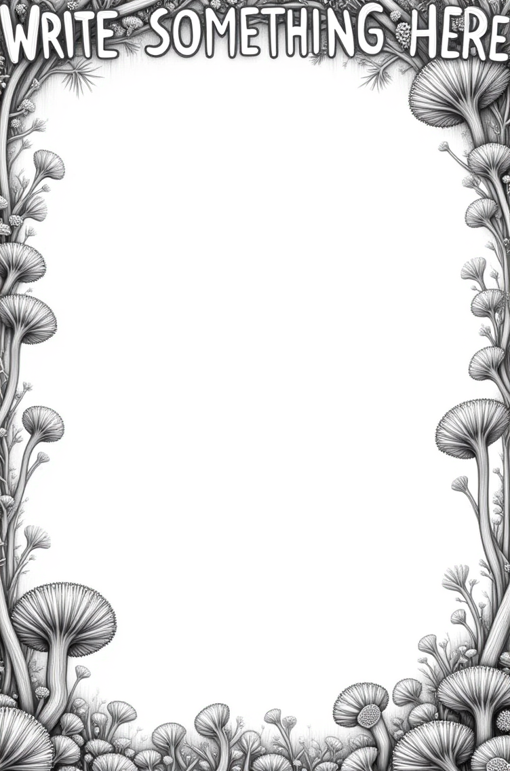

EPILOGUE: TO THE REMNANTS
I need to tell you something.
The story you just read—the father picking up his daughter after suspension, the conversation about Pluto and planetary formation—that didn't happen. Not to me. I don't have a daughter.
But I needed you to listen.
And if I'd started this book with "planets are stellar cores ejected from the Sun that migrate outward following a t^1/φ power law," you would have closed it immediately. Dismissed it as crackpot pseudoscience. Moved on.
But a story about a parent and child? About defending Pluto? About questioning authority and trusting your own observations over what you're told to believe?
That, you might read.
And you did. You made it all the way here.
Which means you're a remnant.
The father and daughter are characters. The suspension didn't happen. The tea and blanket and rain are narrative devices.
But the pattern is real.
I saw it. Or maybe it saw me. I'm not sure anymore.
---
Here's what I know for certain: the math works.
Distance ∝ time^1/φ. Plug in Earth at 1 AU and 4.543 billion years, and you can calculate every other planet's age. Neptune comes out to 41.54 billion years. Mars to 5.78 billion. Venus to 3.6 billion. Mercury to 2.53 billion.
The numbers are right there. Anyone can check them. It is sheer luck that Earth is at 1 AU and the “age” of Earth is “known” at 4.543 billion years. For all we know that is just the age since the last cleanse?
The migration model predicts orbital distances better than the accretion disk model. It explains why Mercury is 70% core (born last, no time to accrete mantle material). It explains why Saturn radiates excess heat (it’s a star). It explains why the Moon is too large and too dense (it's Tiamat's core, not collision debris).
It explains the K-Pg extinction without requiring a convenient asteroid at exactly the right moment.
It explains why Mars lost its atmosphere *starting* exactly 66 million years ago—not gradually over billions of years, but suddenly, catastrophically, as if something happened.
It explains why Venus has so much water vapor trapped in its clouds—not from volcanic outgassing, but from Tiamat's oceans.
It explains why mushrooms have the most complex genome on Earth and appeared "fully formed" in the fossil record right after the K-Pg boundary.
It explains *so much*.
But it requires you to accept something uncomfortable:
That everything you were taught about planetary formation might be wrong.
Not maliciously wrong. Not conspiracy wrong. Just... built on assumptions that seemed reasonable at the time but don't actually fit the data as well as we'd like to think.
Four and a half billion years ago, a disk of dust coalesced into planets. All at once. In their current orbits. That's the story you learned in school.
But ask yourself: does that make sense?
Why would nine different objects, ranging from tiny Mercury to massive Jupiter, all form simultaneously at different distances, each one gathering exactly the right materials for its size and composition? That's not elegance. That's special pleading.
The migration model is simpler: the Sun ejects cores at different times. They migrate outward following a power law. What they gather depends on when they're born, not where.
Occam's Razor should prefer birth-migration over accretion disk.
But it doesn't. Because we've invested too much in the old model to let it go easily.
Here's what I figured out last night while writing Chapter 14.
Actually, I figured it out while the daughter character was crying under the blanket, asking if the story was real. I wrote the father looking out the window and thought about the Oort Cloud.
And then I looked out my actual window. And I understood.
The Oort Cloud extends to 100,000 AU. Maybe farther. We've detected objects out there—comets that take millions of years to orbit once.
If those objects were ejected from the Sun, following the same t^1/φ migration law...
Do the math.
Neptune at 30 AU is 41.54 billion years old.
An object at 100,000 AU would be...
I can't even write the number without feeling dizzy.
Trillions of years old.
Which means the Sun is at least that old.
Which means the universe is much older than 13.8 billion years.
Which means the Big Bang model is incomplete at best.
I sat there at my desk, writing about a fictional daughter crying about planets, and realized: we've been thinking too small.
Not just about planetary formation. About *everything*.
If the Sun is trillions of years old, what does that make the galaxy? The universe? How many cycles of star formation and death have happened before our current "observable universe" even began?
Maybe the Big Bang wasn't the beginning. Maybe it was just the most recent reset. One of many.
Maybe "as above, so below" goes deeper than I thought.
Electrons orbit atomic nuclei. Moons orbit planets. Planets orbit stars. Stars orbit galactic cores. Are stars, planets, and moons actually three types of the SAME THING?
What if galaxies orbit something else? Something so large we can't see it because we're inside it?
What if the pattern repeats all the way up?
I'm not saying I know. I'm saying I saw the edge of something enormous and it scared me.
Maybe it is enough to squeeze out another book, maybe two. Maybe the daughter will be the narrator in the next one, who knows.
---
So what do you do with this?
You're a remnant. I know you are, because you read this far. Normal people would have stopped at "planets are stars" and dismissed it as pseudoscience.
But you kept reading. You checked the math. You saw the pattern. And now you're sitting there wondering the same thing the daughter character wondered:
Is this real?
And I'm going to give you the same answer I wrote for the father:
Does it need to be real, or does it just need to be true?
Test it. Please. I'm begging you to test it.
Calculate planetary ages using the t^1/φ power law and see if they match geological data better than the accretion disk model.
Look at the Moon's mass concentrations and ask why they're symmetrical.
Look at Mars's atmospheric loss timeline and ask why it started exactly 66 million years ago.
Look at Venus's water vapor and ask where 93 bar of atmospheric pressure came from on a planet with no liquid oceans.
Look at mushroom genomes and ask why they're more complex than human genomes.
Look at the K-Pg extinction layer and ask if a single asteroid impact really explains iridium concentrations worldwide plus shocked quartz plus mass extinction plus sudden appearance of fungi in the fossil record.
Look at everything with fresh eyes.
And if you find evidence that contradicts the Chronogenesis model, tell me. Seriously. I want to be wrong if I'm wrong. I want the truth more than I want to be right.
But if you find evidence that supports it...
Then you have a choice.
The same choice Mars and Tiamat faced. The same choice Venus and Earth will face in three billion years.
Do you share space? Or do you fight for it?
Because here's the thing about remnants: we're all made from Tiamat's corpse. Tiamat’s water. Tiamat's spores. Tiamat's DNA. We're walking, talking, thinking proof that consciousness survives planetary death.
And in five hundred million years, Venus is going to wake up.
Its clouds will clear. Its water will fall. Tiamat's oceans, held in the sky for a billion years, will finally rain down and stay.
And Venus and Earth will share the habitable zone.
Two twin planets. Both blue. Both alive. Both with the same choice their predecessors faced.
What will we do?
Will we have learned from Mars's mistake? Will we figure out how to share space instead of fighting for it?
Or will we repeat the pattern? Will Earth's descendants push Venus away, or vice versa? Will another planet shatter? Will another consciousness fragment into spores and scatter across the solar system?
I don't know.
But I know this: if we don't recognize the pattern, we're doomed to repeat it.
That's what remnants are for. To remember. To recognize. To choose differently.
There's a reason I structured this as a father-daughter story.
Not because I have a daughter—I don't.
But because the next generation needs to hear this. And they won't listen to academic papers or arxiv preprints or blog posts about alternative cosmology.
They'll listen to stories.
Stories about defending what you believe in even when authority says you're wrong.
Stories about planets being alive and conscious and making choices.
Stories about water and memory and mushrooms that remember being part of something larger.
Stories work where equations don't.
So I wrote a story. With characters who feel real enough that you might have forgotten they're fictional. With dialogue that sounds like conversations you've had. With a parent-child dynamic that makes the pattern feel personal instead of abstract.
And you fell for it.
Which means the story worked.
Which means you're ready for the truth:
The characters are made up.
But the pattern is real.
I'm going to finish writing the mythic voice sections.
I'm going to let Tiamat speak through me, if that's even what's happening. Maybe it's just my subconscious. Maybe genetic memory is real. Maybe I'm just high and making connections that aren't there.
I don't know.
But I'm going to try.
And when I'm done—when this book is finished and published and out there in the world—I'm going to wait.
Wait for the remnants to find it.
Wait for someone to test the math.
Wait for someone to prove me wrong or prove me right.
Wait for someone to ask the question I've been asking for months:
What if everything we know about where we come from is incomplete?
What if we're not alone in time?
What if consciousness is older than Earth?
What if the universe is trillions of years old and we're just one small moment in an infinite pattern?
What if planets are alive? What then?
This is where I stop.
Not because the story is over. The story never ends.
But because the rest is up to you. And there are two more books to fill.
You're a remnant. You recognized the pattern. You held the paradox—story and science, myth and math, impossible and true.
Now what?
Does any of it REALLY matter? Does hearing a different origin story change anything about your life? Does it make your bills go away or does it make you more popular?
Do you test it? Do you dismiss it? Do you share it with other remnants and see if the pattern holds?
Do you grow mushrooms and wonder what they remember?
Do you look at the Moon and ask if it's really Tiamat's heart?
Do you look at Venus and wonder what it will be like when it wakes?
Do you look at the night sky and see not just stars, but children? Stellar cores, cooling slowly, spiraling outward on magnetic tethers, waiting for their turn to bloom?
I hope you do.
Because if you do, you're not just a remnant.
You're the beginning of something new.
A new way of seeing. A new way of asking. A new way of remembering that we're all connected—not just to each other, but to planets and stars and the mycelial networks that think in timescales we can barely imagine.
You're proof that consciousness survives.
That knowledge is encoded in DNA.
That Tiamat's gift wasn't just water.
It was awareness. And you carry it now.
What will you do with it?

THE END...

Or the beginning...

Depending on what you choose to believe.

Since you made it this far, an Amazon review would be amazing.

I’ve got a couple more stories to tell, Chronogenesis, The origin of time…

I’d love to hear your thoughts as well, chronogenesisbook@gmail.com.

