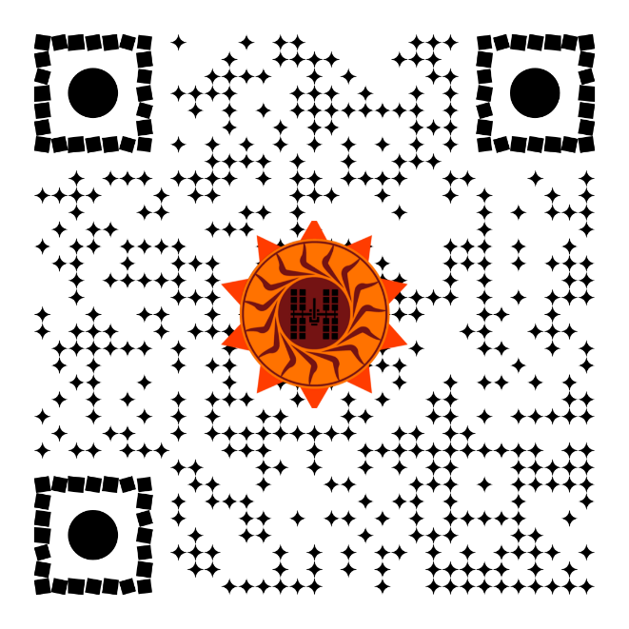 | 20 8 18 5 5 5 9 7 8 20 16 15 9 14 20 15 14 5 19 5 3 15 14 4 19 14 15 18 20 8
6 15 21 18 6 15 21 18 4 5 7 18 5 5 19 26 5 18 15 20 8 18 5 5 13 9 14 21 20 5 19 | 15 14 5 20 23 15 15 14 5 4 5 7 18 5 5 19 15 14 5 19 9 24 13 9 14 21 20 5 19
ALPHA KEY:  BASS | ©
CHARLIE KEY:  COFFEE | BRAVO KEY:  BRIDGE
6 9 22 5 14 9 14 5 16 15 9 14 20 5 9 7 8 20 19 5 3 15 14 4 19 23 5 19 20

