ANSWER

Ver 0.1 | 2 September 2015
Ver 0.2 | 15 December 2015

Andrew Brown

1. Introduction

2. Usage
2.1 Circuit description
2.1.1 Parameter set definition
2.1.2 Devices
2.1.3 Sources
2.1.4 Clocks
2.1.5 Stop time
2.1.6 Comments
2.1.7 Sinks
2.2 Output
2.2.1 Text files
2.2.2 Graphical output
2.3 Device models

3. Internals
3.1 Overall structure
3.2 ANSWER Classes
3.2.1 Main function
3.2.2 Ans_t
3.2.3 Device_t
3.2.4 Circuit_t
3.2.5 Events
3.2.6 Drawpix_t
3.3 Library classes
3.3.1 pdigraph
3.3.2 EvPump
3.3.3 Lex
3.3.4 Rand
3.3.5 FileName
3.3.6 Flat routines
3.4 Error handling

Change log

Ver 0.1 | 2 September 2015 | Original
Ver 0.2 | 15 December 2015 | Introduced sink device

1. Introduction
ANSWER (Another Neural Simulator Without Extensive Reality) is a naive event-based discrete simulator, supplied with built-in models to support the simulation of networks of leaky-integrate-and-fire neurons. Without any tuning, V0.1 is capable of a throughput of over 170000 events/s. The system as it stands is not intended for a naive user; it is intended as a base design to be developed further as necessary at the source code level.
The source language is ANSI C++98, using std::stl extensively but no language extensions. Gnuplot 4.6 is used for the graphical output, which is currently a simple .jpg file.
ANSWER is intended to be a point tool in a much larger software system. As such, the interfaces and I/O will require significant further development. V0.1 is just a starting point, and it hasn't been tested - there will be bugs. This documentation should be read in conjunction with the source, and the documentation for the library classes supplied.

2. Usage
ANSWER takes two ASCII text files as command line arguments. The first describes the topology of the network to be simulated, the parameters of the neural models and a small number of control parameters. The second (optional) file (the monitor file) contains a list of devices in the circuit that are to be monitored (i.e. the output histories written). If the monitor file is omitted, all the device histories from the circuit are saved. As disk I/O is still a relatively slow process, this can take quite a while for large circuits, and some care should be taken in choosing what to save and what to discard. The output consists of time histories (in the form of ASCII files suitable for direct input to Gnuplot), and a .jpg file showing the event queue occupancy as a passage of both simulated and wallclock time. Although this is informative, the graphical output is included mainly to demonstrate how Gnuplot can be driven remotely from an external process. (I have tried to use the Gnuplot Windows API described in the documentation, but with zero success.) On execution, ANSWER will produce something similar to the text box above.
ANSWER simulator V0.1
(32-bit version)

[Prologue ...
Circuit_t::Parsing stuff.cct
15 devices to be monitored in stuff.mon
... prologue done in 1250 wall ms]

[Simulation ...
Event pump stop code 3 (Asynchronous stop request issued)
... simulation done in 1750 wall ms]

[Epilogue ...
--> rmdir stuff /s /q
--> mkdir stuff
Simulation [0:8.175000e-03] sim secs
Events:
Total 2877 ( 1.64e+03 /wall secs)
MaxQ 1025
Clock 145 ( 8.29e+01 /wall secs)
Source 1
Neuron 2731 ( 1.56e+03 /wall secs)
GnuPlot stuff complete
... epilogue done in 5141 wall ms]

ANSWER v0.1 closing down ...
Smite any key to go
Execution is conventional, and consists of three phases: Prologue, simulation and epilogue.
Prologue (here 1.25 wallclock seconds) is concerned with parsing the input files, and building and initialising the datastuctures. It should be approximately proportional to the number of devices in the circuit.
Simulation (here 1.75 wallclock seconds) is the time spent in the event pump, and will dominate the overall execution time for circuits of any significant size.
Epilogue (here 5.141 wallclock seconds) is the time taken to read the internal data histories and write them to disk.

2.1 Circuit description
The circuit is described as a vertex-on-vertex graph: each device (neuron) is declared along with a connection set (defining the network topology) and a parameter set (defining the static parameters of the device). The expectation is that many devices will share the same parameters (and not the same connectivity), so a level of indirection is provided: each device definition has exactly one parameter set name associated with it; the parameter set is expanded by a subsequent parameter set declaration.
The V0.1 circuit description consists of a set of records; the box below contains 'one of everything'.
device1 param d1 d2 ... // Device definition
device2 param d1 d2 ... // Device definition
> source paramS d1 d2 ... // Source definition
* clk paramC // Clock definition
== 76 // Simulated time limit
! param p1 p2 ... // Model definition
The description is a (trivial) LR grammar, with the first token of each record defining the record type (and hence structure). The set of device definitions defines the directed circuit graph; no hierarchy is supported.

2.1.1 Parameter set definition
A record beginning with the token "!" defines an ordered set of parameter values. In the example above, !param p1 p2 describes a parameter set called param, containing two parameters, values p1 and p2.

2.1.2 Devices
A record beginning with a string is assumed to represent a device definition. This is followed by the name of the parameter set defining the device parameters, and the unordered set of (target) devices which the (source) device drives. A simple circuit and the associated defining text is shown in figure 1. Here, all four devices (A, B, C and D) have the same parameter set (here named param_1). When the circuit is built, parameters value p_23 p_76 and p_x will be associated with all four devices. Note it is necessary to define device D, even though it drives nothing, because the definition provides the anchor for invoking the device parameters.
A
Figure 1: Simple circuit
D
C
B
A param_1 B C D
B param_1 C
C param_1 D C B
D param_1
!param_1 p_23 p_76 p_x
Devices have internal state, but respond only to external excitation (which may come from themselves - as with device C in figure 1).
Two neuron models are currently provided; both are leaky-integrate-and-fire, they differ only when the internal state of the device is updated.
Type 1: Circuits containing devices of this type expect the existence of a clock. The internal state (the integrand and the refractory timer) is updated every clock tick AND every time an excitation (spike) arrives.
Figure 2: Neuron model parameters
Out
Threshold
In
S
Refractory
Output height
Fire delay
Leak rate (%/t)
Refractory period
Type 2: The internal states of these neuron are only updated when a spike arrives; there is no clock. The advantage of this model is speed - the state is only changed (updated) if it is going to be read. The disadvantage is that the time history does not show intermediate values of refractory timer or decaying integrand.
Neuron models have six parameters associated with them; their relationship is shown in figure 2.

Neuron parameter | Meaning
0 | Model type
1 | Height of output pulse
2 | Internal firing threshold
3 | Refractory period
4 | Integral leak rate (%/t - giving an exponential decay with time)
5 | Firing delay

2.1.3 Sources
A record beginning with the token ">" defines an independent source, although there is nothing to stop the user defining the source to accept input. Sources are treated differently to devices within the simulator; there is an implied feedback loop from output back to the device so that every time a source event is popped from the event queue, the next event can be generated by the source and inserted into the queue. A source needs to be explicitly connected to the devices it is expected to drive.
One type of independent source is provided with ANSWER 0.1: it can be configured to provide bursts of spikes.
Figure 3: Signal source parameters
N major
N minor
Output height
T minor
T major
Start delay
Source parameter | Meaning
0 | Height of output pulse
1 | Start delay
2 | T minor - spike spacing within bursts
3 | N minor - number of spikes within a burst
4 | T major - spacing between the beginnings of bursts
5 | N major - number of bursts

The degenerate case of a single spike at time t can be obtained by setting the start delay to t, and N major and N minor to 1.

2.1.4 Clocks
A record beginning with the token "*" defines a named clock. All clocks are implicitly connected to all devices that are not sources or other clocks; they are implicitly connected to themselves.
Figure 4: Clock parameters
Output height
Tick
Start delay
Clock parameter | Meaning
0 | Start delay
1 | Tick - spacing between events

2.1.5 Stop time
A record beginning with the token "==" defines a simulated time stop time. The event queue allows a number of circumstances to stop it. Including this record allows the user to dictate the maximum simulated time for the simulation run. (The run will terminate prematurely if the event queue becomes empty - i.e. there is nothing left to do.)

2.1.6 Comments
The token "//" delineates the beginning of a comment in the circuit input file; everything between "//" and EOR is ignored by ANSWER.

2.1.7 Sinks
A record beginning with the token "<" defines a sink device. The device has only two parameters:

Sink parameter | Meaning
0 | Internal firing threshold
1 | Integral leak rate (%/t - giving an exponential decay with time)

From the perspective of input, it looks like a conventional neuron; it has a threshold and a decay rate. The distinction is that when the device 'fires' it does not emit a spike, it simply stops the simulation.

2.2 Output
Output is currently provided through two routes: ASCII files (written into a subdirectory created under the location of the simulator) and a jpg file (written into the same directory as the simulator).

2.2.1 Text files
Text files are intended for input to GnuPlot, not human inspection. Currently, associated with every monitored neuron is a file of the form:
..which gives the time histories of the neuron output, the internal integrand, and the time left of any refractory period.

Output files (time histories) associated with clock devices (!pclk 1.000000e-03 0.00005) yield the rather uninteresting
# SOURCE stuff\s1_stuff.ans
# Time Pulse Minor count Major count
2.700000e+01 2.200000e+00 0 0
2.900000e+01 2.200000e+00 1 0
3.100000e+01 2.200000e+00 2 0
3.300000e+01 2.200000e+00 3 0
3.800000e+01 2.200000e+00 0 1
4.000000e+01 2.200000e+00 1 1
4.200000e+01 2.200000e+00 2 1
4.400000e+01 2.200000e+00 3 1
And for sources (!ps 2.2 27.0 2.0 4 11.0 2):
# CLOCK stuff\clk_stuff.ans
# Time Pulse
1.000000e-03 1.000000e+00
1.050000e-03 1.000000e+00
1.100000e-03 1.000000e+00
1.150000e-03 1.000000e+00
1.200000e-03 1.000000e+00
1.250000e-03 1.000000e+00
1.300000e-03 1.000000e+00
Displaying this with GnuPlot (plot "s1_test2.ans" u 1:2 w impulses lw 4, "" u 1:3 w steps,"" u 1:4 w steps) gives
# NEURON stuff\d2729_stuff.ans
# Time Pulse Integrand Refractory
6.450000e-03 0.000000e+00 0.000000e+00 0.000000e+00
6.500000e-03 0.000000e+00 0.000000e+00 0.000000e+00
6.500000e-03 0.000000e+00 4.000000e+00 0.000000e+00
6.500000e-03 0.000000e+00 2.000000e+00 0.000000e+00
6.550000e-03 0.000000e+00 0.000000e+00 9.500000e-04
6.600000e-03 0.000000e+00 0.000000e+00 9.000000e-04
6.650000e-03 0.000000e+00 0.000000e+00 8.500000e-04
6.700000e-03 0.000000e+00 0.000000e+00 8.000000e-04
6.750000e-03 0.000000e+00 0.000000e+00 7.500000e-04
6.800000e-03 0.000000e+00 0.000000e+00 7.000000e-04
6.850000e-03 0.000000e+00 0.000000e+00 6.500000e-04
6.900000e-03 0.000000e+00 0.000000e+00 6.000000e-04
6.950000e-03 0.000000e+00 0.000000e+00 5.500000e-04
7.000000e-03 0.000000e+00 0.000000e+00 5.000000e-04
7.000000e-03 2.000000e+00 6.000000e+00 1.000000e-03
7.050000e-03 0.000000e+00 0.000000e+00 4.500000e-04
7.100000e-03 0.000000e+00 0.000000e+00 4.000000e-04
7.150000e-03 0.000000e+00 0.000000e+00 3.500000e-04
7.200000e-03 0.000000e+00 0.000000e+00 3.000000e-04
7.250000e-03 0.000000e+00 0.000000e+00 2.500000e-04
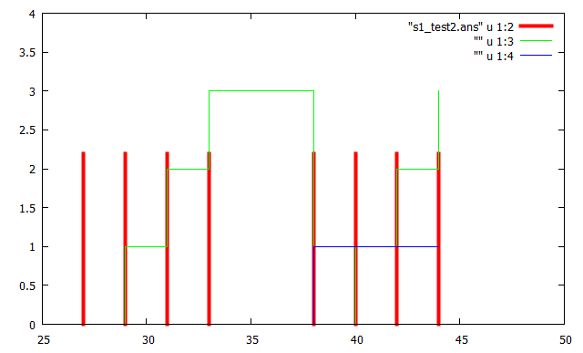
Figure 5: Source internal state variables

where the red bars are the output spikes, and the blue and green stepped lines are the internal state counters of the source.

2.2.2 Graphical output
The graphical output is intended more as an extended example of how to connect GnuPlot to a program than anything else. It will clearly (have to) change as the functionality of ANSWER evolves.

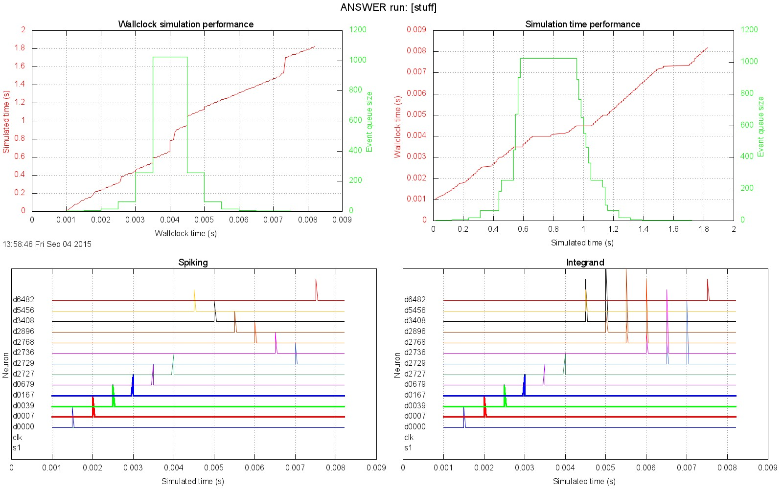
Figure 6: Interfacing to GnuPlot

2.3 Device models

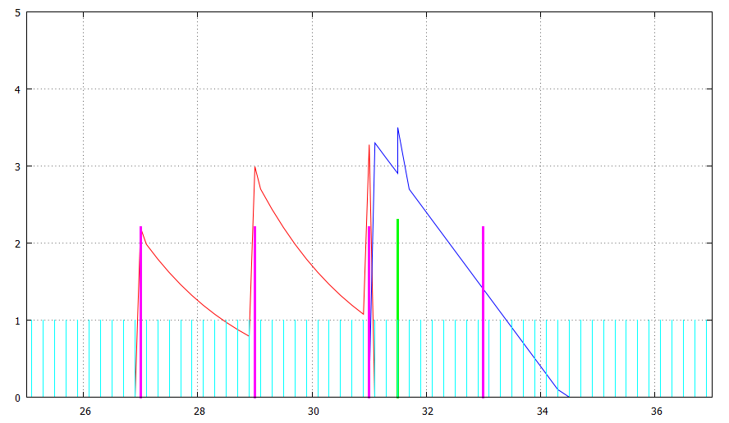
The type 1 model passes timestamped neural events between devices, and also allows the passage of time to be continuously modelled by a ubiquitous clock, generating clock tick events (figure 7). This means the decay of the integrand and the passage of the refractory timer can be modelled and observed continuously, but obviously increases the traffic through the event pump.
dA p1 dB
dB p1 dC
dC p1
>s1 ps dA
*clk pclk
!p1 1 2.3 3.0 4.0 0.6 0.5
!ps 2.2 27.0 2.0 4 11.0 2
!pclk 0.1 0.2
== 67
S1
A
B
C
clk
!pclk 0.1 0.2
!ps 2.2 27.0 2.0 4 11.0 2
!p1 1 2.3 3.0 4.0 0.6 0.5

Figure 7: Type 1 neuron internal state variables

Figure 7 was produced with the GnuPlot script

set xrange [25:37]
set yrange [0:5]
plot "da_test2.ans" u 1:3 w lines, "" u 1:2 w impulses lw 3, \
"" u 1:4 w lines, "s1_test2.ans" u 1:2 w impulses lw 3, \
"clk_test2.ans" u 1:2 w impulses

Type 2 models
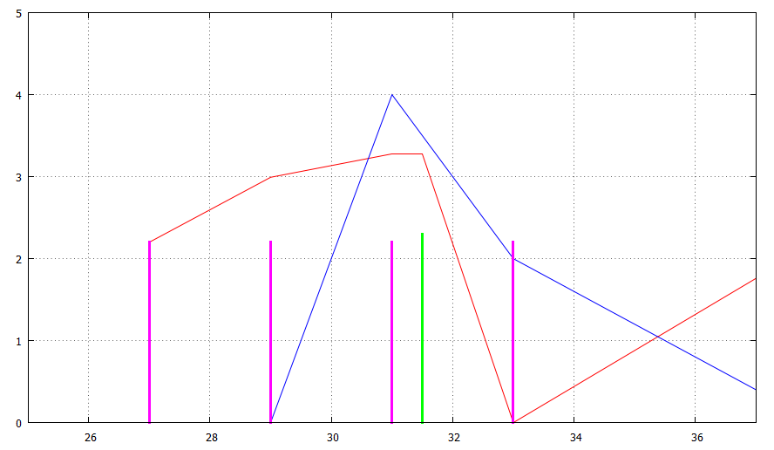
dA p1 dB
dB p1 dC
dC p1
>s1 ps dA
!p1 2 2.3 3.0 4.0 0.6 0.5
!ps 2.2 27.0 2.0 4 11.0 2
== 67
Internal state variables updated on signal arrival
S1
A
B
C
Figure 8: Type 2 neuron models
Figure 8 shows the output generated by the same circuit; the only difference is the type of the model and the absence of clock. The internal state variables are only updated on arrival of an event (either from another neuron or a source), so the only time the values coincide with the type 1 model is the points at which (biological) events occur. The traces of the internal variables are less intuitive than those generated by type 1, but the interneuron traffic (cyan and green impulses in the figures) remains the same, and the wallclock simulation time is concomitantly faster.

Figure 9 shows the canonical ring oscillator: the neuron parameters are such that a single pulse from the source is enough to set the ring oscillating.

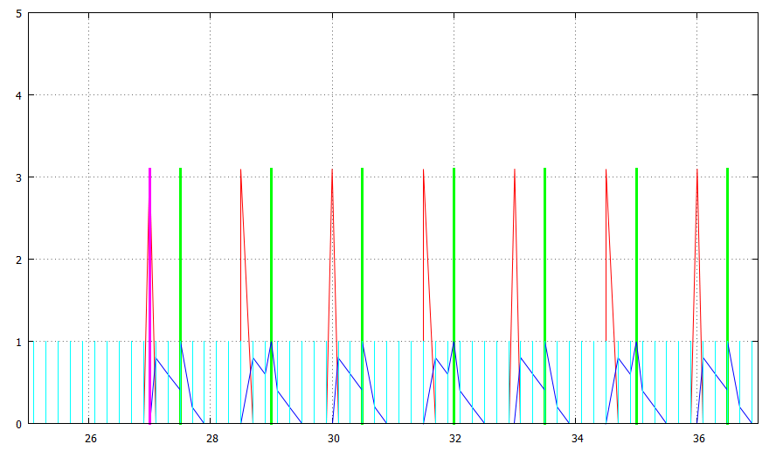
dA p1 dB
dB p1 dC
dC p1 dA
>s1 ps dA
*clk pclk
!p1 1 3.1 3.0 1.5 0.6 0.5
!ps 3.1 27.0 2.0 1 11.0 1
!pclk 0.1 0.2
== 67

Figure 9: Type 1 ring oscillator
S1
A
B
C
clk
3. Internals
This document is designed to be read in conjunction with the ANSWER V0.1 source; obviously it will go out of date very quickly as the system is developed.

3.1 Overall structure
The overall system is shown in figure 5. The discrete circuit is held as a digraph, holding devices. Device_t is a base class from which neuron, source and clock devices are derived. Events are generated and pumped round the system by an event pump object.
Time histories associated with each device are stored locally within the device as they are generated, and a further history is generated and stored in Ans_t, recording the behaviour of the event pump and the simulated/wallclock time relationship. These datastructures are written to persistent storage in the epilogue.

3.2 ANSWER Classes
The entry point of ANSWER is in file AnsMain1.cpp. This must be compiled and linked with other files as below:
File | Description
AnsMain1.cpp - no header |  | ANSWER entry point
Ans_t.cpp / Ans_t.h |  | Main event loop control
Device_t.cpp / Device_t.h |  | Device base class and derived models
Circuit_t.cpp / Circuit_t.h |  | Circuit topology
Event_t.cpp / Event_t.h |  | Derived event classes
Drawpix_t.cpp / Drawpix_t.h |  | Interface to Gnuplot
Lex.cpp / Lex.h |  | Stream tokeniser (library class)
Flat.cpp / Flat.h |  | Miscellaneous utilities (library unit)
Rand.cpp / Rand.h |  | Random number generator (library class)
FileName.cpp / FileName.h |  | Filename processor (library class)
Pdigraph.hpp / Pdigraph.tpp |  | Digraph template
EvPump.hpp /EvPump.tpp |  | Event pump template
E.h |  | Trivial exception class; there is no corresponding .cpp file
macros.h |  | stl container walking macros

Note the two templated classes are #included as .hpp files (and from there .tpp files) where necessary and are not separate compilation units.

3.2.1 Main function
The main function does nothing but invoke the simulator proper (instantiated as an Ans_t constructor) and catch any exceptions thrown.

3.2.2 Ans_t
The constructor of Ans_t realises figure 5. Other methods are responsible for parsing the monitor list file (if present, the names of the devices to be monitored are stored in vector<string> vMon), instantiating the event pump template (EvPump<EvTime_t> * pEv) and the circuit under simulation (Circuit_t Cct), and priming the event pump queue. (This last action - Device_t::virtual Event_t * Get1() - involves walking the device list in Cct, and pulling the first independent event from every source and clock device found there.) An advantage of encapsulating the simulator as a class is that it can be invoked as a point tool by incorporating it into other programs, rather than having to invoke it from the system level.

3.2.3 Device_t
The Device_t files hold the definition of the device base class (Device_t) and three classes derived from it: C_neuron, C_source and C_clock. (C_link and C_pin are currently there just to keep pdigraph happy, but C_pin is the natural place to put a synapse model.)

Device_t is an abstract base, and holds data common to all three derived classes: the device name, the parameter set name, a back-pointer to the circuit object, and two callbacks for pdigraph to be able to dump the circuit sensibly.
Device_t::Elaborate() is virtual; each derived class uses their own instance to extract the parameter values (held as strings in Circuit_t::map<string,vector<string> > params) into the appropriate numeric values in each device instance. (The key of params is the parameter set name, the data is the vector of parameters themselves, held as strings.)
Device_t::OnImpulse(Event_t *), Device_t::OnTick(Event_t *) and Device_t::OutAns(string) are all virtual, and never used in the base class.

3.2.4 Circuit_t
Most of this class is devoted to parsing the input files and creating the circuit (pdigraph<string,Device_t *,string,Device_t *,string,C_pin *> G) and the parameter bank (map<string,vector<string> > params).
Parse(string) oversees the parsing process, and ParseClock(), ParseNeuron(Lex::tokdat), ParseParams(), ParseSource() and ParseStop() handle the individual record types described in the previous sections.
ChkInteg() performs an integrity check on the constructed circuit graph. Currently the only test implemented is to ensure that every neuron referenced by another neuron is also defined somewhere. (Whenever a new neuron name is encountered, whether as a source or target, it is entered into the circuit graph. Neurons that are never declared will have blank parameter strings).

OutAns(vector<string> & vMon) walks the results store in each device and dumps it to a file in the scratch subdirectory (modulated by the monitor list handed in as argument).
EvPump
Figure 9: ANSWER coarse structure
Events inserted arbitrarily
decoder callback

event
Head of queue popped
Decoder callback directs (and duplicates if necessary) events to the target component(s)
Device_t
Device_t
Device_t
C_neuron
C_source
C_clock
pdigraph<string,Device_t *,
string,Device_t *,
string,C_pin *> G
eDecoder(...) -
flat function defined in file Ans_t.cpp
3.2.5 Events
Event_t is derived from BASE_EVENT; it is used for all events (clock, source and neuron sourced in ANSWER. The only extra field it possesses is the spike height. (Yes, this could have been accessed via the .tag field in BASE_EVENT, which points back to the originating device, but this is marginally faster and lays the foundations for more complex events to be constructed.)

3.2.6 Drawpix_t
Drawpix_t might as well have been a flat function - all the functionality lies in the constructor and there are no methods. However, as ever, this makes making it much more complicated much easier.
In essence, the code creates a file with the same base as the circuit, extension ".gpc". (GnuPlot Control). This contains the necessary GnuPlot commands to create a .jpg file. At the end of the Drawpix_t constructor,

string sss = "call D:\\Apps\\GnuPlot\\gnuplot\\bin\\gnuplot.exe " + cmnd.FNComplete();
system(sss.c_str());

builds the necessary system command and executes it. (All my machines have the same setup, so I know where GnuPlot is. You may have it somewhere else, of course......)

3.3 Library classes
ANSWER is constructed from the codebase described above, but relies heavily on pre-existing classes, some of which are reasonably complex.

3.3.1 pdigraph
See separate documentation.

3.3.2 EvPump
See separate documentation.

3.3.3 Lex
See separate documentation.

3.3.4 Rand
pdigraph needs a random number generator to be able to select random nodes, if required. This capability is not used in ANSWER, but nevertheless the link tag exists. I know, I ought to change it to a couple of callbacks, but it's more trouble than it's worth. pdigraph also pre-dates C++11, and the C++98 random number library left much to be desired, which is why this explicit version is included. The Rand class is taken verbatim from "The C++ programming language", Addison-Wesley, Bjarne Stroustrup, Edition 1 p686 et seq.

3.3.5 FileName
See separate documentation.

3.3.6 Flat routines
This is a collection on flat utility routines.

3.4 Error handling
ANSWER 0.1 is a not a user-oriented service, it is designed to be a point tool embedded into a larger system. There is no error recovery or diagnostics built in. All detected errors result in a thrown exception. This is caught in the main program, where the originating filename and line number is reported to stdout, and the program closed down.
Resource Options (CodeGuard Configuration Utility)

The Resource Options page shows the types of resource that can be tracked by CodeGuard and lets you change the coverage options for each one. To use the Resource Options page, select a resource type in the box on the left, then select the options you want on the right.

Enable tracking. Use this check box to enable or disable tracking of the item selected on the left. When you disable resource tracking, you conserve memory and get faster execution, but CodeGuard does not notify you of violations for that type of resource.

Track resource leaks. Report resource allocations that have no matching deallocations. For example, a leak can be caused by failure to free a file handle before closing its application.
Report invalid handle/resource parameters. Report incorrect usage of resources in function arguments.
Delay free. Tracks resources even after you have deallocated them. When this option is on, CodeGuard marks each resource when the application releases it, preventing the runtime libraries and Windows from attempting to reuse it. CodeGuard then notifies you whenever your application attempts to access a resource that has been marked as freed. (Some resources, such as stack memory allocations, cannot be queued for delayed release.)

Delay queue length (objects). Specifies the number of objects that can be queued for delayed release. The maximum allowable number is 65535.
Maximum memory block size (bytes). Specifies the size of the memory block that CodeGuard can keep in the delay queue. The maximum allowable size is 65535 bytes.

C. elegans contains around 300 neurons; if each neuron fires continuously at 100 Hz, approximately 30000 events/s will be generated. ANSWER is capable of handling over 170000 events/s, corresponding to just over five complete animals in real time.
A couple of useful third-party books: "Gnuplot in action", P.K. Janert, Manning Publications, ISBN 978-1-933988-39-9 "Gnuplot cookbook", L. Phillips, Packt publishing, ISBN 978-1-84951-724-9

