VR_t - Virtual reality class

Ver 0.1 | 10 September 2015

Andrew Brown

1. Introduction

2. Usage
2.1 void PlayPen(P3_t<pos_t> &, P3_t<pos_t> &)
2.2 void Add(P3_t<pos_t> & p, double H, double n=1.0, double r₀=0.1, bool de=true)
2.3 void Munch(P3_t<pos_t> & p, double m)
2.4 void DrawPix(string fname)
2.5 void Elaborate(pos_t dx,pos_t dy,string ans)

3. Internals

1. Introduction
VR_t provides a rudimentary 2-D virtual environment for Norman. The class defines a rectangular bounded (non-periodic) 2-D plane, with a scalar food density over the plane that can be configured by the user. Norman can deplete the food density locally where he is.
Food densities are established by the insertion of user-defined "seeds" - see figure 1.
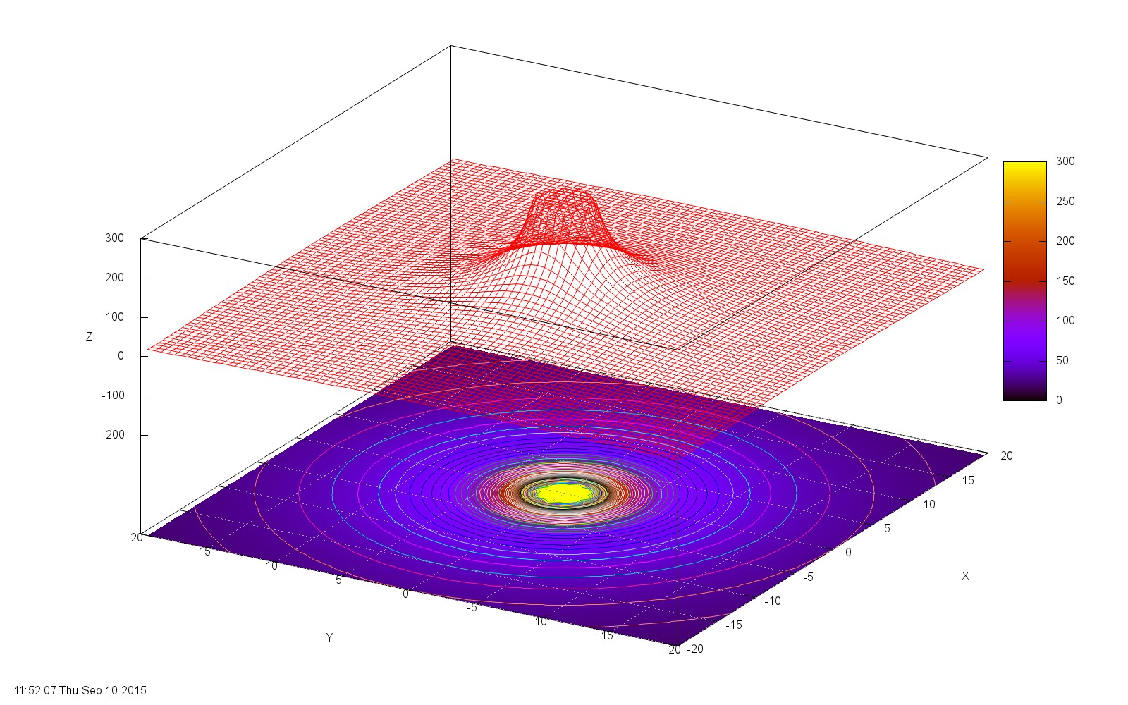
Figure 1: Simple food source
The height, plateau radius, decay power and 'depleteability' (i.e. whether or not Norman can change the food value by eating it) are all controlled by the user. The configuration can also include "anti-seeds" - sources of negative food. The total food supply available at any point is obtained by summing the contribution from all seeds at that point and clipping to zero if the total is negative - see figure 2.
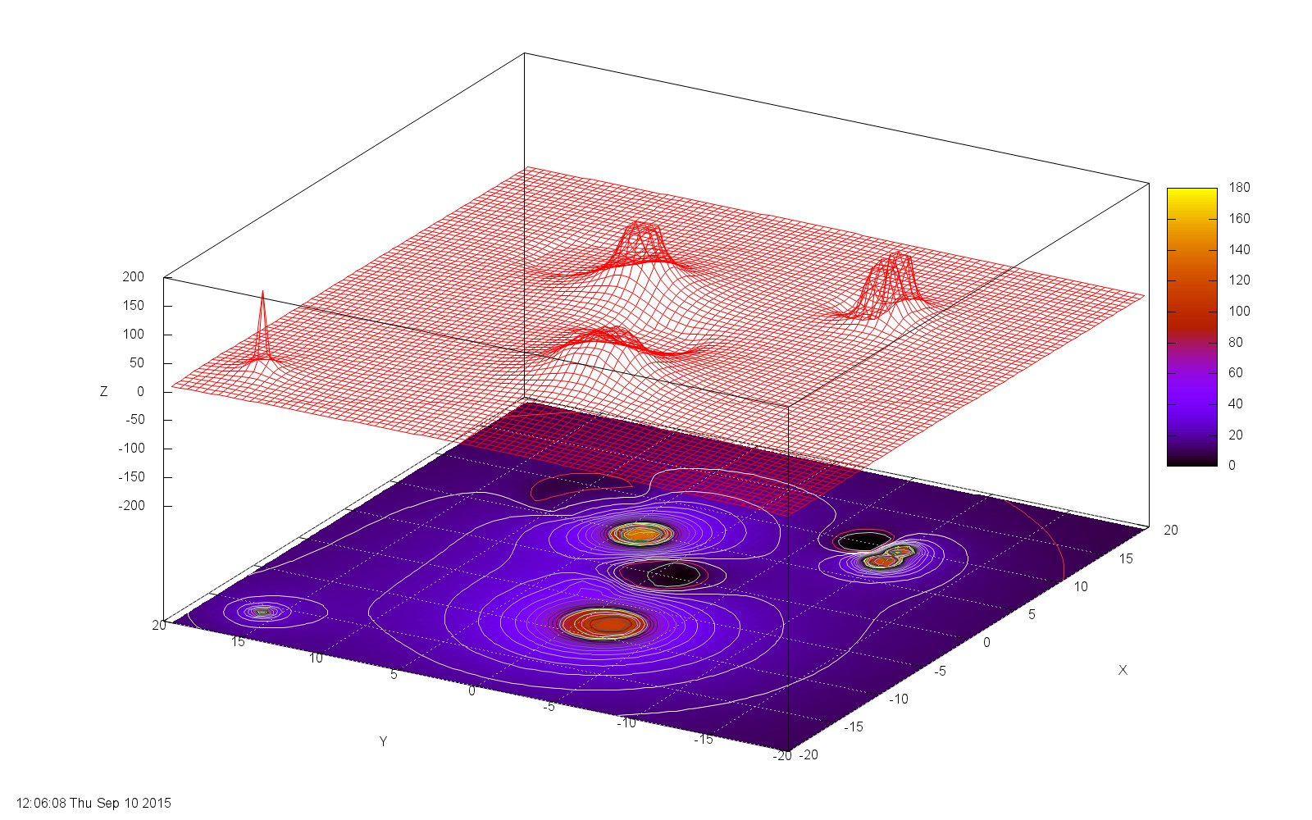
Figure 2: Compound food surface
2. Usage
The constructor takes no arguments and does nothing.

2.1 void PlayPen(P3_t<pos_t> &, P3_t<pos_t> &)
Playpen defines the size of the Universe. This is only used for display purposes; there is nothing to stop the user placing seeds outside the Universe, and nothing to stop Norman wandering outside.

2.2 void Add(P3_t<pos_t> & p, double H, double n=1.0, double r₀=0.1, bool de=true)
Allows the user to establish food "seeds" throughout the Universe. The functional dependence of the food contribution a distance r from the seed (see figure 3) is

F(r) = H(r₀/r)^{n} r>r₀
H r<= r₀
Figure 3: Food source parameters
H
decay exponent
r₀

The flag de indicates if the source is depleteable by being eaten (see Munch). The food source is radially symmetric.
Figure 2 is created with the calls
vr1.Add(P3_t<pos_t>( -3.3, 2.1), 16.9,1,1);
vr1.Add(P3_t<pos_t>( 4.9, 3.8), 135.4,1,1);
vr1.Add(P3_t<pos_t>( 8.4, 9.2),-12.3,2.5,3.0);
vr1.Add(P3_t<pos_t>( -8.2, -1.2), 64.3,1,2);
vr1.Add(P3_t<pos_t>( -8.0, -1.7), 44.3,1,1);
vr1.Add(P3_t<pos_t>( 0.0, 0.0),-44.3,1,2);
vr1.Add(P3_t<pos_t>( 9.9, -9.9), 100.0,2,0.6);
vr1.Add(P3_t<pos_t>( 9.9, -7.9),-100.0,2,0.7);
vr1.Add(P3_t<pos_t>( 7.9, -9.9), 100.0,2,0.8);
vr1.Add(P3_t<pos_t>(-16.0, 16.0), 150.0,0.9);

2.3 void Munch(P3_t<pos_t> & p, double m)
This routine allows Norman to deplete the food at point p, by taking a bite (m) from the available food. The consequence of a bite is that all the depleteable sources in the Universe are reduced, depending on their contribution to the food supply at point p according to the following scheme:

Norman takes a bite size m at point p
Total available food at p (i.e. F(p) - see Add()) = S_{f}, say
m = min(m,S_{f}) - Norman can't eat what isn't there
Calculate S_{m} = sum of food from all positive seeds (i.e. >= S_{f})
Contribution of food at p from source i = H_{i}F_{i}(d_{i})
So new value of food at p = H_{i}(m/S_{m})

(I'm not entirely happy with this - it could do with some more thorough exercising to see if the behaviour makes sense. Specifically, if you look at the Dump() outputs for the test program, the rate at which the food is going down doesn't make sense?)

2.4 void DrawPix(string fname)
Produces a jpeg in the style of figure 2.

2.5 void Elaborate(pos_t dx,pos_t dy,string ans)
Produces a file containing a matrix of food values on a grid spaced (dx,dy) within the Universe.

3. Internals
The attributes of each food source are held in a structure sing_t. Each call to Add() creates a new instance of sing_t which is stored in vector<sing_t> vval. sing_t::VR_f(P3_t<pos_t> & p) provides the non-truncated contribution of that particular seed at point p.

All position coordinates are defined in terms of the template class P3_t<T>, which provides the usual operations on geometric points. Although P3_t defines points in 3D space, only the first two dimensions are ever used in this system.

VR_t uses the local type pos_t for physical location; this is typedefed to double.

