

**Tec Galaxy**

**420-ZT2-GX Professional Integration Project**

**Cegep de la Gaspésie et des Iles**

**Submitted To Submitted By**

Prof. Lucas Brancatella Heli Patel (1994098)

Prof. Sébastien Richer Rushita Kheni (1994147)

Prof. Sakshi Sharma Vempati Sai (1995877)

Parshadi Jariwala (1994459)

**Index**

**Introduction**  **3**

**Purpose**   **3**

**Scope**   **3**

**Functional Requirements**   **4**

**Non-Functional Requirements**   **6**

**Use case Diagram**  **7**

**Class Diagram 9**

**References 10**

**Introduction**

The online market of digital components is getting expanded nowadays. This Tec Galaxy Website is focused on to sale all of the possible digital computer hardware products with the possibility to build user’s own machine according to their requirements. This website is for all of those people who are eager to use new hardware technologies even if they know nothing about it! The website includes the feature to reach out for help in case the user does not know which kind of machine the one wants. In this the user can simply fill up the questioner answering all the necessity questions, giving the users the almost accurate lists the components from which they can choose accordingly.

As the name suggest tec galaxy– this website is the galaxy containing the most recent technological machines as well as components.

**Purpose**

The main objective of this website is to sale tech products and components related to computer online. Where user can signup to purchase any of the products as well as can build their own product/machine to keep in mind of his/her requirements without any extra charge. User can avail the help through filling out simple questioner in case they do not have an idea about the kind of machine they require to complete their tasks.

**Scope:**

* **Scope Statement :**

This third party website is to sale tech products. This website has some interesting fetures such as AI advisor help, build your own machine, filters through products etc.

* **Deliverable:**
  + Admin panel
  + Product module
  + Filter module
  + Assembly module
  + AI advisor/reparation
  + Cart/Buy product/s module
  + Payment Gateway
  + Invoice Generation
* **Out of scope**
  + Online Payment gateway
  + Comment/like module
* **Milestone**
  + Creating admin panel
  + Product display
  + Filtration module
  + Machine assemble module
  + Creating AI advisor
  + Reparation
  + Payment gateway
  + Cart, orders/invoice module
* **Assumptions**
  + Registered device has an access to the internet
  + User can read and understand English
  + Users who are using Assembling machine feature do not know anything about which components will required to build up a specific machine but some of the features.
  + User who are tempt to use AI advisor help do not know anything at all about a machine nor the components.

**Functional requirement**

|  |  |  |
| --- | --- | --- |
| **Requirement Id** | **Requirement** | **Comment** |
| FR01 | Guest users should allow to view products and do customization without have to sign in/sign up. | So that the users can easily surf through website. |
| FR02 | User must sign up So that he/she can access all the feature of the website. | User can create an account to access the services of the whole website. |
| FR03 | Sign in is required to make transactions on the website. | To add more security and accessibility to the user account. |
| FR04 | Sign Up/sign in email must be in correct format as well as Password must be at least 8 to 10 characters long with at least a single special character with the combination of upper and lowercase alphabets. | To enhance security. |
| FR05 | Admin can signup using correct email format and a valid password containing at least single special character, lowercase letter, uppercase letter, a number with at least 8 characters long. | To create an account for admin to gain control over database of the website. |
| FR06 | Admin can addnew/delete/modify product to the website. | So the admin can handle the products inventory. |
| FR07 | Admin can deactivate/create a user. | So the admin can help manage users who repeatedly try to cheat with the shipment and delivery status. |
| FR08 | Admin can add/remove the deals. | So that admin can apply these deals to the multiple products. |
| FR09 | Users can able to customize their own machine. | Users can have the features they want in their customised machine. |
| FR10 | User can take advisor from the AI advisor questioner. | Even if the user does not know anything about machines, they can manage to buy their machine according to their requirements. |
| FR11 | User can access the reparation service. | To give more convenience to the users. |
| FR12 | Registered user can update their personal profile. | So that user can easily change their details if anything changes. |
| FR13 | Users can add multiple products to the cart as well as they can delete one from the cart. | So that they can conveniently buy products of their choice. |
| FR14 | Registered users can see their invoice history. | To have access through the orders they have placed. |
| FR15 | Registered user can buy products online. | To get more convenience. |
| FR16 | Users can filter the products by name, category, price. | So that users can find desired products easily. |

**Non function Requirements:**

|  |  |  |
| --- | --- | --- |
| **Requirement Id** | **Requirement Status** | **Type** |
| NFR01 | The account must be accessed by authorised user with correctly formatted emailed and valid password i.e. 8 characters long at least containing one upper and lower case combination and at least single special character, | Security |
| NFR02 | Website will be accessible 24/7. | Availability. |
| NFR03 | Website should load every page within 5 secs | Efficiency. |
| NFR04 | User’s personal data must be secured with a password. | Confidentiality |
| NFR05 | Data of the website must be recovered after a failure. | Recoverability |
| NFR06 | UI must be easy to understand for all the age groups above 11 | Usability |
| NFR07 | The website must be easy to maintain. | Maintainability |
| NFR08 | System must handle heavy traffic efficiently | Scalability |
| NFR09 | Error with the invoice generation must be less then 0.99% | Integrity |
| NRF10 | AI advisor should suggests the components which matches more then 90% of the user requirements. | Performance accuracy |
| NRF11 | Displayed sale prices must be accurate almost 99.99%. | Accuracy |

**Use case Diagram**

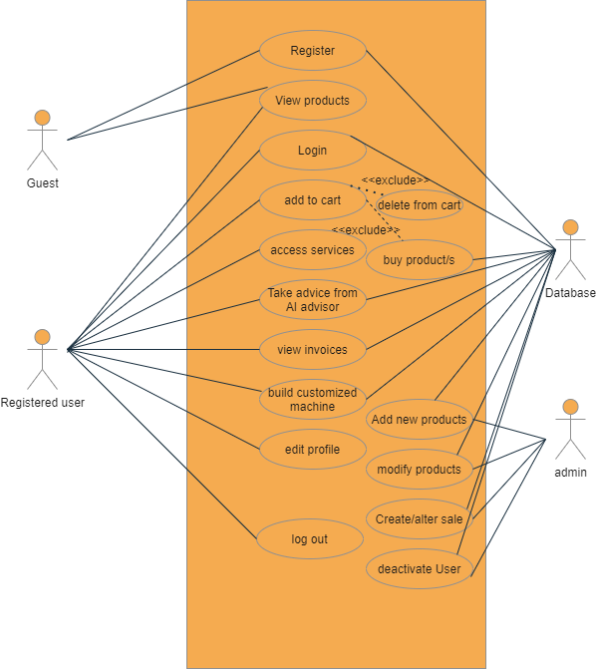

**Class diagram**

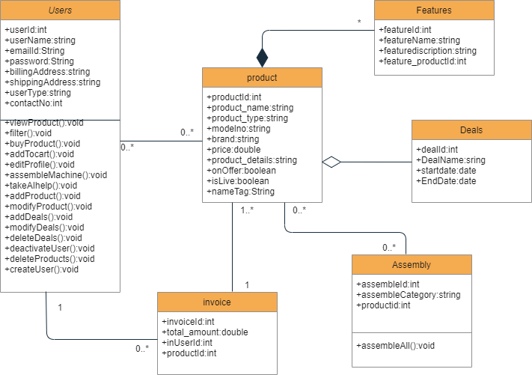

**References:**

<https://knowhow.visual-paradigm.com/uml/>

Github:

<https://github.com/helipatel95/ComputerHardwareStore2021.git>